Internet Programing

Name: Venu Koduru

ID:1253307

Name: Garlapad Krishna Harsha Chary

ID:1260441

Output:

**Home Page:**

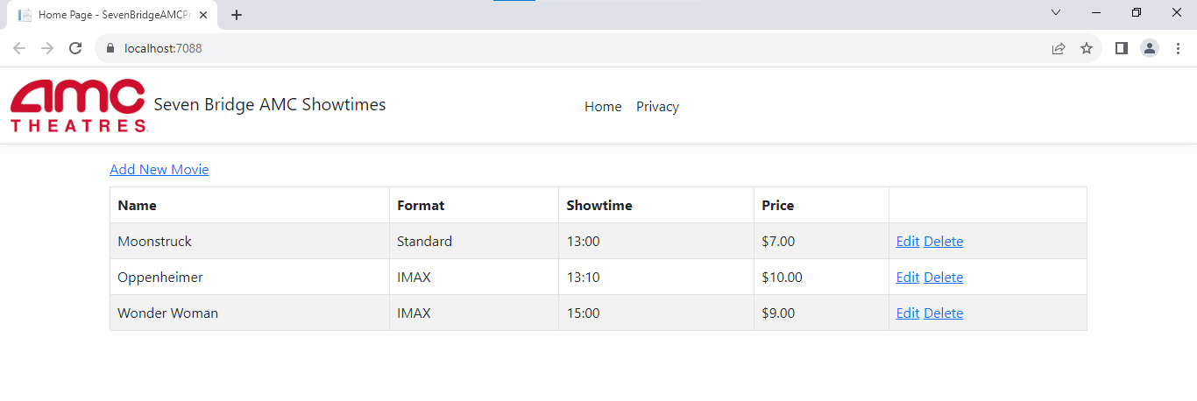

**All Validations in Error Theme:**

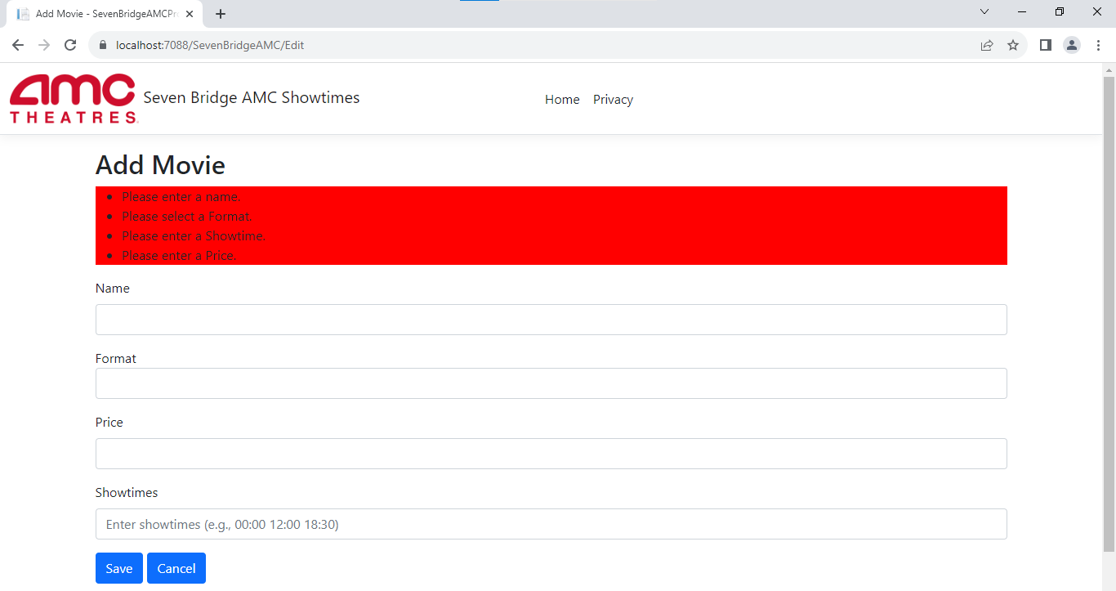

**Adding Movies**

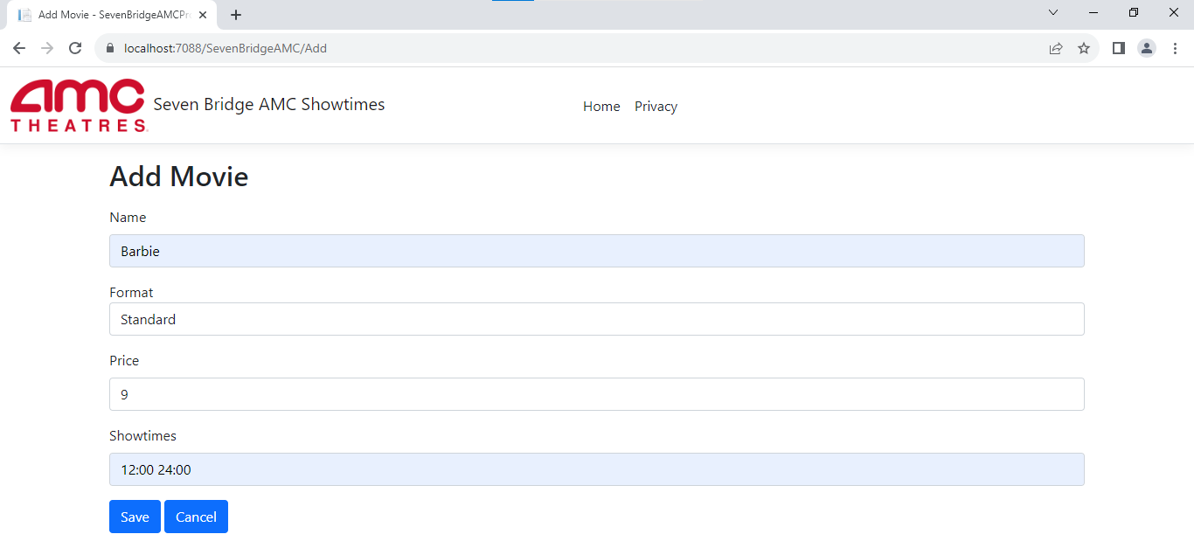

**Success Message in Green Theme after Adding Movie**

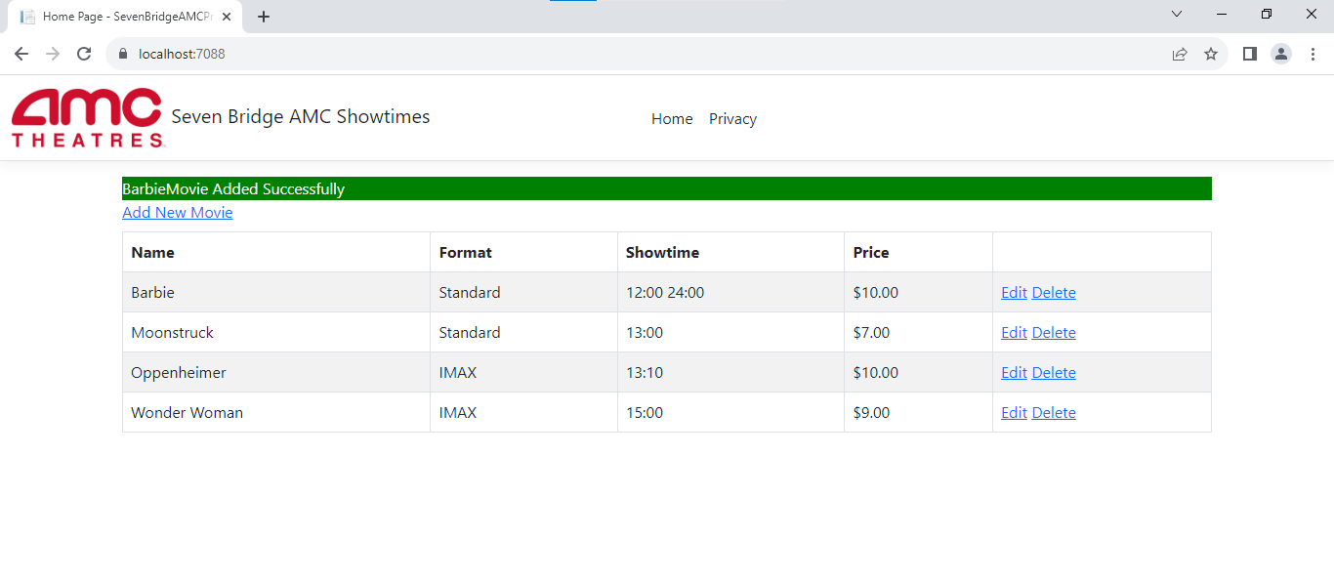

**Edit / Updating Movie**

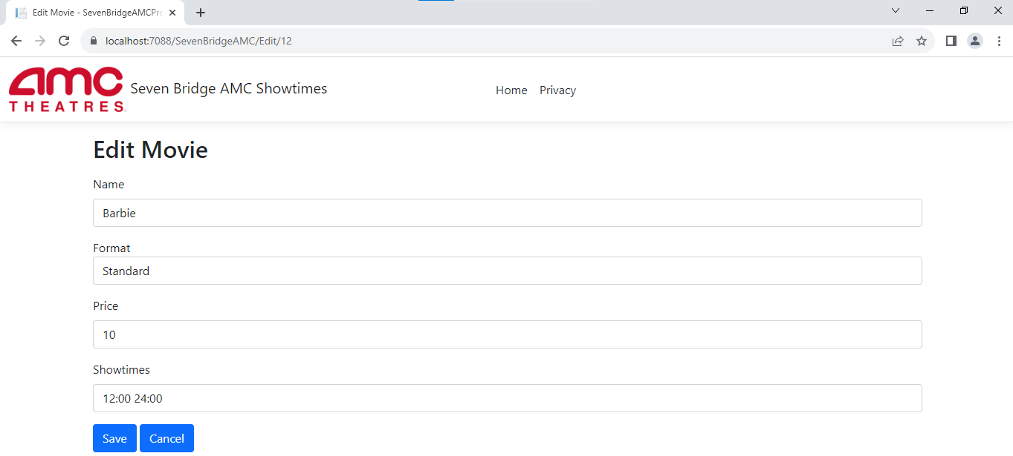

**Updated Success After updating movie details in Green Theme**

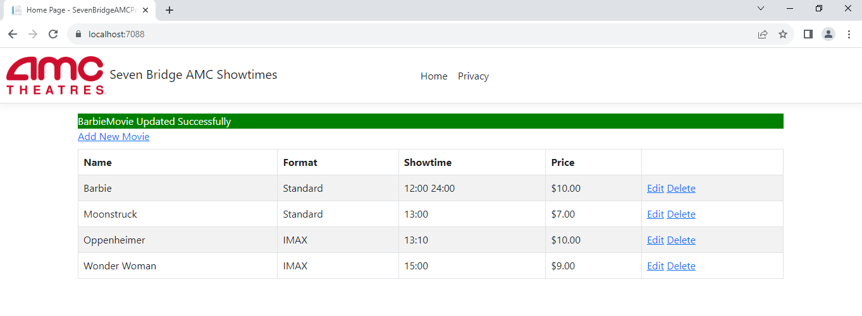

**Prompt Deletion**

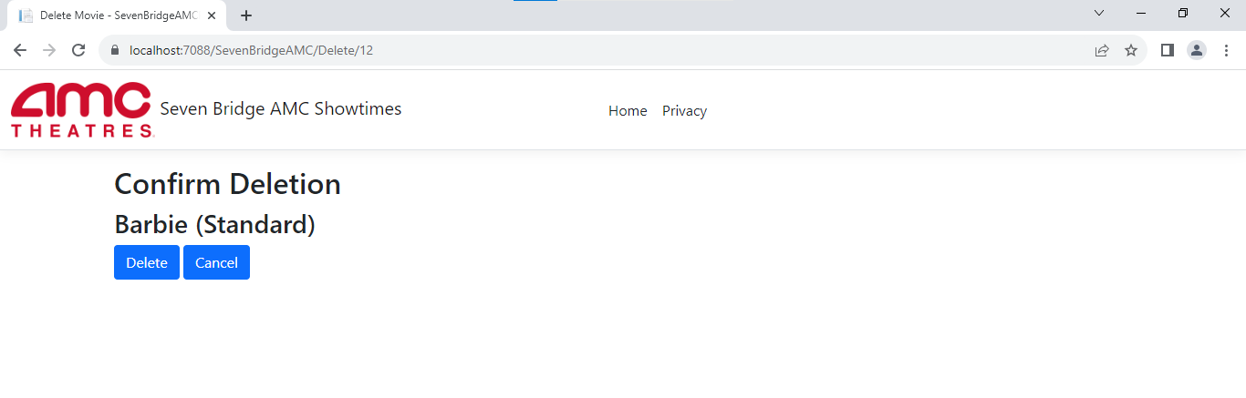

**Delete Success Message In Green Theme After Deleting**

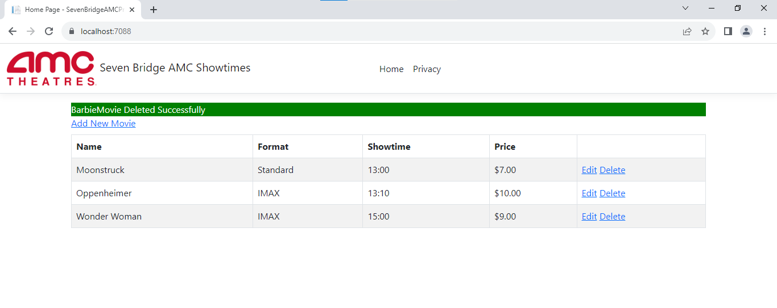

Project Source Code:

Controller files:

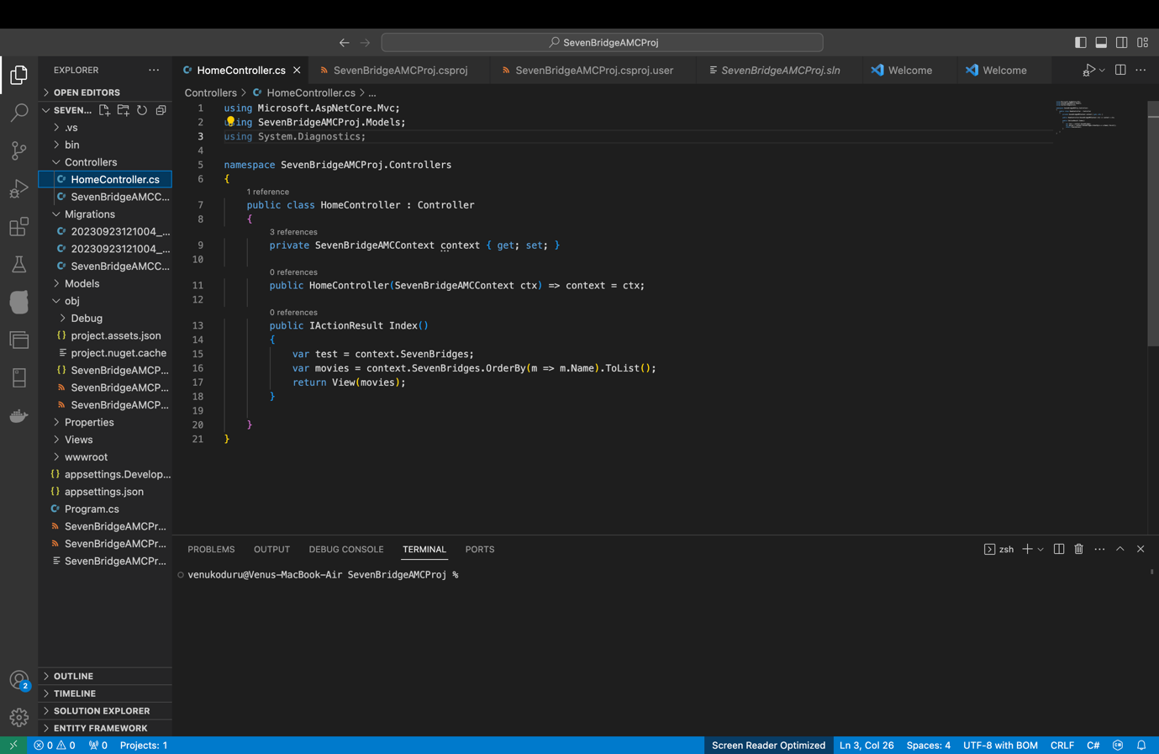

Migration files:

Models File

Views Files:

Program.cs

.csproj file

