# DOCKERS – ASSIGNMENT-2

Attaching the screenshots of docker commands in CMD and the image/container information from Docker Desktop tool.

**Running hello-world image in detached mode (-d):**

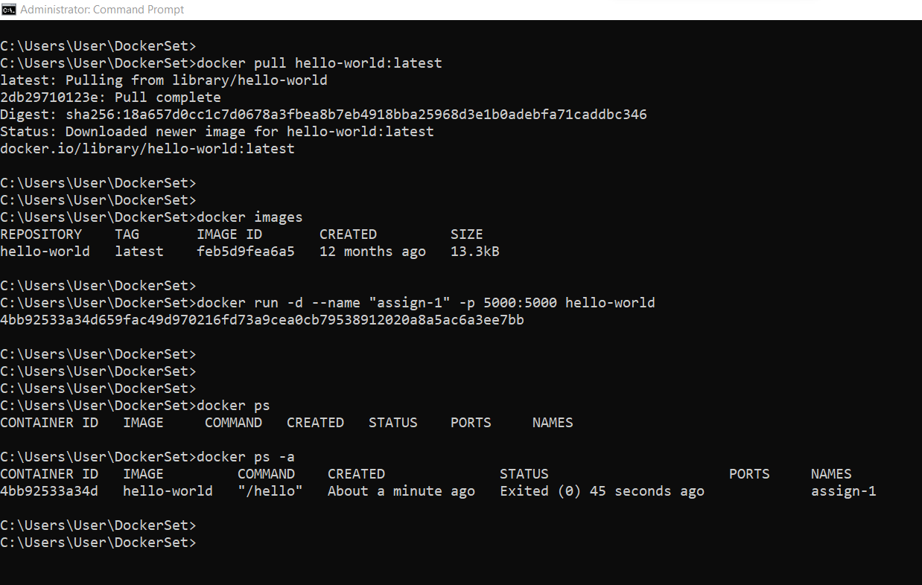

**Running hello-world image normal mode:**

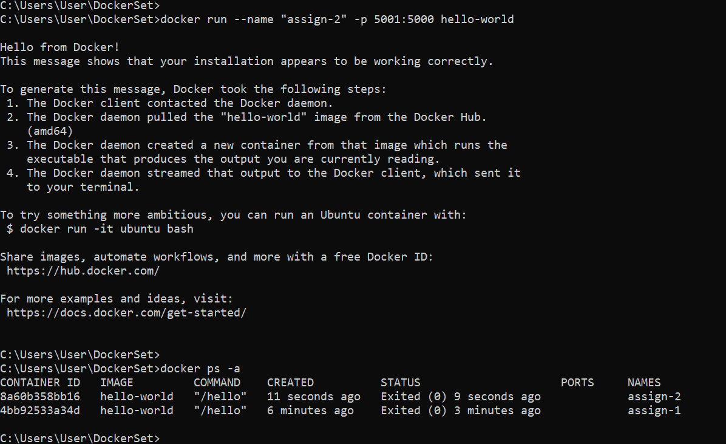

The image and containers information from Docker Desktop tool:

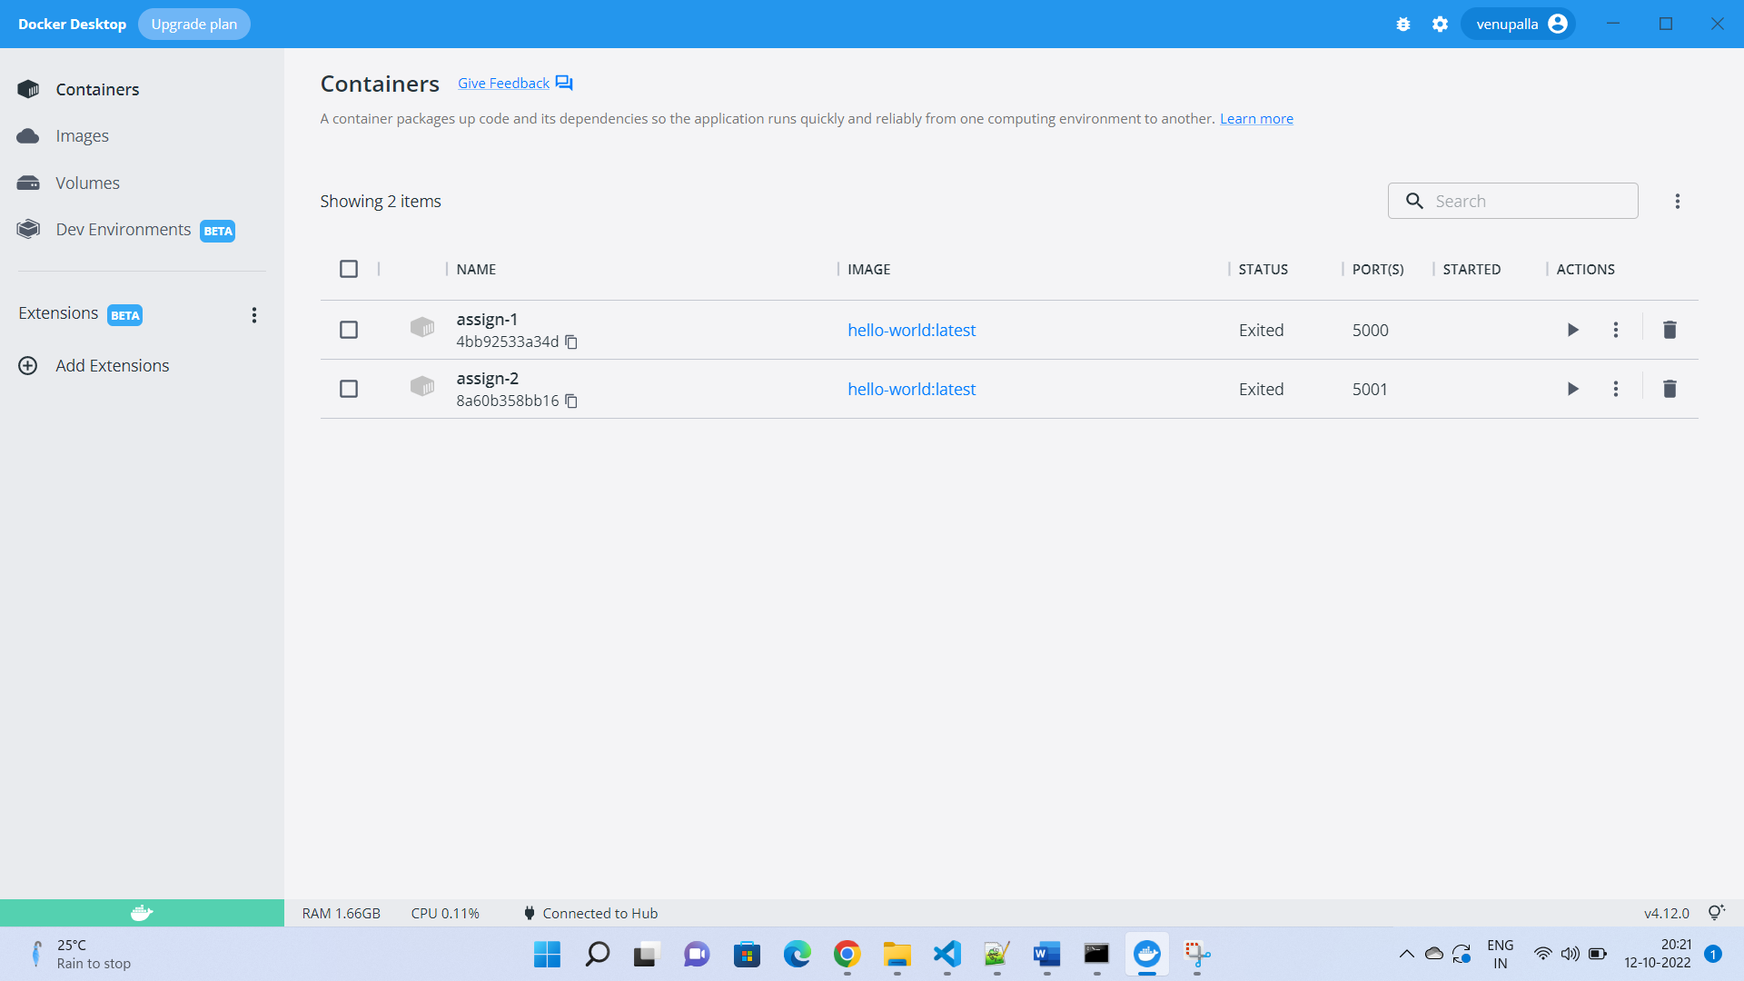

Container log output:

