# DOCKERS – ASSIGNMENT-3

Docker hub repo URL after pushing the image to server: <https://hub.docker.com/repository/docker/venupalla/helloworld-fastapi/>

Created FastAPI application and ran it locally:

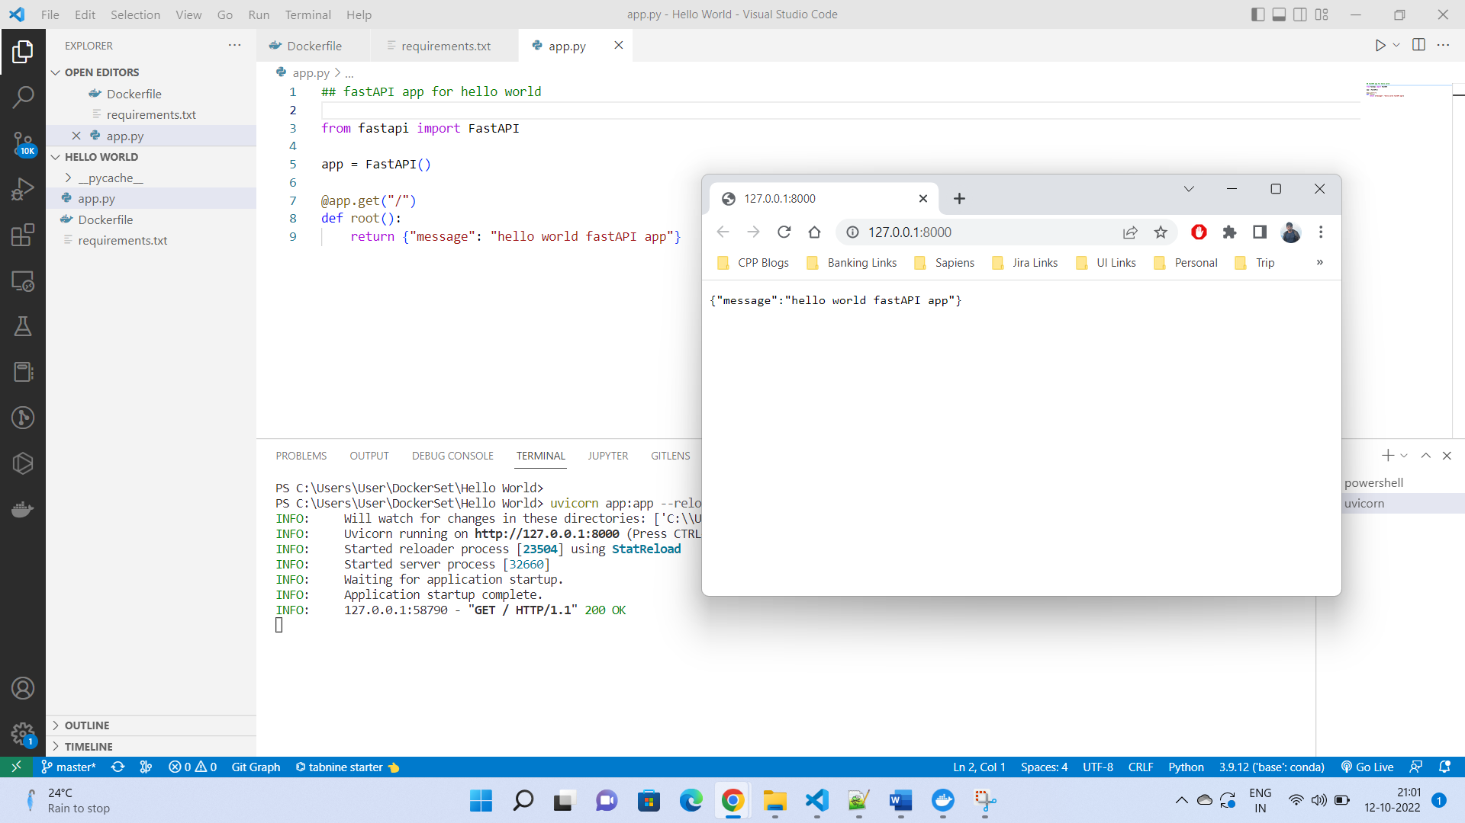

Building the docker image:

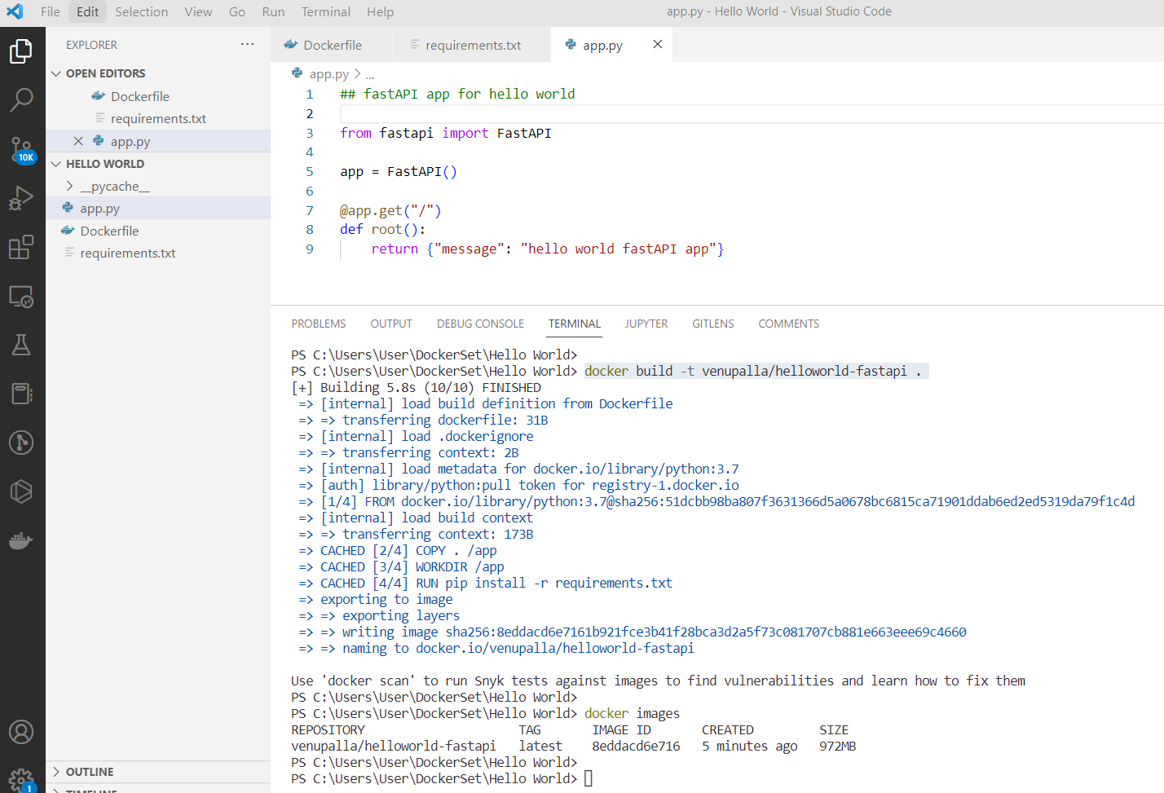

Running the image built in previous step:

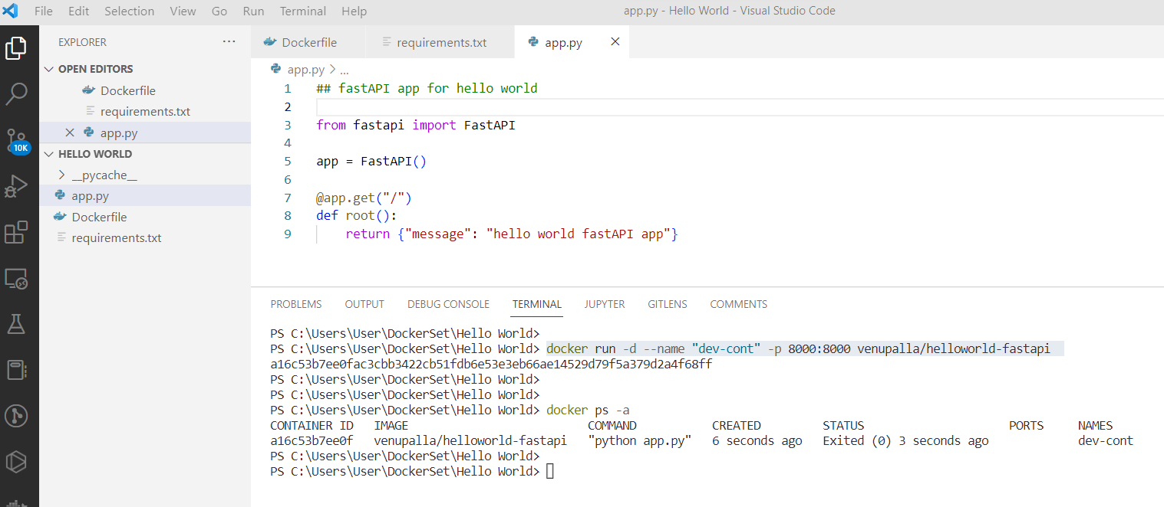

Pushing the image to Docker Hub repository:

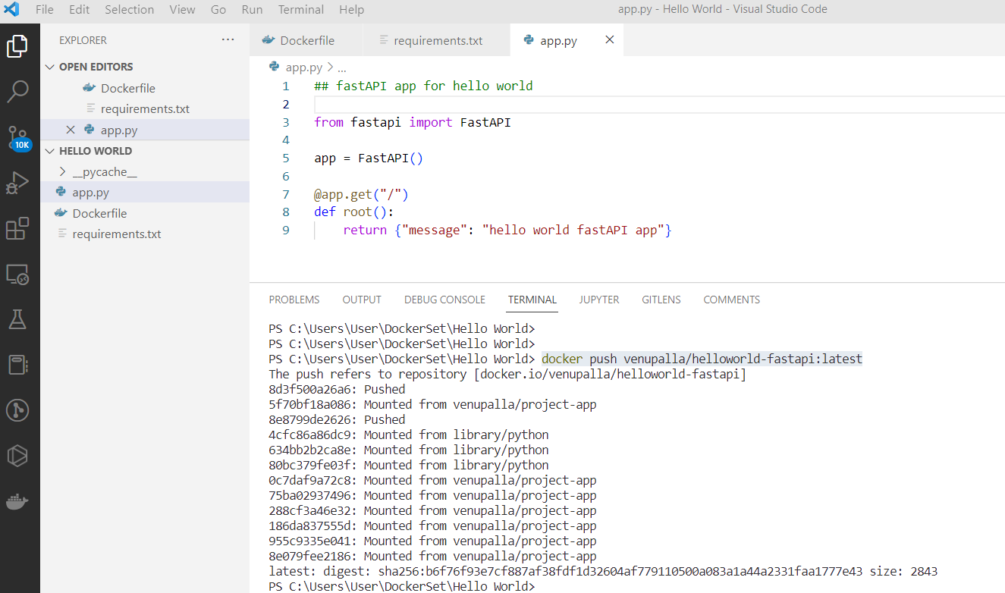

The image will appear in Docker Hub website as follows:

