GIT COMMANDS – EXAMPLES

Create new folder using ‘mkdir’.

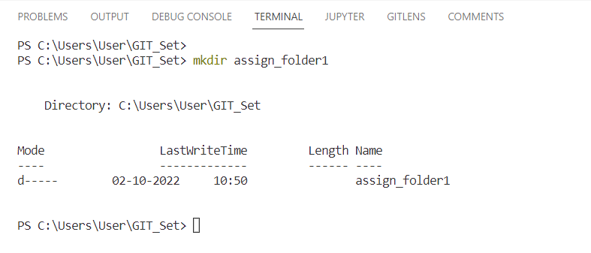

1. Create new file ‘README.md’.

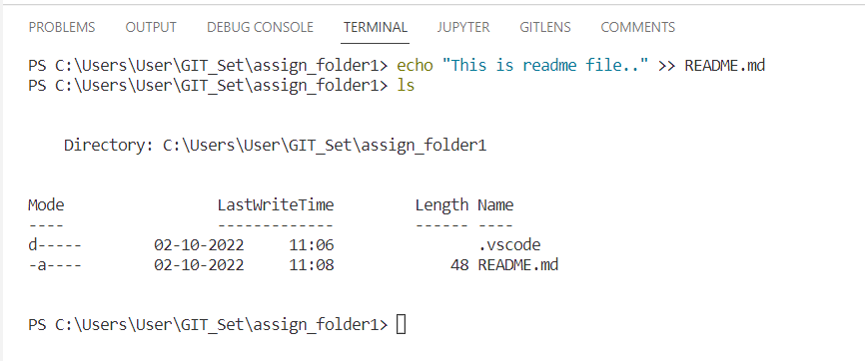

1. Initializes the git repository using **‘git init’** command

and checking for new/modified files using **‘git status’**.

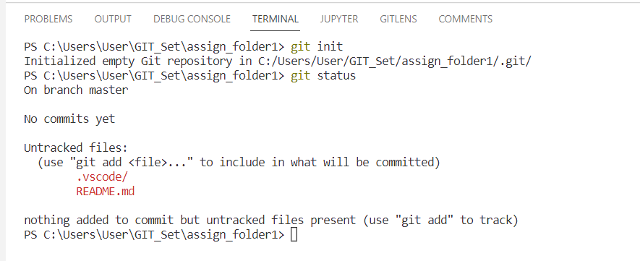

1. Adding the files to git so that we can track them using :

**git add . ->**  dot (.) is used for committing all files

**git add <filename1> <file2> ..<>** : commits the input files

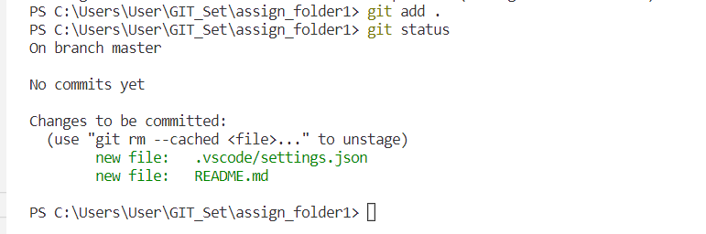

1. Committing the files to git using **git commit -m “message”.**

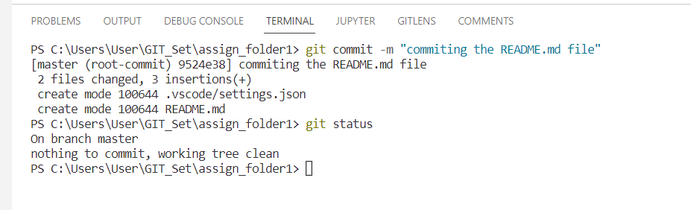

Now files will be saved to Staging area. We need to push them to main in-order to save them to main repository.

1. Check if the origin exists or not. If not, add the remote origin.

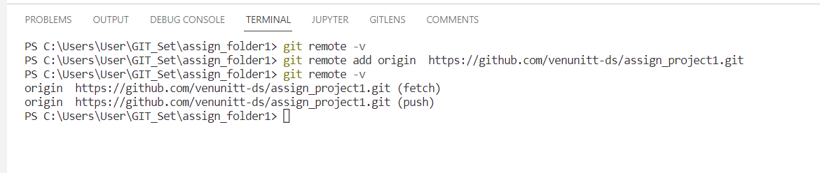

**git remote -v** : lists the remotes for current repository.

**git remote add origin <url>** : adds the remote ‘origin’ to repository

1. Now the final step is pushing the changes/files from origin to main using ‘**git push origin main’** command.

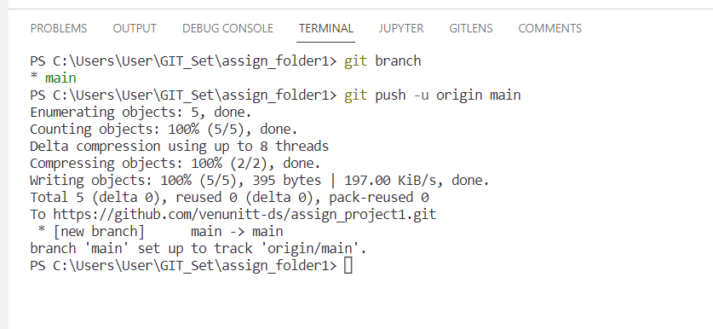

Now we can see the new files added to GIT repository from browser as follows.

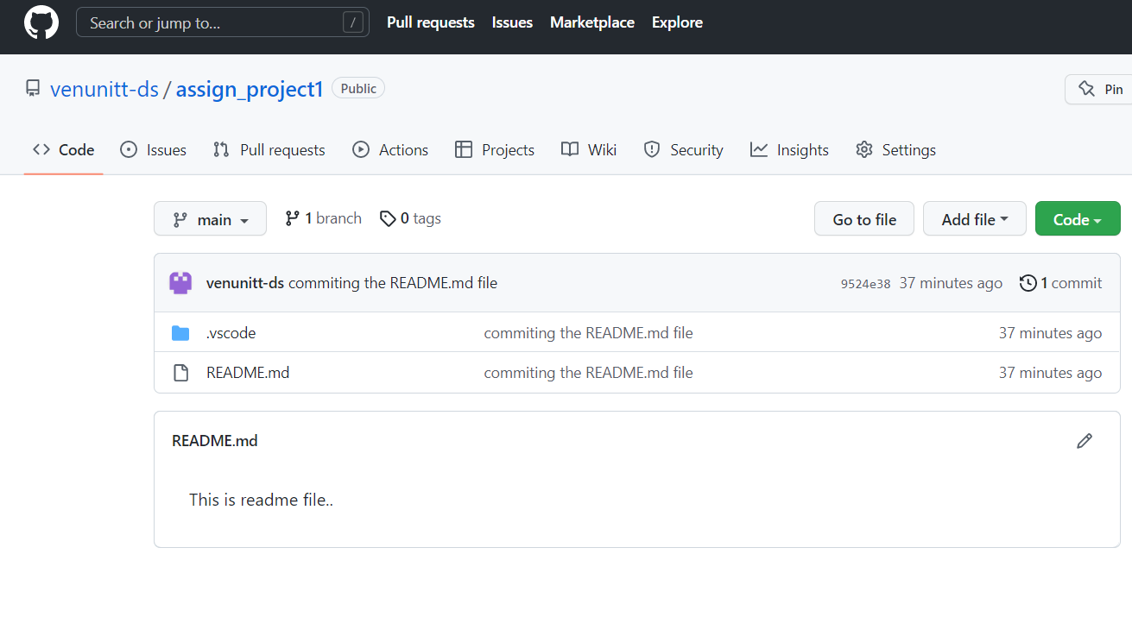

1. Remove the origin from repository using ‘**git remote remove origin’** command.

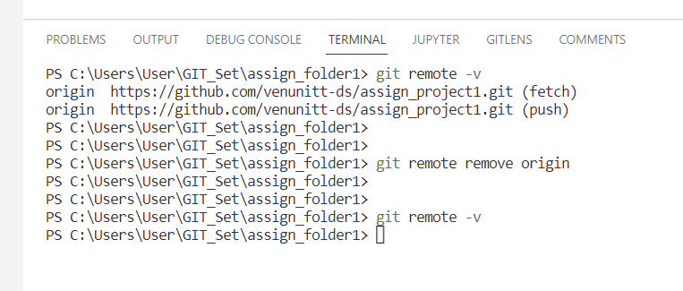

**BRANCH - OPERATIONS**

1. Create new branch using **‘git branch <branch_name>’** command.

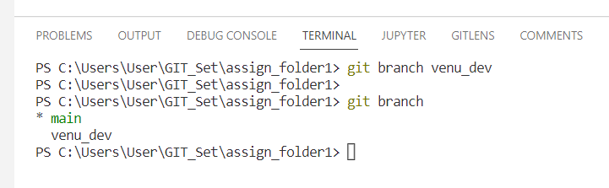

1. Switch between the branches using **‘git checkout <branch_name>’** command.

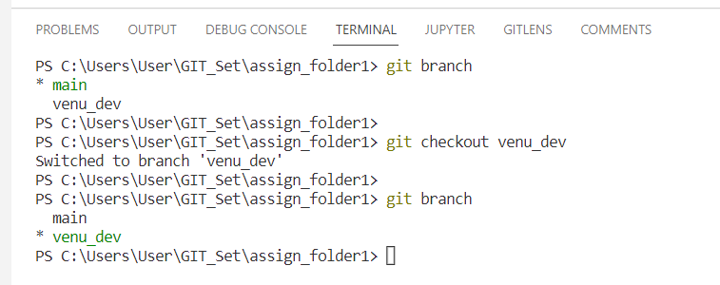

Created new file ‘dependencies.txt’ in branch and add data in it.

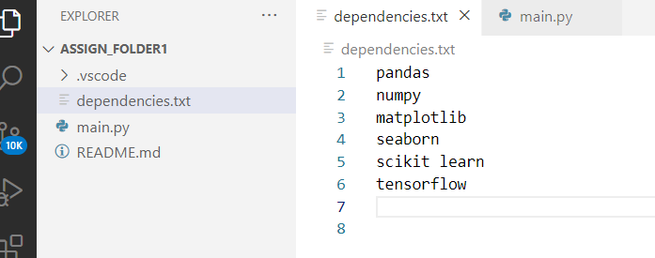

Added one more python file:

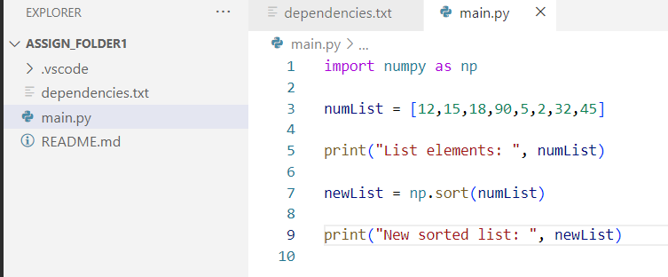

1. Commit these files to branch repo first using previously explained commands.

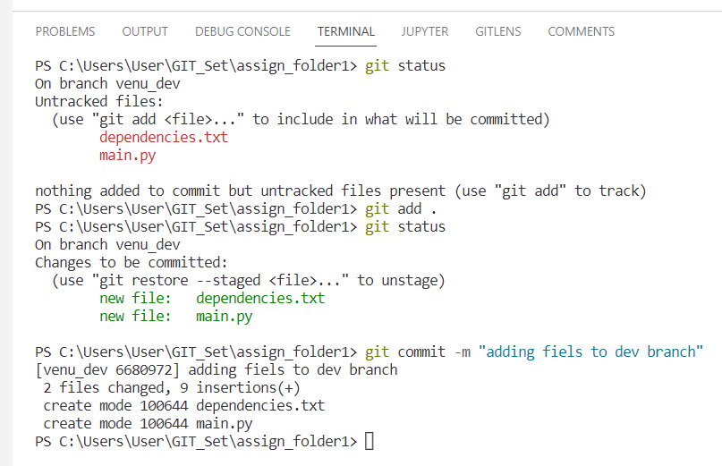

1. Now we need to MERGE these changes from venu_dev branch to main repository.

We use **‘git merge <dev-branch> main’** command to do it.

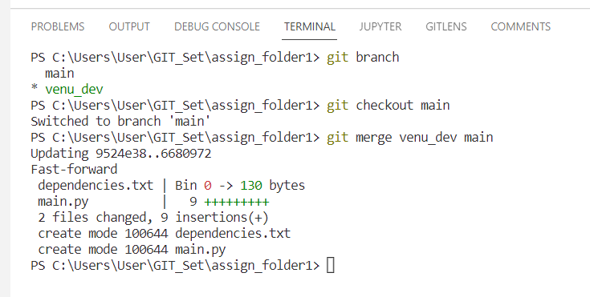

At this point, the files are added (staged) to main branch but not saved to git repository server.

1. Again, we need to add the origin and then push the changes from origin to main.

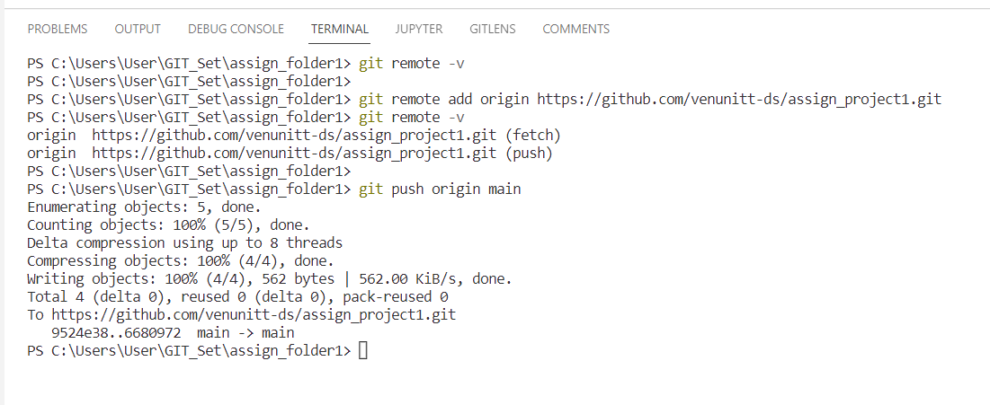

And git server now has the files and we can see them from browser.

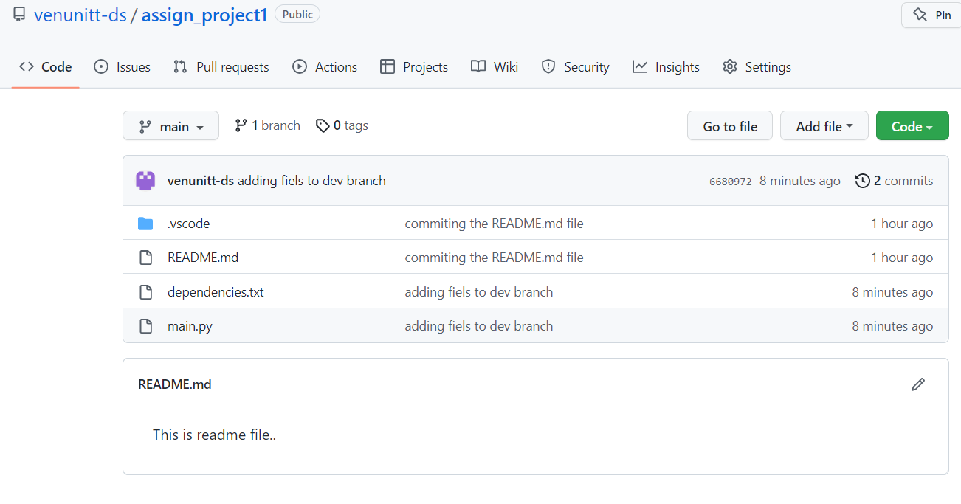

1. To see the log, we can use **‘git log’** command.

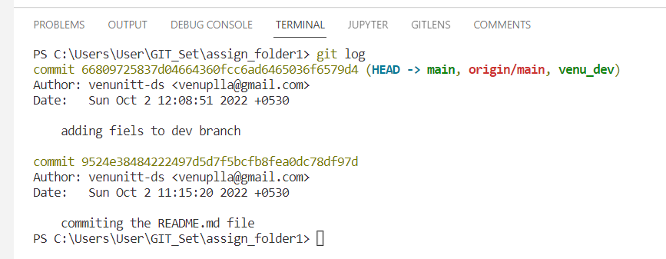

1. Clone the git repository using URL.

The repository link can be found under ‘Code’ tab -> HTTPS option.

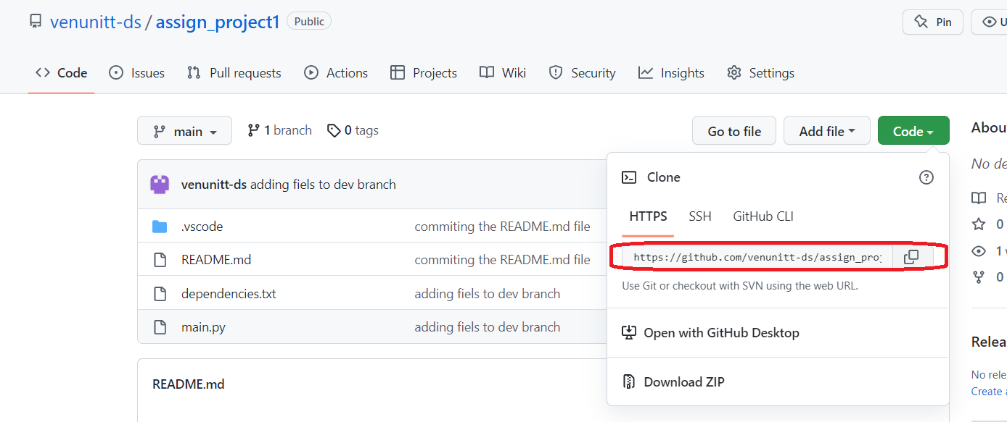

Using **‘git clone <url>’** command, we can clone/copy the repository to our local folder.

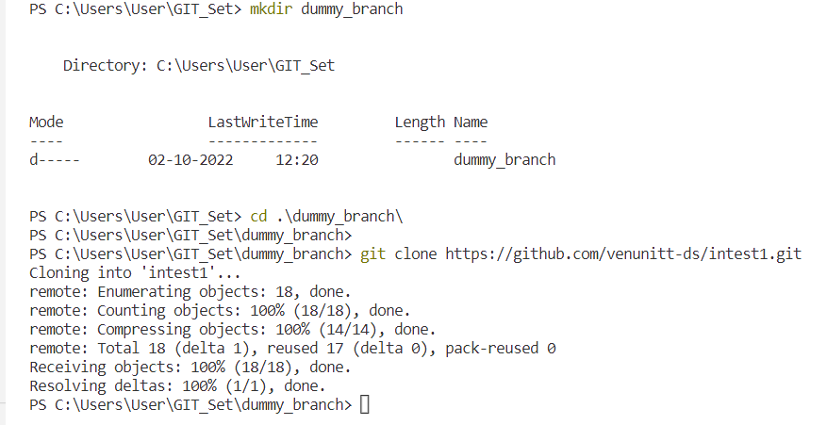

After cloning, we can use previously discussed steps to create new branch, add/modify files, commit to branch and push to main repository.

1. ‘**git diff’** shows the changes made to files.

‘+’ symbol: new line added

‘-‘ symbol: line deleted

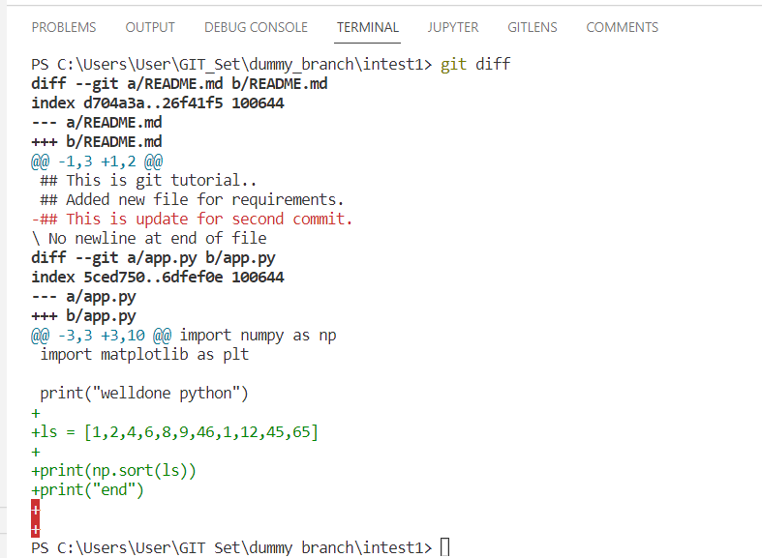

1. To review the particular commit, firtst use ‘**git log’** to see all the commits.

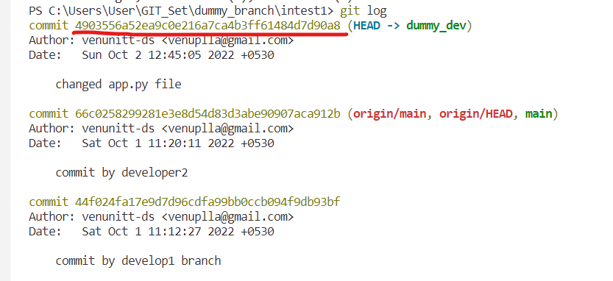

We can see the commit ID values in log. Using them, we can see that particular commit changes with ‘**git show <id>’** command.

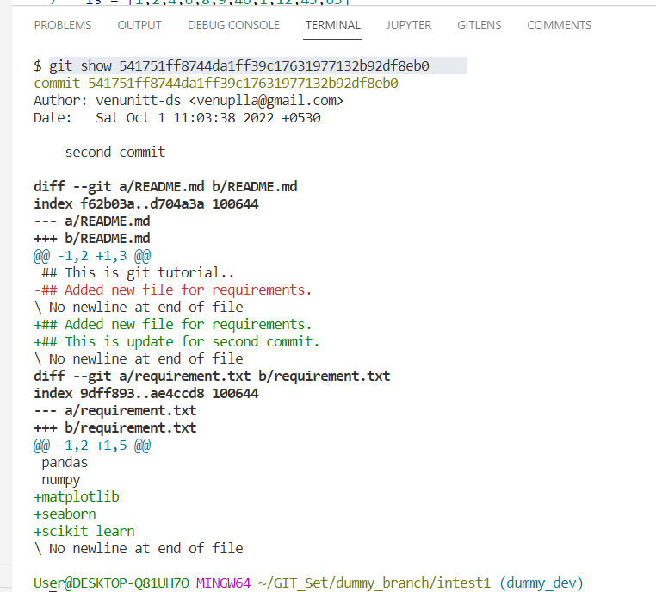

1. Getting the changes from origin repository before pushing changes from our branch using

**‘git pull origin main’** command.

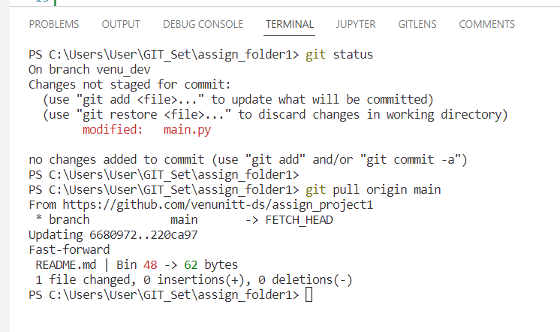

Here we can see that README.md file is modified and the changes are pulled into local repository. We can use **‘git log’** commandto see the commit information.

1. Rename the files using **‘git mv filename1 <newfilename>’** command:

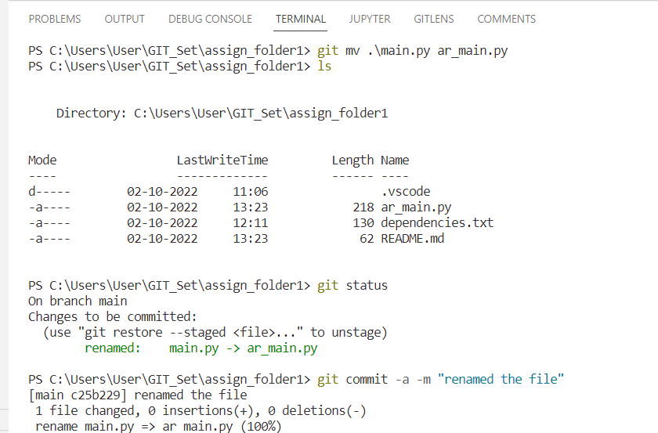

1. Delete the branch using **‘git branch -D <branch-name>’** command:

