Create a virtual network

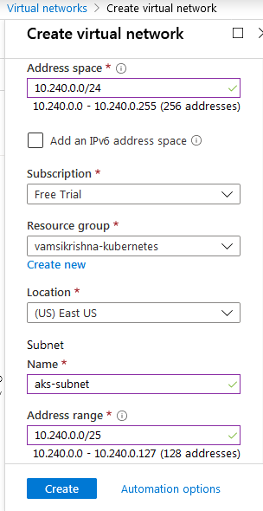

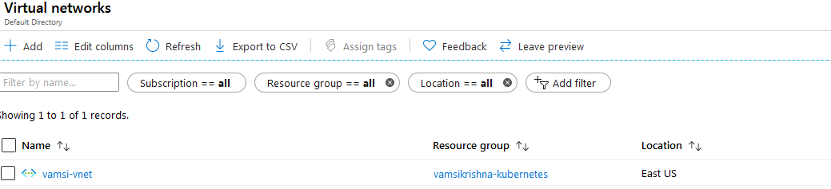

Create azure kuberentes cluster from azure portal

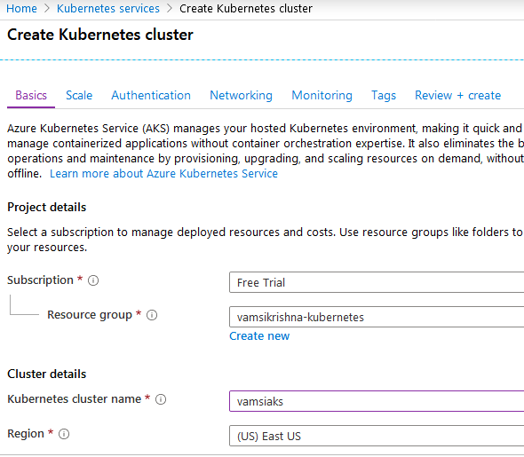

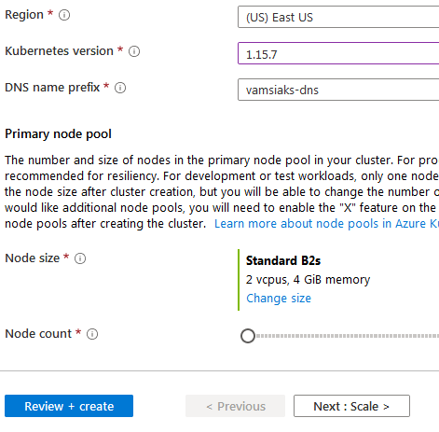

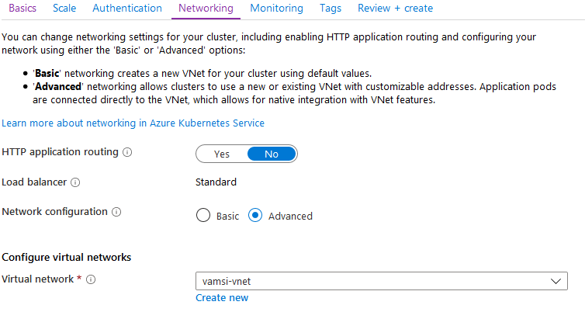

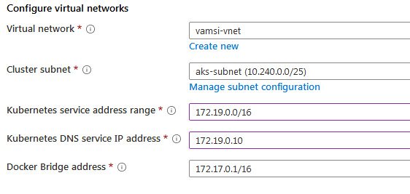

AKS cluster can also be setup using Azure client

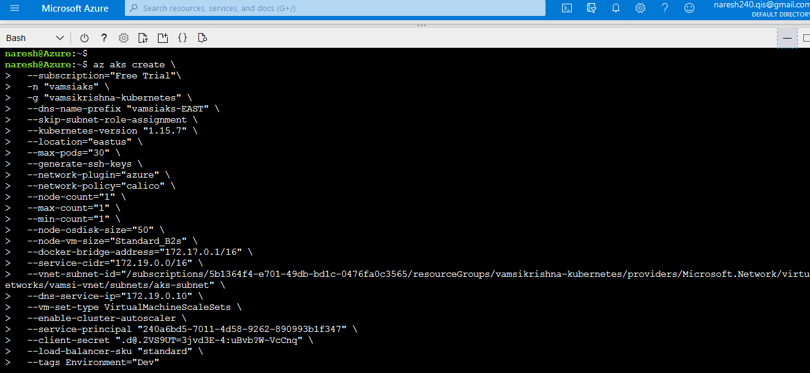

For connecting to AKS get kubeconfig file and connect

***az aks get-credentials --name vamsiaks --resource-group vamsikrishna-kubernetes***



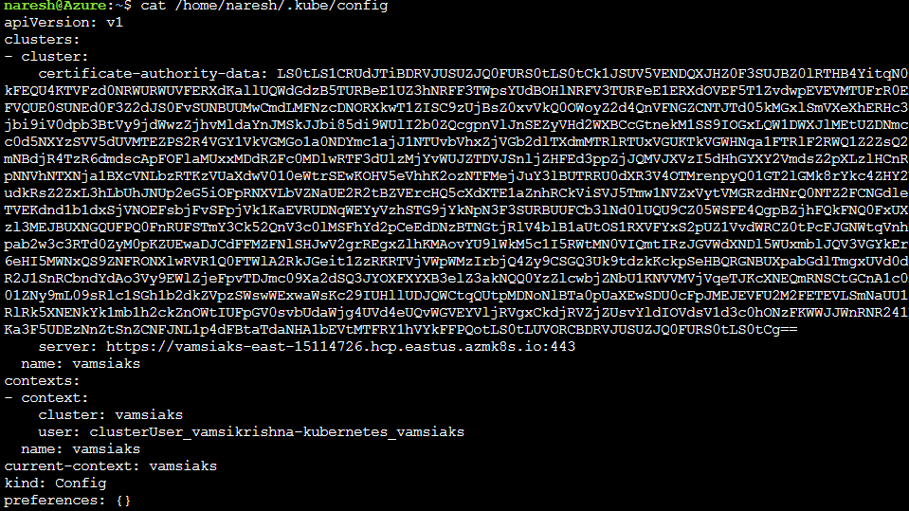

Run kubectl and check client and server info



sss