**Convert .csv file data (From S3 buscket) into Table using Athena**

**Create S3 bucket**

Open S3 service in AWS

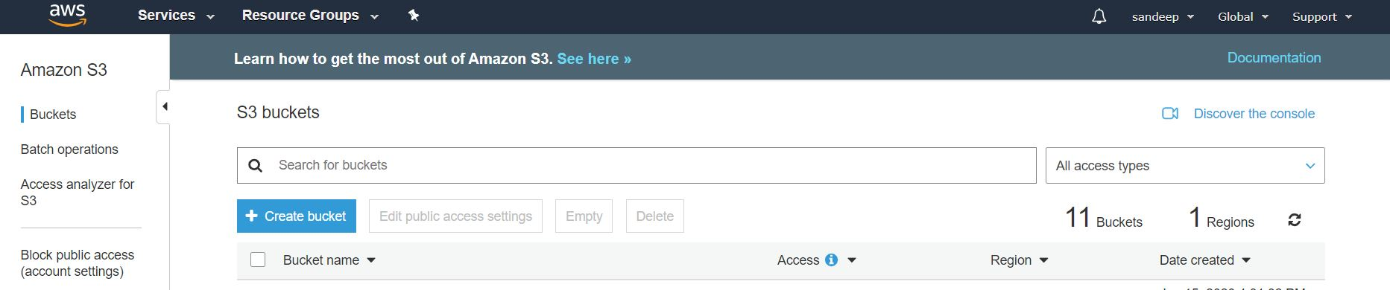

Click on create bucket with the name of **athena-project-simple**

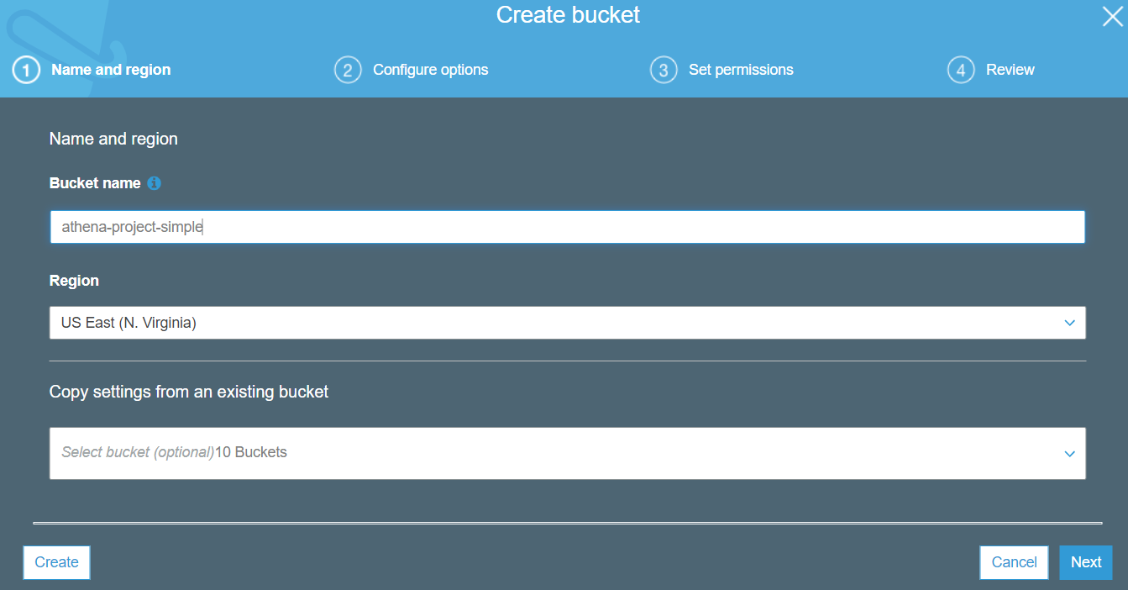

Click on Create

Bucket created, check in below table

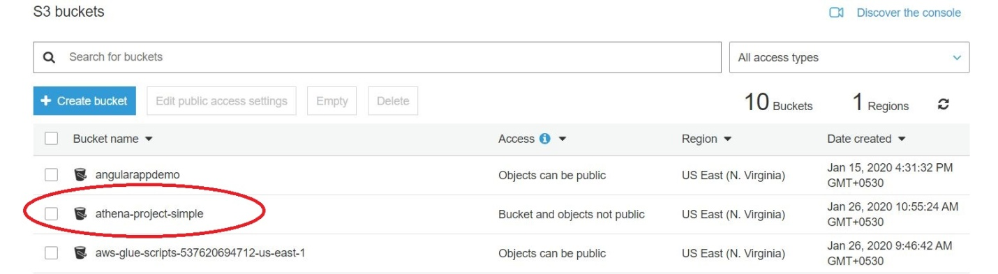

Click on bucket and upload csv file

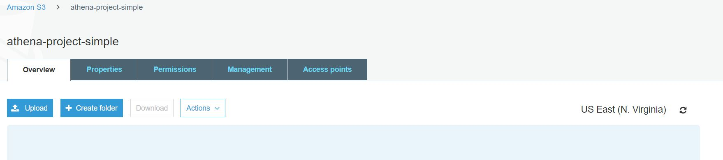

Click on Create folder to create new folder with the name of **csvinput** and **csvoutput**

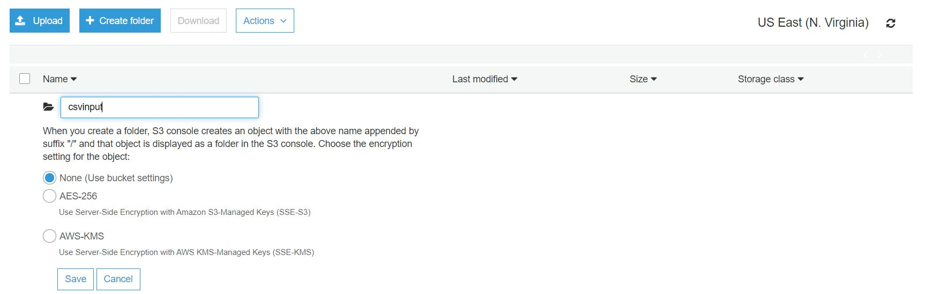

Check file created or not

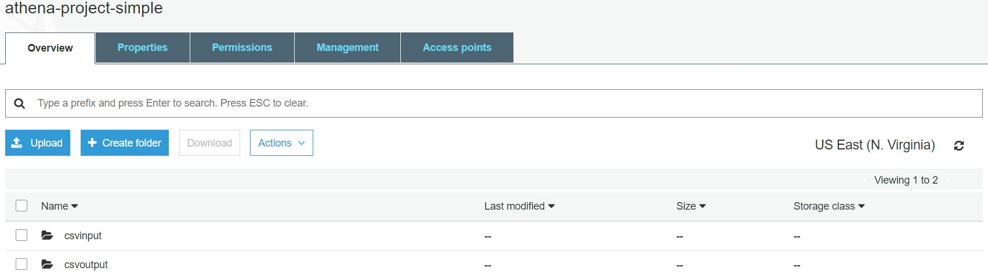

Click on csvinput file and click on upload

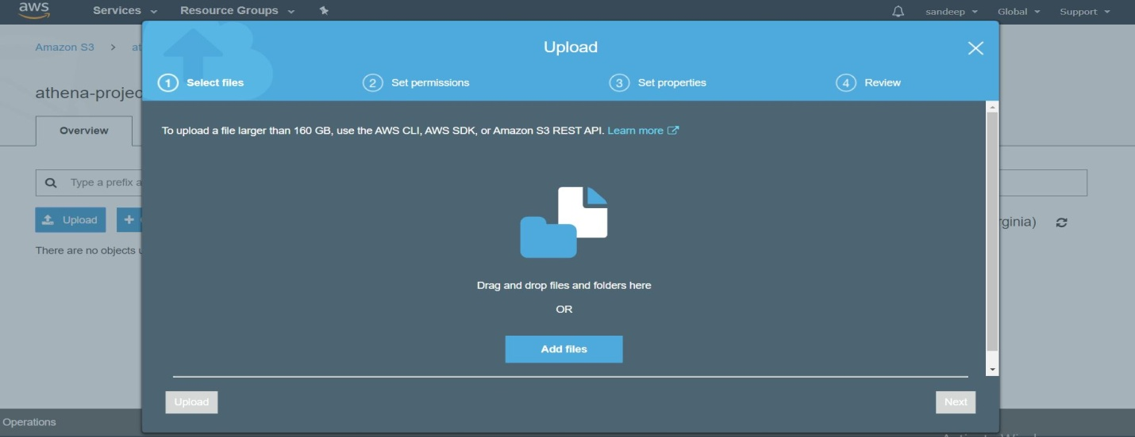

Click on Add file and upload csv file

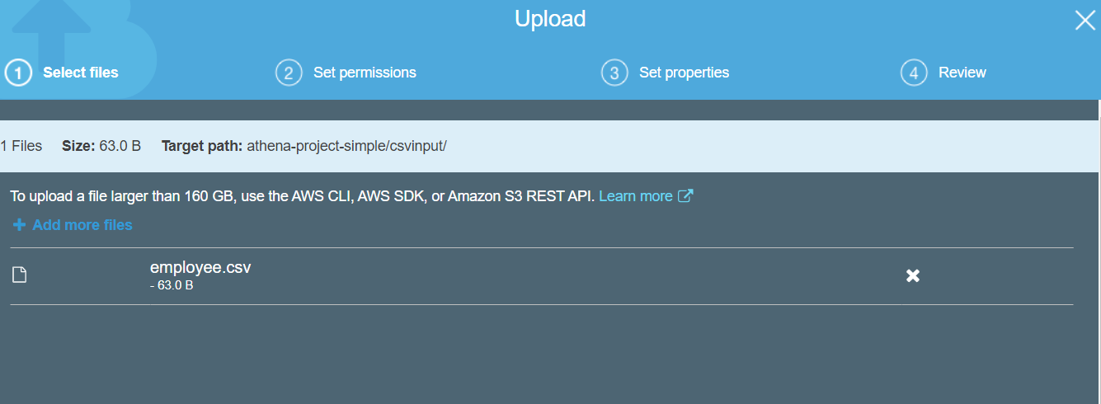

Check whether file is uploaded or not

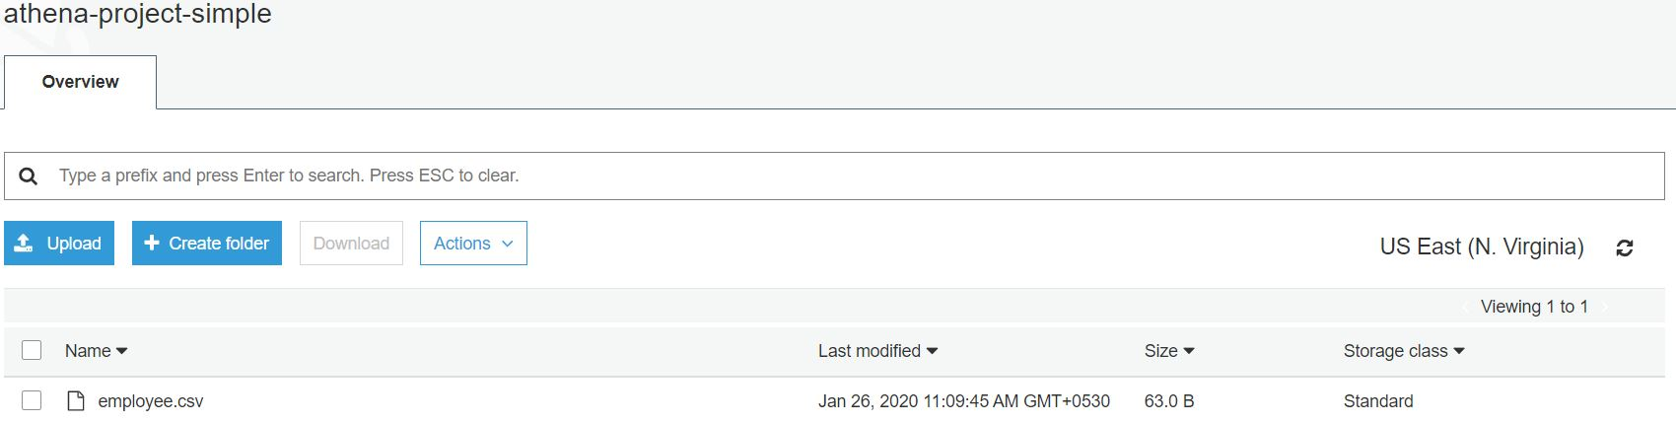

**Open Athena service in AWS**

Set Query Result location path:

Athena 🡪settings

Provide Query result location as s3://athena-project-simple/csvoutput/

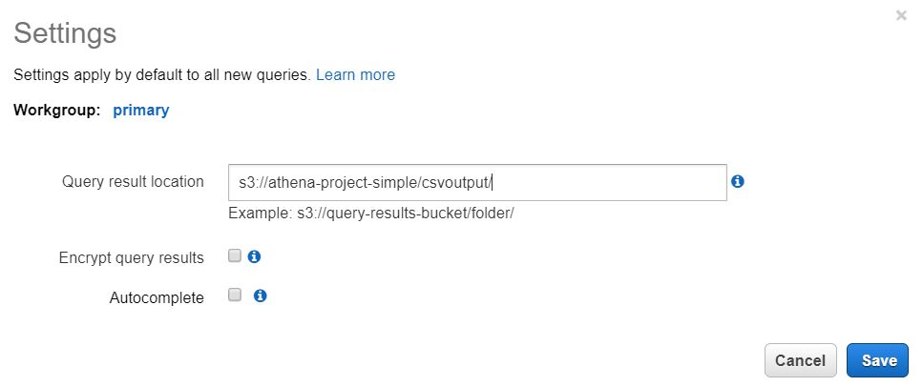

**Create table for conversion of csv file data into table:**

Open Athena Service

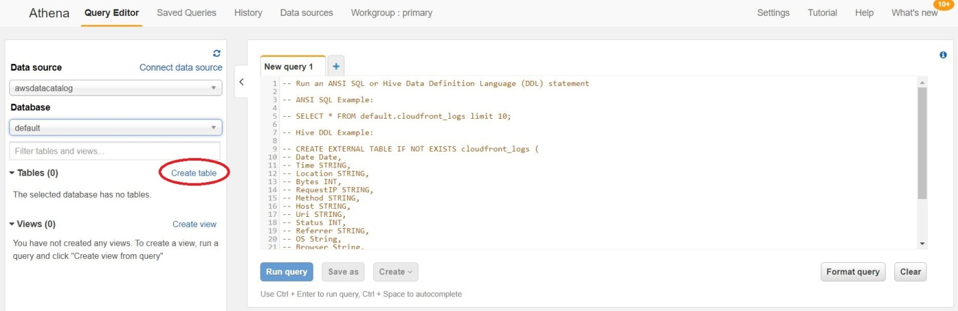

Click on **Create table**

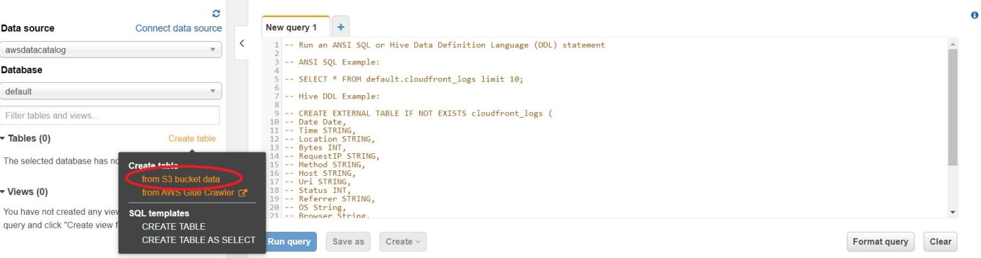

Click on **from S3 bucket data**

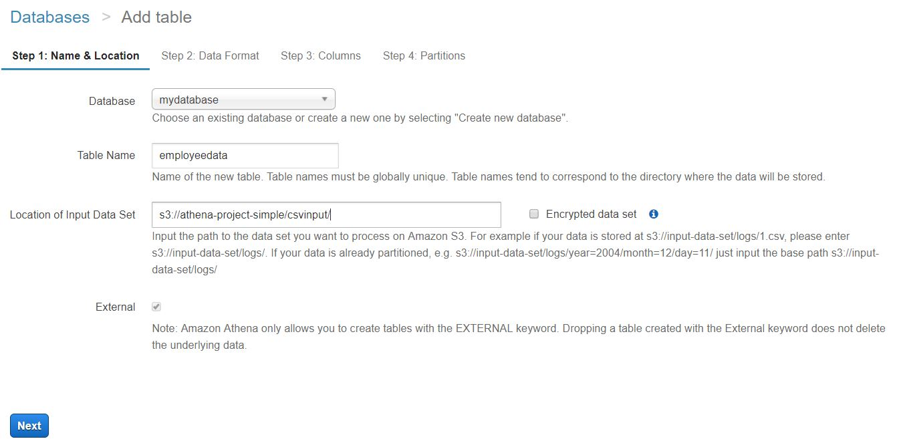

Give **Database name, Table name and Location of input Data Set** and then click on **Next**

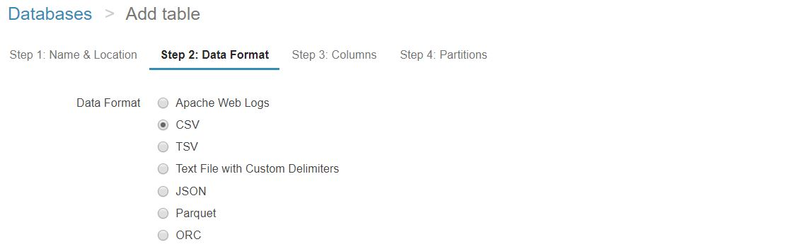

Set **Data Format** as **CSV** and click on **Next**

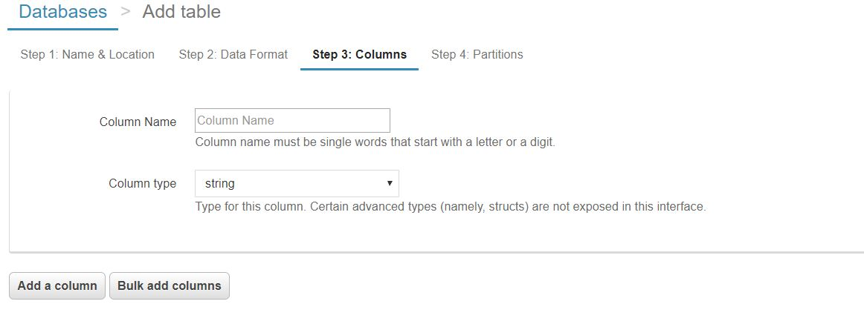

Click on **Bulk add colums** and give cloums which we have in CSV files

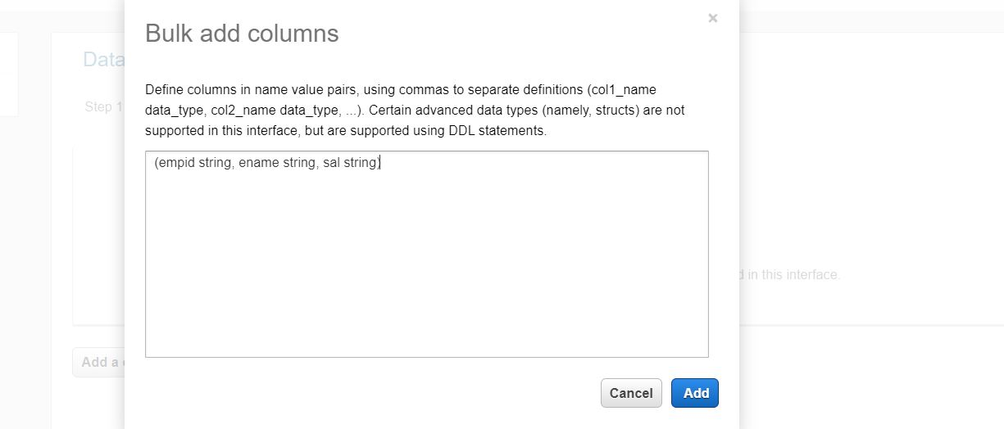

Click on add

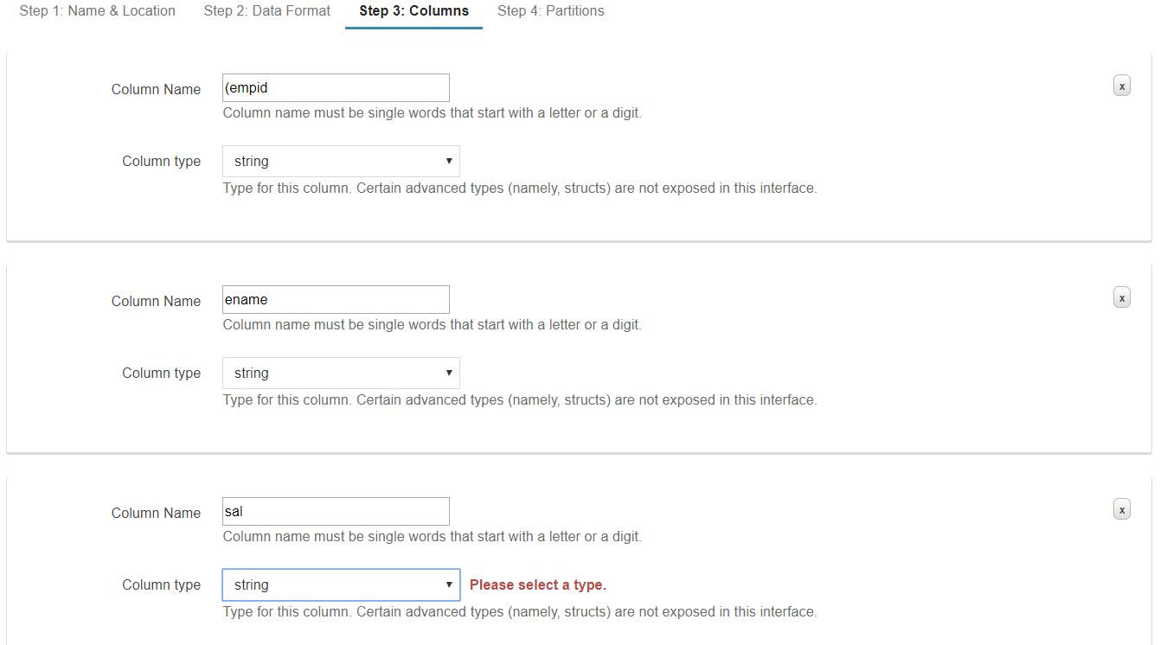

Click on **Next** and then click on **Create table** will get page like as below

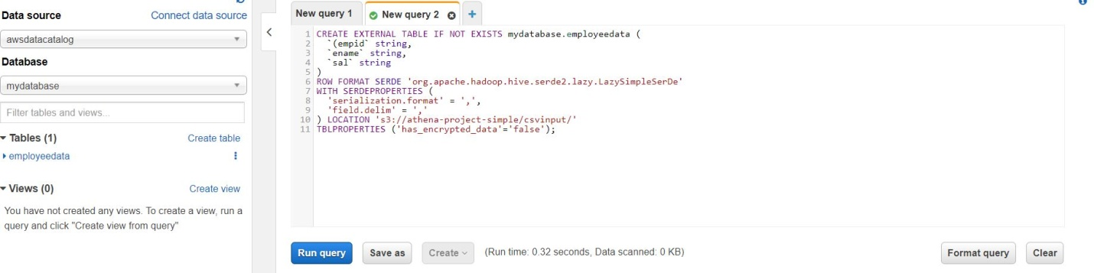

Click on **Run query**

Now open new query editor and check data for table of **employeedata**

select * from mydatabase.employeedata

