**Configure Jenkins Slaves on AWS EC2**

Jenkins is a self-contained Java-based program, ready to run out-of-the-box, with packages for Windows, Mac OS X and other Unix-like operating systems. As an extensible automation server, Jenkins can be used as a simple CI server or turned into the continuous delivery hub for any project.

**Prerequisites:**

1. Jenkins Master Instance

* Install Java

yum install java-1.8.0-openjdk java-1.8.0-openjdk-devel -y

* Install jenkins

sudo wget -O /etc/yum.repos.d/jenkins.repo http://pkg.jenkins-ci.org/redhat-stable/jenkins.repo

sudo rpm --import https://jenkins-ci.org/redhat/jenkins-ci.org.key

sudo yum install jenkins -y

service jenkins start

1. Jenkins Slave Instance Instance

* Install Java

yum install java-1.8.0-openjdk java-1.8.0-openjdk-devel -y

**Setup Jenkins Slave:**

* Create user and add the user to wheel group

useradd jenkins-slave-01

* Create SSH Keys

sudo su - jenkins-slave-01

ssh-keygen -t rsa -N "" -f /home/jenkins-slave-01/.ssh/id_rsa

cd .ssh

cat id_rsa.pub > authorized_keys

chmod 700 authorized_keys

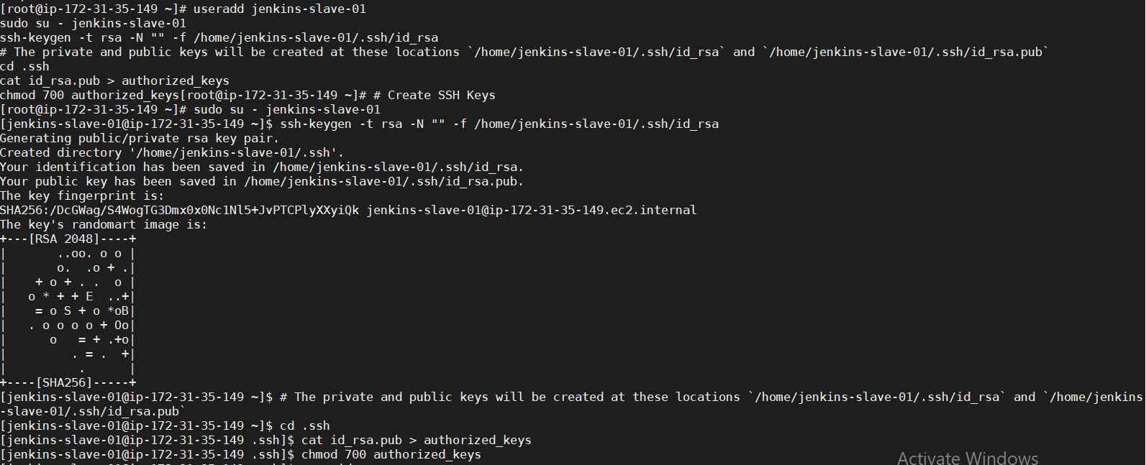

**Configuration on Master:**

* Copy the slave node's public key[id_rsa.pub] to Master Node's known_hosts file

mkdir -p /var/lib/jenkins/.ssh

cd /var/lib/jenkins/.ssh

ssh-keyscan -H SLAVE-NODE-IP-OR-HOSTNAME >>/var/lib/jenkins/.ssh/known_hosts

# ssh-keyscan -H 172.31.38.42 >>/var/lib/jenkins/.ssh/known_hosts

chown jenkins:jenkins known_hosts

chmod 700 known_hosts

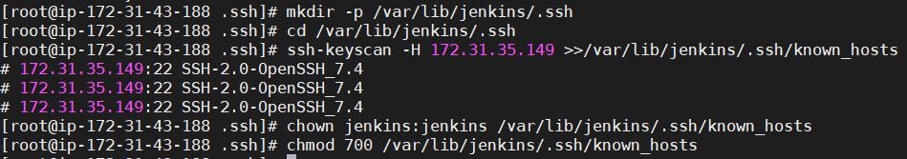

* **Configure the Slave using** --> Manage Jenkins

Configure the node as shown here: Manage Jenkins > Manage Nodes > New Node

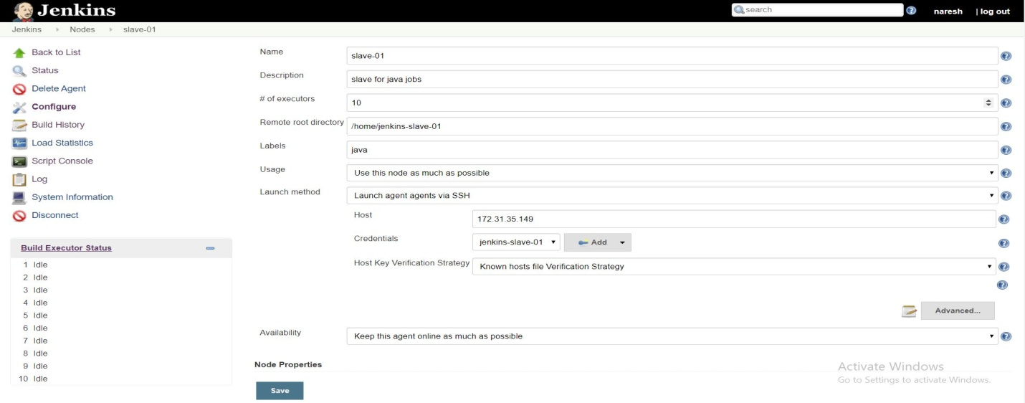

**Credentials:**

Jenkins🡪Credentials🡪System🡪Global Credentials(unrestricted)

Kind : SSH Username with private key

Username : jenkins-slave-01

Privatekey : copy private key of slave node (Run command: more id_rsa)

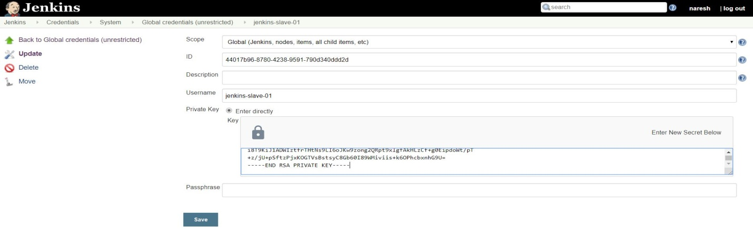

**Check jenkin master and nodes:**

Goto Jenkins Dashboard 🡪Manage Jenkins 🡪Manage nodes

