**Kubernates-Kops**

* Created Role with below policies
* IAM Full Access
* EC2 Full Access
* VPC Full Access
* ROUTE53 Full Access
* S3 Full Access
* Create IAM Role with these policies

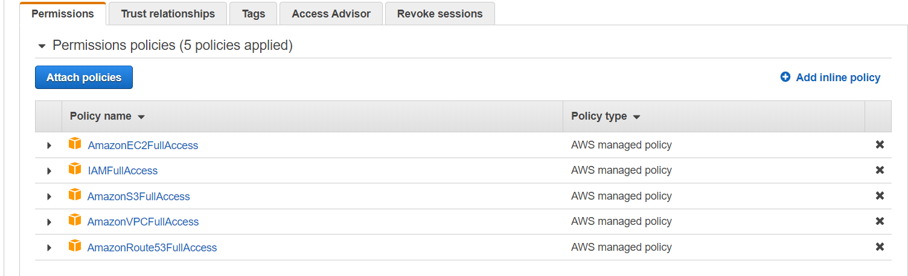

* **To InstallAWS-CLI**

yum install python2-pip –y

pip2 install awscli

**For User Credentials:**

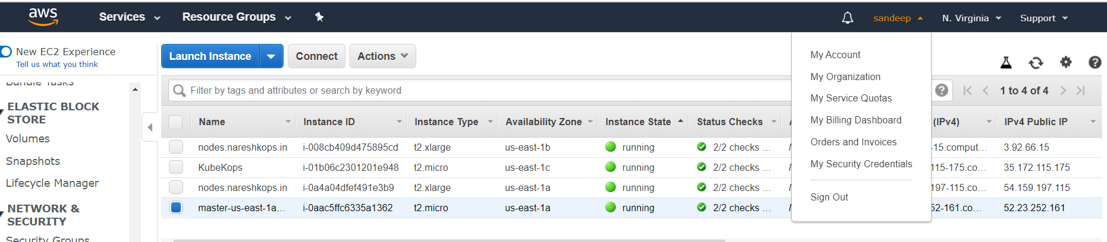

Click on my Security Credentials

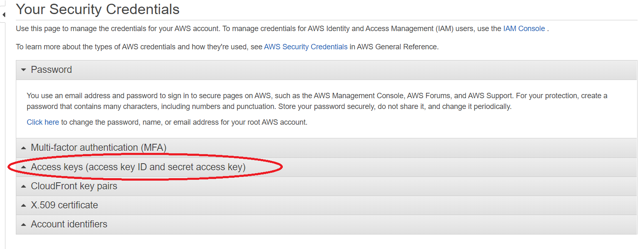

Click on Access keys(Access key ID and Secret Accesskey)

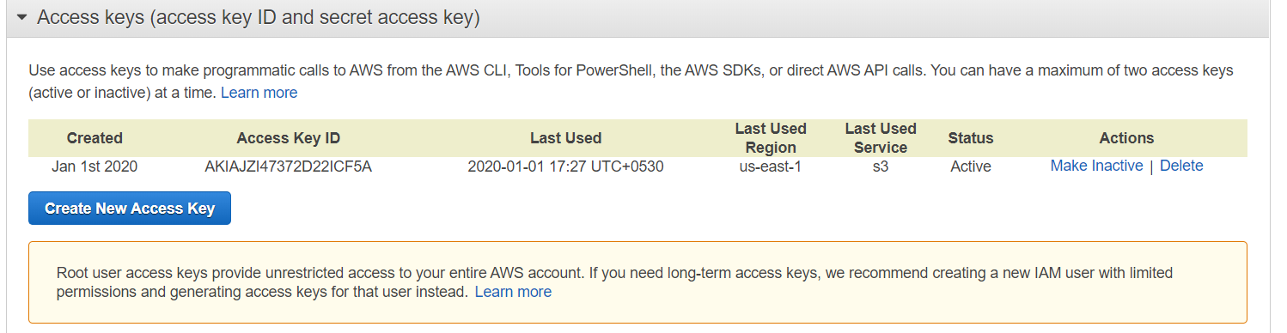

Click Om Create New Access key

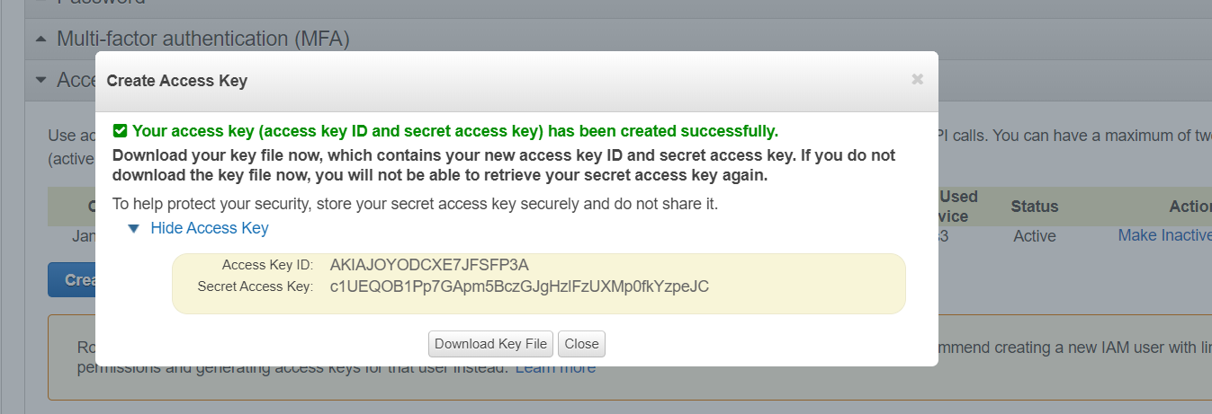

Here you can Find Access key ID and Secret Access Key

aws configure

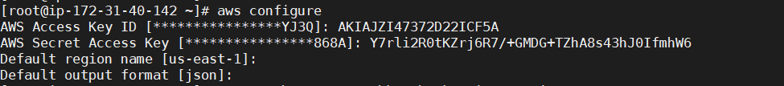

* To Install kubectl

curl -o kubectl https://amazon-eks.s3-us-west-2.amazonaws.com/1.14.6/2019-08-22/bin/linux/amd64/kubectl

chmod +x ./kubectl

cp ./kubectl /usr/local/bin/kubectl && export PATH=$PATH:/usr/local/bin

echo 'export PATH=/usr/local/bin:$PATH' >> ~/.bashrc

kubectl version --short --client

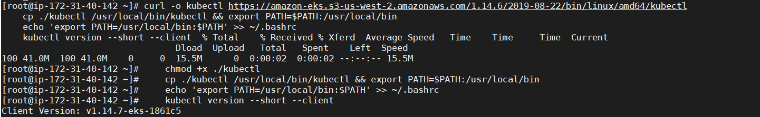

* To Install Kops

wget https://github.com/kubernetes/kops/releases/download/1.10.0/kops-linux-amd64

chmod +x kops-linux-amd64

mv kops-linux-amd64 /usr/local/bin/kops

kops version

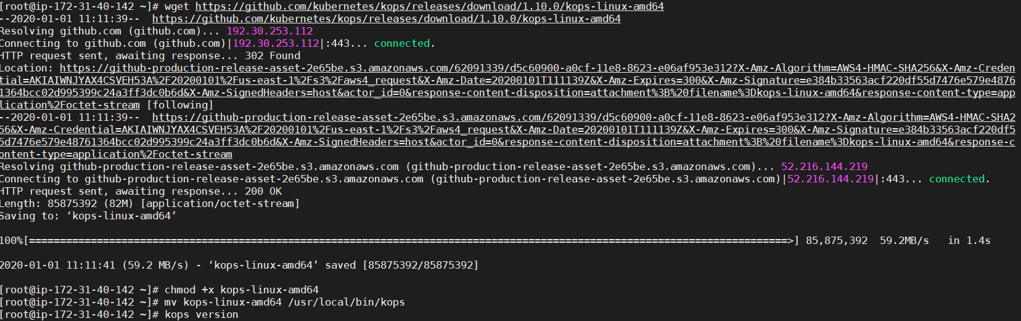

* To Create key

ssh-keygen

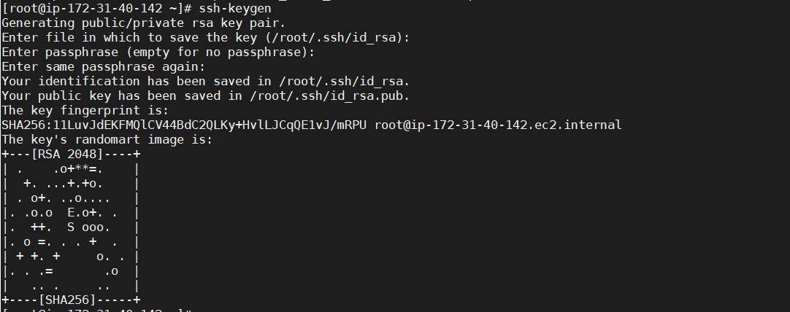

* Create domain at ROUTE53

Given domain name --> nareshkops.in

type Private Hosted Zone for Amazon VPC - Taken VPC(Viginia)

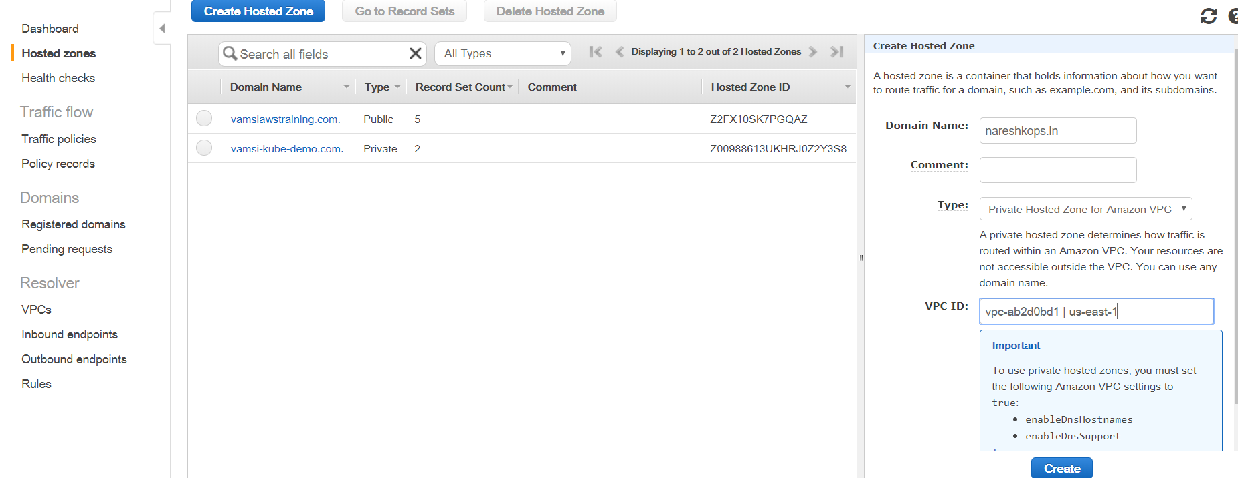

* Created Bucket with the name of nareshkopsbucket.in

aws s3 mb s3://nareshkopsbucket.in --region us-east-1

export KOPS_STATE_STORE=s3://nareshkopsbucket.in

C:\Users\hp\Desktop\Naresh\Capture.PNG

* Created kops cluster

kops create cluster \

--cloud=aws \

--zones=us-east-1a,us-east-1b\

--name=nareshkops.in \

--master-size="t2.micro" \

--node-size="t2.xlarge" \

--node-count="2" \

--dns-zone=nareshkops.in \

--dns private

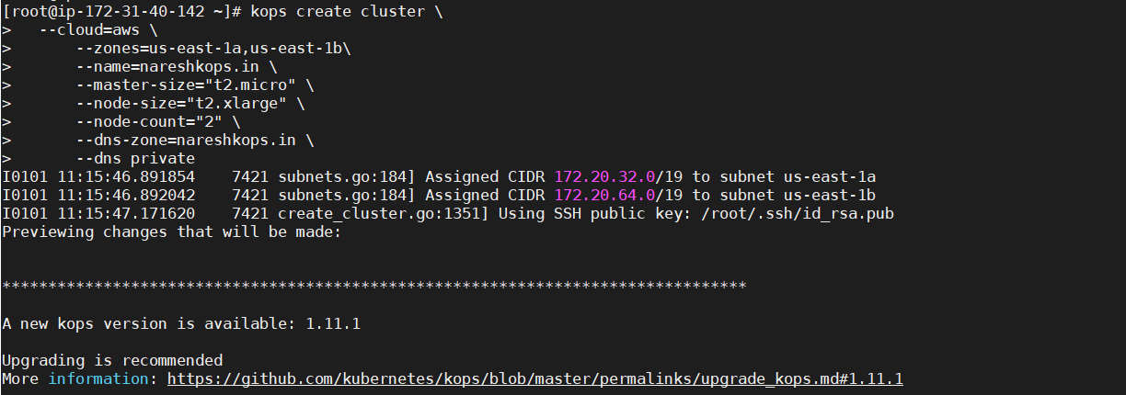

kops update cluster nareshkops.in --yes

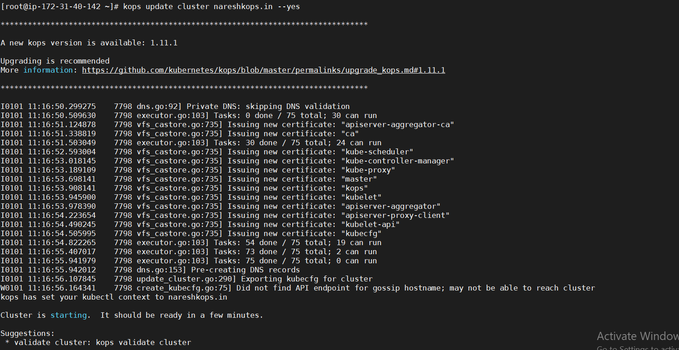

* kops validate cluster

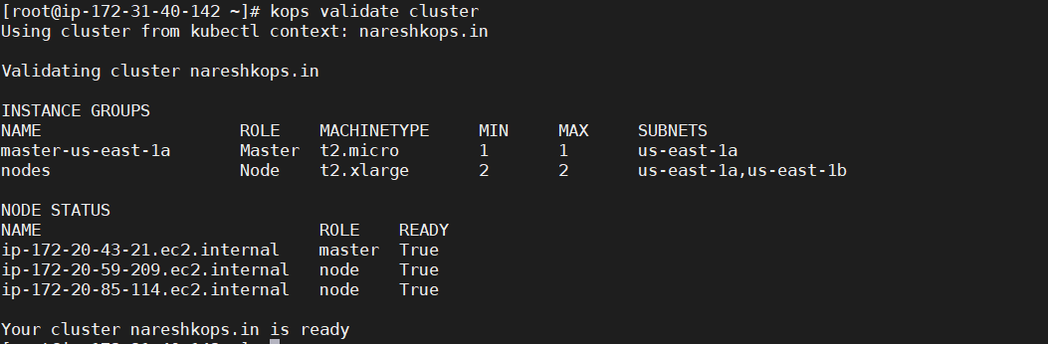

* Conncet to master

ssh -i .ssh/id_rsa admin@<IP of master>

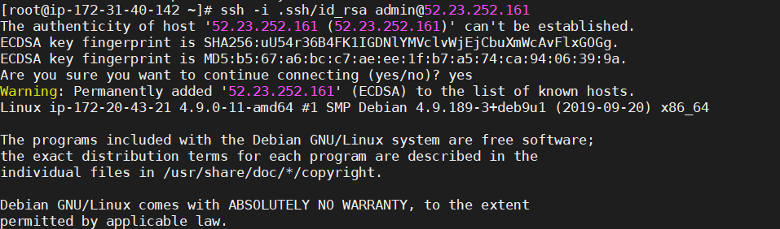

* To check nodes of cluster

kubectl get nodes

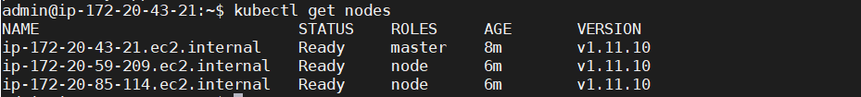

* To create Deployment of sample-nginx

kubectl run sample-nginx --image=nginx --replicas=2 --port=80

C:\Users\hp\Desktop\Naresh\Capture.PNG

* To Expose Deployment

kubectl expose deployment sample-nginx --port=80 --type=LoadBalancer

C:\Users\hp\Desktop\Naresh\Capture.PNG

* To check pods

kubectl get pods

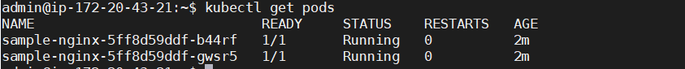

* To check Deployments

kubectl get deployments



* To check Services

kubectl get services -o wide (or)

kubectl get svc



* To check nginx with loadbalancer DNS Name

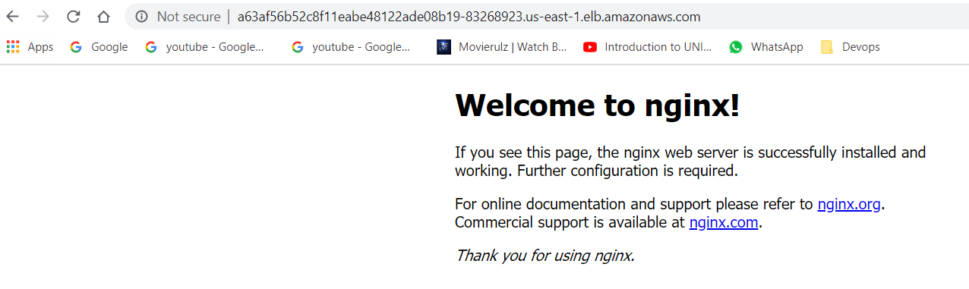

* kubectl get pods

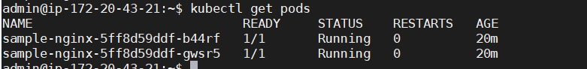

* To delete services

kubectl delete services sample-nginx

C:\Users\hp\Desktop\Naresh\Capture.PNG

* To get and delete Deployments

kubectl get deployments

kubectl delete deployments sample-nginx

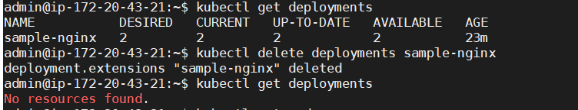

**Nodeport:**

kubectl get svc

kubectl run sample-nginx --image=nginx --replicas=2 --port=80

kubectl expose deployment sample-nginx --port=80 --type=NodePort

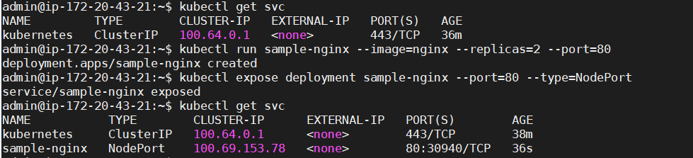

* **To check output:**

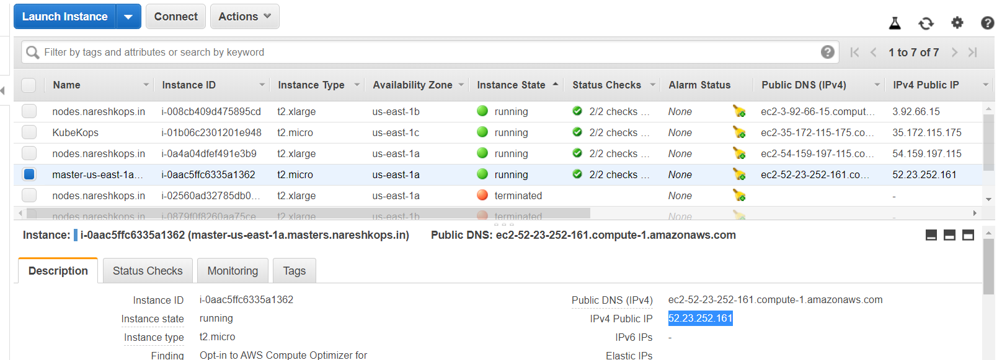

<Master ip-address>:<portnumber>

Note: Port number which is created automatically.

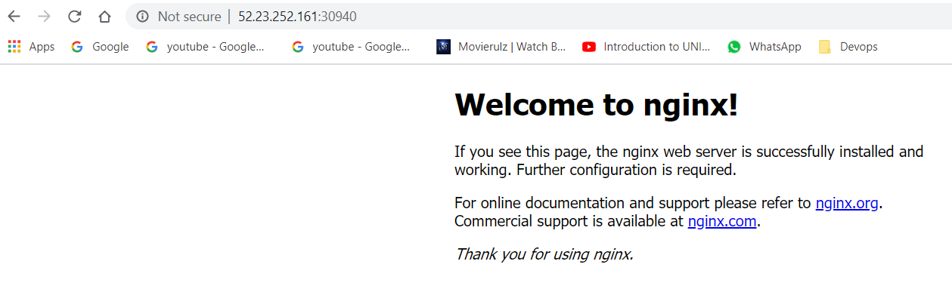

* To delte Deployments and services

kubectl delete deployments sample-nginx

kubectl delete services sample-nginx

kubectl get svc

kubectl get deployments

