**New Relic Agent Installation on Linux**

Prerequisites:

* java
* tomcat8
* newrelic account

Create newrelic free account:

<https://newrelic.com/signup?via=login>

Take EC2 Instance with security group port numbers: 80 and 8080

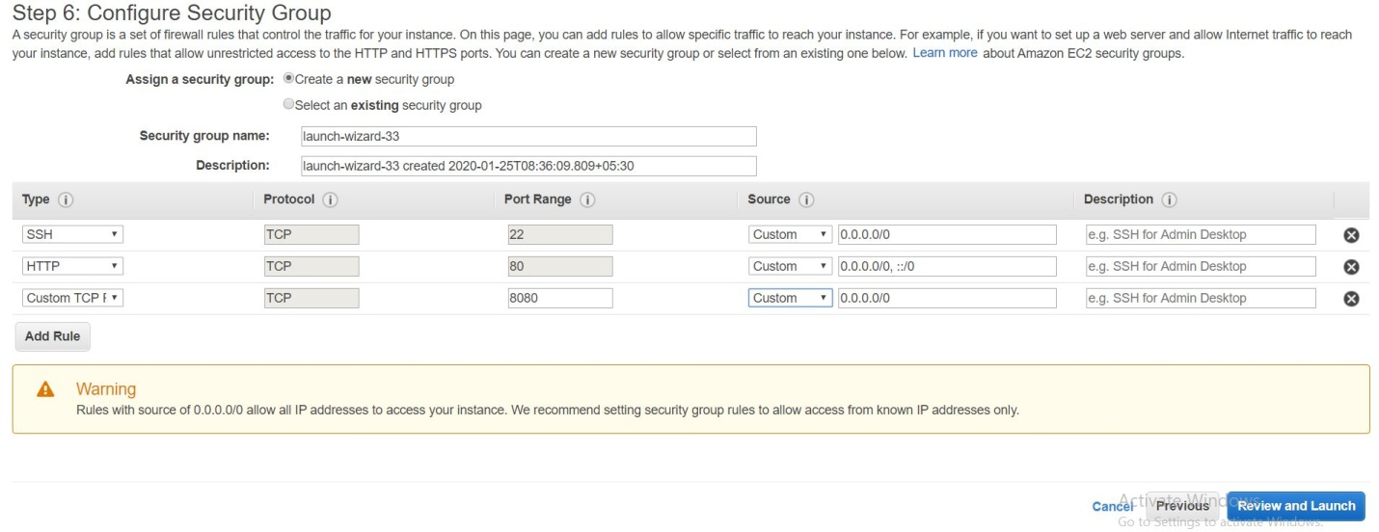

Update:

yum update –y

Install java:

yum install java-1.8.0-openjdk java-1.8.0-openjdk-devel –y

Install tomcat8:

wget <http://mirrors.estointernet.in/apache/tomcat/tomcat-8/v8.5.50/bin/apache-tomcat-8.5.50.tar.gz>

tar xvzf apache-tomcat-8.5.50.tar.gz

mv apache-tomcat-8.5.50 /usr/share/tomcat8/

cd /usr/share/tomcat8/bin

./startup.sh

Create directory with the name of newrelic:

mkdir newrelic

Download "**newrelic-agent-4.2.0.jar**":

cd newrelic/

wget <https://download.newrelic.com/newrelic/java-agent/newrelic-agent/4.2.0/newrelic-agent-4.2.0.jar>

Goto bin folder and open "catalina.sh" and add path with export command:

vi /usr/share/tomcat8/bin/catalina.sh

export JAVA_OPTS="$JAVA_OPTS -javaagent:/usr/share/tomcat8/newrelic/newrelic-agent-4.2.0.jar"

Open "**newrelic** " folder and run below command:

cd /usr/share/tomcat8/newrelic/

java -jar newrelic-agent-4.2.0.jar install

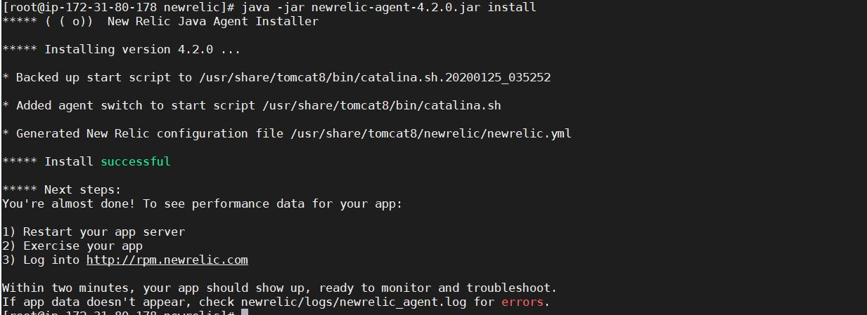

* Now check our folder we can find "newrelic.yml" added
* Now login to newrelic.com

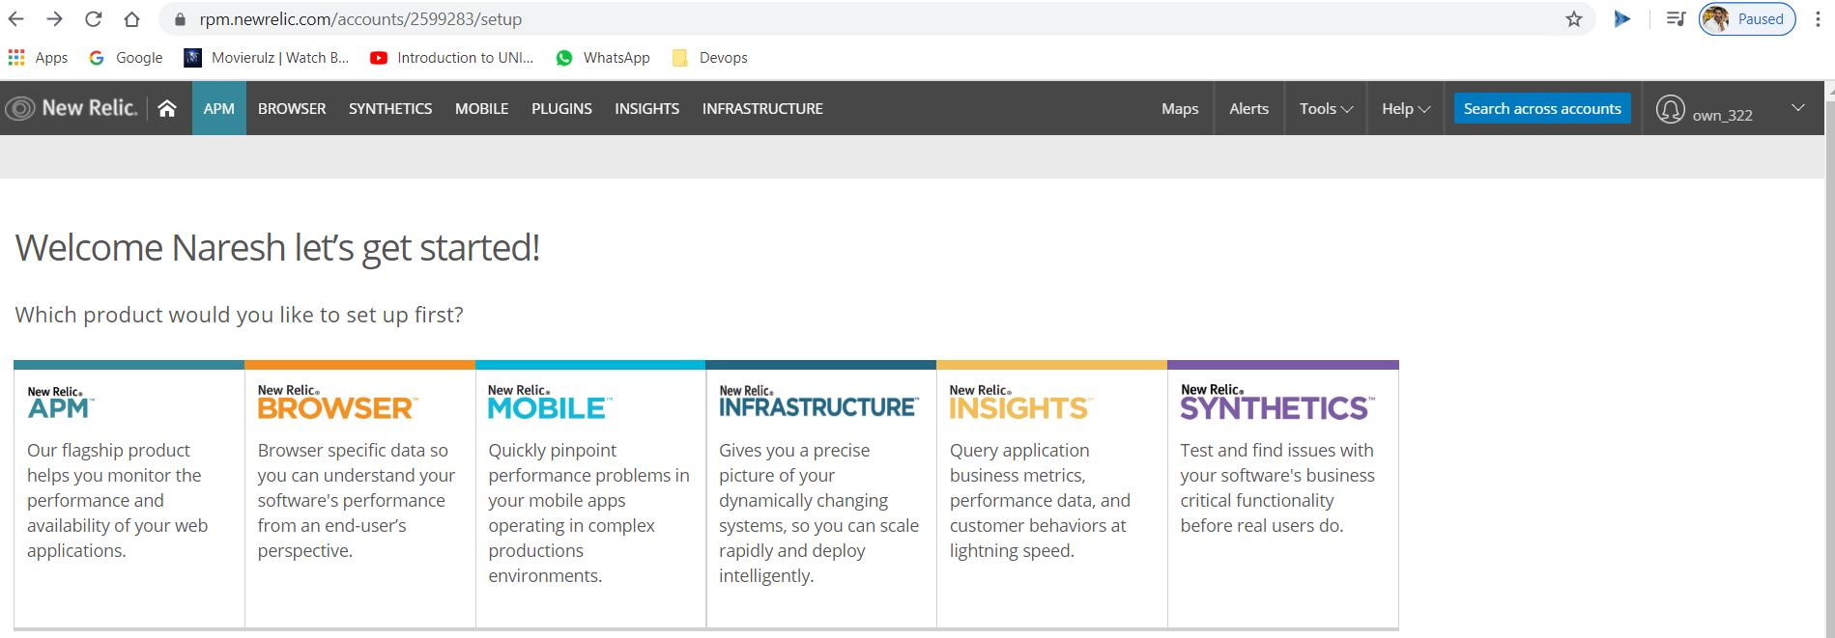

* Click on APM

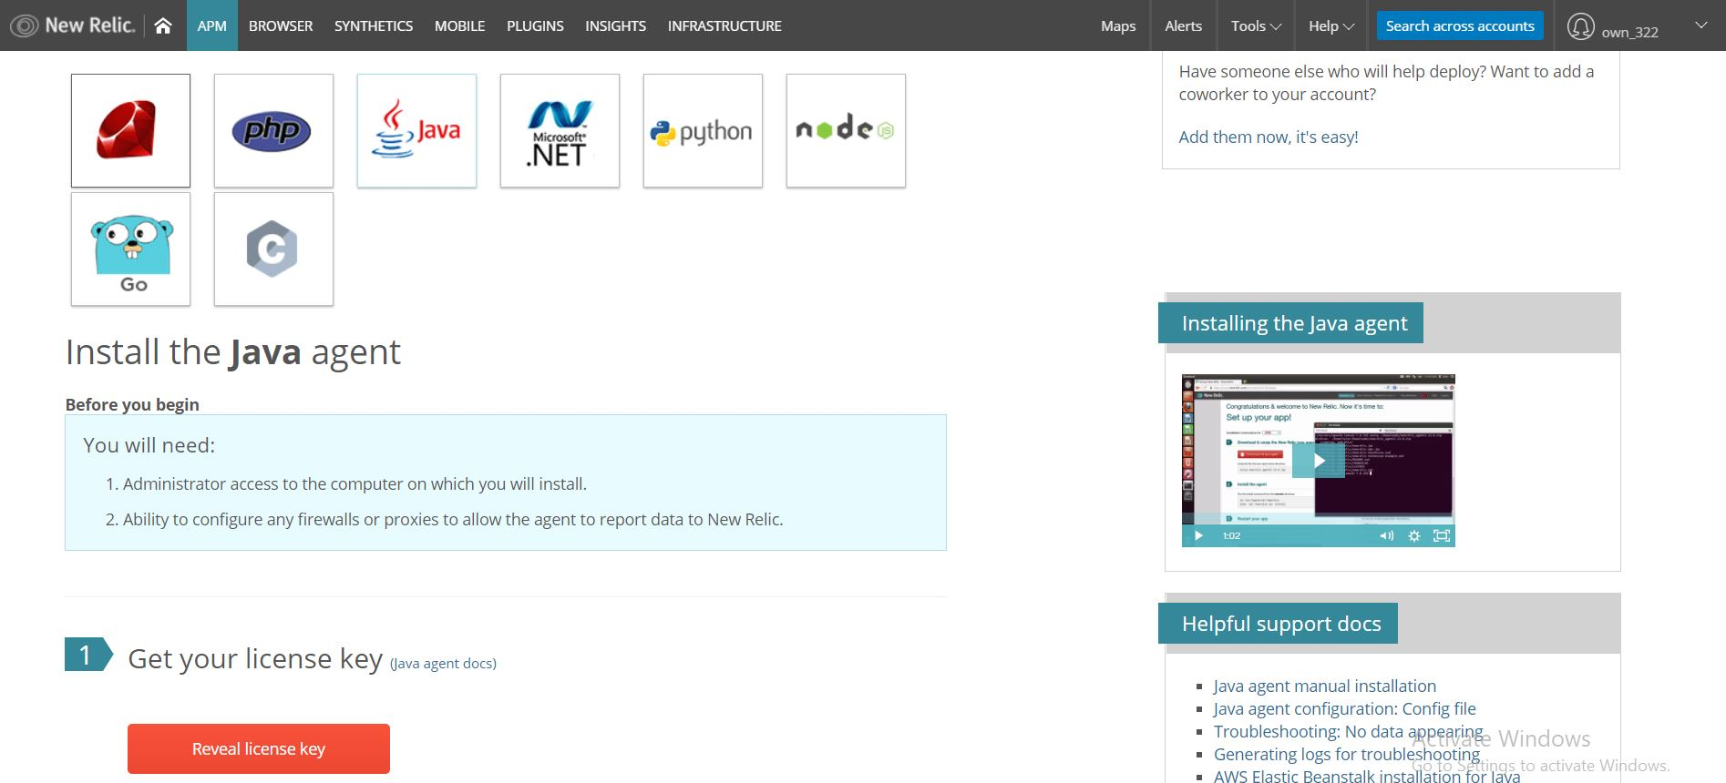

* Click on Reveal license key and copy key
* Open newrelic.yml

vi newrelic.yml

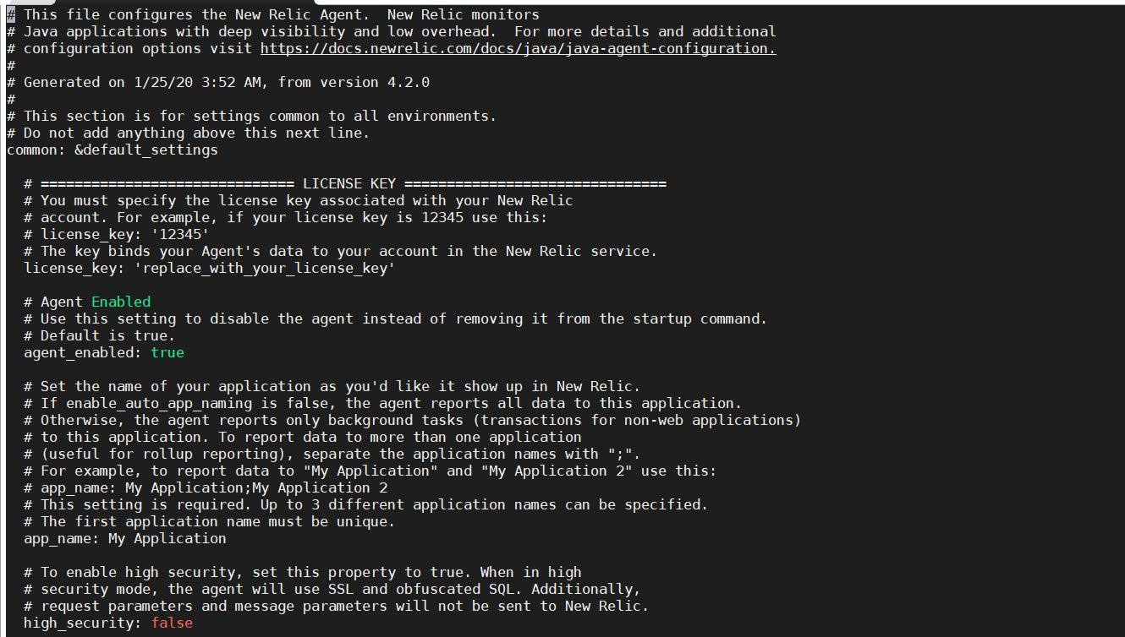

* Give **license_key** and **app_name**

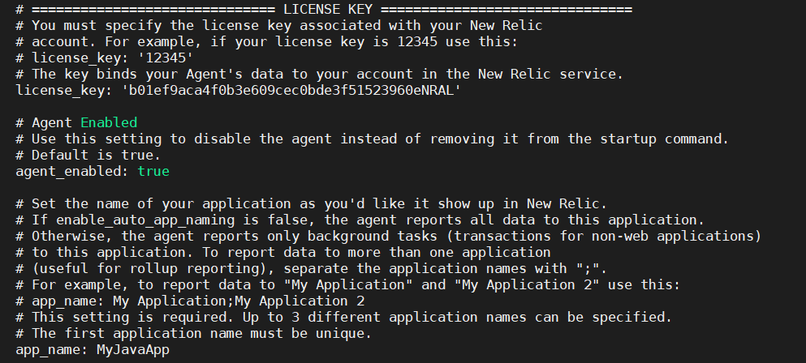

* Restart our App:

cd /usr/share/tomcat8/bin

./startup.sh

In a few minutes, your application will send data to New Relic

Once New Relic receives the data, your application will be listed here

APM page will look similar to: