# Deploy Spring Boot + MYSQL RDS Application to Docker and ECS

**Prerequisites:**

1. Python2
2. Maven
3. Java-1.8.0-openjdk & Java-1.8.0-openjdk-devel
4. Awscli
5. Docker
6. git

Create EC2 Instance 🡪 Here I used RHEL Amazon Machine Image

**Update yum command:**

yum update -y

**Install java,git and wget:**

yum install java-1.8.0-openjdk java-1.8.0-openjdk-devel wget git -y

**Install Python2:**

yum install python2-pip -y

alternatives --config python

**Install Awscli:**

pip2 install awscli

aws configure

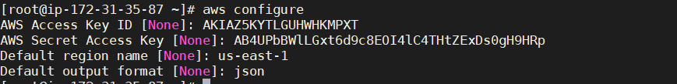

**Install Docker on RHEL:**

Dnfconfig-manager --add repo=https://download.docker.com/linux/centos/docker-ce.repo

dnf install docker-ce-3:18.09.1-3.el7

systemctl enable docker

systemctl start docker

**Create Mysql RDS:**

* Please check below code to create MYSQL RDS instance
* Note: Here we should mention dbname to connect

aws rds create-db-instance \

--db-name mysqldb \

--allocated-storage 20 \

--db-instance-class db.t2.micro \

--db-instance-identifier mysqltest \

--engine mysql \

--master-username master \

--master-user-password Naresh#240

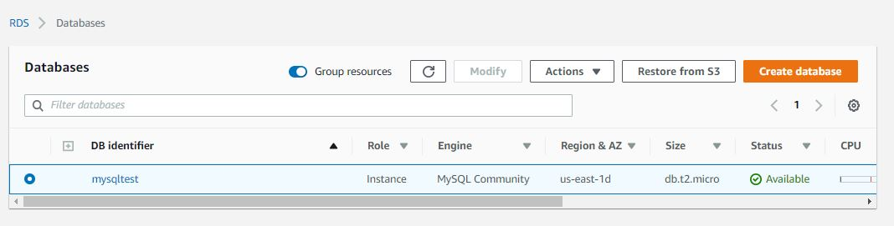

**Pull file from github:**

git clone <https://github.com/Naresh240/springboot_mysqldb_docker.git>

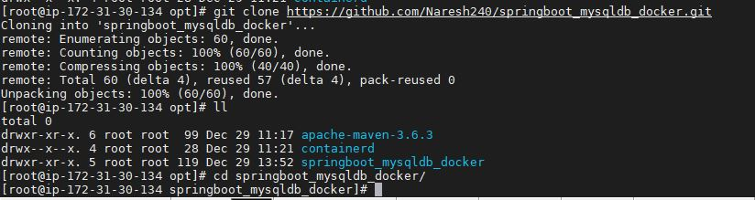

Move into file “springboot_mysqldb_docker”

cd springboot_mysqldb_docker

Then create jar file by using below command

mvn clean install

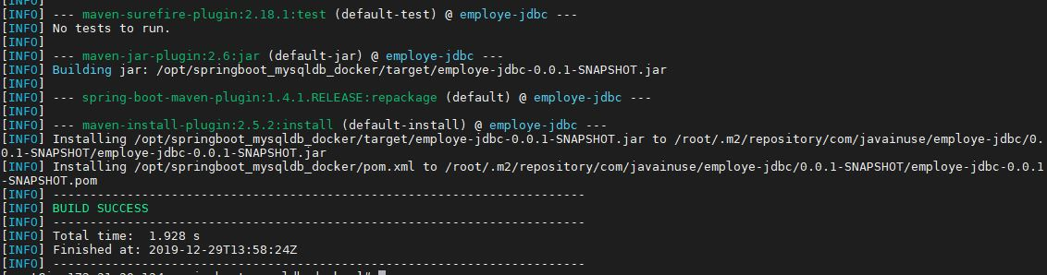

**Requirements to createDocker Image:**

* Here we need to check **application.properties** file [Path:src/main/resources/application.properties]

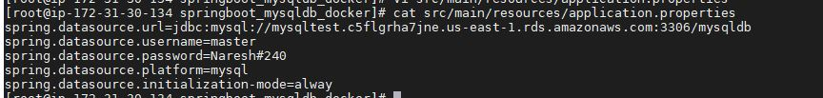

url=jdbc:mysql://<Endpoint of date base>:<port-number>/dbname

In below figure we can check Endpoint

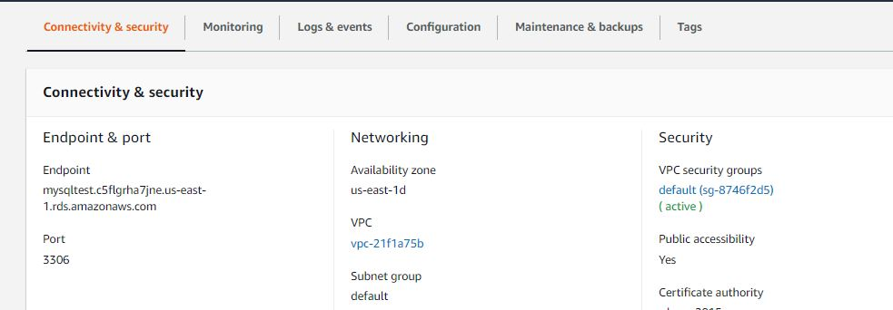

**Create docker image:**

docker build -t springboot_mysqldb_docker .

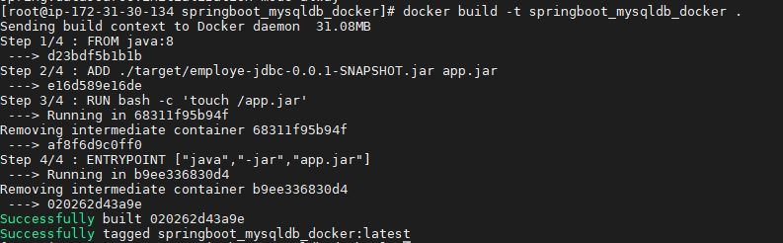

**Run Docker image using below command:**

docker run --name springboot_mysqldb_docker -p 8080:8080 -d springboot_mysqldb_docker



**To check output we need postman app:**

Goto postman:

**To call insertemployeeapi:**

1. Fix to Post and give url as <http://100.26.35.194:8080/insertemployee>
2. Click on Body given data in Json format

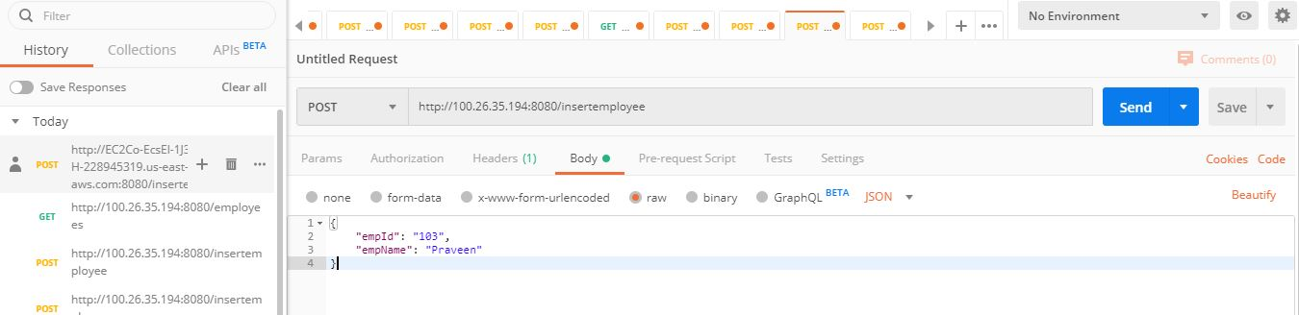

**To call employee api:**

<http://100.26.35.194:8080/employees>

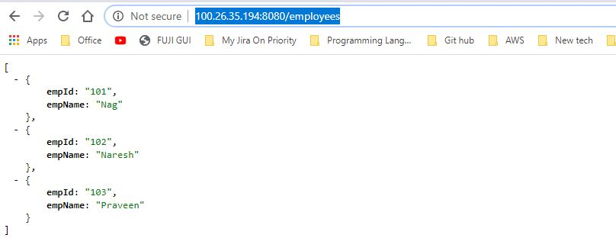

**Creating Repository on ECR using below steps:**

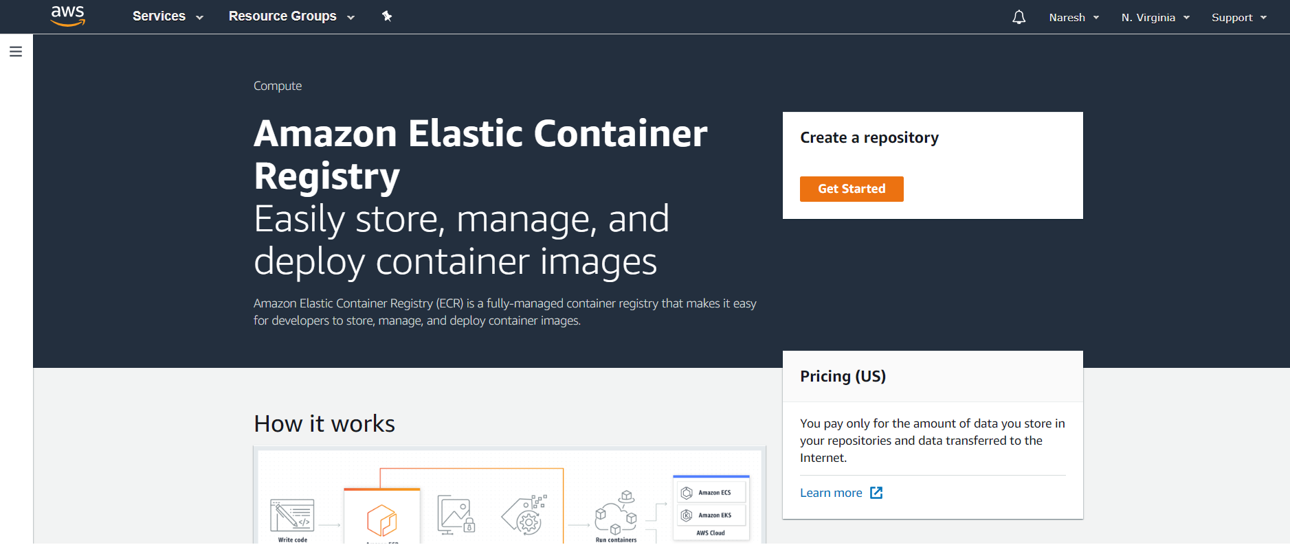

* Click on **Get Started**

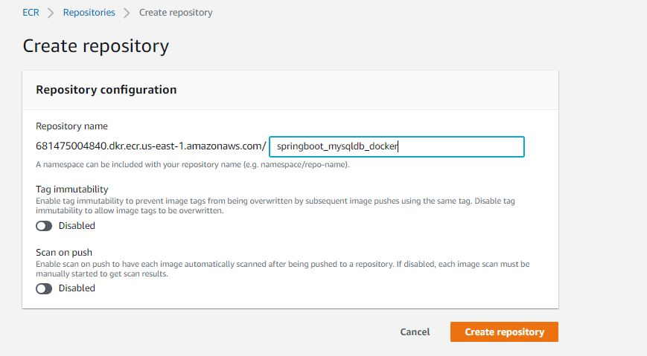

* Give Repository name as “**springboot_mysqldb_docker”** and Click on **Create repository**
* Below figure shows created Repository

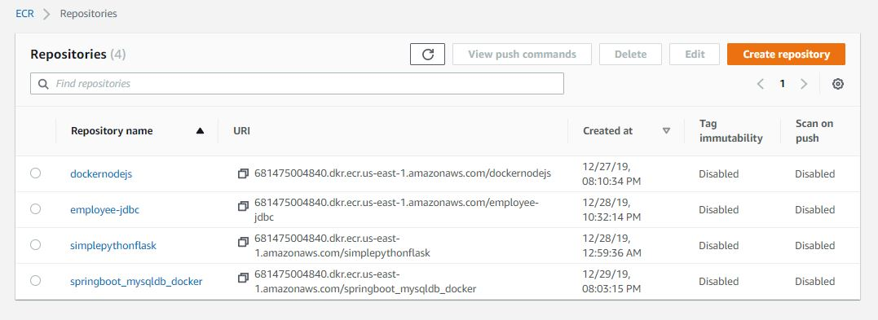

**Steps to push docker image to ECR:**

1. Login to aws ECR:

$(awsecr get-login --no-include-email --region us-east-1)

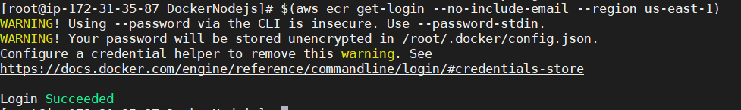

1. Build Docker images:

docker build -t springboot_mysqldb_docker.



1. Tag Docker image:

docker tag springboot_mysqldb_docker:latest 681475004840.dkr.ecr.us-east-1.amazonaws.com/springboot_mysqldb_docker:latest

1. Push Docker image to ECR:

docker push 681475004840.dkr.ecr.us-east-1.amazonaws.com/dockernodejs:latest

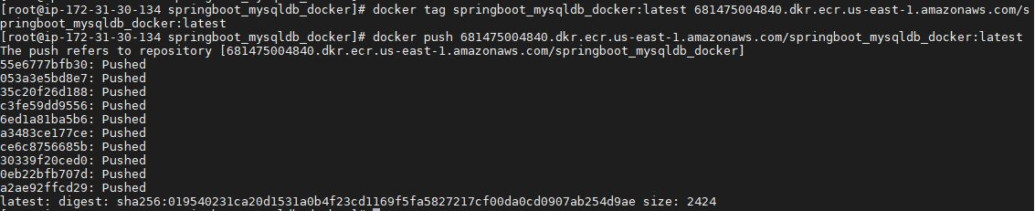

**Finally Repository stored in ECR:**

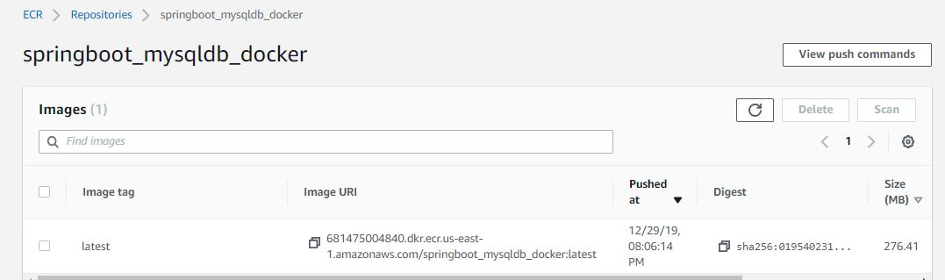

**Open ECS on AWS and Create Cluster using below steps and fill details:**

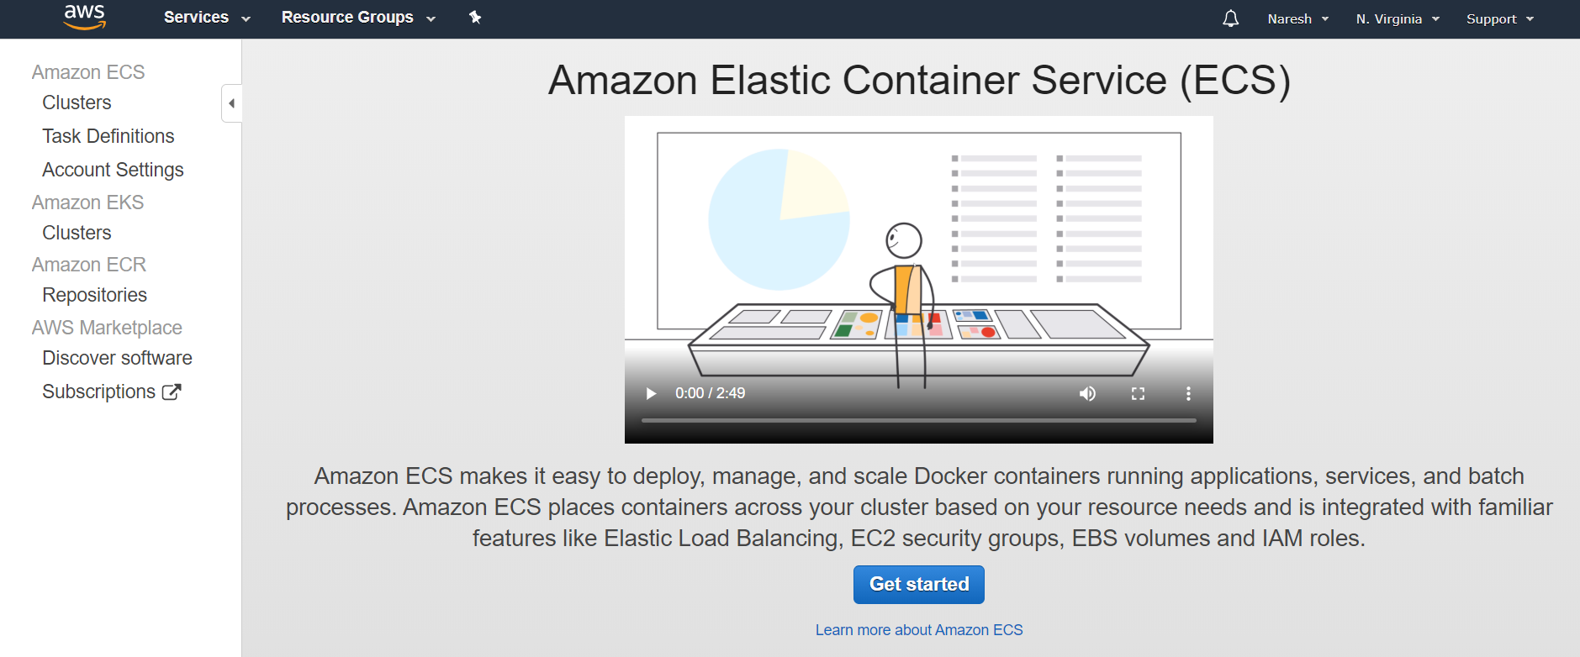

* Click on **Get started**

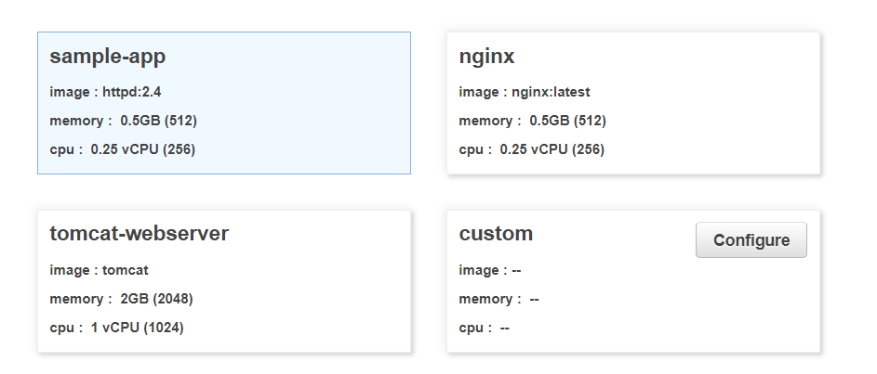

* Click on **Configure**

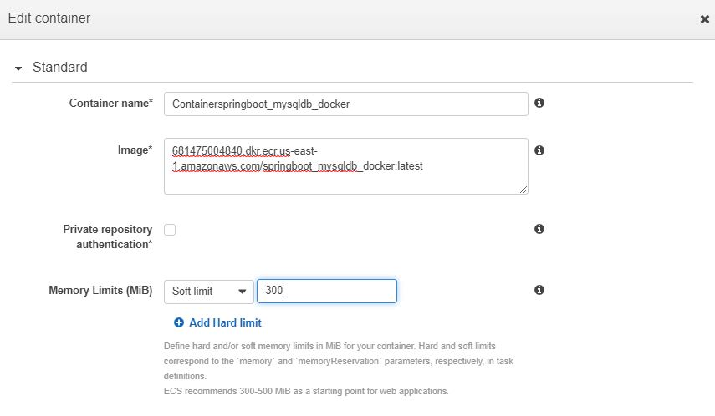

* Click on **update**

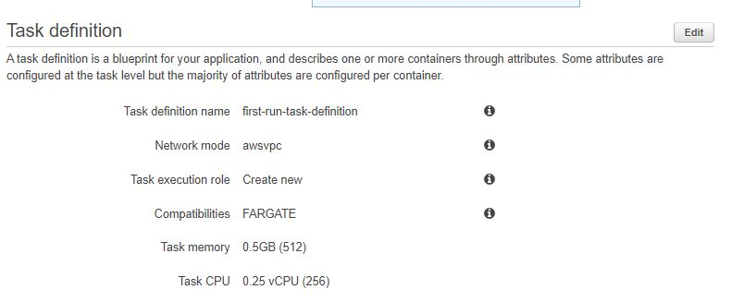

* Click on **Edit** to give Run Task defination details

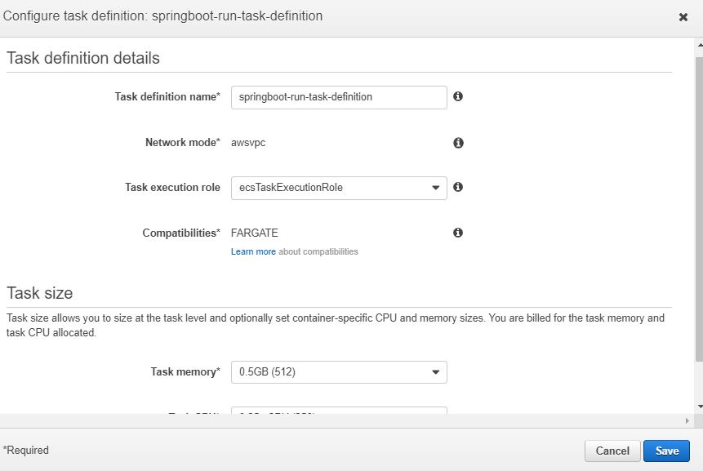

* Click on **save** and click **Next** and Edit details for Container Service

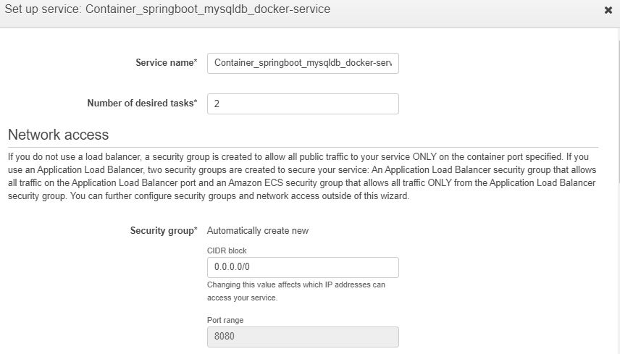

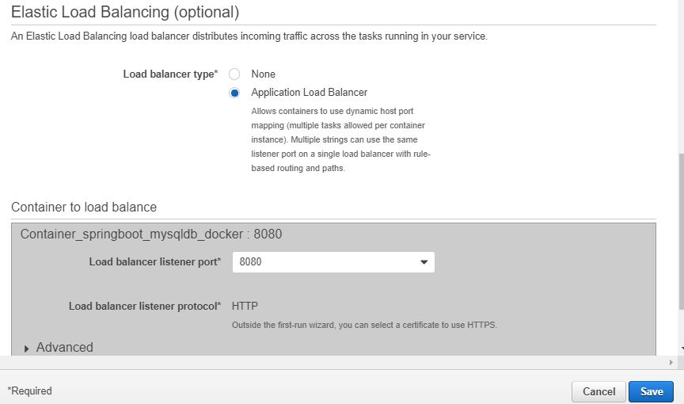

* Click on **save** and click on **Next**

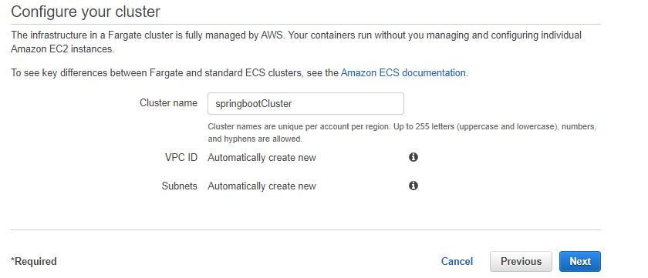

* Click on **Next**
* Click on **Create**

Check below figure shows Cluster succefully created

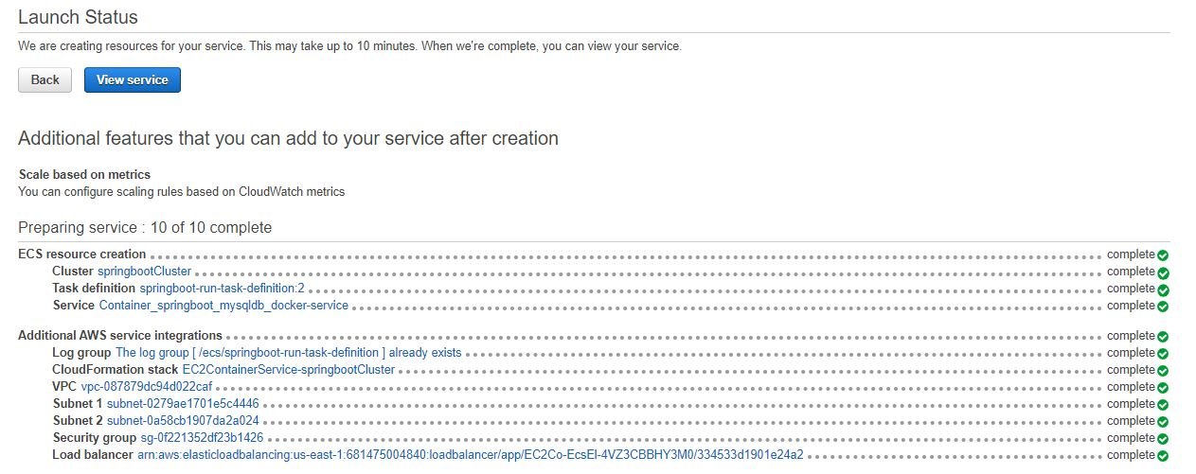

After Creation of Cluster need to wait untill task status shows in **RUNNING** mode

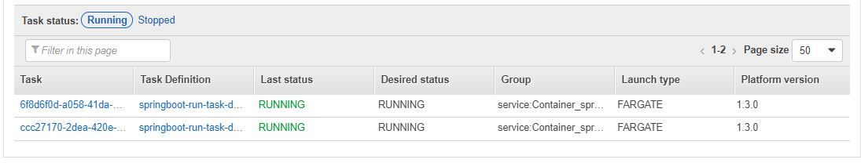

Check Load Balancer, you will get new ELB

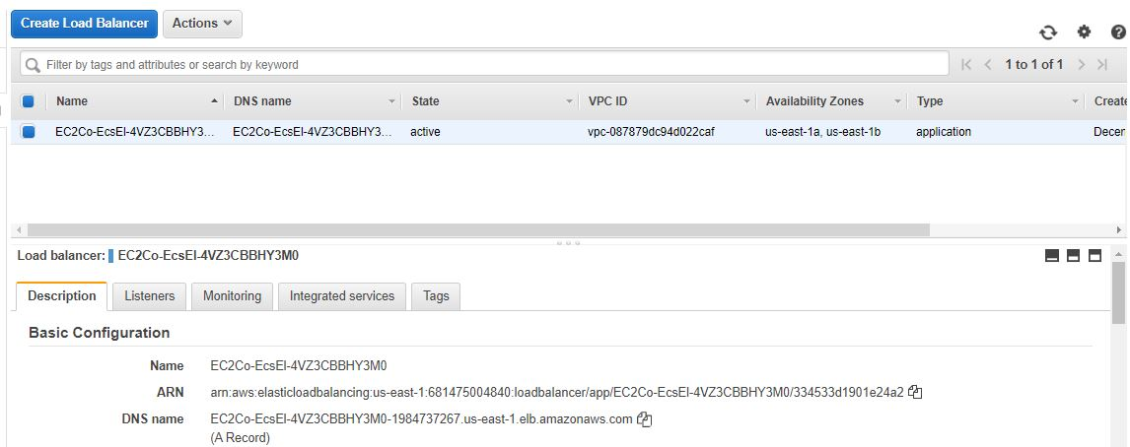

Copy DNS Name and give at GUI with port number and api

<http://EC2Co-EcsEl-4VZ3CBBHY3M0-1984737267.us-east-1.elb.amazonaws.com:8080/insertemployee>

**To call insertemployeeapi:**

1. Fix to Post and give url as above
2. Click on Body given data in Json format

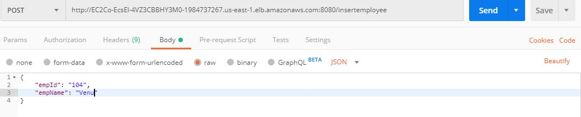

**To call employee api:**

<http://ec2co-ecsel-4vz3cbbhy3m0-1984737267.us-east-1.elb.amazonaws.com:8080/employees>

