**Harti First Page Foods**

**Seasonality**

**Maha** - **[**Sep, October, November, December, January, February, March**]**

**Yala** - **[**May, June, July, August**]**

**Intern monsoon** – April

**Data available in the first page**

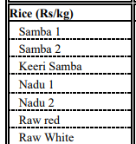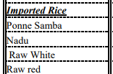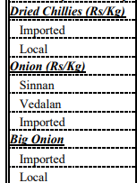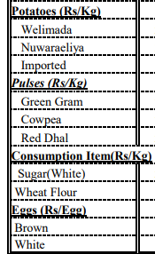

**Data I’m working on to develop a model**

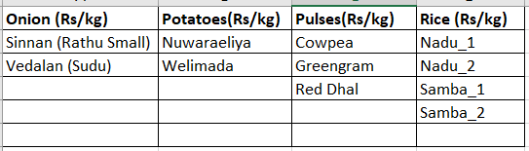

**Harti Second Page Discussion Points**

