Margaret Shimerdla

Module 5.2 MySQL Functions

Ceiling Function

The Ceiling function can be used if you want to round a number up. This is helpful if you want to make sure you will not be getting a floating number or if you just want to round a number up.

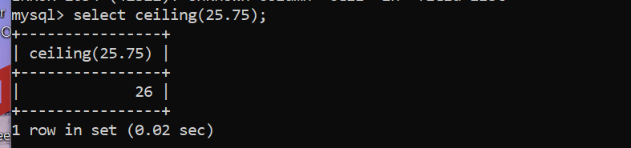

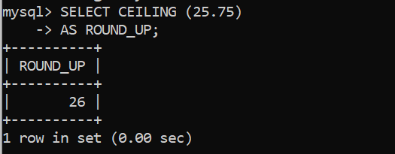

Power function

The Power function can be used if you want to multiply a number exponentially. This is especially useful in math problems.

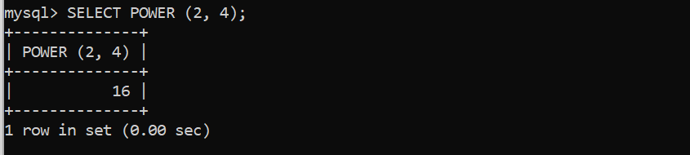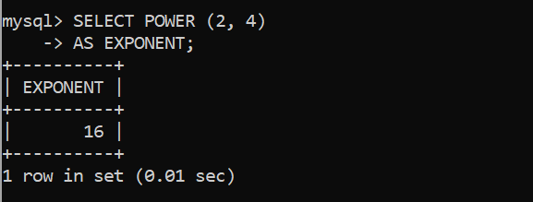

Current Time Stamp function

The Current Time Stamp function can be used for a time stamp that you would want on your pictures that you take. The time stamp on a picture is very helpful so that you can always remember what time you took your pictures.

