
VENUS PIPES AND TUBES LIMITED
Manufacturing Intelligence & Reporting
REPORT MIS DOCUMENT
Production, Scrap & Manpower Cost Reports
Access links, dashboard previews and step-by-step generation guide
Document Title | Report MIS Document
Version | 1.0
Date | 28 September 2026
Prepared By | Shubham Kakde
Status | Released

Document Control

Revision History
Version | Date | Author | Description
1.0 | 28 September 2026 | Shubham Kakde | Initial release of the MIS report guide

Table of Contents
1 Introduction
1.1 Purpose
1.2 Report Summary
2 Live Power BI Reports
2.1 Seamless (Pipe/Tube/BA) Production Details Report
2.2 Welded/L-Saw/Condenser Production Details Report
2.3 Job Cardwise_Production_Details Report
3 Automation Dashboards
3.1 Machine Capacity vs Actual Production
3.2 Scrap MIS Dashboard
3.3 Job Cardwise Production Scrap Report
3.4 Manpower Cost Report

1 Introduction

1.1 Purpose
This document is the single reference for the Management Information System (MIS) reports used for production, scrap and manpower cost monitoring. For each report it gives the access link, a preview of the dashboard and, where the dashboard is generated from an exported file, the exact steps to produce it.
The reports fall into two categories: live Power BI reports, which are always up to date and can be opened directly, and automation dashboards, which are generated by exporting data from the ERP Report Engine and uploading it into a generator file.

1.2 Report Summary
# | Report | Type | How to Use
1 | Seamless (Pipe_Tube_BA) Production Details Report | Live – Power BI | Open the link
2 | Welded_Lsaw_Condenser Production Details Report | Live – Power BI | Open the link
3 | Job Cardwise Production Report | Live – Power BI | Open the link
4 | Machine Capacity vs Actual Production | Automation | Export CSV, upload to generator
5 | Scrap MIS Dashboard | Automation | Export 4 CSVs, upload to generator
6 | Job Cardwise Production Scrap Report | Automation | Export CSV, upload to generator
7 | Manpower Cost Report | Automation | Upload salary input sheet

2 Live Power BI Reports
These reports are published in Power BI and refresh automatically. Open the link to view the latest production figures.

2.1 Seamless (Pipe_Tube_BA) Production Details Report
Report Name | Seamless (Pipe/Tube/BA) Production Details Report-Live
Type | Live – Power BI
Access Link | Open in Power BI
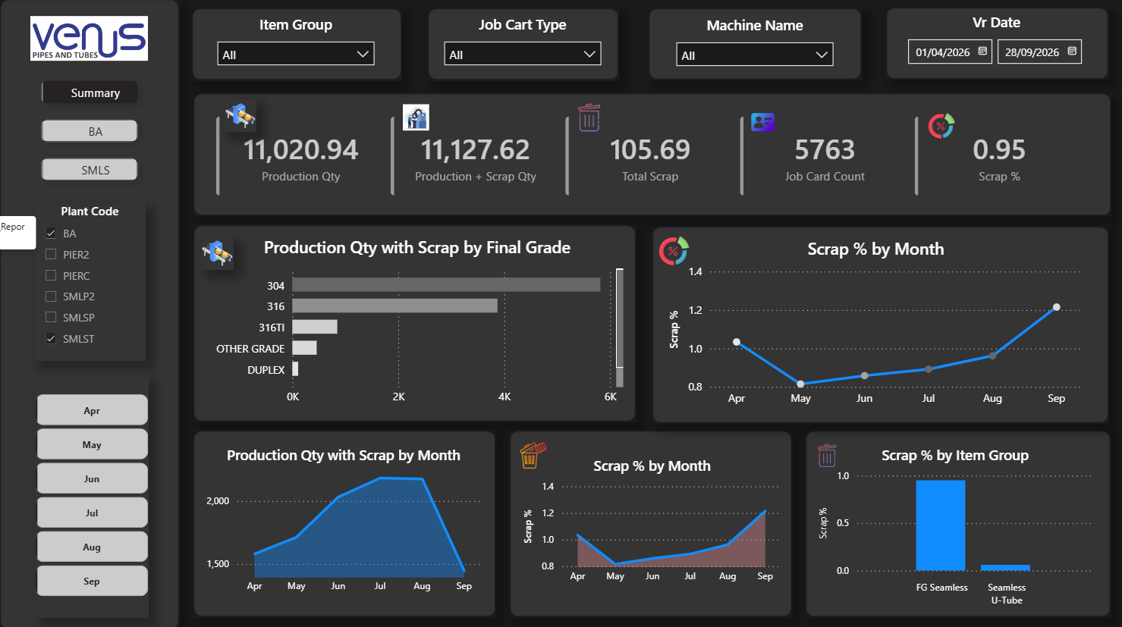
Figure 1: Seamless Production Details Report (Live)

Power BI Credentials
ID: powerbi@venuspipes.onmicrosoft.com
Password: VenusPipes@2026

2.2 Welded_Lsaw_Condenser Production Details Report
Report Name | Welded_Lsaw_Condenser_Production_Details_Report-Live
Type | Live – Power BI
Access Link | Open in Power BI
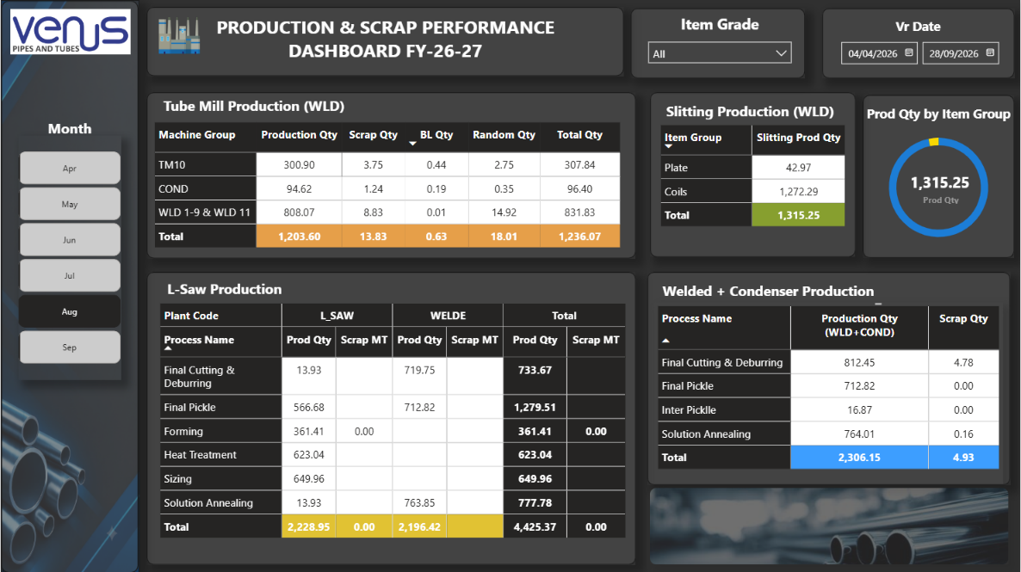
Figure 2: Welded / Lsaw / Condenser Production Details Report (Live)

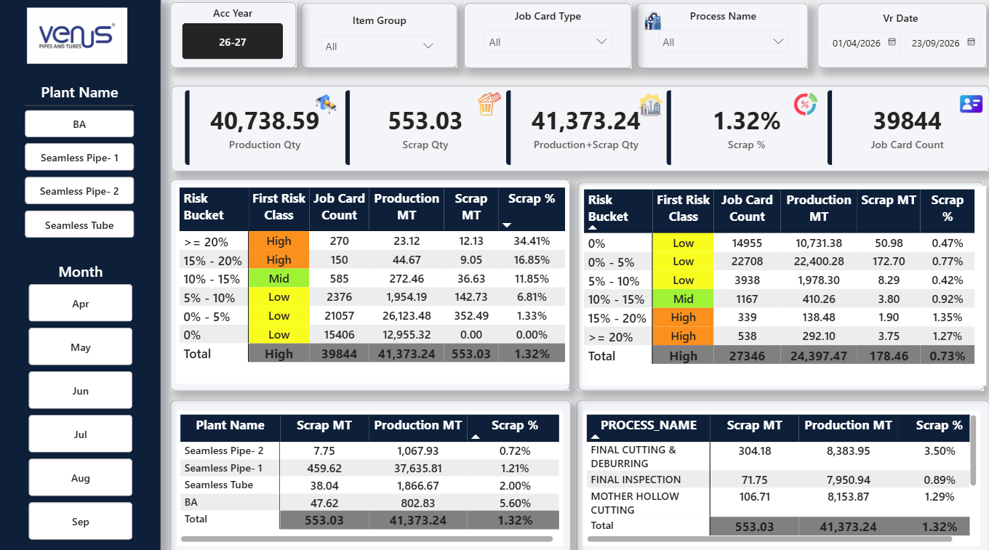
2.3 Job Cardwise_Production_Details Report
Report Name | Job Cardwise_Production_Details_Report-Live
Type | Live – Power BI
Access Link | Open in Power BI

3 Automation Dashboards
These dashboards are generated on demand. Data is exported from the Report Engine Configuration in the ERP and uploaded into the corresponding generator file, which builds the dashboard instantly.

3.1 Machine Capacity vs Actual Production
Report Name | Machine Capacity vs Actual Production-Automation
Type | Automation
Generator | Machine_Capacity_vs_Actual_Production_Generator.html

Steps:
- Open ERP & Go to this Module 06.410.03 - Production Engine (Process Wise).
- Find R955 Machine Capacity Vs Production PBI (Right Side).
- Click on Machine Capacity vs Actual Production and export it as CSV or Excel.
- Open the Machine_Capacity_vs_Actual_Production_Generator.html
- Upload the CSV file into it. Your dashboard is ready.
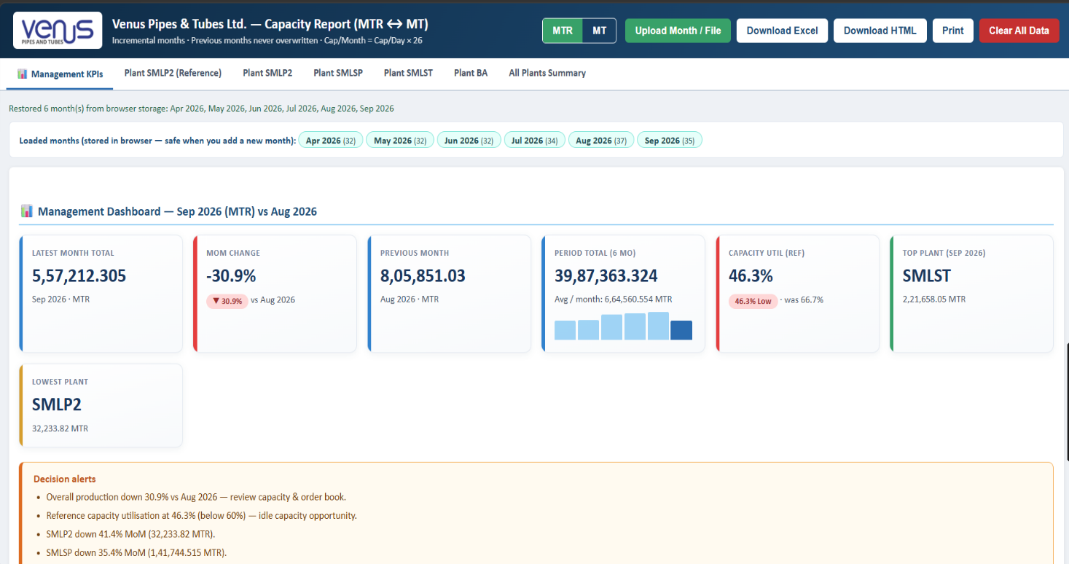
Figure 3: Machine Capacity vs Actual Production dashboard

3.2 Scrap MIS Dashboard
Report Name | Scrap MIS Dashboard-Automation
Type | Automation
Generator | Scrap_MIS_Dashboard_Generator.html
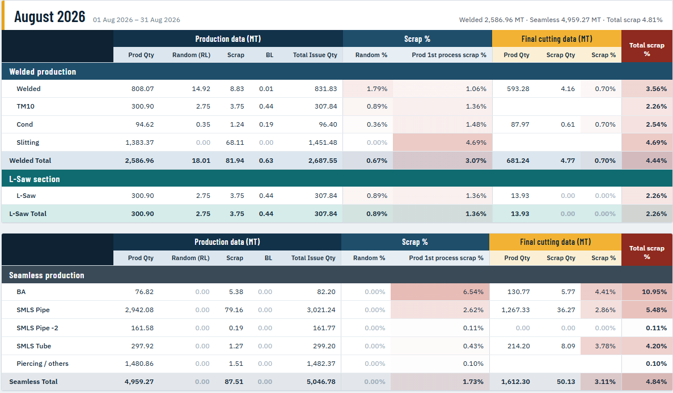
Figure 4: Scrap MIS Dashboard

Steps:
- Open ERP & Go to 06.400.00 - Special Engines - Production Planning and untick Dashboard Engine.
- Click on Production Summary & Find R959 Production Summary Report-Welded.
- Select the period, export as CSV and name the file 'Welded'.
- Find R960 Production Summary Report-Seamless in same Engine.
- Select the period, export as CSV and name the file 'Seamless'.
- Go to Slitting Plan Report on same Path 06.400.00 - Special Engines - Production Planning.
- Find R961 Slitting Production Summary Report.
- Select the period, export as CSV and name the file 'Slitting'.
- Now, go to 06.410.03 - Production Engine (Process Wise) module & open it.
- Find R950 Final Cutting Scrap Report-PBI on Right Side.
- Select the period, export as CSV and name the file 'Final_Cutting'.
- Now Go to 06.300.00 - Special Engines - Sales & Distribution & Find Seamless Scrap Report.
Find R984 > Seamless Scrap Qty, export in csv and name it ‘M2M’.
- 13. Open the Scrap_MIS_Dashboard_Generator.html file and upload 'Welded', 'Seamless', 'Slitting' and 'Final_Cutting' & ‘M2M’. Your dashboard is ready.

3.3 Job Cardwise Production Scrap Report
Report Name | Job Cardwise Production Scrap Report-Automation
Type | Automation
Generator | Job Cardwise Production Scrap Report Generator
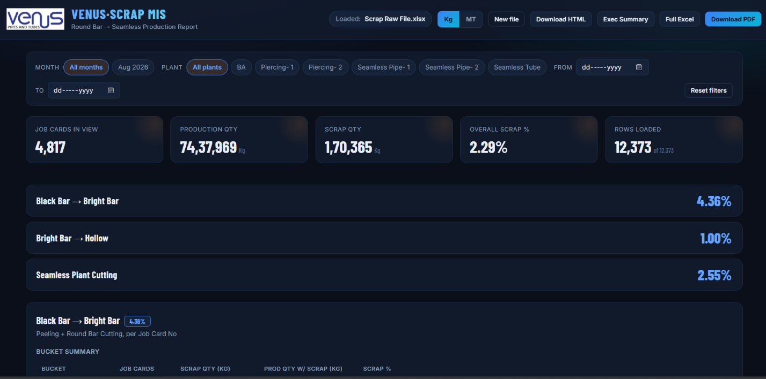
Figure 5: Job Cardwise Production Scrap Report, dashboard (1 of 2)
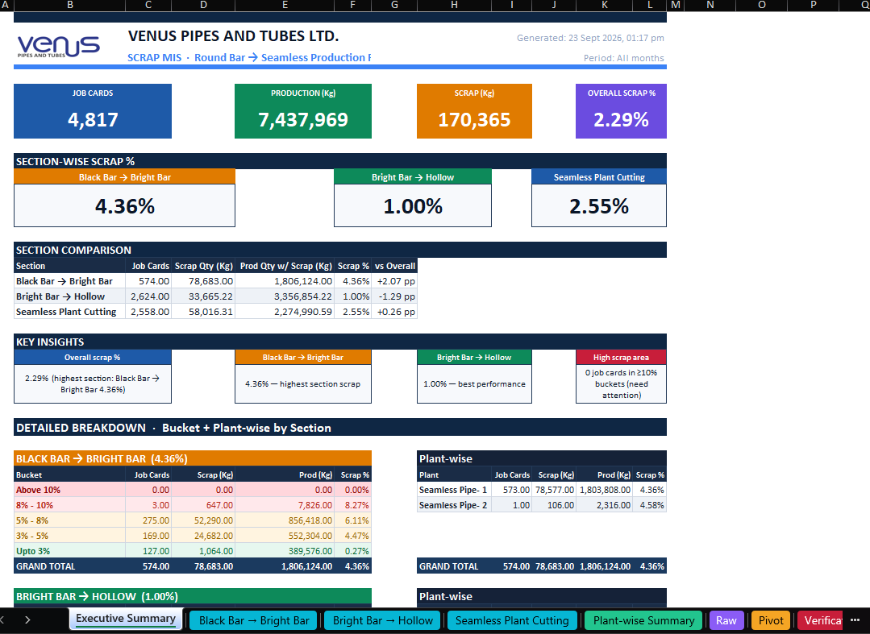
Figure 6: Job Cardwise Production Scrap Report, dashboard (2 of 2)

Steps:
- Open ERP & go to 06.410.03 - Production Engine (Process Wise).
- Find R957 Job Cardwise Scrap MIS-PBI.
- Select the period and export the report as CSV.
- Upload the CSV into the Job Cardwise Production Scrap Report Generator. Your dashboard is ready.

3.4 Manpower Cost Report
Report Name | Manpower Cost Report-Automation
Type | Automation
Generator | Manpower Cost Processing System
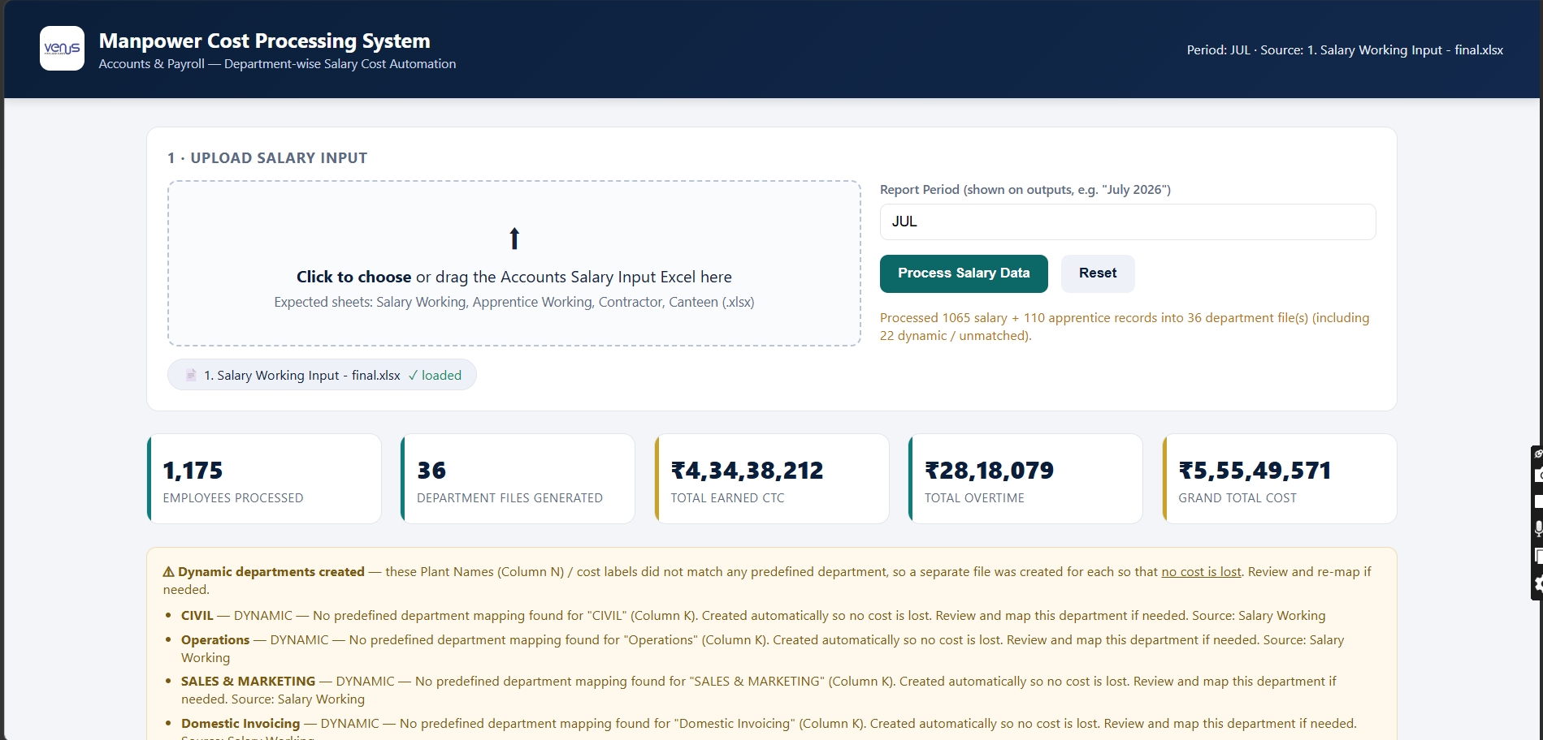
Figure 7: Manpower Cost Processing System

Steps:
- Click on the link above to open the generator.
- Upload your Salary Input sheet. Name the file Salary Input and keep only the columns shown in the reference sheet.
- Your dashboard is ready. You can download the output as Excel or PDF.

