PROJECT REPORT
AI DENTAL ANALYZER
An AI-Assisted Dental Image and Symptom Assessment System
Submitted in partial fulfillment of the requirements for
[Degree / Program Name]
[Department / Institution Name]

Report detail | Information
Submitted by | [Student name and registration number]
Project guide | [Guide name and designation]
Department | [Department name]
Institution | [Institution name]
Academic year | [Academic year]

October 2026

CERTIFICATE
This is to certify that the project report entitled “AI Dental Analyzer: An AI-Assisted Dental Image and Symptom Assessment System” is a record of project work prepared by [Student name / registration number] under the guidance of [Guide name] during the academic year [Academic year]. The report is submitted in partial fulfillment of the requirements for [Degree / Program].

Project Guide | Head of Department | External Examiner
Name: __________________  Signature: _______________ | Name: __________________  Signature: _______________ | Name: __________________  Signature: _______________

DECLARATION
I/We declare that this project report, titled “AI Dental Analyzer: An AI-Assisted Dental Image and Symptom Assessment System,” describes work carried out for academic purposes. The work and sources of information are represented to the best of my/our knowledge. The system is a prototype for educational and preliminary information purposes and is not a clinically validated diagnostic device.
Place: ____________________
Date: _____________________
Student signature(s): ______________________________

ACKNOWLEDGEMENT
I/We express sincere gratitude to [Project Guide], [Department / Institution], and the faculty members who provided guidance and support during this project. I/We also acknowledge the maintainers of the open-source libraries and services used in the prototype, including Streamlit, Google GenAI, Supabase, and Python. Any institutional acknowledgements should be reviewed and completed by the student before submission.

ABSTRACT
The AI Dental Analyzer is a web-based application designed to provide users with a preliminary, educational assessment of dental images and reported symptoms. Developed with Python and Streamlit, the system accepts an uploaded or camera-captured dental photograph together with structured information such as age, pain level, pain type and duration, sensitivity, gum symptoms, and additional notes. Users can identify affected teeth using an interactive chart based on the FDI two-digit numbering system. The application combines these inputs with Google Gemini’s multimodal analysis capabilities and a retrieval-augmented generation (RAG) pipeline. The RAG component creates an embedding for the symptom context and searches a Supabase pgvector knowledge store for relevant dental reference material. If no retrieved result meets the configured similarity threshold, the application can attempt a web-based fallback and pass the available supporting context to the model. The response is presented as a preliminary assessment that separates visible observations from reported symptoms, possible explanations, image limitations, concern level, recommended next steps, and warning signs. Assessment information and generated text can be stored in Supabase and reviewed through an analytics dashboard showing assessment totals, symptom distributions, pain patterns, age distribution, and selected teeth. Google OAuth provides sign-in for the Streamlit application. The prototype does not establish a definitive diagnosis, measure clinical accuracy, or replace examination by a qualified dental professional. Image quality, retrieval coverage, external connectivity, and generative-model errors are important limitations; outputs require professional verification.
Keywords: Dental image analysis; multimodal artificial intelligence; retrieval-augmented generation; FDI tooth numbering; Streamlit; Supabase; preliminary assessment.

CONTENTS
Update fields in Word
In Microsoft Word, select the contents and choose Update Field (or press Ctrl+A, then F9) to refresh headings and page numbers.

LIST OF FIGURES
Update fields in Word

LIST OF TABLES
Update fields in Word

ABBREVIATIONS AND SYMBOLS
Abbreviation / symbol | Meaning
AI | Artificial intelligence
API | Application programming interface
DFD | Data-flow diagram
FDI | Fédération Dentaire Internationale (two-digit tooth notation)
GUI | Graphical user interface
LLM | Large language model
OAuth | Open Authorization
RAG | Retrieval-augmented generation
SQL | Structured Query Language
UI | User interface
Vector embedding | Numeric representation used to compare semantic similarity
pgvector | PostgreSQL extension for storing and searching vector embeddings

CHAPTER 1 — OVERVIEW

1.1 Introduction
Oral symptoms and visible changes can be difficult for a person to describe consistently before a dental visit. This project develops an interactive web application that collects a dental photograph and structured symptom information and uses a multimodal generative model with retrieved reference context to produce a cautious, preliminary explanation. The application is designed as an information-support prototype, not a diagnostic instrument.

1.2 Background
Dental assessment normally depends on history-taking, direct clinical examination, and, where appropriate, diagnostic tests such as radiographs. A photograph may show surface appearance but cannot reliably establish lesion depth, pulp status, periodontal measurements, or the cause of pain. Generative AI can interpret image and text inputs together, while RAG can provide relevant reference passages as context. These capabilities can improve the organization and accessibility of information, but they also introduce uncertainty, privacy considerations, and the need for professional oversight.

1.3 Importance of the Project
- Offers one structured place to record an image, symptoms, and affected tooth numbers.
- Uses an explicit knowledge-retrieval step rather than relying only on an unconstrained model response.
- Communicates image limitations and recommends professional evaluation rather than claiming a confirmed diagnosis.
- Demonstrates integration of multimodal AI, vector search, a database, authentication, and analytics in a single prototype.
- Provides aggregate views that can help a project administrator inspect recorded assessment patterns; these are not epidemiological or clinical conclusions.

1.4 Perspective of Stakeholders and Customers
Stakeholder | Interest / need | System response and limitation
User / patient | Simple entry of image and symptoms; clear next-step information. | Guided Streamlit form and cautious generated response; not a diagnosis or emergency triage service.
Dentist / clinician | Patient-reported context that may support a later conversation. | Structured summary and selected FDI teeth; clinician must independently examine and diagnose.
Project administrator | Review application use and broad assessment patterns. | Analytics dashboard; stored records require privacy, access, and retention governance.
Developer / maintainer | Maintainable integration and traceable data flow. | Separate modules for UI, retrieval, persistence, analytics, embeddings, and web fallback.
Institution / evaluator | Demonstrable requirements, architecture, and test plan. | This report documents current implementation and distinguishes planned testing from measured results.

1.5 Objectives and Scope of the Project
Objectives:
- Build a Streamlit interface for image upload or camera capture and structured symptom entry.
- Allow one or more affected teeth to be selected using FDI numbering.
- Retrieve relevant dental knowledge using embedding-based similarity search and use a fallback when retrieval is insufficient.
- Combine image, symptoms, and available context in a multimodal Gemini request and present an explicitly preliminary response.
- Persist assessment fields and AI text in Supabase and summarize stored records in an analytics page.
- Require Google OAuth sign-in in the application and keep service credentials in server-side configuration.
Scope and exclusions:
- The prototype accepts JPG/JPEG/PNG dental images and user-reported context.
- It does not train or deploy a project-specific dental classifier, validate a clinical model, or confirm disease.
- It does not replace radiographs, chairside tests, examination, prescription, or treatment planning.
- The current knowledge documents are a compact general-reference set; retrieval quality depends on their scope and the configured threshold.
- The current persistence flow stores the image filename and MIME type, not the image binary itself.
- The concern-level column is stored with a placeholder value in the current save call; it should not be interpreted as an extracted clinical risk label.

1.6 Summary
Chapter 1 introduced the purpose, stakeholders, objectives, and boundaries of the prototype. The system organizes user-provided information and AI-generated explanations, while retaining a clear distinction between preliminary assistance and professional diagnosis.

CHAPTER 2 — LITERATURE SURVEY AND PROPOSED WORK

2.1 Introduction
This chapter places the prototype in the context of AI in dentistry, multimodal language models, and retrieval-augmented generation. The literature supports technical exploration, but it does not establish that this particular implementation is clinically accurate or safe for autonomous diagnosis.

2.2 Literature Survey Table
Table Update fields in Word. Selected literature and technical references
Ref. | Work / source | Relevance to this project | Limitation for this project
[1] | Schwendicke, Samek & Krois (2020), AI in Dentistry: Chances and Challenges. | Discusses opportunities, validation, and governance issues for dental AI. | A review does not validate this application or its outputs.
[2] | Khanagar et al. (2021), systematic review of AI applications in dentistry. | Summarizes dental AI applications and evaluation considerations. | Studies concern heterogeneous tasks; results cannot be transferred to this prototype.
[3] | Lewis et al. (2020), Retrieval-Augmented Generation for Knowledge-Intensive NLP Tasks. | Provides the foundational RAG concept used to combine retrieval with generation. | General NLP results do not establish clinical suitability.
[4] | Gemini Team (2023), Gemini: A Family of Highly Capable Multimodal Models. | Describes multimodal model capabilities relevant to image-plus-text prompts. | Model capabilities do not guarantee reliable dental interpretation.
[5] | Google Gemini API documentation. | Documents the API surface used for text/image generation and embeddings. | API documentation is not an independent clinical evaluation.
[6] | Supabase documentation: vector columns / pgvector. | Describes vector storage and similarity-search mechanisms used by RAG. | Retrieval relevance depends on embedding, corpus, index, and threshold.
[7] | Streamlit documentation. | Documents the Python framework used for the interactive web interface. | Framework documentation does not assess AI or clinical risk.

2.3 Problem Definition
A user may have a dental concern and a photograph but lack a consistent way to record symptoms, identify the affected tooth, and understand what a photo can and cannot reveal. The project problem is to build a prototype that organizes these inputs, retrieves relevant general dental material, and presents a cautious AI-generated explanation with limitations and recommended professional follow-up. The system must avoid representing an image-only inference as a confirmed diagnosis.
Input: user-selected image, age, pain level/type/duration, sensitivity and other symptom indicators, selected FDI teeth, and free-text description.
Output: structured preliminary assessment text, retrieval/web source status, saved assessment record when database persistence succeeds, and aggregate dashboard charts.

2.4 Feasibility Study
Table Update fields in Word. Feasibility assessment
Dimension | Assessment | Conditions / constraints
Technical | Feasible as a prototype using Python, Streamlit, Gemini, Supabase and pgvector. | Requires valid API credentials, network access, database schema, and compatible embedding dimension.
Economic | Can be developed with open-source libraries and hosted services with usage-based or free-tier options. | Actual operational cost depends on model calls, hosting, database use, and web requests; no cost benchmark is included.
Operational | A web form and dashboard are suitable for demonstration and controlled evaluation. | Users need connectivity and clear training/disclaimers; clinicians remain responsible for care.
Schedule | A staged implementation is manageable for a student project. | Schedule in Figure 7 is illustrative and must be aligned to the institutional calendar.
Legal / ethical | A privacy-aware prototype is possible when used with appropriate consent and access controls. | Health information and images are sensitive; verify applicable law, consent, retention, vendor terms, and institutional approval before real-patient use.

2.5 Methodology Used
- Requirement analysis: identify user inputs, output sections, authentication, persistence, and analytics needs.
- Interface design: implement the workflow using Streamlit widgets and an FDI-based tooth selector.
- Context construction: combine symptoms and user description into a retrieval query.
- Knowledge retrieval: create a Gemini embedding, search Supabase pgvector, and retain only context meeting the configured similarity threshold.
- Fallback and generation: attempt web retrieval when vector context is insufficient, then submit available image and context to Gemini.
- Presentation and persistence: show the preliminary response, retrieval details, and caveats; save assessment fields and analysis text to Supabase.
- Analytics and verification: summarize stored records and use component-level scripts plus a defined test plan to validate behavior.
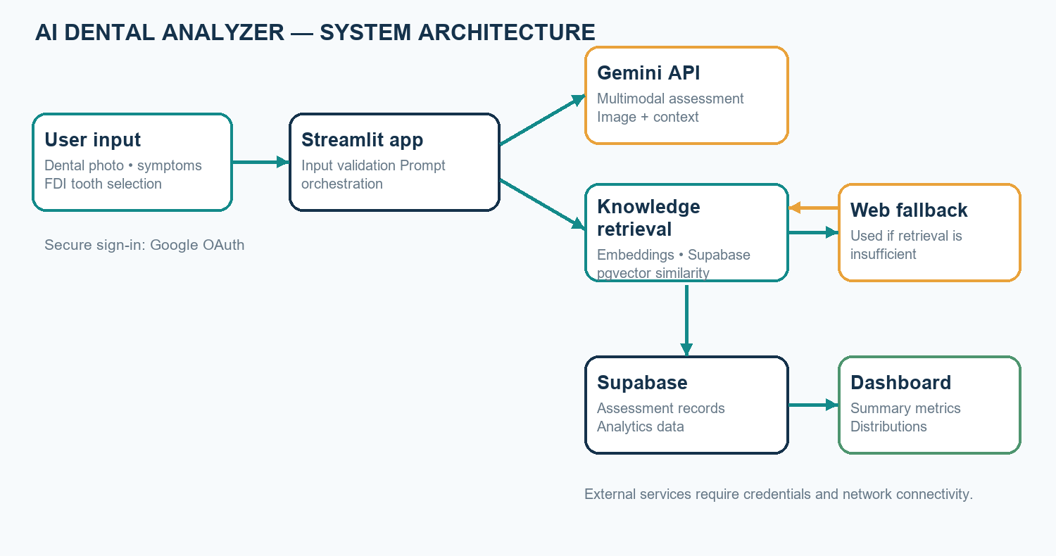
Figure Update fields in Word. System architecture of the AI Dental Analyzer

2.6 Summary
The proposed system combines multimodal generation with retrieved general knowledge, but its value depends on transparent limitations and professional review. The feasibility assessment is conditional on external services, data governance, and evaluation.

CHAPTER 3 — ANALYSIS AND PLANNING

3.1 Introduction
The analysis phase defines the user journey, system requirements, data boundaries, and a staged development plan. The design prioritizes a small number of clearly separated components so that input collection, retrieval, model calls, persistence, and reporting can be tested independently.

3.2 Project Planning
Table Update fields in Word. Functional and non-functional requirements
ID | Requirement | Category / acceptance point
FR-01 | Allow Google sign-in before use. | Functional: unauthenticated user is shown sign-in and cannot continue.
FR-02 | Accept a dental image from upload or camera. | Functional: JPG/JPEG/PNG accepted; missing or unsupported image is rejected.
FR-03 | Collect age, pain, symptoms, notes, and selected teeth. | Functional: fields are incorporated in the assessment context.
FR-04 | Retrieve dental references using vector similarity. | Functional: query embedding is sent to match_documents; threshold is applied.
FR-05 | Use web fallback when RAG is insufficient. | Functional: attempt fallback and expose available sources/context.
FR-06 | Generate a cautious image-and-symptom assessment. | Functional: response distinguishes observations, symptoms, uncertainty, and next steps.
FR-07 | Persist assessment information. | Functional: save record to Supabase and report persistence errors.
FR-08 | Display assessment analytics. | Functional: summarize stored records and distributions.
NFR-01 | Protect secrets and restrict access. | Security: keep API/service credentials server-side; configure OAuth and database access.
NFR-02 | Communicate limitations. | Safety: avoid definitive diagnosis claims and include professional-care guidance.
NFR-03 | Maintain understandable response time and usable layout. | Usability/performance: evaluate under representative network conditions.
NFR-04 | Handle external-service failure explicitly. | Reliability: show errors/status rather than implying an unavailable result succeeded.

Data and privacy planning
The database schema stores demographic and symptom fields, affected teeth, image filename/MIME type, generated analysis, concern-level field, and timestamp. The reviewed save path does not upload the image itself. Health-related descriptions and AI output remain sensitive data. Before using real patient data, the project owner should document consent, purpose limitation, access policy, data retention/deletion, vendor processing terms, and applicable institutional and legal requirements. A service-role key must stay on the server and must not be exposed in client code.

Risk analysis
Table Update fields in Word. Project risks and mitigations
Risk | Potential effect | Mitigation / control
Incorrect or overconfident AI text | User misunderstands a possibility as a diagnosis. | Use cautious prompts, explicit caveats, warning signs, and professional evaluation guidance; perform clinical review before any real-world use.
Poor image quality | Unreliable visible observations. | Guide image capture and state that image quality limits analysis.
Irrelevant or incomplete RAG content | Misleading context or unsupported generation. | Apply a similarity threshold, inspect corpus quality, disclose source status, and evaluate retrieval.
External service or network outage | Analysis, fallback, or persistence unavailable. | Show clear status/errors and test failure paths; do not imply a result was saved if persistence fails.
Sensitive data exposure | Privacy and compliance harm. | Use server-side secrets, least privilege, consent, retention rules, and deployment access controls.
No clinical evaluation evidence | Unjustified trust in outputs. | Do not claim diagnostic performance; conduct an approved, independently designed evaluation before clinical use.

3.3 Scheduling
The following eight-week schedule is a planning illustration, not a record of completed work. It assumes overlapping development and should be revised to match the course timetable, team size, and review milestones.
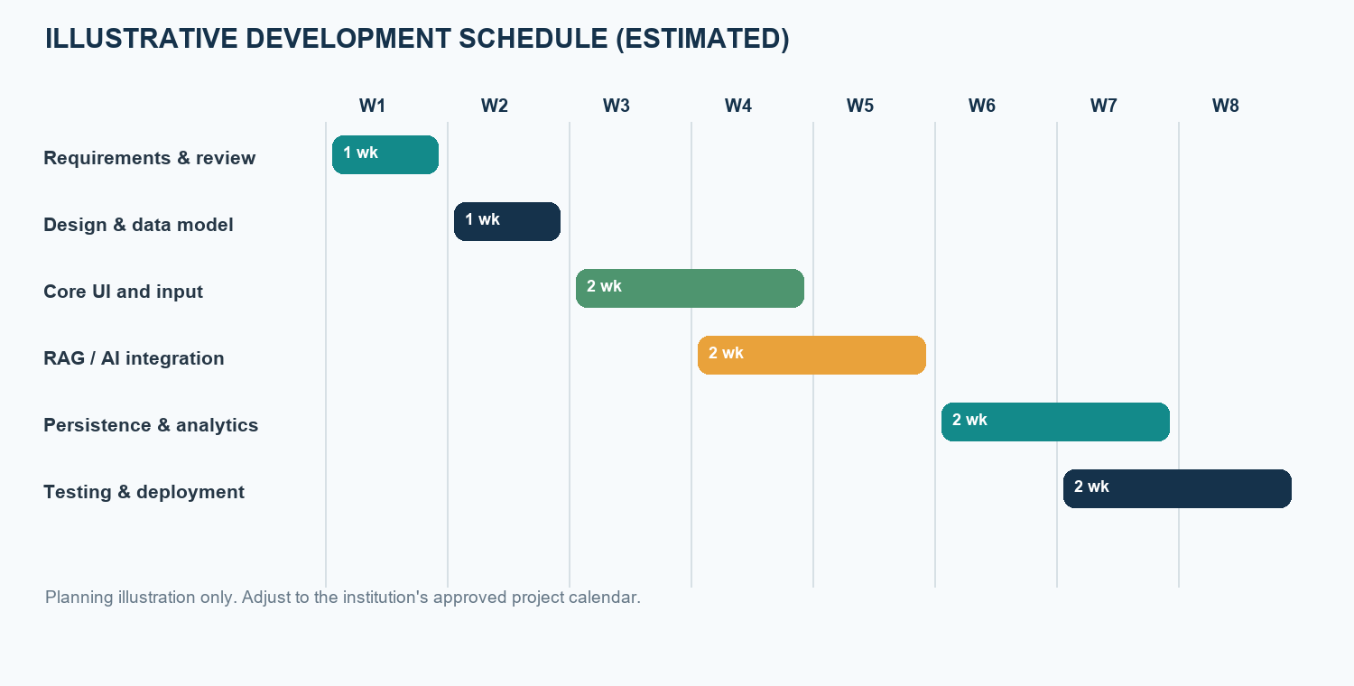
Figure Update fields in Word. Illustrative project schedule; durations are estimates, not measured project history

3.4 Summary
Requirements and risks were translated into functional checkpoints and a staged schedule. Data privacy, AI uncertainty, retrieval quality, and external-service availability are central project constraints.

CHAPTER 4 — DESIGN AND IMPLEMENTATION

4.1 Data-Flow Diagram (DFD)
The DFD shows how user-supplied inputs pass through validation, retrieval and generation, and how the resulting record is stored for later analytics. External providers are distinct from the application boundary.
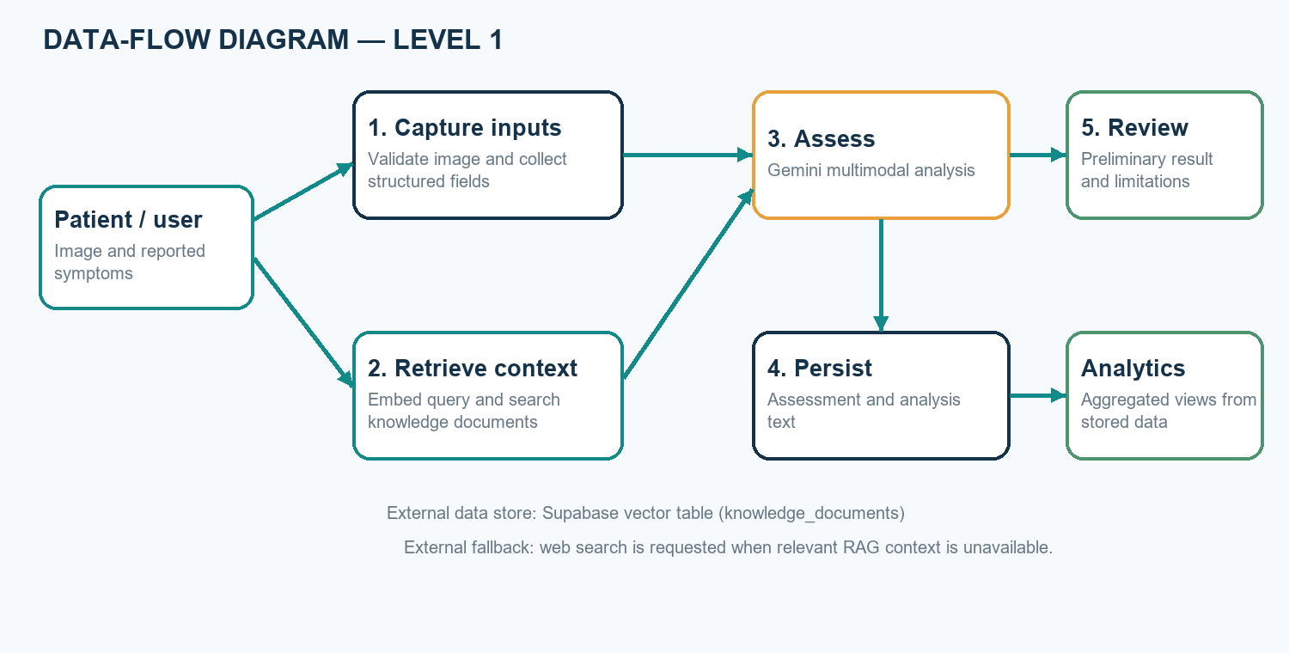
Figure Update fields in Word. Level-1 data-flow diagram for assessment processing

4.2 Block Diagram
The system architecture is modular: Streamlit manages interaction; the embedding and retrieval modules query Supabase; a web fallback can add supporting material; Gemini generates a text response; database.py persists assessment data; and the analytics page summarizes saved records.
Figure Update fields in Word. Block diagram of application components and external services

4.3 Flowchart
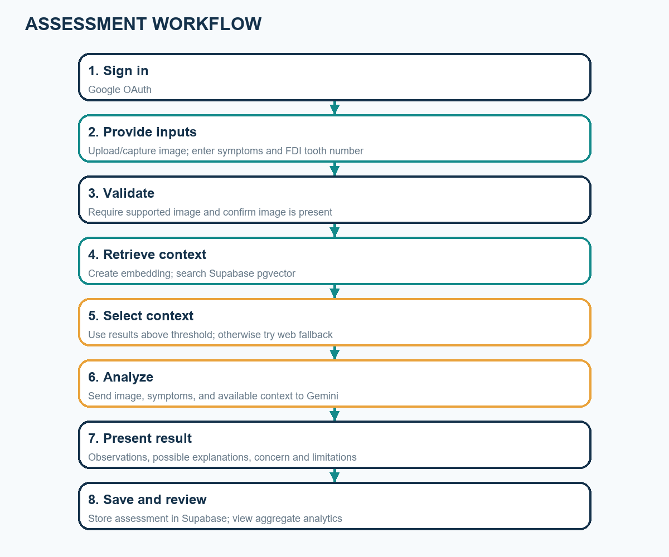
Figure Update fields in Word. User-to-assessment processing flow

4.4 UML Use-Case View
The primary actor is an authenticated user. The user can provide an image and symptoms, select teeth, request an assessment, review the generated information, and view saved analytics where authorized. The figure is a UML-style use-case overview, not a formal executable UML model.
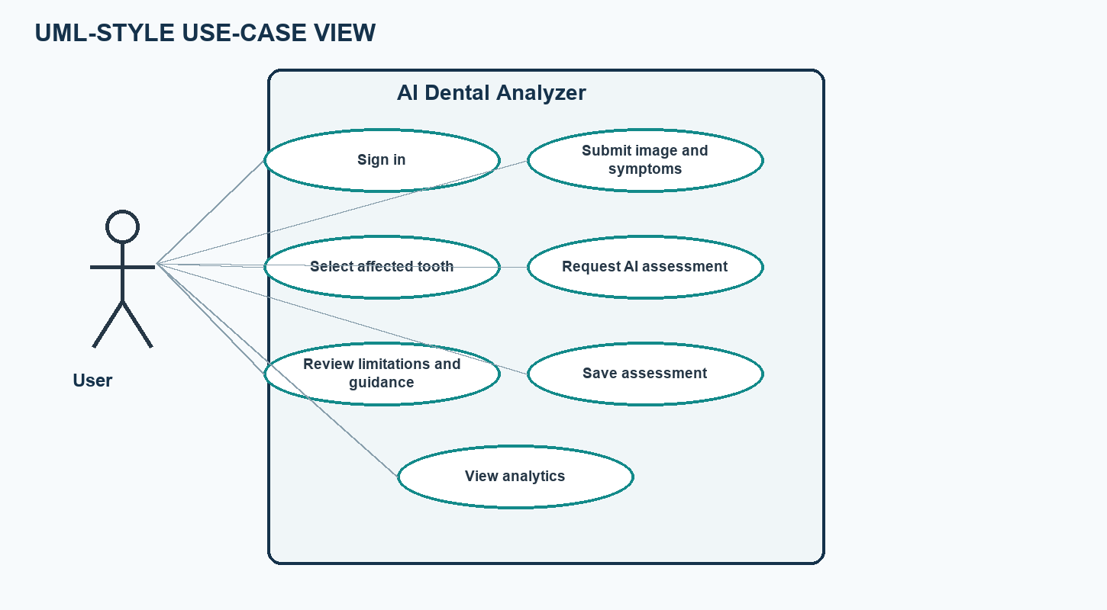
Figure Update fields in Word. UML-style use-case diagram

4.5 GUI Screenshot / Interface Design
The project contains a Streamlit interface with image source selection, patient-information fields, an FDI reference chart and tooth-selection controls, analysis status, and generated results. The figure below is an illustrative wireframe reconstructed from implemented controls; it is not a screenshot of a running application. Replace it with a genuine, privacy-safe screenshot before final submission if screenshots are required by the institution.
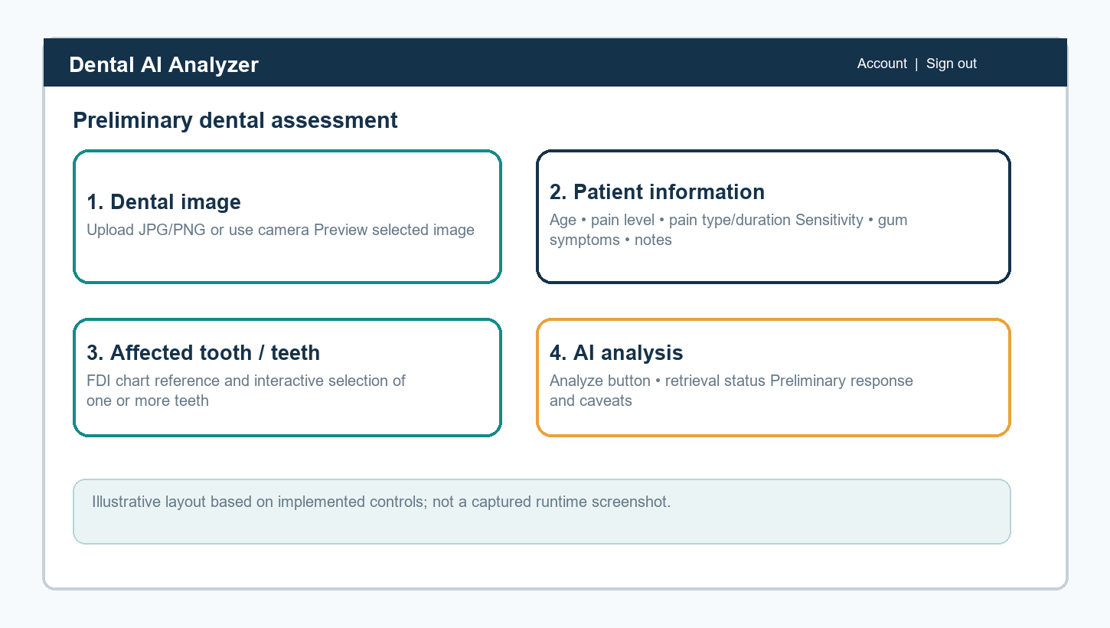
Figure Update fields in Word. Illustrative GUI wireframe; not a runtime screenshot
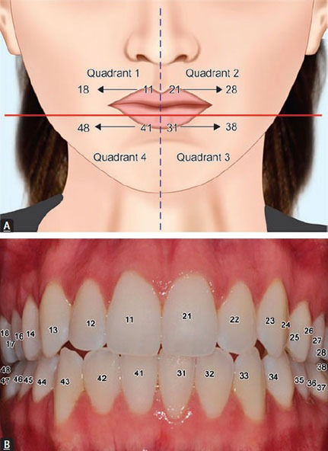
Figure Update fields in Word. FDI tooth numbering reference image included with the project
Table Update fields in Word. Principal software modules
Module / file | Responsibility
app.py | Streamlit authentication, image and symptom UI, tooth selection, retrieval/generation orchestration, and result presentation.
knowledge/embeddings.py | Creates 768-dimensional Gemini embeddings.
rag.py | Submits embeddings to the Supabase match_documents function and returns matching records.
knowledge/documents.py and ingest.py | Define and ingest the general dental knowledge documents.
web_fallback.py | Searches the web and extracts supporting page text when invoked.
database.py | Saves assessments and queries assessment data for the dashboard.
analytics.py and pages/2_Analytics.py | Calculates and displays summary metrics and distributions.
supabase_setup.sql | Creates assessment and knowledge tables, vector index, match function, and service-role permissions.

CHAPTER 5 — RESULTS AND DISCUSSION

5.1 Actual Results
Repository inspection confirms implementation of the main prototype components: Streamlit sign-in and assessment UI, image upload/camera input, structured symptom fields, FDI tooth selection, Gemini multimodal calls, vector retrieval, a conditional web fallback, Supabase persistence, and an analytics page. The source includes test scripts for embedding creation, RAG retrieval, and analytics access. These scripts require live credentials/services and are not equivalent to a saved automated test report.
No assessment dataset, benchmark labels, measured diagnostic accuracy, latency study, or executed test log was present in the project files reviewed for this report. Therefore, this report does not claim numerical model performance, patient benefit, clinical validation, or successful live-service testing. Any demo output should be treated as qualitative and illustrative until independently evaluated.
Table Update fields in Word. Implemented capabilities and evidence available in the project
Capability | Implementation evidence | Result statement
Image + symptom input | UI controls in app.py | Implemented in source; runtime behavior should be verified in deployment.
FDI tooth selection | Interactive controls and included tooth chart | Implemented in source.
RAG retrieval | Embedding function, Supabase RPC, knowledge corpus | Integration path implemented; live retrieval depends on credentials and seeded data.
Web fallback | Search and page extraction module | Fallback path implemented; results depend on external network and site availability.
Assessment persistence | Supabase insert in database.py | Implemented; successful save requires configured schema and credentials.
Analytics | Streamlit page and aggregation logic | Implemented; values require saved assessment records.
Clinical performance | No labeled evaluation data or validation protocol in repository | Not established; no accuracy or diagnostic claim is made.

5.2 Future Scope
- Conduct usability testing with non-clinical demonstration data and collect feedback.
- Develop a clinically governed evaluation protocol with expert-labeled data, appropriate ethics approval, privacy protections, and clear outcome measures.
- Improve source provenance and citations for both curated knowledge documents and web fallback content.
- Add robust extraction and validation for structured concern categories; avoid treating a placeholder field as a risk score.
- Add consent-aware image handling, retention/deletion controls, audit logging, and role-based access.
- Evaluate RAG retrieval quality, threshold calibration, failure cases, and response latency using a documented test set.
- Consider clinician review workflows and mobile usability only after safety and privacy requirements are defined.
- Explore dental radiograph support only as a separately validated capability; it is outside the current implementation.

5.3 Testing
The current repository includes manual scripts (test_embedding.py, test_rag.py, and test_analytics.py). They are integration checks that require configured API/database access, not self-contained unit tests. The table below is a proposed test plan. Status is intentionally marked “Not run for this report” because no controlled test environment or saved execution results were available.
Table Update fields in Word. Proposed functional and integration test cases
ID | Test | Expected outcome | Status
T-01 | Open app while signed out. | Sign-in guidance shown; assessment form is not available. | Not run for this report
T-02 | Submit without an image. | Clear validation message; analysis does not start. | Not run for this report
T-03 | Upload unsupported image type. | Unsupported format is rejected. | Not run for this report
T-04 | Enter symptoms and select FDI tooth(s). | Values are reflected in the query and saved assessment. | Not run for this report
T-05 | Query a seeded knowledge base. | Matching records are returned and threshold behavior is reported. | Not run for this report
T-06 | Force empty/low-relevance RAG response. | Web fallback is attempted; unavailable results are not represented as sources. | Not run for this report
T-07 | Simulate Gemini/API failure. | Failure is surfaced; no success-shaped assessment is presented. | Not run for this report
T-08 | Simulate Supabase insert failure. | AI result may be shown, but save failure is explicitly reported. | Not run for this report
T-09 | Load analytics with no records and with records. | Empty state and calculated charts/metrics render appropriately. | Not run for this report
T-10 | Review safety language in generated output. | No definitive diagnosis claim; limitations and care guidance remain visible. | Not run for this report

5.4 Deployment
- Install dependencies from requirements.txt in a supported Python environment.
- Create a Supabase project and run the repository's supabase_setup.sql script; configure the knowledge corpus as required.
- Configure server-side GEMINI_API_KEY, model settings, SUPABASE_URL, SUPABASE_KEY, and the RAG threshold without committing secrets.
- Configure Google OAuth redirect URI and Streamlit authentication secrets for the actual deployment URL.
- Launch the Streamlit application using the deployment platform's supported process and verify sign-in, image handling, RAG, fallback, database writes, and dashboard behavior.
- Before any use with real patient information, complete privacy, consent, access-control, retention, and institutional/legal review; monitor errors and usage.
For local demonstration, the project README documents running Streamlit with app.py. Production deployment should use a managed secret store and server-side database credentials. A successful local startup alone does not validate external integrations or clinical safety.

CHAPTER 6 — CONCLUSION
The AI Dental Analyzer demonstrates an end-to-end prototype that combines dental image and symptom input, FDI tooth selection, multimodal generative AI, vector-based knowledge retrieval, conditional web fallback, Supabase persistence, and dashboard analytics. Its key contribution is integration and organization of information into a preliminary educational workflow. The system does not establish a dental diagnosis or clinical accuracy; the quality of its output depends on image quality, user-provided information, model behavior, reference coverage, external services, and professional interpretation. Future work should prioritize documented functional testing, privacy governance, source transparency, and independent clinical validation before considering any clinical use.

REFERENCES
[1] F. Schwendicke, W. Samek, and J. Krois, “Artificial Intelligence in Dentistry: Chances and Challenges,” Journal of Dental Research, vol. 99, no. 7, pp. 769–774, 2020. doi: 10.1177/0022034520915714.
[2] A. A. Khanagar et al., “Developments, application, and performance of artificial intelligence in dentistry—A systematic review,” Journal of Dental Sciences, vol. 16, no. 1, pp. 508–522, 2021. doi: 10.1016/j.jds.2020.06.019.
[3] P. Lewis et al., “Retrieval-Augmented Generation for Knowledge-Intensive NLP Tasks,” Advances in Neural Information Processing Systems, vol. 33, pp. 9459–9474, 2020.
[4] Gemini Team, “Gemini: A Family of Highly Capable Multimodal Models,” arXiv:2312.11805, 2023.
[5] Google AI for Developers, “Gemini API documentation.” https://ai.google.dev/gemini-api/docs (accessed October 23, 2026).
[6] Supabase, “AI and Vector Columns / pgvector documentation.” https://supabase.com/docs/guides/ai (accessed October 23, 2026).
[7] Streamlit, “Streamlit documentation.” https://docs.streamlit.io/ (accessed October 23, 2026).
[8] Project source repository, AI Dental Analyzer: app.py, analytics.py, database.py, rag.py, web_fallback.py, knowledge/, and supabase_setup.sql. Accessed October 23, 2026.

APPENDIX A — SUBMISSION CUSTOMIZATION CHECKLIST
- Replace bracketed title-page and certificate placeholders with approved student, guide, department, and institution details.
- Update the table of contents, list of figures, list of tables, and page numbers in Word using Ctrl+A, then F9.
- Insert actual, privacy-safe application screenshots if required; the included wireframe is explicitly illustrative.
- Run and record the integration tests in a configured environment; replace “Not run for this report” only with verified results.
- Verify citation formatting and institutional report requirements, including page size, margins, and declaration wording.
- Do not include real patient identifiers or images without appropriate consent and approval.

