PROJECT REPORT
AI DENTAL ANALYZER
An AI-Assisted Dental Image and Symptom Assessment System
Submitted in partial fulfillment of the requirements for
[Degree / Program Name]
[Department / Institution Name]

Report detail | Information
Submitted by | [Student name and registration number]
Project guide | [Guide name and designation]
Department | [Department name]
Institution | [Institution name]
Academic year | [Academic year]

October 2026

CERTIFICATE
This is to certify that the project report entitled “AI Dental Analyzer: An AI-Assisted Dental Image and Symptom Assessment System” is a record of project work prepared by [Student name / registration number] under the guidance of [Guide name] during the academic year [Academic year]. The report is submitted in partial fulfillment of the requirements for [Degree / Program].

Project Guide | Head of Department | External Examiner
Name: __________________  Signature: _______________ | Name: __________________  Signature: _______________ | Name: __________________  Signature: _______________

DECLARATION
I/We declare that this project report, titled “AI Dental Analyzer: An AI-Assisted Dental Image and Symptom Assessment System,” describes work carried out for academic purposes. The work and sources of information are represented to the best of my/our knowledge. The system is a prototype for educational and preliminary information purposes and is not a clinically validated diagnostic device.
Place: ____________________
Date: _____________________
Student signature(s): ______________________________

ACKNOWLEDGEMENT
I/We express sincere gratitude to [Project Guide], [Department / Institution], and the faculty members who provided guidance and support during this project. I/We also acknowledge the maintainers of the open-source libraries and services used in the prototype, including Streamlit, Google GenAI, Supabase, and Python. Any institutional acknowledgements should be reviewed and completed by the student before submission.

ABSTRACT
The AI Dental Analyzer is a web-based application designed to provide users with a preliminary, educational assessment of dental images and reported symptoms. Developed with Python and Streamlit, the system accepts an uploaded or camera-captured dental photograph together with structured information such as age, pain level, pain type and duration, sensitivity, gum symptoms, and additional notes. Users can identify affected teeth using an interactive chart based on the FDI two-digit numbering system. The application combines these inputs with Google Gemini’s multimodal analysis capabilities and a retrieval-augmented generation (RAG) pipeline. The RAG component creates an embedding for the symptom context and searches a Supabase pgvector knowledge store for relevant dental reference material. If no retrieved result meets the configured similarity threshold, the application can attempt a web-based fallback and pass the available supporting context to the model. The response is presented as a preliminary assessment that separates visible observations from reported symptoms, possible explanations, image limitations, concern level, recommended next steps, and warning signs. Assessment information and generated text can be stored in Supabase and reviewed through an analytics dashboard showing assessment totals, symptom distributions, pain patterns, age distribution, and selected teeth. Google OAuth provides sign-in for the Streamlit application. The prototype does not establish a definitive diagnosis, measure clinical accuracy, or replace examination by a qualified dental professional. Image quality, retrieval coverage, external connectivity, and generative-model errors are important limitations; outputs require professional verification.
Keywords: Dental image analysis; multimodal artificial intelligence; retrieval-augmented generation; FDI tooth numbering; Streamlit; Supabase; preliminary assessment.

CONTENTS
Update fields in Word
In Microsoft Word, select the contents and choose Update Field (or press Ctrl+A, then F9) to refresh headings and page numbers.

LIST OF FIGURES
Update fields in Word

LIST OF TABLES
Update fields in Word

ABBREVIATIONS AND SYMBOLS
Abbreviation / symbol | Meaning
AI | Artificial intelligence
API | Application programming interface
DFD | Data-flow diagram
FDI | Fédération Dentaire Internationale (two-digit tooth notation)
GUI | Graphical user interface
LLM | Large language model
OAuth | Open Authorization
RAG | Retrieval-augmented generation
SQL | Structured Query Language
UI | User interface
Vector embedding | Numeric representation used to compare semantic similarity
pgvector | PostgreSQL extension for storing and searching vector embeddings

CHAPTER 1 — OVERVIEW

1.1 Introduction
Oral symptoms and visible changes can be difficult for a person to describe consistently before a dental visit. This project develops an interactive web application that collects a dental photograph and structured symptom information and uses a multimodal generative model with retrieved reference context to produce a cautious, preliminary explanation. The application is designed as an information-support prototype, not a diagnostic instrument.
The application is intended to make initial information gathering more organized. Instead of relying only on an unstructured description, it combines a photograph with specific fields for pain, sensitivity, gum symptoms, duration, and tooth location. This structured context supports the retrieval and generation workflow, while diagnosis and treatment decisions remain the responsibility of a qualified dental professional.
A signed-in user supplies information through a browser. The Streamlit application constructs a symptom query, searches a vector-based reference collection, and compares retrieved similarity with a configured threshold. The multimodal model receives the image and available text context. Its response is presented as preliminary information and may be saved for later review.
The project also demonstrates how an interactive Python interface, an external generative AI service, embedding generation, a PostgreSQL vector extension through Supabase, optional web retrieval, and database analytics can be connected. Each dependency can affect availability and quality, so external-service limitations are part of the system design.

1.2 Background
Dental assessment normally depends on history-taking, direct clinical examination, and, where appropriate, diagnostic tests such as radiographs. A photograph may show surface appearance but cannot reliably establish lesion depth, pulp status, periodontal measurements, or the cause of pain. Generative AI can interpret image and text inputs together, while RAG can provide relevant reference passages as context. These capabilities can improve the organization and accessibility of information, but they also introduce uncertainty, privacy considerations, and the need for professional oversight.
Dental conditions are assessed using multiple kinds of evidence. A dental professional can ask about symptom onset and triggers, inspect oral tissues directly, perform clinical tests, and request imaging when appropriate. A patient-supplied photograph provides only a limited visual view and may be affected by focus, lighting, angle, obstructions, or resolution. It cannot establish the full extent of a condition or reliably exclude disease.
Multimodal models accept image and text inputs, enabling a request to consider a photograph alongside a symptom narrative. However, generated explanations are probabilistic: a model can omit findings, misinterpret visual details, or produce plausible-sounding unsupported statements. The project therefore frames results as possible explanations and emphasizes professional follow-up.
Retrieval-augmented generation (RAG) retrieves relevant material from a defined knowledge collection before generation. Here, symptom context is embedded and compared with stored document embeddings using vector similarity. Similarity does not prove that a passage is clinically correct or applicable. Corpus quality, query wording, threshold selection, and database configuration influence retrieval.

1.3 Importance of the Project
- Offers one structured place to record an image, symptoms, and affected tooth numbers.
- Uses an explicit knowledge-retrieval step rather than relying only on an unconstrained model response.
- Communicates image limitations and recommends professional evaluation rather than claiming a confirmed diagnosis.
- Demonstrates integration of multimodal AI, vector search, a database, authentication, and analytics in a single prototype.
- Provides aggregate views that can help a project administrator inspect recorded assessment patterns; these are not epidemiological or clinical conclusions.
The project is significant as a software engineering exercise because it combines interface design, input validation, AI integration, semantic retrieval, database operations, authentication, and analytics. Separate modules make responsibilities clearer and expose integration concerns such as missing credentials, network failures, unavailable reference data, and failed database writes.
For users, structured symptom fields can help organize observations before a dental visit. The application can present a concise summary and general considerations in one place. It does not establish that a condition exists, rank users by validated clinical risk, or replace routine or emergency care. Clear safety language is therefore a core system requirement.
Analytics demonstrate how saved form data can be aggregated into descriptive summaries. These charts describe records within this application; they do not estimate disease prevalence or establish population-level patterns. Such conclusions require an appropriate sampling design, privacy safeguards, and domain expertise.

1.4 Perspective of Stakeholders and Customers
Stakeholder | Interest / need | System response and limitation
User / patient | Simple entry of image and symptoms; clear next-step information. | Guided Streamlit form and cautious generated response; not a diagnosis or emergency triage service.
Dentist / clinician | Patient-reported context that may support a later conversation. | Structured summary and selected FDI teeth; clinician must independently examine and diagnose.
Project administrator | Review application use and broad assessment patterns. | Analytics dashboard; stored records require privacy, access, and retention governance.
Developer / maintainer | Maintainable integration and traceable data flow. | Separate modules for UI, retrieval, persistence, analytics, embeddings, and web fallback.
Institution / evaluator | Demonstrable requirements, architecture, and test plan. | This report documents current implementation and distinguishes planned testing from measured results.

The primary user needs a clear way to provide an image and symptoms and to understand the meaning and limitations of the response. The interface separates image capture, patient information, affected-tooth selection, and analysis. Guidance should make clear that poor image quality limits observations and that generated text is not a diagnosis.
A dentist is not currently an in-app reviewer. In a future workflow, a structured history and tooth number could help a patient explain a concern during an appointment. A clinician would still need to verify the information independently and perform appropriate examination and testing.
The administrator or maintainer is responsible for service configuration, authentication, database availability, knowledge-base updates, and analytics access. Because stored descriptions and generated text may be sensitive health information, access, retention, deletion, and third-party processing must be addressed for the intended deployment.
Academic evaluators need evidence that implementation matches the stated scope. This report distinguishes features present in source code from live-service behavior that needs configuration, and distinguishes both from clinical validation, which has not been established.

1.5 Objectives and Scope of the Project
Objectives:
- Build a Streamlit interface for image upload or camera capture and structured symptom entry.
- Allow one or more affected teeth to be selected using FDI numbering.
- Retrieve relevant dental knowledge using embedding-based similarity search and use a fallback when retrieval is insufficient.
- Combine image, symptoms, and available context in a multimodal Gemini request and present an explicitly preliminary response.
- Persist assessment fields and AI text in Supabase and summarize stored records in an analytics page.
- Require Google OAuth sign-in in the application and keep service credentials in server-side configuration.
Scope and exclusions:
- The prototype accepts JPG/JPEG/PNG dental images and user-reported context.
- It does not train or deploy a project-specific dental classifier, validate a clinical model, or confirm disease.
- It does not replace radiographs, chairside tests, examination, prescription, or treatment planning.
- The current knowledge documents are a compact general-reference set; retrieval quality depends on their scope and the configured threshold.
- The current persistence flow stores the image filename and MIME type, not the image binary itself.
- The concern-level column is stored with a placeholder value in the current save call; it should not be interpreted as an extracted clinical risk label.
The objectives form a connected workflow rather than isolated demonstrations. User-entered information is reused in retrieval and generation, and selected fields are submitted for persistence after analysis. Retrieval status and similarity information are surfaced so users can see whether the application found supporting knowledge or attempted the fallback path.
The project boundary is preliminary educational information. The application does not train a dental image classifier on a labeled dataset, provide a validated probability of disease, or perform treatment planning. The reviewed save operation records image filename and MIME type, not the image binary, in the assessment table.
Operation depends on external configuration: Google authentication credentials, a Gemini API key, a Supabase project with the required schema and vector function, and network access. A local checkout alone does not mean these services are provisioned or the knowledge base is populated.

1.6 Summary
Chapter 1 introduced the purpose, stakeholders, objectives, and boundaries of the prototype. The system organizes user-provided information and AI-generated explanations, while retaining a clear distinction between preliminary assistance and professional diagnosis.
The project organizes user-reported dental concerns through a web-based prototype. Its intended contribution is an integrated workflow for collecting image and symptom context, retrieving general reference material, generating a preliminary explanation, and summarizing saved records.
The system is not a medical diagnosis, a substitute for clinical care, or an independently validated diagnostic model. These constraints inform the literature review, design choices, testing, and future work.

CHAPTER 2 — LITERATURE SURVEY AND PROPOSED WORK

2.1 Introduction
This chapter places the prototype in the context of AI in dentistry, multimodal language models, and retrieval-augmented generation. The literature supports technical exploration, but it does not establish that this particular implementation is clinically accurate or safe for autonomous diagnosis.
The literature review considers artificial intelligence applications in dentistry, multimodal generative models, and retrieval-augmented generation. These areas motivate the prototype while highlighting why performance claims require task-specific evidence and why integrating an API is not equivalent to clinical validation.
Research papers provide background on opportunities and limitations; official documentation describes APIs and frameworks. These source types have different purposes and should not be treated as equivalent clinical evidence.

2.2 Literature Survey Table
Table Update fields in Word. Selected literature and technical references
Ref. | Work / source | Relevance to this project | Limitation for this project
[1] | Schwendicke, Samek & Krois (2020), AI in Dentistry: Chances and Challenges. | Discusses opportunities, validation, and governance issues for dental AI. | A review does not validate this application or its outputs.
[2] | Khanagar et al. (2021), systematic review of AI applications in dentistry. | Summarizes dental AI applications and evaluation considerations. | Studies concern heterogeneous tasks; results cannot be transferred to this prototype.
[3] | Lewis et al. (2020), Retrieval-Augmented Generation for Knowledge-Intensive NLP Tasks. | Provides the foundational RAG concept used to combine retrieval with generation. | General NLP results do not establish clinical suitability.
[4] | Gemini Team (2023), Gemini: A Family of Highly Capable Multimodal Models. | Describes multimodal model capabilities relevant to image-plus-text prompts. | Model capabilities do not guarantee reliable dental interpretation.
[5] | Google Gemini API documentation. | Documents the API surface used for text/image generation and embeddings. | API documentation is not an independent clinical evaluation.
[6] | Supabase documentation: vector columns / pgvector. | Describes vector storage and similarity-search mechanisms used by RAG. | Retrieval relevance depends on embedding, corpus, index, and threshold.
[7] | Streamlit documentation. | Documents the Python framework used for the interactive web interface. | Framework documentation does not assess AI or clinical risk.

The surveyed work supports investigation of AI for organizing and interpreting information, and RAG as a method for grounding generated text in retrieved passages. It does not demonstrate that a general-purpose multimodal model can diagnose dental disease accurately from a consumer photograph. Published results depend on study datasets, imaging protocols, labels, tasks, and evaluation methods that this prototype does not reproduce.
Accordingly, the literature motivates design exploration rather than a performance claim. A future evaluation should define intended use, select representative data, establish expert reference labels, measure relevant errors, and obtain required ethics and privacy approvals.

2.3 Problem Definition
A user may have a dental concern and a photograph but lack a consistent way to record symptoms, identify the affected tooth, and understand what a photo can and cannot reveal. The project problem is to build a prototype that organizes these inputs, retrieves relevant general dental material, and presents a cautious AI-generated explanation with limitations and recommended professional follow-up. The system must avoid representing an image-only inference as a confirmed diagnosis.
Input: user-selected image, age, pain level/type/duration, sensitivity and other symptom indicators, selected FDI teeth, and free-text description.
Output: structured preliminary assessment text, retrieval/web source status, saved assessment record when database persistence succeeds, and aggregate dashboard charts.
The practical software problem is fragmented context: a photograph may be available without structured symptom history, a symptom description may not identify the tooth, and a user may not know what a photograph cannot reveal. The application attempts to collect these inputs consistently and return an explanation that states uncertainty and suggests professional follow-up.
The technical problem includes selecting relevant references and preventing an empty or irrelevant search from being presented as reliable support. The retrieval threshold is a configuration value, not a clinically calibrated confidence boundary. The application reports retrieval information and can attempt web search when vector context is insufficient, while recognizing that web material varies in quality.
The supported success criterion is functional integration and transparent limitations. Diagnostic sensitivity, specificity, reduced appointment delay, and patient outcomes are not established by the repository and are not claimed.

2.4 Feasibility Study
Table Update fields in Word. Feasibility assessment
Dimension | Assessment | Conditions / constraints
Technical | Feasible as a prototype using Python, Streamlit, Gemini, Supabase and pgvector. | Requires valid API credentials, network access, database schema, and compatible embedding dimension.
Economic | Can be developed with open-source libraries and hosted services with usage-based or free-tier options. | Actual operational cost depends on model calls, hosting, database use, and web requests; no cost benchmark is included.
Operational | A web form and dashboard are suitable for demonstration and controlled evaluation. | Users need connectivity and clear training/disclaimers; clinicians remain responsible for care.
Schedule | A staged implementation is manageable for a student project. | Schedule in Figure 7 is illustrative and must be aligned to the institutional calendar.
Legal / ethical | A privacy-aware prototype is possible when used with appropriate consent and access controls. | Health information and images are sensitive; verify applicable law, consent, retention, vendor terms, and institutional approval before real-patient use.

Technical feasibility is supported by Python libraries and hosted APIs for the required functions. The source separates the Streamlit application, embedding generation, vector retrieval, web fallback, database operations, and analytics. This reduces the need to implement infrastructure from scratch but increases dependence on credentials, API availability, model configuration, and network access.
Economic feasibility is conditional rather than quantified. Open-source components can reduce licensing requirements, while hosted inference, database capacity, authentication, and deployment may incur costs or usage limits. A budget should be based on chosen provider plans and expected traffic, not inferred from a local demonstration.
Operational and ethical feasibility depends on deployment context. A classroom demonstration is materially different from a service used by real patients. Real-world use requires stronger privacy and security review, disclosures, support processes, and qualified oversight. The application must not imply that it is an emergency service or provides confirmed diagnoses.

2.5 Methodology Used
- Requirement analysis: identify user inputs, output sections, authentication, persistence, and analytics needs.
- Interface design: implement the workflow using Streamlit widgets and an FDI-based tooth selector.
- Context construction: combine symptoms and user description into a retrieval query.
- Knowledge retrieval: create a Gemini embedding, search Supabase pgvector, and retain only context meeting the configured similarity threshold.
- Fallback and generation: attempt web retrieval when vector context is insufficient, then submit available image and context to Gemini.
- Presentation and persistence: show the preliminary response, retrieval details, and caveats; save assessment fields and analysis text to Supabase.
- Analytics and verification: summarize stored records and use component-level scripts plus a defined test plan to validate behavior.
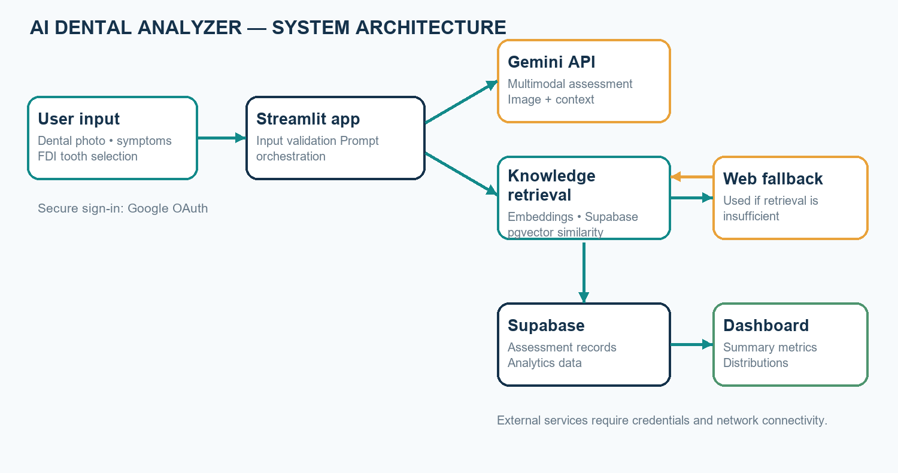
Figure Update fields in Word. System architecture of the AI Dental Analyzer
The methodology follows an iterative prototype lifecycle. Expected inputs and output sections were identified first, followed by interface design and integration of retrieval, generation, persistence, and analytics. Component scripts can exercise embeddings, retrieval, and database access when valid credentials and data are available.
During an assessment, symptom values and the free-text description are assembled into a retrieval query. The embedding component requests a fixed-size vector, and the retrieval module calls Supabase match_documents with the query embedding, threshold, and result limit. Results are normalized and only context meeting the configured threshold is included as RAG knowledge. If adequate context is unavailable, the application may invoke web search.
The image, reported information, and available supporting context are provided to Gemini with instructions to distinguish observations from symptoms and possible explanations. The response is displayed alongside retrieval details and limitations. The application then attempts to save structured fields and analysis text; a save can fail independently of generation, and the user is notified.
Verification should cover expected and failure behavior: image validation, missing credentials, low-similarity retrieval, web-search failure, model errors, and database write failures. Integration scripts alone cannot establish clinical quality; usability and clinical evaluation require separate protocols.

2.6 Summary
The proposed system combines multimodal generation with retrieved general knowledge, but its value depends on transparent limitations and professional review. The feasibility assessment is conditional on external services, data governance, and evaluation.
The literature motivates multimodal input and retrieval-assisted generation but does not validate this model, prompt, knowledge base, or threshold. The proposed method provides a structured route from user input to preliminary output and a stored record, with explicit dependence on external services.
The next chapter translates this methodology into requirements, privacy considerations, risks, and an estimated schedule. These controls are necessary both for a software demonstration and to prevent prototype outputs from being mistaken for clinical conclusions.

CHAPTER 3 — ANALYSIS AND PLANNING

3.1 Introduction
The analysis phase defines the user journey, system requirements, data boundaries, and a staged development plan. The design prioritizes a small number of clearly separated components so that input collection, retrieval, model calls, persistence, and reporting can be tested independently.
Analysis and planning connect project objectives to observable requirements. The plan addresses user actions, data movement, system responses to dependency failures, and evidence needed to consider the implementation complete.
This is an integration prototype using hosted services for inference and persistence. Reliability and privacy therefore depend on local code as well as provider configuration, service policies, network availability, and deployment controls.

3.2 Project Planning
Table Update fields in Word. Functional and non-functional requirements
ID | Requirement | Category / acceptance point
FR-01 | Allow Google sign-in before use. | Functional: unauthenticated user is shown sign-in and cannot continue.
FR-02 | Accept a dental image from upload or camera. | Functional: JPG/JPEG/PNG accepted; missing or unsupported image is rejected.
FR-03 | Collect age, pain, symptoms, notes, and selected teeth. | Functional: fields are incorporated in the assessment context.
FR-04 | Retrieve dental references using vector similarity. | Functional: query embedding is sent to match_documents; threshold is applied.
FR-05 | Use web fallback when RAG is insufficient. | Functional: attempt fallback and expose available sources/context.
FR-06 | Generate a cautious image-and-symptom assessment. | Functional: response distinguishes observations, symptoms, uncertainty, and next steps.
FR-07 | Persist assessment information. | Functional: save record to Supabase and report persistence errors.
FR-08 | Display assessment analytics. | Functional: summarize stored records and distributions.
NFR-01 | Protect secrets and restrict access. | Security: keep API/service credentials server-side; configure OAuth and database access.
NFR-02 | Communicate limitations. | Safety: avoid definitive diagnosis claims and include professional-care guidance.
NFR-03 | Maintain understandable response time and usable layout. | Usability/performance: evaluate under representative network conditions.
NFR-04 | Handle external-service failure explicitly. | Reliability: show errors/status rather than implying an unavailable result succeeded.

The authenticated Streamlit session is the principal user-facing boundary. Input widgets collect the image and structured context; orchestration validates the image, constructs the retrieval query, obtains context, calls the model, presents the result, and attempts persistence. Supporting modules encapsulate embeddings, vector search, web retrieval, database writes, and analytics queries.
Some workflow logic remains in the main application file. Future maintenance could improve testability by extracting prompt construction, retrieval decision rules, and result parsing into small functions with explicit contracts. Refactoring should preserve the existing user flow and safety language.
The schema represents age and pain level numerically and stores symptom, tooth, image-metadata, and analysis values. The interface provides bounded age and pain controls, fixed-choice fields, symptom checkboxes, and FDI tooth choices. The application checks image presence and accepted MIME types before analysis.
Data minimization should be considered at each stage. Collect only information needed for the stated purpose, and avoid entering identifiers in free-text fields unless necessary and authorized. Stored health-related descriptions and generated text require policies for access, backup, retention, deletion, and incident response.
A software demonstration should verify sign-in, input validation, retrieval, low-relevance fallback, response presentation, save success and failure messages, and both empty and populated analytics states. These functional criteria are separate from clinical release decisions, which require formal intended-use, regulatory, expert oversight, and evaluation processes.

Data and privacy planning
The database schema stores demographic and symptom fields, affected teeth, image filename/MIME type, generated analysis, concern-level field, and timestamp. The reviewed save path does not upload the image itself. Health-related descriptions and AI output remain sensitive data. Before using real patient data, the project owner should document consent, purpose limitation, access policy, data retention/deletion, vendor processing terms, and applicable institutional and legal requirements. A service-role key must stay on the server and must not be exposed in client code.

Risk analysis
Table Update fields in Word. Project risks and mitigations
Risk | Potential effect | Mitigation / control
Incorrect or overconfident AI text | User misunderstands a possibility as a diagnosis. | Use cautious prompts, explicit caveats, warning signs, and professional evaluation guidance; perform clinical review before any real-world use.
Poor image quality | Unreliable visible observations. | Guide image capture and state that image quality limits analysis.
Irrelevant or incomplete RAG content | Misleading context or unsupported generation. | Apply a similarity threshold, inspect corpus quality, disclose source status, and evaluate retrieval.
External service or network outage | Analysis, fallback, or persistence unavailable. | Show clear status/errors and test failure paths; do not imply a result was saved if persistence fails.
Sensitive data exposure | Privacy and compliance harm. | Use server-side secrets, least privilege, consent, retention rules, and deployment access controls.
No clinical evaluation evidence | Unjustified trust in outputs. | Do not claim diagnostic performance; conduct an approved, independently designed evaluation before clinical use.

3.3 Scheduling
The following eight-week schedule is a planning illustration, not a record of completed work. It assumes overlapping development and should be revised to match the course timetable, team size, and review milestones.
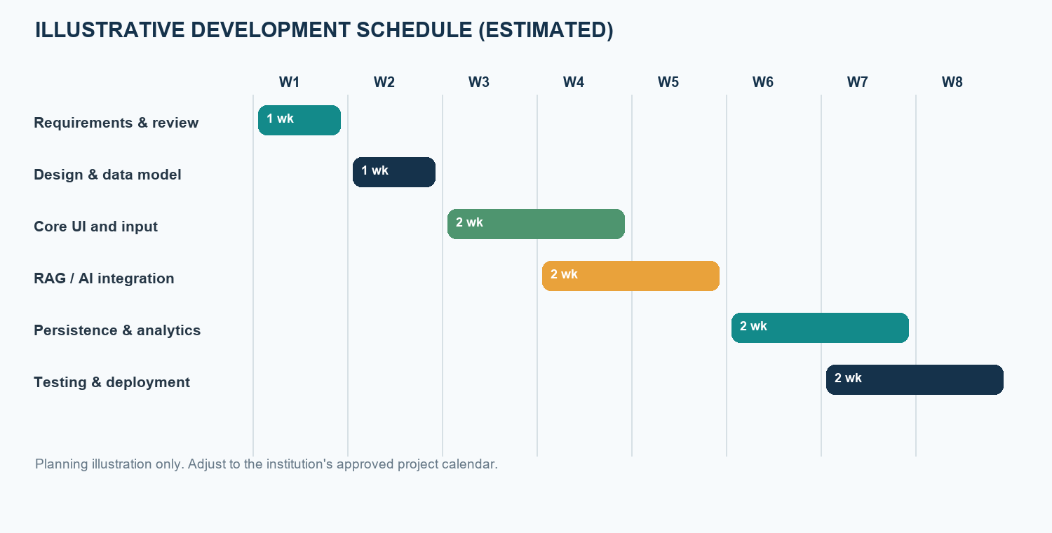
Figure Update fields in Word. Illustrative project schedule; durations are estimates, not measured project history
The schedule divides work into requirements, data and architecture design, interface development, AI and retrieval integration, persistence and analytics, and testing/deployment. These are work packages rather than verified dates. End-to-end testing depends on defined interfaces, configured services, and representative test records.
Progress can be tracked through deliverables such as approved requirements, reviewed schema, working input form, seeded knowledge collection, successful integration checks, and deployment checklist. Reserve contingency time for third-party API changes, authentication setup, database configuration, and test failures.
Durations in the chart are illustrative. Replace them with the actual institutional calendar, milestones, and team responsibilities before treating the chart as a project schedule.

3.4 Summary
Requirements and risks were translated into functional checkpoints and a staged schedule. Data privacy, AI uncertainty, retrieval quality, and external-service availability are central project constraints.
This chapter defined functional acceptance points and identified security, privacy, service reliability, and clinical overreach as major risks. It also described how a staged schedule can make dependencies and evidence of progress visible.
The next chapter maps those requirements to data flow, application components, user interactions, and interface design. The diagrams are conceptual views and should be read together with the stated limitations.

CHAPTER 4 — DESIGN AND IMPLEMENTATION

4.1 Data-Flow Diagram (DFD)
The DFD shows how user-supplied inputs pass through validation, retrieval and generation, and how the resulting record is stored for later analytics. External providers are distinct from the application boundary.
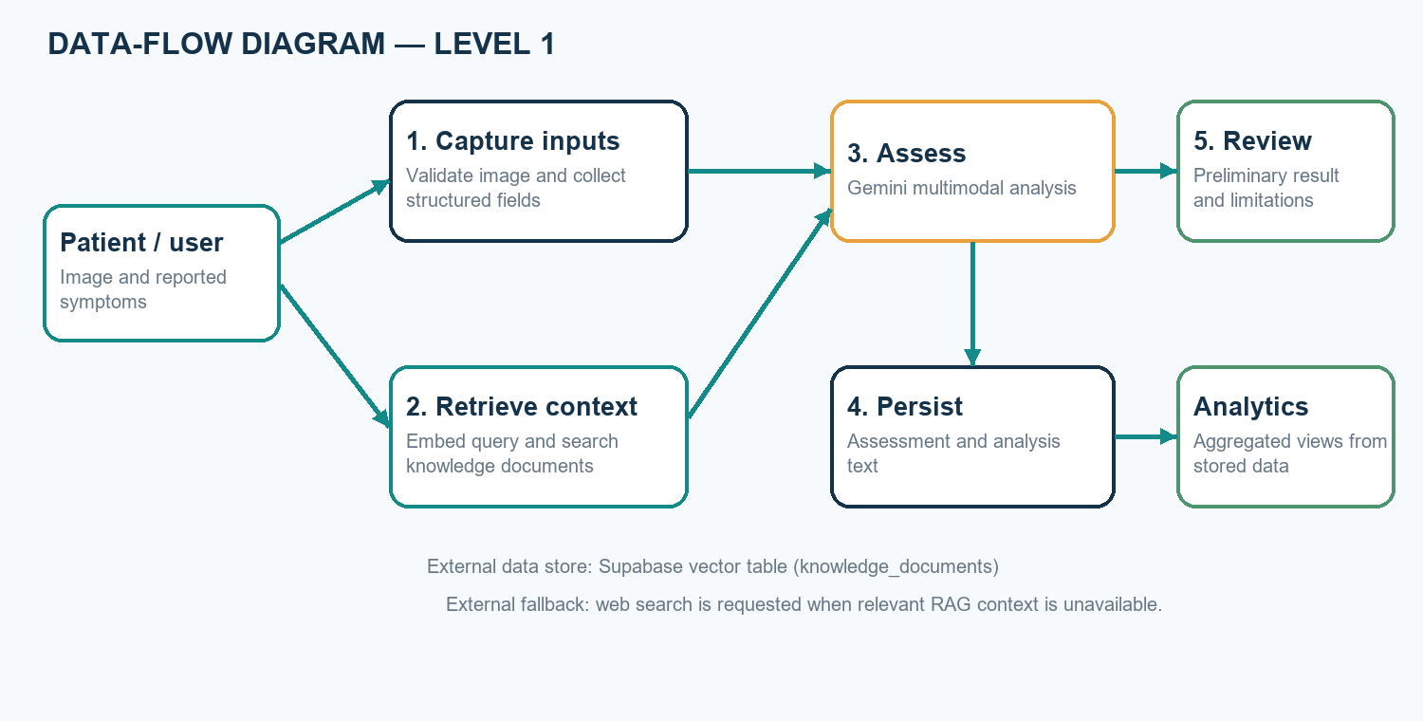
Figure Update fields in Word. Level-1 data-flow diagram for assessment processing
The user provides a dental image and symptoms. The application validates the image and creates text context for retrieval. The embedding service converts that context into a vector, and the database function compares it with vectors stored for reference documents. Only material that satisfies the configured threshold is treated as adequate RAG context.
When retrieved context is inadequate, the application can query the web fallback and may include resulting material in the model prompt. Gemini receives image and text context and generates assessment text. The application displays the result and attempts to save the record. Analytics reads stored assessment fields; it does not independently evaluate the clinical correctness of prior results.
The diagram does not imply that the image is stored in the assessment table. The reviewed save method stores image metadata, while image bytes are used for the model request. Provider-side processing and retention depend on deployment and service terms and should be reviewed separately.

4.2 Block Diagram
The system architecture is modular: Streamlit manages interaction; the embedding and retrieval modules query Supabase; a web fallback can add supporting material; Gemini generates a text response; database.py persists assessment data; and the analytics page summarizes saved records.
Figure Update fields in Word. Block diagram of application components and external services
The Streamlit front end coordinates the user interaction. The Gemini client handles multimodal generation and embedding requests. RAG uses the embedding to call the Supabase vector-search function; the knowledge package defines documents and ingestion behavior. The fallback module retrieves external information only when vector context is insufficient.
Persistence and reporting are separate from generation. database.py inserts records and queries stored rows; analytics.py transforms those rows into metrics and charts. Consequently, an analysis may be generated even if a later database write fails, and the interface reports that distinction.
Google OAuth controls entry to the application, but sign-in alone is not equivalent to fine-grained authorization for database records. Production configuration must protect the server-side service key and ensure data access meets privacy requirements.

4.3 Flowchart
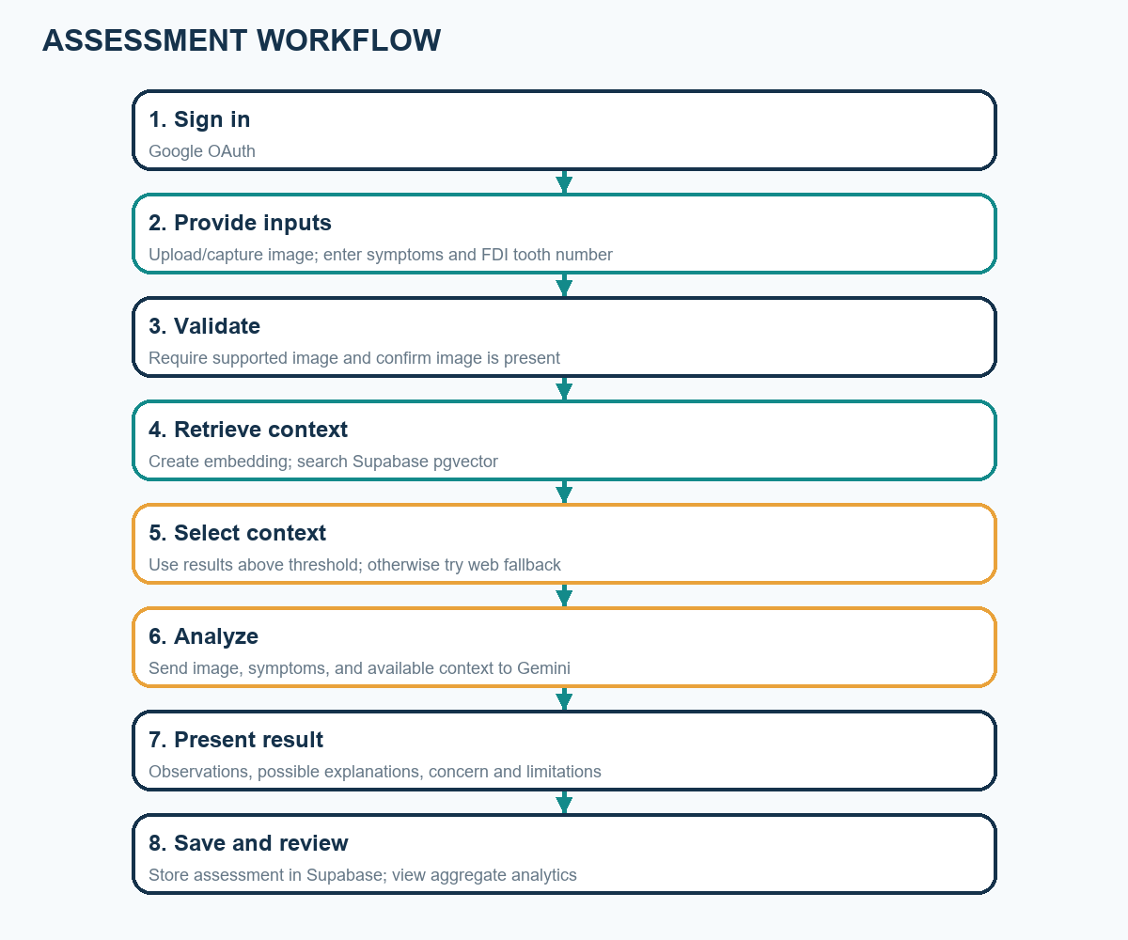
Figure Update fields in Word. User-to-assessment processing flow
The workflow begins with authentication and input collection. Before external model processing, the application checks that an image is present and that its MIME type is accepted. It forms a symptom query and attempts vector retrieval. Adequate results are included as context; otherwise, the application attempts web fallback.
After context construction, the model generates explanatory text from the image and available information. The response is rendered with retrieval status and cautionary language, and the application attempts persistence. A database failure is separate from a model failure and should be communicated accurately.
The flowchart represents intended control flow, not a guarantee that every dependency succeeds. Network errors, invalid credentials, provider limits, or malformed responses may interrupt processing and should be included in deployment verification.

4.4 UML Use-Case View
The primary actor is an authenticated user. The user can provide an image and symptoms, select teeth, request an assessment, review the generated information, and view saved analytics where authorized. The figure is a UML-style use-case overview, not a formal executable UML model.
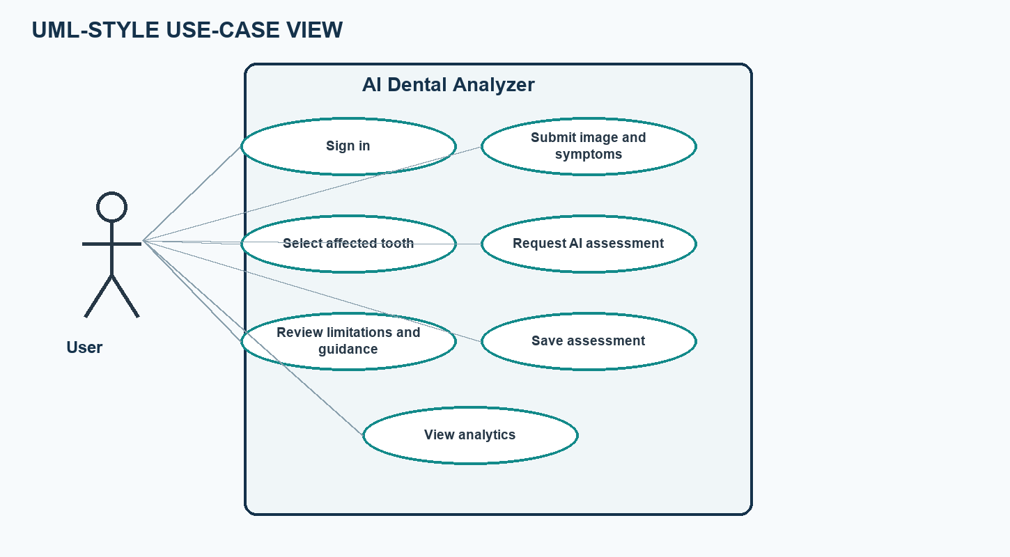
Figure Update fields in Word. UML-style use-case diagram
The primary actor is the user, who signs in, provides an image and symptoms, selects teeth, requests a preliminary analysis, reviews its limitations and guidance, and may view analytics when authorized.
Gemini and Supabase are supporting external actors in the broader architecture. Gemini generates embeddings and assessment text; Supabase supports vector retrieval and persistence. The web fallback is an optional external dependency rather than a diagnostic actor.
A clinician review use case is intentionally not shown as implemented. It could be future work but would require a defined clinician role, authorization, auditability, workflow design, and governance. The figure is a high-level use-case illustration, not a complete formal UML specification.

4.5 GUI Screenshot / Interface Design
The project contains a Streamlit interface with image source selection, patient-information fields, an FDI reference chart and tooth-selection controls, analysis status, and generated results. The figure below is an illustrative wireframe reconstructed from implemented controls; it is not a screenshot of a running application. Replace it with a genuine, privacy-safe screenshot before final submission if screenshots are required by the institution.
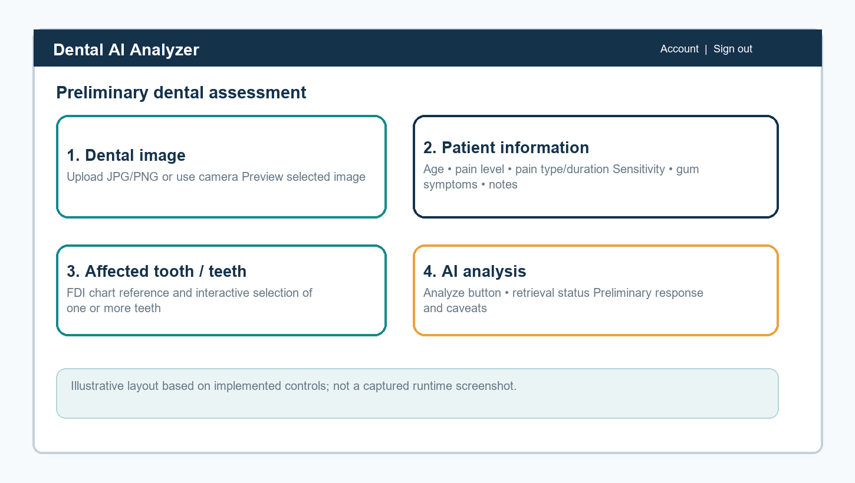
Figure Update fields in Word. Illustrative GUI wireframe; not a runtime screenshot
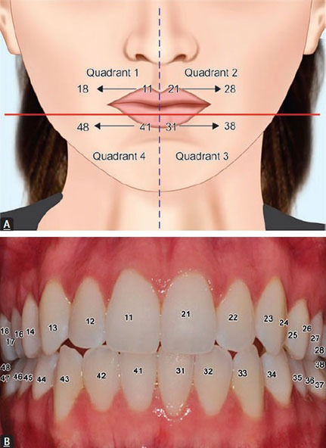
Figure Update fields in Word. FDI tooth numbering reference image included with the project
Table Update fields in Word. Principal software modules
Module / file | Responsibility
app.py | Streamlit authentication, image and symptom UI, tooth selection, retrieval/generation orchestration, and result presentation.
knowledge/embeddings.py | Creates 768-dimensional Gemini embeddings.
rag.py | Submits embeddings to the Supabase match_documents function and returns matching records.
knowledge/documents.py and ingest.py | Define and ingest the general dental knowledge documents.
web_fallback.py | Searches the web and extracts supporting page text when invoked.
database.py | Saves assessments and queries assessment data for the dashboard.
analytics.py and pages/2_Analytics.py | Calculates and displays summary metrics and distributions.
supabase_setup.sql | Creates assessment and knowledge tables, vector index, match function, and service-role permissions.

The interface groups controls in the order a user needs them: choose an image source, enter patient information, select teeth, add a description, and request analysis. A preview helps confirm the chosen image. The FDI chart provides a reference alongside interactive choices to reduce numbering ambiguity.
Status feedback is an important part of the UI. The application indicates retrieval and web-search activity, reports the highest similarity and configured threshold, and exposes available web sources. The response is organized into sections so observations, reported symptoms, possible explanations, limitations, concern level, recommendations, and warning signs are not presented as one undifferentiated conclusion.
The figure is a wireframe derived from the implemented workflow, not a captured screenshot. A final submission should use screenshots from the running application with secrets, account details, and personal information omitted. Do not imply successful backend behavior unless it was observed.

CHAPTER 5 — RESULTS AND DISCUSSION

5.1 Actual Results
Repository inspection confirms implementation of the main prototype components: Streamlit sign-in and assessment UI, image upload/camera input, structured symptom fields, FDI tooth selection, Gemini multimodal calls, vector retrieval, a conditional web fallback, Supabase persistence, and an analytics page. The source includes test scripts for embedding creation, RAG retrieval, and analytics access. These scripts require live credentials/services and are not equivalent to a saved automated test report.
No assessment dataset, benchmark labels, measured diagnostic accuracy, latency study, or executed test log was present in the project files reviewed for this report. Therefore, this report does not claim numerical model performance, patient benefit, clinical validation, or successful live-service testing. Any demo output should be treated as qualitative and illustrative until independently evaluated.
Table Update fields in Word. Implemented capabilities and evidence available in the project
Capability | Implementation evidence | Result statement
Image + symptom input | UI controls in app.py | Implemented in source; runtime behavior should be verified in deployment.
FDI tooth selection | Interactive controls and included tooth chart | Implemented in source.
RAG retrieval | Embedding function, Supabase RPC, knowledge corpus | Integration path implemented; live retrieval depends on credentials and seeded data.
Web fallback | Search and page extraction module | Fallback path implemented; results depend on external network and site availability.
Assessment persistence | Supabase insert in database.py | Implemented; successful save requires configured schema and credentials.
Analytics | Streamlit page and aggregation logic | Implemented; values require saved assessment records.
Clinical performance | No labeled evaluation data or validation protocol in repository | Not established; no accuracy or diagnostic claim is made.

Implementation evidence in the repository includes interface controls, service integrations, database functions, and dashboard logic. The knowledge package contains general documents about caries, gingivitis, periodontitis, sensitivity, cracked teeth, abscess, erosion, and plaque. The SQL file defines an assessment table, knowledge-document vector column, vector index, and matching function.
This demonstrates an implemented integration path but does not establish that every path passed in a live deployment. The manual scripts require external services and do not include a saved execution report. No labeled evaluation dataset or expert-adjudicated outcomes were found. This report therefore records implementation status rather than numerical performance.
The concern_level field must be interpreted carefully: the current save call stores a placeholder, not an extracted and validated clinical category. Dashboard summaries of that value must not be treated as reliable risk results. Future work should validate structured extraction or mark the field unavailable.
Update this section after reproducible testing. Record environment, input type, expected and observed behavior, pass/fail status, date, and issues. Do not include identifiable patient data or claim diagnostic accuracy solely because an API returned text.

5.2 Future Scope
- Conduct usability testing with non-clinical demonstration data and collect feedback.
- Develop a clinically governed evaluation protocol with expert-labeled data, appropriate ethics approval, privacy protections, and clear outcome measures.
- Improve source provenance and citations for both curated knowledge documents and web fallback content.
- Add robust extraction and validation for structured concern categories; avoid treating a placeholder field as a risk score.
- Add consent-aware image handling, retention/deletion controls, audit logging, and role-based access.
- Evaluate RAG retrieval quality, threshold calibration, failure cases, and response latency using a documented test set.
- Consider clinician review workflows and mobile usability only after safety and privacy requirements are defined.
- Explore dental radiograph support only as a separately validated capability; it is outside the current implementation.
Near-term work could improve observability and testability. Prompt construction, retrieval filtering, response parsing, and concern-level extraction could be independently tested functions. Mocked provider responses would enable deterministic tests without live API calls; a smaller integration suite could check actual external services.
Knowledge quality could be improved through source curation, version tracking, provenance, review dates, and citations alongside retrieved passages. Retrieval should be evaluated on representative queries with relevance judgments and a documented threshold-selection method. Web sources should be reviewed for authority, currency, and suitability.
Clinical validation must be planned separately from software testing. It requires a defined intended use, approvals, privacy-preserving data handling, representative data, qualified reference assessments, predefined outcomes, and failure-mode analysis across image conditions and user groups. Until then, the project should remain an educational prototype.
Further application work could include consent and retention controls, user-visible deletion, role-based authorization, audit logs, accessible mobile layouts, and clinician-mediated review. Each addition requires privacy, security, and usability assessment.

5.3 Testing
The current repository includes manual scripts (test_embedding.py, test_rag.py, and test_analytics.py). They are integration checks that require configured API/database access, not self-contained unit tests. The table below is a proposed test plan. Status is intentionally marked “Not run for this report” because no controlled test environment or saved execution results were available.
Table Update fields in Word. Proposed functional and integration test cases
ID | Test | Expected outcome | Status
T-01 | Open app while signed out. | Sign-in guidance shown; assessment form is not available. | Not run for this report
T-02 | Submit without an image. | Clear validation message; analysis does not start. | Not run for this report
T-03 | Upload unsupported image type. | Unsupported format is rejected. | Not run for this report
T-04 | Enter symptoms and select FDI tooth(s). | Values are reflected in the query and saved assessment. | Not run for this report
T-05 | Query a seeded knowledge base. | Matching records are returned and threshold behavior is reported. | Not run for this report
T-06 | Force empty/low-relevance RAG response. | Web fallback is attempted; unavailable results are not represented as sources. | Not run for this report
T-07 | Simulate Gemini/API failure. | Failure is surfaced; no success-shaped assessment is presented. | Not run for this report
T-08 | Simulate Supabase insert failure. | AI result may be shown, but save failure is explicitly reported. | Not run for this report
T-09 | Load analytics with no records and with records. | Empty state and calculated charts/metrics render appropriately. | Not run for this report
T-10 | Review safety language in generated output. | No definitive diagnosis claim; limitations and care guidance remain visible. | Not run for this report

Testing should be organized at multiple levels. Unit tests can verify normalization, FDI selection handling, threshold decisions, and formatting with controlled fixtures. Integration tests can exercise Gemini embeddings, Supabase RPC, inserts, and analytics queries with a test project. End-to-end tests can verify the authenticated user journey in staging. These levels answer different questions.
Positive tests should cover supported images, retrieval above threshold, response rendering, successful insertion, and populated analytics. Negative tests should cover missing images, unsupported MIME types, empty retrieval, fallback failure, API errors, database write failure, empty data, and malformed results. Safety review should confirm cautious language in each path.
The test matrix in this report is a proposed plan, not evidence that tests passed. Record actual outputs and attach logs or screenshots with secrets and personal information removed. Software tests verify behavior and error handling; they cannot alone establish medical validity.

5.4 Deployment
- Install dependencies from requirements.txt in a supported Python environment.
- Create a Supabase project and run the repository's supabase_setup.sql script; configure the knowledge corpus as required.
- Configure server-side GEMINI_API_KEY, model settings, SUPABASE_URL, SUPABASE_KEY, and the RAG threshold without committing secrets.
- Configure Google OAuth redirect URI and Streamlit authentication secrets for the actual deployment URL.
- Launch the Streamlit application using the deployment platform's supported process and verify sign-in, image handling, RAG, fallback, database writes, and dashboard behavior.
- Before any use with real patient information, complete privacy, consent, access-control, retention, and institutional/legal review; monitor errors and usage.
For local demonstration, the project README documents running Streamlit with app.py. Production deployment should use a managed secret store and server-side database credentials. A successful local startup alone does not validate external integrations or clinical safety.
Deployment configuration should separate source code from secrets. Gemini and Supabase credentials, OAuth client details, and cookie secrets belong in the hosting platform's protected secret mechanism. The Supabase service-role key is privileged and must remain server-side, never in browser-visible code or a public repository.
Before access is opened, verify the database schema, vector extension, matching function, populated knowledge corpus, and matching embedding dimensions. Also check the OAuth redirect URI, accepted image formats, and behavior of model, retrieval, fallback, and persistence failures.
A production readiness review should include access controls, HTTPS, privacy notices, consent, retention and deletion, backups, monitoring, cost limits, dependency updates, and incident response. Use synthetic data for smoke tests. Real patient data requires appropriate institutional, legal, and professional approval.

CHAPTER 6 — CONCLUSION
The AI Dental Analyzer demonstrates an end-to-end prototype that combines dental image and symptom input, FDI tooth selection, multimodal generative AI, vector-based knowledge retrieval, conditional web fallback, Supabase persistence, and dashboard analytics. Its key contribution is integration and organization of information into a preliminary educational workflow. The system does not establish a dental diagnosis or clinical accuracy; the quality of its output depends on image quality, user-provided information, model behavior, reference coverage, external services, and professional interpretation. Future work should prioritize documented functional testing, privacy governance, source transparency, and independent clinical validation before considering any clinical use.
The implementation demonstrates how user input, multimodal generation, retrieval context, persistence, and descriptive analytics can be integrated in one web application. Structured symptom fields and FDI selection provide consistent inputs; retrieval and fallback make supporting-information status visible.
Integration does not equal validation. A model can be wrong, a photograph can omit clinically important evidence, retrieved material may not apply to an individual, and stored analytics may reflect incomplete participation. The system cannot be relied upon to diagnose, rule out disease, or determine urgency.
The project is best regarded as an educational prototype and a foundation for further evaluation. Responsible next steps are reproducible functional testing, improved provenance and data governance, and independent usability and clinical evaluation under appropriate oversight before any proposed clinical use.

REFERENCES
[1] F. Schwendicke, W. Samek, and J. Krois, “Artificial Intelligence in Dentistry: Chances and Challenges,” Journal of Dental Research, vol. 99, no. 7, pp. 769–774, 2020. doi: 10.1177/0022034520915714.
[2] A. A. Khanagar et al., “Developments, application, and performance of artificial intelligence in dentistry—A systematic review,” Journal of Dental Sciences, vol. 16, no. 1, pp. 508–522, 2021. doi: 10.1016/j.jds.2020.06.019.
[3] P. Lewis et al., “Retrieval-Augmented Generation for Knowledge-Intensive NLP Tasks,” Advances in Neural Information Processing Systems, vol. 33, pp. 9459–9474, 2020.
[4] Gemini Team, “Gemini: A Family of Highly Capable Multimodal Models,” arXiv:2312.11805, 2023.
[5] Google AI for Developers, “Gemini API documentation.” https://ai.google.dev/gemini-api/docs (accessed October 23, 2026).
[6] Supabase, “AI and Vector Columns / pgvector documentation.” https://supabase.com/docs/guides/ai (accessed October 23, 2026).
[7] Streamlit, “Streamlit documentation.” https://docs.streamlit.io/ (accessed October 23, 2026).
[8] Project source repository, AI Dental Analyzer: app.py, analytics.py, database.py, rag.py, web_fallback.py, knowledge/, and supabase_setup.sql. Accessed October 23, 2026.

APPENDIX A — SUBMISSION CUSTOMIZATION CHECKLIST
- Replace bracketed title-page and certificate placeholders with approved student, guide, department, and institution details.
- Update the table of contents, list of figures, list of tables, and page numbers in Word using Ctrl+A, then F9.
- Insert actual, privacy-safe application screenshots if required; the included wireframe is explicitly illustrative.
- Run and record the integration tests in a configured environment; replace “Not run for this report” only with verified results.
- Verify citation formatting and institutional report requirements, including page size, margins, and declaration wording.
- Do not include real patient identifiers or images without appropriate consent and approval.

