AF 52
Synopsis
AI DENTAL ANALYZER
Submitted in partial fulfilment of the requirements of the degree of
Bachelor of Engineering
In
Artificial Intelligence and Machine Learning

by
Name of Student [PID No.]
Name of Student [PID No.]
Name of Student [PID No.]

Under the Guidance of
(Guide name)
Designation, Department of AIML, SJCEM



DEPARTMENT OF ARTIFICIAL INTELLIGENCE AND MACHINE LEARNING
ST. JOHN COLLEGE OF ENGINEERING & MANAGEMENT
UNIVERSITY OF MUMBAI
2026-2027



Certificate of Approval

This is to certify that _____________________ are bonafide students of B. Tech in Artificial Intelligence and Machine Learning, Department of Artificial Intelligence and Machine Learning, St. John College of Engineering and Management, Mumbai. They have satisfactorily completed the requirements of the Synopsis as prescribed by ST. JOHN COLLEGE OF ENGINEERING AND MANAGEMENT (An Autonomous College affiliated to University of Mumbai), while working on “AI Dental Analyzer”.

Signature :  Name : Guide Name & Signature  Designation | Signature :  Name :HOD Name & Signature  Designation

Signature:
Name : Dr. Kamal Shah Principal,
St. John College of Engineering and Management.

Declaration

I/we declare that this written submission represents my/our ideas in my/our own words and where others ideas or words have been included, I/we have adequately cited and referenced the original sources. I/we also declare that I/we have adhered to all principles of academic honesty and integrity and have not misrepresented or fabricated or falsified any idea/data/fact/source in my/our submission. I/we understand that any violation of the above will be cause for disciplinary action by the Institute and can also evoke penal action from the sources which have thus not been properly cited or from whom proper permission has not been taken when needed.

(Signature)

.

(Student Name )
Date:

Acknowledgement
We express our sincere gratitude to all those who have contributed to the preparation of this project synopsis on the AI Dental Analyzer.
We are grateful to Dr. Kamal Shah, Principal, St. John College of Engineering and Management, for providing the academic environment and facilities supporting this project.
We extend our heartfelt thanks to the Mr. Ajay Sirsat, Head of the Department of AIML, for the constant encouragement, valuable suggestions, and continuous support throughout the preparation of this synopsis.
We would like to express our sincere appreciation to our project guide, Dr./Prof. __________________________, for their invaluable guidance, constructive suggestions, technical expertise, and continuous motivation. Their encouragement and insightful feedback have been instrumental in shaping this project synopsis.
We also acknowledge the faculty members and staff of the Department of Artificial Intelligence and Machine Learning for their assistance and cooperation.
Finally, we thank our families, friends, and classmates for their encouragement and support.

Group Members

ABSTRACT

The AI Dental Analyzer is a web-based prototype designed to provide preliminary, educational information from a dental photograph and user-reported symptoms. Developed with Python and Streamlit, it accepts an uploaded or camera-captured image and structured details such as age, pain level, pain type and duration, sensitivity, gum symptoms, additional notes, and affected teeth selected using the FDI two-digit numbering system. A retrieval-augmented generation workflow creates an embedding from the symptom context and searches a Supabase pgvector knowledge store for relevant general dental information. When relevant vector results do not meet the configured similarity threshold, the application can attempt a web-based fallback. Google Gemini receives the image and available context and generates a response organized around visible observations, reported symptoms, possible explanations, image limitations, concern level, and recommended next steps. Assessment fields and generated text can be stored in Supabase and reviewed through a descriptive analytics dashboard. Google OAuth supports sign-in. The prototype is not a diagnostic device, has not been clinically validated, and cannot replace examination by a qualified dental professional. Image quality, knowledge coverage, retrieval relevance, network availability, and model errors are important limitations; all output requires professional verification.

C O N T E N T S

- List of Figures i
- List of Tables ii
- Abbreviations and symbols iii

Chapter No. | Topic | Page No.
Chapter 1  Chapter 1 | Introduction: Background, Problem Statement, Need, Objectives, Scope, Expected Outcomes | Update in Word
Chapter 2 | Literature Review: Survey, Research Gap, Novelty / Innovation | Update in Word
Chapter 3 | Proposed Methodology: Working Principle, Architecture, Flow Chart, Components | Update in Word
Chapter 4 | Project Planning: WBS, Gantt Chart, Roles, Risk Assessment | Update in Word
Chapter 5  Chapter 5 | Resources and Feasibility: Technical, Economic, Operational, Budget, Software BOM | Update in Word
Chapter 6 | Expected Results and Evaluation Plan | Update in Word
Chapter 7 | Sustainability and Impact: Industrial, Societal, Environmental, SDG Mapping | Update in Word
Chapter 8 | Conclusion | Update in Word
References | IEEE-style references | Update in Word
Appendix | Supporting figure and project material | Update in Word

List of Figures

Figure No. | Figure Name | Page No.
1 | System Architecture | Update in Word
2 | Data-Flow Diagram | Update in Word
3 | Assessment Workflow | Update in Word
4 | Illustrative Project Schedule | Update in Word
5 | FDI Tooth Numbering Reference | Update in Word

List of Tables

Table No. | Table Name | Page No.
1 | Literature Review Summary | Update in Word
2 | Project Components / Software BOM | Update in Word
3 | Work Breakdown Structure | Update in Word
4 | Roles and Responsibilities | Update in Word
5 | Risk Assessment | Update in Word
6 | Budget Estimation | Update in Word

Abbreviations and symbols

- AI: Artificial Intelligence
- API: Application Programming Interface
- DFD: Data-Flow Diagram
- FDI: Fédération Dentaire Internationale
- GUI: Graphical User Interface
- LLM: Large Language Model
- NLP: Natural Language Processing
- OAuth: Open Authorization
- RAG: Retrieval-Augmented Generation
- SQL: Structured Query Language
- pgvector: PostgreSQL vector similarity extension

CHAPTER 1: INTRODUCTION

1.1 Background
Dental assessment combines a patient history with direct clinical examination and, where needed, diagnostic tests such as radiographs. A photograph can show some surface appearance, but lighting, focus, angle, image quality, and obstructions affect what is visible. A photograph alone cannot reliably establish lesion depth, pulp status, periodontal measurements, or the cause of pain.
Multimodal generative AI can accept images and text together, while retrieval-augmented generation can provide relevant reference passages as context. Both methods have limitations: AI may omit or misinterpret findings, and retrieved material may be incomplete or inapplicable. The project therefore presents possible explanations rather than confirmed diagnoses and emphasizes professional review.

In a conventional dental visit, assessment is based on more than the visible surface of a tooth. A clinician considers the patient's history, examines the mouth, and may use diagnostic procedures or imaging. This broader context matters because symptoms such as sensitivity or pain during chewing can have multiple possible causes. The prototype therefore treats patient-entered symptoms as reported information, not as confirmed clinical findings.
The application accepts a single dental photograph as one source of context. It does not perform calibrated image capture or guarantee that the entire affected area is visible. Lighting, focus, camera distance, reflections, and the user's ability to position the camera can affect the image. The interface encourages a clear image, but these suggestions cannot eliminate the limitations of consumer photography.
The technical design brings together two AI concepts. A multimodal generative model can process image and text inputs in one request, while retrieval-augmented generation (RAG) searches a curated knowledge collection and supplies relevant passages as context. The application combines them so that a response can consider both the user's description and available general-reference material.
These capabilities need careful boundaries. A language model can make errors, a retrieved passage may not apply to a particular person, and a high vector similarity is not a clinical confidence score. The project uses cautious wording and explains that professional assessment is needed. It should be treated as an educational prototype and not as an autonomous diagnostic tool.

1.2 Problem Statement
Users may have a dental photograph and symptoms but lack a consistent way to record the concern, identify the affected tooth, and understand the limits of visual assessment. The software problem is to organize these inputs, retrieve relevant general dental information, and generate a cautious preliminary explanation.
The system must also avoid presenting low-relevance retrieval as reliable support. The current prototype uses a configurable similarity threshold and can attempt web retrieval when vector results are insufficient. Neither similarity scores nor web results establish a diagnosis or the clinical correctness of a generated response.

The central problem addressed is the lack of a structured, accessible way for a user to assemble a dental photograph, symptom history, and affected-tooth location into one preliminary information request. Unstructured descriptions can omit useful details such as symptom duration or triggers, and an image alone may not identify which tooth is affected.
A second problem is how to provide contextual information without presenting generated text as authoritative. Pure generation can produce unsupported statements, while a retrieval component can return irrelevant passages if the knowledge base or query is inadequate. The system must therefore expose retrieval status, apply a relevance threshold, and communicate uncertainty.
The project defines success as a functioning software workflow that accepts the intended inputs, attempts retrieval and analysis, reports service failures clearly, and presents limitations with the result. Success is not defined as diagnosing disease, achieving a clinical accuracy percentage, or replacing a dentist; no such performance has been demonstrated.

1.3 Need of the Project
The project demonstrates an integrated way to collect image and symptom context in a structured interface and make general information more accessible. It may help a user organize observations before consulting a dental professional, while clearly identifying uncertainty and the need for examination.
From an engineering perspective, it brings together a web interface, multimodal AI, embeddings, vector search, authentication, database persistence, and analytics. The intended value is educational and demonstrative; clinical benefit and diagnostic performance have not been established.

A structured interface may help users organize observations before seeking professional care. Age, pain level, pain type, duration, sensitivity, gum symptoms, and tooth location are collected in a consistent form. This can make the information easier to review than a single free-text statement, while the additional description field allows users to explain details not covered by predefined controls.
The project is also useful as a practical study of current software architecture patterns. It connects a web application to hosted AI APIs, an embedding model, vector search, external web retrieval, database persistence, OAuth sign-in, and an analytics dashboard. This offers a realistic example of dependency management, error handling, privacy considerations, and integration testing.
The need for explicit safety communication is especially important in health-related applications. The system can help describe possibilities but cannot verify them. Clear limits can reduce the risk that users interpret a generated explanation as a confirmed diagnosis or delay necessary care.

1.4 Objectives
The general objective is to build a web-based prototype that organizes dental image and symptom information and provides a preliminary, educational AI-assisted response.
Specific objectives: (1) accept a JPG/JPEG/PNG image by upload or camera; (2) collect structured symptoms and free-text notes; (3) allow affected teeth to be identified using FDI numbering; (4) retrieve general dental information with vector similarity search and conditional web fallback; (5) present a multimodal AI response with limitations and professional-care guidance; (6) save assessment fields and display descriptive analytics.

The general objective is to create a web-based prototype that combines dental image input with user-reported symptoms and provides a preliminary, educational response supported by retrieved general information when available.
The input objective includes accepting JPG, JPEG, and PNG images from a file upload or camera control, collecting structured symptom values, and allowing selection of one or more teeth using the FDI two-digit numbering scheme. The interface should reject a missing image or unsupported image type before analysis begins.
The retrieval objective is to transform symptom context into an embedding, query the Supabase vector database, compare retrieval similarity with a configurable threshold, and use a conditional web fallback when local retrieval is insufficient. The threshold is an engineering setting and not a medically validated confidence boundary.
The output objective is to request a multimodal response from Gemini and present it in understandable sections, distinguishing visual observations and reported symptoms from possible explanations. The system should also explain image limitations, recommended next steps, and warning signs without claiming a definitive diagnosis.
The data objective is to save relevant assessment fields and generated text in Supabase and display descriptive summaries through an analytics page. The project also aims to document technical limitations and provide a test plan for normal and failure scenarios.

1.5 Scope
The prototype covers a Streamlit web interface, Google OAuth sign-in, symptom and image input, FDI-based tooth selection, Gemini embedding and multimodal API calls, Supabase vector retrieval and assessment storage, web fallback, and analytics. The reviewed save path stores image filename and MIME type, not image bytes in the assessment table.
The system does not confirm disease, measure validated clinical risk, prescribe treatment, analyze radiographs, or replace dental examination. Output depends on image quality, user input, curated knowledge coverage, provider availability, and generative-model behavior. Future work could add a consent-aware clinician review workflow and independent evaluation.

The software scope includes the Streamlit interface, Google OAuth sign-in, symptom collection, image preview, FDI tooth selection, Gemini embedding and multimodal API integration, retrieval from Supabase pgvector, optional web fallback, assessment insertion, and a dashboard for aggregated records.
The reviewed database flow stores the uploaded image filename and MIME type with the assessment, but does not upload the image binary into the assessment table. Image handling by the model provider and any provider-side retention are subject to service configuration and terms and require separate review.
The project does not train a dental classifier, make a confirmed diagnosis, prescribe medication, determine treatment, read dental radiographs, or establish a validated triage score. The saved concern-level field currently uses a placeholder in the application code and must not be treated as an extracted or clinically meaningful risk classification.
The system depends on internet access, valid Gemini and Supabase credentials, a correctly initialized schema, a populated knowledge collection, and OAuth configuration. Future scope could include a clinician-mediated review path, stronger source citations, automated response parsing, accessibility improvements, consent and retention controls, and independent evaluation.

1.6 Expected Outcomes
Expected outcomes are a working academic prototype, documented architecture and workflow, structured input and output screens, a vector-retrieval demonstration, database-backed assessment records, and a descriptive analytics page.
The project also expects to produce a functional test plan and identify failure modes. No accuracy, clinical effectiveness, or patient-outcome target is claimed because the repository contains no expert-labeled evaluation dataset or completed clinical validation.

The expected software deliverables are an interactive prototype, documented architecture and data flow, FDI tooth selection, a retrieval-assisted multimodal workflow, database persistence, and a descriptive analytics page. The project should also produce a reproducible demonstration scenario using non-identifying test data.
Expected verification evidence includes successful handling of a supported image, clear rejection of invalid input, visible retrieval status, correct behavior when retrieval is insufficient, explicit reporting of external-service failures, correct database save messaging, and appropriate empty and populated dashboard states.
These outcomes concern software behavior only. Clinical accuracy, improved patient outcomes, reduced appointment delays, or diagnostic reliability are not expected claims unless separately demonstrated through an approved and appropriately designed evaluation.

CHAPTER 2: LITERATURE REVIEW

2.1 Introduction
Research in dental artificial intelligence spans image analysis, radiographic interpretation, decision support, and digital dentistry. Multimodal foundation models and retrieval-augmented generation offer additional ways to combine images, text, and reference material. The studies below provide technical context, not direct validation of this project's implementation.

The literature review covers dental AI applications, dental image analysis, multimodal model capabilities, and retrieval-augmented generation. Dental studies provide domain context, while technical reports and API documentation explain the software methods used. These sources have different evidence levels and are not treated as interchangeable.
Much published dental AI research studies defined tasks using selected datasets and specific imaging modalities. The present project has a broader user-facing workflow and uses a general-purpose multimodal API with user-submitted photographs and symptom descriptions. The evidence from task-specific studies cannot be transferred directly to this implementation.

2.2 Literature Review Table
The selected literature highlights the potential of AI in dentistry while identifying variation in datasets, tasks, clinical validation, and generalizability. RAG and multimodal model reports are included as technical foundations; they are not dental diagnostic studies.
Table 1. Selected literature review
Ref. | Method / focus | Relevant finding | Gap relevant to this project
[1] Schwendicke et al., 2020 | Review of AI opportunities and challenges in dentistry | Discusses potential applications and validation needs. | Does not evaluate this application or general-purpose image prompting.
[2] Khanagar et al., 2021 | Systematic review of AI applications in dentistry | Reports diverse tasks and approaches across dental domains. | Evidence is heterogeneous and cannot be transferred to this prototype.
[3] Alharbi & Alhasson, 2024 | Systematic review of AI in dental image detection | Surveys AI tasks and image-based approaches. | Image tasks and study datasets differ from user smartphone photos.
[4] Uribe et al., 2024 | Review of publicly available dental image datasets | Highlights data availability and dataset considerations. | A curated, representative evaluation set is still needed.
[5] Cantu et al., 2020 | Deep learning on bitewing radiographs | Studies automated caries detection using radiographic images. | Radiographic setting is not equivalent to ordinary dental photographs.
[6] Lee et al., 2018 | CNN-based periodontal tooth prognosis | Explores deep learning for a defined periodontal task. | Task-specific labels and clinical setting limit generalization.
[7] Lewis et al., 2020 | Retrieval-Augmented Generation | Combines parametric generation with retrieved passages. | General NLP method; retrieval does not guarantee clinical correctness.
[8] Gemini Team, 2023 | Technical report on multimodal models | Describes image-and-text model capabilities. | Capability report is not clinical validation of dental assessment.

The reviewed studies illustrate that AI in dentistry is an active research area, but methods and evaluation settings vary. Image modality, sample selection, labeling procedures, and target tasks affect reported results. A system that performs well on a controlled radiographic dataset does not automatically perform well on ordinary photographs submitted through a web interface.
RAG research provides a method for supplementing generated responses with retrieved passages. Its contribution is architectural: retrieval can make external knowledge available at generation time. It does not by itself guarantee the quality, authority, currency, or clinical applicability of those passages. The project must therefore evaluate retrieval separately from generation.
For a stronger future survey, the project team should search a recognized scholarly database using reproducible keywords, record inclusion and exclusion criteria, confirm bibliographic metadata, and summarize a larger set of recent peer-reviewed studies. The current table is a selected foundation and should not be described as an exhaustive systematic review.

2.3 Research Gap
Prior research includes narrowly defined dental image tasks, commonly using curated datasets and specific modalities such as radiographs. The present project instead demonstrates an integrated user workflow with patient-reported symptoms, consumer-style images, FDI tooth selection, retrieval, and a general multimodal model.
The unresolved gap is not simply the absence of an AI response; it is the lack of demonstrated reliability, clinical validation, and representative evaluation for this exact workflow. This prototype addresses the software-integration and transparency aspects but does not claim to close the clinical evidence gap.

Existing dental AI literature commonly focuses on a defined task such as image classification or detection, often with a fixed imaging modality and labeled dataset. This prototype instead combines an image with patient-entered symptoms, tooth location, reference retrieval, fallback web content, and a generated natural-language explanation in one web workflow.
The remaining gap is whether such an integrated workflow is accurate, safe, usable, and equitable for its intended users. The current repository has no expert-labeled evaluation dataset or clinical study. The prototype addresses the engineering gap of connecting components, but does not resolve the clinical evidence gap.
A future study would need to define an intended-use statement, collect appropriate data with consent and oversight, establish expert reference assessments, predefine measurable outcomes, and analyze errors across image quality and user groups. Functional software tests alone cannot answer those clinical questions.

2.4 Novelty / Innovation
The project's contribution is a combination of image and structured symptom input, interactive FDI tooth selection, similarity-thresholded retrieval, conditional web fallback, cautious multimodal response formatting, persistence, and descriptive analytics in one prototype.
This is an integration and educational contribution rather than a new AI model or clinically validated diagnostic algorithm. Its distinguishing design emphasis is to expose retrieval status and image limitations and to avoid representing generated possibilities as confirmed diagnoses.

The innovation in this project is primarily the integration of multiple components in a single, understandable workflow. The user can combine image input, structured symptoms, free-text context, and tooth numbering; the application can search a dental knowledge base, conditionally seek web information, and request multimodal generation.
The interface also exposes retrieval details, including similarity information and whether contextual knowledge was available. This helps distinguish an assessment based on retrieved information from one based primarily on the image and user-reported context. It does not transform retrieval similarity into a clinical confidence score.
The system should be presented as a prototype integration, not as a newly trained model or a validated diagnostic method. Its contribution is practical demonstration and documentation of limitations, risks, and evaluation needs.

CHAPTER 3: PROPOSED METHODOLOGY

3.1 Proposed System
The proposed system is a Streamlit application for authenticated users. It collects a dental photograph, patient-reported information, and affected teeth. A retrieval query is embedded and matched to general dental reference documents stored in Supabase pgvector. If relevant results are insufficient, the application may try a web fallback. Gemini then produces a preliminary response from the image and available text context. Assessment details can be saved in Supabase and summarized in a separate dashboard.

The application is divided conceptually into a user-interface layer, orchestration layer, AI and retrieval services, persistence layer, and analytics layer. Streamlit presents the assessment workflow and authentication. Application logic validates input, builds queries, chooses knowledge context, constructs the model request, presents the output, and attempts to save a record.
The knowledge layer consists of general dental reference documents, an embedding-generation function, and a Supabase vector-search function. The fallback module can search external web pages when the local results are insufficient. The Gemini service is used for embeddings and multimodal response generation. Supabase stores assessment records and serves the analytics queries.
These are logical components and do not imply that each service is always available. The user interface should report when retrieval, web search, generation, or persistence cannot be completed. The saved assessment operation is separate from generation, so a generated result and a successful database save are distinct outcomes.

3.2 Working Principle
The expected operating sequence is:
1. User signs in and selects image upload or camera capture. 2. Application checks image presence and accepted JPG/JPEG/PNG format. 3. User enters age, pain characteristics, symptoms, affected FDI tooth number(s), and notes. 4. Application embeds symptom context and queries the vector database. 5. Results below the configured threshold trigger an optional web fallback. 6. Gemini analyzes the image and available context and generates a structured preliminary response. 7. The response and retrieval status are displayed; the application attempts to save the assessment. 8. The dashboard summarizes saved records.
Failure of a model, web, or database service is distinct from a successful result and should be reported as such. The result is informational and requires professional verification.

At the beginning of an assessment, the user signs in and chooses either file upload or camera capture. The selected image is previewed, and the user enters structured symptoms and any additional description. One or more affected teeth can be selected using FDI numbering.
When the user requests analysis, the application verifies that an image is present and checks its MIME type. It then constructs a text query from the form values. The embedding API converts that text into a vector, and the retrieval module calls the Supabase match_documents function with a threshold and result count.
If relevant documents meet the configured threshold, their content is included as supporting context. If not, the application can attempt a web fallback and format available search results as context. If fallback is unavailable, the analysis may continue with image and user-reported information, but the absence of supporting context should not be hidden.
The application then sends the image and available textual context to Gemini. Its response is shown to the user with visible limitations and retrieval status. Finally, the application attempts to write the structured assessment and generated text to Supabase. A database error should be shown separately and must not be presented as a successful save.

3.3 System Architecture / Block Diagram
The Streamlit application coordinates input and response display. Gemini provides embedding and multimodal generation APIs; Supabase hosts the assessment records and vector search function. The web retrieval module is conditional, and analytics reads saved records independently from the generation path.
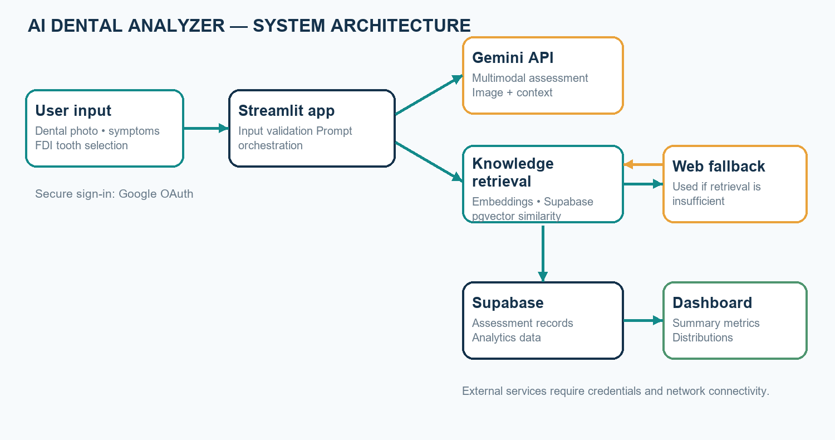
Figure 1. System architecture
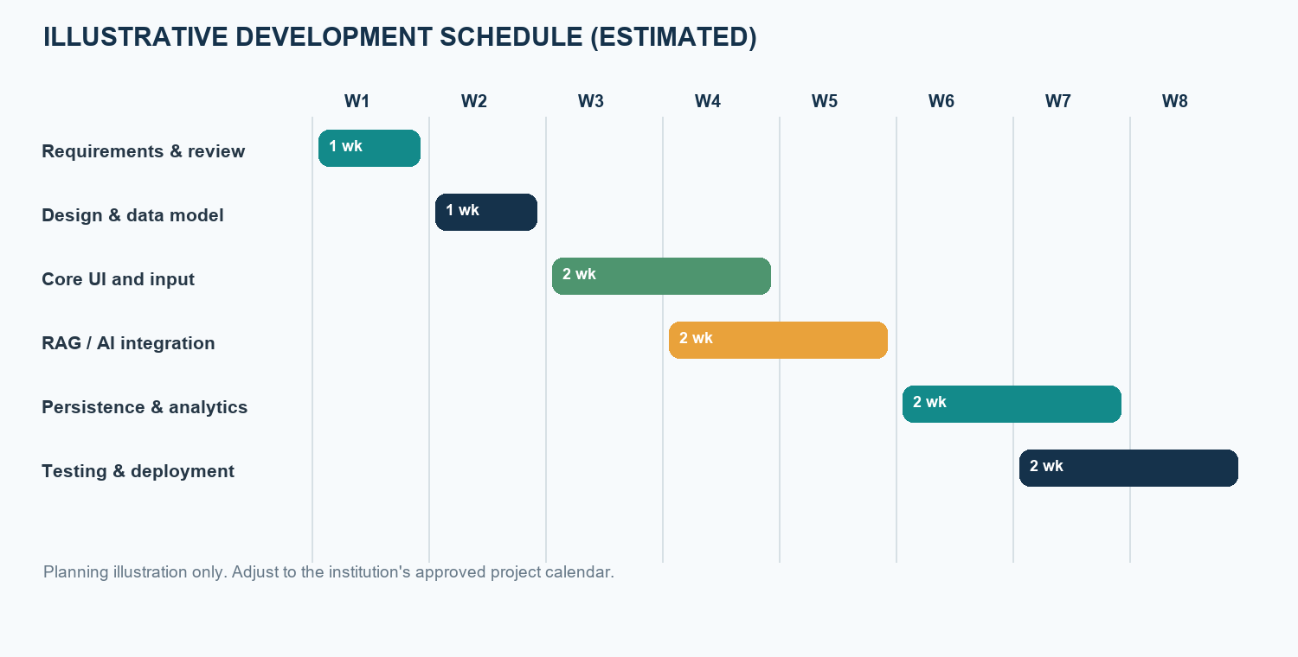
Figure 2. Assessment data-flow diagram

The architecture places Streamlit between the user and the external services. Google OAuth supplies sign-in. The Streamlit process holds server-side configuration and invokes Gemini, Supabase, and the web fallback. The vector store contains document embeddings, while the assessment table contains selected patient-reported fields and generated text.
The embedding and generation calls have different purposes. Embedding converts a text query to a numeric vector for semantic comparison; generation combines the image and selected context into natural-language output. Similarity search selects candidate references; the generative model does not independently verify that a candidate is clinically applicable.
Analytics reads saved assessment records and calculates descriptive summaries. These charts describe the records available to the application and should not be generalized to a broader population. Authentication and database policies must be configured for the deployment; a sign-in screen by itself does not constitute a complete privacy or authorization program.

3.4 Flow Chart
The workflow includes authentication, input validation, retrieval selection, multimodal analysis, result presentation, and persistence. The flow below is illustrative of the implemented process and assumes required services are configured.
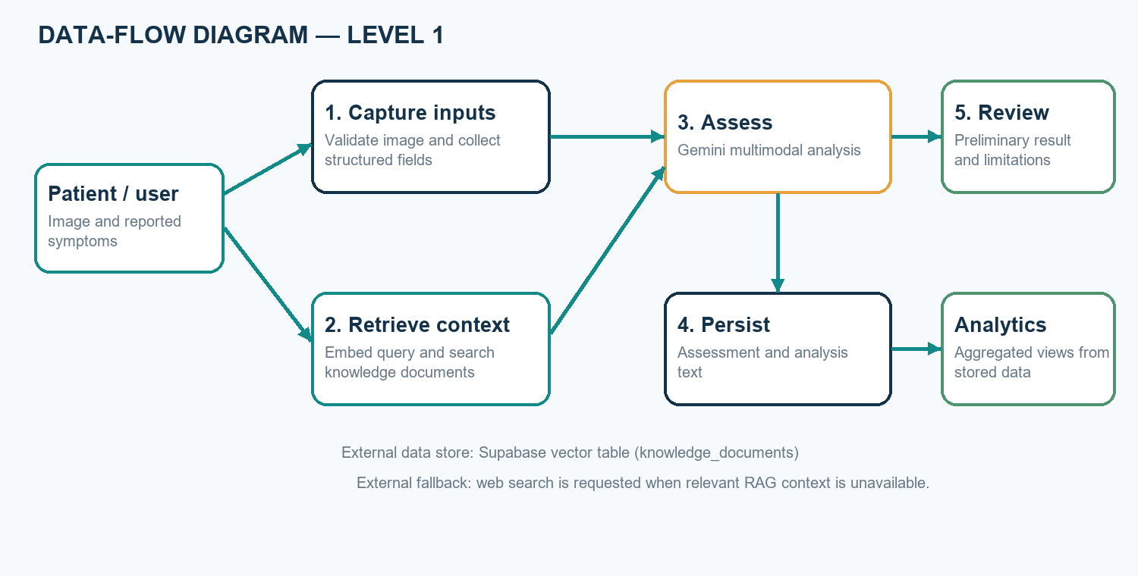
Figure 3. Assessment workflow

The flowchart represents both decision points and service dependencies. Image validation occurs before analysis. Retrieval then determines whether local reference context meets the configured threshold. Insufficient retrieval routes the workflow to an optional web search, but failure of that search does not prove that no relevant information exists.
Generation, display, and database persistence are separate stages. A response can be generated while persistence fails, and an external service may fail before a response is produced. The implementation and deployment tests should verify these alternate paths and ensure the interface communicates the actual outcome.

3.5 Methodology
The development methodology is an iterative software-prototyping process: identify inputs and safety requirements; design the Streamlit workflow and Supabase schema; implement image and symptom collection; integrate embedding and vector retrieval; add conditional web fallback and Gemini generation; connect persistence and analytics; and prepare tests for success and failure cases.
The retrieval threshold is a configuration parameter, not a medically validated confidence score. A future evaluation should measure retrieval relevance, model response quality, usability, error handling, and response time with a documented test set. Clinical evaluation would require qualified reviewers, representative data, privacy protections, and appropriate institutional approval.

The development approach follows an iterative prototype process. Requirements and safety boundaries are identified first; the input flow and database entities are then designed; integration proceeds through the user interface, embeddings, retrieval, fallback, generation, persistence, and analytics; finally, functional and integration tests are planned.
The retrieval pipeline begins by converting the symptom narrative into an embedding of the configured dimensionality. The vector-search function orders candidate documents by cosine distance and applies a threshold and result limit. Application logic filters results before constructing prompt context. Threshold choice should be evaluated using relevant queries rather than treated as a fixed measure of clinical certainty.
The prompt should instruct the model to distinguish what appears visible from what the user reports, state uncertainty, describe the limitations of photographs, and recommend professional evaluation where appropriate. Generated text should be reviewed for unsupported claims and misleading reassurance. Web content is external material whose quality and freshness may vary.
The persistence method writes structured inputs, image metadata, generated analysis, and a concern-level field to the assessment table. In the current code, the concern-level value is a placeholder, which is an implementation limitation. Analytics should label missing or placeholder values accurately rather than implying validated risk extraction.
Testing should be divided into deterministic unit checks, service integration checks, and end-to-end workflow checks. Unit tests can use mocked service responses for threshold and formatting logic. Integration tests require a non-production Supabase project and valid API credentials. Clinical evaluation is a separate activity requiring approvals and qualified reference labels.

3.6 Components / Materials
This is primarily a software project; no specialized physical bill of materials is required. Operational use depends on the following software services and development resources.
Table 2. Components and software resources
Component | Specification / purpose | Quantity
Python | Application language and integration logic | 1 runtime
Streamlit | Web UI, authentication integration, and dashboard | 1 application
Google Gemini API | Multimodal generation and 768-dimensional embeddings | API access
Supabase / PostgreSQL | Assessment storage, pgvector, and similarity search | 1 project
Dental knowledge corpus | Curated general reference documents for retrieval | Project corpus
Web fallback libraries | Requests and BeautifulSoup for optional retrieval | Software modules
Development computer | Browser and Python environment for development/testing | 1 or more
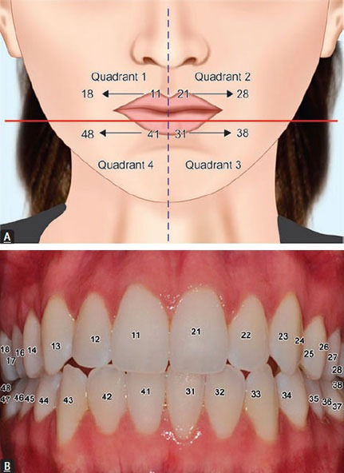
Figure 4. FDI tooth-numbering reference included with the project

The system is a software-only prototype with no specialized physical materials. Its software components have distinct responsibilities: Streamlit provides the UI; Python modules implement retrieval and persistence; Gemini provides embedding and generation APIs; Supabase supplies PostgreSQL storage and pgvector search; and web libraries support optional external retrieval.
The external services introduce configuration requirements. API keys, database credentials, OAuth secrets, and cookie secrets must be kept outside source control and stored using server-side secret management. The database setup must create a vector column whose dimensions match the embedding output and a matching function that accepts the expected parameters.
A test environment should use synthetic or properly authorized data and a separate database project where possible. Production access should not be granted until authentication, database permissions, privacy notices, retention, and failure handling have been reviewed.

CHAPTER 4: PROJECT PLANNING

4.1 Work Breakdown Structure
The work breakdown organizes the synopsis project into manageable phases. The items are planned deliverables, not a claim that every verification activity has been completed.
Table 3. Work breakdown structure
Work package | Main activities | Deliverable
1. Requirements | Define user, inputs, outputs, safety boundaries | Requirements and scope
2. Design | Plan interface, architecture, schema, retrieval flow | Design diagrams and schema
3. Implementation | Build UI, embeddings, RAG, fallback, persistence | Integrated prototype
4. Analytics | Create metrics and dashboard views | Analytics page
5. Verification | Test validation, service paths, errors, data display | Test evidence and issue list
6. Documentation | Prepare synopsis and deployment guidance | Project documentation

The requirements and scope phase defines the intended educational use, user inputs, response sections, privacy boundaries, and exclusions. The design phase produces a component architecture, workflow diagrams, database schema, and acceptance criteria. These deliverables provide a basis for implementation and review.
The implementation phase can be divided into interface and authentication, image and symptom handling, knowledge ingestion and vector retrieval, fallback and multimodal generation, persistence, and analytics. Each work package should have a demonstrable completion condition, such as validated form input or a successful query against a test knowledge collection.
The verification and documentation phases include normal-path and failure-path tests, setup instructions, known limitations, and a final demonstration using non-identifying examples. Clinical evaluation is not part of routine software completion and would require separate planning and approval.

4.2 Gantt Chart
The schedule is an illustrative eight-week estimate. Replace it with the approved academic calendar and actual progress dates before submission.
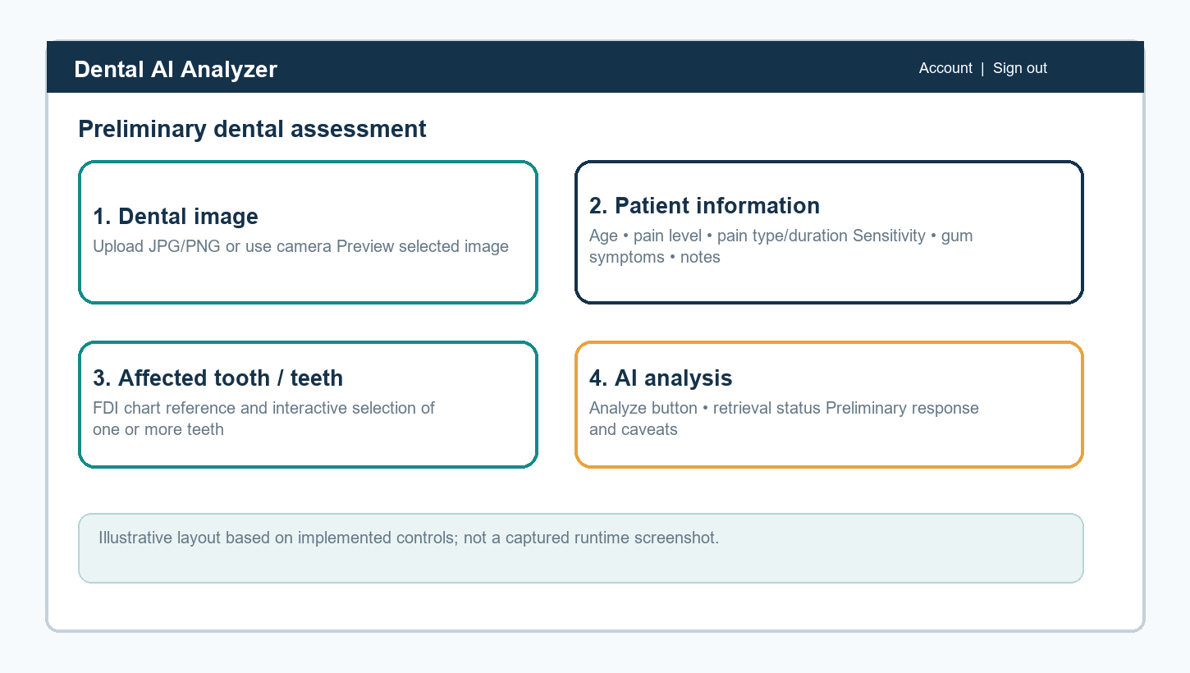
Figure 5. Illustrative project schedule (estimated)

The eight-week chart is an illustrative estimate for sequencing work packages, not a verified record of the project timeline. Requirements and architecture precede most implementation work; integration and database setup can proceed after interfaces and schemas are agreed; final testing depends on stable configuration and representative test cases.
The team should replace estimated week numbers with institutional dates and identify milestones such as requirements approval, design review, feature freeze, integration testing, report submission, and demonstration. Contingency should be reserved for API changes, OAuth configuration, database setup, and corrections discovered during testing.

4.3 Roles and Responsibilities
Individual names and assigned responsibilities should be completed by the project team and guide. The role descriptions below are suggested and do not assume specific team assignments.
Table 4. Suggested roles and responsibilities
Role | Responsibility
Student / development team | Requirements, implementation, tests, documentation, and presentation
Project guide | Technical guidance, progress review, and academic feedback
Dental-domain reviewer (if assigned) | Review safety language and general dental references; not a substitute for formal clinical validation
Deployment administrator | Configure credentials, access, database, and operational controls

For an individual project, one student may perform several roles; for a team, responsibilities should be assigned explicitly. The development role covers requirements, code, tests, and documentation. The guide reviews scope and academic progress. A domain reviewer, if available, can review terminology and safety statements but does not replace a formal validation study.
The deployment administrator manages protected credentials, access settings, database initialization, and operational monitoring. Responsibilities for approving real patient data, responding to privacy incidents, or making clinical decisions must not be assumed by the software developer unless formally assigned and qualified.

4.4 Risk Assessment
Table 5. Project risk assessment
Risk | Impact | Mitigation
Incorrect or overconfident AI text | User may mistake a possibility for a diagnosis | Cautious prompts, visible limitations, professional-care advice, and expert review before real-world use
Poor image quality | Visible findings may be incomplete or misleading | Capture guidance and explicit image limitations
Irrelevant or incomplete retrieval | Unsupported context may influence generation | Thresholding, corpus review, retrieval testing, and source transparency
External-service outage | Analysis, fallback, or save may fail | Clear failure messages and staged integration tests
Sensitive data exposure | Privacy or compliance harm | Consent, data minimization, server-side secrets, access controls, and retention rules
No clinical validation | Users may over-trust prototype output | Do not claim diagnostic performance; keep use educational pending approved evaluation

The primary safety risk is that a user treats an AI-generated possibility as a diagnosis or is falsely reassured. Mitigation includes careful prompt wording, visible disclaimers, warning-sign language, and professional-care recommendations. These controls reduce misunderstanding but cannot guarantee safe interpretation.
Data risks include accidental collection of identifiers, unauthorized access to health-related records, exposure of privileged credentials, and retention beyond the intended purpose. Controls should include data minimization, consent, least-privilege access, protected secrets, access logging where appropriate, and documented retention and deletion.
Technical risks include poor image quality, API rate limits, changing provider behavior, mismatched vector dimensions, an empty or stale knowledge collection, irrelevant retrieval, web-page changes, and failed database writes. Each risk should have a reproducible test case, visible error handling, and a documented recovery approach.
A further project risk is overclaiming evidence. A successful software demonstration only shows that a configured workflow ran; it does not prove diagnostic accuracy, fairness, or clinical benefit. Reports and presentations should distinguish implementation evidence from expert-reviewed validation.

CHAPTER 5: RESOURCES & FEASIBILITY

5.1 Technical Feasibility
The prototype is technically feasible using existing Python libraries, Streamlit, Google Gemini APIs, and Supabase with pgvector. Source modules separate the user interface, embedding generation, retrieval, web fallback, persistence, and analytics. Feasibility depends on valid credentials, a configured database schema, a populated knowledge corpus, compatible vector dimensions, and network access.

The required capabilities are available through established Python libraries and hosted services. The application already separates major integration concerns into modules, and Supabase provides a PostgreSQL-backed vector store. This makes an academic prototype technically achievable without training a custom model.
Feasibility depends on matching the embedding dimension used by the Gemini API to the vector column and index, applying the expected RPC parameter names, having the knowledge collection ingested, and configuring API access. Model or library updates may change behavior, so dependency and configuration versions should be recorded for reproducible testing.
The architecture requires network access to multiple external services. Latency and availability therefore depend on connectivity and provider service levels. Offline use and guaranteed response time are not supported by the current design.

5.2 Economic Feasibility
The prototype can be developed with open-source packages and hosted services, but operational costs depend on provider plans, model usage, database capacity, hosting, and web requests. No project-specific bill or usage benchmark is available in the repository. Current provider pricing and expected usage should be checked before deployment.

The development stack uses open-source packages and may be suitable for a low-cost academic demonstration, particularly where existing student equipment and institutional internet are available. However, free access is subject to provider eligibility, quotas, and terms and should not be assumed.
Recurring cost categories include model requests and embeddings, database storage and query limits, application hosting, domain configuration, monitoring, and maintenance. The total cost depends on traffic, image processing, retention period, and selected service plans. No measured usage or price estimate is included because these depend on deployment choices.
Before deployment, estimate typical and peak request volumes, define a budget limit, monitor consumption, and evaluate whether the selected provider's data-handling terms are appropriate for the intended data.

5.3 Operational Feasibility
A browser-based interface and dashboard are suitable for a controlled academic demonstration. Users need an internet connection and clear instructions. Real-patient use would require consent, privacy review, access and retention controls, qualified clinical oversight, and any required legal or institutional approvals. The application is not an emergency triage service.

The interface uses a familiar browser workflow and provides image previews and form controls, making it suitable for demonstration by users with basic web experience. Clear instructions are needed for capturing an image and identifying teeth using the FDI chart.
Operational suitability is conditional on clear responsibility and support. Users need to know the application is not a medical service, that generated information may be wrong, and how to seek professional care. Administrators need procedures for account access, secret rotation, updates, data retention, and service outages.
The prototype should initially be operated with synthetic or properly authorized data. Using real patient information requires appropriate consent, institutional review, privacy safeguards, and compliance with applicable laws and service terms.

5.4 Budget Estimation
The values below are not quoted prices. They identify cost categories that must be estimated from the actual deployment plan and current provider rates. A classroom prototype may use existing equipment and free-tier services if eligible.
Table 6. Budget categories for estimation
Item | Quantity | Cost estimate
Development computer | Existing / as required | Use existing asset or obtain institutional quote
Internet access | Project duration | Institutional or local plan
Gemini API usage | Usage dependent | Check current provider pricing; not measured
Supabase database / hosting | Usage dependent | Check selected plan and storage limits
Streamlit hosting | One deployment | Depends on chosen host and traffic
Domain / security services | Optional | Quote only if required for deployment

A responsible budget should distinguish one-time academic development costs from recurring operation. One-time effort includes setup, integration, testing, documentation, and review. Recurring expense may include model use, database capacity, web hosting, monitoring, and maintenance.
The budget table deliberately uses estimate categories instead of invented monetary figures. Before submission or deployment, the project team should obtain current provider pricing, record assumptions for expected request volume and data retention, and state whether costs are covered by the institution, project team, or a service free tier.

5.5 Bill of Materials (BOM), if applicable
A conventional physical BOM is not applicable to this software prototype. The software resources are summarized in Table 2. Any hosting or API purchase should be based on an approved deployment estimate rather than assumed costs.

A physical bill of materials is not applicable because this project does not manufacture a device. The relevant resource list is the software and hosted services in Table 2. Optional hardware is limited to a development computer and a camera-enabled device capable of providing a supported image.

CHAPTER 6: EXPECTED RESULTS
The project is expected to deliver a functioning prototype that accepts supported dental images and structured symptom information, provides FDI tooth selection, executes a retrieval-assisted multimodal workflow when services are configured, displays a preliminary response with limitations, and supports persistence and descriptive analytics.
Evaluation should report functional pass/fail outcomes, retrieval relevance on a reviewed query set, usability feedback, response-time observations, and errors across service-failure cases. These are proposed evaluation measures; no numerical accuracy or clinical-performance result is claimed in this synopsis.
The system is not expected to confirm a diagnosis or replace professional examination. Any future clinical performance study would require an approved protocol, qualified reference assessors, representative data, privacy protections, and independent analysis.

The expected result is a demonstrable application that accepts supported image formats and symptom information, lets a user select affected teeth, and produces a structured preliminary response when external services are configured. The interface should communicate whether retrieval context was available and should show limitations alongside the response.
Expected engineering outputs include a successful end-to-end path for a valid test case, clear rejection of invalid images, an observable response when RAG is insufficient, explicit handling of web or model failures, separate reporting for database save failure, and analytics behavior for empty and populated records.
A future evaluation can measure functional test pass rates, retrieval relevance judged by reviewers, response latency under specified network conditions, usability feedback, and the frequency and type of unsupported or ambiguous model statements. These measurements have not been performed for this synopsis and no numerical target or achieved result is asserted.
Clinical performance must be evaluated separately from software functionality. It requires a defined intended use, representative data, qualified reference assessments, predefined measures, privacy safeguards, and appropriate ethical and institutional review. Until then, the tool remains educational and preliminary.

CHAPTER 7: SUSTAINABILITY & IMPACT

7.1 Industrial Relevance
The project demonstrates technologies relevant to digital health software, including multimodal interfaces, semantic retrieval, cloud databases, authentication, and descriptive analytics. It may serve as an academic prototype for studying user-centered decision-support concepts. It is not ready for clinical or commercial deployment without validation, governance, and compliance review.

The project demonstrates integration patterns that are relevant to digital health and software product development: multimodal interfaces, semantic retrieval, cloud persistence, authentication, and analytics. It can support academic discussion of how AI services might be incorporated into information workflows.
The current prototype is not ready for clinical or commercial deployment. Product use would require a well-defined intended purpose, reliability engineering, privacy and security controls, regulatory assessment where applicable, professional oversight, and evidence supporting safety and performance.

7.2 Societal Impact
A carefully framed information tool may help users organize symptoms and prepare questions for a dental professional. Potential benefit must not be overstated: inaccurate or misunderstood output could cause unnecessary concern or delay care. Clear disclaimers, accessibility, privacy safeguards, and professional referral guidance are essential.

A carefully explained tool may help a user organize observations and prepare questions for a dental appointment. Potential value depends on accessibility, understandable language, and responsible recommendations; it must not be presented as a substitute for access to professional care.
Potential harms include anxiety from an incorrect possibility, false reassurance, privacy loss, and unequal performance across image quality, devices, or user groups. Monitoring and evaluation should examine both benefits and harms and should avoid implying that a general-purpose AI response is a clinical decision.

7.3 Environmental Impact
The software requires no dedicated manufacturing process or physical equipment beyond computing and network resources. Cloud inference and data storage consume energy, so efficient API use, data minimization, and avoiding unnecessary image retention are appropriate design considerations. No quantitative environmental assessment has been performed.

The project does not require dedicated manufacturing or physical materials beyond ordinary computing devices. Its environmental footprint comes primarily from device use, network traffic, hosted inference, and data storage. Efficient requests, retention minimization, and avoiding unnecessary image processing are reasonable design considerations.
No quantitative life-cycle or energy assessment has been performed. Any future environmental claim should be supported by measured or provider-reported data rather than inferred from the software architecture.

7.4 SDG Mapping
Possible alignment is conceptual and does not represent measured impact: SDG 3 (Good Health and Well-Being) relates to responsible health information; SDG 9 (Industry, Innovation and Infrastructure) relates to software prototyping; and SDG 10 (Reduced Inequalities) may be relevant only if accessibility and equitable performance are evaluated. The project does not claim that these outcomes have been achieved.

The project may be discussed in relation to SDG 3 (Good Health and Well-Being) as a responsible health-information prototype, and SDG 9 (Industry, Innovation and Infrastructure) as an example of applied digital technology. This is conceptual alignment only and does not demonstrate measurable impact.
Potential alignment with SDG 10 (Reduced Inequalities) would require accessible design and evaluation across user groups and devices. Without evidence on accessibility, fairness, adoption, or outcomes, the project should not claim that it has reduced inequality or improved population health.

CHAPTER 8: CONCLUSION
The AI Dental Analyzer brings together image and symptom input, FDI tooth selection, vector-based dental knowledge retrieval, conditional web fallback, multimodal generation, Supabase storage, and analytics in a single academic prototype. The synopsis describes its objectives, architecture, planning, feasibility, and expected evaluation.
The project remains educational and preliminary. A photograph and generated response cannot establish a diagnosis, and no clinical performance has been measured. Responsible future work should prioritize repeatable software testing, data governance, source transparency, usability evaluation, and independent clinical validation under appropriate oversight.

The AI Dental Analyzer combines image and symptom input, FDI tooth selection, vector-based general knowledge retrieval, optional web fallback, multimodal response generation, Supabase persistence, authentication, and descriptive analytics. The supplied synopsis template has been used to describe the problem, objectives, methodology, planning, feasibility, expected outcomes, and impact considerations.
The main project contribution is an integrated educational prototype and a documented workflow. The tool cannot confirm or exclude a dental condition, and the repository does not establish clinical accuracy or patient benefit. The result depends on user input, image quality, reference coverage, external service behavior, and the model's generated output.
Further development should prioritize reproducible testing, better source provenance, consent and retention controls, structured handling of generated fields, accessibility, and independent review. Any clinical evaluation or deployment should proceed only under appropriate professional, institutional, privacy, and legal oversight.

REFERENCES
[1] F. Schwendicke, W. Samek, and J. Krois, “Artificial Intelligence in Dentistry: Chances and Challenges,” Journal of Dental Research, vol. 99, no. 7, pp. 769–774, 2020, doi: 10.1177/0022034520915714.
[2] A. A. Khanagar et al., “Developments, application, and performance of artificial intelligence in dentistry—A systematic review,” Journal of Dental Sciences, vol. 16, no. 1, pp. 508–522, 2021, doi: 10.1016/j.jds.2020.06.019.
[3] S. S. Alharbi and H. F. Alhasson, “Exploring the Applications of Artificial Intelligence in Dental Image Detection: A Systematic Review,” Diagnostics, vol. 14, no. 21, 2024, doi: 10.3390/diagnostics14212442.
[4] S. E. Uribe et al., “Publicly Available Dental Image Datasets for Artificial Intelligence,” Journal of Dental Research, 2024, doi: 10.1177/00220345241272052.
[5] C. Cantu et al., “Detecting caries lesions of different radiographic extension on bitewings using deep learning,” Journal of Dentistry, vol. 100, 2020, article 103425, doi: 10.1016/j.jdent.2020.103425.
[6] J.-H. Lee et al., “Diagnosis and prediction of periodontally compromised teeth using a deep learning-based convolutional neural network algorithm,” Journal of Periodontal & Implant Science, vol. 48, no. 2, pp. 114–123, 2018, doi: 10.5051/jpis.2018.48.2.114.
[7] P. Lewis et al., “Retrieval-Augmented Generation for Knowledge-Intensive NLP Tasks,” Advances in Neural Information Processing Systems, vol. 33, pp. 9459–9474, 2020.
[8] Gemini Team, “Gemini: A Family of Highly Capable Multimodal Models,” arXiv:2312.11805, 2023.
[9] World Health Organization, Global Oral Health Status Report: Towards Universal Health Coverage for Oral Health by 2030, Geneva, 2022.
[10] International Organization for Standardization, ISO 3950:2016, Dentistry—Designation System for Teeth and Areas of the Oral Cavity, 2016.
[11] Google AI for Developers, “Gemini API documentation.” https://ai.google.dev/gemini-api/docs (accessed October 23, 2026).
[12] Supabase, “AI and Vector Columns documentation.” https://supabase.com/docs/guides/ai (accessed October 23, 2026).
[13] Streamlit, “Streamlit documentation.” https://docs.streamlit.io/ (accessed October 23, 2026).
[14] AI Dental Analyzer project source repository: app.py, analytics.py, database.py, rag.py, web_fallback.py, knowledge/, and supabase_setup.sql, accessed October 23, 2026.

APPENDICES (Optional)
Appendix A. FDI tooth chart and system diagrams are included in Chapter 3. The figures are illustrative representations of the documented prototype.
Appendix B. The repository contains integration scripts for embeddings, RAG retrieval, and analytics. They require configured external credentials and services; test execution should be documented separately before submission.
Appendix C. Replace student, guide, and signature placeholders on the cover and approval pages. Update the contents and figure/table page numbers in Word after final pagination.

