AF 52
Synopsis
AI DENTAL ANALYZER
Submitted in partial fulfilment of the requirements of the degree of
Bachelor of Engineering
In
Artificial Intelligence and Machine Learning

by
Name of Student [PID No.]
Name of Student [PID No.]
Name of Student [PID No.]

Under the Guidance of
(Guide name)
Designation, Department of AIML, SJCEM



DEPARTMENT OF ARTIFICIAL INTELLIGENCE AND MACHINE LEARNING
ST. JOHN COLLEGE OF ENGINEERING & MANAGEMENT
UNIVERSITY OF MUMBAI
2026-2027



Certificate of Approval

This is to certify that _____________________ are bonafide students of B. Tech in Artificial Intelligence and Machine Learning, Department of Artificial Intelligence and Machine Learning, St. John College of Engineering and Management, Mumbai. They have satisfactorily completed the requirements of the Synopsis as prescribed by ST. JOHN COLLEGE OF ENGINEERING AND MANAGEMENT (An Autonomous College affiliated to University of Mumbai), while working on “AI Dental Analyzer”.

Signature :  Name : Guide Name & Signature  Designation | Signature :  Name :HOD Name & Signature  Designation

Signature:
Name : Dr. Kamal Shah Principal,
St. John College of Engineering and Management.

Declaration

I/we declare that this written submission represents my/our ideas in my/our own words and where others ideas or words have been included, I/we have adequately cited and referenced the original sources. I/we also declare that I/we have adhered to all principles of academic honesty and integrity and have not misrepresented or fabricated or falsified any idea/data/fact/source in my/our submission. I/we understand that any violation of the above will be cause for disciplinary action by the Institute and can also evoke penal action from the sources which have thus not been properly cited or from whom proper permission has not been taken when needed.

(Signature)

.

(Student Name )
Date:

Acknowledgement
We express our sincere gratitude to all those who have contributed to the preparation of this project synopsis on the AI Dental Analyzer.
We are grateful to Dr. Kamal Shah, Principal, St. John College of Engineering and Management, for providing the academic environment and facilities supporting this project.
We extend our heartfelt thanks to the Mr. Ajay Sirsat, Head of the Department of AIML, for the constant encouragement, valuable suggestions, and continuous support throughout the preparation of this synopsis.
We would like to express our sincere appreciation to our project guide, Dr./Prof. __________________________, for their invaluable guidance, constructive suggestions, technical expertise, and continuous motivation. Their encouragement and insightful feedback have been instrumental in shaping this project synopsis.
We also acknowledge the faculty members and staff of the Department of Artificial Intelligence and Machine Learning for their assistance and cooperation.
Finally, we thank our families, friends, and classmates for their encouragement and support.

Group Members

ABSTRACT

The AI Dental Analyzer is a web-based prototype designed to provide preliminary, educational information from a dental photograph and user-reported symptoms. Developed with Python and Streamlit, it accepts an uploaded or camera-captured image and structured details such as age, pain level, pain type and duration, sensitivity, gum symptoms, additional notes, and affected teeth selected using the FDI two-digit numbering system. A retrieval-augmented generation workflow creates an embedding from the symptom context and searches a Supabase pgvector knowledge store for relevant general dental information. When relevant vector results do not meet the configured similarity threshold, the application can attempt a web-based fallback. Google Gemini receives the image and available context and generates a response organized around visible observations, reported symptoms, possible explanations, image limitations, concern level, and recommended next steps. Assessment fields and generated text can be stored in Supabase and reviewed through a descriptive analytics dashboard. Google OAuth supports sign-in. The prototype is not a diagnostic device, has not been clinically validated, and cannot replace examination by a qualified dental professional. Image quality, knowledge coverage, retrieval relevance, network availability, and model errors are important limitations; all output requires professional verification.

C O N T E N T S

- List of Figures i
- List of Tables ii
- Abbreviations and symbols iii

Chapter No. | Topic | Page No.
Chapter 1  Chapter 1 | Introduction: Background, Problem Statement, Need, Objectives, Scope, Expected Outcomes | Update in Word
Chapter 2 | Literature Review: Survey, Research Gap, Novelty / Innovation | Update in Word
Chapter 3 | Proposed Methodology: Working Principle, Architecture, Flow Chart, Components | Update in Word
Chapter 4 | Project Planning: WBS, Gantt Chart, Roles, Risk Assessment | Update in Word
Chapter 5  Chapter 5 | Resources and Feasibility: Technical, Economic, Operational, Budget, Software BOM | Update in Word
Chapter 6 | Expected Results and Evaluation Plan | Update in Word
Chapter 7 | Sustainability and Impact: Industrial, Societal, Environmental, SDG Mapping | Update in Word
Chapter 8 | Conclusion | Update in Word
References | IEEE-style references | Update in Word
Appendix | Supporting figure and project material | Update in Word

List of Figures

Figure No. | Figure Name | Page No.
1 | System Architecture | Update in Word
2 | Data-Flow Diagram | Update in Word
3 | Assessment Workflow | Update in Word
4 | Illustrative Project Schedule | Update in Word
5 | FDI Tooth Numbering Reference | Update in Word

List of Tables

Table No. | Table Name | Page No.
1 | Literature Review Summary | Update in Word
2 | Project Components / Software BOM | Update in Word
3 | Work Breakdown Structure | Update in Word
4 | Roles and Responsibilities | Update in Word
5 | Risk Assessment | Update in Word
6 | Budget Estimation | Update in Word

Abbreviations and symbols

- AI: Artificial Intelligence
- API: Application Programming Interface
- DFD: Data-Flow Diagram
- FDI: Fédération Dentaire Internationale
- GUI: Graphical User Interface
- LLM: Large Language Model
- NLP: Natural Language Processing
- OAuth: Open Authorization
- RAG: Retrieval-Augmented Generation
- SQL: Structured Query Language
- pgvector: PostgreSQL vector similarity extension

CHAPTER 1: INTRODUCTION

1.1 Background
Dental assessment combines a patient history with direct clinical examination and, where needed, diagnostic tests such as radiographs. A photograph can show some surface appearance, but lighting, focus, angle, image quality, and obstructions affect what is visible. A photograph alone cannot reliably establish lesion depth, pulp status, periodontal measurements, or the cause of pain.
Multimodal generative AI can accept images and text together, while retrieval-augmented generation can provide relevant reference passages as context. Both methods have limitations: AI may omit or misinterpret findings, and retrieved material may be incomplete or inapplicable. The project therefore presents possible explanations rather than confirmed diagnoses and emphasizes professional review.

1.2 Problem Statement
Users may have a dental photograph and symptoms but lack a consistent way to record the concern, identify the affected tooth, and understand the limits of visual assessment. The software problem is to organize these inputs, retrieve relevant general dental information, and generate a cautious preliminary explanation.
The system must also avoid presenting low-relevance retrieval as reliable support. The current prototype uses a configurable similarity threshold and can attempt web retrieval when vector results are insufficient. Neither similarity scores nor web results establish a diagnosis or the clinical correctness of a generated response.

1.3 Need of the Project
The project demonstrates an integrated way to collect image and symptom context in a structured interface and make general information more accessible. It may help a user organize observations before consulting a dental professional, while clearly identifying uncertainty and the need for examination.
From an engineering perspective, it brings together a web interface, multimodal AI, embeddings, vector search, authentication, database persistence, and analytics. The intended value is educational and demonstrative; clinical benefit and diagnostic performance have not been established.

1.4 Objectives
The general objective is to build a web-based prototype that organizes dental image and symptom information and provides a preliminary, educational AI-assisted response.
Specific objectives: (1) accept a JPG/JPEG/PNG image by upload or camera; (2) collect structured symptoms and free-text notes; (3) allow affected teeth to be identified using FDI numbering; (4) retrieve general dental information with vector similarity search and conditional web fallback; (5) present a multimodal AI response with limitations and professional-care guidance; (6) save assessment fields and display descriptive analytics.

1.5 Scope
The prototype covers a Streamlit web interface, Google OAuth sign-in, symptom and image input, FDI-based tooth selection, Gemini embedding and multimodal API calls, Supabase vector retrieval and assessment storage, web fallback, and analytics. The reviewed save path stores image filename and MIME type, not image bytes in the assessment table.
The system does not confirm disease, measure validated clinical risk, prescribe treatment, analyze radiographs, or replace dental examination. Output depends on image quality, user input, curated knowledge coverage, provider availability, and generative-model behavior. Future work could add a consent-aware clinician review workflow and independent evaluation.

1.6 Expected Outcomes
Expected outcomes are a working academic prototype, documented architecture and workflow, structured input and output screens, a vector-retrieval demonstration, database-backed assessment records, and a descriptive analytics page.
The project also expects to produce a functional test plan and identify failure modes. No accuracy, clinical effectiveness, or patient-outcome target is claimed because the repository contains no expert-labeled evaluation dataset or completed clinical validation.

CHAPTER 2: LITERATURE REVIEW

2.1 Introduction
Research in dental artificial intelligence spans image analysis, radiographic interpretation, decision support, and digital dentistry. Multimodal foundation models and retrieval-augmented generation offer additional ways to combine images, text, and reference material. The studies below provide technical context, not direct validation of this project's implementation.

2.2 Literature Review Table
The selected literature highlights the potential of AI in dentistry while identifying variation in datasets, tasks, clinical validation, and generalizability. RAG and multimodal model reports are included as technical foundations; they are not dental diagnostic studies.
Table 1. Selected literature review
Ref. | Method / focus | Relevant finding | Gap relevant to this project
[1] Schwendicke et al., 2020 | Review of AI opportunities and challenges in dentistry | Discusses potential applications and validation needs. | Does not evaluate this application or general-purpose image prompting.
[2] Khanagar et al., 2021 | Systematic review of AI applications in dentistry | Reports diverse tasks and approaches across dental domains. | Evidence is heterogeneous and cannot be transferred to this prototype.
[3] Alharbi & Alhasson, 2024 | Systematic review of AI in dental image detection | Surveys AI tasks and image-based approaches. | Image tasks and study datasets differ from user smartphone photos.
[4] Uribe et al., 2024 | Review of publicly available dental image datasets | Highlights data availability and dataset considerations. | A curated, representative evaluation set is still needed.
[5] Cantu et al., 2020 | Deep learning on bitewing radiographs | Studies automated caries detection using radiographic images. | Radiographic setting is not equivalent to ordinary dental photographs.
[6] Lee et al., 2018 | CNN-based periodontal tooth prognosis | Explores deep learning for a defined periodontal task. | Task-specific labels and clinical setting limit generalization.
[7] Lewis et al., 2020 | Retrieval-Augmented Generation | Combines parametric generation with retrieved passages. | General NLP method; retrieval does not guarantee clinical correctness.
[8] Gemini Team, 2023 | Technical report on multimodal models | Describes image-and-text model capabilities. | Capability report is not clinical validation of dental assessment.

2.3 Research Gap
Prior research includes narrowly defined dental image tasks, commonly using curated datasets and specific modalities such as radiographs. The present project instead demonstrates an integrated user workflow with patient-reported symptoms, consumer-style images, FDI tooth selection, retrieval, and a general multimodal model.
The unresolved gap is not simply the absence of an AI response; it is the lack of demonstrated reliability, clinical validation, and representative evaluation for this exact workflow. This prototype addresses the software-integration and transparency aspects but does not claim to close the clinical evidence gap.

2.4 Novelty / Innovation
The project's contribution is a combination of image and structured symptom input, interactive FDI tooth selection, similarity-thresholded retrieval, conditional web fallback, cautious multimodal response formatting, persistence, and descriptive analytics in one prototype.
This is an integration and educational contribution rather than a new AI model or clinically validated diagnostic algorithm. Its distinguishing design emphasis is to expose retrieval status and image limitations and to avoid representing generated possibilities as confirmed diagnoses.

CHAPTER 3: PROPOSED METHODOLOGY

3.1 Proposed System
The proposed system is a Streamlit application for authenticated users. It collects a dental photograph, patient-reported information, and affected teeth. A retrieval query is embedded and matched to general dental reference documents stored in Supabase pgvector. If relevant results are insufficient, the application may try a web fallback. Gemini then produces a preliminary response from the image and available text context. Assessment details can be saved in Supabase and summarized in a separate dashboard.

3.2 Working Principle
The expected operating sequence is:
1. User signs in and selects image upload or camera capture. 2. Application checks image presence and accepted JPG/JPEG/PNG format. 3. User enters age, pain characteristics, symptoms, affected FDI tooth number(s), and notes. 4. Application embeds symptom context and queries the vector database. 5. Results below the configured threshold trigger an optional web fallback. 6. Gemini analyzes the image and available context and generates a structured preliminary response. 7. The response and retrieval status are displayed; the application attempts to save the assessment. 8. The dashboard summarizes saved records.
Failure of a model, web, or database service is distinct from a successful result and should be reported as such. The result is informational and requires professional verification.

3.3 System Architecture / Block Diagram
The Streamlit application coordinates input and response display. Gemini provides embedding and multimodal generation APIs; Supabase hosts the assessment records and vector search function. The web retrieval module is conditional, and analytics reads saved records independently from the generation path.
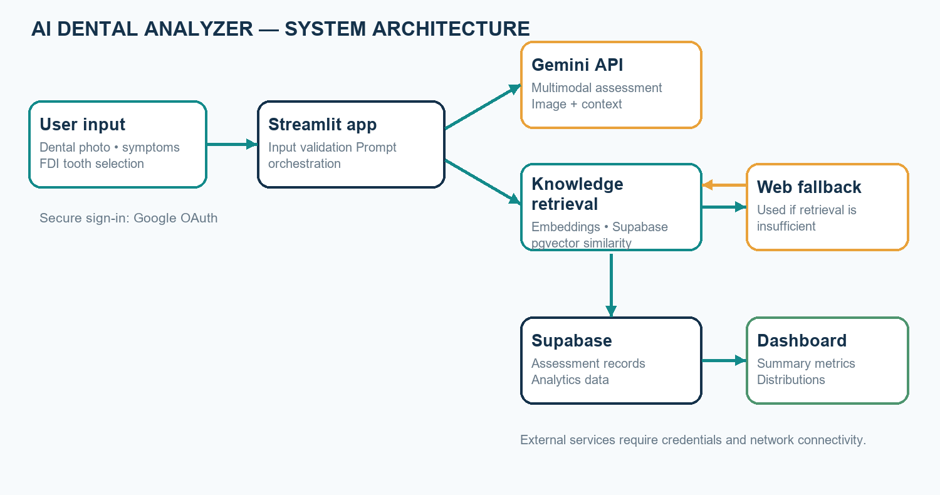
Figure 1. System architecture
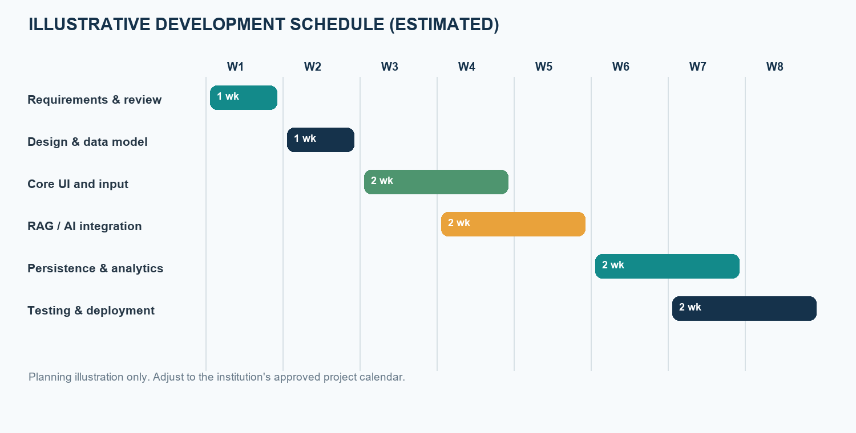
Figure 2. Assessment data-flow diagram

3.4 Flow Chart
The workflow includes authentication, input validation, retrieval selection, multimodal analysis, result presentation, and persistence. The flow below is illustrative of the implemented process and assumes required services are configured.
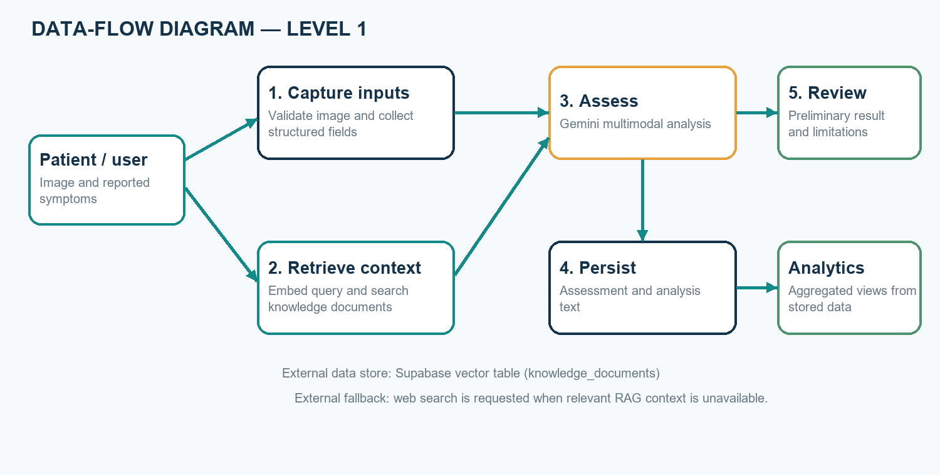
Figure 3. Assessment workflow

3.5 Methodology
The development methodology is an iterative software-prototyping process: identify inputs and safety requirements; design the Streamlit workflow and Supabase schema; implement image and symptom collection; integrate embedding and vector retrieval; add conditional web fallback and Gemini generation; connect persistence and analytics; and prepare tests for success and failure cases.
The retrieval threshold is a configuration parameter, not a medically validated confidence score. A future evaluation should measure retrieval relevance, model response quality, usability, error handling, and response time with a documented test set. Clinical evaluation would require qualified reviewers, representative data, privacy protections, and appropriate institutional approval.

3.6 Components / Materials
This is primarily a software project; no specialized physical bill of materials is required. Operational use depends on the following software services and development resources.
Table 2. Components and software resources
Component | Specification / purpose | Quantity
Python | Application language and integration logic | 1 runtime
Streamlit | Web UI, authentication integration, and dashboard | 1 application
Google Gemini API | Multimodal generation and 768-dimensional embeddings | API access
Supabase / PostgreSQL | Assessment storage, pgvector, and similarity search | 1 project
Dental knowledge corpus | Curated general reference documents for retrieval | Project corpus
Web fallback libraries | Requests and BeautifulSoup for optional retrieval | Software modules
Development computer | Browser and Python environment for development/testing | 1 or more
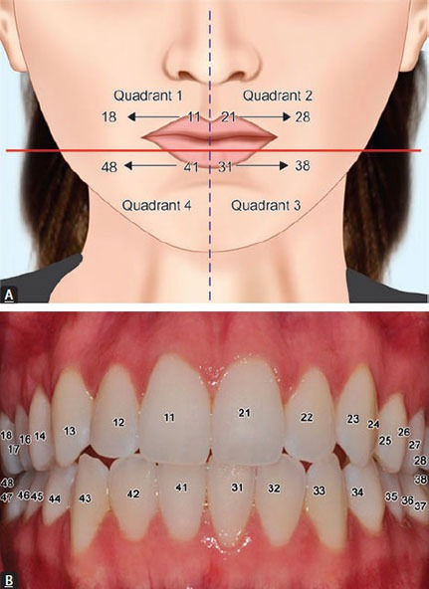
Figure 4. FDI tooth-numbering reference included with the project

CHAPTER 4: PROJECT PLANNING

4.1 Work Breakdown Structure
The work breakdown organizes the synopsis project into manageable phases. The items are planned deliverables, not a claim that every verification activity has been completed.
Table 3. Work breakdown structure
Work package | Main activities | Deliverable
1. Requirements | Define user, inputs, outputs, safety boundaries | Requirements and scope
2. Design | Plan interface, architecture, schema, retrieval flow | Design diagrams and schema
3. Implementation | Build UI, embeddings, RAG, fallback, persistence | Integrated prototype
4. Analytics | Create metrics and dashboard views | Analytics page
5. Verification | Test validation, service paths, errors, data display | Test evidence and issue list
6. Documentation | Prepare synopsis and deployment guidance | Project documentation

4.2 Gantt Chart
The schedule is an illustrative eight-week estimate. Replace it with the approved academic calendar and actual progress dates before submission.
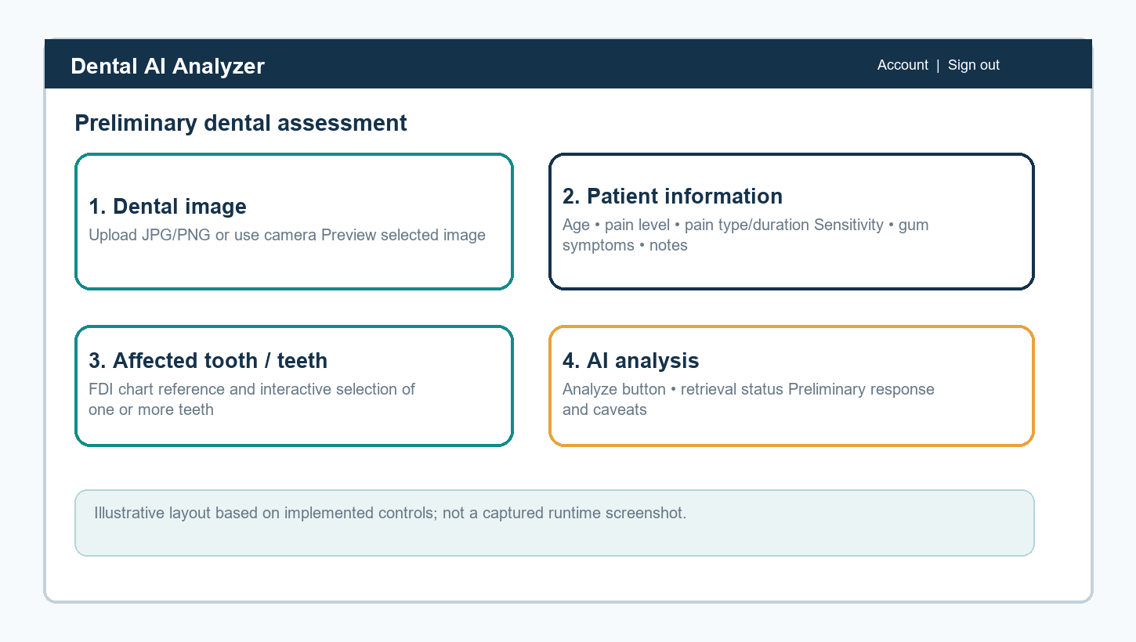
Figure 5. Illustrative project schedule (estimated)

4.3 Roles and Responsibilities
Individual names and assigned responsibilities should be completed by the project team and guide. The role descriptions below are suggested and do not assume specific team assignments.
Table 4. Suggested roles and responsibilities
Role | Responsibility
Student / development team | Requirements, implementation, tests, documentation, and presentation
Project guide | Technical guidance, progress review, and academic feedback
Dental-domain reviewer (if assigned) | Review safety language and general dental references; not a substitute for formal clinical validation
Deployment administrator | Configure credentials, access, database, and operational controls

4.4 Risk Assessment
Table 5. Project risk assessment
Risk | Impact | Mitigation
Incorrect or overconfident AI text | User may mistake a possibility for a diagnosis | Cautious prompts, visible limitations, professional-care advice, and expert review before real-world use
Poor image quality | Visible findings may be incomplete or misleading | Capture guidance and explicit image limitations
Irrelevant or incomplete retrieval | Unsupported context may influence generation | Thresholding, corpus review, retrieval testing, and source transparency
External-service outage | Analysis, fallback, or save may fail | Clear failure messages and staged integration tests
Sensitive data exposure | Privacy or compliance harm | Consent, data minimization, server-side secrets, access controls, and retention rules
No clinical validation | Users may over-trust prototype output | Do not claim diagnostic performance; keep use educational pending approved evaluation

CHAPTER 5: RESOURCES & FEASIBILITY

5.1 Technical Feasibility
The prototype is technically feasible using existing Python libraries, Streamlit, Google Gemini APIs, and Supabase with pgvector. Source modules separate the user interface, embedding generation, retrieval, web fallback, persistence, and analytics. Feasibility depends on valid credentials, a configured database schema, a populated knowledge corpus, compatible vector dimensions, and network access.

5.2 Economic Feasibility
The prototype can be developed with open-source packages and hosted services, but operational costs depend on provider plans, model usage, database capacity, hosting, and web requests. No project-specific bill or usage benchmark is available in the repository. Current provider pricing and expected usage should be checked before deployment.

5.3 Operational Feasibility
A browser-based interface and dashboard are suitable for a controlled academic demonstration. Users need an internet connection and clear instructions. Real-patient use would require consent, privacy review, access and retention controls, qualified clinical oversight, and any required legal or institutional approvals. The application is not an emergency triage service.

5.4 Budget Estimation
The values below are not quoted prices. They identify cost categories that must be estimated from the actual deployment plan and current provider rates. A classroom prototype may use existing equipment and free-tier services if eligible.
Table 6. Budget categories for estimation
Item | Quantity | Cost estimate
Development computer | Existing / as required | Use existing asset or obtain institutional quote
Internet access | Project duration | Institutional or local plan
Gemini API usage | Usage dependent | Check current provider pricing; not measured
Supabase database / hosting | Usage dependent | Check selected plan and storage limits
Streamlit hosting | One deployment | Depends on chosen host and traffic
Domain / security services | Optional | Quote only if required for deployment

5.5 Bill of Materials (BOM), if applicable
A conventional physical BOM is not applicable to this software prototype. The software resources are summarized in Table 2. Any hosting or API purchase should be based on an approved deployment estimate rather than assumed costs.

CHAPTER 6: EXPECTED RESULTS
The project is expected to deliver a functioning prototype that accepts supported dental images and structured symptom information, provides FDI tooth selection, executes a retrieval-assisted multimodal workflow when services are configured, displays a preliminary response with limitations, and supports persistence and descriptive analytics.
Evaluation should report functional pass/fail outcomes, retrieval relevance on a reviewed query set, usability feedback, response-time observations, and errors across service-failure cases. These are proposed evaluation measures; no numerical accuracy or clinical-performance result is claimed in this synopsis.
The system is not expected to confirm a diagnosis or replace professional examination. Any future clinical performance study would require an approved protocol, qualified reference assessors, representative data, privacy protections, and independent analysis.

CHAPTER 7: SUSTAINABILITY & IMPACT

7.1 Industrial Relevance
The project demonstrates technologies relevant to digital health software, including multimodal interfaces, semantic retrieval, cloud databases, authentication, and descriptive analytics. It may serve as an academic prototype for studying user-centered decision-support concepts. It is not ready for clinical or commercial deployment without validation, governance, and compliance review.

7.2 Societal Impact
A carefully framed information tool may help users organize symptoms and prepare questions for a dental professional. Potential benefit must not be overstated: inaccurate or misunderstood output could cause unnecessary concern or delay care. Clear disclaimers, accessibility, privacy safeguards, and professional referral guidance are essential.

7.3 Environmental Impact
The software requires no dedicated manufacturing process or physical equipment beyond computing and network resources. Cloud inference and data storage consume energy, so efficient API use, data minimization, and avoiding unnecessary image retention are appropriate design considerations. No quantitative environmental assessment has been performed.

7.4 SDG Mapping
Possible alignment is conceptual and does not represent measured impact: SDG 3 (Good Health and Well-Being) relates to responsible health information; SDG 9 (Industry, Innovation and Infrastructure) relates to software prototyping; and SDG 10 (Reduced Inequalities) may be relevant only if accessibility and equitable performance are evaluated. The project does not claim that these outcomes have been achieved.

CHAPTER 8: CONCLUSION
The AI Dental Analyzer brings together image and symptom input, FDI tooth selection, vector-based dental knowledge retrieval, conditional web fallback, multimodal generation, Supabase storage, and analytics in a single academic prototype. The synopsis describes its objectives, architecture, planning, feasibility, and expected evaluation.
The project remains educational and preliminary. A photograph and generated response cannot establish a diagnosis, and no clinical performance has been measured. Responsible future work should prioritize repeatable software testing, data governance, source transparency, usability evaluation, and independent clinical validation under appropriate oversight.

REFERENCES
[1] F. Schwendicke, W. Samek, and J. Krois, “Artificial Intelligence in Dentistry: Chances and Challenges,” Journal of Dental Research, vol. 99, no. 7, pp. 769–774, 2020, doi: 10.1177/0022034520915714.
[2] A. A. Khanagar et al., “Developments, application, and performance of artificial intelligence in dentistry—A systematic review,” Journal of Dental Sciences, vol. 16, no. 1, pp. 508–522, 2021, doi: 10.1016/j.jds.2020.06.019.
[3] S. S. Alharbi and H. F. Alhasson, “Exploring the Applications of Artificial Intelligence in Dental Image Detection: A Systematic Review,” Diagnostics, vol. 14, no. 21, 2024, doi: 10.3390/diagnostics14212442.
[4] S. E. Uribe et al., “Publicly Available Dental Image Datasets for Artificial Intelligence,” Journal of Dental Research, 2024, doi: 10.1177/00220345241272052.
[5] C. Cantu et al., “Detecting caries lesions of different radiographic extension on bitewings using deep learning,” Journal of Dentistry, vol. 100, 2020, article 103425, doi: 10.1016/j.jdent.2020.103425.
[6] J.-H. Lee et al., “Diagnosis and prediction of periodontally compromised teeth using a deep learning-based convolutional neural network algorithm,” Journal of Periodontal & Implant Science, vol. 48, no. 2, pp. 114–123, 2018, doi: 10.5051/jpis.2018.48.2.114.
[7] P. Lewis et al., “Retrieval-Augmented Generation for Knowledge-Intensive NLP Tasks,” Advances in Neural Information Processing Systems, vol. 33, pp. 9459–9474, 2020.
[8] Gemini Team, “Gemini: A Family of Highly Capable Multimodal Models,” arXiv:2312.11805, 2023.
[9] World Health Organization, Global Oral Health Status Report: Towards Universal Health Coverage for Oral Health by 2030, Geneva, 2022.
[10] International Organization for Standardization, ISO 3950:2016, Dentistry—Designation System for Teeth and Areas of the Oral Cavity, 2016.
[11] Google AI for Developers, “Gemini API documentation.” https://ai.google.dev/gemini-api/docs (accessed October 23, 2026).
[12] Supabase, “AI and Vector Columns documentation.” https://supabase.com/docs/guides/ai (accessed October 23, 2026).
[13] Streamlit, “Streamlit documentation.” https://docs.streamlit.io/ (accessed October 23, 2026).
[14] AI Dental Analyzer project source repository: app.py, analytics.py, database.py, rag.py, web_fallback.py, knowledge/, and supabase_setup.sql, accessed October 23, 2026.

APPENDICES (Optional)
Appendix A. FDI tooth chart and system diagrams are included in Chapter 3. The figures are illustrative representations of the documented prototype.
Appendix B. The repository contains integration scripts for embeddings, RAG retrieval, and analytics. They require configured external credentials and services; test execution should be documented separately before submission.
Appendix C. Replace student, guide, and signature placeholders on the cover and approval pages. Update the contents and figure/table page numbers in Word after final pagination.

