**Sprint 1 Progress Report**

**Capstone Project / System Development Course**  
**Sprint Duration:** Week 1 – Week 2  
**Report Title:** Sprint 1 Progress Report  
**Submission Date:**

**I. Project Information**

* **Project Title:** **Solar Powered Charging Station with RFID Authentication and Real Time Monitoring**
* **Team Name / Individual Developer:**

Venus M. Sey-Ang – Documenter

Daniella Kim S. Longgat - Programmer

Vhen Carl M. Castillo – Quality Assuror

* **Course / Section: BSIT 4-2**
* **Adviser: ENGR. FREDERICK VON A. IBASCO, MSIT**
* **Sprint Dates:** August 12, 2025– August 22, 2025

**II. Sprint Objectives**

**We have successfully set up our GitHub account and integrated it into our development workflow. Additionally, we have completed 45% of the system, having established the foundational infrastructure, implemented key modules, and ensured version control practices are in place for efficient collaboration and code management**

**III. Tasks Completed**

| **Task No.** | **Task Description** | **Completion Date** | **Remarks** |
| --- | --- | --- | --- |
| 1 | Set up GitHub repository | 08/13/2025 | Repository created and shared with advisers |
| 2 | Designed database schema | 08/19/2025 | Includes ERD and initial SQL scripts |
| 3 | Implemented user login/logout | 08/19/2025 | Basic session-based authentication completed |
| 4 | Developed CRUD for **Users** | 08/19/2025 | Add, Edit, Delete, View features functional |

**IV. Screenshots or System Output**

* **This picture shows GitHub repository. Uploading codes.**

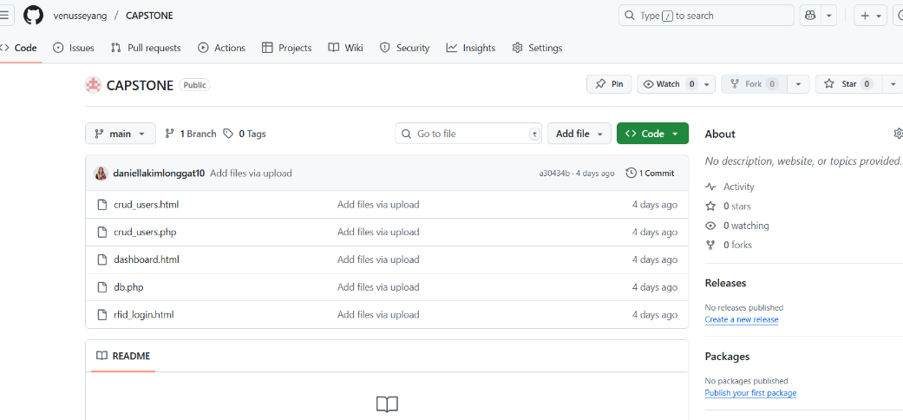

* **This picture shows login test on how the user will register through RFID card.**

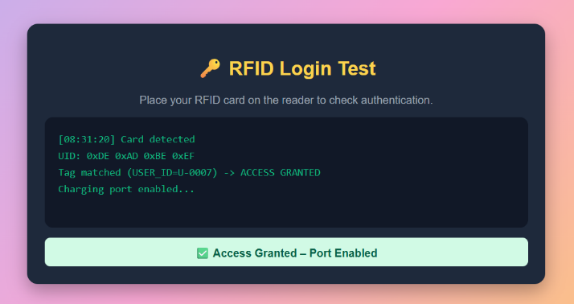

* **This picture lets the administrator manage user accounts by adding, updating, or deleting admin credentials.**

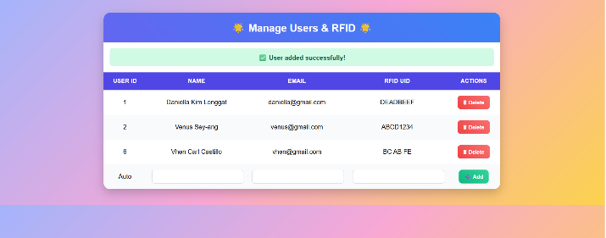

* **This picture shows the user interface, monitoring charging sessions.**

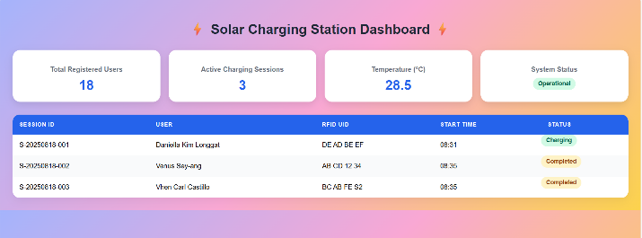

**V. Issues and Challenges Encountered**

* Lack of internet access during the development of the system
* Confusion with Git functions and merging
* Errors during the development of the system
* Problem with the Storage of the laptop used

**VI. Actions Taken to Address Issues**

* Ensured offline development by downloading necessary resources and establishing scheduled internet access for updates and pushes.
* Improved Git workflow understanding through training, visual tools, and clear commit guidelines.
* Utilized debugging, automated testing, and peer reviews to identify and resolve issues early.
* Implemented external storage, and regular cleanups to optimize available space on the laptop.

**VII. Pending Tasks / Carried Over to Next Sprint**

List tasks that were not completed and will be moved to Sprint 2.

| **Task** | **Reason for Delay** | **Planned Completion** |
| --- | --- | --- |
| Create user registration module | Ran out of time in the week 1&2 | Week 3 |
| Improve the Use Interface | Insufficient design staff to focus on UI improvements. | Week 3 |
| Complete the Materials | Delay in term of the shipping of materials due to weather issues | Week 3 |

**VIII. Reflection / Self-Evaluation**

The development process often encounters challenges such as lack of internet access, confusion with Git branching, errors during coding, storage limitations, and delays in UI improvements. Addressing these requires proactive solutions, such as preparing for offline work, establishing clear Git workflows, leveraging debugging and automated testing, and managing storage effectively through backups and external devices. Delays in UI improvements are often due to technical constraints and iterative design, reminding us of the importance of balancing creativity, user feedback, and practical limitations. These challenges highlight the need for flexibility, collaboration, and continuous learning to keep projects on track and improve future workflows.

**IX. Adviser’s Comments/Signature**

*(To be filled out by the adviser during consultation)*

**Adviser Consultation Log**

**Title Project:** **Solar Powered Charging Station with RFID Authentication and Real Time Monitoring**   
**Student Name / Team:**

**Venus M. Sey-Ang**

**Daniella Kim S. Longgat**

**Vhen Carl M. Castillo**

**Week Num: WEEK 1**

**Date:**

| **Date** | **Participants** | **Summary of Discussion** | **Feedback from Adviser** | **Agreed Action Items** | **Target Deadline** |
| --- | --- | --- | --- | --- | --- |
|  |  |  |  |  |  |
|  |  |  |  |  |  |
|  |  |  |  |  |  |
|  |  |  |  |  |  |
|  |  |  |  |  |  |
|  |  |  |  |  |  |
|  |  |  |  |  |  |

**Adviser’s Name & Signature: ENGR.FREDERICK VON A. IBASCO, MSIT**

**Date:**

**Code Review Checklist**

**Project Information**

* **Project Title: Solar Powered Charging Station with RFID Authentication and Real Time Monitoring**
* **Team Name / Individual Developer:**

**Venus M. Sey-Ang**

**Daniella Kim S. Longgat**

**Vhen Carl M. Castillo**

* **Course / Section: BSIT 4-2**
* **Sprint Dates:** August 11, 2025– August 22, 2025

**Feature/Module Reviewed:**  
**Date:**

| **Criterion** | **Yes/No** | **Comments** |
| --- | --- | --- |
| Code is clean and readable |  |  |
| Functions/methods are properly modular |  |  |
| Code follows naming conventions |  |  |
| No security vulnerabilities present |  |  |
| Meets system requirements |  |  |

**Adviser’s Printed Name & Signature:** ENGR.FREDERICK VON A. IBASCO, MSIT

**Date:**