**Sprint 2 Progress Report**

**Sprint Duration:** Week 3 – Week 4  
**Report Title:** Sprint 1 Progress Report  
**Submission Date:** September 5, 2025

**I. Project Information**

* **Project Title:** **Solar Powered Charging Station with RFID Authentication and Real Time Monitoring**
* **Team Name / Individual Developer:**

Venus M. Sey-Ang – Documenter

Daniella Kim S. Longgat - Programmer

Vhen Carl M. Castillo – Quality Assuror

* **Course / Section: BSIT 4-2**
* **Adviser: ENGR. FREDERICK VON A. IBASCO, MSIT**
* **Sprint Dates:** [AUGUST 28] – [SEPTEMBER 05]

**II. Sprint Objectives**

Our Sprint 2 focuses on continuing the unfinished tasks from Sprint 1. Our goal is to improve the system's functionality for both admin and user interfaces by adding new monitoring feature designs and simplifying the system's terms to make it simpler for users to explore and adjust. We also add our progress in our prototype for solar charging.

**III. Tasks Completed**

List all tasks that were successfully completed during Sprint 2.

| **Task No.** | **Task Description** | **Completion Date** | **Remarks** |
| --- | --- | --- | --- |
| 1 | Buying materials for prototype | [08/26 /2025] | Materials have successfully arrived. |
| 2 | Solar panel set up | [08/27 /2025] | Successfully set up solar panel |
| 3 | Improve the User and admin Interface | [08/29 /2025] | Add, edit and delete functionality |
| 4 |  | [MM/DD/YYYY] |  |

**IV. Screenshots or System Output**

Attach relevant screenshots or code snippets to show evidence of working modules.

* The picture below shows the admin interface with functionalities to add, edit, and delete users.

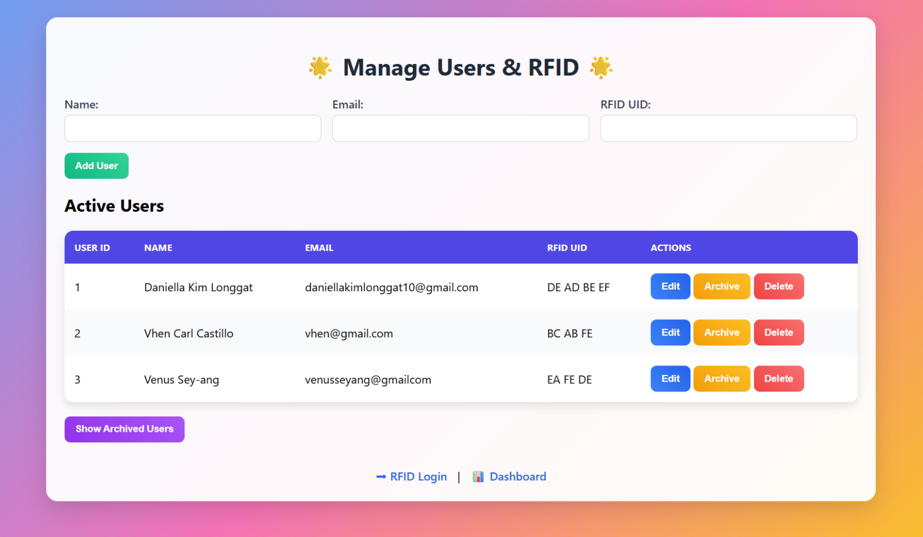

* The picture below shows the edit functionality.

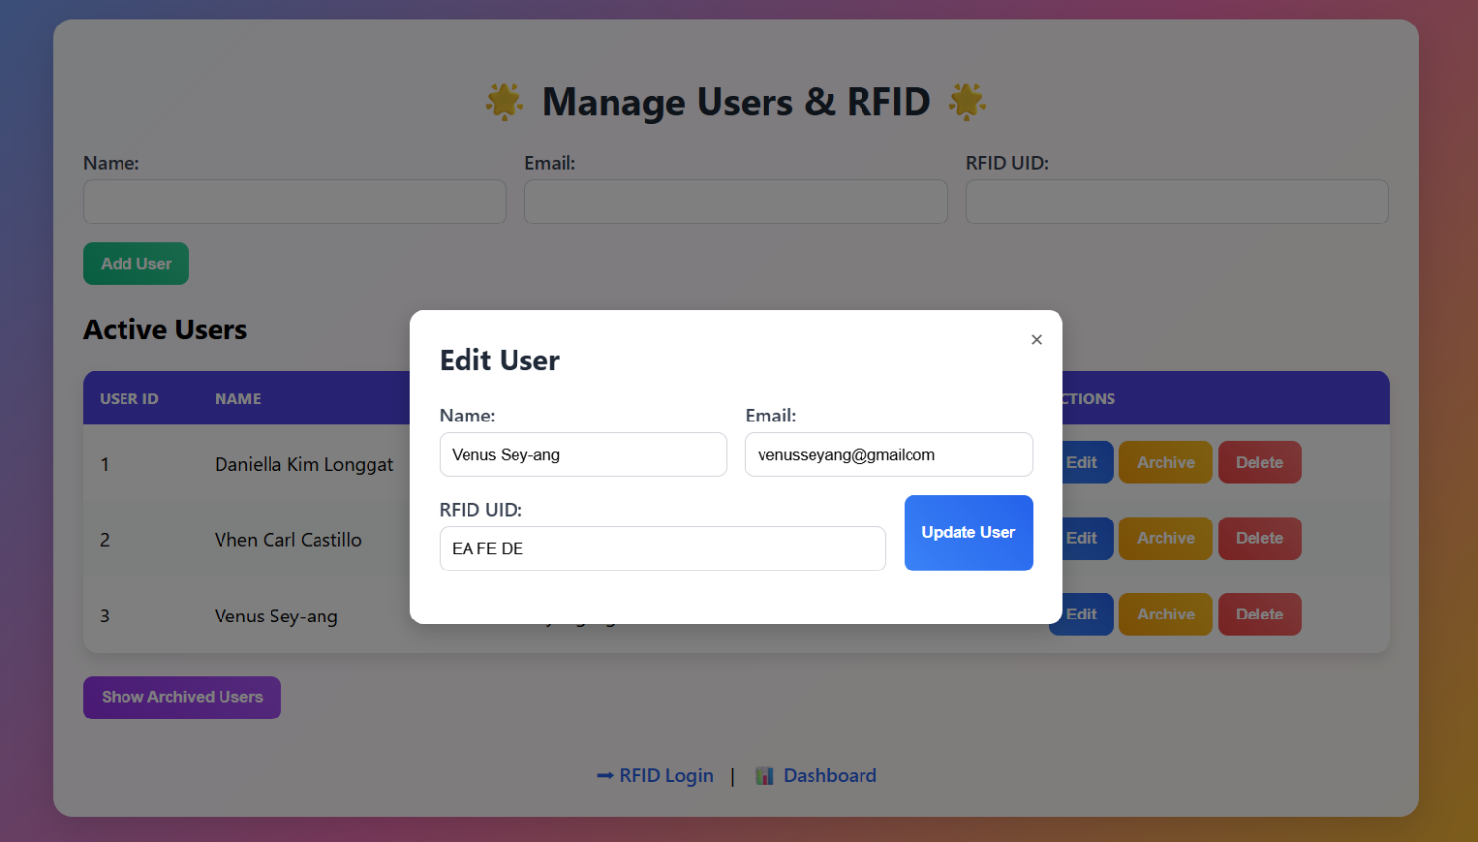

* The picture below shows system dashboard, monitoring for total users, available ports and system status.

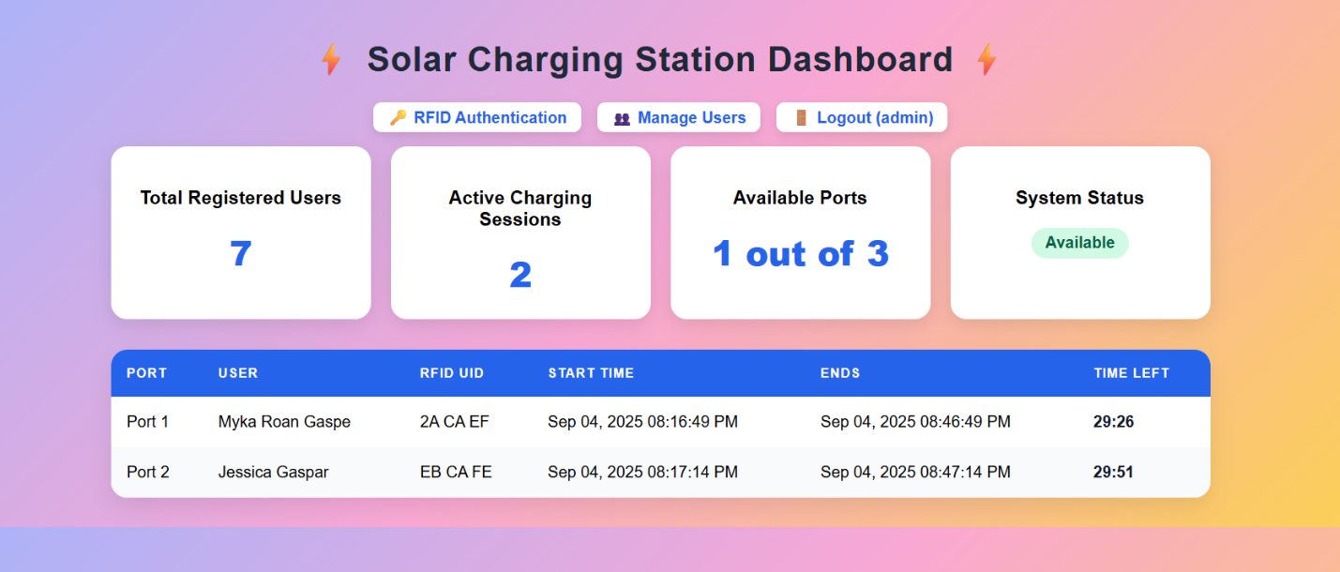

* The pictures below are the solar panel set up. Cellphone can already charge in controller.

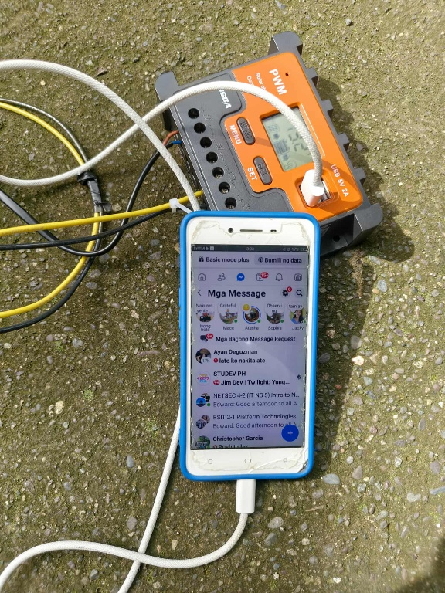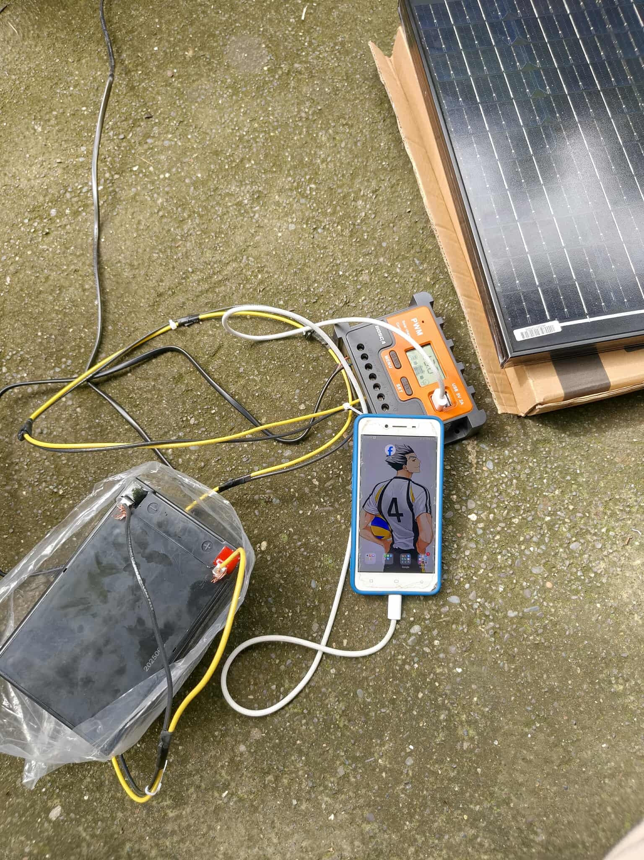

**V. Issues and Challenges Encountered**

Describe any difficulties or blockers experienced during the sprint.

* During Sprint 2, we faced several difficulties in both our system and prototype. In the system, one programmer’s laptop had limited storage, and some features required extra research and troubleshooting. For the prototype, we struggled with limited knowledge in solar setup and delays in shipping materials due to weather. Time management was also a challenge, as it was hard to balance feature development, code reviews, prototype building and documentation within the sprint timeline.

**VI. Actions Taken to Address Issues**

Explain how the challenges were managed or resolved.

* To address these challenges, we used other groupmates’ laptops and did additional research and testing to integrate and ensure the new features worked well. For the prototype, we bought some materials from physical stores and asked help from a solar specialist to guide us in setting up the solar panel for charging.

**VII. Reflection / Self-Evaluation**

Provide a short reflection on what went well, what could be improved, and lessons learned.

* In Sprint 2, we faced issues in our system, prototype, and budget, which affected our finances. We even missed some classes to work on the setup. Despite these challenges, we learned how to debug effectively, organize our tasks, and improve our coding practices. With our adviser’s feedback, we enhanced the system’s quality. Overall, this sprint taught us the importance of teamwork, continuous testing, and proper planning in building a reliable system.

**VIII. Adviser’s Comments**

____________________________________________________________________________________________________________________________________________________________________________________________________________________________________________________________________________________________________________________________________________________

**Adviser’s Printed Name & Signature: ENGR. FREDERICK VON A. IBASCO, MSIT**

**Date:**

**Code Review Checklist**

**I. Project Information**

* **Project Title:** Solar Powered Charging Station with RFID Authentication and Real Time Monitoring
* **Team Name / Individual Developer:**
* Venus M. Sey-Ang – Documenter
* Daniella Kim S. Longgat - Programmer
* Vhen Carl M. Castillo – Quality Assuror
* **Course / Section:** BSIT 4-2 NETSEC
* **Sprint Dates:** [AUGUST 28] – [SEPTEMBER 05]

**Feature/Module Reviewed:**  
**Date:**

| **Criterion** | **Yes/No** | **Comments** |
| --- | --- | --- |
| Code is clean and readable |  |  |
| Functions/methods are properly modular |  |  |
| Code follows naming conventions |  |  |
| No security vulnerabilities present |  |  |
| Meets system requirements |  |  |

**Adviser’s Printed Name & Signature: ENGR. FREDERICK VON A. IBASCO, MSIT**

**Date:**

**Adviser Consultation Log**

**Project Title: Solar Powered Charging Station with RFID Authentication and Real Time Monitoring**

**Student Name / Team:**

Venus M. Sey-Ang – Documenter

Daniella Kim S. Longgat - Programmer

Vhen Carl M. Castillo – Quality Assuror

**Week Num:**

**Date:**

| **Date** | **Participants** | **Summary of Discussion** | **Feedback from Adviser** | **Agreed Action Items** | **Target Deadline** |
| --- | --- | --- | --- | --- | --- |
|  |  |  |  |  |  |
|  |  |  |  |  |  |
|  |  |  |  |  |  |
|  |  |  |  |  |  |
|  |  |  |  |  |  |
|  |  |  |  |  |  |
|  |  |  |  |  |  |

**Adviser’s Name & Signature: ENGR. FREDERICK VON A. IBASCO, MSIT**

**Date:**