[MCB User Management Application]
Architecture/Design Document

Table of Contents
1 Introduction 3
2 Design Goals 4
3 System Behavior 5
4 Logical View 5
4.1 High-Level Design (Architecture) 5
4.2 Database Design 6
4.3 Detailed Class Design 6
5 Process View 6
6 Physical View 6
7 Use Case View 6

Change History
Version: 1.0
Modifier: Sahithi Kandakatla, Bikash Jyotirmaya choudhury
Reviewer: Venu Vinjamoori
Date: May12th, 2019
Description of Change: Initial Design & Architecture Draft
______________________________________________________
Version: <x.y>
Modifier: <Name>
Date: mm/dd/yyyy
Description of Change: <What was modified/added?>

Introduction

Architecture and Design
This document being created to help the readers(developers/end users) to understand the overall design and architecture of MCB User Management Application.
MCB User Management Application is useful where system and organization administrators use a combination of user logins, privileges, permissions and roles(role-based access control) to manage Data Director users.User based access control provides management of users and the tasks(services) that they can perform on objects.At the system level only, we can grant and revoke roles and permissions on organizations and on database groups,databases and templates within organization.
Roles are sets of permissions required to perform particular jobs.Jobs are sets of tasks that a user with a particular role is responsible for performing such as the set of tasks that are the responsibility of a database administrator.System and organization administrators define roles as part of defining security policies,and grant the roles to users.
1.To add a user to a job,the system and organization administrator grants the role to the user and by making role-based access active,user can be added to a job.
2.To remove a user from a job, the system and organization administrator revokes the role from user and by making role-based access inactive, user can be removed from a job.
3.To add a service to a user, the system and organization administrator grants the role to the user and by making role-based access active,service can be added to a user.
4.To revoke a service from user,the system and organization administrator grants the role to the user and by making role-based access inactive,service can be removed from a user.

The purpose of the architecture/design document is to explain the organization of the code. A well-written architecture document will make it easier for new programmers to become familiar with the code.

The architecture/design document should identify major system components and describe their static attributes and dynamic patterns of interaction.

Software architecture and designs are typically expressed with a mix of UML models (class and sequence diagrams being the two most common) and prose. Dataflow diagrams are also helpful for understanding the interaction between components and overall flow of data through the system.
About this Template
This template suggests one way of documenting a software system’s architecture/design. You aren’t required to include every section in this template nor all the content in the sections you do include. However, the document you do submit should pass the following checklist:
- Are design objectives clearly stated? For example, if performance is more important than reusability, this should be made clear at the start of the design specification.
- Does the architecture partition the implementation into clearly defined subsystems or modules with well-defined interfaces?
- Does the architecture express in a clear way the main patterns of communication between subsystems and modules?
- Does the architecture satisfy the requirements?
- Is the architecture traceable to requirements?
- Any models created should either be expressed with a well-known modeling language, or if a well-known modeling language isn't used, the syntax and semantics of the symbols that are used should be defined.

This document describes the architecture and design for the <product name> application being developed for <customer>. <brief description of what the software does>.

The purpose of this document is to describe the architecture and design of the <product name> application in a way that addresses the interests and concerns of all major stakeholders. For this application the major stakeholders are:

- Users and the customer – they want assurances that the architecture will provide for system functionality and exhibit desirable non-functional quality requirements such as usability, reliability, etc.
- Developers – they want an architecture that will minimize complexity and development effort.
- Project Manager – the project manager is responsible for assigning tasks and coordinating development work. He or she wants an architecture that divides the system into components of roughly equal size and complexity that can be developed simultaneously with minimal dependencies. For this to happen, the modules need well-defined interfaces. Also, because most individuals specialize in a particular skill or technology, modules should be designed around specific expertise. For example, all UI logic might be encapsulated in one module. Another might have all business logic.
- Maintenance Programmers – they want assurance that the system will be easy to evolve and maintain on into the future.

The architecture and design for a software system is complex and individual stakeholders often have specialized interests. There is no one diagram or model that can easily express a system’s architecture and design. For this reason, software architecture and design is often presented in terms of multiple views or perspectives [IEEE Std. 1471]. Here the architecture of the <product name> application is described from 4 different perspectives [1995 Krutchen]:

- Logical View – major components, their attributes and operations. This view also includes relationships between components and their interactions. When doing OO design, class diagrams and sequence diagrams are often used to express the logical view.
- Process View – the threads of control and processes used to execute the operations identified in the logical view.
- Development View – how system modules map to development organization.
- Use Case View – the use case view is used to both motivate and validate design activity. At the start of design the requirements define the functional objectives for the design. Use cases are also used to validate suggested designs. It should be possible to walk through a use case scenario and follow the interaction between high-level components. The components should have all the necessary behavior to conceptually execute a use case.

Design Goals

The overall goal is to make web services access restricted to only authorized users by controlling over the User and Service through User-Service Mapping.

Admin can add/delete/update an user , add/delete/update a service and add/delete/update a mapping between user and service .This platform acts as a management tool for user and services .

UserName | MCB Service | Role-Based Access

There is no absolute measure for distinguishing between good and bad design. The value of a design depends on stakeholder priorities. For example, depending on the circumstances, an efficient design might be better than a maintainable one, or vise versa. Therefore, before presenting a design it is good practice to state the design priorities. The design that is offered will be judged according to how well it satisfies the stated priorities.

The design priorities for the <product name> application are:
- The design should minimize complexity and development effort.
- The design should <another design goal>.

System Behavior
Only adminstrator can log in and perform all above said operations to manage access based web service consumption .

Logical View
1.Log in page

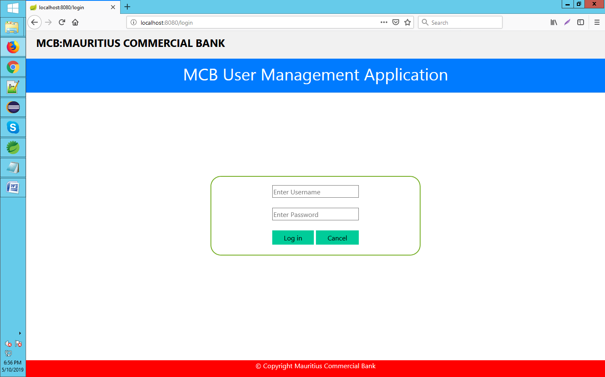

2.Home page

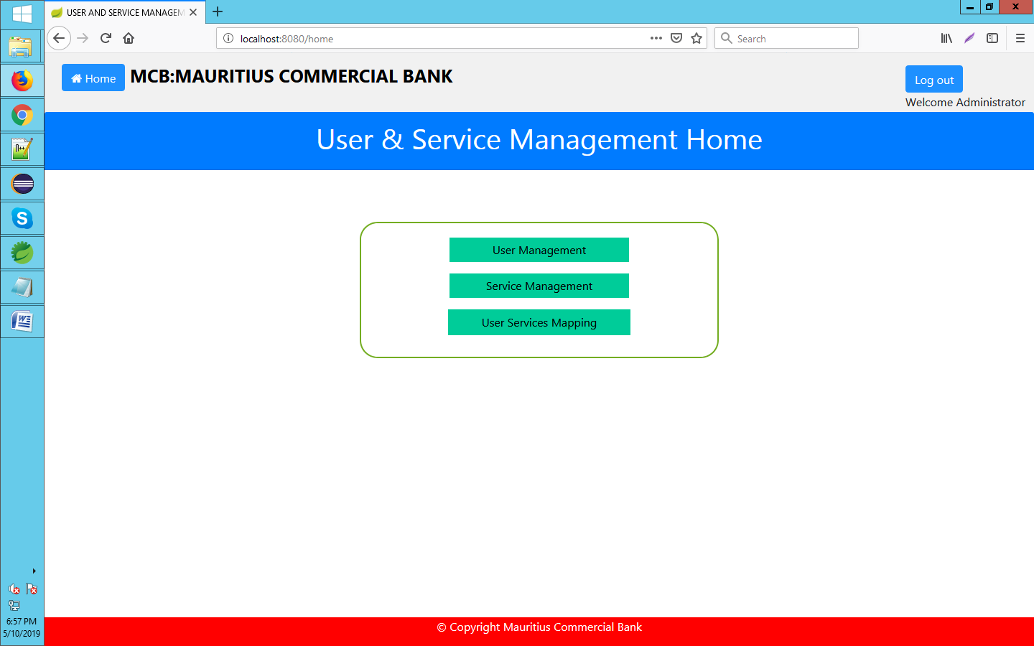

3.Display all users details with delete and edit functionality

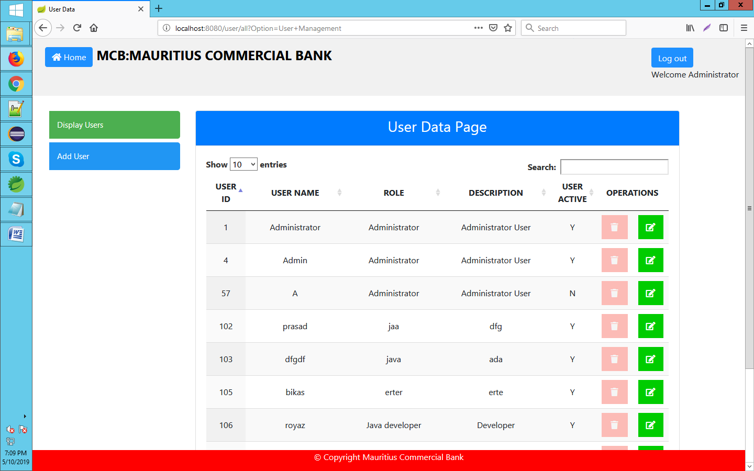

4.Add users

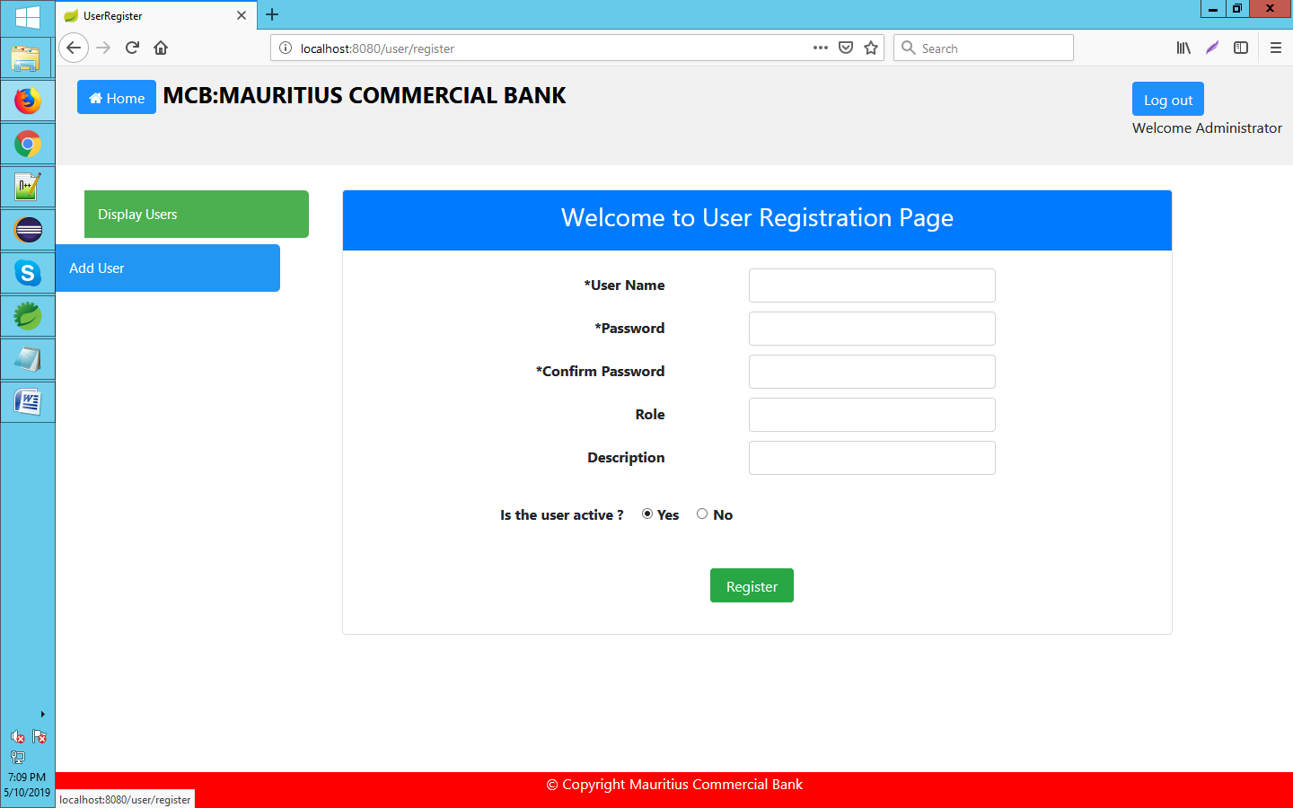

5. Display all service details with delete and edit functionality

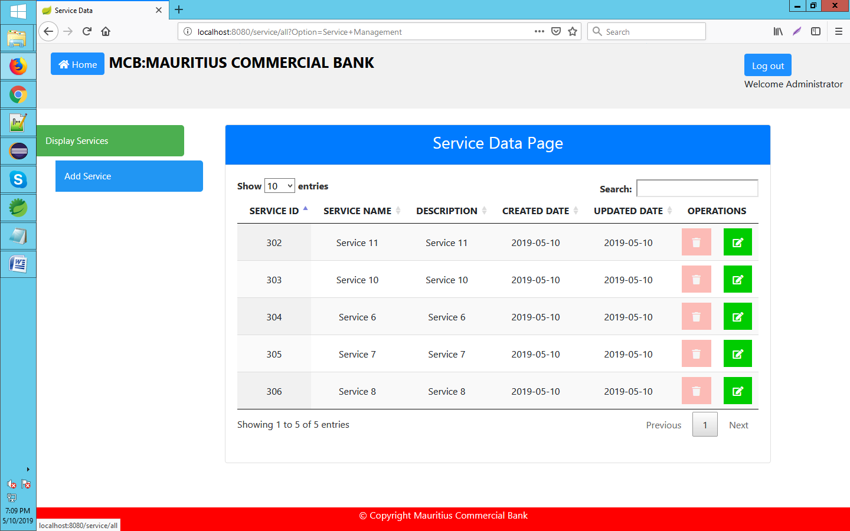

6.Add new services

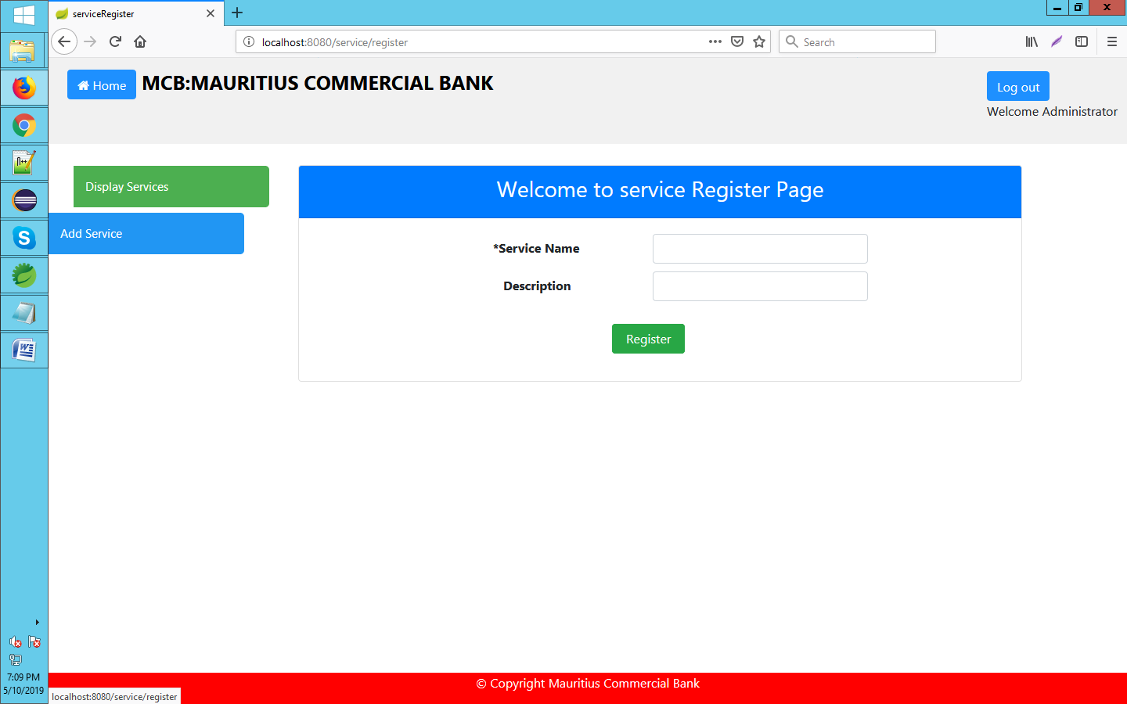

6.Map services to user .

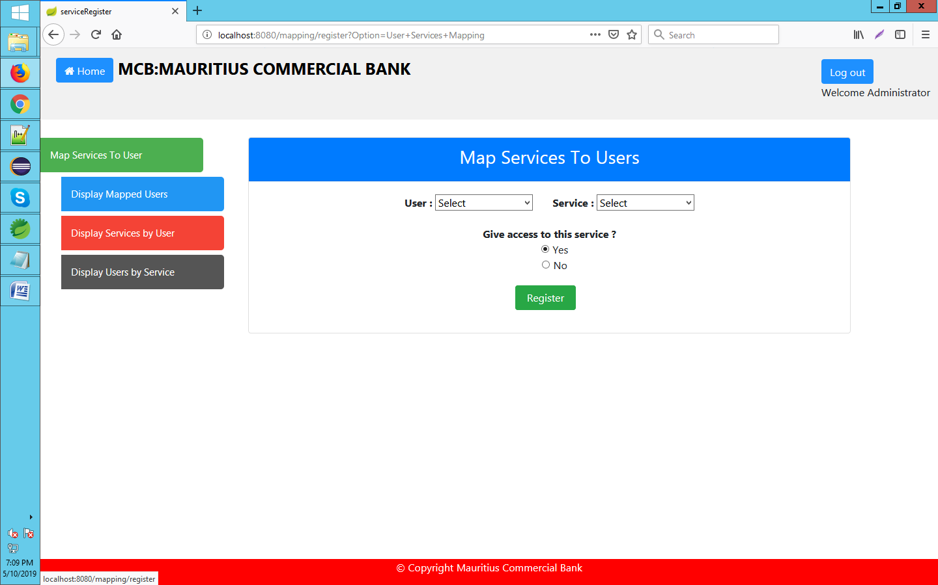

7.Display services mapped to different users

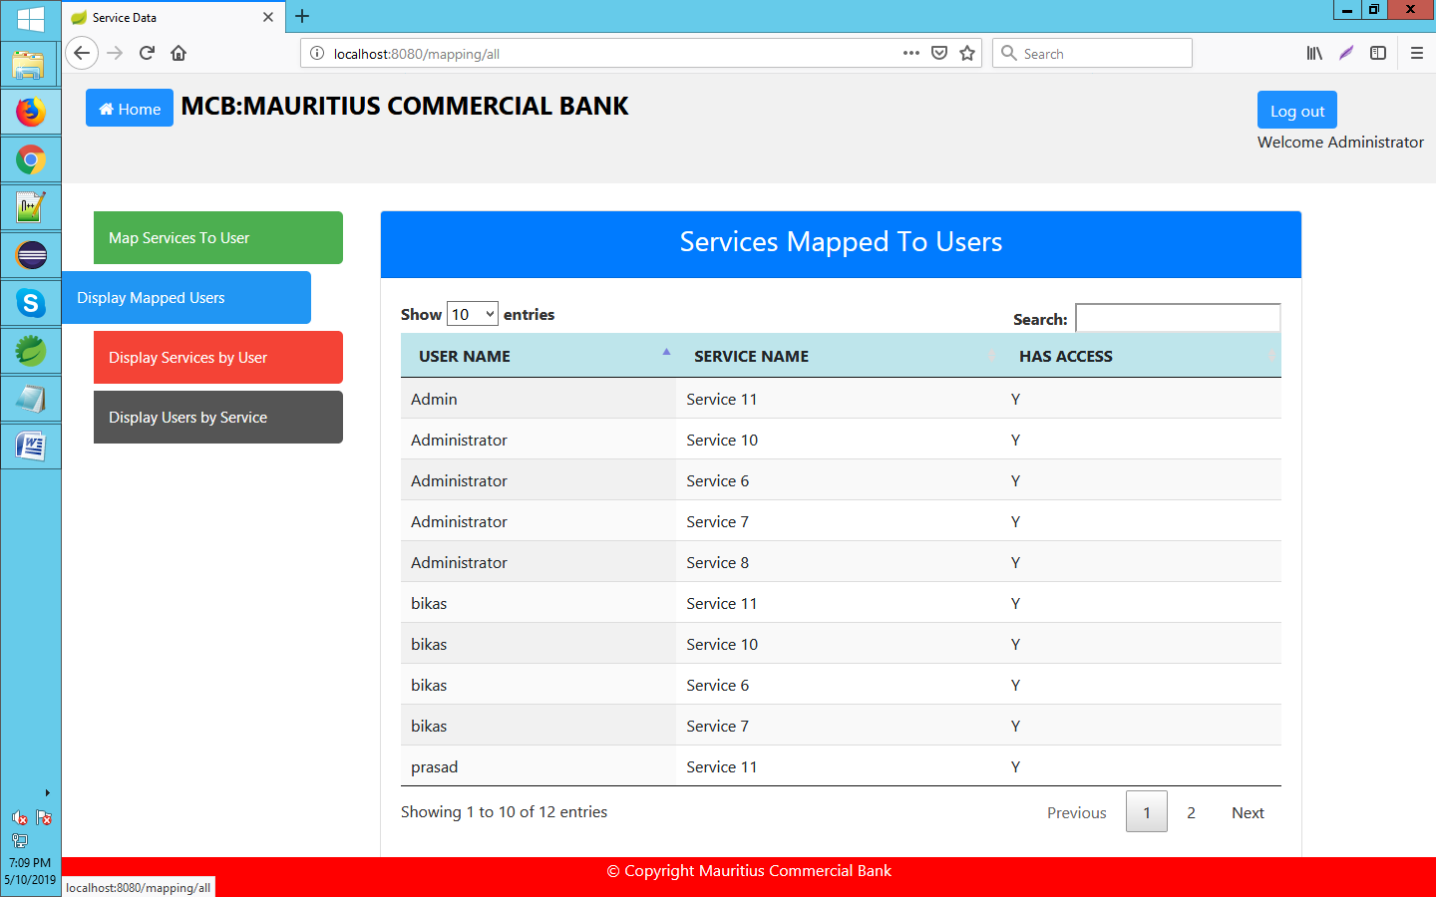

8.Display services mapped to selected user

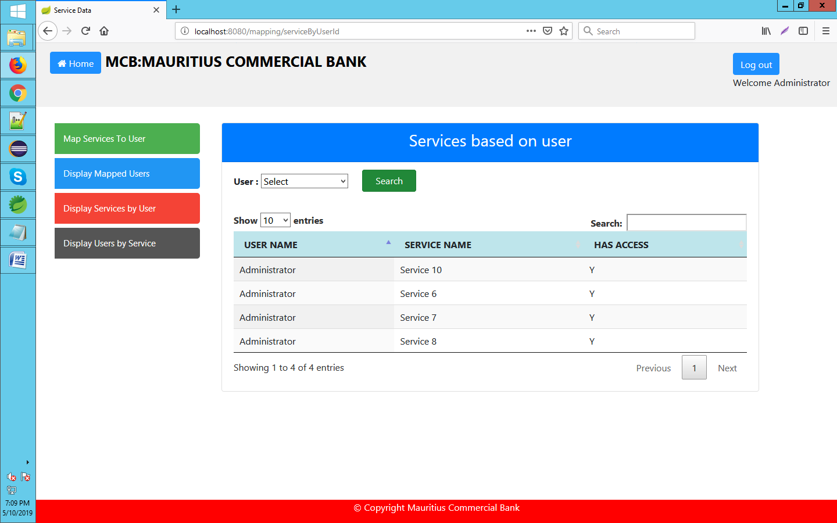

9.Display users mapped to a selected service

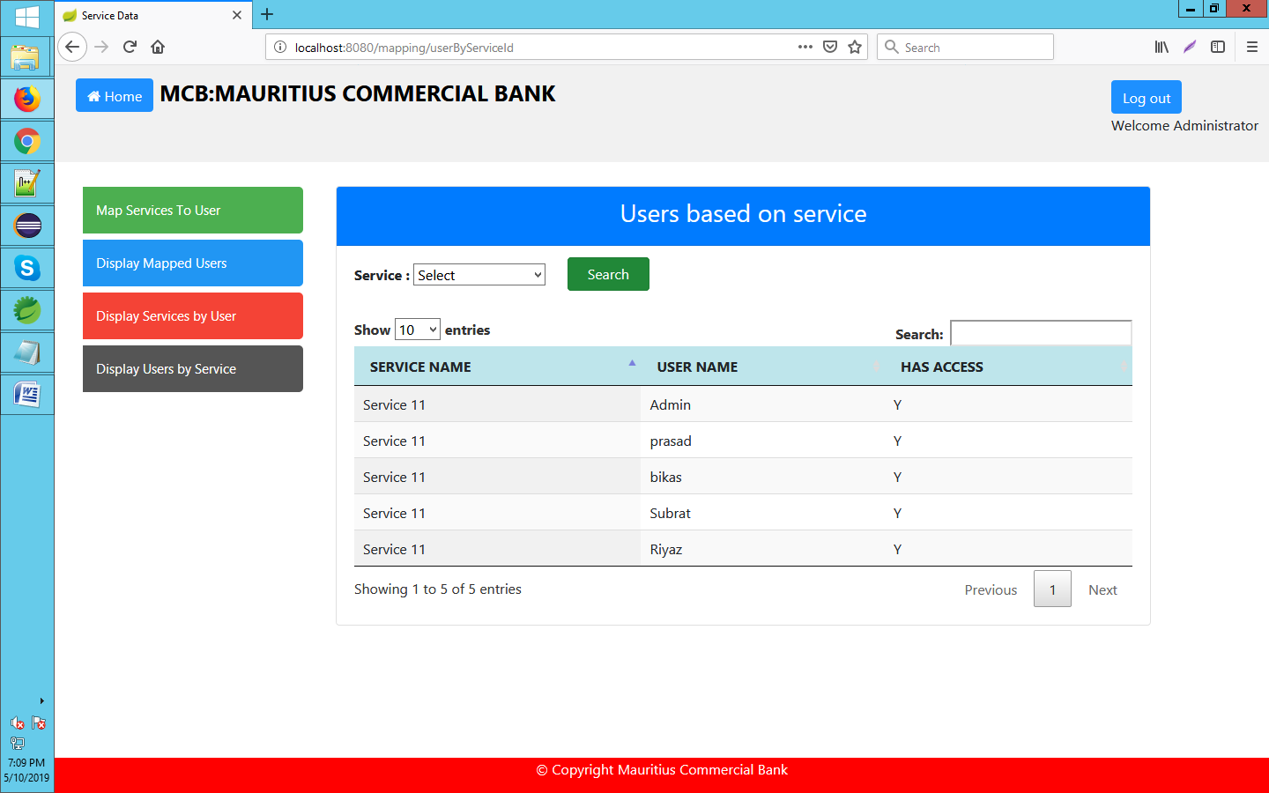

The logical view describes the main functional components of the system. This includes modules, the static relationships between modules, and their dynamic patterns of interaction.

In this section the modules of the system are first expressed in terms of high level components (architecture) and progressively refined into more detailed components and eventually classes with specific attributes and operations.

High-Level Design (Architecture)
The high-level view or architecture consists of <?> major components:

<list and/or show major architecture components>
MCB User Management Application

User Management
Service Management
User Services Mapping

Database

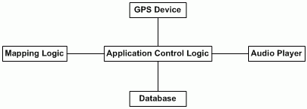
Example:
System Architecture
- The GPS device provides the user’s location on campus (longitude and latitude coordinates). In basic mode, the user’s position is used to decide which buildings to announce.
- The Database is a central repository for data on buildings, their locations and associated audio segments.
- The Audio Player controls playback of audio files.
- Given a position on earth, the Mapping Logic will calculate nearby buildings.
- The Application Control Logic is the main driver of the application. It presents information to the user and reacts to user inputs.

Technology Stack
Spring Boot,Hibernate,ThymeLeaf,CSS,Javascript,Oracle 11g,JBoss server.

Database Design
The MCB User Management Application uses the Oracle database with 3 tables such as User-Info, Service-Info and User-Service-Map Info.

1.User-Info Table:By providing the Primary-Key to the User-Id,making all the data with role-based access(active-Y/inactive-N).

2.Service_info Table:By providing the Primary-Key to the Service-Id,making all data i.e. Service name & Service description.

3. User-Service-Map Info Table:To get the UserName through User-Id,ServiceName through Service-Id along with the Role-Based Access by joining the tables.

1.User-Info Table:

User-ID | UserName | Password-Hash | User-Role | Role Description | User Active | Created Date | Updated Date
Number(10)-PK | Varchar(60) | Varchar(255) | Varchar(20) | Varchar(255) | Varchar(1) | Date | Date

2.Service_info Table:

Service-ID | MCB-Service | MCB-Service Description | Created Date | Updated Date
Number(10)-PK | Varchar(60) | Varchar(255) | Date | Date

3. User-Service-Map Info Table:
(Composite Primary-Key User-ID,Service-ID)

User-ID | Service-ID | Has-Access | Created Date | Updated Date
Number(10)-FK | Number(10)-FK | Varchar(1) | Date | Date

Attached SQL Queries:
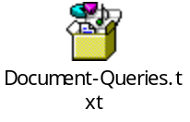

<TO BE FILLED BY SAHITHI>

Detailed Class Design
<For a few key classes you might want to show associations, attributes and methods.>

Process View

<Where are the threads of control in the application?>

Physical View
<Where will major components be physically deployed?>

Use Case View
<Sketch architecturally significant use cases.>

