**Basic ChatBot Application**

* To create chatbot application, it requires IBM Cloud account.
* Url to create account for IBM Cloud : <https://cloud.ibm.com/registration>

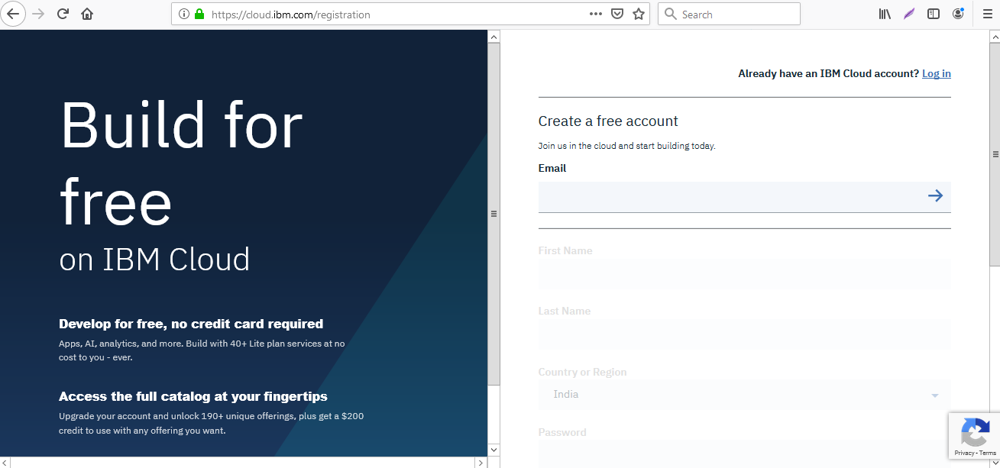

* After logging in navigate to Watson section.

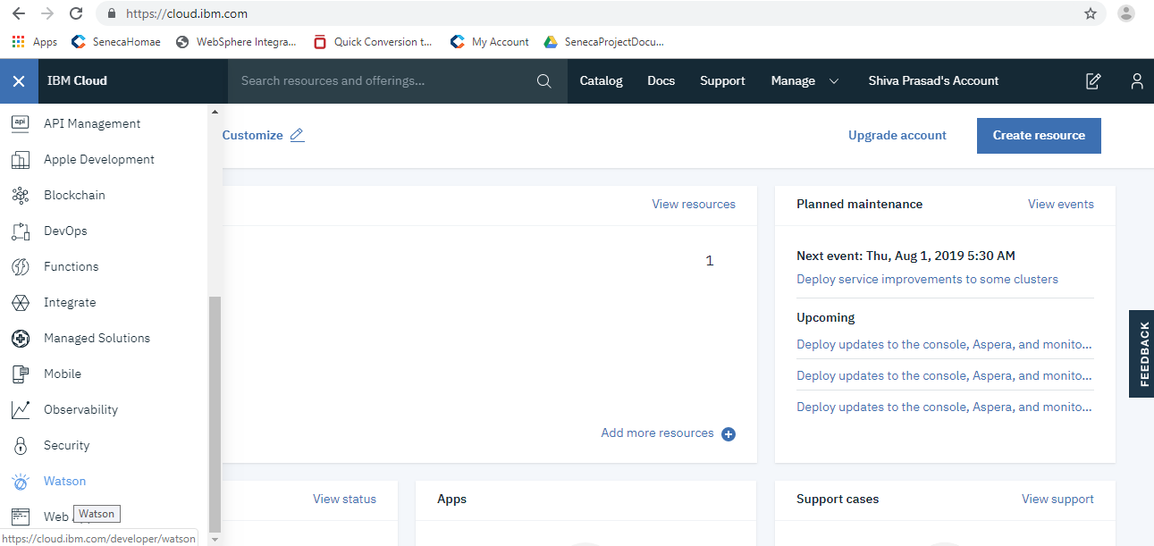

* Below "Build a chatbot" click on get started button.

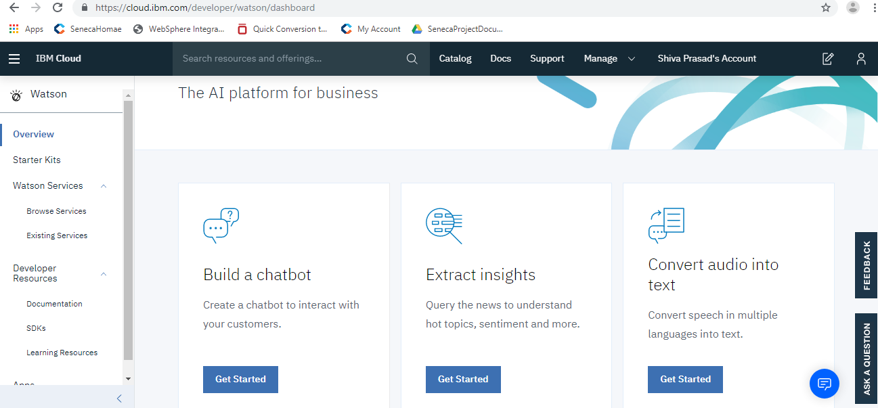

* Provide required service name and click on create.

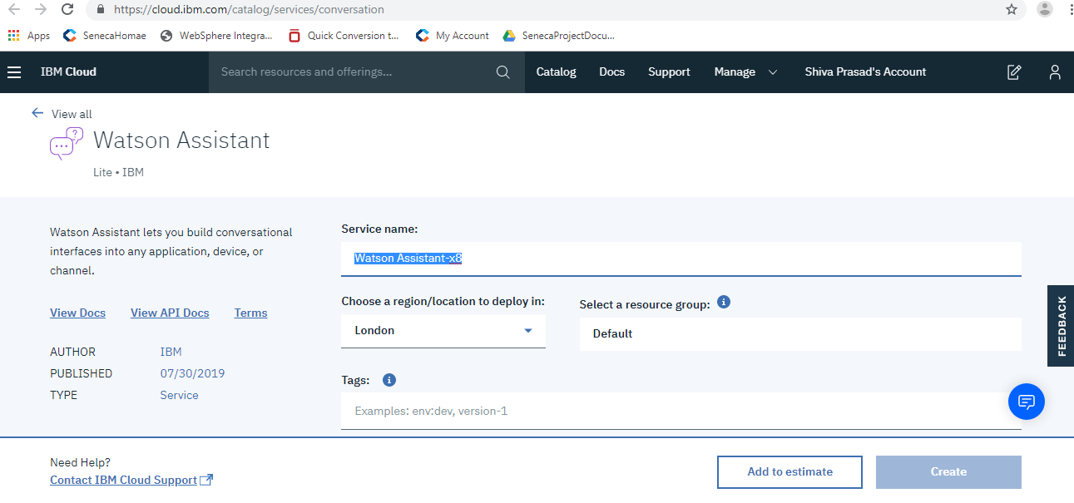

* Now click on Launch Watson Assistant.

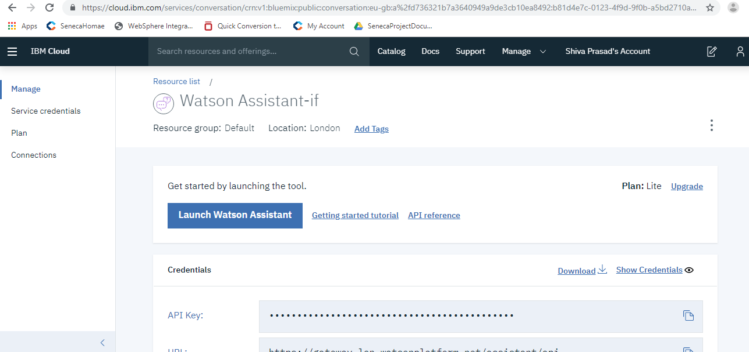

* Click on create assistant.

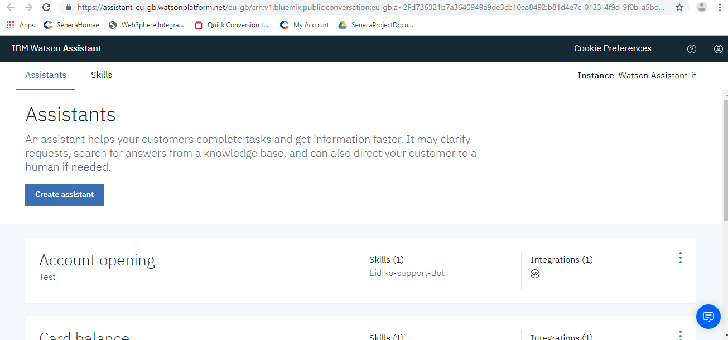

* Create an assistant by providing a name.

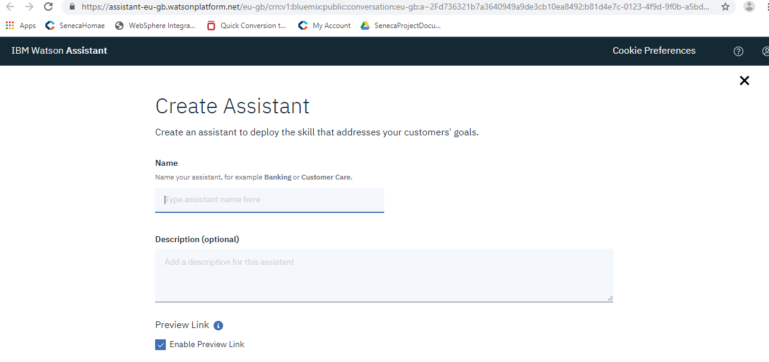

* Click on add dialog skill.

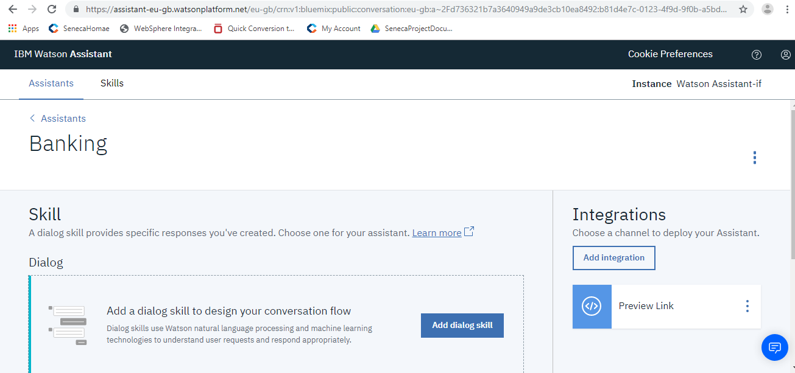

* We can create a new skill by clicking on create skill or we can add existing skill by clicking on add existing skill.
* After clicking on create skill, provide required details and click on create dialog skill.

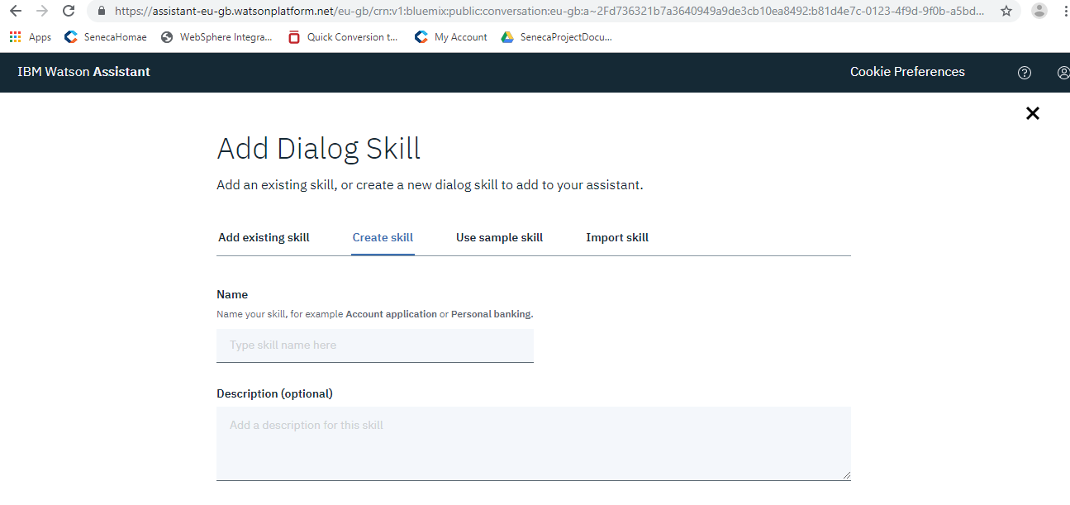

* **Intents:** Intents are purposes or goals that are expressed in a customer's input, such as answering a question or processing a bill payment. By recognizing the intent expressed in a customer's input, the Watson Assistant service can choose the correct dialog flow for responding to it.
* Now click on intents and create an intent.

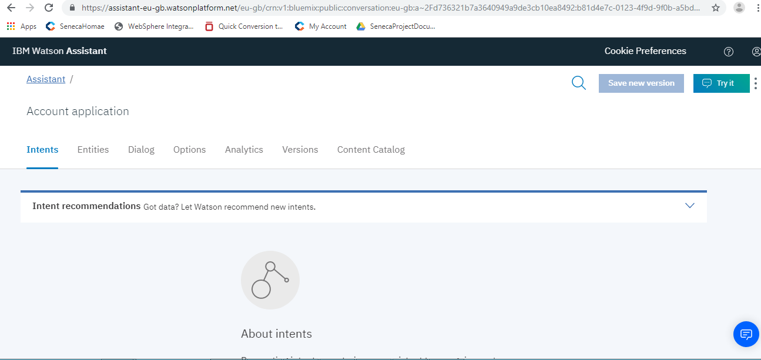

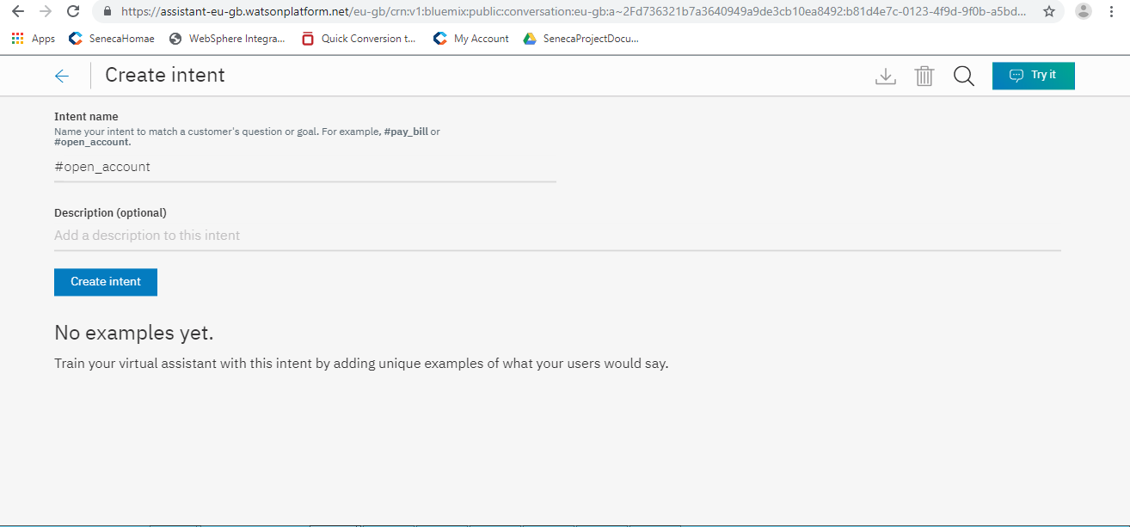

* After creating intent we need to train the bot by adding few user examples. It is because the bot should identify the question which is asked by user.

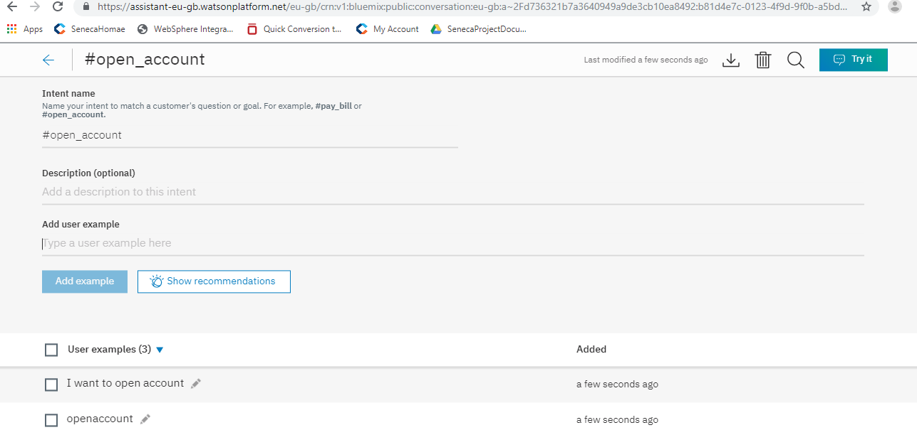

* **Dialog:** The dialog uses the intents that are identified in the user's input, plus context from the application, to interact with the user and ultimately provide a useful response.
* Click on dialog and create a dialog.

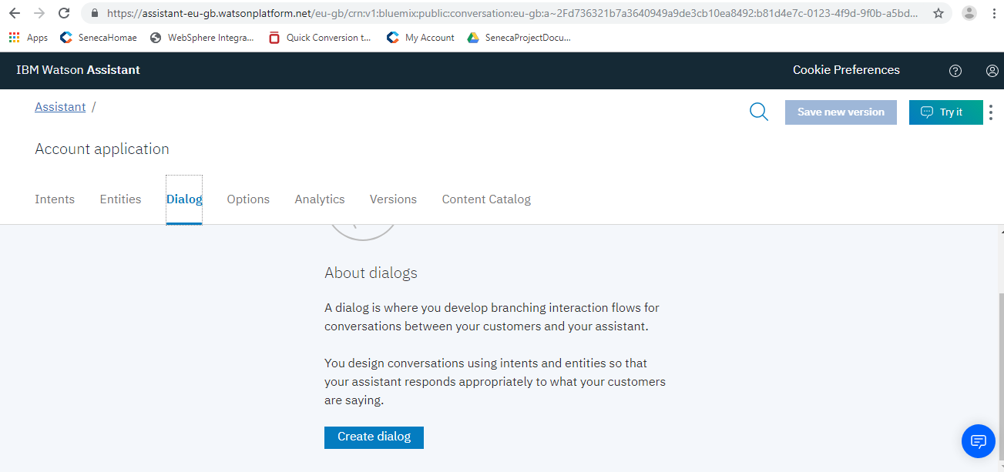

* Add a child node to welcome page and provide a name and in "If account recognizes" section, provide the intent name which is created above.

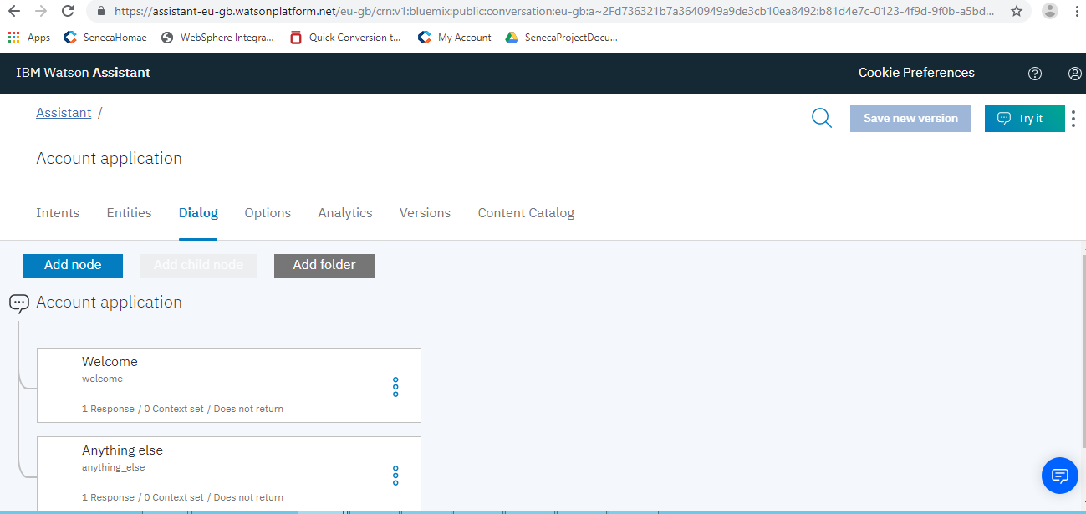

* Add response in "Then respond with" section. It will be the response to that particular intent to the user in the chatbot. It can be extended as per the requirement.

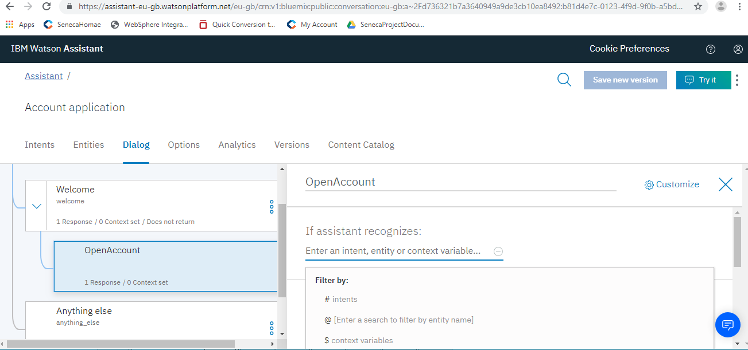

* **Entities:** Entities represent information in the user input that is relevant to the user's purpose.
* In entity section there will be two sections one is to create a new entity and the second one is to use existing entities.

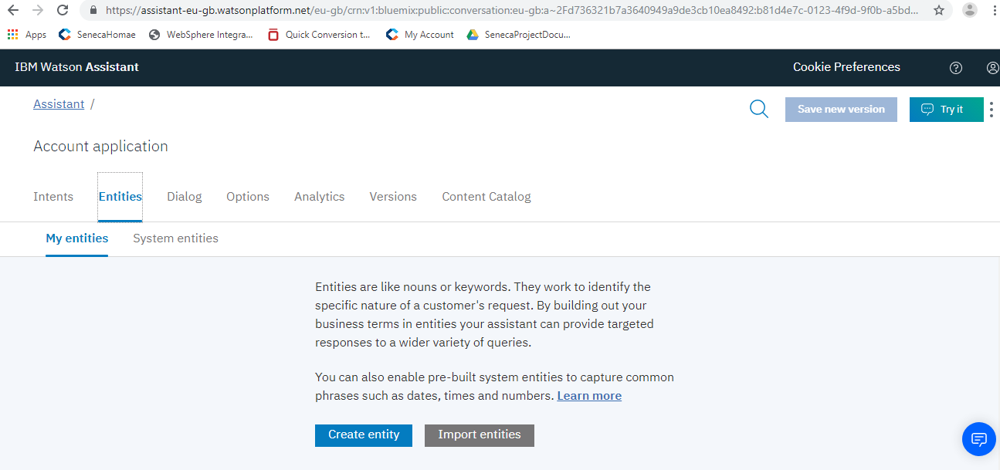

* If you want to use existing entities you need to enable the existing entities (depends on requirement).

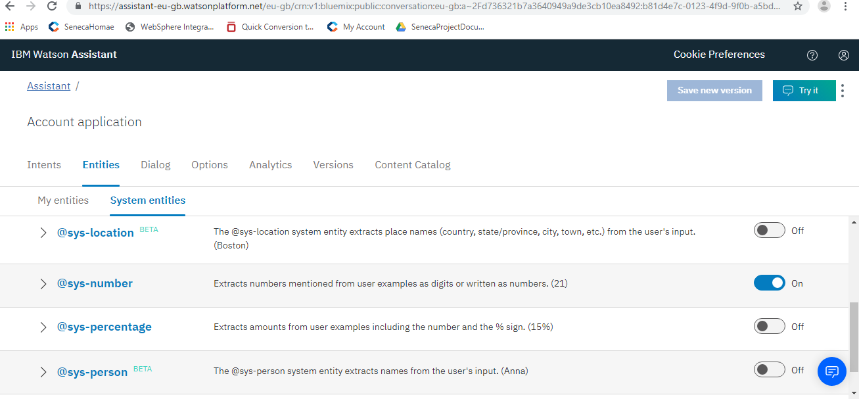

* If it is required to create new entity, after clicking on create entity add value names. Add synonyms if required.

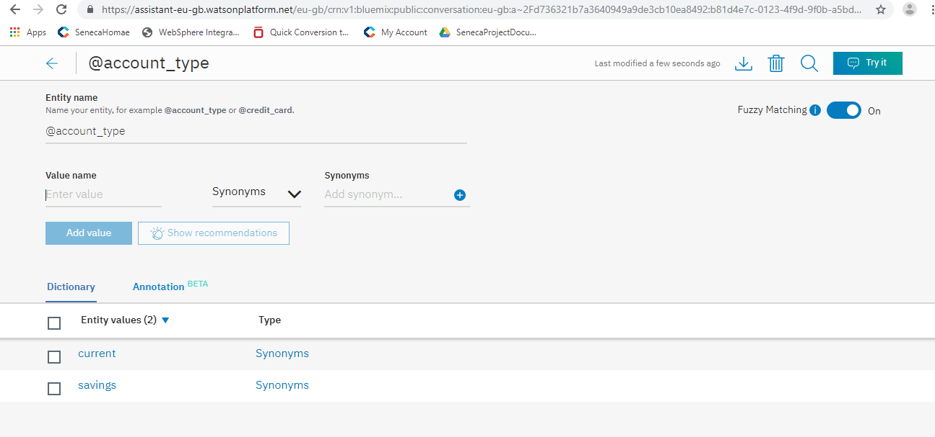

* We can add these entities in the dialog (depends on requirement).
* Everything that is created can be tested in try it section.

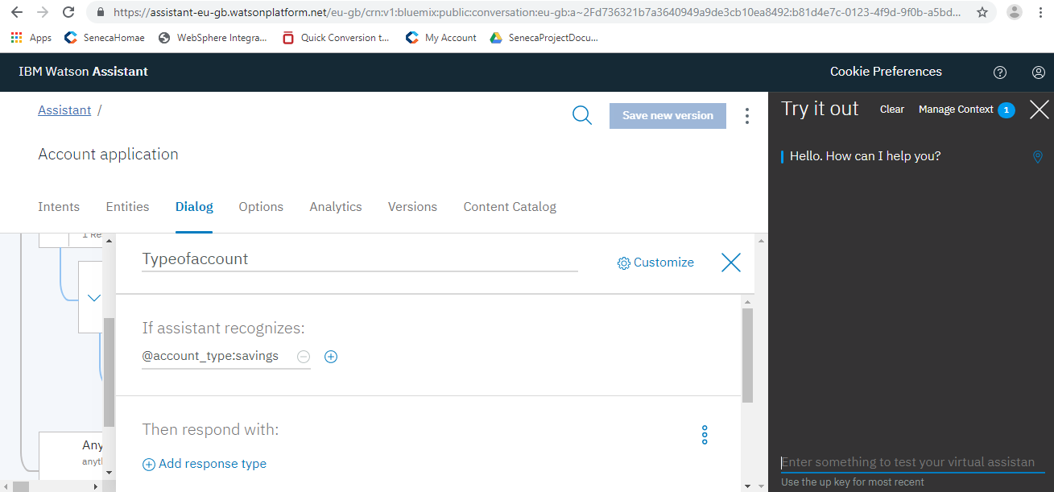

Creating a service to get a value of a parameter by sending a parameter:

* Required : STS IDE ,Mysql Database.
* Create a service using spring boot.
* Service should accept a parameter as input and return a value of different parameter.
* Create a table in database with fields including these two parameters.
* In chat-bot, go to dialog section and in "Then set context" section find json editor and add parameters which are required to send to service, add user name and password which are present in functions-->actions. This is to send chat-bot parameters to function(node.js). Include result parameter too, to display result in the chat-bot.
* Go to Functions -->Actions section in IBM cloud and create a function in node.js.
* Function is to get parameters from chat-bot and send them to the service, get result from service and send it to chat-bot.
* Service returns a parameter and you need to configure dialog in chat-bot to display the result. The output will be displayed in chat-bot when the required parameter is given as input.