COMPUTER ARCHITECTURE | COURSE PROJECT REPORT
Memory-Centric Computing Architecture
Runtime Computation Placement Between a Host Processor and Near-Memory Processing Units
Design, discrete-event simulation and evaluation of MemCentric-Sim
Submitted by: [Student name] ([Roll number])
Course: Computer Architecture
Institution: Indian Institute of Information Technology, Design and Manufacturing, Kancheepuram
Source code: github.com/venuvivek-byte/memcentric
Date: November 2026
Abstract
Moving data between memory and the processor now costs more time and energy than computing on it. Near-memory processing addresses this by placing simple compute units next to the DRAM banks, but it is not a universal answer: those units are slower than a host core, and a kernel that reuses its data heavily runs better on the host. The right place to run a piece of computation therefore depends on the data it touches, where that data currently lives, and how busy the shared interconnect is at that moment.
This report presents MemCentric-Sim, a discrete-event simulator of a heterogeneous system in which a 4-core SIMD host with a three-level cache hierarchy is connected over a CXL-style serial link to a 32-bank DRAM module with eight processing elements on its logic die. A runtime placement engine samples each task's address stream, estimates its working set, checks which of its lines are already cached (and dirty) on the host, measures DRAM bank load and reads the current link backlog. An analytical cost model, parameterised from the simulated hardware, then predicts the completion time on each side, and the task is dispatched to the faster one. Profiling and decision costs are charged to the task, and offloading a task forces a coherence write-back of its dirty host lines.
On seven workloads, dynamic placement achieves 23.68x to 43.45x speedup on streaming and random-access kernels, avoids the 1.95x slowdown that static offloading causes on matrix multiplication, and reaches 99.5% of an exhaustive oracle on a mixed-dataset session, choosing the same target as the oracle in all eight phases. A roofline policy that uses operational intensity alone reaches 80.8% on the same session. Sampling 10% of the address stream costs 0.45% of runtime; the approach stops paying off once profiling costs about eight cycles per sampled access.
Keywords: processing-in-memory, near-memory computing, computation placement, discrete-event simulation, data movement, cache coherence, runtime scheduling
Contents
1 Introduction 5
1.1 Motivation 5
1.2 Problem statement 5
1.3 Objectives 5
1.4 Contributions 6
1.5 Organisation of the report 6
2 Background and Related Work 7
2.1 The cost of data movement 7
2.2 Near-memory and in-memory processing 7
2.3 Deciding where to compute 7
2.4 Position of this work 8
3 System Architecture 9
3.1 Overview 9
3.2 Host processor and cache hierarchy 10
3.3 Interconnect 10
3.4 DRAM subsystem 10
3.5 Near-memory processing units 10
3.6 Coherence on offload 11
4 Runtime Placement Engine 12
4.1 Overview 12
4.2 Sampled micro-profiler 12
4.3 Analytical cost model 13
4.4 Placement policies 13
5 Simulation Methodology 15
5.1 Discrete-event engine and task life cycle 15
5.2 Workloads 15
5.3 The mixed-dataset session 16
5.4 Metrics 16
5.5 Experimental setup 16
6 Implementation 17
6.1 Software organisation 17
6.2 Verification 17
6.3 Visualisation 18
7 Results 19
7.1 Overall performance 19
7.2 Data movement and energy 20
7.3 Mixed-dataset session 21
7.4 Accuracy of the cost model 22
7.5 Feasibility and overhead of dynamic placement 22
8 Discussion 25
8.1 When does dynamic placement pay off? 25
8.2 Limitations 25
8.3 Threats to validity 25
9 Conclusion and Future Work 26
References 27
Appendix A Reproducing the Results 28
Appendix B Complete Results 29

1 Introduction

1.1 Motivation
For several decades processor throughput has grown faster than memory bandwidth and latency have improved. The result, often called the memory wall [1], is that many modern workloads spend most of their time and energy moving data rather than operating on it. Reading a 64-byte line from off-chip DRAM costs on the order of a nanojoule, while a double-precision addition costs a few picojoules [2]. For data-intensive kernels such as database scans, graph traversal and embedding lookups, the processor is mostly waiting on the memory system.
Near-memory processing (also called processing-in-memory, PIM) moves part of the computation to logic placed beside the DRAM arrays, typically on the base die of a 3D-stacked memory [3], [4]. A kernel running there can read the banks at internal bandwidth and send only its result across the external link. The cost is that these units are small: they run at a lower clock, with narrow datapaths and no large caches. A kernel with high data reuse, such as dense matrix multiplication, runs considerably slower on them than on a host core whose caches already capture that reuse.
Neither "always on the host" nor "always in memory" is correct in general. The same system may in one minute process a reusable dataset, a streaming dataset and a randomly accessed dataset, and the best location for each piece of work changes with it. It also changes with system state: data that the host has just produced is already in its caches, and a link that is busy with I/O traffic makes every host miss more expensive. A memory-centric architecture therefore needs a runtime component that decides, task by task, where computation should happen.

1.2 Problem statement
The goal of this project is to design an architecture that dynamically decides where computation should take place based on the location, movement, reuse and characteristics of the data involved. The design must be simulated with memory, compute resources, data movement, computation placement and runtime decision-making explicitly interacting, so that both the feasibility and the overhead of dynamic placement can be evaluated.

1.3 Objectives
- Model a heterogeneous system consisting of a host processor with caches, an external memory interconnect, a banked DRAM subsystem and near-memory processing elements, with timing and energy for each component.
- Design a runtime placement engine that observes a task's data (reuse, working set, access pattern, location in the cache hierarchy, DRAM bank distribution) and the state of the interconnect, and selects the execution target.
- Execute all tasks through a discrete-event engine so that the state left by one task (cache contents, open DRAM rows, link reservations) influences the next decision.
- Account for the cost of the decision itself, including profiling, and for the coherence work that an offload implies.
- Evaluate the approach against static policies, a roofline heuristic and an exhaustive oracle, and quantify when the overhead of deciding outweighs its benefit.

1.4 Contributions
The main outcomes of the project are:
- A discrete-event simulator, MemCentric-Sim, of a host-plus-PIM system in which caches, interconnect, DRAM banks, PIM units, a background DMA agent and the placement runtime share state across tasks.
- A sampled profiler whose cost scales with the work it performs, and a working-set estimator that remains accurate at a 10% sampling rate.
- A cost model derived from the simulated hardware parameters that accounts for cache residency, coherence write-back, DRAM bank load, row-buffer locality and link congestion.
- A mixed-dataset workload that reproduces the scenario in the problem statement, together with an oracle policy and a sweep of profiling cost that locates the break-even point of dynamic placement.
- An interactive web dashboard and a test suite that verify the key behaviours of the system.

1.5 Organisation of the report
Chapter 2 reviews the background and related work. Chapter 3 describes the simulated architecture and Chapter 4 the runtime placement engine. Chapter 5 covers the simulation methodology and workloads, and Chapter 6 the implementation. Results are presented in Chapter 7 and discussed in Chapter 8. Chapter 9 concludes. Appendices give the commands needed to reproduce every number in this report and the full results for all policies.

2 Background and Related Work

2.1 The cost of data movement
Wulf and McKee observed in 1995 that, if processor and DRAM performance kept improving at their respective rates, average memory access time would eventually dominate execution [1]. Caches hide much of this gap for programs with locality, but they do little for programs that touch large data structures once or in an unpredictable order. Horowitz's energy figures for a 45 nm process show that a DRAM access costs roughly two orders of magnitude more energy than an arithmetic operation [2]. Reducing the number of bytes that cross the processor-memory boundary is therefore a first-order design goal for both performance and energy.

2.2 Near-memory and in-memory processing
3D-stacked memories such as HMC and HBM place a logic die underneath the DRAM layers, connected through thousands of through-silicon vias. This die can host simple processing elements that access the banks at much higher aggregate bandwidth than the external link provides. Tesseract [4] used this organisation to accelerate graph processing, and commercial devices such as UPMEM place small cores inside the DRAM chips themselves [5]. Mutlu et al. provide a broad survey of the field [3]. A recurring observation across this work is that PIM excels on low-reuse, bandwidth-bound kernels and performs poorly on compute-bound kernels with good cache behaviour.

2.3 Deciding where to compute
The roofline model [6] characterises a kernel by its operational intensity, the number of operations per byte of memory traffic. Plotting attainable performance against intensity for the host and for the PIM units gives a crossover point: below it the kernel is bandwidth-bound and benefits from near-memory execution, above it the host's compute capability wins. Figure 2.1 shows the roofline of the configuration modelled in this project. A static threshold on operational intensity is a simple and common placement heuristic, and it is one of the baselines evaluated here.
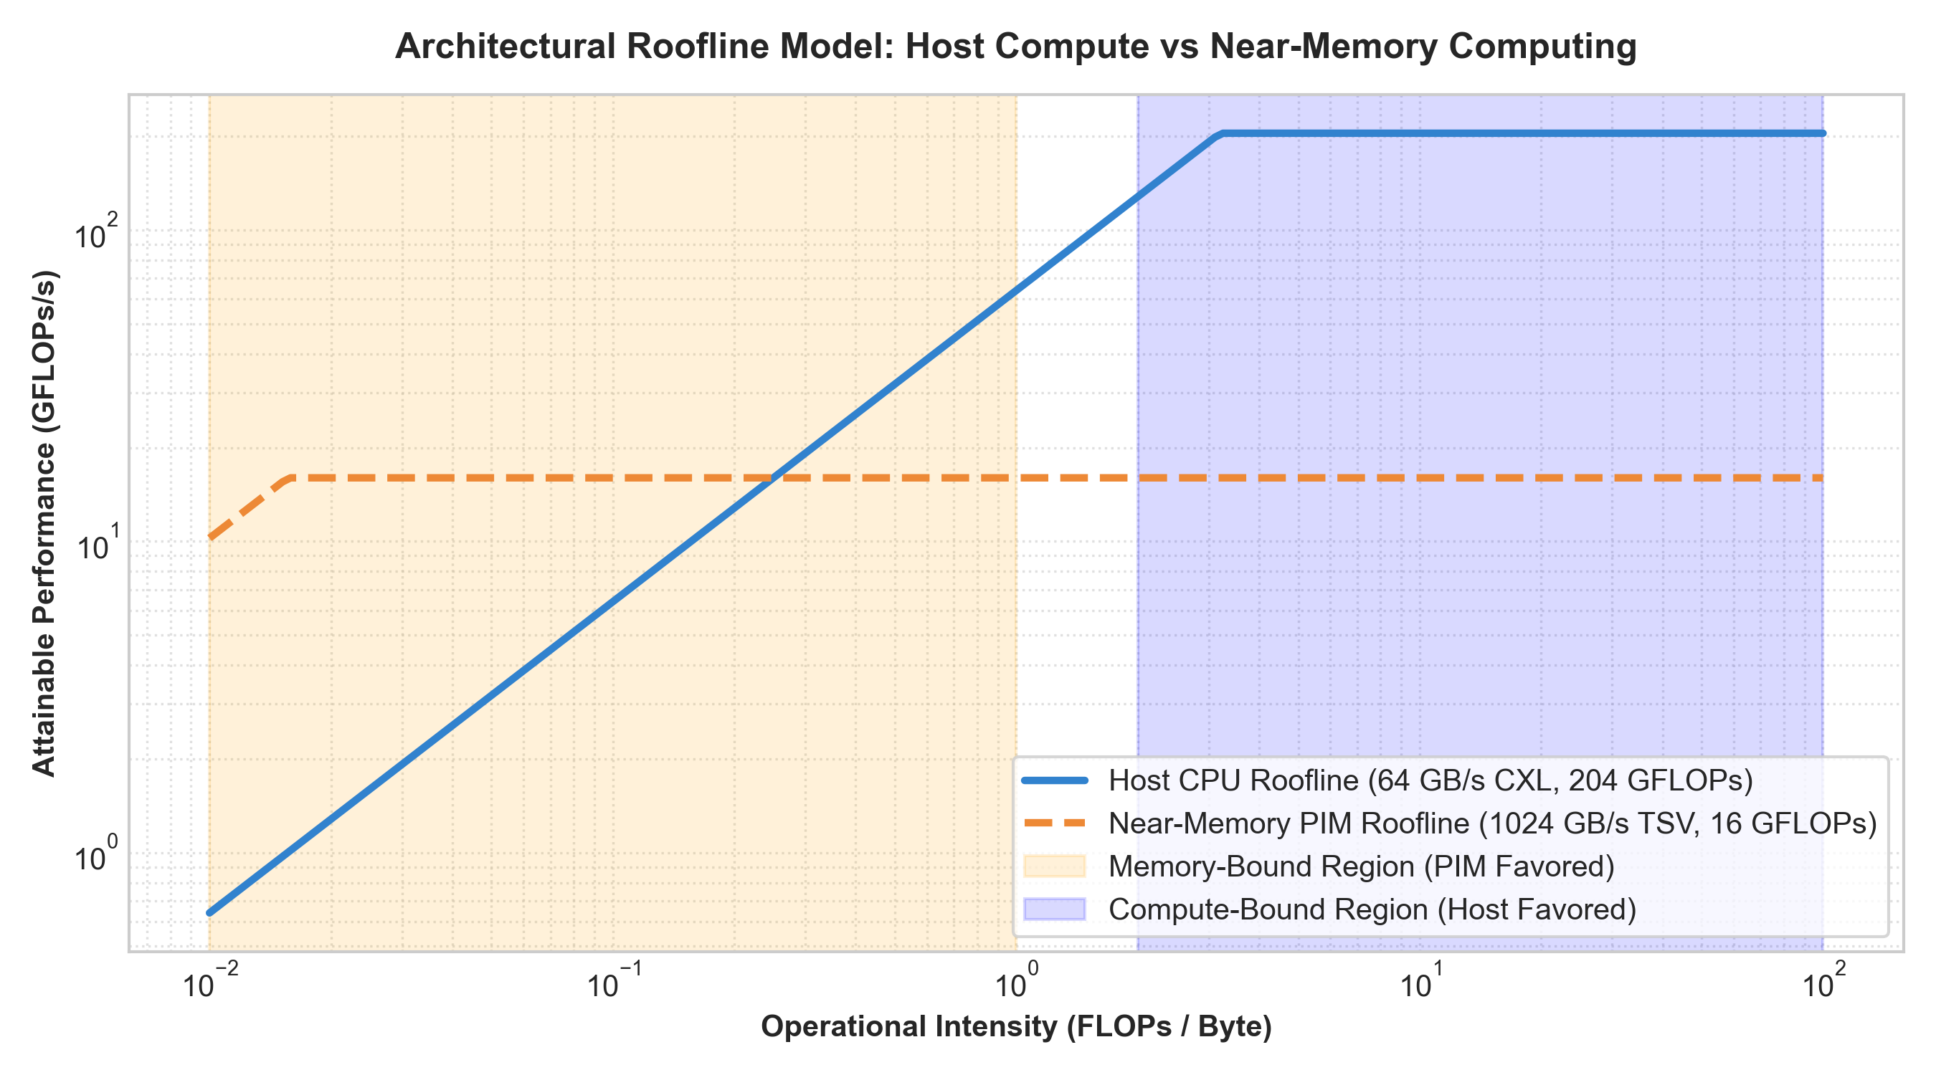
Figure 2.1 Roofline of the modelled host (4 cores, 8-lane SIMD, 64 GB/s link) and near-memory units (8 PEs, internal bank bandwidth).
Operational intensity is a property of the kernel, not of the machine state, and several studies have shown that state matters. PIM-enabled instructions [7] execute an operation on the host when its data is already cached and in memory otherwise, using a locality monitor. TOM [8] combines compiler identification of offload candidates with a runtime decision that considers bandwidth and memory-module load. Offloading also creates a coherence problem: the host may hold dirty copies of the data the PIM unit is about to read. LazyPIM [9] and CoNDA [10] propose speculative and optimistic coherence schemes to reduce this cost, which confirms that it cannot simply be ignored.

2.4 Position of this work
This project does not propose new hardware. It builds a simulation framework in which a placement runtime can be evaluated end to end, with the costs that a real system would pay: the time to profile a task, the coherence write-back on offload, and contention with other traffic on the link. The emphasis is on whether dynamic placement is feasible once those costs are included, and on how far a lightweight analytical model can get compared with an oracle that knows the outcome of both choices.

3 System Architecture

3.1 Overview
Figure 3.1 shows the simulated system. The host processor package contains four SIMD cores, a three-level cache hierarchy and the placement runtime. It reaches main memory through a CXL-style serial link. On the far side, a 3D-stacked memory module contains four channels of eight banks each and a logic die with eight near-memory processing elements (PEs). A background DMA agent, standing in for a network interface or storage controller, shares the same link.
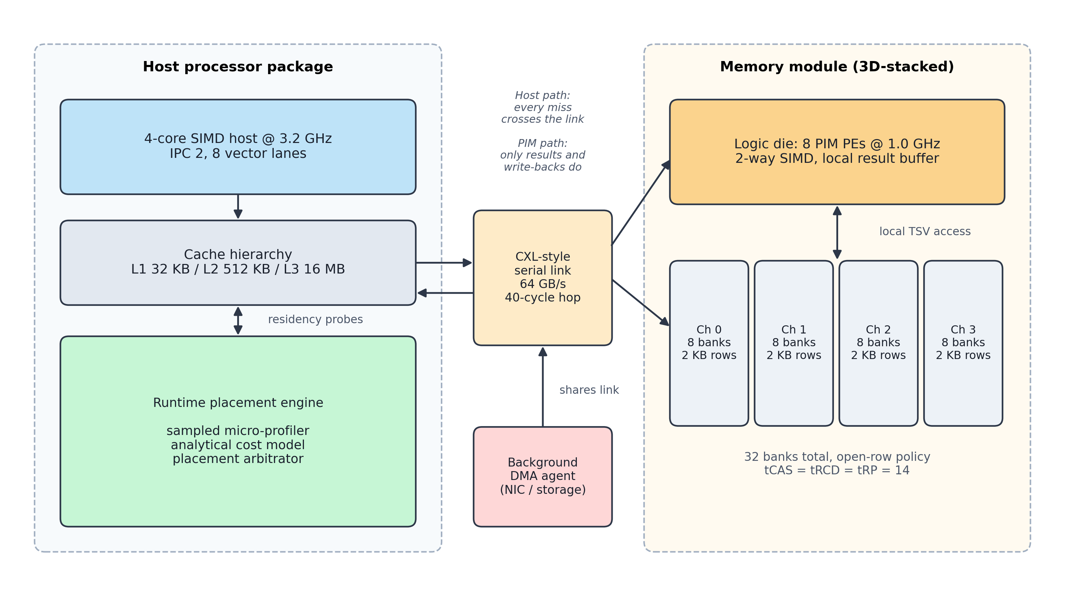
Figure 3.1 Simulated system. On the host path every cache miss crosses the link; on the PIM path only results and coherence write-backs do.
The two execution paths differ in where data moves. On the host path, every miss in the cache hierarchy becomes a request across the link, an access to a DRAM bank and a 64-byte response back across the link. On the PIM path, the PEs access the banks directly, perform the computation on the logic die and return only the result. Table 3.1 lists the main parameters.
Table 3.1 Simulated hardware configuration
Component | Parameter | Value
Host | Cores / clock | 4 cores at 3.2 GHz
 | Issue width / SIMD | IPC 2, 8 vector lanes (64 ops per cycle peak)
 | Power | 65 W active, 10 W idle
Caches | L1D | 32 KB, 8-way, 4 cycles
 | L2 | 512 KB, 8-way, 14 cycles
 | L3 | 16 MB, 16-way, 40 cycles; 64 B lines, LRU, write-back
Interconnect | Bandwidth / latency | 64 GB/s, 40-cycle base latency
 | Energy | 120 pJ per byte transferred
DRAM | Organisation | 4 channels x 8 banks, 2 KB rows, open-row policy
 | Timing | tCAS = tRCD = tRP = 14, tCCD = tBURST = 4 (memory cycles)
 | Energy | ACT 2.4 nJ, PRE 1.4 nJ, RD 0.9 nJ, WR 0.95 nJ per 64 B
PIM | Processing elements | 8 PEs at 1.0 GHz, 2-way SIMD, IPC 1
 | Power | 0.8 W per active PE, 0.5 W idle
DMA agent | Burst granularity | 4 KB packets on the shared link

3.2 Host processor and cache hierarchy
The host executes a task's arithmetic at a throughput of cores x IPC x SIMD lanes for vectorisable kernels (high-reuse and streaming categories) and without the SIMD factor otherwise. Memory accesses go through an inclusive L1/L2/L3 hierarchy with LRU replacement and write-back of dirty lines. Each cache level keeps hit, miss, eviction and write-back statistics. Two operations were added for the runtime: a probe, which reports whether a line is resident and dirty without updating LRU state or statistics, and an invalidate, which removes a line from every level and reports whether it was dirty.

3.3 Interconnect
The link is modelled as a single FIFO resource with a busy-until reservation. A transfer that arrives while the link is occupied waits until it is free; its completion time is the start time plus the serialisation time of its bytes plus the base latency. Requests are 8 bytes and responses 64 bytes. The difference between the busy-until time and the current time is the link backlog, which the runtime reads when a task arrives.
Traffic from the DMA agent occupies the link in exactly the same way but is recorded in separate counters, so that the bytes reported for a workload are only those it moved itself. This distinction is necessary for a fair comparison: background traffic should slow a workload down, but it should not be counted as data the workload moved.

3.4 DRAM subsystem
Physical addresses are interleaved across channels and banks at line granularity. Each bank keeps its open row. An access to the open row costs tCAS; an access to a different row costs tRP + tRCD + tCAS and incurs precharge and activation energy. Banks are independent, so accesses to different banks proceed in parallel, while accesses to the same bank are serialised. Converted to host cycles, a row hit costs 18 cycles and a row conflict 46 cycles.

3.5 Near-memory processing units
A task offloaded to PIM issues all its accesses to the DRAM banks directly. Its memory time is set by the most heavily loaded bank, since banks work in parallel. Its compute time is the operation count divided by the PIM throughput (8 PEs x 2 lanes x IPC 1), scaled by the ratio of host to PIM clock. The final result is sent to the host across the link. A task whose result is a single reduced value therefore moves almost nothing over the link, regardless of how much data it read.

3.6 Coherence on offload
Before a task starts on the PIM units, the runtime invalidates every host-cached copy of the lines the task will touch. Lines that were dirty are written back to DRAM over the link first, because otherwise the PEs would read stale data. These write-backs are real link transfers and are charged to the task. As Chapter 7 shows, this cost decides the placement of data that the host has just produced.

4 Runtime Placement Engine

4.1 Overview
Placement is decided once per task, at the moment the task arrives. The engine has three parts: a sampled micro-profiler that characterises the task and the current location of its data, an analytical cost model that predicts the completion time on each target, and an arbitrator that applies the selected policy and charges the decision overhead. The task is dispatched only after that overhead has elapsed, so a slow decision delays the task exactly as it would in a real system.

4.2 Sampled micro-profiler
Examining every address of a large task would cost as much as executing it. The profiler instead inspects a random sample containing a fraction q of the task's accesses (10% by default, seeded for reproducibility). From the sample it estimates the following quantities.

Working set
The number of distinct cache lines, U, determines how many misses the host will take. Lines seen three or more times in the sample are treated as hot and counted directly. For the remaining lines, the ratio of lines seen exactly twice (f₂) to lines seen exactly once (f₁) estimates the average number of times each line is accessed:
c ≈ 1 + 2(1 − q) f₂ / (q f₁), U ≈ U_{hot} + N_{cold} / c (1)
where N_{cold} is the number of accesses not attributed to hot lines. On a kernel with a known working set of 1,024 lines accessed twice, this estimate stays within 25% of the true value at a 10% sampling rate, which is enforced by a unit test.

Data location
For each distinct sampled line, and for the task's output region, the profiler probes the host caches without side effects. This yields the fraction of the working set that is resident in the host caches and the fraction that is dirty. These two values are what make the decision location-aware: resident lines will not miss on the host, and dirty lines must be written back before an offload.

Bank load and row locality
Each sampled line is mapped to its DRAM bank. The largest per-bank count, scaled by 1/q, estimates the load on the busiest bank, which bounds PIM memory time. Replaying the sample against the bank mapping with a 128-access window gives row-hit rates for the two paths: the PIM path sees every access, whereas the host path sees only the first touch of each line, because later touches hit in the caches.

Other characteristics
The profiler also reports operational intensity (operations per byte of input), the reduction ratio between input and output size, the dominant stride, and whether the kernel is vectorisable.

Profiling cost
The profiler's cost is proportional to the work it does. With W the number of sampled accesses plus tag probes plus the replay window,
T_{profile} = 25 + ⌈0.5 · W⌉ cycles (2)
and energy is charged at 2 pJ per item. The constant of 0.5 cycles per item is varied in Section 7.5 to find the point at which dynamic placement stops paying off.

4.3 Analytical cost model
The cost model is constructed directly from the simulated components, so it uses the same core counts, clock rates, cache latencies, link bandwidth and DRAM timings as the simulator. For the host it predicts:
T_{host} = T_{comp} + t_{cache} + N_{miss} (t_{req} + t_{dram} + t_{resp}) + max(0, Q − T_{comp} − t_{cache}) (3)
T_{comp} is the operation count divided by host throughput, t_{cache} the 58-cycle hit path through L1, L2 and L3, t_{req} and t_{resp} the link time for an 8-byte request and a 64-byte response, and Q the link backlog observed at arrival. N_{miss} counts only the lines that are not already resident, plus the output lines that are not resident. If the working set exceeds the L3 capacity, reuse cannot be captured and every non-resident access is treated as a miss. The DRAM time is blended from the profiled row-hit rate h:
t_{dram} = h · 18 + (1 − h) · 46 cycles (4)
For the PIM path the model predicts:
T_{pim} = N_{dirty} · t_{line} + L_{bank} · t_{dram} + T_{comp,pim} + t_{result} + Q' (5)
N_{dirty} · t_{line} is the coherence write-back of dirty host lines (which also waits behind any backlog), L_{bank} the load on the busiest bank, T_{comp,pim} the PIM compute time, t_{result} the time to return the result, and Q' the part of the backlog that the result transfer still has to wait for. The task is placed on whichever target has the lower predicted time, with ties going to the host. Energy for both targets is also estimated and logged.

4.4 Placement policies
Six policies are implemented. Table 4.1 summarises how each decides and what it pays to do so.
Table 4.1 Placement policies
Policy | Decision rule | Overhead charged
STATIC_HOST | Always run on the host | None
STATIC_PIM | Always offload to PIM | None
ROOFLINE_OI | PIM if operational intensity < 2.0 ops/byte | Profiling + 5 cycles
DYNAMIC_ANALYTICAL | Lower predicted time from Eqs. (3) and (5) | Profiling + 35 cycles
ADAPTIVE_CONGESTION | Dynamic, with a congestion bias toward PIM for clean data | Profiling + 35 cycles
ORACLE | Runs the task on copies of the machine for both targets and keeps the faster | None (evaluation only)

The oracle deep-copies the entire simulated machine at each arrival, executes the task on the host in one copy and on PIM in the other, and dispatches to whichever finished first. It is not implementable in practice; it provides an upper bound against which the realistic policies are measured.

5 Simulation Methodology

5.1 Discrete-event engine and task life cycle
All execution is driven by a priority queue of timestamped events. Figure 5.1 shows the life cycle of a task. When a task arrives, the runtime profiles it, reads the link backlog and makes its decision. A dispatch event is scheduled after the decision overhead. At dispatch, an offload first performs the coherence flush, then the task executes on its target, and a completion event is scheduled at its finish time. Completion records the task's statistics and schedules the arrival of the next task. If a task is associated with background I/O, a DMA burst event is scheduled at the same timestamp with higher priority, so the burst is on the link before the runtime takes its measurement.
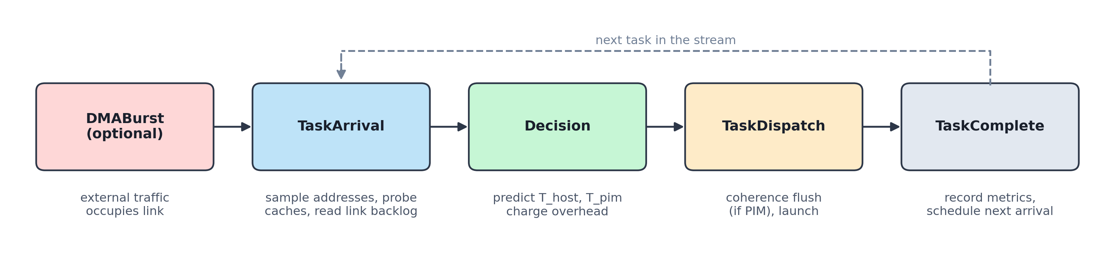
Figure 5.1 Event sequence for one task. State in the caches, DRAM rows and link reservations persists between tasks.
Because the caches, DRAM row buffers and link reservation persist across tasks, the state left by one task is visible to the next decision. This is what allows the system to respond to data that a previous task produced, which a per-kernel analysis cannot capture.

5.2 Workloads
Seven workloads were evaluated, covering the three data categories in the problem statement. Each generates a concrete address trace, so cache and DRAM behaviour emerge from the simulation rather than being assumed.
Table 5.1 Evaluated workloads
Workload | Category | Description
GEMM | High reuse | 64 x 64 dense matrix multiplication, 2n³ operations
Vector sum | Streaming | Reduction over 32,768 elements, single pass
DB scan | Streaming | Predicate filter and sum over 50,000 eight-byte records
Graph BFS | Random access | Frontier of 500 nodes, 8 edges each, over a 10,000-node graph
Embedding gather | Random access | 1,000 lookups into a 20,000-entry table of 64-byte vectors
Analytics pipeline | Mixed | Log filter, entity lookup, GEMM inference, global reduction
Mixed-dataset session | Mixed | Eight phases on one system, with cache state and I/O traffic (Table 5.2)

5.3 The mixed-dataset session
The mixed-dataset session is designed to reproduce the scenario in the problem statement: one machine processing reusable, streaming and randomly accessed data in sequence. It also contains two deliberate tests of state awareness, shown in Table 5.2. Phases S2 and S3 run the same streaming kernel, but S2 reads a buffer that S1 has just written and that is still dirty in the host caches, whereas S3 reads a cold table in DRAM. Phases S6 and S7 run the same moderate-intensity kernel on fresh data, but S7 arrives while the DMA agent has a 1 MB transfer on the link.
Table 5.2 Phases of the mixed-dataset session
Phase | Kernel | Data | What it tests
S1 | Ingest transform | Reusable | Compute-heavy producer; writes a 256 KB buffer
S2 | Hot-buffer aggregate | Streaming | Data already resident and dirty on host
S3 | Cold table scan | Streaming | Same kernel type as S2, data only in DRAM
S4 | Embedding gather | Random | Irregular access, low reuse
S5 | Model GEMM | Reusable | Compute-bound kernel
S6 | Feature cross, quiet link | Moderate intensity | Baseline for S7 (about 11 ops/byte)
S7 | Feature cross, 1 MB DMA | Moderate intensity | Same kernel under link congestion
S8 | Graph frontier | Random | Pointer chasing

5.4 Metrics
All times are expressed in host clock cycles at 3.2 GHz. The following metrics are reported:
- Speedup: host-only cycles divided by the policy's cycles.
- Data moved: bytes the workload transferred over the link, excluding background DMA traffic.
- Energy and EDP: total energy of host, caches, link, DRAM and PIM, and the energy-delay product.
- Oracle efficiency: oracle cycles divided by the policy's cycles, in percent.
- Oracle agreement: number of tasks for which the policy chose the same target as the oracle.
- Decision overhead: cycles spent on profiling and decision-making, as a share of total runtime.

5.5 Experimental setup
The simulator is written in Python 3 and is fully deterministic: workload generators and the profiler's sampler use fixed seeds, so repeated runs produce identical results. Every combination of seven workloads and six policies is run on a freshly constructed system. The overhead study re-runs the mixed session with sampling rates from 100% down to 0.5% and with profiling costs from 0.5 to 128 cycles per sampled item. The commands are listed in Appendix A.

6 Implementation

6.1 Software organisation
The simulator is organised as a Python package with separate modules for the event engine, each hardware component, the runtime and the workloads. Table 6.1 lists the main modules. The full code base, including tests, benchmarks and the dashboard, is about 5,300 lines.
Table 6.1 Main modules
Module | Responsibility
core/engine.py | Priority event queue, simulation clock, stop and clear operations
hardware/host.py | Host cores, compute timing and energy
hardware/cache.py | L1/L2/L3 with LRU and write-back; side-effect-free probe and invalidate
hardware/interconnect.py | Link reservation, backlog, separate accounting for background traffic
hardware/memory.py | Channel and bank mapping, open-row timing and energy
hardware/pim.py | Near-memory processing elements and result return
hardware/dma.py | Background DMA agent that issues bursts as events
runtime/profiler.py | Sampling, working-set estimation, residency, bank load, profiling cost
runtime/cost_model.py | Host and PIM time and energy prediction from hardware parameters
runtime/policy.py | Policies, overhead charging, decision log
system.py | Event handlers for arrival, dispatch and completion; coherence flush; oracle
workloads/ | Trace generators for all seven workloads
benchmarks/run_experiments.py | Policy sweeps, overhead study, export of results and dashboard data
visualizer/plots.py, web/ | Figures for this report and the interactive dashboard

6.2 Verification
Six test files check the components individually and the system as a whole. Beyond basic tests of cache hits and evictions, DRAM row behaviour and link timing, a dedicated suite checks the behaviours this report relies on:
- each task produces exactly three events, and tasks execute back to back on the simulated clock;
- a cache probe changes neither LRU state nor statistics, and invalidation reports dirty lines correctly;
- data that is hot and dirty on the host stays there under the dynamic policy, while the roofline policy offloads it and pays coherence write-backs;
- the same kernel moves to PIM when a DMA burst congests the link, and the burst's bytes are not attributed to the workload;
- decision overhead grows with the sampling rate and is zero for static policies;
- the working-set estimate is within 25% of the true value at 10% sampling;
- on the mixed session, the dynamic policy makes the same choices as the oracle and is faster than the roofline policy.
All tests pass on the version of the code used for this report.

6.3 Visualisation
The benchmark script writes its results to JSON and to a JavaScript data file read by a web dashboard. The dashboard lets the user select a workload and policy and shows speedup, data movement, energy and per-task placement decisions with the cost model's reasoning. All figures in Chapter 7 are generated from the same results by the plotting module.

7 Results

7.1 Overall performance
Table 7.1 gives the execution time of each workload under each policy, together with the dynamic policy's speedup over the host and its efficiency relative to the oracle. Figure 7.1 shows the speedups on a logarithmic scale.
Table 7.1 Execution time in host cycles, speedup and oracle efficiency of the dynamic policy
Workload | Host only | PIM only | Roofline | Dynamic | Oracle | Speedup | vs. oracle
GEMM (high reuse) | 72,966 | 142,630 | 73,586 | 73,616 | 72,966 | 0.99x | 99.1%
Vector sum (streaming) | 533,302 | 19,022 | 19,543 | 19,573 | 19,022 | 27.25x | 97.2%
DB scan (streaming) | 681,843 | 14,927 | 15,663 | 15,693 | 14,927 | 43.45x | 95.1%
Graph BFS (random) | 270,180 | 8,530 | 9,139 | 9,169 | 8,530 | 29.47x | 93.0%
Embedding gather (random) | 126,142 | 5,087 | 5,298 | 5,328 | 5,087 | 23.68x | 95.5%
Analytics pipeline (4 stages) | 1,035,975 | 170,346 | 102,893 | 103,013 | 101,116 | 10.06x | 98.2%
Mixed-dataset session (8 phases) | 2,035,653 | 2,172,289 | 1,185,084 | 962,352 | 958,040 | 2.12x | 99.5%

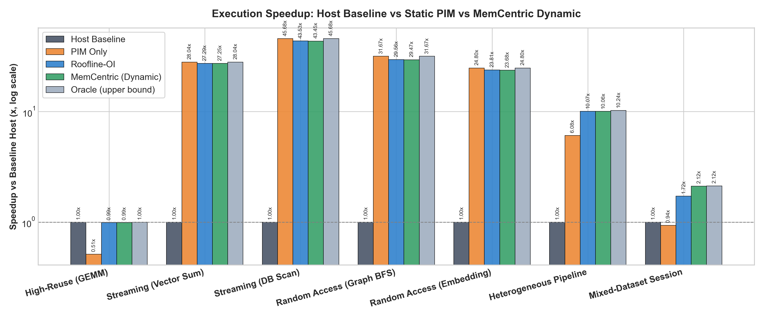
Figure 7.1 Speedup over the host baseline for each policy (log scale).
The results fall into three groups. For GEMM, the only purely compute-bound workload, offloading to PIM roughly halves performance (0.51x), because the eight PEs offer far less throughput than the host's vector units and the host's caches already capture the reuse. Both the roofline and dynamic policies keep it on the host and lose only their decision overhead.
For the four streaming and random-access kernels, PIM is 24.80x to 45.68x faster than the host. Here the correct placement is obvious, and every policy that offloads gets it right; the dynamic policy reaches 93.0% to 97.2% of the oracle. The gap is entirely its own overhead, which is relatively large because these kernels run for only 5,000 to 20,000 cycles on PIM.
The two multi-task workloads are where placement decisions matter. In the analytics pipeline, the dynamic policy sends three stages to PIM and keeps the GEMM stage on the host, which is 39.5% faster than offloading everything. In the mixed-dataset session the difference between policies is largest, and it is analysed in Section 7.3.

7.2 Data movement and energy
Table 7.2 compares the dynamic policy with the host baseline in terms of link traffic, energy and energy-delay product. Figures 7.2 and 7.3 show the same comparison for all policies.
Table 7.2 Link traffic and energy of the dynamic policy relative to the host baseline
Workload | Host data (KB) | Dynamic data (KB) | Traffic saved | Energy saved | EDP reduction
GEMM (high reuse) | 31.5 | 31.5 | 0.0% | 0.0% | -0.9%
Vector sum (streaming) | 288.1 | 0.0 | 100.0% | 40.3% | 97.8%
DB scan (streaming) | 439.5 | 0.0 | 100.0% | 61.7% | 99.1%
Graph BFS (random) | 146.0 | 1.6 | 98.9% | 63.5% | 98.8%
Embedding gather (random) | 67.4 | 0.1 | 99.9% | 79.4% | 99.1%
Analytics pipeline (4 stages) | 607.2 | 31.6 | 94.8% | 31.5% | 93.2%
Mixed-dataset session (8 phases) | 1120.0 | 397.9 | 64.5% | 2.1% | 53.7%

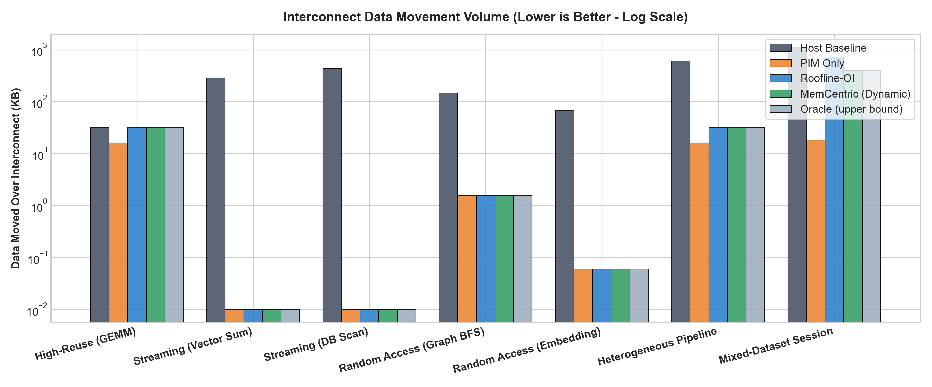
Figure 7.2 Data moved over the interconnect by each policy (log scale).
Offloaded kernels return only their reduced result, so their link traffic falls by 99% or more. The mixed session saves 64.5% of link traffic rather than nearly all of it, because four of its eight phases correctly remain on the host. Energy savings follow traffic savings closely, since link and DRAM interface energy dominate the host path for these kernels. For GEMM, static offloading raises energy by 39.2% because the slower PIM execution keeps the system active for longer.
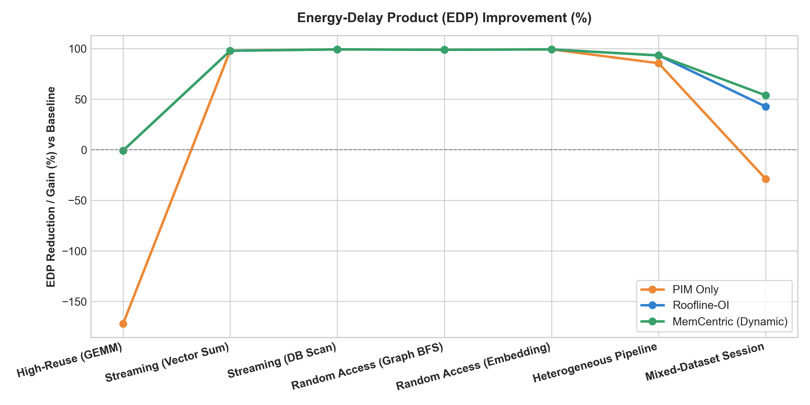
Figure 7.3 Energy-delay product reduction relative to the host baseline.

7.3 Mixed-dataset session
Table 7.3 lists the target and execution time chosen by the dynamic and roofline policies for each phase. The two policies agree on six phases and differ on two, and those two account for the whole gap between them.
Table 7.3 Per-phase placement and cycles in the mixed-dataset session
Phase | Category | Dynamic | Roofline
S1 Ingest Transform | high reuse | HOST 587,594 | HOST 587,564
S2 HotBuffer Aggregate | streaming | HOST 1,781 | PIM 195,752
S3 ColdTable Scan | streaming | PIM 15,707 | PIM 15,677
S4 Embedding Gather | random access | PIM 5,525 | PIM 5,495
S5 Model GEMM | high reuse | HOST 73,922 | HOST 74,034
S6 FeatureCross QuietBus | high reuse | HOST 123,287 | HOST 123,257
S7 FeatureCross BusyBus | high reuse | PIM 145,353 | HOST 174,152
S8 Graph Frontier | random access | PIM 9,183 | PIM 9,153

Phase S2: data location. S2 is a streaming reduction with low operational intensity, so the roofline policy offloads it. However, S1 has just written the buffer that S2 reads, and its 4,096 lines are still dirty in the host caches. Before PIM can read them they must be written back across the link. The dynamic policy sees from its residency probes that the data is cached and dirty, predicts the write-back cost, and keeps the task on the host, where it runs from the caches in 1,781 cycles. The roofline placement takes 195,752 cycles, about 110 times longer, almost all of it coherence traffic. S3 runs the same kind of kernel on data that exists only in DRAM, and both policies correctly offload it.
Phase S7: link congestion. S6 and S7 run the same kernel, with an operational intensity of about 11 operations per byte. On a quiet link the host is faster, and both policies choose it. In S7 a 1 MB DMA transfer is already on the link when the task arrives. The dynamic policy reads a backlog of about 62,464 cycles, predicts that every host miss will wait behind it, and moves the task to PIM, finishing in 145,353 cycles. The roofline policy, which does not see the link, keeps it on the host and takes 174,152 cycles.
Over the whole session, the dynamic policy finishes in 962,352 cycles against 1,185,084 for roofline, 18.8% less time, and within 0.5% of the oracle's 958,040 cycles. It matches the oracle's choice in all eight phases; the remaining gap is its decision overhead of 4,312 cycles. Neither static policy is competitive: running everything on the host takes 2,035,653 cycles and offloading everything 2,172,289.

7.4 Accuracy of the cost model
Table 7.4 compares the cost model's prediction for the chosen target with the time actually measured in simulation, for each phase of the mixed session.
Table 7.4 Predicted and simulated execution time on the chosen target
Phase | Target | Predicted | Simulated | Error
S1 Ingest Transform | HOST | 664,000 | 586,810 | +13.2%
S2 HotBuffer Aggregate | HOST | 1,212 | 1,230 | -1.5%
S3 ColdTable Scan | PIM | 15,441 | 14,941 | +3.3%
S4 Embedding Gather | PIM | 6,923 | 5,285 | +31.0%
S5 Model GEMM | HOST | 64,118 | 73,272 | -12.5%
S6 FeatureCross QuietBus | HOST | 123,254 | 122,946 | +0.3%
S7 FeatureCross BusyBus | PIM | 145,752 | 145,012 | +0.5%
S8 Graph Frontier | PIM | 9,924 | 8,544 | +16.2%

Errors range from -12.5% to +31.0%, with a mean absolute error of 9.8%. The largest errors are on the short random-access PIM tasks, where the model's estimate of the busiest bank, scaled up from a 10% sample, is pessimistic. These errors do not change any decision: in every phase the predicted margin between host and PIM is larger than the prediction error. The model does not need to be precise; it needs to rank the two targets correctly.

7.5 Feasibility and overhead of dynamic placement
The central question of the project is whether a runtime decision is worth its cost. Two sweeps on the mixed session address this. Figure 7.4 summarises both.
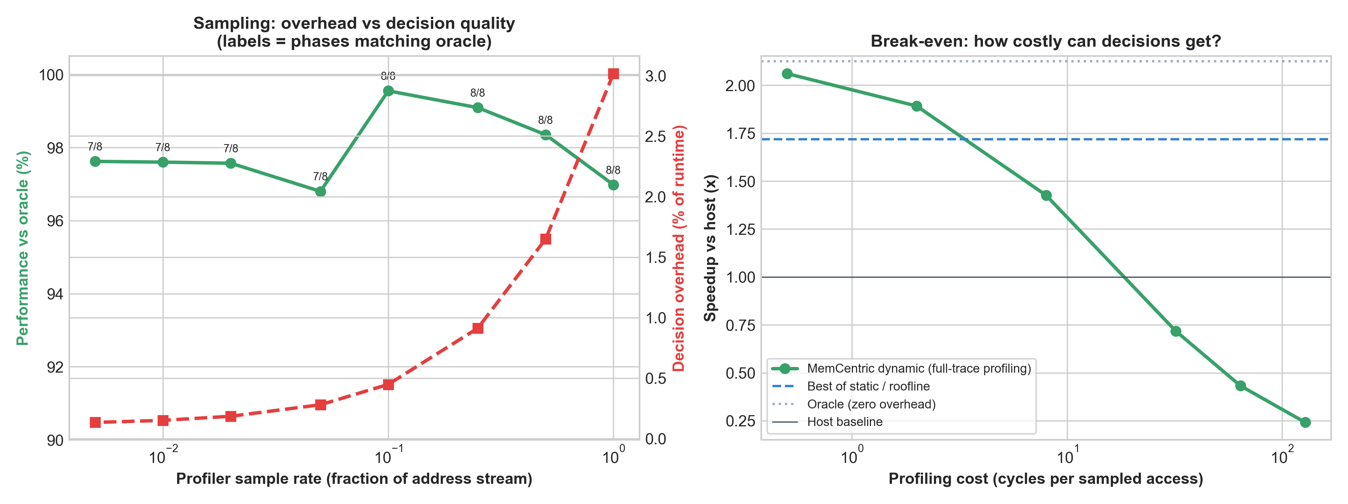
Figure 7.4 Left: effect of sampling rate on decision overhead and quality. Right: speedup as the per-sample profiling cost increases.

Sampling rate
Table 7.5 Effect of profiler sampling rate (mixed session)
Sample rate | Overhead (cycles) | Overhead (% of runtime) | Phases matching oracle | vs. oracle
100% | 29,793 | 3.02% | 8 / 8 | 97.0%
50% | 16,076 | 1.65% | 8 / 8 | 98.3%
25% | 8,829 | 0.91% | 8 / 8 | 99.1%
10% | 4,312 | 0.45% | 8 / 8 | 99.5%
5% | 2,770 | 0.28% | 7 / 8 | 96.8%
2% | 1,816 | 0.18% | 7 / 8 | 97.6%
1% | 1,487 | 0.15% | 7 / 8 | 97.6%
0.5% | 1,314 | 0.13% | 7 / 8 | 97.6%

Profiling the full trace costs 3.02% of runtime. Reducing the sample to 10% lowers this to 0.45% with no loss in decision quality. Below 5%, the working-set estimate becomes noisy enough that one phase is misplaced, and performance drops to about 97% of the oracle. At very low rates the overhead is small but the wrong decision costs more than the overhead saved. A sampling rate around 10% is the best compromise for these workloads.

Profiling cost
Table 7.6 Effect of per-sample profiling cost (full-trace profiling, mixed session)
Cycles per sample | Overhead (% of runtime) | Speedup vs. host | Beats best static / roofline
0.5 | 3.0% | 2.06x | Yes
2 | 10.9% | 1.89x | Yes
8 | 32.9% | 1.43x | No
32 | 66.2% | 0.72x | No
64 | 79.7% | 0.43x | No
128 | 88.7% | 0.24x | No

With profiling made progressively more expensive, the dynamic policy still makes the same eight correct decisions, but the time spent deciding grows. At 2 cycles per sampled access the overhead is 10.9% of runtime and the dynamic policy is still faster than the best alternative (1.72x). At 8 cycles per sample the overhead reaches 32.9% and the advantage is gone. At 32 cycles or more, the system is slower than if it had never made a decision at all. The break-even point therefore lies between 2 and 8 cycles per sampled access, which is comfortably above the cost of a hardware sampling monitor or a lightweight software profiler working on access descriptors.

8 Discussion

8.1 When does dynamic placement pay off?
The results show a clear pattern. When a workload consists of one kernel whose best placement follows from its type, a static rule or the roofline heuristic is enough, and a dynamic decision only adds overhead. On those workloads the dynamic policy loses 1% to 7% to the oracle, all of it from the cost of deciding.
The benefit appears when the best placement depends on system state rather than on the kernel alone. In the mixed session, two such cases occur: data that is already cached and dirty on the host, and a link occupied by unrelated traffic. Operational intensity cannot see either, so the roofline policy makes the wrong choice in both, and those two phases account for the 18.8% difference in total time. This is the core argument for a memory-centric runtime: the location and movement of data change during execution, and the placement decision has to follow them.
A second observation is that coherence is not a minor detail. The single misplacement of phase S2 by the roofline policy costs more than all other phases of the session combined on PIM. Any system that offloads computation to memory must either track where the most recent copy of the data is or pay to make memory consistent first.

8.2 Limitations
- Transaction-level timing. The host issues all of a task's misses together, and the link serialises them in order. There is no out-of-order core model, no memory-level parallelism limit and no prefetching. Absolute cycle counts should therefore be read as estimates; the comparison between policies is more reliable than individual numbers.
- Address stream known at launch. The profiler samples the task's address trace before the task runs. A real system would need this information from access descriptors, compiler annotations or a short profiling run.
- One decision per task. Placement is made at kernel granularity. A task cannot migrate mid-execution, and the host and PIM units do not execute concurrently.
- Policy overlap. Once the dynamic policy observes link congestion directly, the adaptive congestion policy makes identical decisions on every workload tested.

8.3 Threats to validity
The workloads are synthetic trace generators rather than traces from real applications, chosen to represent the three data categories in the problem statement. Hardware parameters are representative of current systems but have not been calibrated against a specific device, and the energy model is first-order. The conclusions most likely to carry over are the qualitative ones: the existence of state-dependent placement cases, the cost of coherence on offload, and the existence of a profiling-cost break-even point.

9 Conclusion and Future Work
This project designed and evaluated a memory-centric architecture in which a runtime engine decides, for each task, whether to compute on the host or near memory. The decision considers the task's operational intensity and reuse, the current location of its data in the cache hierarchy, the distribution of its data across DRAM banks, and the load on the shared link. The system was built as a discrete-event simulator in which all of these components share state over time, and the cost of the decision itself is charged to the task.
On streaming and random-access kernels, the dynamic policy achieves 23.68x to 43.45x speedup and removes almost all link traffic, while keeping compute-bound kernels on the host. On a mixed session that combines all three data categories, it matches an exhaustive oracle in every phase and reaches 99.5% of its performance, compared with 80.8% for a roofline heuristic. Sampling 10% of each task's accesses keeps the overhead below half a percent of runtime, and the approach remains beneficial until profiling costs several cycles per sampled access. Dynamic placement is therefore feasible, and its benefit comes precisely from the runtime information that static analysis cannot see.
Several extensions would strengthen the study:
- finer-grained placement, splitting a task between host and PIM or migrating it when conditions change;
- concurrent execution on both sides, turning placement into a scheduling problem with contention for banks and link;
- a learned or feedback-corrected cost model that uses measured execution times to reduce prediction error;
- lazy or speculative coherence in the style of LazyPIM or CoNDA, to reduce the cost of offloading recently written data;
- validation against traces from real applications and calibration of parameters against an existing PIM device.

References
[1] W. A. Wulf and S. A. McKee, "Hitting the memory wall: Implications of the obvious," ACM SIGARCH Computer Architecture News, vol. 23, no. 1, pp. 20-24, 1995.
[2] M. Horowitz, "Computing's energy problem (and what we can do about it)," in Proc. IEEE International Solid-State Circuits Conference (ISSCC), 2014, pp. 10-14.
[3] O. Mutlu, S. Ghose, J. Gómez-Luna, and R. Ausavarungnirun, "A modern primer on processing in memory," in Emerging Computing: From Devices to Systems, Springer, 2023.
[4] J. Ahn, S. Hong, S. Yoo, O. Mutlu, and K. Choi, "A scalable processing-in-memory accelerator for parallel graph processing," in Proc. ISCA, 2015, pp. 105-117.
[5] J. Gómez-Luna, I. El Hajj, I. Fernandez, C. Giannoula, G. F. Oliveira, and O. Mutlu, "Benchmarking a new paradigm: Experimental analysis and characterization of a real processing-in-memory system," IEEE Access, vol. 10, pp. 52565-52608, 2022.
[6] S. Williams, A. Waterman, and D. Patterson, "Roofline: An insightful visual performance model for multicore architectures," Communications of the ACM, vol. 52, no. 4, pp. 65-76, 2009.
[7] J. Ahn, S. Yoo, O. Mutlu, and K. Choi, "PIM-enabled instructions: A low-overhead, locality-aware processing-in-memory architecture," in Proc. ISCA, 2015, pp. 336-348.
[8] K. Hsieh, E. Ebrahimi, G. Kim, N. Chatterjee, M. O'Connor, N. Vijaykumar, O. Mutlu, and S. W. Keckler, "Transparent offloading and mapping (TOM): Enabling programmer-transparent near-data processing in GPU systems," in Proc. ISCA, 2016, pp. 204-216.
[9] A. Boroumand, S. Ghose, M. Patel, H. Hassan, B. Lucia, K. Hsieh, K. T. Malladi, H. Zheng, and O. Mutlu, "LazyPIM: An efficient cache coherence mechanism for processing-in-memory," IEEE Computer Architecture Letters, vol. 16, no. 1, pp. 46-50, 2017.
[10] A. Boroumand, S. Ghose, M. Patel, H. Hassan, B. Lucia, R. Ausavarungnirun, K. Hsieh, N. Hajinazar, K. T. Malladi, H. Zheng, and O. Mutlu, "CoNDA: Efficient cache coherence support for near-data accelerators," in Proc. ISCA, 2019, pp. 629-642.
[11] A. Chao, "Nonparametric estimation of the number of classes in a population," Scandinavian Journal of Statistics, vol. 11, no. 4, pp. 265-270, 1984.

Appendix A Reproducing the Results
All results in this report are generated by the commands below, run from the repository root with Python 3 and the packages listed in requirements.txt. The simulation is deterministic, so repeated runs give identical numbers.
Table A.1 Commands
Command | Effect
python main.py | Runs the mixed-dataset session with host-only and dynamic placement and prints a per-task summary
python main.py --run-all | Runs every workload under every policy, the oracle and the overhead study; writes benchmarks/results.json, benchmarks/overhead_study.json and web/data.js; regenerates all figures
python main.py --test | Runs the six test files
python main.py --plot | Regenerates the figures from existing results
python main.py --serve 8080 | Serves the interactive dashboard at http://localhost:8080

Appendix B Complete Results
Table B.1 lists, for every workload and policy, the execution time, the share of the oracle's performance, the number of decisions that matched the oracle, and the decision overhead.
Table B.1 Results for all workloads and policies
Workload | Policy | Cycles | Speedup | vs. oracle | Matches oracle | Data (KB) | Overhead
GEMM (high reuse) | Host | 72,966 | 1.00x | 100.0% | 1/1 | 31.5 | 0.00%
 | PIM | 142,630 | 0.51x | 51.2% | 0/1 | 16.0 | 0.00%
 | Roofline | 73,586 | 0.99x | 99.2% | 1/1 | 31.5 | 0.84%
 | Dynamic | 73,616 | 0.99x | 99.1% | 1/1 | 31.5 | 0.88%
 | Adaptive | 73,616 | 0.99x | 99.1% | 1/1 | 31.5 | 0.88%
 | Oracle | 72,966 | 1.00x | 100.0% | 1/1 | 31.5 | 0.00%
Vector sum (streaming) | Host | 533,302 | 1.00x | 3.6% | 0/1 | 288.1 | 0.00%
 | PIM | 19,022 | 28.04x | 100.0% | 1/1 | 0.0 | 0.00%
 | Roofline | 19,543 | 27.29x | 97.3% | 1/1 | 0.0 | 2.67%
 | Dynamic | 19,573 | 27.25x | 97.2% | 1/1 | 0.0 | 2.81%
 | Adaptive | 19,573 | 27.25x | 97.2% | 1/1 | 0.0 | 2.81%
 | Oracle | 19,022 | 28.04x | 100.0% | 1/1 | 0.0 | 0.00%
DB scan (streaming) | Host | 681,843 | 1.00x | 2.2% | 0/1 | 439.5 | 0.00%
 | PIM | 14,927 | 45.68x | 100.0% | 1/1 | 0.0 | 0.00%
 | Roofline | 15,663 | 43.53x | 95.3% | 1/1 | 0.0 | 4.70%
 | Dynamic | 15,693 | 43.45x | 95.1% | 1/1 | 0.0 | 4.88%
 | Adaptive | 15,693 | 43.45x | 95.1% | 1/1 | 0.0 | 4.88%
 | Oracle | 14,927 | 45.68x | 100.0% | 1/1 | 0.0 | 0.00%
Graph BFS (random) | Host | 270,180 | 1.00x | 3.2% | 0/1 | 146.0 | 0.00%
 | PIM | 8,530 | 31.67x | 100.0% | 1/1 | 1.6 | 0.00%
 | Roofline | 9,139 | 29.56x | 93.3% | 1/1 | 1.6 | 6.66%
 | Dynamic | 9,169 | 29.47x | 93.0% | 1/1 | 1.6 | 6.97%
 | Adaptive | 9,169 | 29.47x | 93.0% | 1/1 | 1.6 | 6.97%
 | Oracle | 8,530 | 31.67x | 100.0% | 1/1 | 1.6 | 0.00%
Embedding gather (random) | Host | 126,142 | 1.00x | 4.0% | 0/1 | 67.4 | 0.00%
 | PIM | 5,087 | 24.80x | 100.0% | 1/1 | 0.1 | 0.00%
 | Roofline | 5,298 | 23.81x | 96.0% | 1/1 | 0.1 | 3.98%
 | Dynamic | 5,328 | 23.68x | 95.5% | 1/1 | 0.1 | 4.52%
 | Adaptive | 5,328 | 23.68x | 95.5% | 1/1 | 0.1 | 4.52%
 | Oracle | 5,087 | 24.80x | 100.0% | 1/1 | 0.1 | 0.00%
Analytics pipeline (4 stages) | Host | 1,035,975 | 1.00x | 9.8% | 1/4 | 607.2 | 0.00%
 | PIM | 170,346 | 6.08x | 59.4% | 3/4 | 16.1 | 0.00%
 | Roofline | 102,893 | 10.07x | 98.3% | 4/4 | 31.6 | 1.73%
 | Dynamic | 103,013 | 10.06x | 98.2% | 4/4 | 31.6 | 1.84%
 | Adaptive | 103,013 | 10.06x | 98.2% | 4/4 | 31.6 | 1.84%
 | Oracle | 101,116 | 10.24x | 100.0% | 4/4 | 31.6 | 0.00%
Mixed-dataset session (8 phases) | Host | 2,035,653 | 1.00x | 47.1% | 4/8 | 1120.0 | 0.00%
 | PIM | 2,172,289 | 0.94x | 44.1% | 4/8 | 18.1 | 0.00%
 | Roofline | 1,185,084 | 1.72x | 80.8% | 6/8 | 725.6 | 0.34%
 | Dynamic | 962,352 | 2.12x | 99.5% | 8/8 | 397.9 | 0.45%
 | Adaptive | 962,352 | 2.12x | 99.5% | 8/8 | 397.9 | 0.45%
 | Oracle | 958,040 | 2.13x | 100.0% | 8/8 | 397.9 | 0.00%

