Database System Engineering and Distributed Backend Development
Course Code: 25CS13002E
2520030531
D. Venya Sri
AGGREGATE FUNCTIONS with WHERE, GROUP BY,
HAVING, ORDER BY

Query 1: Create database
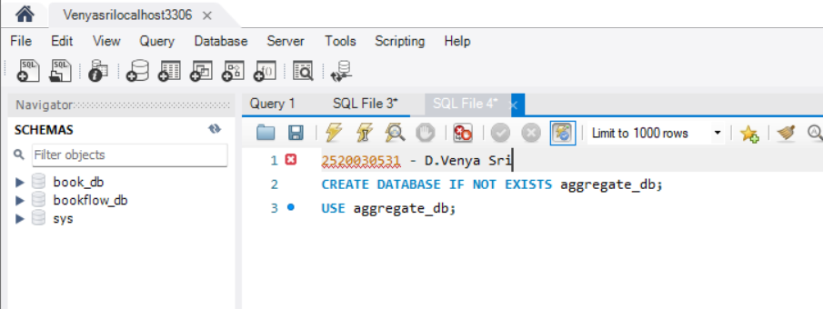

OUTPUT
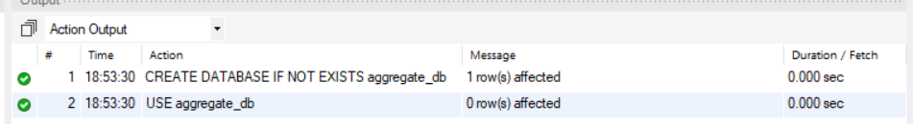

Query 2: Create Table
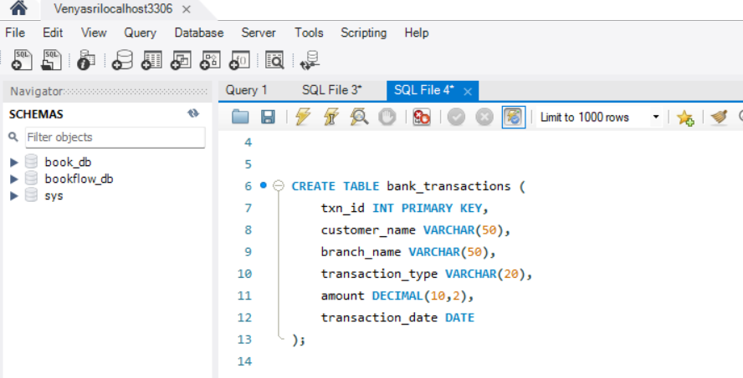

OUTPUT

Query 3: Insert Data
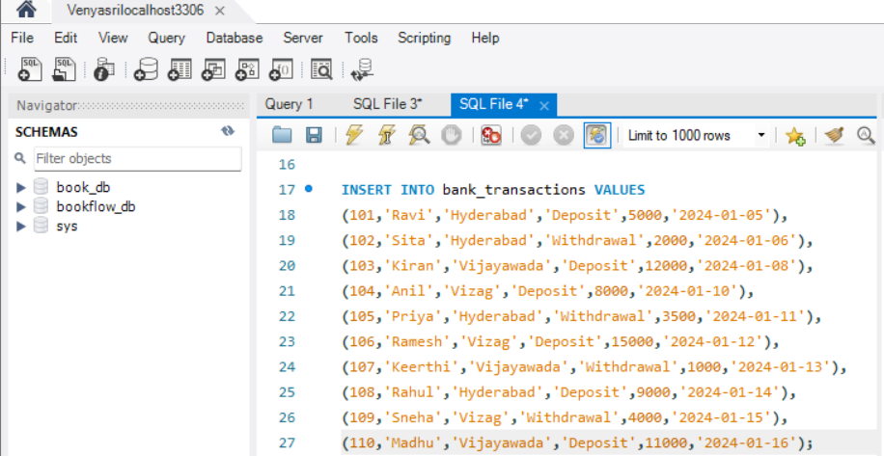

OUTPUT

Query 4: SUM()
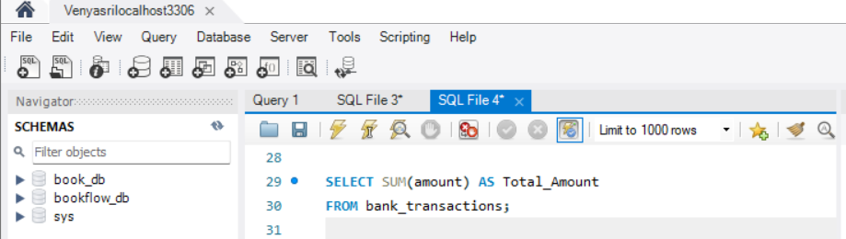

OUTPUT
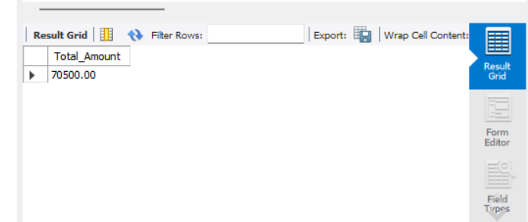

Query 5: AVG()
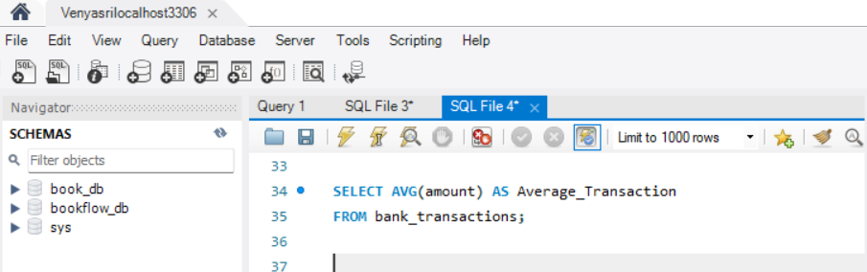
OUTPUT
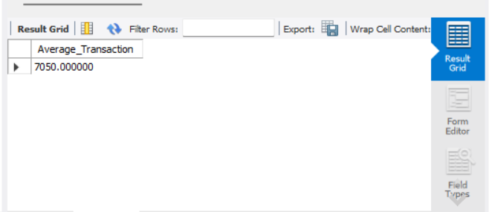

Query 6: MAX()
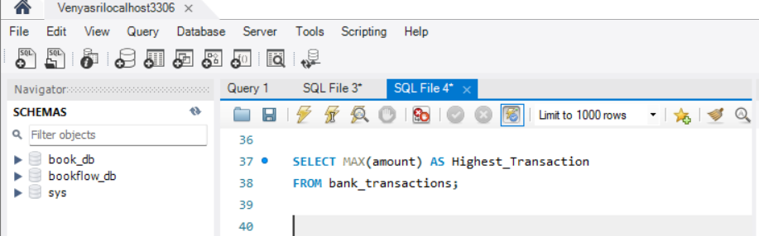

OUTPUT
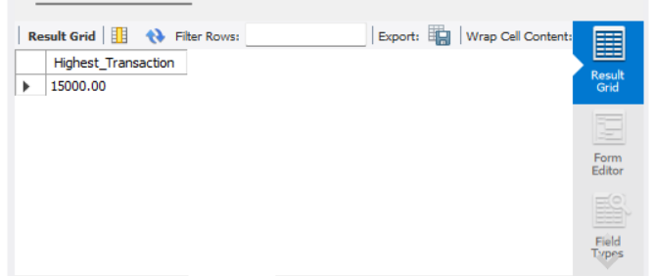

Query 7: MIN()
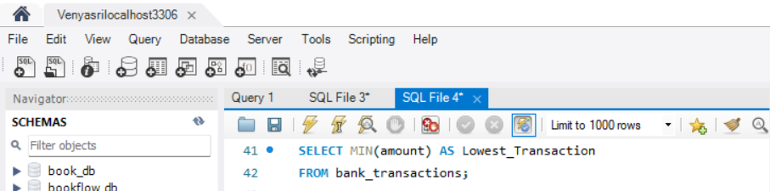
OUTPUT
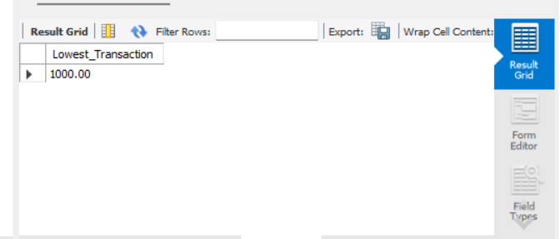

Query 8: COUNT()
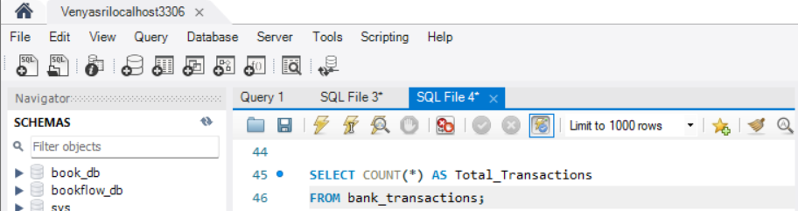
OUTPUT
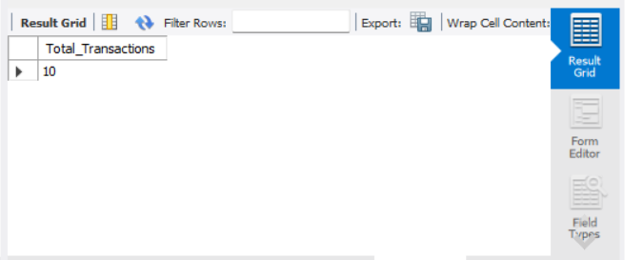
Query 9: Where + Sum
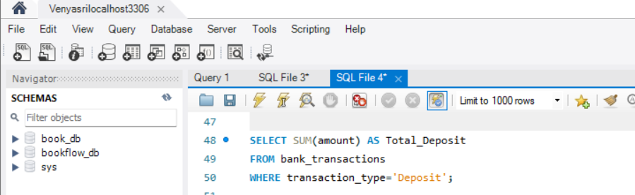
OUTPUT
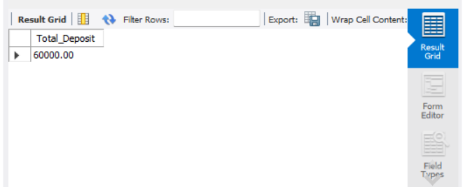

Query 10: Group By
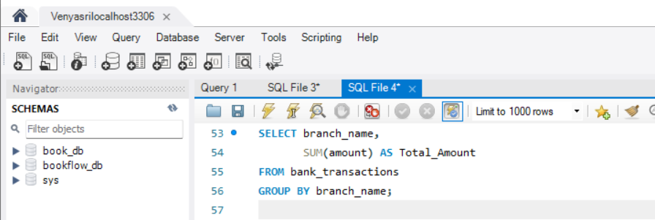
OUTPUT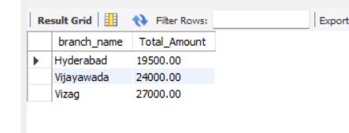
Query 11: Group By + Having
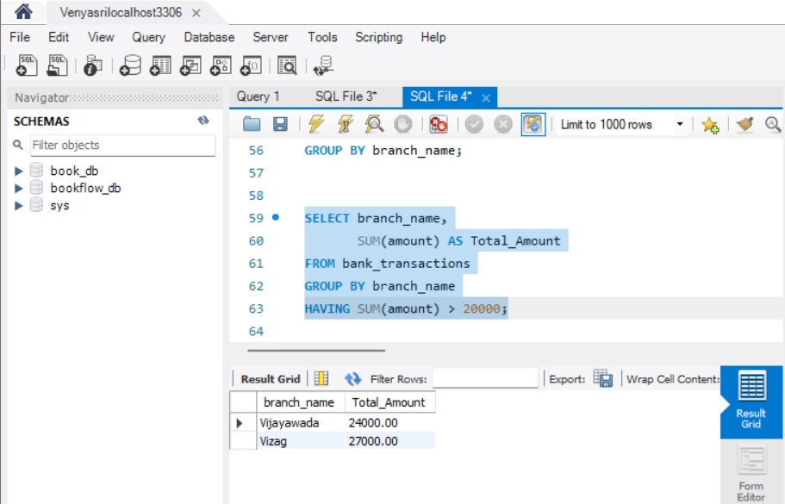
Query 12: Group By + Order By
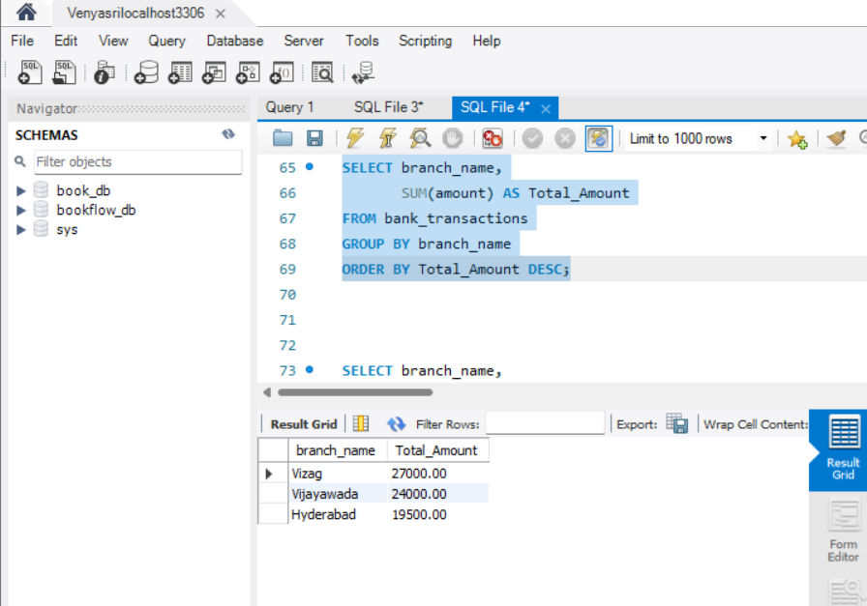

Query 13: Group By + Having + Order By
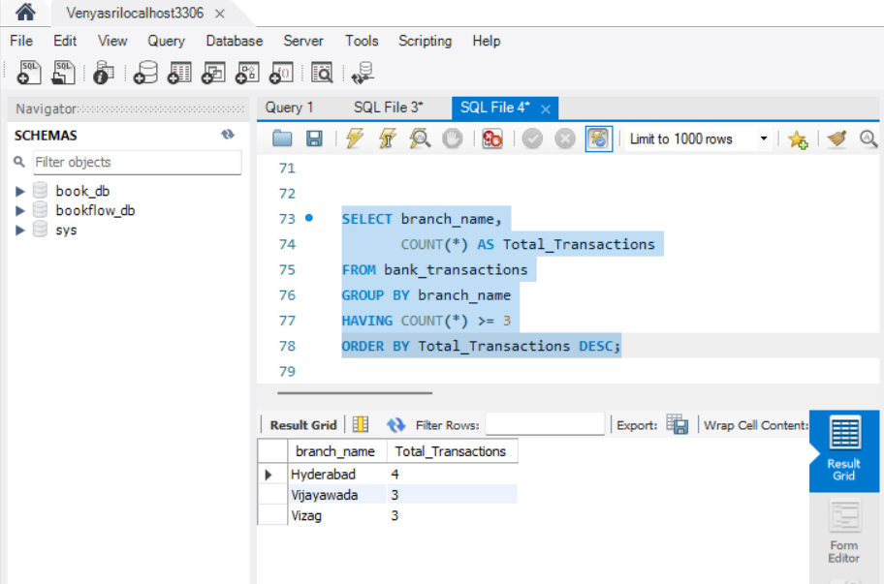
Query 14: Where + COUNT()
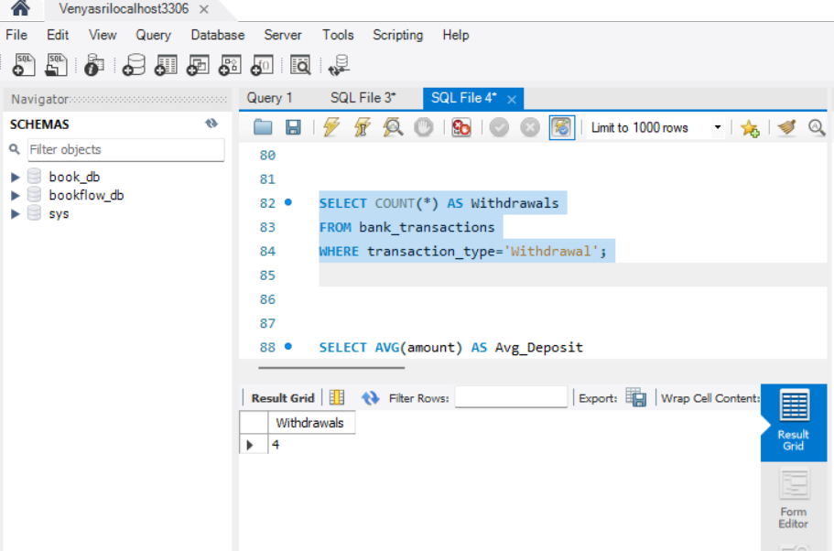
Query 15: Where + AVG()
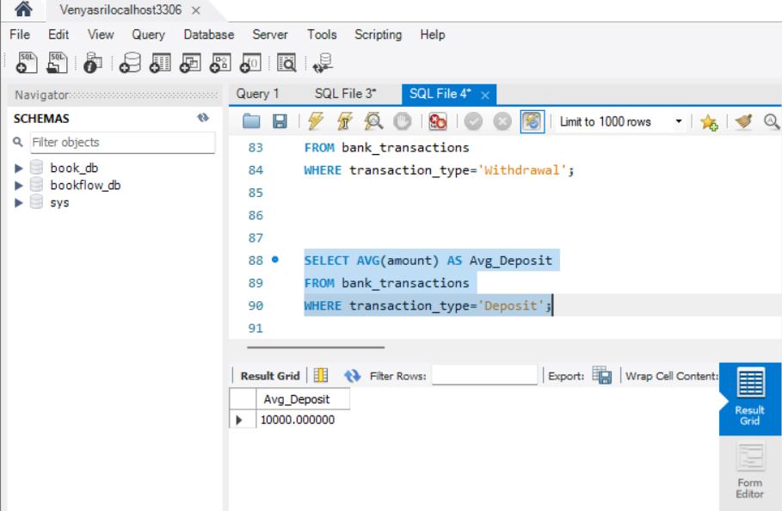
Query 16: Group By + MAX()
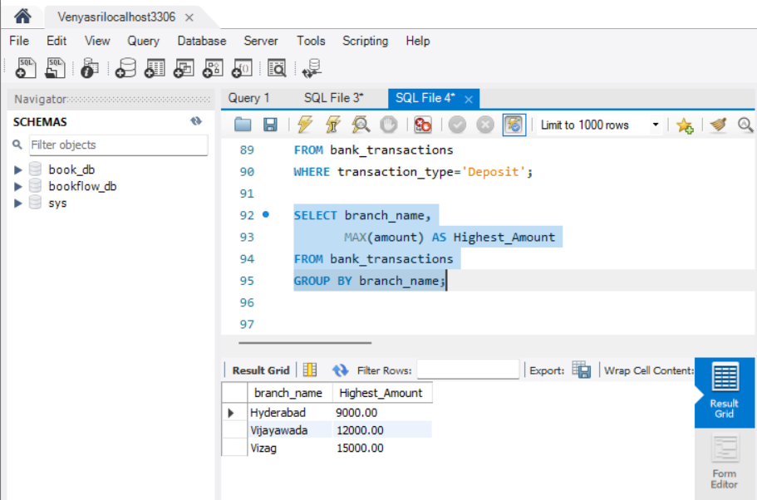

Query 17: Group BY + MIN()
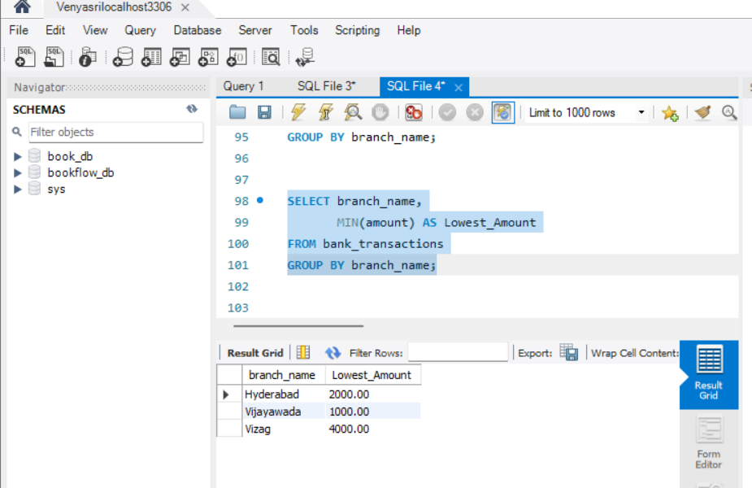
Query 18: Where + Order By
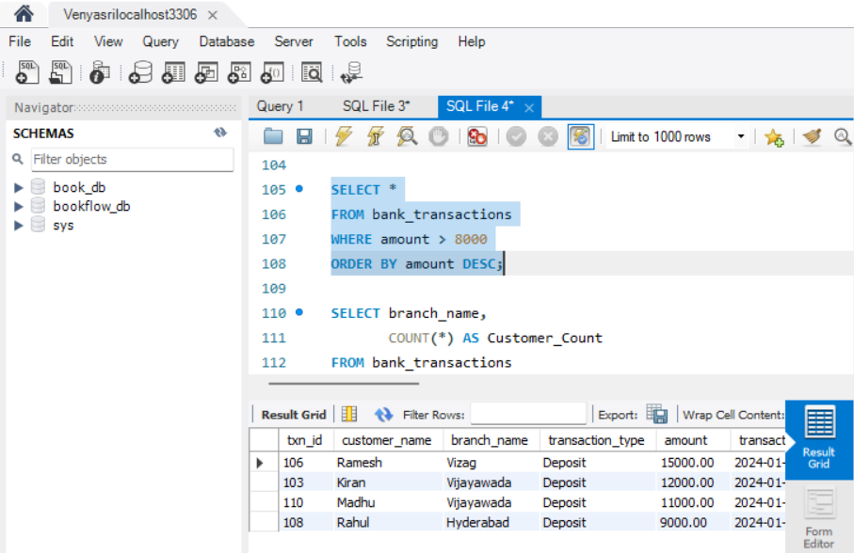

Query 19: Group By + COUNT()
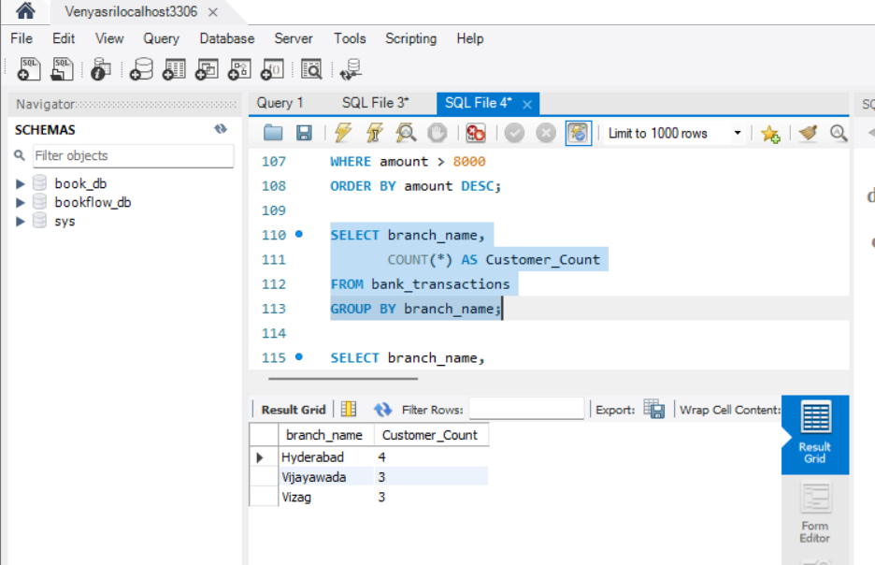
Query 20: Having + COUNT()
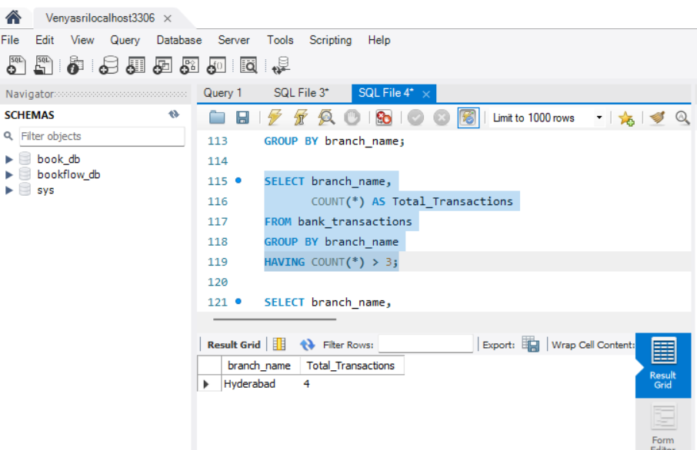

Query 21: Group By + AVG()
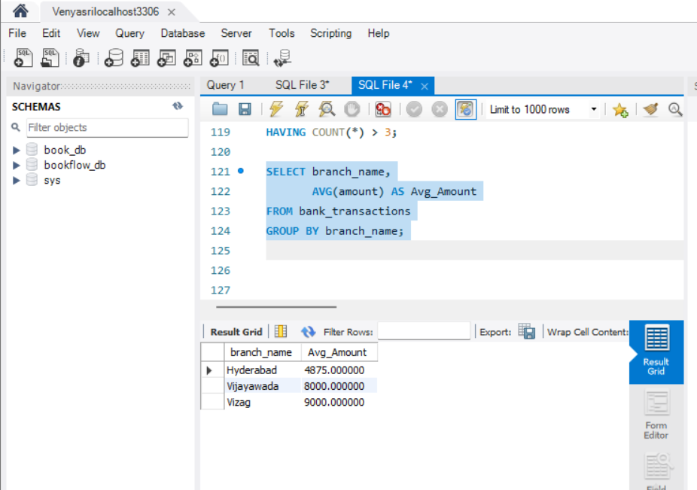
Query 22: Where + Group By + Having
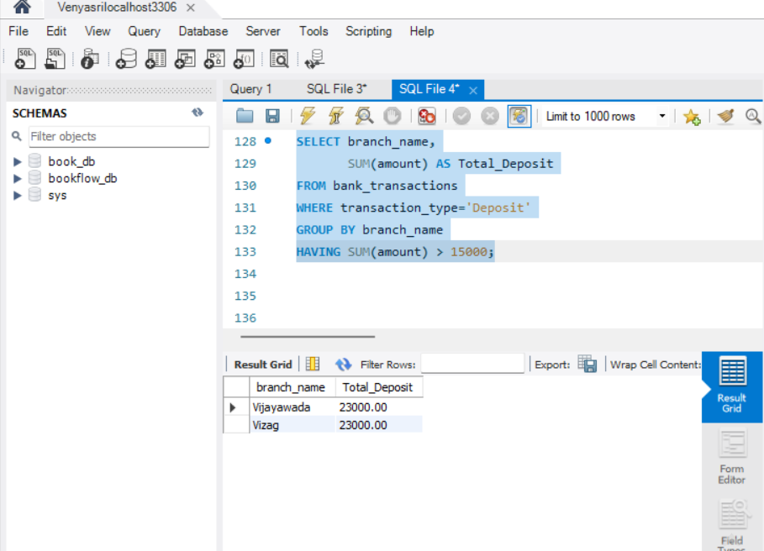

Query 23: Group By + Having + Order By
