-BORN2BEROOT
Download virtualbox
Download debian iso file
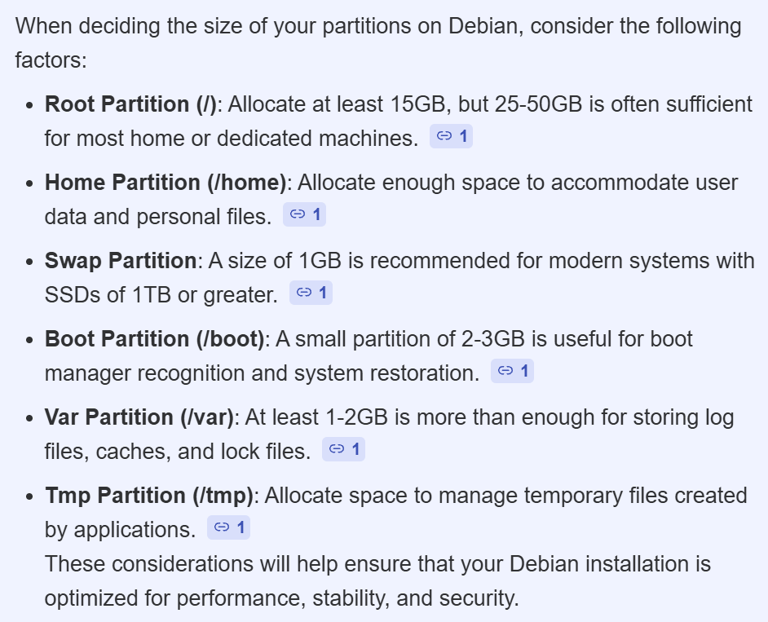
Create new VM
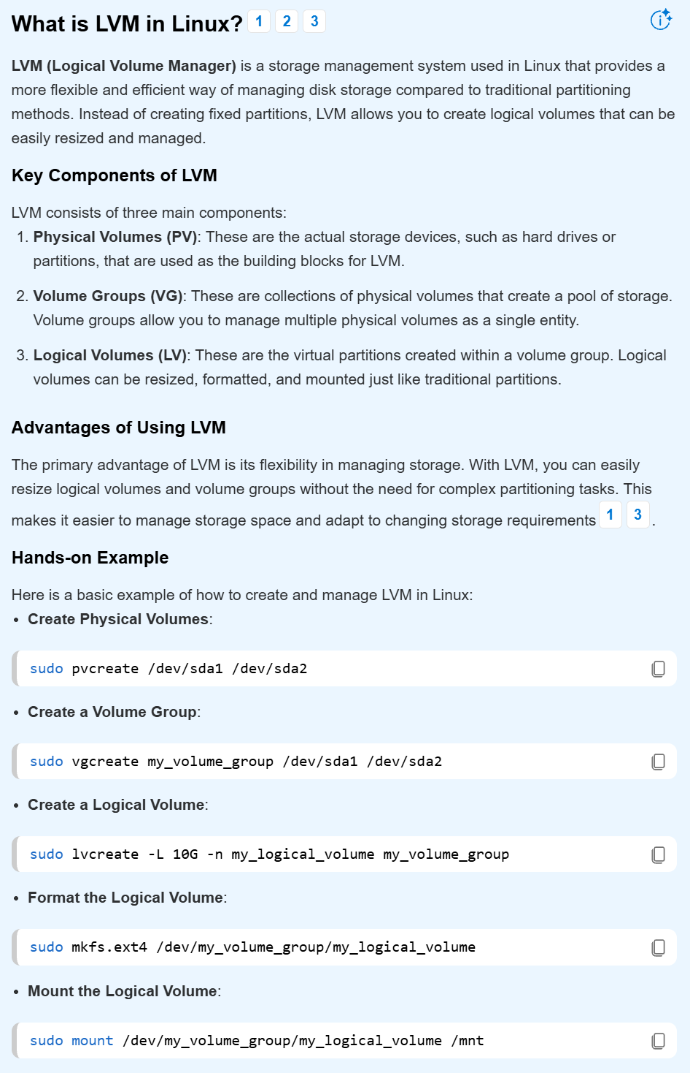
Checking the partition of data
- lsblk
- fdisk -l (-1 ?)
- fdisk -l /dev/sda
Using fdisk :
https://linuxize.com/post/fdisk-command-in-linux/#:~:text=%EE%80%80fdisk%EE%80%81%20is%20a%20menu-driven%20command-line%20utility
Using parted package:
https://www.tecmint.com/parted-command-create-linux-partitions/

https://linuxconfig.org/linux-lvm-logical-volume-manager

INSTALL SUDO
- su –
- apt update
- apt install sudo
- usermod -aG sudo ton_nom_utilisateur
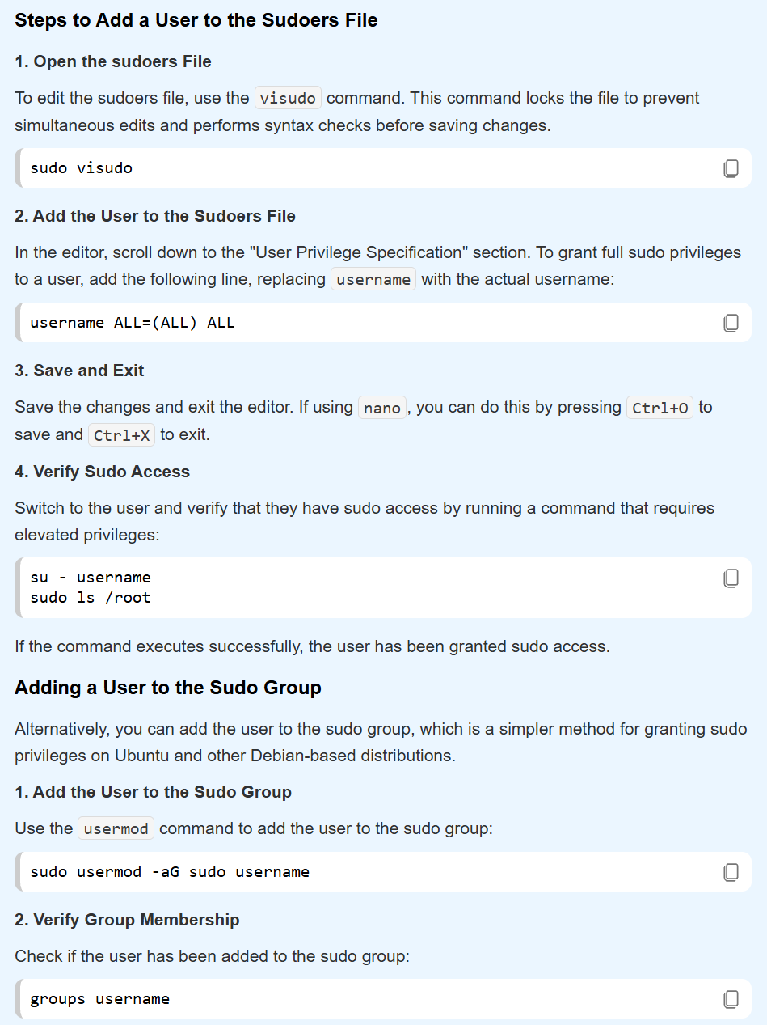
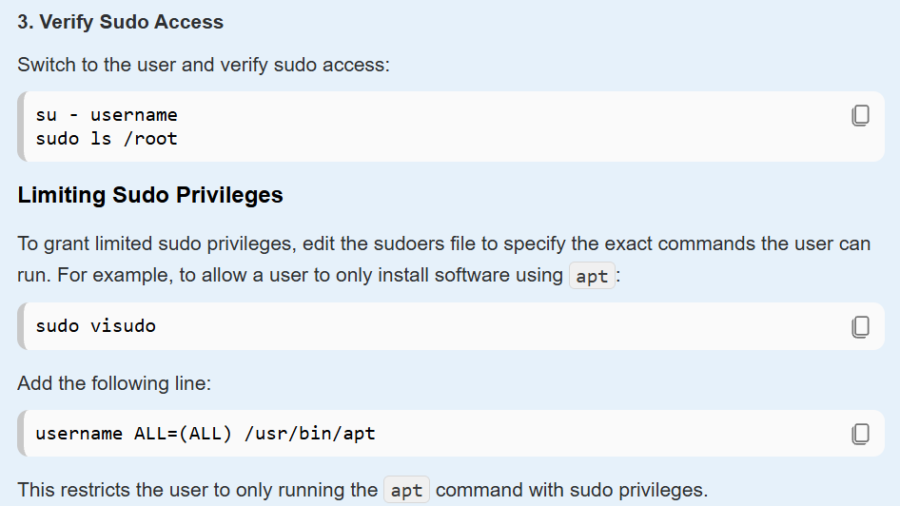

Vérifier les membres du groupe sudo
> getent group sudo
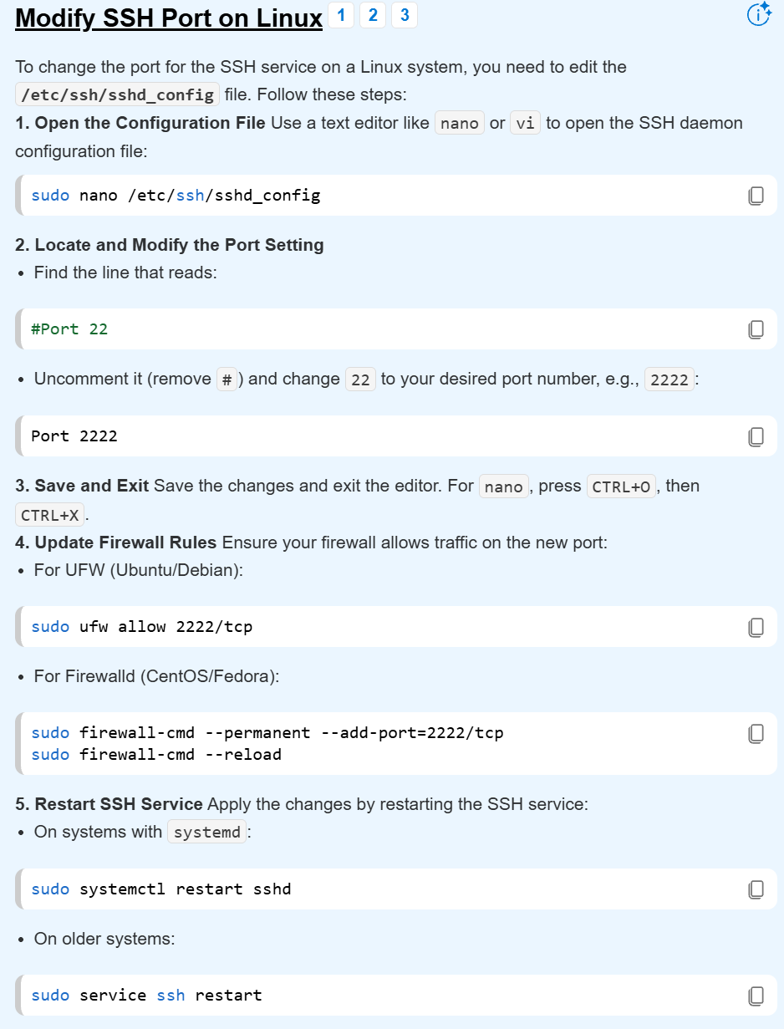
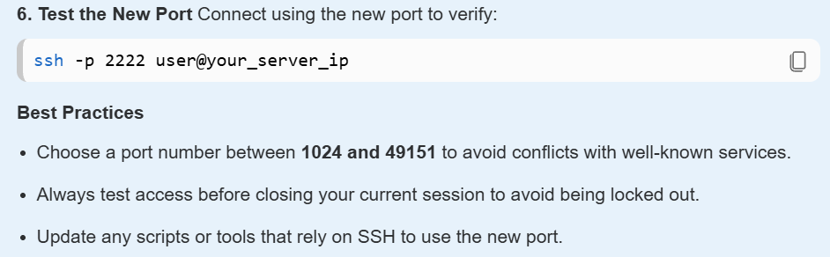
SETTING UP THE FIREWALL / INSTALL UFW
- apt install ufw vephan
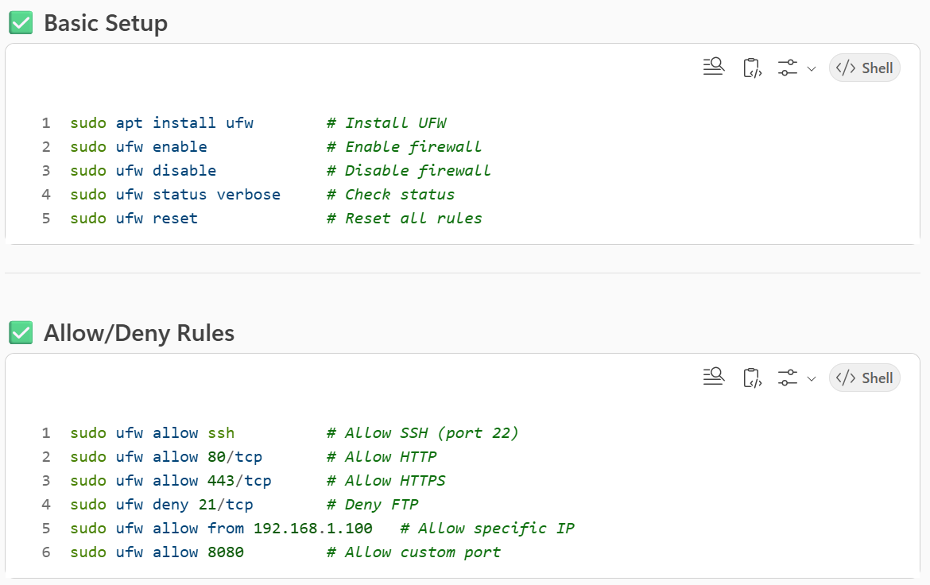
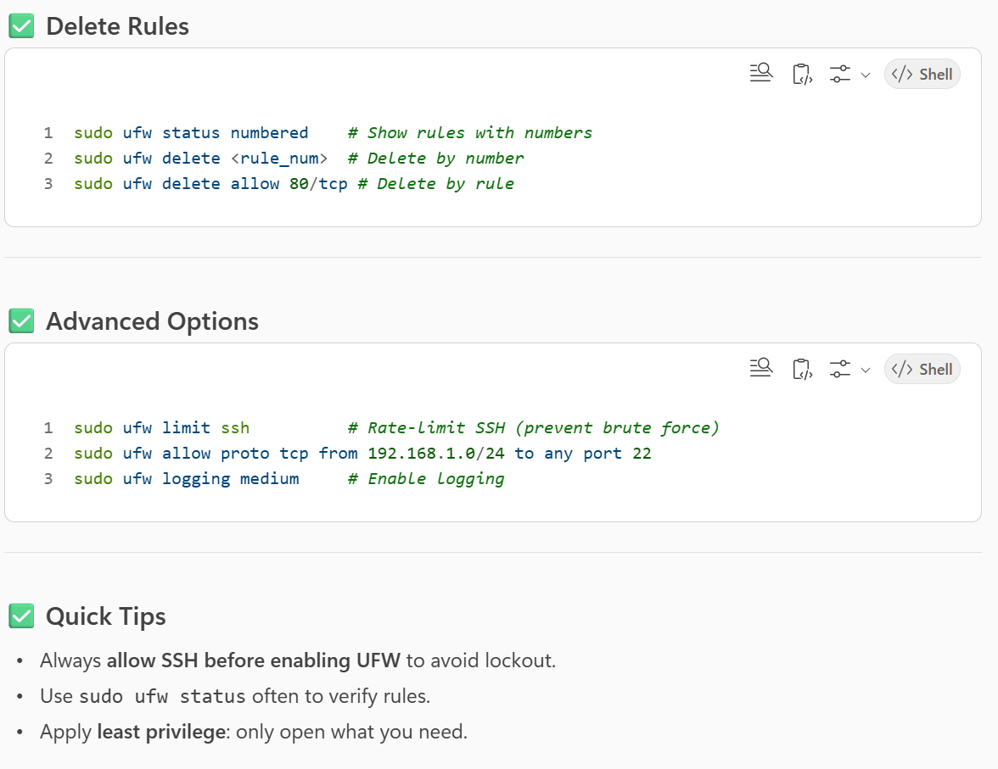
INSTALL OPENSSH (in order to use SSHD)
- apt-get install openssh-server
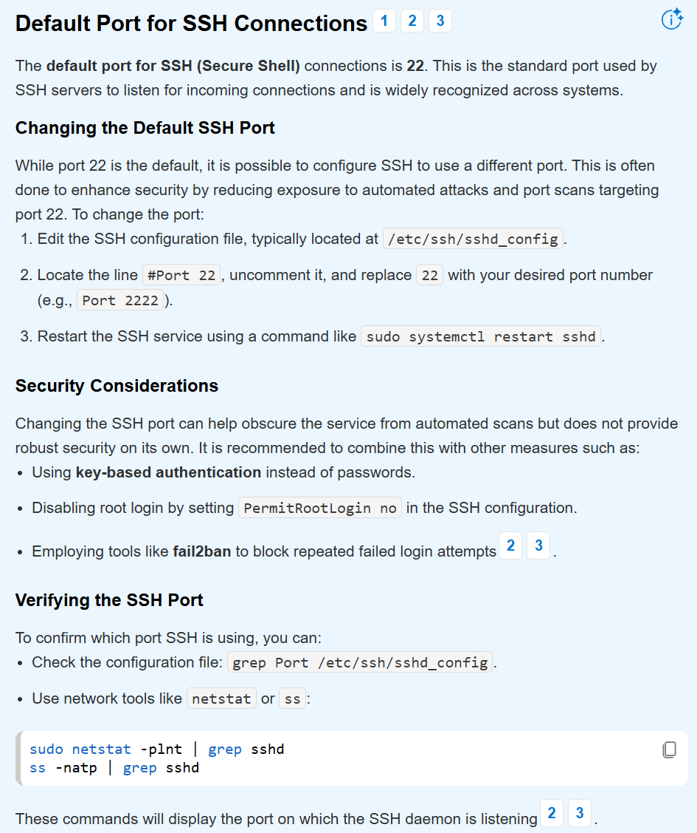

CHANGE THE HOSTNAME
Verify the hostname
- hostname
- hostnamectl
change hostname
- sudo hostnamectl set-hostname NEW_NAME
verify change
- hostnamectl
make the change effective
- reboot
ENFORCING A PASSWORD POLICY
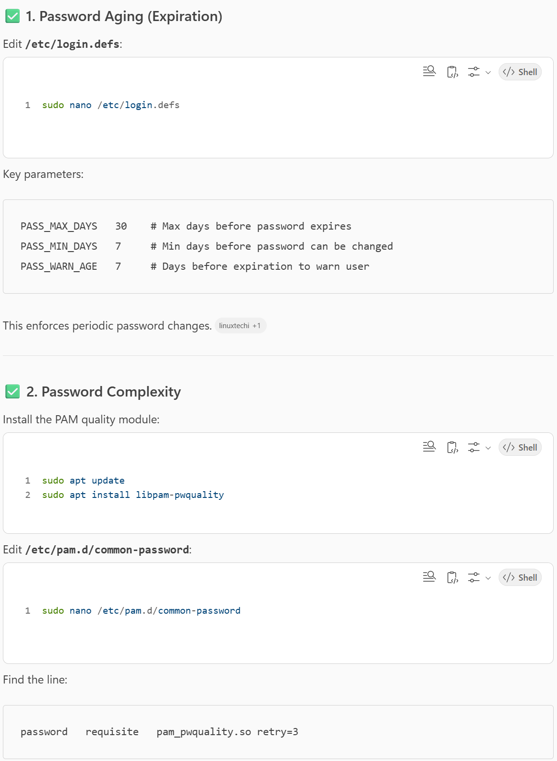

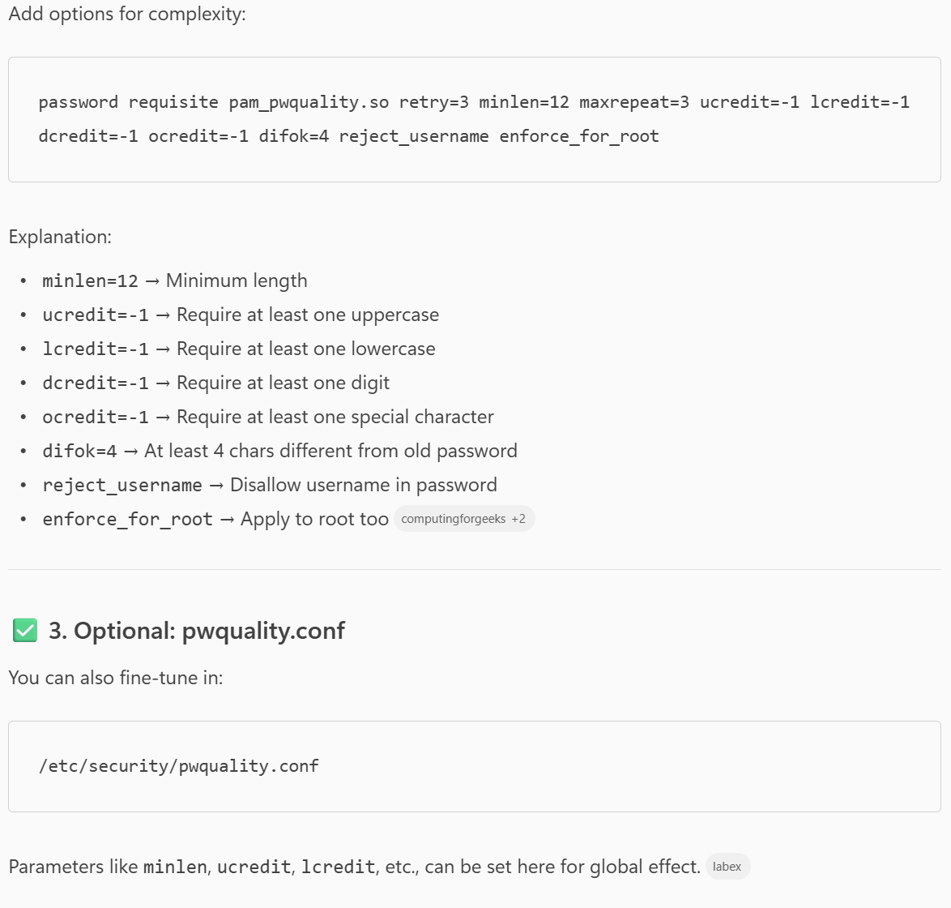
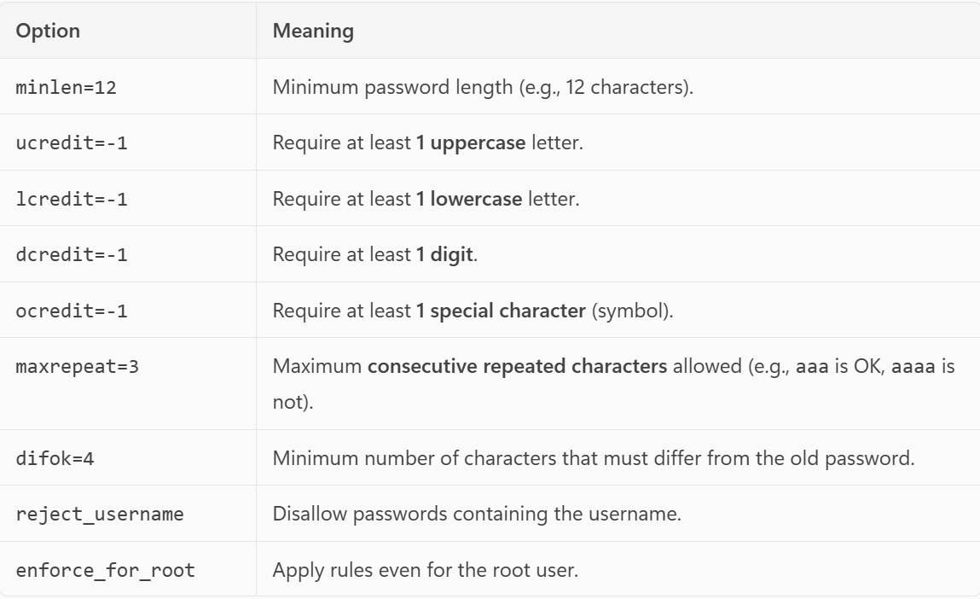
Update password aging policy:
- sudo chage -M 30 username # Max 30 days
- sudo chage -m 2 username # Min 2
Verify
- chage -l username
For root, add:
- password requisite pam_unix.so obscure enforce_for_root

ENFORCING SUDO RULES
sudo visudo
# --- Security Hardening ---
Defaults requiretty # Force TTY for sudo
Defaults passwd_tries=2 # Limit password attempts
Defaults timestamp_timeout=0 # Require password every time
Defaults logfile="/var/log/sudo.log" # Log all sudo commands
Defaults secure_path="/usr/local/sbin:/usr/local/bin:/usr/sbin:/usr/bin:/sbin:/bin"

# --- Customization ---
Defaults badpass_message="Wrong password! Access denied."
Defaults passprompt="Enter your sudo password: "

# --- Command Restrictions ---
# Full access for admin group
%admin ALL=(ALL:ALL) ALL
# Example: Allow only apt-get and systemctl for user 'student'
student ALL=(ALL) /usr/bin/apt-get, /usr/bin/systemctl

# --- Optional: Disable root escalation via sudo ---
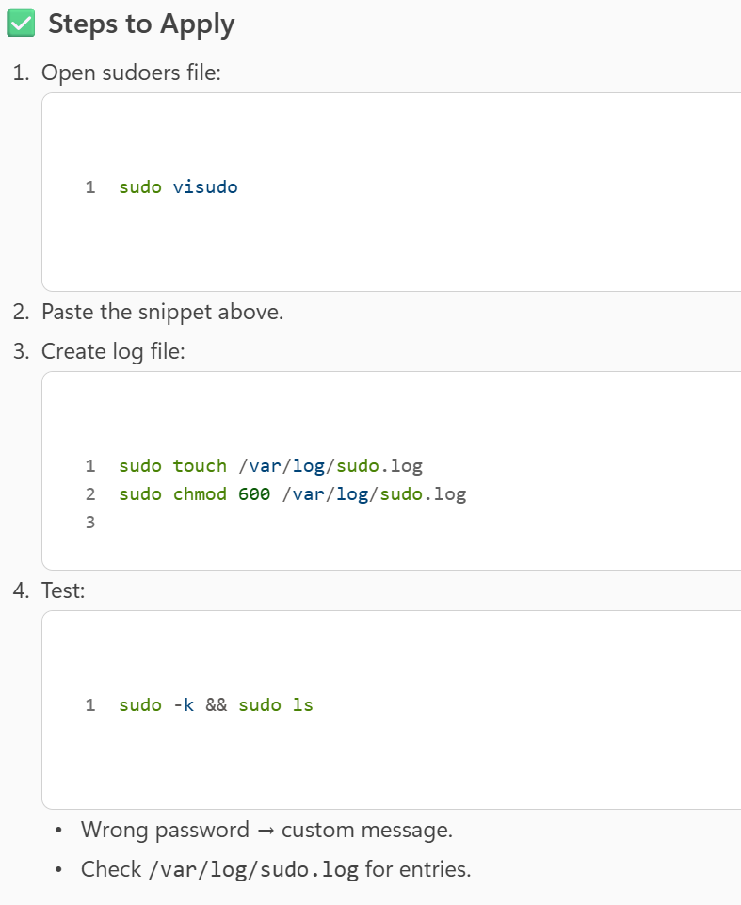
Defaults !root_sudo

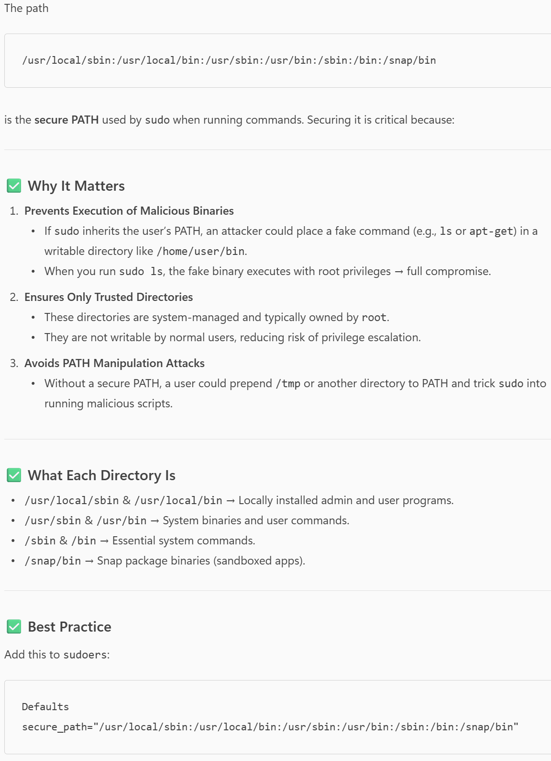

CREATING RULES IN /ETC/SUDOERS.D
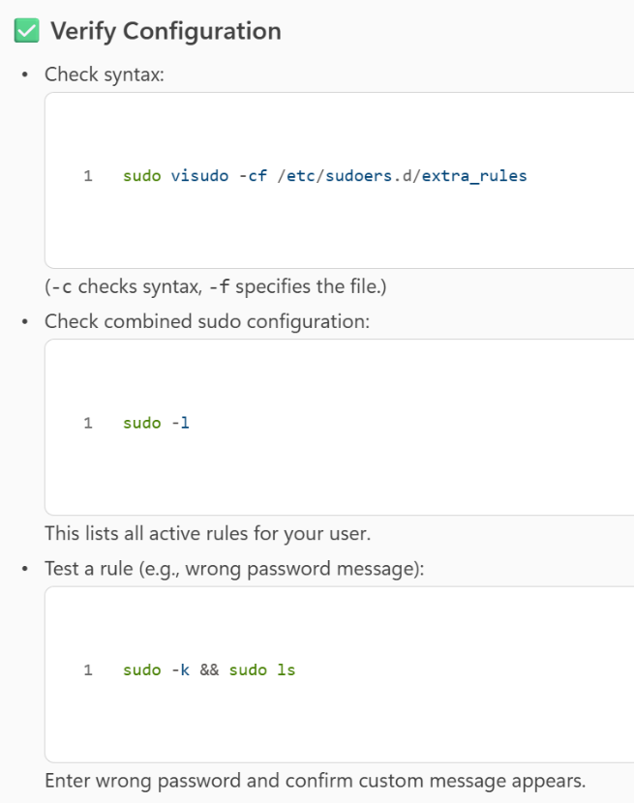
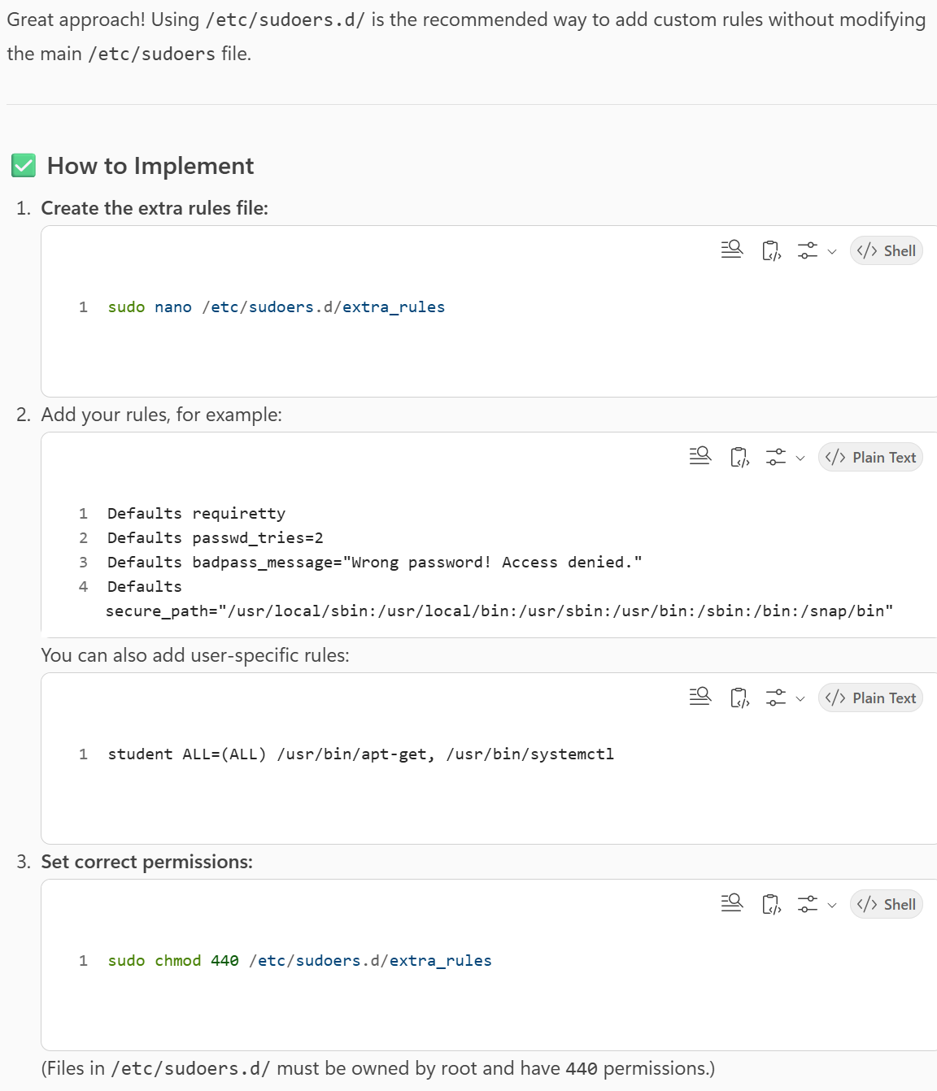

SCHEDULING SOME MONITORING TASKS
- Cron and crontab packages
- Hostnamectl (os, kernel version)
- hostnamectl | ”Operating System”
- hostnamectl | ”Kernel”
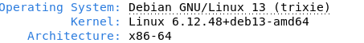
- Lscpu (ou nproc –all, ou getconf _NPROCESSORS_ONLN) –
- lscpu | grep "Socket(s)"
- nproc
- free -m | awk ‘/Mem:/ {printf(“%d\n, $2)}’
- free | awk '/Mem:/ {printf("RAM Usage: %.2f%%\n", $3/$2*100)}’

Available RAM
- free -m | awk ‘/Mem:/ {printf(“Mem usage: %0.1f/%0.1fMB %0.1f%%\n, $4, $2, $3/$2*100)$’
- top -bnl | grep “MiB Mem” | awk ‘{printf(“Mem usage: %0.1f %%\n”, ($10 +$8)*100/$4)}’

Available storage
- df -h / | awk ‘NR==2 {printf(“Disk usage: %0.1f/%0.1fGB %0.1f%%\n”, $4, $2, $5)}’

CPU utilization
- top -bn1 | grep "Cpu(s)" | awk ‘{printf(“CPU utilization: %d\n”, (100 - $8))}’
last reboot
- Uptime -s | ‘awk {printf(“last boot: %s at %s\n”, $1, $2)}’
Count open active connections
- ss -lptun | awk '{print $5}' | sort | uniq | wc -l
Count nb of users using the servers
- who | awk ‘{print $1}’ | uniq | wc -l
Get IP address
- ip address | grep -w “inet” | grep -v “127.0.0.1” | awk ‘{print”IP address: “ $2}’
Get MAC address
- Ip link | grep link/ether | awk ‘{print “MAC address: “ $2}’
Check sudo logs
- grep -c "COMMAND" /var/log/sudo.log

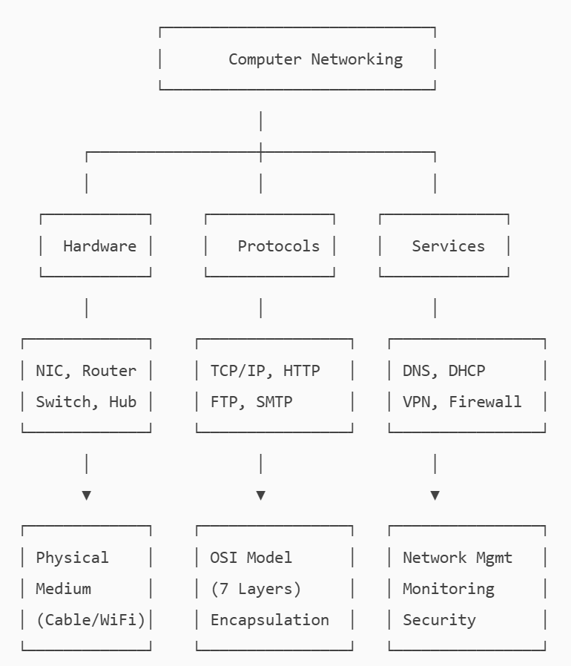
OSI 7-LAYER MODEL
https://www.youtube.com/watch?v=vv4y_uOneC0&t=995s
Problem to solve: communication betweeen two different computers

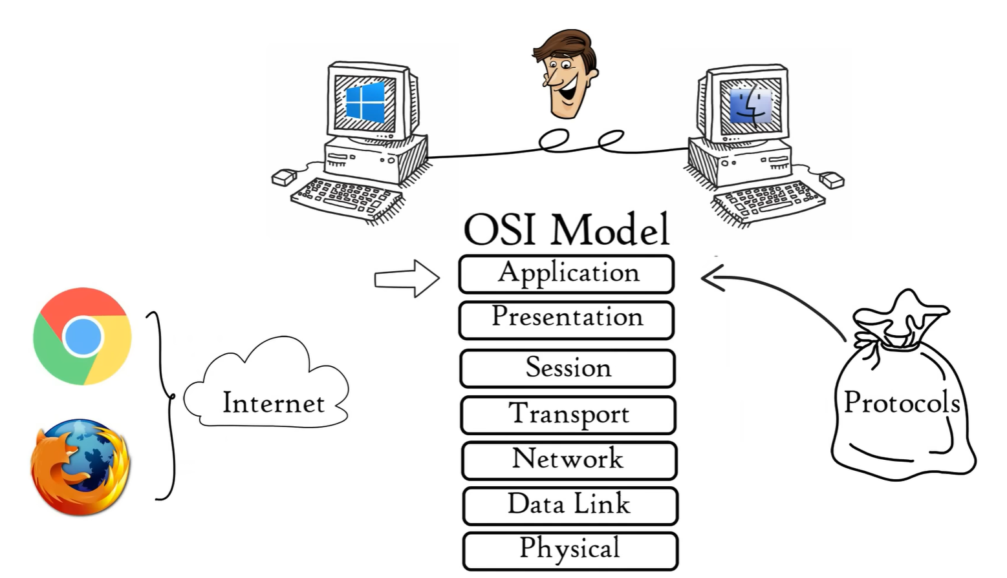
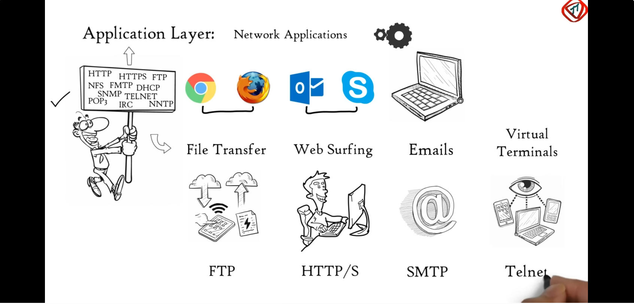
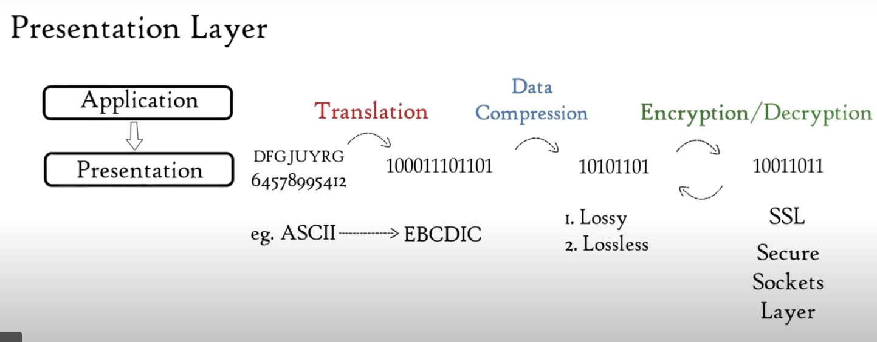
SESSION LAYER
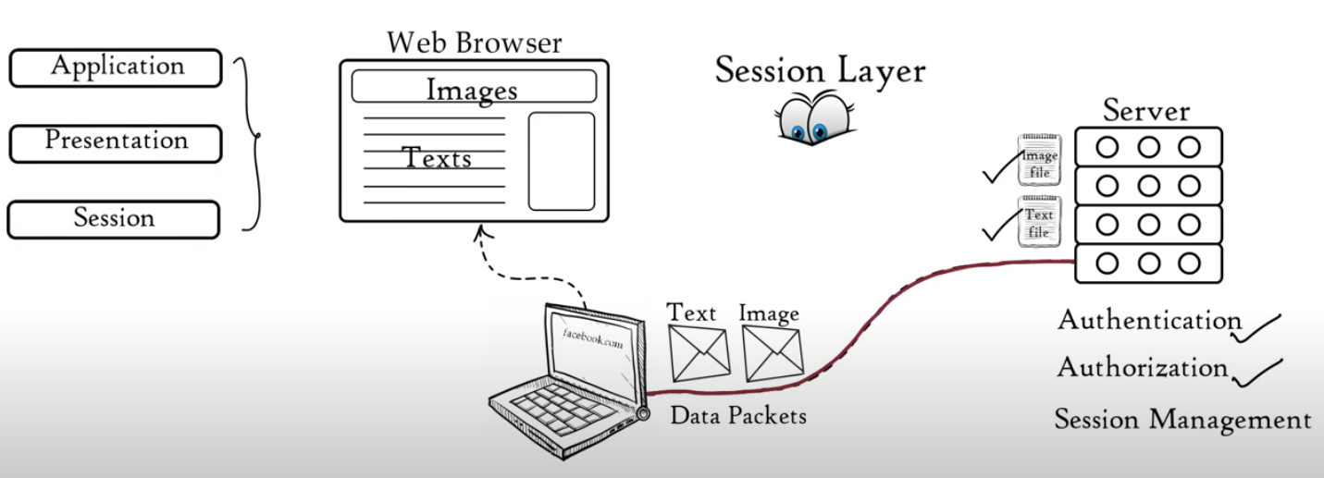
TRANSPORT LAYER (RELIABILITY OF THE COMMUNICATION)
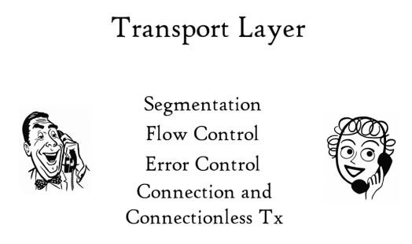
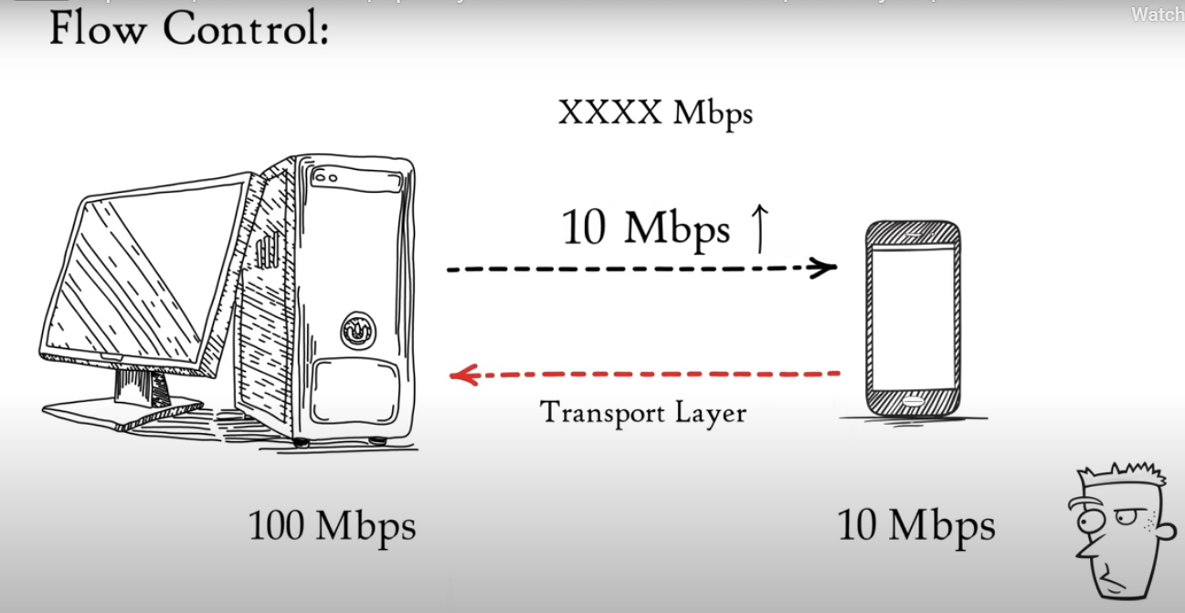

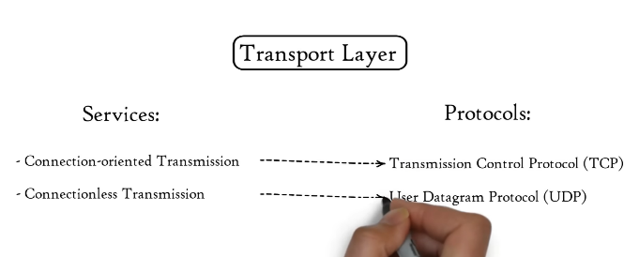
NETWORK LAYER
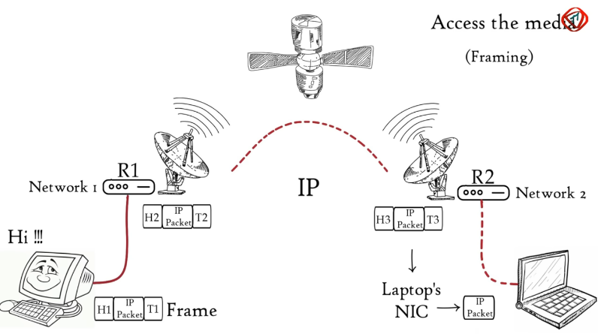
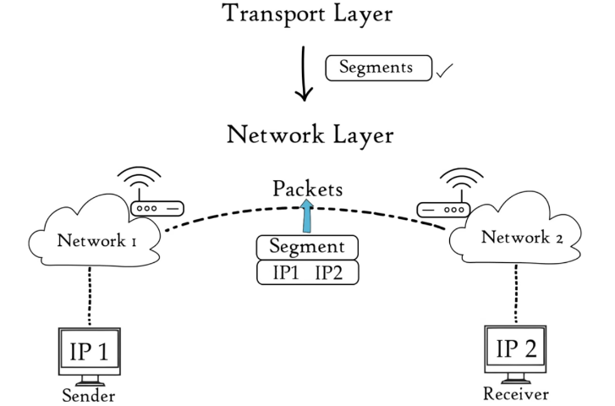
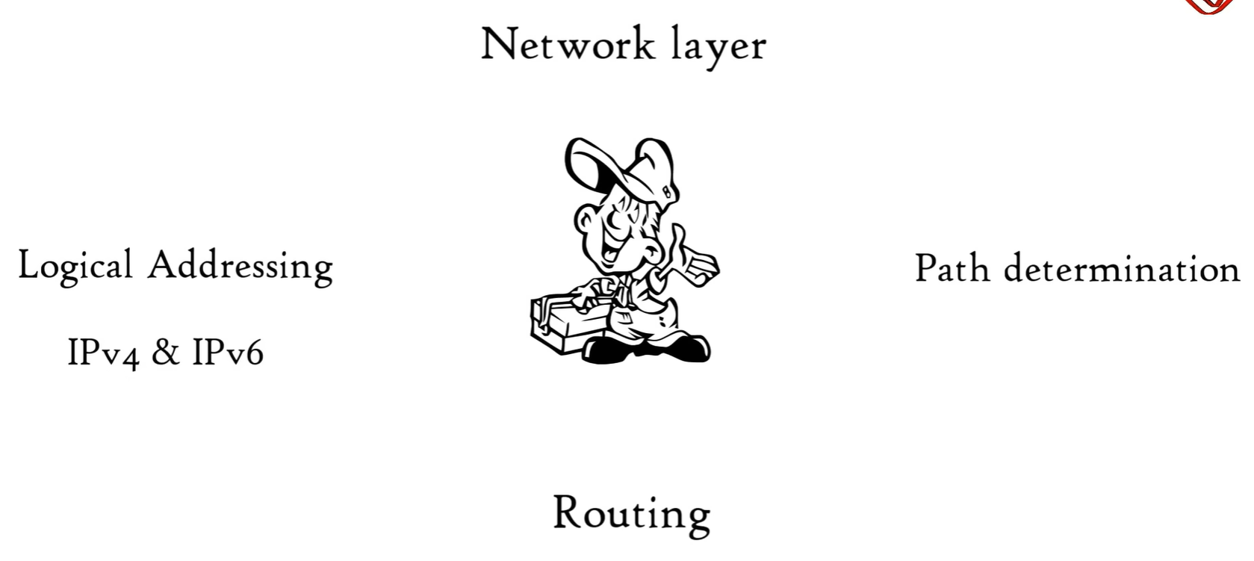

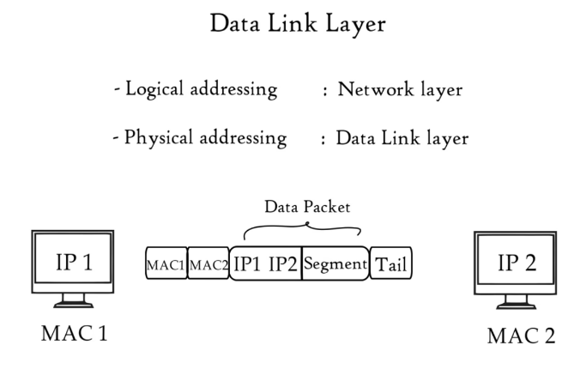
DATA LAYER
