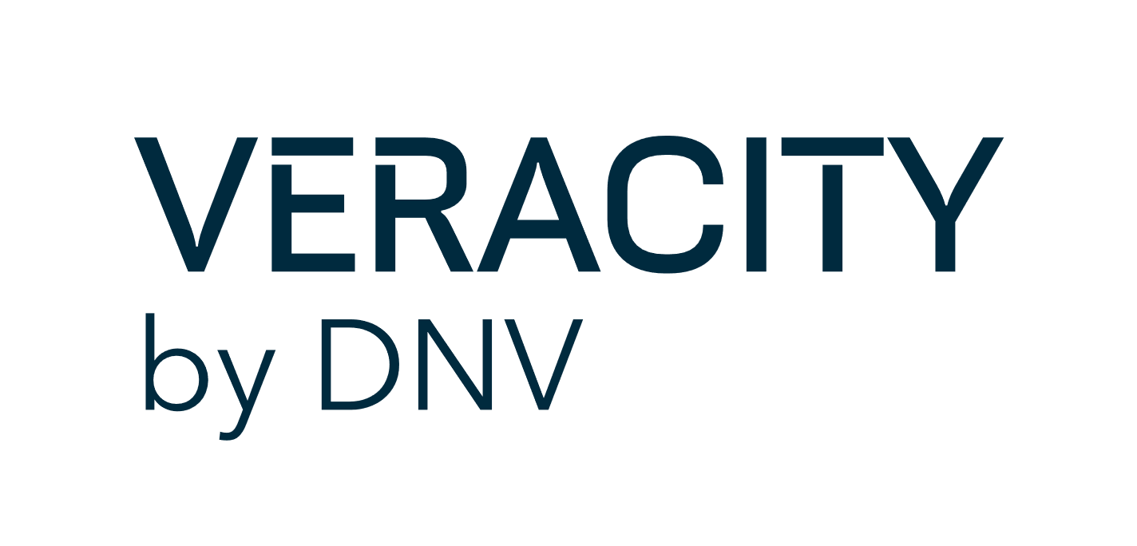

**Service content form**

**for the Veracity Marketplace**

Last update: May 2021

**Before to start**

Please read the [online documentation](https://developer.veracity.com/docs/section/marketplace/productpresentation) for onboarding / listing a service on marketplace.

If you plan to integrate your service/product with Veracity identity (log in to the service through Veracity ID / account), please read this [technical documentation](https://developer.veracity.com/article/veracity-technical-requirements).

**Listing your service on marketplace**

The process of creating a Veracity marketplace page for your service includes 3 steps:

1. **SERVICE CONTENT**  
   Fill-in the form with content information about your service/product.  
   Content to be provided in English only
2. **MEDIA** (images/illustrations, video)  
   Indicate in the form the different media (images, logo, pictogram, video) you want displayed.
3. **SEND US**

Send back the filled in document and all the relevant attachment by e-mail to onboarding@veracity.com

If you need any assistance or information, please contact: [onboarding@veracity.com](mailto:onboarding@veracity.com)

**SERVICE CONTENT**Please fill-in the form in English.  
(Read [online documentation](https://developer.veracity.com/docs/section/marketplace/productpresentation) for guidance)

|  |  |  |
| --- | --- | --- |
| **Service information and categorization** We need this info for categorization and search. On marketplace home user can filter the widgets or search with key words. | |  |
| Service name Avoid abbreviations, and try to be short (max 60 characters) |  |  |
| Service owner contact  (Name and email) |  |  |
| Indicate if the service is: (check the correct option) | **Ready for online sales.** Prices can be displayed in the marketplace and the customer can complete an online purchase process (Only available for DNV services. For 3rd party services, please contact us)  **Free.** The service or dataset as such can be made available for free. The page will get a “Free access” button  ☐ **Free but** we want to validate everyone who gets access (not recommended due to manual process/extra costs)  **Paid service but not ready for online sales.** Cannot display prices easily or not perform an online sale yet, so we only want to capture leads for now. The page will get a “Get a price quote” button  **OTHER** (specify):__________________  N.B.: A “**Contact provider”** button will be displayed on product pages for all services, so customers have the possibility to contact you with their questions. |  |
|  |  |  |
| **Type of service**:  one or more choices | Software (downloadable software)  Online service (SaaS)  Dataset  APIs  Advisory service |  |
|  |  |  |
| **Service industry**  one or more choices | Energy and renewables  Maritime  Oil and gas  All industries  Other (specify) :__________________ |  |
|  |  |  |
| **Service category**  we recommend checking a maximum of 5 categories | Analytics / insights  Building and engineering  Certification and approval  Communication and Collaboration  Cost management  Cyber Security  Data management  Data quality assessment  Digital Growth  Emissions  Fleet Management  Forecasting  Fuel efficiency  Maintenance  Monitoring  Operational efficiency  Performance  Pipeline  Predictive maintenance  Quality, health and safety  Remote services  Risk Management  Rules and standards  Sensors and connectivity  Ship efficiency  Supply chain management  Sustainability  Wells and drilling |  |
|  |  |  |

**Service Terms & Conditions**

If you are selling a service on the Veracity Marketplace we recommend having a valid Terms & Conditions document.   
For internal DNV services/products you must have a Terms & Condition approved by DNV Group Legal.

Contact us to learn more ([onboarding@veracity.com](mailto:onboarding@veracity.com))

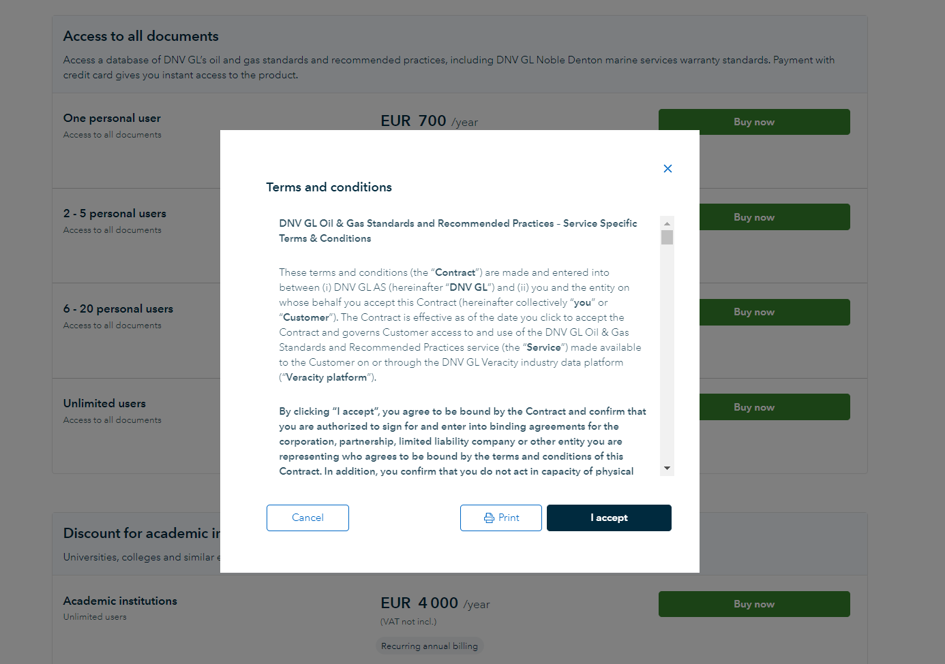

The customer buying your service/product will need to accept the T&C at the starting of the checkout process

To access the service the user will also need to accept separate Veracity platform T&C’s. This is done as a step of the sign-up process. Veracity will manage these Terms and Conditions.

**SERVICE MEDIA** (text, video, images and illustration)

|  |  |  |
| --- | --- | --- |
| **Widget on Marketplace** | | |
| **Widget Tagline** A brief, one-sentence statement explaining the product’s core Value Proposition.  What is the product? What will the user get?  (see example)  *maximum 100 characters (including white space).* | Eg. A fully digital collaborative tool connecting LNG fuel suppliers and ship owners | logo | |
| **Service picture** | You have three options for creating your widget image. Select the one you wish to use:  Representative image (recommended)  Own logo  Icon / pictogram (only for DNV services) | Image    Pictogram | |
| *If image* | Please send us a high resolution jpg. |  | |
| *If icon/pictogram* | Please send us the file in vectorial format (eg. .eps, .svg)  INFO only for DNV services: - the pictogram will get a SKY blue color as a background  - contact us if you need help in creating a pictogram |  | |

|  |  |  |  |
| --- | --- | --- | --- |
| **Product page – top banner** Your service will have a dedicated product page showing the main key benefits and describing what the service is about  If applicable it will also show price and delivery details. | | | |
| **Service Tagline** (1) **same as Widget tagline** A brief, one-sentence statement explaining the product's core value proposition. This will appear on top of the  product page.  *maximum 100 characters (including white space).* | eg. Latest requirements and guidance for marine warranty based on DNV GL experience | |  |
| **Banner image** (2) | **Please provide us with a high-resolution jpg, png or tiff image Size 4:3  (eg. 800x600 px)**  The image will be automatically cut whenever adapting to different devices. Try to select a picture that has main subject in the centrum, so that main subject won`t be cut when adapting to mobile devices (see example on the side) | | Good image example: |
| **Video link on image** (3) optional | Allowed locations for videos are:  **Youtube**: [https://www.youtube.com/**embed**/oV4g6dm74_E](https://www.youtube.com/embed/oV4g6dm74_E)  Embed URL format required.  **Vimeo**: [https://**player**.vimeo.com/video/289631805](https://player.vimeo.com/video/289631805)  Player URL format required  **DailyMotion**: http://www.dailymotion.com  **Wistia**: [https://fast.wistia.net](https://fast.wistia.net/)  **PressToGo**: https://production.presstogo.com  **For DNV services Brand central is also accepted** https://brandcentral.dnv.com/ | Write your video url here: | |
| **Product key benefit (4)** Explain in 3 point what is the added value of your product.  Why should the buyer come to you first instead of going to a competitor`s product?  My product is… | Key benefits, are shown with an icon that we will select from our archive. You provide the text and Veracity will select an appropriate icon.  Examples of “key benefits”:  1. Time saving thanks to digital certification process  2. Easy to download and access  3. Offering industry benchmarking | |  |
| 1st key benefit: *maximum 60 characters (including white space).* |  | |  |
| 2nd key benefit: *maximum 60 characters (including white space).* |  | |  |
| 3rd key benefit: *maximum 60 characters (including white space).* |  | |  |

|  |  |  |
| --- | --- | --- |
| **Product page – features paragraphs** Service can be described in detail through 1 to 5 paragraphs.  NOTE:*if you also have another product page hosted somewhere else, make sure the text is not identical.  This is to avoid duplicating content as this can affect ranking in search engines* | |  |
| **Paragraph description** Try to describe in detail what the user will get, how the software works, different type of features, or packages you sell. Adding a screenshot of the application is also a good way to present your service. | |  |
| 1st Paragraph Title: *maximum 70 characters (including white space).* |  |
| 1st Paragraph Text: *maximum 550 characters (including white space).* |  |
| Video link (optional): *For allowed video locations see Video link on page banner.* |  |
| **Required media:** 1 image for 1st paragraph in .jpg (please provide high resolution) | |
|  |  |
| 2nd Paragraph Title: *maximum 70 characters (including white space).* |  |
| 2nd Paragraph Text: *maximum 550 characters (including white space).* |  |
| Video link (optional): *For allowed video locations see Video link on page banner.* |  |
| **Required media:** 1 image for 2nd paragraph in .jpg (please provide high resolution) | |
| 3rd Paragraph Title: *maximum 70 characters (including white space).* |  |
| 3rd Paragraph Text: *maximum 550 characters (including white space).* |  |
| Video link (optional): *For allowed video locations see Video link on page banner.* |  |
| **Required media:** 1 image for 3rd paragraph in .jpg (please provide high resolution) | |
|  |  |
| 4th Paragraph Title: *maximum 70 characters (including white space).* |  |
| 4th Paragraph Text: *maximum 550 characters (including white space).* |  |
| Video link (optional): *For allowed video locations see Video link on page banner.* |  |
| **Required media:** 1 image for 4th paragraph in .jpg (please provide high resolution) | |
|  |  |
| 5th Paragraph Title: *maximum 70 characters (including white space).* |  |
| 5th Paragraph Text: *maximum 550 characters (including white space).* |  |
| Video link (optional): *For allowed video locations see Video link on page banner.* |  |
| **Required media:** 1 image for 5th paragraph in .jpg (please provide high resolution) | |

|  |  |  |
| --- | --- | --- |
| **Product page – Pricing plans** (optional)If you are selling your product / service digitally we have section for showing your pricing plan. Read more on this in our [online documentation](https://developer.veracity.com/docs/section/marketplace/choosingyourpricingmodel)  We also explain all the pricing possibilities in another larger guide. Contact us on [onboarding@veracity.com](mailto:onboarding@veracity.com) to get access to extra material. | | Visual examples |
| **Write a brief description of your product variants, their prices and how they are sold (i.e. per ship, per user, yearly subscription etc)**  Leave this field empty if you are still working on your business model. |  |  |

|  |  |  |
| --- | --- | --- |
| **Product page – customer success stories** (optional)Here you can list relevant quotes from customers. | |  |
| Testimony author name: |  | Ex. From Meteomatics |
| Testimony author role and company |  |
| Testimony text *maximum 500 characters (including white space).* |  |
| **Required media: 1 Testimony author picture.**  **FORMAT:** .jpg in high resolution If not available we will use our default avatar | |

|  |  |  |
| --- | --- | --- |
| **Product page – Learn more content** (optional)You can add 2 to 6 additional links.  We have a set of icons that we will select to fit your “learn More” link | | Visual examples |
|  |  |  |
| 1st Additional link - Title |  |
| 1st Additional link – Text *maximum 190 characters (including white space).* |  |
| URL link |  |
|  |  |
| 2nd Additional link - Title |  |
| 2nd Additional link – Text *maximum 190 characters (including white space).* |  |
| URL link |  |
|  |  |
| 3rd Additional link - Title |  |
| 3rd Additional link – Text *maximum 190 characters (including white space).* |  |
| URL link |  |
|  |  |
| 4th Additional link - Title |  |
| 4th Additional link – Text *maximum 190 characters (including white space).* |  |
| URL link |  |

|  |  |  |
| --- | --- | --- |
| **Product page – Service provider information** | |  |
| Service provider name/company |  |  |
| Service provider description ***For DNV providers*** *you do not need to enter a content. We have default boiler plate from DNV BAs.* |  |
| **Required media: Company Logo in high resolution.  It is** recommended to send vectorial files with white background (e.g. .eps, .svg) | |