

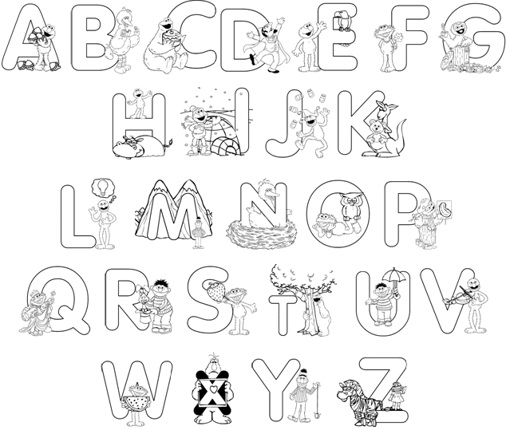
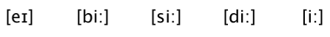
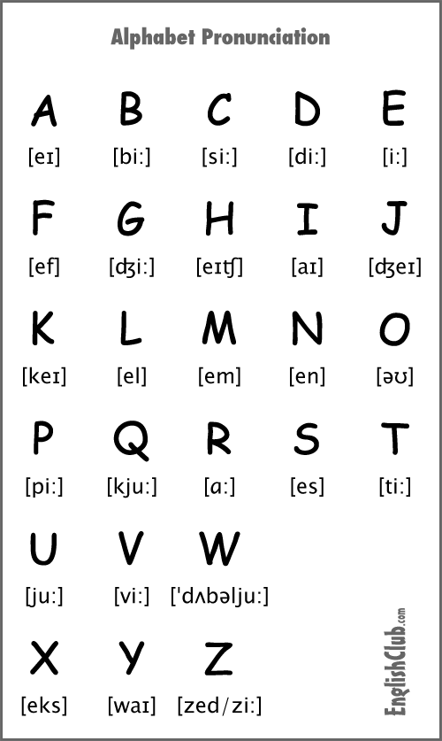


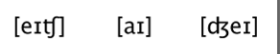
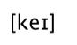
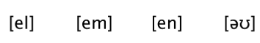


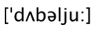


1. Colour the alphabet letters in :

Blue – A H O V Purple – B I P W
Green – C J Q X Yellow – D K R Y
Orange – E L S Z Red – F M T
Pink – G N U

2. How do you spell your name? _______________________________

