**GSM Based Weather Reporting (Temperature/Light/Humidity)**

**Q1: Background of GSM-based weather reporting (Temperature/Light/Humidity) project**

The GSM-based weather reporting project aims to develop a system capable of sensing and reporting weather conditions such as temperature, light intensity, and humidity. This system leverages GSM technology to transmit the collected data wirelessly via SMS, allowing users to monitor weather conditions remotely. Key components include a temperature sensor, light sensor, and humidity sensor, interfaced with an ATmega328 microcontroller. The microcontroller processes sensor data and sends it to a GSM modem, which then sends the data as an SMS to a predefined user. This project addresses the need for a convenient and efficient weather monitoring solution, eliminating the necessity for users to be physically present at the monitoring site.

**Q2: Block diagram of your GSM-based weather reporting (Temperature/Light/Humidity) system, and list down all the parts/components/sub-circuits that constitute the assembly of your system.**

**Block Diagram:**

**Components:**

Sensors: DHT-11 Digital Temperature And Humidity Sensor, Light Sensor

Microcontroller:ATmega328

GSM Modem: GSM(Global System for Mobile Communication) Module

Power Supply: Voltage Regulator,Transformer/Adapter

User Interface: LCD, Phone

Supporting Components: Resistors, Capacitors, Cables and Connectors, Diodes

**Q3: Specific principle of operation, theory, types, and sub-circuit connections/diagrams in the GSM-based weather reporting (Temperature/Light/Humidity) system.**

The temperature sensor operates on the principle of measuring ambient temperature using a thermistor or a similar temperature-sensitive device. The theory behind it is that changes in temperature cause a change in resistance, which is then converted to a voltage that can be read by the microcontroller. Common types of temperature sensors include DHT11, LM35, and DS18B20. In the circuit, the temperature sensor is connected to the analog input pin of the microcontroller.

The light sensor measures light intensity using a photoresistor or photodiode. Its principle of operation is based on the fact that light intensity changes the resistance of the sensor, resulting in a corresponding voltage change. Types of light sensors include LDR (Light Dependent Resistor) and photodiodes. This sensor is also connected to the analog input pin of the microcontroller.

The humidity sensor measures humidity levels in the air using either a capacitive or resistive sensor. The theory is that changes in humidity alter the capacitance or resistance, which is then read by the microcontroller. Examples of humidity sensors include DHT11 and DHT22. The humidity sensor is typically connected to the digital input pin of the microcontroller.

The ATmega328 microcontroller serves as the central processing unit for the system. It reads data from the sensors, processes this data, and controls communication with the GSM modem. The theory involves using embedded C programming to operate and control peripheral devices. The microcontroller interfaces with all sensors, the GSM modem, and other components.

The GSM modem is responsible for sending SMS messages using the GSM network. It operates on the principle of encoding sensor data into SMS format and transmitting it to the user's phone number. Common types of GSM modems include SIM800 and SIM900. The GSM modem is connected to the microcontroller via UART (Universal Asynchronous Receiver-Transmitter).

The voltage regulator ensures a stable power supply by regulating voltage. It converts varying input voltage to a constant output voltage. A typical example is the 7805 voltage regulator, which provides a 5V output. This regulator powers the microcontroller and other components.

Other supporting components include the resistors, capacitors, transistors, and diodes used for signal conditioning and power regulation tasks.

**Q4: Considering the flow of input/output signals that you’ve logically established in the block diagram of Q2 and the parts in Q3, synthesize and architect the detailed circuit diagram of the GSM-based weather reporting (Temperature/Light/Humidity) system, illustrating the connection of various controller pins to the terminals of the interfaced parts.**

**(**PROTEUS**)**

**Q5: Does the hardware circuit diagram developed in Q4 for the GS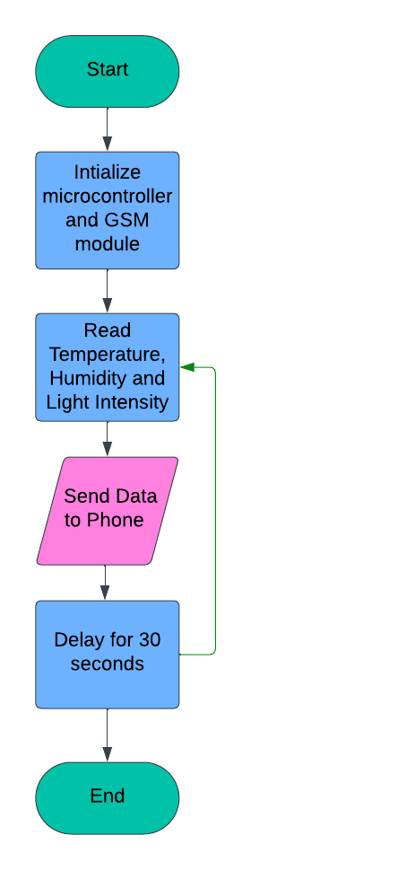M-based weather reporting (Temperature/Light/Humidity) system require controller software/coding for processing the inputs to actuate the system output functions? (Y/N). If yes, establish and write down the sequence of steps, from “start to stop,” and provide a flowchart for the required code.**

Yes.

**Sequence of Steps:**

1. Start
2. Initialize Microcontroller and GSM Modem
3. Read Data from Temperature Sensor
4. Read Data from Light Sensor
5. Read Data from Humidity Sensor
6. Process Sensor Data
7. Format Data for SMS
8. Send SMS via GSM Modem
9. Wait for a Defined Interval
10. Repeat from Step 3

**Q6: Using a suitable microcontroller platform such as Arduino, Raspberry Pi, or ARM, develop the code to meet the requirements you have outlined in Q5 for the GSM-based weather reporting (Temperature/Light/Humidity) system. Carry out debugging and ensure there are no errors once you run the code on the selected platform.**

**(**Arduino Code**)**

**Q7: Model the hardware circuit diagram of Q4 in simulation software and transfer the code developed in Q6 into the controller over the simulation platform. Run the simulation and observe the input-output logic realized for the GSM-based weather reporting (Temperature/Light/Humidity) system.**

DONE

**Q8: Analyze different cases of results based on different inputs to the simulation in Q7. Do the results obtained meet the requirements that you expected while conceptualizing the GSM-based weather reporting (Temperature/Light/Humidity) project? (Y/N). If not, what caused the discrepancies?**

Analysis:

* Expected Results: Correct temperature, humidity, and light readings sent via SMS.
* Case 1: Normal Conditions - All values are as expected, SMS sent correctly.
* Case 2: Extreme Temperature - Extreme values read correctly, SMS sent.
* Case 3: Low Light - Low light values read correctly, SMS sent.
* Case 4: High Humidity - High humidity values read correctly, SMS sent.

Result: If discrepancies occur, check sensor calibration, connections, and code logic.

**Q9: Design and draw the PCB layout plan for your GSM-based weather reporting (Temperature/Light/Humidity) project using the simulation software.**

DONE

**Q10: Add one more structured research question into this list of research questions and provide a solution to it, for instance, regarding a more improved version of your GSM-based weather reporting (Temperature/Light/Humidity) project.**

### Research Question:

**How can the GSM-based weather reporting system be enhanced by integrating a Bluetooth module for improved local data transmission and user accessibility?**

### Solution:

To improve the GSM-based weather reporting system, integrating a Bluetooth module such as the HC-05 allows for local wireless communication, enabling users to access data directly on their smartphones or tablets without the need for an internet connection. The integration involves connecting the HC-05 module to the Arduino's TX and RX pins and modifying the code to send temperature, humidity, and light data via Bluetooth. This setup provides a seamless way for users to receive real-time environmental data within a short range, enhancing convenience and immediacy of information.

GSM modules have significant drawbacks, including reliance on cellular networks, which can be unreliable in remote areas, and ongoing costs for SIM cards and data plans. In contrast, Bluetooth modules offer advantages such as independence from network availability and cost efficiency, as they do not require data plans or SIM cards, making them ideal for short-range, reliable, and economical local data transmission.