Safari Browsing History User Guide

This manual is created for new Apple tech customers, especially for **iPad or iPhone buyers**. As Safari browser is now available only for operating systems developed by Apple Inc. newcomers could experience some difficulties using the browser. In the document Safari users can find tips for work with web browsing history on iPad. The manual is based on the **iPadOS 14.2** operating system.

Contents

Web Browsing History 1

Work with the History 2

Opening 2

Deleting 4

Deleting a single Request 4

Deleting browser History for a certain period 5

Deleting browser History through Settings 6

Private Browsing in Safari 9

Turn on Private Browsing 9

Turn off Private Browsing 11

Favourites 11

Add a webpage to Favourites 11

Edit Favourites 13

Summarized Information 16

# Web Browsing History

Web browsing history is a record of visited web pages. The history includes site names and search time. The browser collects the information privately and do not publish it publicly.

Safari stores this information:

- to provide the user with a history list to go back to previously visited pages;

- to load pages quickly on next visits rather than download them from the servers.

Safari also can remember the pages users frequently visit and display them in the main window as top sites.

# Work with the History

## Opening

1. In the Safari app  on your iPad find the **Bookmarks** button in the toolbar and press it:

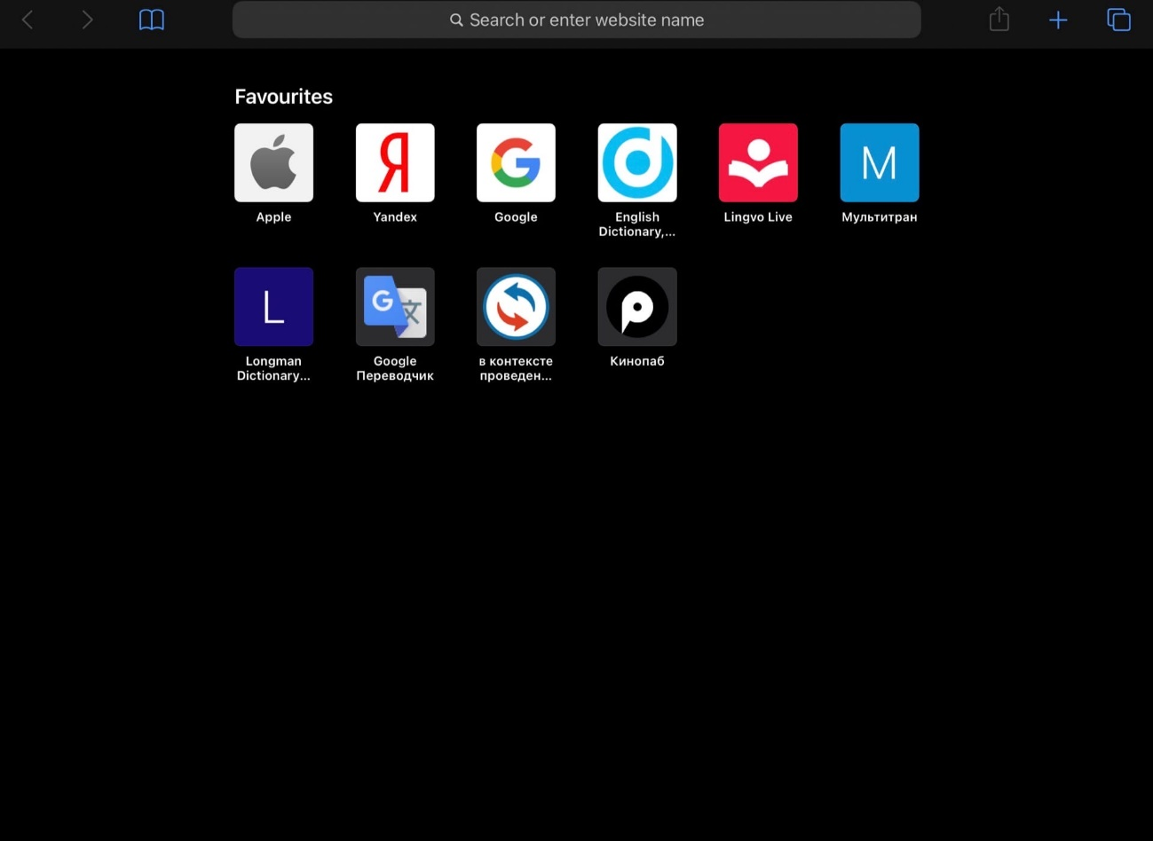

1. Select the **History icon** in the upper left corner. That displays the full search history from all tabs:

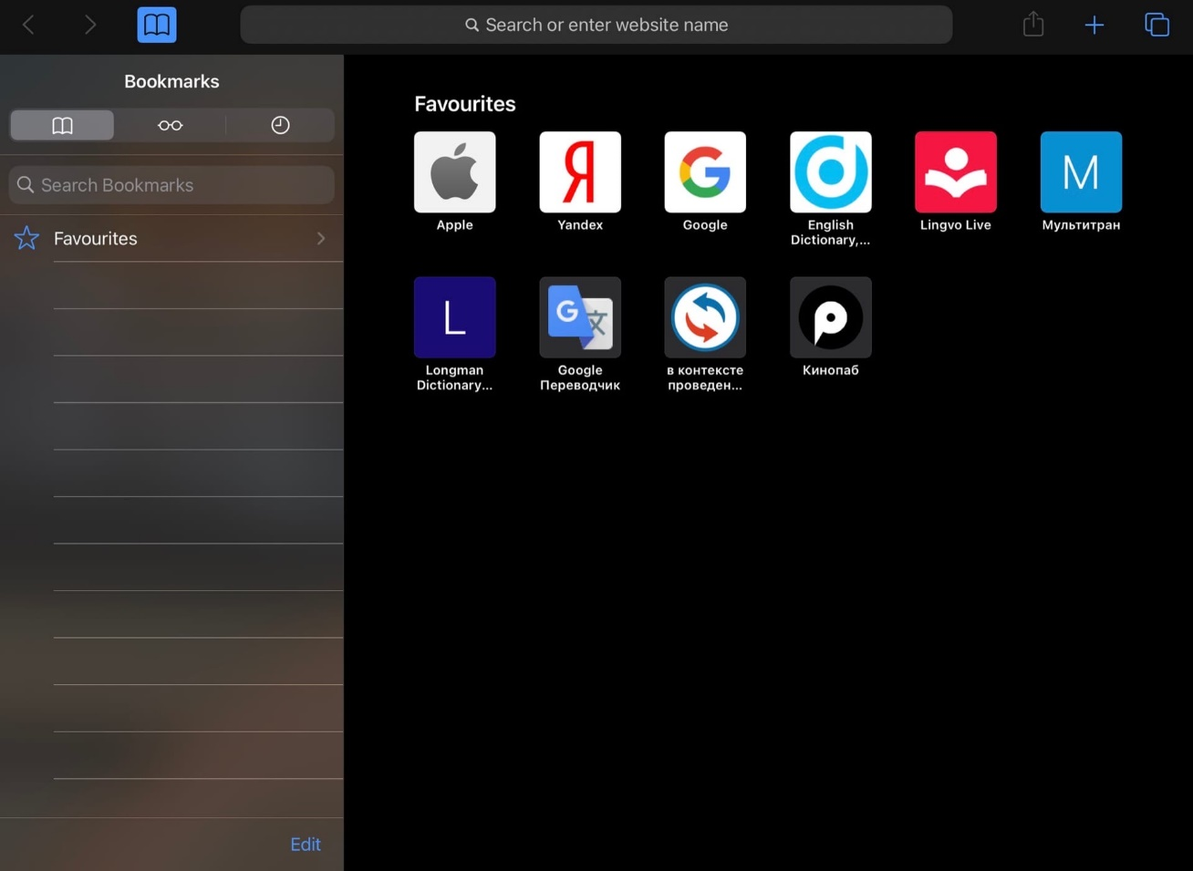

1. Inter your query in the **Search bar** and select the required option:

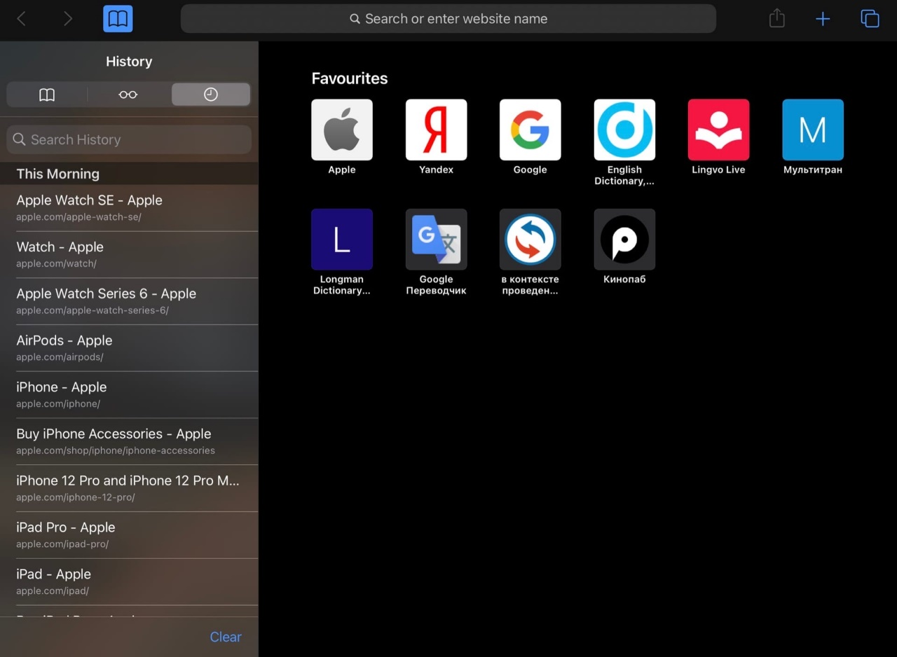

## Deleting

### Deleting a single Request

1. In the Safari app  on your iPad find the **Bookmarks** button in the toolbar and press it (see point 1 in the Opening section).
2. Select the **History icon** in the upper left corner. That displays the full search history from all tabs (see point 2 in the Opening section).
3. Find the required request and **swipe left** to delete it from your history:

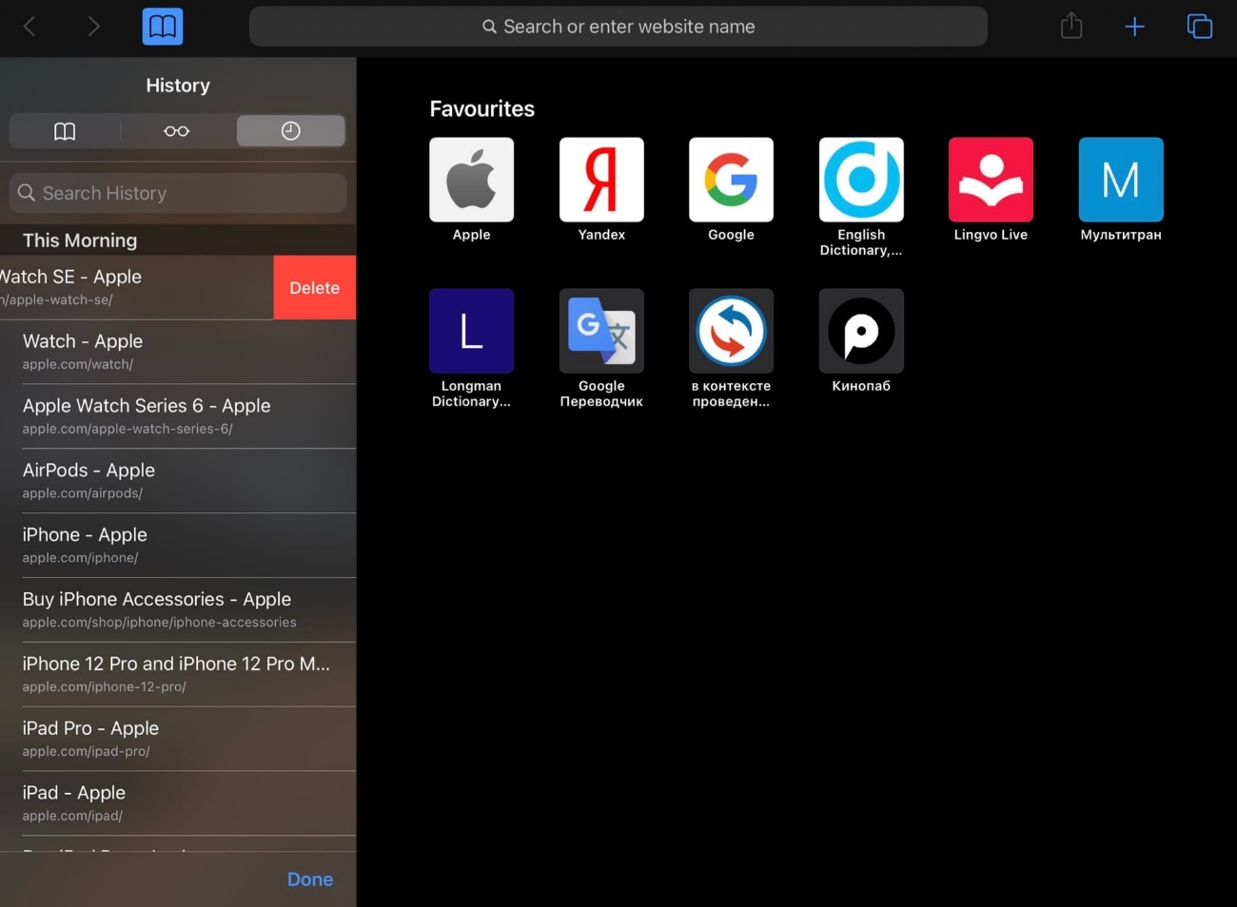

1. Tap **Done** or swipe left one more time:

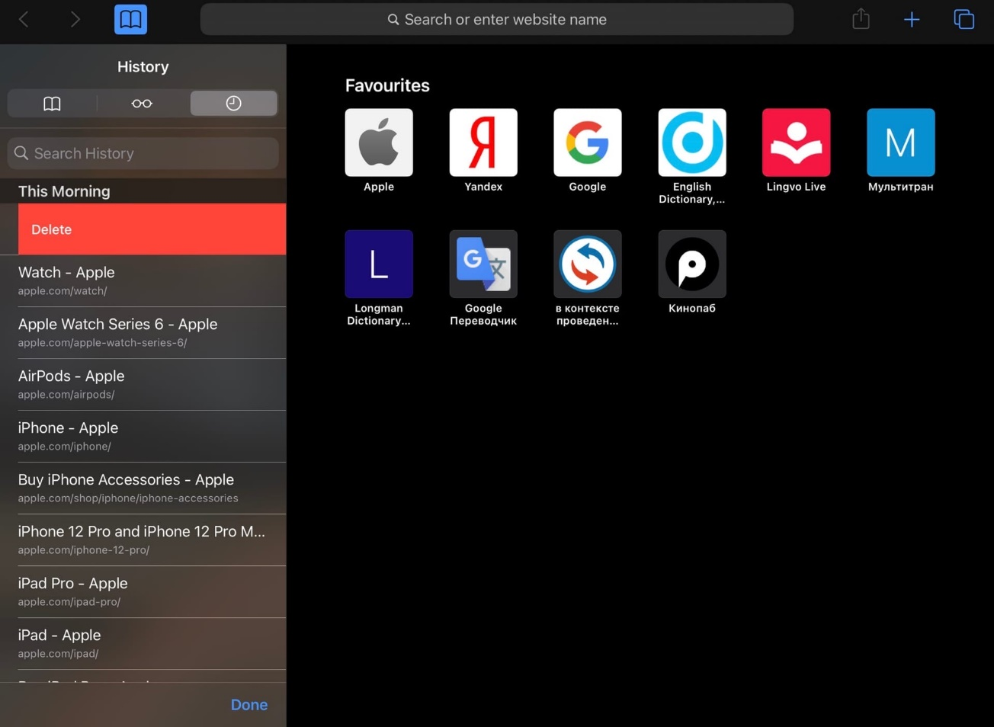

### Deleting browser History for a certain period

1. In the Safari app  on your iPad find the **Bookmarks** button in the toolbar and press it (see point 1 in the Opening section).
2. Select the **History icon** in the upper left corner. That displays the full search history from all tabs (see point 2 in the Opening section).
3. Tap **Clear** and select the period for which you want to delete your browsing history:

* All time
* Today and yesterday
* Today
* The last hour

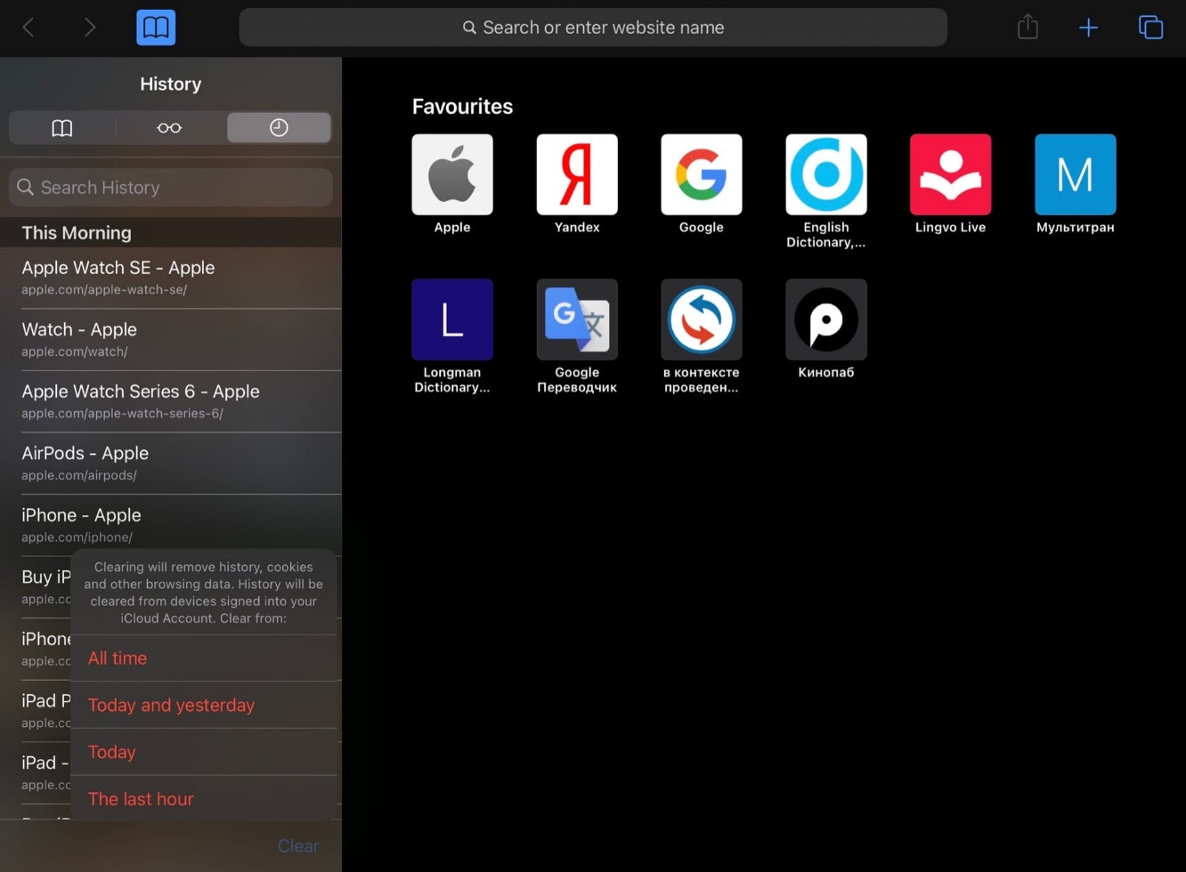

1. Select the required option. This clears the history from all devices signed into your iCloud Account.

### Deleting browser History through Settings

Aside from deleting the browser history in the Safari app, you can also do it through the Settings app.

1. In the Settings app  on your iPad swipe up and find **Safari**:

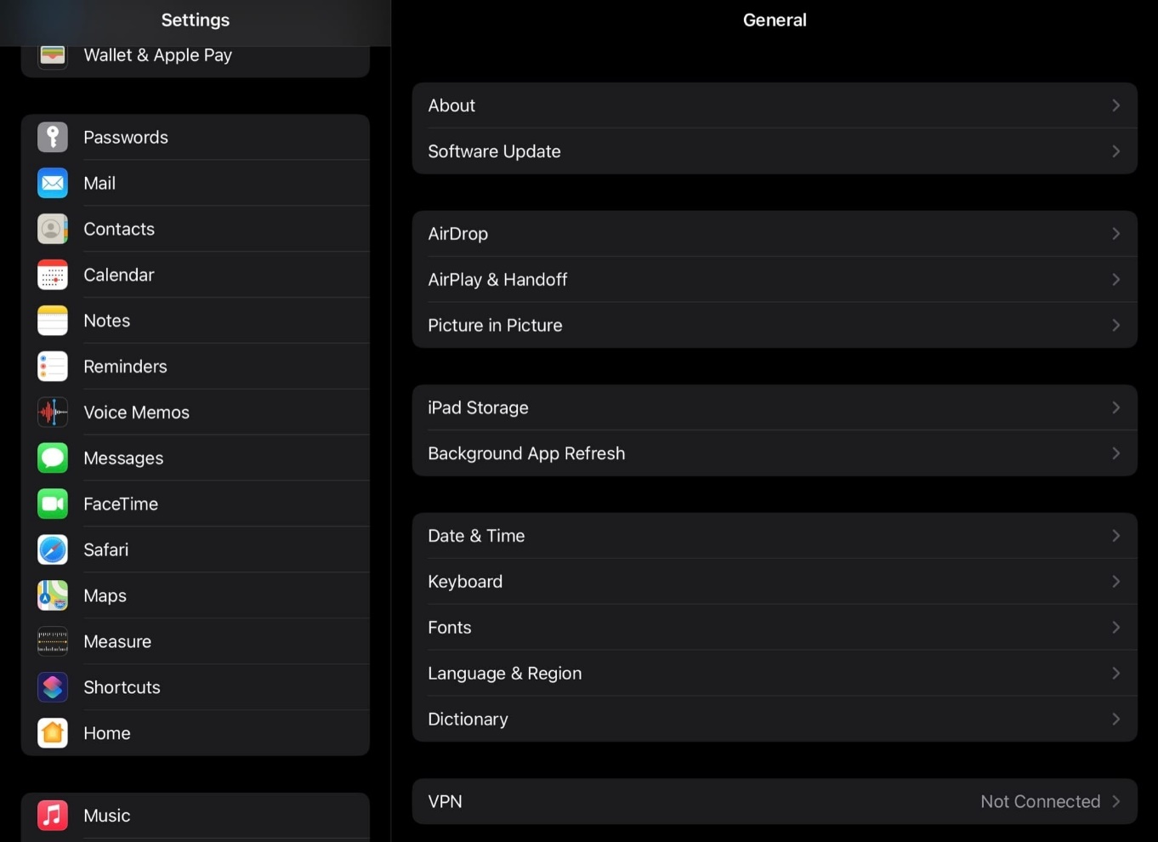

1. Inside the Safari menu, swipe up and tap **Clear History and Website Data**:

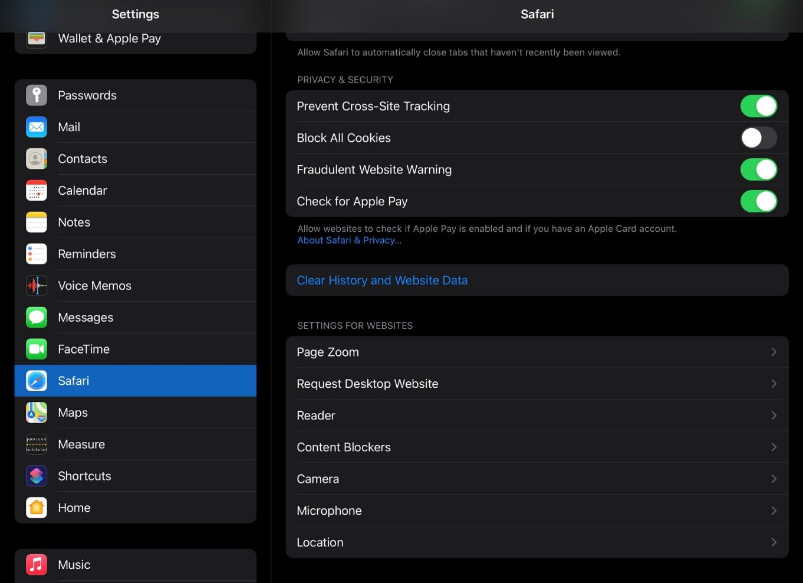

1. Select **Clear**. This clears the history from all devices signed into your iCloud Account:

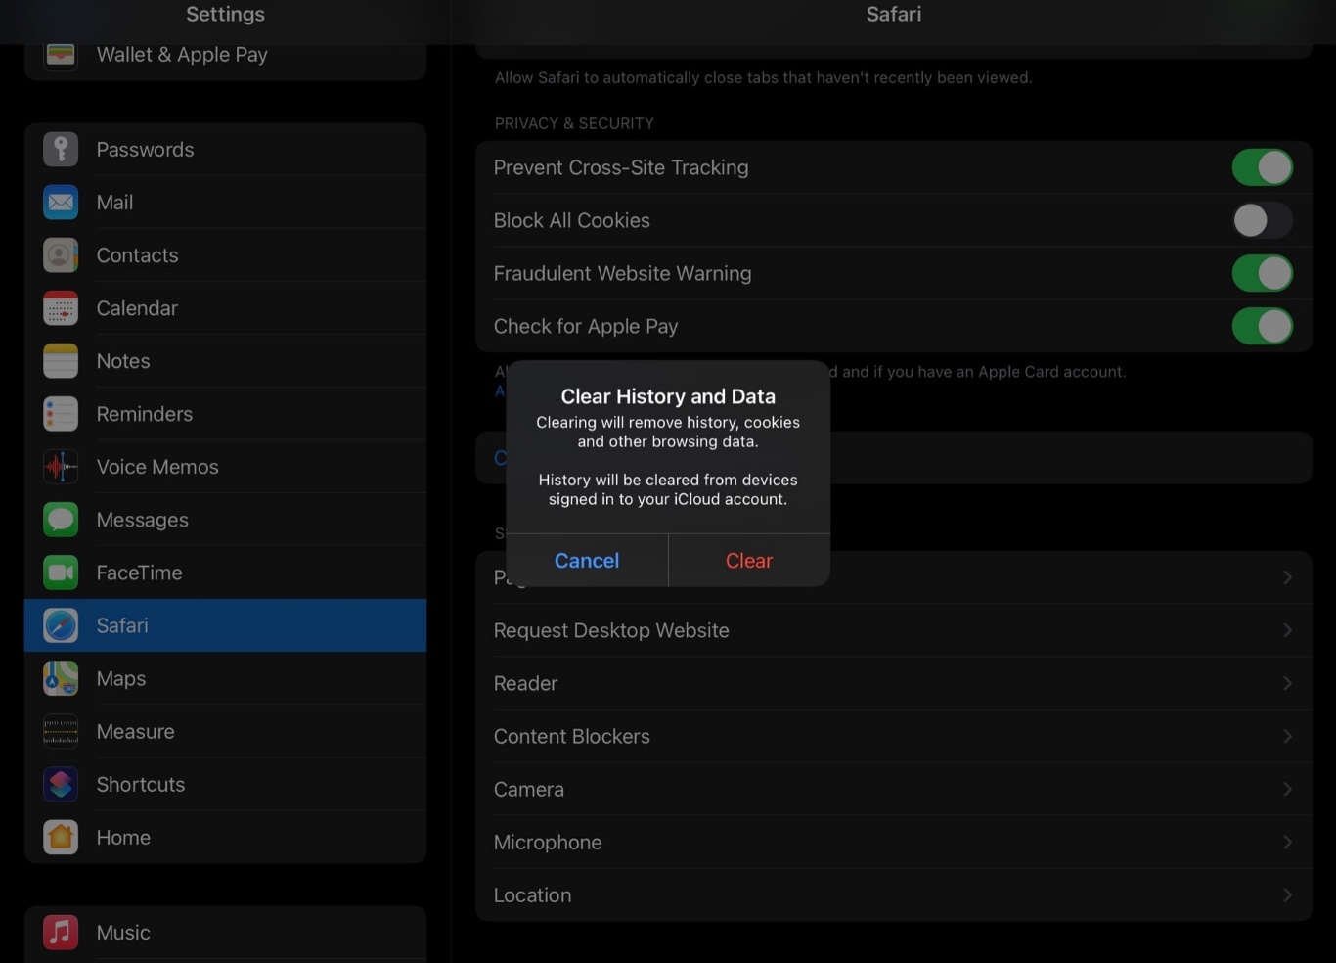

# Private Browsing in Safari

## Turn on Private Browsing

If you do not want Safari to save the details of your browsing and the websites you visit – use Safari private browsing mode.

1. In the Safari app  on your iPad find the **New Page** button in the toolbar and press it:

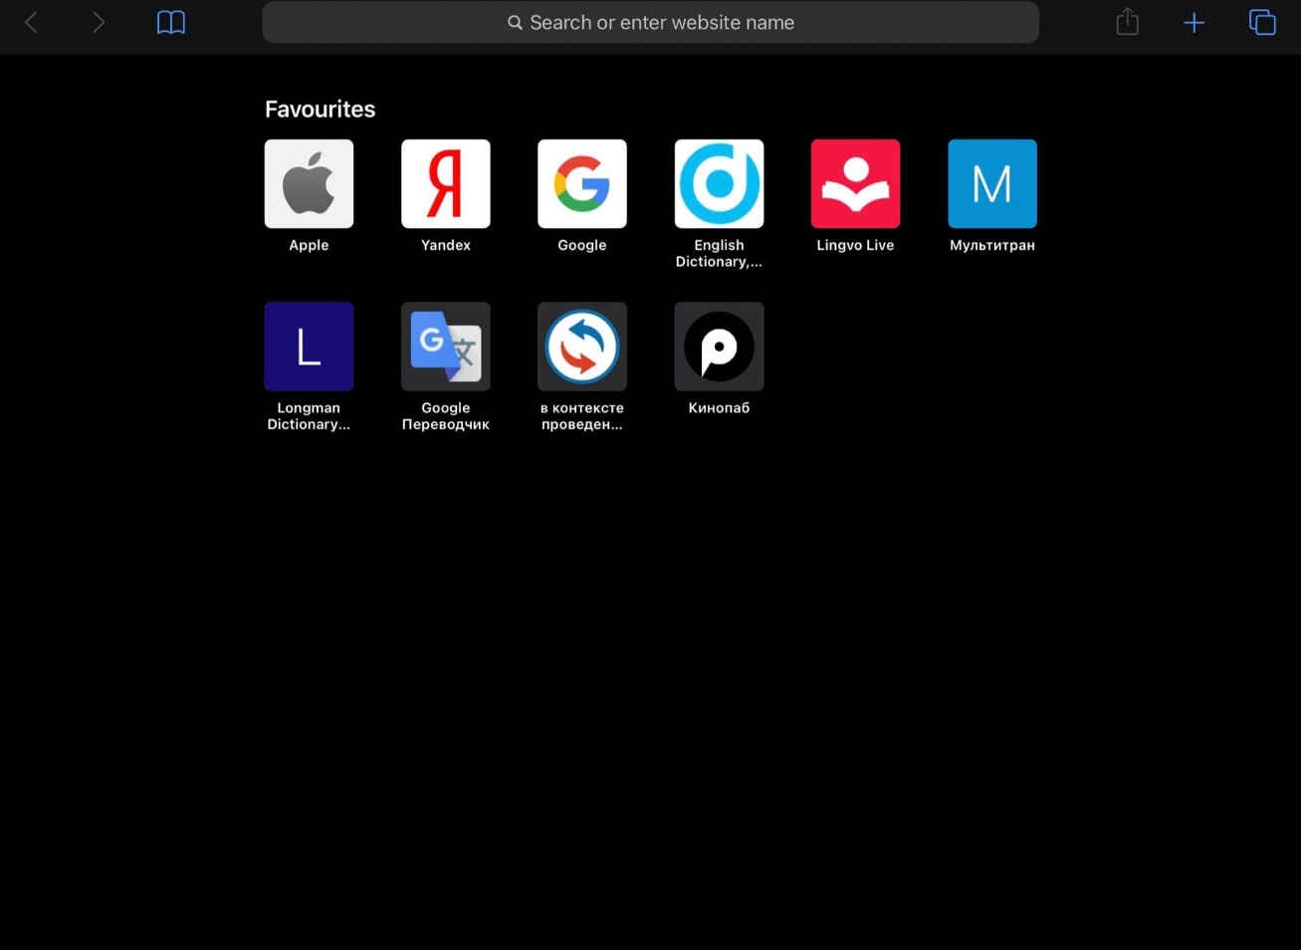

1. Tap the **Private** button in the toolbar:

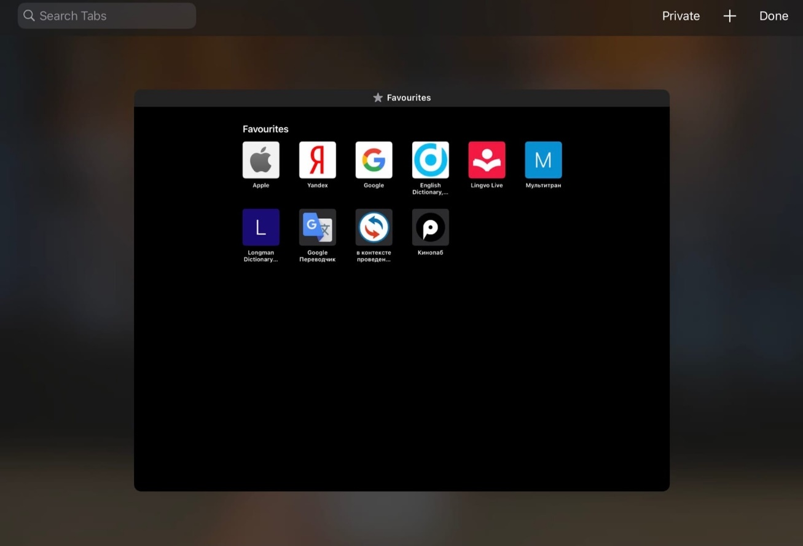

1. Tap the **Done** button near the Private button in the toolbar.

## Turn off Private Browsing

1. In the Safari app  on your iPad find the **New Page** button in the toolbar and press it (see point 1 in the Turn on Private Browsing section).
2. Tap **Private** in the toolbar in the upper right corner (see point 2 in the Turn on Private Browsing section).
3. Tap **Done** in the toolbar in the upper right corner.

# Favourites

## Add a webpage to Favourites

If you want to easily access the frequently visited pages without searching for them – use Favourites.

1. In the Safari app  on your iPad find and open the **page** you want to save.
2. Tap the **Share** button in the upper right corner of the toolbar.

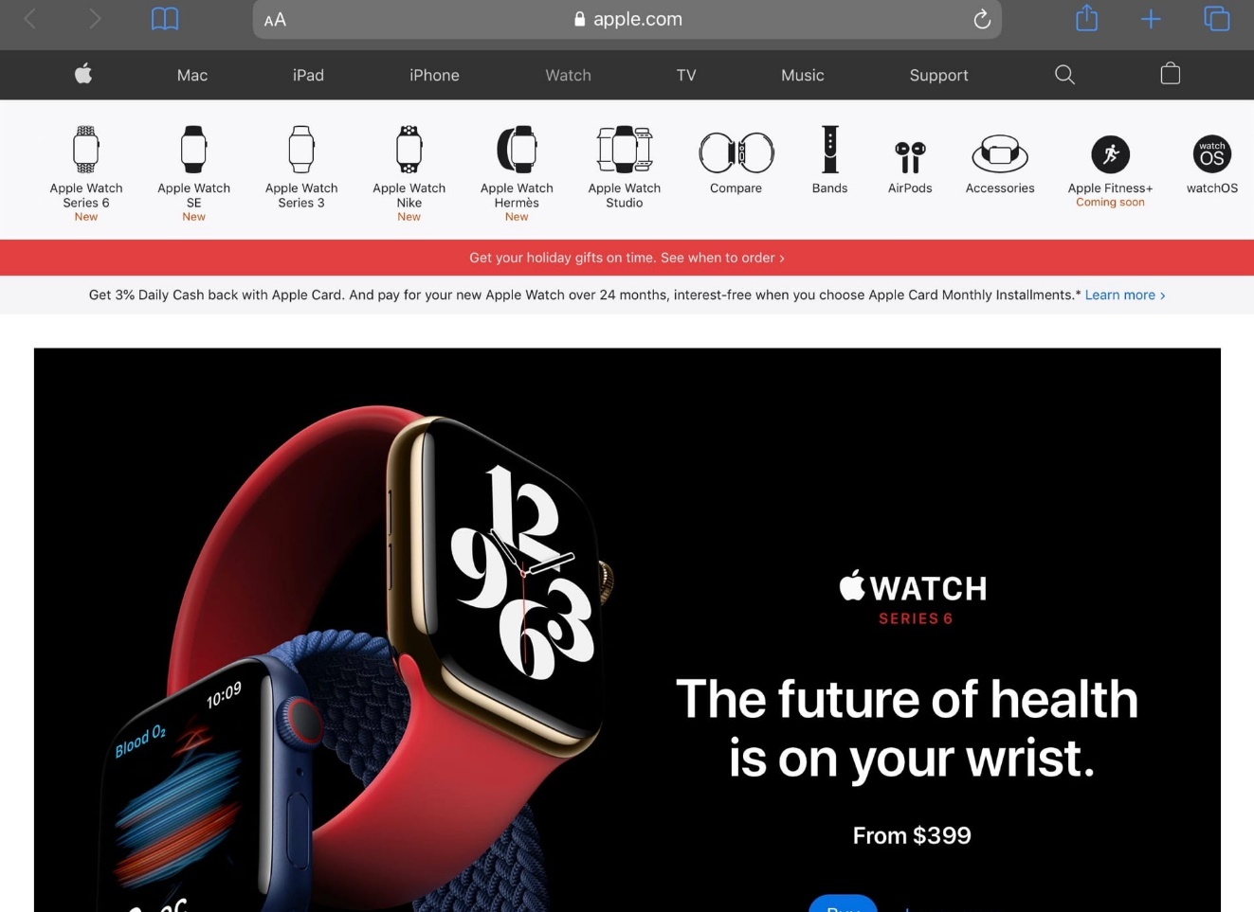

1. Select **Add to Favourites**:

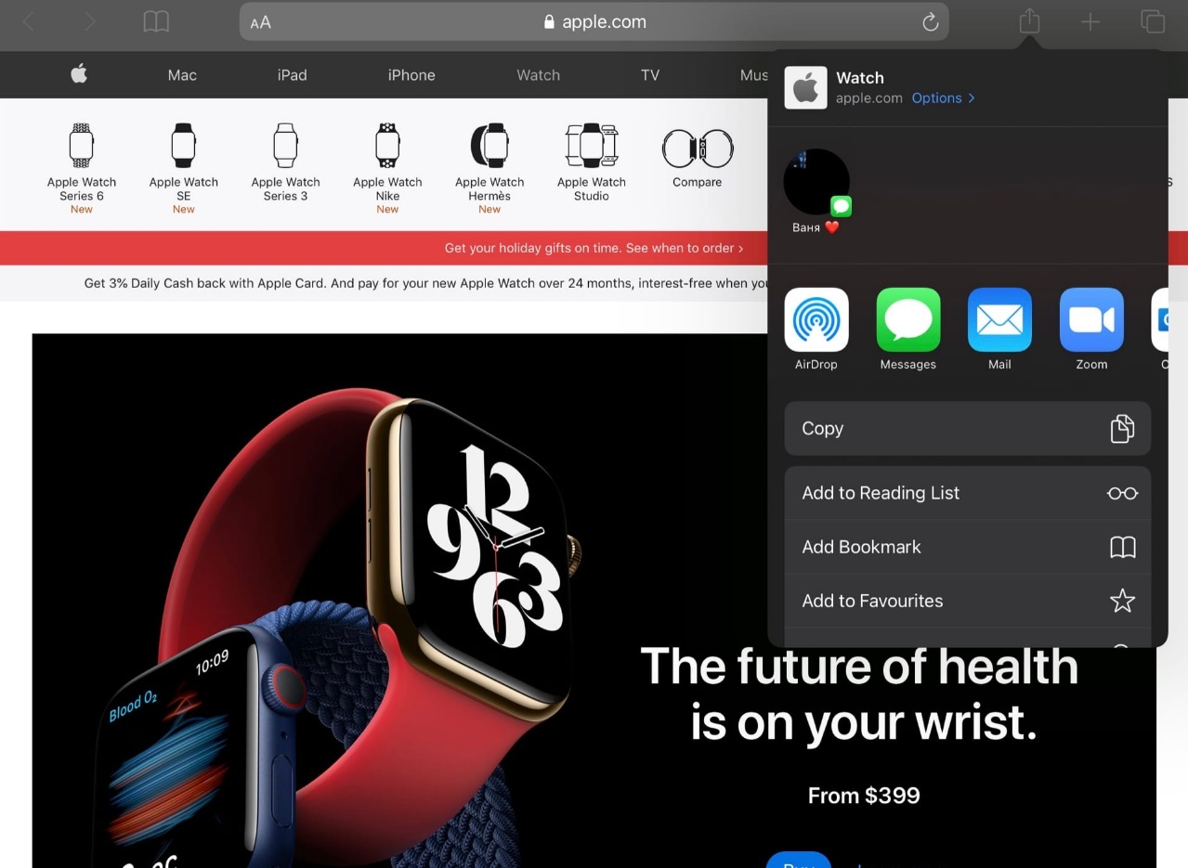

You can change the name of the website that will be displayed in the main window.

1. Tap **Save**:

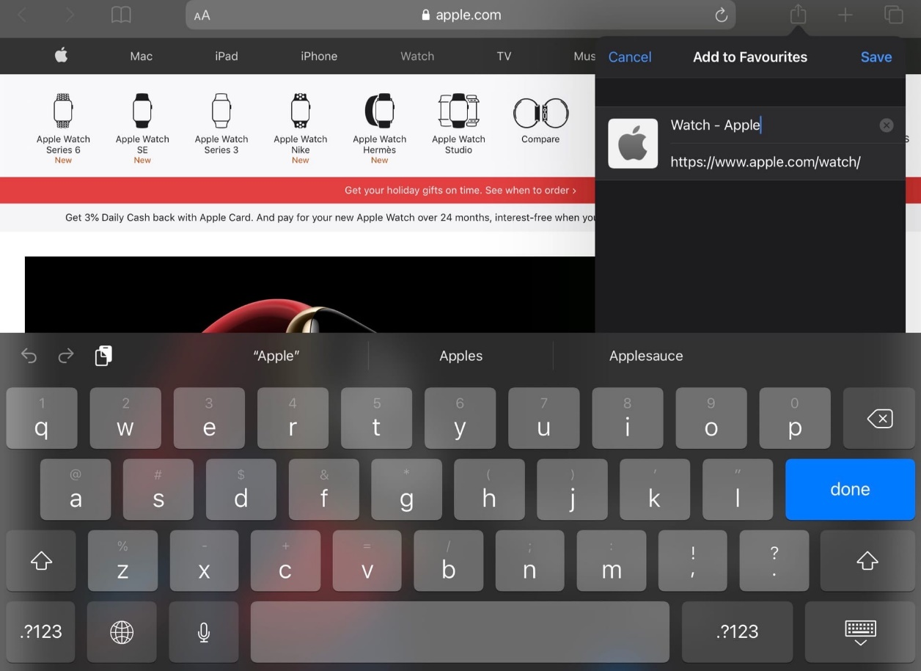

## Edit Favourites

1. In the Safari app  on your iPad find the **Bookmarks** button in the toolbar and press it (see point 1 in the Opening section).
2. Select the **Bookmarks** icon in the upper left corner:

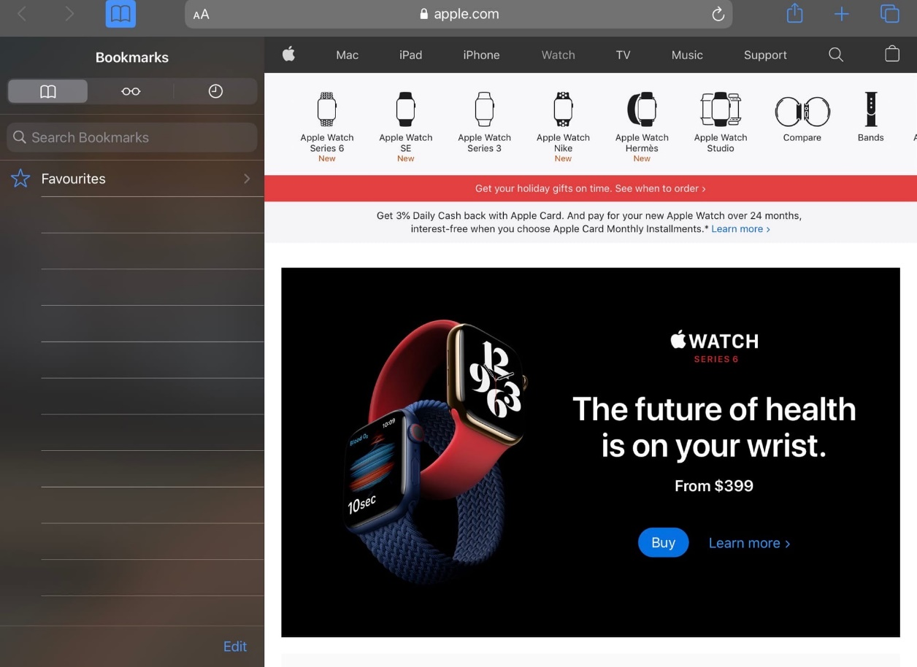

1. Select **Favourites**:



1. Swipe down to search your Favourites by names:

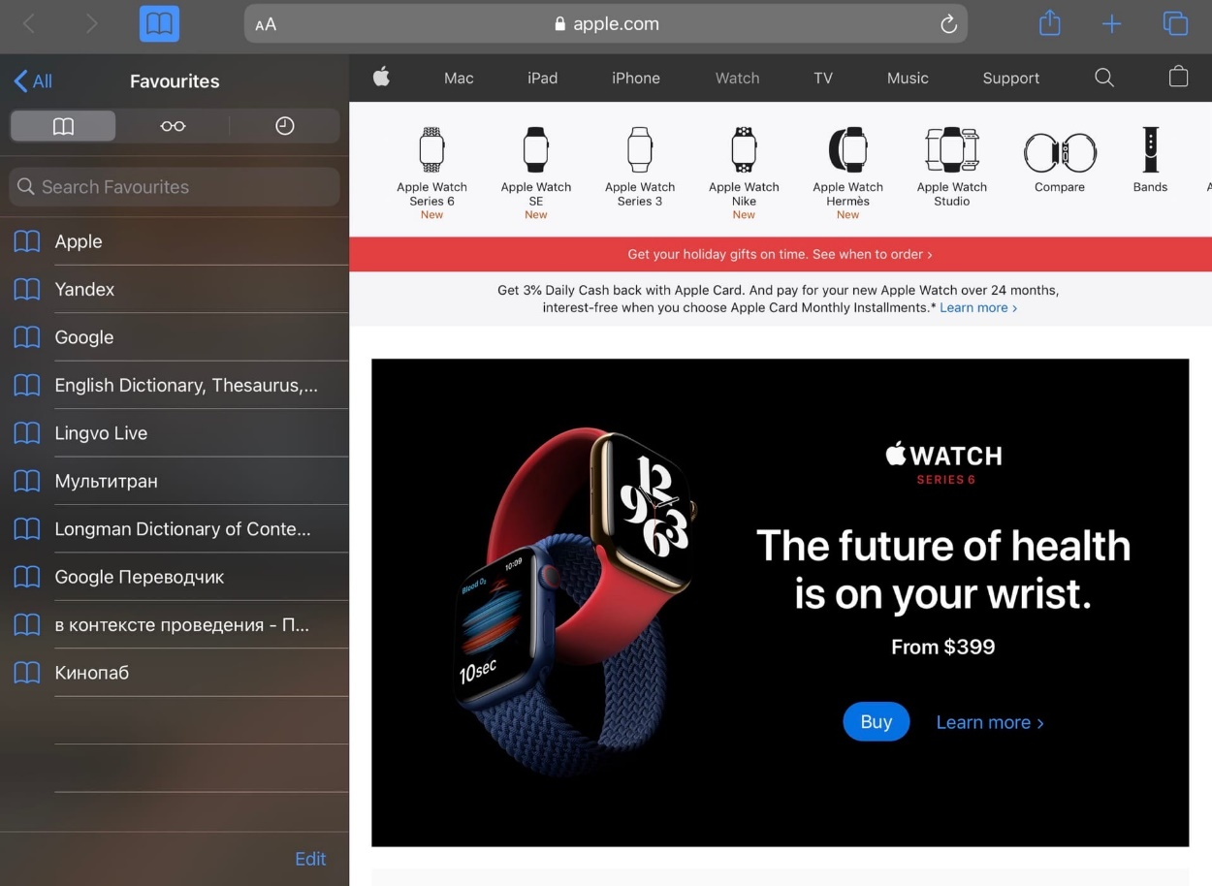

1. Tap **Edit**. From there you can delete or rearrange your Favourites:



1. To rename a specific site, select it and change the name:

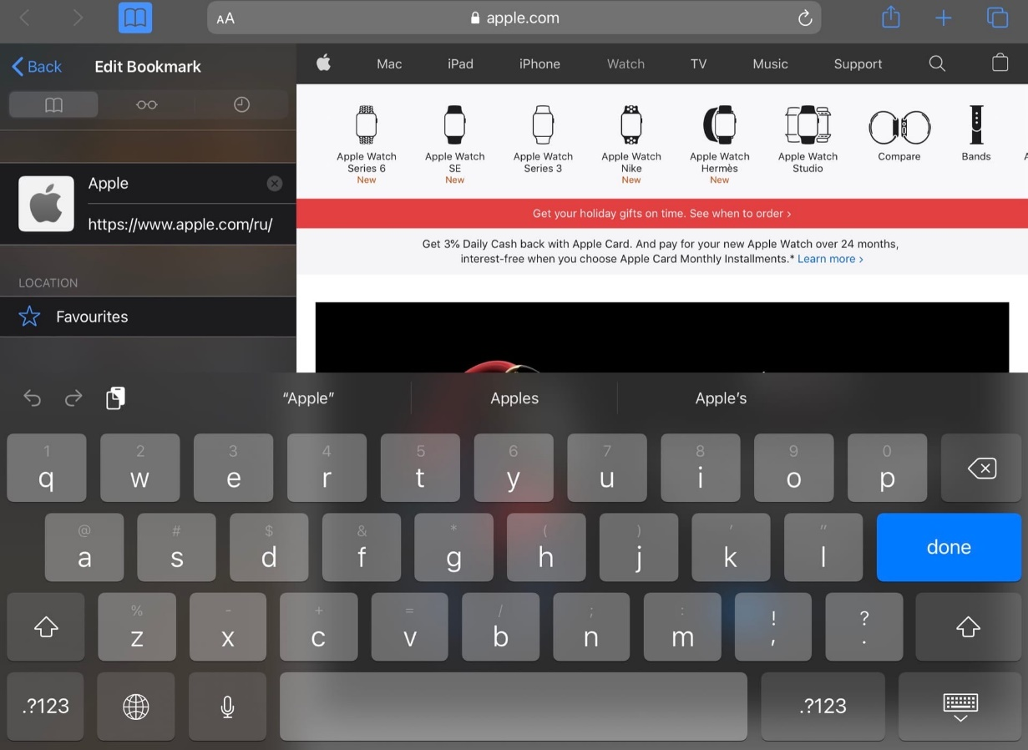

# 

# Summarized Information

This manual provides detailed instructions for work with the **Safari** browser on the **iPadOS 14.2** operating system. Such concepts as work with the web browsing History, Private Browsing mood and Favourites were covered in the document.