Namesayer User Manual

By Samuel Neale and Max Benson

**Table of Contents**

**First Time Launch** 2

**Files** 2

**Main Screen** 3

**Create a Playlist Screen** 4

**Practice Screen** 7

**Database Screen** 9

**Import/Export Screen** 10

**Progress Screen** 11

# **First Time Launch**

Thank you for choosing to use the Namesayer Application! Before you launch Namesayer please note that it is platform dependent and is only compatible with UNIX/Linux operating systems. Namesayer also requires the ffmpeg library to be installed on your computer.

To install ffmpeg go to the terminal and type the following command:

sudo apt-get install ffmpeg libav-tools x264 x265pt-get install

On the first launch, Namesayer creates several files which are used to store the internal state of the application. These are described in more detail below.

# **Files**

/database stores the given database of recordings, which Namesayer does not allow you to modify outside of the provided import/export functionality. Inside this folder, userdata.xml stores data representing the relationships between recordings and names, as well as recording ratings. ratings.txt is an output showing the rating data as a simple text file, modifying this file will have no effect as it is just an output.

/userdata stores the database of user recordings, which are modifiable by the user. It contains userdata.xml and ratings.txt as described above. /userdata also contains progressdata.xml, which stores the previous scores the user gave themselves on a playlist.

/Playlist stores temporary audio files that are created when names are combined in a playlist.

/temp stores temporary audio files that are created when the user records their own attempt of a name while practicing, so they can compare it to the correct version.

Both copies of userdata.xml, both copies of ratings.txt, and progressdata.xml won’t be in the zip archive to start with. They are generated when first running the application.

/database/userdata.xml and /userdata/userdata.xml are both generated based on the audio files in their respective directories. If you wanted to regenerate these files and the corresponding application state manually, you could delete them and restart Namesayer.

During this process, all audio files in /database and /userdata are processed to improve their quality.

# **Main Screen**

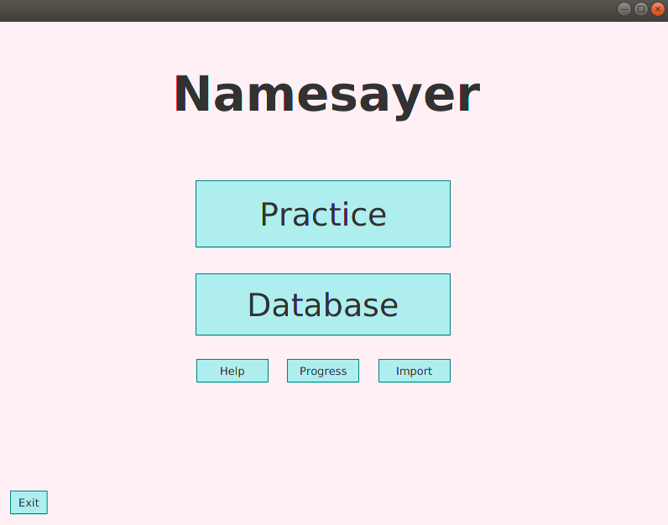Figure 1: Namesayer Main Screen

Initially a splash screen (initial loading start-up screen) is displayed before the main screen. While the splash screen is present the processes detailed in the previous section are occurring. Once the splash screen closes the application opens upon the Main Screen (shown in figure 1 above). From the main screen there are several options that can be selected:

* The Practice button takes you to the create a playlist screen (shown in figure 2 below)
* The Database button takes you to the database management screen (shown in figure 4 below)
* The Help button which leads you to this User Manual
* The Progress button takes you to the progress screen which is used to track your progress through your playlist (shown in figure 6)
* The Import button which takes you to the import screen (shown in figure 5) here you can import a different database of names.
* The Exit button which closes Namesayer

# **Create a Playlist Screen**

Figure 2: Create a Playlist Screen

The create a playlist screen displays the Names that are in the pre-loaded database, and in the user database. The names in the user database are displayed with a [USER] tag to differentiate them from the user database. Within the names list you can search for a name in the search bar above the names list

In the create a playlist screen, you have several options to create a playlist of names.

1. Manually creating a playlist.

There is a three-step process to manually creating a playlist. From the left-hand list of *Names in Database*select the name you wish to add to the current name in the middle column of the screen then click the *Add to Current Name* button. This adds the currently selected name to the middle columns *Current Name to Add To Playlist* text field. This text field can also be edited, and you can type the name you wish to enter.

Once you are happy with the *Current Name To Add To Playlist* click the *Add To Playlist* button. You can also clear the current name by pressing the *Clear Name* button.

Repeat adding Names as many times as you like until you have finished creating your playlist and then click the *Start Playlist* button.

1. Importing a Playlist

Clicking the *Import Playlist* button opens the pop-up box (shown in figure 3 below). Here there are two options for how to import a playlist. You can manually type out a playlist separated by spaces commas or newlines.

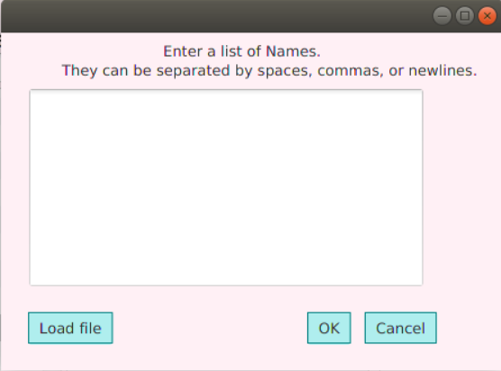 Alternatively, you can import a text file containing names separated by spaces, commas, or newlines. This is done by clicking the *Load File* button. Note that a text file means a file type of .txt.

Figure 3: Import Playlist Pop-Up Box

From the Create a Playlist Screen you can also export your currently created playlist to a .txt file which can then be used to re-upload the same playlist. This is done by clicking the *Export Playlist* button, which will open your computers file browser allowing you to choose a filename and location to save it at.

If you attempt to add a name to the playlist that is not in the pre-loaded database, you will be prompted to add a new name with a recording for it (shown in figure 4 below). This will add the recording to the user database as the pre-loaded database cannot be edited.

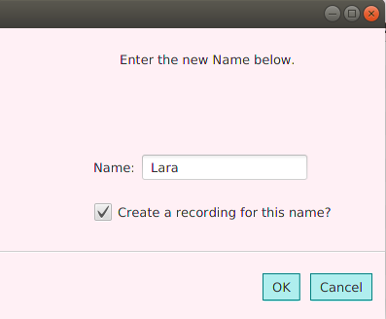

Figure 4: Create a New Name.

Once you are satisfied with the playlist you have created either by importing a playlist or creating one manually you can begin to practice. Clicking the *Start Playlist* button will take you to the Practice Screen and automatically play the first name in the playlist.

# **Practice Screen**

Figure 5: Practice Screen

The practice screen is where you learn how to pronounce the names in their created playlist. On the right side of the screen is the *Next* button, below which is the next name in the playlist. Clicking the *Next* button will play the database recording for the next name. If you would like to hear the recording again, click the play button below the name in red which is the name you are currently practicing.

To record your attempt at pronouncing the current name press the *Record Your Attempt* button. This will open the following pop-up box (shown in figure 6 below) prompting you to record. On this pop-up box there are two buttons one to test your microphone input level to ensure your microphone is on and working. The second button you press at the start when you record your attempt, and then again when you are finished recording.

Once you have recorded your attempt, you can click the *Listen to Your Attempt* button to hear it, this can be used to compare it to the database recording to check your pronunciation.

As with the *Next* button the *Previous* button plays the previous name in the playlist, which is shown in text below the button. If there is no previous name in the playlist then this button will be greyed out.

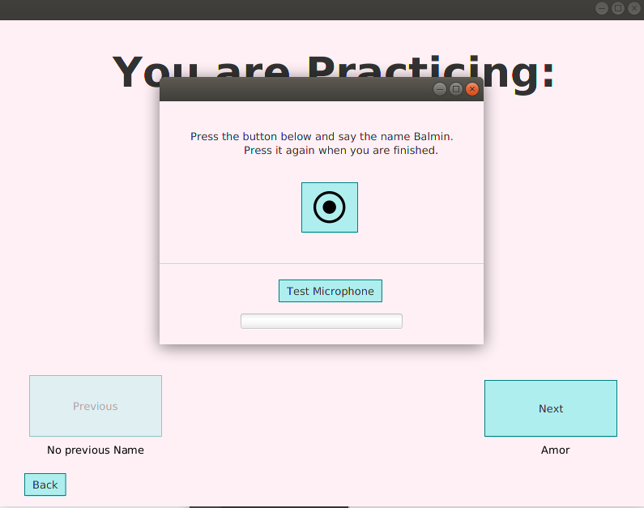Figure 6: Record Your Attempt Pop-Up Box

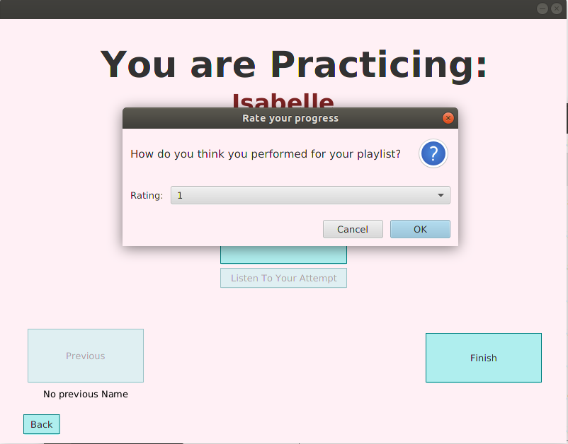When you have reached the end of the playlist, the *Next* button will become the *Finish* button and upon clicking this another pop-up box (shown in figure 7 below) will appear asking you to rate your personal performance from 1 to 10. This rating is used to track your progress which is displayed in the progress screen.

Figure 7: Rate your Progress Pop-Up Box

# **Database Screen**

Figure 4: Database Management Screen

The database manager screen allows you to create, delete, play, and rate names and recordings in the default and user databases. The default database cannot be modified outside of rating its recordings, so some buttons are unselectable as shown in Figure 4. The user database can be fully modified.

The *Swap to User Recordings* button changes which of the two databases is shown. Initially the default database is shown.

*Delete Name* and *New Name* are mostly self-explanatory. Deleting a name deletes all associated recordings, and adding a new name prompts you for the name and asks if you would like to create a new recording too.

*Rate Recording*, *Delete Recording*, and *New Recording* operate on the recordings belonging to the currently selected name in the names list. Recordings rated as bad are marked with a [BAD] tag next to their filename (not shown).

The play button in the bottom right allows you to listen to the currently selected recording.

# **Import/Export Screen**

Figure 5: The Import/Export Screen

The import/export screen provides you with additional functionality to manipulate the internal Namesayer databases. The main intended use of these features is for a lecturer to save and load new databases for a different set of students each semester.

Save database: saves the current database to a .zip file, inside are all audio files and associated metadata.

Load database: loads a .zip file previously saved with the above button.

Clear database: clears all entries in the current database.

Import text file: loads a list of names from a text input or a text file into the USER database. This was intended for use with class rolls. Note that this only generates empty names for which you must add the recordings yourself, and that the entries are created in the user database not the mostly immutable database.

# **Progress Screen**

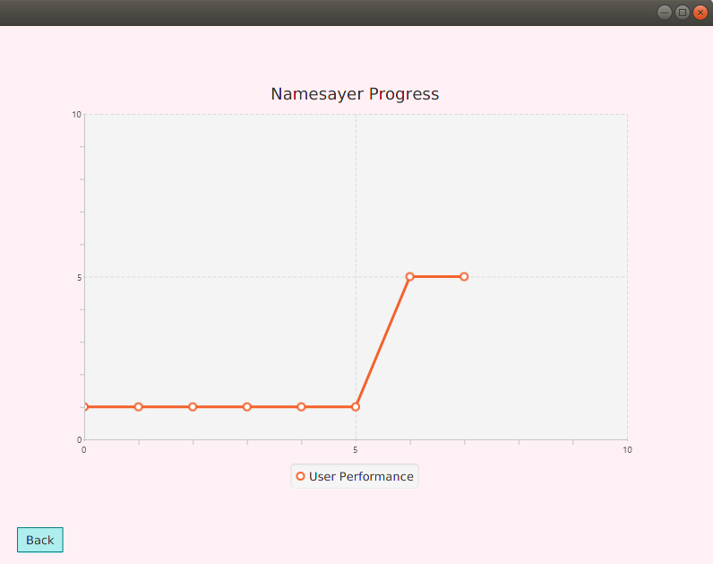

Figure 6: The Progress Screen

The Progress screen of Namesayer simply displays the previous ratings on how you rated your performance of the last playlist. This allows you to track your progress and feel a sense of achievement upon improving your pronunciation.

The *Back* button returns you to the main screen of Namesayer.