**Namesayer User Manual**

Table of Contents

**Type chapter title (level 1)1**

Type chapter title (level 2)2

Type chapter title (level 3)3

**Type chapter title (level 1)4**

Type chapter title (level 2)5

Type chapter title (level 3)6

**First Time Launch**

Thank you for choosing to use the Namesayer Application! Before you launch Namesayer please note that it is platform dependent and is only compatible with UNIX/Linux operating systems. Namesayer also requires the ffmpeg library to be installed on your computer.

To install ffmpeg go to the terminal and type the following command:

sudo apt-get install ffmpeg libav-tools x264 x265pt-get install

On the first launch of the Namesayer application creates several files in the directory that Namesayer is launched from. **\*\*\*\*\* max explain the files that are generated on first launch\*\*\*\***

**Main Screen**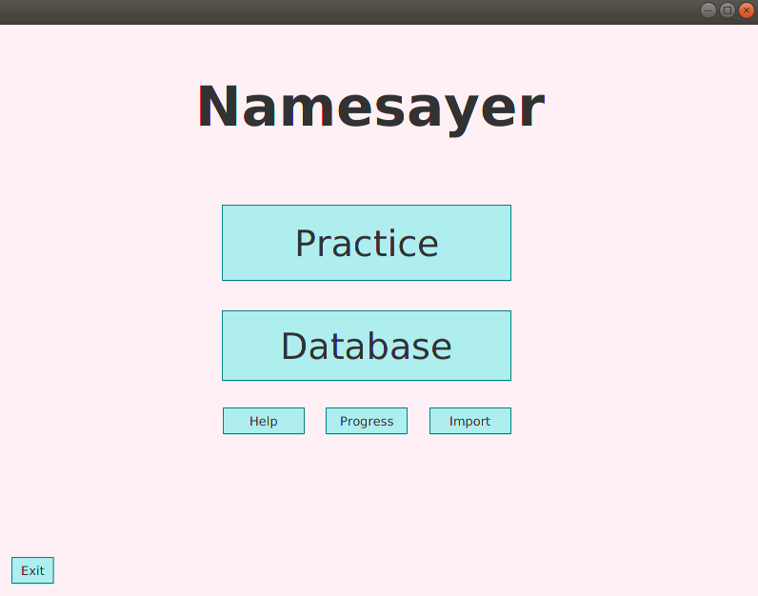

*Figure 1: Namesayer Main Screen*

Initially a splash screen (initial loading start-up screen) is displayed before the main screen. While the splash screen is present audio processing of the recording files is occurring. Once the splash screen closes the application opens upon the Main Screen (shown in figure 1 above). From the main screen there are several options that can be selected:

* The Practice button takes you to the create a playlist screen (shown in figure 2 below)
* The Database button takes you to the database management screen (shown in figure **XX** below)
* The Help button which leads you to this User Manual
* The Progress button takes you to the progress screen which is used to track your progress through your playlist (shown in figure **XX**)
* The Import button which takes you to the import screen (shown in figure **XX**) here you can import a different database of names.
* The Exit button which closes Namesayer

**Create a Playlist Screen**

**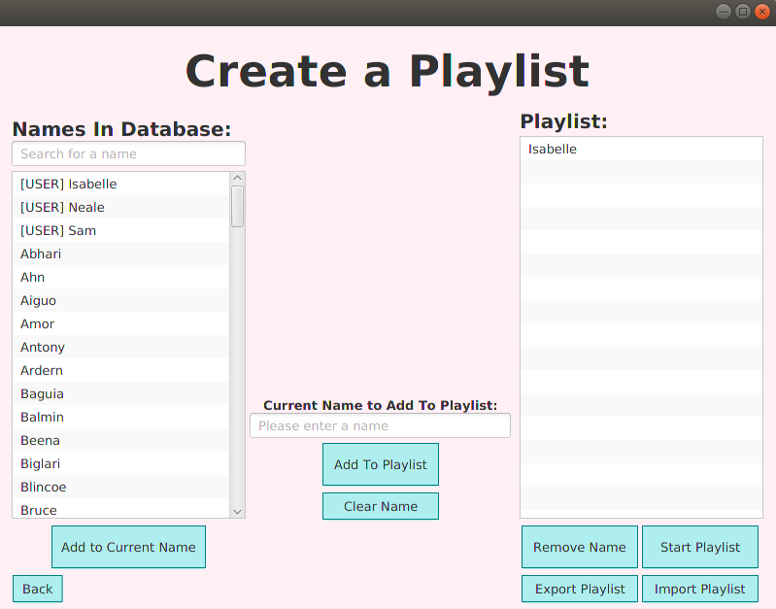***Figure 2: Create a Playlist Screen*

The create a playlist screen displays the Names that are in the pre-loaded database, and in the user database. The names in the user database are displayed with a [USER] tag to differentiate them from the user database. Within the names list you can search for a name in the search bar above the names list

In the create a playlist screen, you have several options to create a playlist of names.

1. Manually creating a playlist.

There is a three-step process to manually creating a playlist. From the left-hand list of *Names in the Database*select the name you wish to add to the current name in the middle column of the screen then click the *Add to Current Name* button. This adds the currently selected name to the middle columns *Current Name to Add To Playlist* text field. This text field can also be edited, and you can type the name you wish to enter.

Once you are happy with the *Current Name To Add To Add To Playlist* click the Add To Playlist button. You can also clear the current name by pressing the *Clear Name* button.

Repeat adding Names as many times as you like until you have finished creating your playlist and then click the *Start Playlist* button.

2. Importing a Playlist.

Clicking the *Import Playlist* button opens the pop-up box (shown in figure 3 below). Here there are two options for how to import a playlist. You can manually type out a playlist separated by spaces commas or newlines.

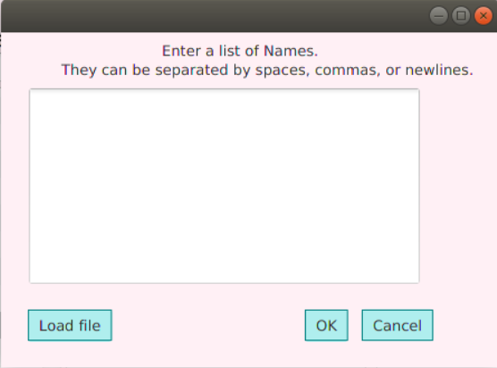 Alternatively, you can import a text file containing names separated by spaces, commas, or newlines. This is done by clicking the *Load File* button. Note that a text file means a file type of .txt.

*Figure 3: Import Playlist Pop-Up Box*

From the Create a Playlist Screen you can also export your currently created playlist to a .txt file which can then be used to re-upload the same playlist. This is done by clicking the *Export Playlist* button, which will open your computers file browser for where you wish to save the file and how you wish to name it (shown in figure 4 below).

**INSERT THE EXPORT PLAYLIST NAME/LOCATION SELECTION SCREENSHOT**

*Figure 4: Export Playlist Pop-Up Box.*

If you attempt to add a name to the playlist that is not in the pre-loaded database, you will be prompted to add a new name with a recording for it (shown in figure 4 below). This will add the recording to the user database as the pre-loaded database cannot be edited.

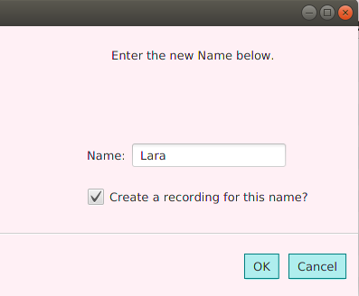

*Figure 4: Create a New Name.*

Once you are satisfied with the playlist you have created either by importing a playlist or creating one manually you can begin to practice. Clicking the *Start Playlist* button will take you to the Practice Screen and automatically play the first name in the playlist.

**Practice Screen**

**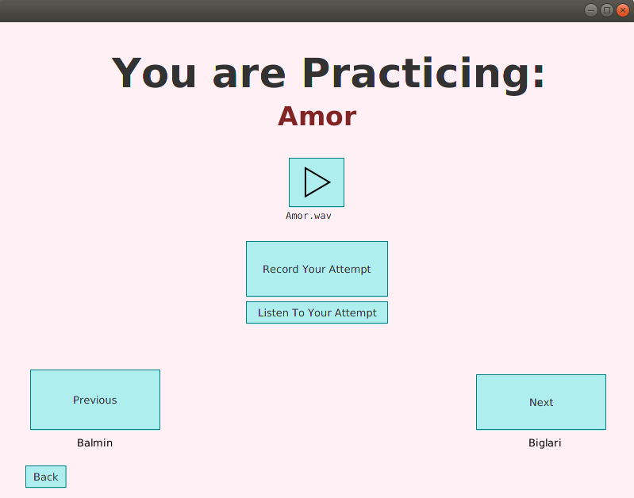***Figure 5: Practice Screen*

The practice screen is where you learn how to pronounce the names in their created playlist. On the right side of the screen is the *Next* button, below which is the next name in the playlist. Clicking the *Next* button will play the database recording for the next name. If you would like to hear the recording again, click the play button below the name in red which is the name you are currently practicing.

To record your attempt at pronouncing the current name press the *Record Your Attempt* button. This will open the following pop-up box (shown in figure 6 below) prompting you to record. On this pop-up box there are two buttons one to test your microphone input level to ensure your microphone is on and working. The second button you press at the start when you record your attempt, and then again when you are finished recording.

Once you have recorded your attempt, you can click the *Listen to Your Attempt* button to hear it, this can be used to compare it to the database recording to check your pronunciation.

As with the *Next* button the *Previous* button plays the previous name in the playlist, which is shown in text below the button. If there is no previous name in the playlist then this button will be greyed out.

**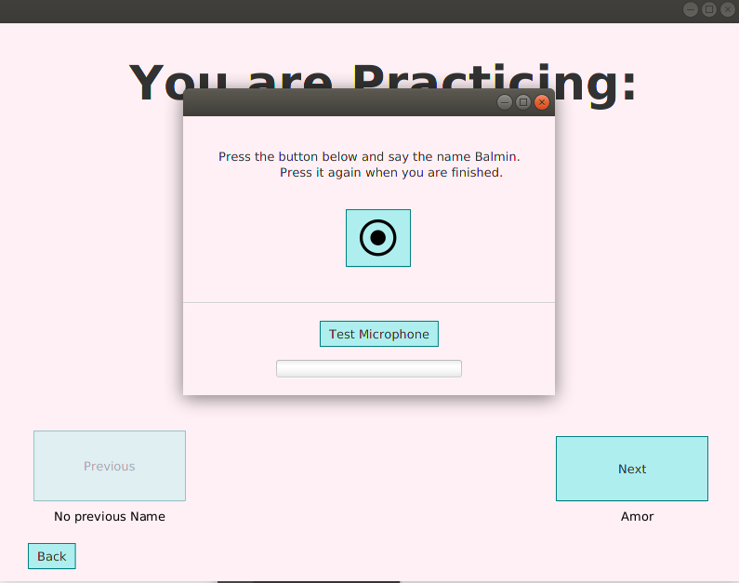***Figure 6: Record Your Attempt Pop-Up Box*

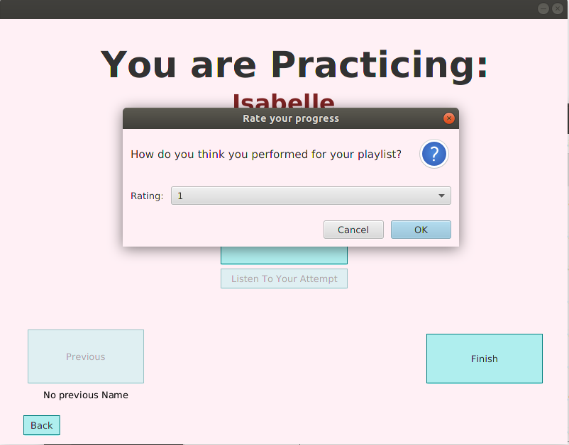When you have reached the end of the playlist, the *Next* button will become the *Finish* button and upon clicking this another pop-up box (shown in figure 7 below) will appear asking you to rate your personal performance from 1 to 10. This rating is used to track your progress which is displayed in the progress view of Namesayer.

*Figure 7: Rate your Progress Pop-Up Box*

**Database Screen**

**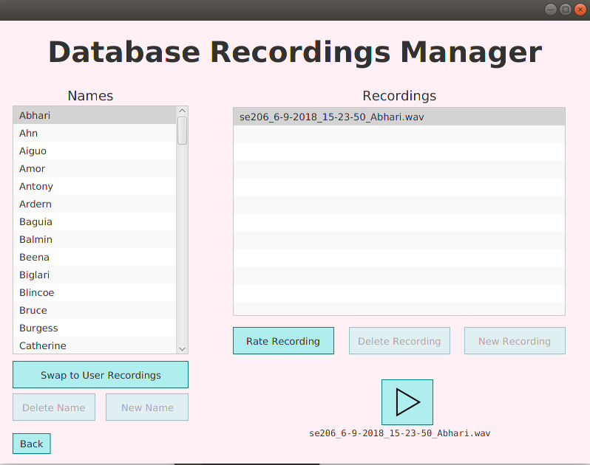***Figure 4: Database Management Screen*

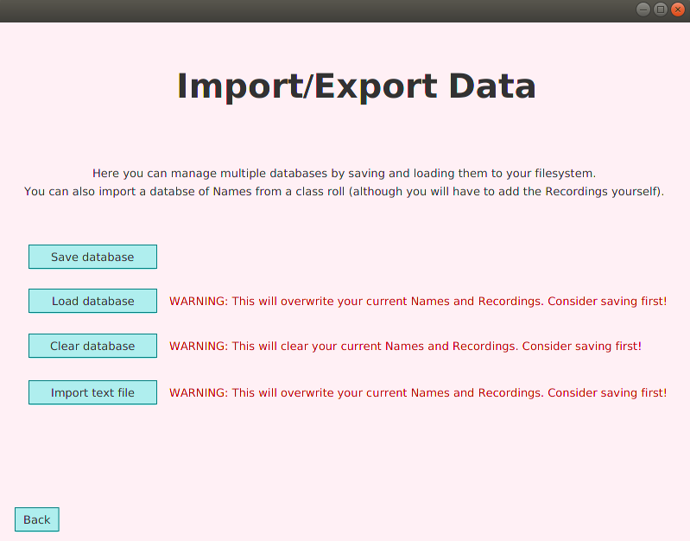**Import/Export Screen**

*Figure 5: The Import/Export Screen*

# Progress Screen

*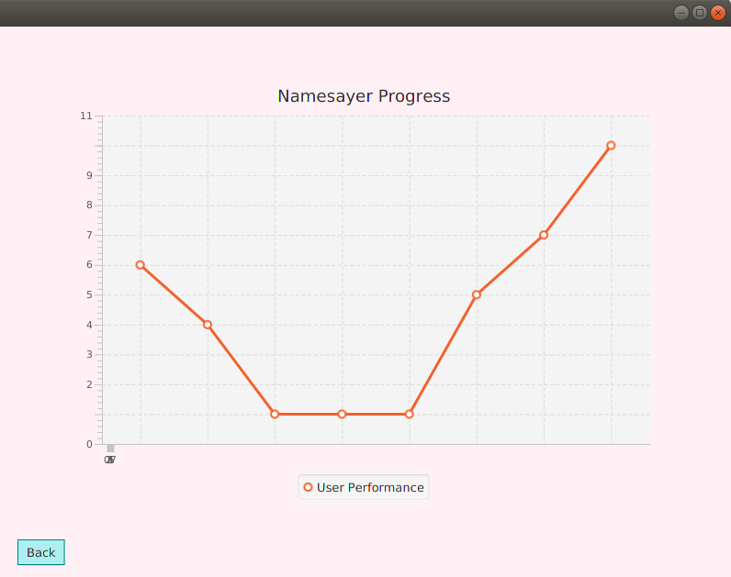Figure 6: The Progress Screen*

The Progress screen of Namesayer simply displays the previous ratings on how you rated your performance of the last playlist.

The *Back* button returns you to the main screen of Namesayer.