BACKROOMS SURVIVOR, Game Reference
Complete reference for all pickups, weapons, controls, and persistent upgrades.
PICKUP ITEMS
Items glow on the ground. Walk over them to pick up. Some are instant (food, stamina drink, ammo), others go to inventory for manual use (almond water, bandages, bombs, batteries).
Item | Glow Color | On Pickup | Use Button | Notes
Almond Water | Cyan | Adds 1 to inventory | D-Pad Up / Key 1 | +40 Hydration, +25 Sanity, +10 HP
Bandage | Green | Adds 1 to inventory | LB / Key 2 | Restores 30 HP
Food | Orange | INSTANT: +40 Stam, +15 San | (consumed on contact) | No inventory, heals on touch
Stamina Drink | Blue | INSTANT: +30 Stamina | (consumed on contact) | No inventory, heals on touch
Ammo | Gold | INSTANT: +25 Ammo | (consumed on contact) | Feeds all ranged weapons
Weapon | Varies | Unlocks + equips weapon | (auto equip) | Random type, +25 Ammo if ranged
Bomb | Orange | Adds 1 to bomb count | RB / Key Q | Massive AoE damage, very loud
Battery | Green | Adds 1 to battery inventory | X Button / Key X | Fully recharges headlamp

CHAOS ORBS
Floating orbs that chase you when you get close. They randomly buff or nerf your stats, enemy stats, or weapon stats when collected.
Orb Type | Effect | Details
Green (Buff) | 80% chance of positive stat roll | 60% spawn rate. Buffs player, nerfs enemies, boosts weapons.
Yellow (Nerf) | 80% chance of negative stat roll | 40% spawn rate. Nerfs player, buffs enemies, degrades weapons.

Player stat effects from chaos orbs:
Stat | Good Roll | Bad Roll | Duration
HP | +10 to +40 instant heal | -5 to -30 instant damage | Instant
Stamina | +10 to +40 instant | -5 to -20 instant | Instant
Speed | +10% to +70% faster | -50% to -70% slower | 15-45 seconds
Damage | +20% to +100% more | -50% to -70% less | 15-45 seconds
Sanity | +25 to +60 instant | -5 to -20 instant | Instant
Hydration | +10 to +35 instant | -5 to -25 instant | Instant
Orbs also roll on enemy stats (HP, speed, damage multipliers) and weapon mods (fire rate, projectile speed, pellet count, damage, accuracy, pierce). Timed effects last 15-45 seconds.

WEAPONS
You start with the machete. Other weapons are found as ground pickups. Cycle with E/Tab, D-Pad Left/Right, or mouse scroll wheel.
Weapon | Type | Dmg | Rate | Noise | Description
Machete | Melee | 25 | 0.5s | 8 | Starting weapon. Reliable all-rounder.
Knife | Melee | 8 | 0.3s | 5 | Fast and quiet. Low damage.
Pipe | Melee | 12 | 0.6s | 15 | Long reach but loud clang.
Axe | Melee | 22 | 0.8s | 12 | Heavy damage, slow swing, stamina hungry.
Pistol | Ranged | 12 | 0.4s | 60 | LOUD. Decent damage per shot.
Shotgun | Ranged | 6x5 | 0.9s | 85 | VERY LOUD. 5 pellets per shot.
SMG | Ranged | 5 | 0.1s | 70 | Full auto, constant noise.
Suppressed Pistol | Ranged | 8 | 0.5s | 15 | Quiet but weak. Stealth option.
Noise attracts enemies. Ranged weapons consume shared ammo. Melee weapons cost stamina per swing. All weapons can be affected by chaos orb modifiers.

CONTROLS
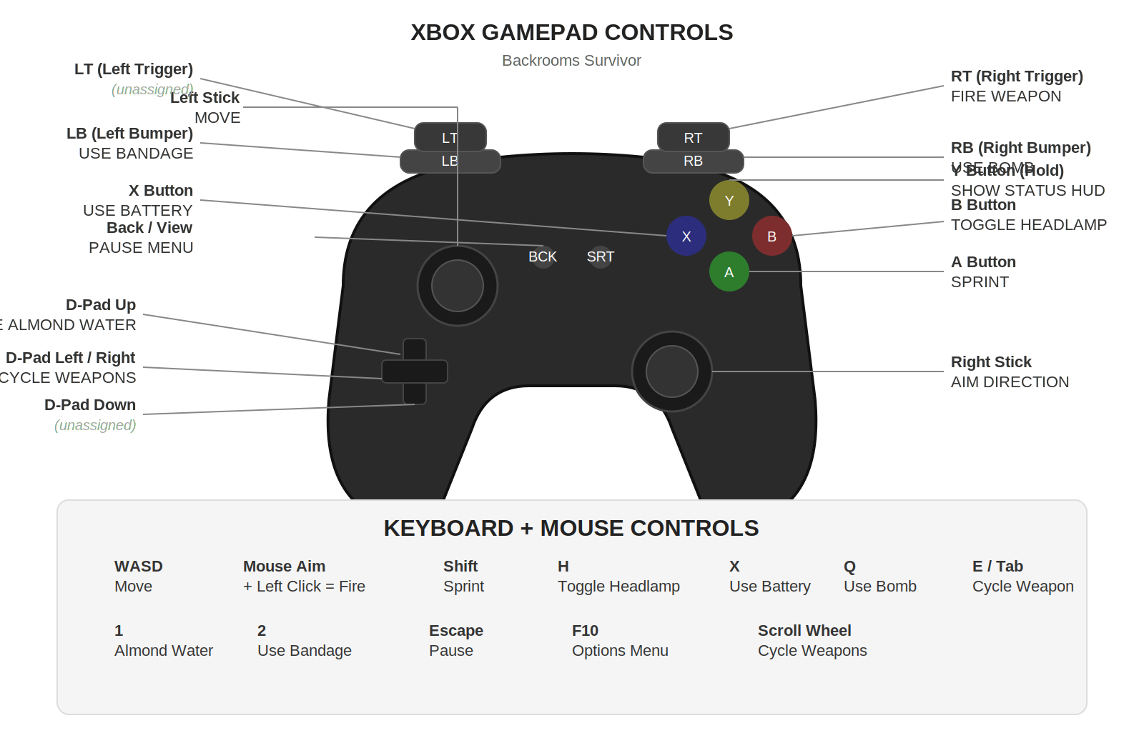
GAMEPAD QUICK REFERENCE
RT: Fire weapon
RB: Use bomb
LB: Use bandage
LT: (unassigned)
A: Sprint
B: Toggle headlamp
X: Use battery
Y (hold): Show status HUD
D-Pad Up: Use almond water
D-Pad Left/Right: Cycle weapons
D-Pad Down: (unassigned)
Back/View: Pause menu
Left Stick: Move
Right Stick: Aim direction

PERSISTENT UPGRADES
Earn Tokens from each run (1 per day survived + 1 per 10 kills, multiplied by difficulty). Spend tokens on permanent stat boosts in the Upgrade Shop.
IMPORTANT: Each difficulty has its OWN separate character profile. Easy upgrades don't carry to Normal, Normal doesn't carry to Hard, etc. Each difficulty level is essentially a different character build.
Access upgrades from: Title Menu > UPGRADES, or Death Screen > UPGRADES
Upgrade | Effect | Max | Base Cost | Cost Growth
Constitution | +10 Max HP per level | 10 | 2 T | +2 T per level
Endurance | +8 Max Stamina per level | 10 | 2 T | +2 T per level
Agility | +3% Move Speed per level | 8 | 3 T | +3 T per level
Iron Mind | -5% Sanity Drain per level | 10 | 3 T | +2 T per level
Camel Blood | -5% Hydration Drain per level | 8 | 2 T | +2 T per level
Ammunition Cache | +5 Starting Ammo per level | 6 | 2 T | +1 T per level
Demolitions Training | +1 Starting Bomb per level | 4 | 4 T | +3 T per level
Power Hoarder | +1 Starting Battery per level | 4 | 3 T | +2 T per level
Extended Battery | +15% Headlamp Battery Life per level | 6 | 3 T | +3 T per level
Combat Training | +5% Base Damage per level | 8 | 4 T | +3 T per level

TOKEN EARNING FORMULA
Base tokens = Days Survived + floor(Kills / 10)
Difficulty multiplier: Easy = 0.5x, Normal = 1.0x, Hard = 1.5x, Nightmare = 2.0x
Example: Survive 5 days with 30 kills on Hard = (5 + 3) x 1.5 = 12 tokens earned.

DIFFICULTY LEVELS
Easy: Full item drops, max 5 bombs, max 3 batteries, brightest ambient light
Normal: 80% item drops, max 4 bombs, max 2 batteries
Hard: 60% item drops, max 3 bombs, max 1 battery, darker
Nightmare: 40% item drops, max 2 bombs, max 0 batteries, near total darkness
Drop reduction applies to both ground spawns and enemy kill drops. Minimum 20% drop rate on Nightmare.

