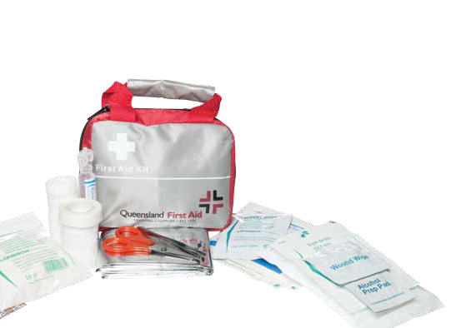

MANUAL

###### Version 1, 2012 Amanda Petersen

National Provider No: 31961



**QLD First Aid Handbook**

First Edition 2012

© 2012 QLD First Aid ISBN 978-0-646-57775-3

By Amanda Petersen

All rights reserved. Reproduction of this book, in part or entirely, without the publisher’s written permission is prohibited.

**Disclaimer**

The information contained in this manual relates to the current accepted first aid practices in Australia at the time of publication. It does not provide information about first aid practices in any other country other than Australia.

This manual is an information resource only and is not a substitute for undertaking a first aid course with an approved provider.

While every effort has been made to ensure that the information is accurate at the time of the publication, the authors are not responsible for the loss, liability, damage or injury that may be suffered or incurred by any person in connection with the information contained in this book, or by anyone who receives first aid treatment from the reader or users of this book.

**Published by**

QLD First Aid

152 Brisbane St, Ipswich QLD Ph +61 7 3281 4003

Email: [info@qldfirstaid.com](mailto:info@qldfirstaid.com) Web: [www.qldfirstaid.com](http://www.qldfirstaid.com/)

**TABLE OF CONTENTS**

**Section 1—Perform CPR**

Legal considerations 2

Action plan 2

**D**anger 3

**R**esponse 4

**S**end for help 5

**A**irway 5

**B**reathing 6

**C**ompressions 7

**D**efibrillation 9

Reasons to stop CPR 9

Secondary survey 9

Special considerations 9

Choking 10

Drowning 11

Rescuers’ recovery 12

Chain of survival 12

Section 2—Medical conditions

Diabetes 13

Stroke 14

Chest pain/cardiac arrest 15

Seizure 16

Asthma 16

Section 3—Wound management

Shock 18

Burns 18

Head injury 21

Spinal injury 22

Crush injury 22

Cold-induced injury 23

Heat-induced injury 23

Sprains and strains 24

Dislocations and fractures 25

Eye injury 27

Ear injury 27

Section 4—Poisons, bites and stings

Poisoning 28

Animal bites 29

Substance misuse 34

Needle stick injury 34

**This manual was brought to you by Queensland First Aid, the best choice for First Aid.**

Since 1975, Queensland First Aid has been serving individuals and corporations in a professional, efficient and friendly manner. Whether you or members of your organisation need to undertake a First Aid Course or purchase a First Aid Kit for your home or office, we have you covered for all your First Aid requirements.

Book your first aid course

‘Come to us or we come to you’

Visit QldFirstAid.com Or call 1300 336 613



[**www.QldFirstAid.com**](http://www.QldFirstAid.com/)

**Section 1—Perform CPR**

“Any attempt at resuscitation is better than no attempt.”—Australian Resuscitation Council

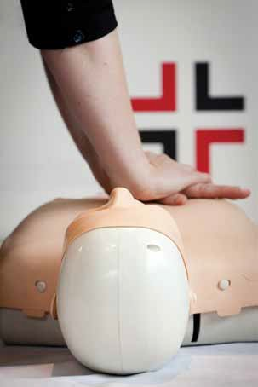

### Legal considerations

#### Negligence

Rescuers need not fear litigation if they come to the aid of a fellow human in need. No ‘good samaritan’ or volunteer in

Australia has ever been successfully sued as a consequence of rendering assistance to a person in need. A ‘good samaritan’ is defined in legislation as a person acting without expecting financial or other reward for providing assistance.

#### Consent

Competent adults are legally entitled to refuse any treatment even if it’s life-sustaining or their decisions are not for their own benefit. Substitute decision-makers, such as parents or

guardians of minors, can likewise refuse treatment, but only if in the ‘best interest’ of their charge.

Because you are the first on the scene it is important to have a plan to help you assess the casualties. This is called your action plan and is the first vital step in first aid.

### Action plan

#### Primary survey

##### **D**anger **R**esponse **S**end for help **A**irway **B**reathing **C**ompressions **D**efibrillation

**Secondary survey—head to toe examination**

* this helps you to assess other injuries
* if the casualty is conscious always explain what you are doing and why.

Where there is more than one casualty the care of an unconscious casualty has priority.

### **D**anger

#### Risks to the first aider

Environmental dangers

For example chemicals, dogs, broken glass, wet surfaces, machinery and many others are a risk to you (rescuer), bystanders and the casualty. These dangers must be isolated or removed before you proceed. Rushing into a scene without managing these risks could potentially cause injury to yourself or others.

Cross infection

Take precautions to protect

* Assess the situation quickly
* Ensure the safety of the rescuer, bystanders and the casualty by reducing or minimising the risk
* Commence appropriate treatment

yourself and the casualty. Use a barrier device if necessary. Ideally gloves are the best barrier but any plastic can be used. First Aiders need to be

mindful to protect not only their hands from contamination. For example wearing gloves does not protect your knees if you are kneeling in blood or bodily fluids.

# *NOTE*

If you don’t have a barrier device with you, such as gloves, you can improvise with other things.

**This icon will appear throughout the book to remind you to consider your own safety.**



**In case of emergency call 000 p. 3**

**Manual handling**

Manual handling is a term used in workplaces to describe when a person is moving something (eg. heavy lifting) without the aid of machinery. Incorrect manual handling practices can result in injury to the worker. When dealing with a casualty, take care to use safe moving and handling principles. Get assistance from other people.

### **R**esponse

Assess the casualty for a response. Is he/she conscious?

If they do NOT respond:

* Check for danger
* Assess the scene—what can you see, hear and smell?

Upon your arrival at an accident scene, unless there are others present, you will have to rely on your own senses. For example, if you found a woman lying at the bottom of the stairs unconscious you wouldn’t know if she fell down the stairs, collapsed walking past the stairs, was pushed down the stairs or collapsed because of a gas leak. You would need to determine the reason she fell,

listen for people or other sounds that may indicate danger and smell for possible fumes or gases in the area before approaching the casualty. You will be unable to assist the casualty if you also fall victim to the danger.

If they DO respond:

* Get consent. Ask “Can I help you?”. Recruit help from others if the casualty does not speak English. Be respectful of cultural differences when assisting an injured person.
* Ask the casualty what happened—this important step helps you to assess not only the injuries incurred but also helps you assess the general well being of the casualty
* Check injuries—once you have been told what happened you will know all injuries sustained in the incident
* Reassess—it is important to reassess the casualty regularly to ensure their condition has not deteriorated
* Get help immediately if required



**In case of emergency call 000 p. 4**

**S**end for help (recruit help wherever possible)

Ask bystanders to call for help on “000/112”.

When calling emergency services it is important to clearly give:

* + Location as accurately as possible
  + Type of accident
  + Number of people injured and the type of injuries they have sustained
  + Need for fire brigade, electricity authorities or other special assistance

If you are out of your service provider’s area and your mobile phone is showing no service call 112. 112 will connect you to emergencies service using any provider coverage in the area. 112 can be used internationally.

**A**irway

If the casualty is unconscious you must check their **a**irway. Open the casualty’s mouth and look inside for any foreign material (solid or liquid). If an obstruction is present place the casualty in the recovery position (on their side) and remove the obstruction.

Once the **a**irway is clear, open the casualty’s airway by tilting the head back, lifting the chin and supporting the jaw. This should be done with their mouth slightly open.



**In case of emergency call 000 p. 5**

### **B**reathing

**Determine if the casualty is breathing Look** and **feel** for movement of the upper abdomen or lower chest, and;

**Listen** and **feel** for the escape of air from nose and mouth.

# *ARE BREATHING*

If they are breathing:

Place in the recovery position. Reassess breathing every minute,

keep talking to the casualty reassuring them (even though they are unconscious), check for any injuries.

*All unconscious, breathing casualties must be placed in the recovery (side lateral) position irrespective of their injuries.*

# *NOT BREATHING*

If they are not breathing or if there is any doubt they are breathing:

Start compressions

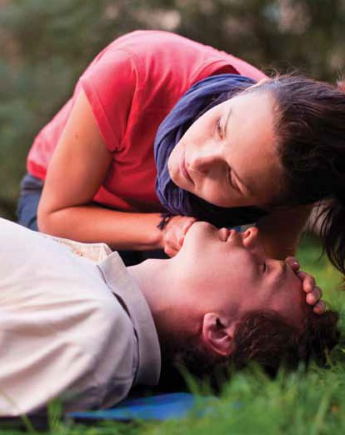

**In case of emergency call 000 p. 6**

### **C**ompressions

* + Place the heel of your hand in the centre of the casualty’s chest (lower half of the sternum in all ages)
  + Arm straight, shoulder above your wrist
  + Compress 1/3 the depth of the chest
  + Allow complete recoil of the chest between each compression

At a rate of 30 compressions : 2 breaths (5 cycles in 2 minutes)

**Breaths**

* + Ensure a full head tilt
  + Take a normal breath, open your mouth as wide as possible and place it over the casualty’s slightly open mouth
  + Seal their nose with your cheek (or pinch nostrils)
  + Blow steadily while watching the chest rise
  + Turn your head towards the chest to watch the chest fall and feel the exhalation on your cheek
  + Continue giving CPR at a ratio of 30 compressions to 2 breaths

If you are unable or unwilling to give rescue breaths continuing chest compressions only is better than no attempt at all.

# *NOTE*

Distension of the stomach may occur when the rescuer either blows too hard or blows when the airway is partially obstructed so that air enters the stomach rather than the lungs.

If the stomach is distended, DO NOT APPLY PRESSURE TO THE STOMACH.

If air is forced into the stomach, some stomach contents can be forced up into the mouth and airway and thus into the lungs.

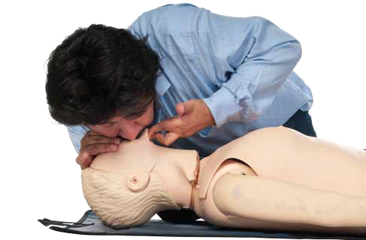

**In case of emergency call 000 p. 7**

**Children (1–8) and**

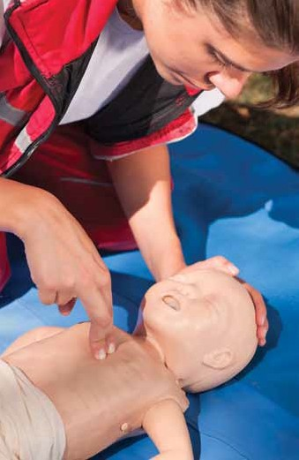

*CHILDREN*

**Infants (under 1)**

Unconscious and breathing—*infants and small children should never be shaken. They should be assessed by verbal and visual stimuli.*

* + - Maintain in recovery position
    - Children should be managed the same as adults
    - Infants—neutral head position/jaw support
    - Monitor airway and breathing Unconscious and not breathing normally
    - Commence CPR
    - Infants use fingers, children one hand
    - 30 compressions : 2 breaths (via nose)

**In case of emergency call 000 p. 8**

### **D**efibrillation

Ventricular Fibrillation (VF) is a phenomenon where the muscles of the heart are fibrillating (quivering), which can impede attempts to restart the heart. Automated External Defibrillators (AEDs) must only be used for a casualty who is unresponsive and not breathing normally. CPR must be continued until the AED is turned on and pads are attached. The first aider should follow the AED prompts.

**Process**

If CPR has been commenced on an unconscious, non- breathing, not moving, not responding casualty and you have a defibrillator, work around the person performing CPR. Follow the voice prompts of the defibrillator. When directed by the

defibrillator, stand clear and ensure that bystanders are not touching the casualty. Continue to follow the voice prompts.

### Reasons to stop CPR

* + Signs of life eg. breathing, coughing
  + It is impossible for you to continue (eg. exhaustion)
  + Someone takes over from you
  + The situation becomes too dangerous

### Secondary survey

**Head to toe examination—**conscious or unconscious breathing casualty. This is done to check for any other injuries

**Visual and physical**—fractures, bleeds and burns. These do not take priority over your DRSABCD

**Assess casualty**—reassess regularly, every minute if unconscious and breathing. If conscious keep talking to the casualty and note any change in their condition.

### Special considerations

Pregnant women—unconscious and breathing. Place her on her left side (labour left). In an obviously-pregnant woman the uterus causes pressure on the major abdominal vessels when she is lying flat, reducing venus return to the heart.

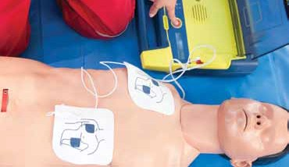

**In case of emergency call 000 p. 9**

### Choking

**Partial obstruction (effective cough— mild airway obstruction)**

Signs and symptoms of a partial obstruction to the throat include:

* + Coughing, gasping, gripping their throat
  + Breathing may be noisy and laboured
  + Some escaped air can be felt from the casualty’s mouth

Management

Encourage the casualty to stay calm, lean forward, take a breath and cough it out. **Don’t hit the back of a casualty with a partial obstruction.**

**Complete obstruction (ineffective cough—severe airway obstruction)** Signs and symptoms of a complete obstruction to the throat

include:

* + The casualty cannot cough, talk, breathe or cry.
  + They may be gripping their throat
  + Distressed

**Managing a complete obstruction**

• Call 000/112

* + - Give five back blows—this should be done with the heel of the hand in an upward action in the middle of the back between shoulder blades. Check between each back blow to see if the obstruction has been relieved. An infant may be placed in a head downwards position prior to delivering the back blows, i.e. across the rescuer’s lap.
    - Give five chest thrusts—to perform chest thrusts identify the same compression point as for CPR and give up to five chest thrusts. These are similar to chest compressions but sharper and delivered at a slower rate. An infant may be placed across the rescuers lap on their back when performing the chest thrusts. Children and adults may be treated in a sitting or standing position.
    - If the obstruction is still not cleared alternate between back blows and chest thrusts.
    - Be prepared to do CPR if the casualty loses consciousness



**In case of emergency call 000 p. 10**

### Drowning

The most devastating consequence of drowning is the interruption of a person’s oxygen supply to the brain. Early rescue and resuscitation are the major factors in survival.

#### Managing drowning

Follow DRSABCD, however, casualties of drowning are rolled onto their side during initial checking (and potential clearing) of the airway.

# *DRSABCD*

Danger—assessing the danger in a drowning situation is unique. Are you a strong swimmer? Is there a rip or debris in the water? Is it safe for you to enter the water?

**Response Send for help Airway**

**Breathing Compressions Defibrillation**

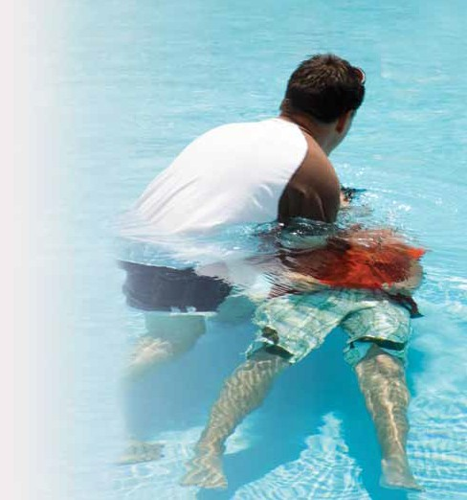

**In case of emergency call 000 p. 11**

### Rescuer’s recovery

First aid situations can be very stressful. The injury sustained by the casualty may or may not be serious. The casualty may be a loved one or colleague. Often first aiders will be concerned that they did everything necessary and that they did it correctly. It is important to:

* + Debrief—what you did, how you are feeling. Do not discuss any personal details about the casualty.
  + Seek professional help—if you are experiencing ongoing affects from the incident. Eg—anxiety, recurring dreams.

# *NOTE*

As a first aider you are not expected to be an emergency expert.

### Chain of survival

**There are 4 links in the chain of survival:**

1. **Early access—**assess and call for help if needed
2. **Early CPR—**any casualty who is unconscious and not breathing must have CPR commenced upon them immediately
3. **Early defibrillation—**for every minute defibrillation is delayed, there is a 10% reduction in survival if the casualty is in cardiac arrest due to VF
4. **Early advanced care—**organise an ambulance (call 000/112) or emergency transport medical as- sistance as quickly as possible



**In case of emergency call 000 p. 12**

## Section 2—Medical conditions

### Diabetes

For our bodies to work properly we need to convert glucose (sugar) from food into energy. A hormone called insulin is essential for the conversion of glucose into energy. In people with diabetes insulin is no longer produced or not produced in sufficient amounts by the body. Diabetics generally manage their condition with oral medications and insulin injections, but sometimes find themselves in a diabetic emergency, the consequences of which can be very serious.

**Signs of a diabetic emergency**

**Managing a diabetic emergency**

If conscious give the casualty

* + A sweet drink—soft drink or juice
  + Honey or sugar
  + Jelly beans

If unconscious implement DRSABCD

**Danger** *DRSABCD*

* + Loss of coordination



* + Slurred speech
  + Confusion
  + Loss of consciousness
  + Seizure

**Response**

Send for help

Airway

**Breathing**

**Compressions Defibrillation**

### Stroke

**What is a stroke**

Brain cell function requires a constant delivery of oxygen and glucose from the bloodstream. A stroke, or cerebrovascular accident (cva), occurs when blood supply to part of the brain is blocked by a clot or plaque, or because a vessel ruptures.

Stroke is the second most common cause of death after heart attack. Every second counts.

#### Signs

**FAST** is a simple way for remembering the signs of stroke.

* **F**ace—check their face. Has their mouth drooped?
* **A**rms—can they lift both arms?
* **S**peech—is their speech slurred? Do they understand you?
* **T**ime is critical. If you see any of these signs call 000 now!

#### Managing stroke

* Call an ambulance (000/112) and stay with the casualty
* If they are conscious provide reassurance, make the casualty comfortable and **do not** give anything to eat or drink
* Stay with the casualty until the ambulance arrives
* If the casualty is unconscious assess and reassess breathing. Be prepared to do CPR

<http://www.strokefoundation.com.au/>



**In case of emergency call 000 p. 14**

### Chest pain/cardiac arrest

###### “Every second counts”

A heart attack occurs when there is a sudden blockage of one of the coronary arteries that supplies the heart. As a result of the interruption to the blood supply, there is an immediate risk of life-threatening changes to the heart rhythm.

People should not ignore discomfort or pain in the centre of the chest, which may come on suddenly or start slowly over minutes. It has been described as tightness, heaviness, fullness or a squeezing sensation. It may be severe, moderate or mild.

The pain may spread or be limited to the neck, throat, jaw, shoulders, the back, either or both arms and in the wrists and hands.

#### Warning signs

Warning signs of heart attack usually last 10 minutes. If the warning signs are severe, or get worse quickly, do not wait, act immediately.

**Managing chest pain/cardiac arrest** Encourage the casualty to immediately stop what they are doing and rest in a position where they are comfortable. Activity must

be kept to a minimum.

If the casualty has been prescribed a medication such as a tablet or oral spray to treat episodes of chest pain or discomfort, assist them to take this as they have been directed.

* + Call an ambulance (000/112), stay with the casualty
  + If they are unconscious—DRSABCD

[www.heartfoundation.org.au](http://www.heartfoundation.org.au/)



**In case of emergency call 000 p. 15**

### Seizure

A seizure may be caused by:

* + Epilepsy
  + Head injury, stroke, meningitis, brain tumour, hypoxia
  + Poisons and drugs
  + Withdrawal from drugs
  + Fever

#### Signs

* + Sudden spasm of muscles producing rigidity and the casualty will fall down
  + Jerking movements of the head, arms and legs may occur
  + If they become unconscious they may have noisy breathing, salivation and urinary incontinence

#### Managing a seizure

Manage a seizure-patient as you would any unconscious causality:

* + Remove any dangerous objects from around the casualty or remove the casualty from danger
  + Avoid restraining the casualty
  + Lay the casualty on their side as soon as the seizure stops
  + If not breathing or any doubt, commence CPR
  + Reassure the casualty
  + Call an ambulance (000/112)
  + If the casualty has not lost consciousness they will require little first aid other than reassurance and protection from injury
  + Febrile convulsions are usually associated with fever.

Three percent of children aged between 6 months and six years will experience febrile convulsions.

### Asthma

Asthma is a disorder of the smaller airways of the lungs. People with asthma have sensitive airways that can narrow when exposed to triggers. This leads to difficulty breathing.

There are many things which can trigger an Asthma attack. Though this is different in each person some triggers are—

* + Colds and flu
  + Cigarette smoke
  + Exercise
  + Inhaled pollens, moulds, animal dander, dust mites
  + Dust, pollution, wood smoke, bush fires
  + Changes in temperature and weather
  + Certain medications (eg. asprin)
  + Perfumes and cleaning products
  + Laughter and stress



**In case of emergency call 000 p. 16**

**Signs**

Ordinary attack

* + Dry, irritating, persistent cough—especially when exercising and in cool of the evening and morning
  + Chest tightness
  + Shortness of breath
  + Wheeze

Severe attack

* + Gasping for breath
  + Severe chest pain
  + Inability to speak more than one or two words per breath
  + Feeling distressed and anxious
  + Little or no improvement after using “reliever” medication
  + Sucking in of throat and rib muscles
  + Blue discolouration around the lips
  + Pale sweaty skin
  + Symptoms worsening quickly or using reliever more than every two hours

**Managing an asthma attack**

If the casualty has a written personal asthma action plan then that plan should be followed.

If there is no plan:

* + Step 1—sit the person comfortably upright. Be calm and reassuring. Do not leave the person alone.
  + Step 2—without delay give four separate puffs of a ‘reliever’. The medication is best given one puff at a time via a spacer device.
  + Step 3—wait four minutes. If there is no improvement give another four puffs
  + Step 4—if there is still no improvement, call an ambulance (000/112) immediately

[www.asthmafoundation.org.au](http://www.asthmafoundation.org.au/)



**In case of emergency call 000 p. 17**

## Section 3—Wound management

### Shock



Shock is a result of the loss of effective circulating blood volume, which can be caused by severe bleeding, fractures or trauma, severe burns, severe diarrhoea or vomiting, severe sweating or dehydration, heart attack.

#### Signs may include:

* + Collapse
  + Vomiting
  + Cold sweaty skin
  + Rapid breathing
  + Confused deterioration level of consciousness Though shock may be hard to detect some symptoms may be :-
  + Dizziness and/or nausea
  + Muscle weakness
  + Thirst
  + Anxiety
  + Restlessness
  + Shortness of breath
  + Feeling cold

#### Managing shock

* + Ensure the situation is safe and that the casualty has a clear airway and is breathing normally (follow DRSABCD)
  + Ensure circulation is optimal—lie or sit the casualty down and elevate legs wherever possible
  + Control external bleeding
  + Reassure the casualty

### Burns

A burn is an injury resulting from heat, chemical, electrical or radiation energy, or a combination of these agents (including sunburn).

#### A significant burn includes

A flame or scald injury greater than 10% of the total body surface area (TBSA) or full-thickness burns greater than 5% of TBSA or any burn involving hands, face (airway burn) or groin.

Significant burns can include:

* + Chemical burns
  + Electrical burns
  + Inhalation burns
  + Burns in the very old or the very young
  + In people with pre-existing medical conditions
  + Burns associated with trauma

#### Managing a major burn

The first priority in managing a burn is to stop the burning process, cool the burn (which will provide pain relief ) and cover the burn.

* + Ensure safety of both the rescuers and bystanders from dangers such as flames, welding equipment, lasers, hot water, microwave equipment or electricity. Do not enter a burning or toxic atmosphere without appropriate protection.
  + Move the casualty to a safe environment as quickly as possible.
  + Stop the burning process—stop, drop, roll and cover
* Smother the flames with a fire blanket or blanket
* Move away from the burn source
* Cool the area with water preferably, if no

water is available use a hydrogel product

(such as burnaid)

* Assess airway and breathing immediately
* Where ever possible remove jewellery, watches and clothing from the burnt area
* Where possible elevate the limb to reduce swelling
* Cover the area lightly with a non-stick dressing
* **DO NOT**—peel off clothing stuck to the burn, use ice or ice water, break blisters or use ointments, creams or powders

All infants or children with burns should be medically assessed.

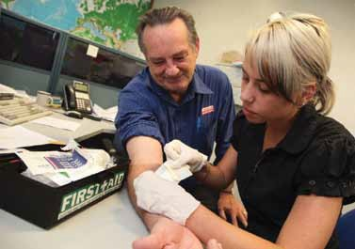

**In case of emergency call 000 p. 19**

**Inhalation Burn**

If a casualty has been trapped in a confined space with hot or toxic fumes from chemicals, an inhalation burn may result. This may cause swelling to the airway. If the casualty has burns to their face, nose or eyelashes you may also see carbon deposits in the nose and or mouth. Coughing, a hoarse voice and or breathing difficulties may all be indicators of an airway burn.

#### Chemical Burns

* + Danger—your initial assessment of the situation is vital when dealing with chemicals
  + Avoid contact with the chemical
  + Refer to the Material Safety Data sheets or the container for specific treatment
  + Call the Poison Information Centre for further advice 13 11 26 [www.health.qld.gov.au/](http://www.health.qld.gov.au/PoisonsInformationCentre/) [PoisonsInformationCentre](http://www.health.qld.gov.au/PoisonsInformationCentre/)
  + Remove contaminated clothing and the chemical (may be a powder) as soon as possible
* If the casualty has had chemicals enter their eye flush the affected area thoroughly as soon as possible for at least 20 minutes and transport to urgent medical attention
* DO NOT neutralise either acid or alkali burns, this will increase the heat generation



**In case of emergency call 000 p. 20**

### Head injury

Head injuries can be caused by a variety of incidents causing damage to the brain, eyes, ears, teeth, airway and mouth. In severe circumstances these injuries may cause death. In all situations the maintenance of a clear airway is the priority.

#### Signs of a serious head injury include:

The casualty may be

* + Conscious
  + Unconscious
  + Experiencing changing levels of consciousness

All casualties who have been unconscious must be assessed by a medical practioner. Other signs and symptoms the casualty may experience are

* + Memory impairment
  + Agitated or irritable behaviour
  + Slurred speech
  + Lack of co-ordination
  + Headaches, dizziness and nausea
  + Seizure
  + Bleeding and discharge from ears, nose or mouth
  + Pupils change size and shape

#### Managing a head injury

If the casualty is conscious, get them to rest and reassure them.

If the casualty is unconscious manage them as an unconscious casualty—DRSABCD.

* + Check and control bleeding, cover wounds
  + Call an ambulance (000/112), stay with the casualty Note any changes to consciousness level, bleeding from the

eyes, mouth and ears, seizures etc.



**In case of emergency call 000 p. 21**

### Spinal injury

Assume the presence of spinal injuries in any accident scene where the casualty is unconscious. This way you can take steps to avoid worsening any possible spinal injuries. However, if you have to move them to avoid injury to yourself or further injury to them, do so.

When assessing spinal injuries it’s important to find out what happened. Spinal injuries often occur in motor vehicle accidents. If it was a motorcycle or bicycle incident, determine whether the casualty was a rider, pillion or pedestrian.

Other possible causes include:

* + Diving into shallow water or being dumped by a wave
  + Falling from a ladder or roof
  + Sporting accidents such as football or a fall from a horse
  + Any fall in the elderly

#### Signs in a conscious casualty

The conscious casualty may have pain, altered or lack of sensation, weakness. Tell the casualty to remain still, when communicating with the casualty position yourself so that the casualty can easily hear you and isn’t trying to turn their

head to see you. If it is necessary to move the casualty due to dangers in the area extreme care must be taken to not cause any movement to the spine.

#### Managing spinal injuries

Implement DRSABCD bearing in mind the following additional guidelines.

If the casualty is conscious and there is no danger **keep them still** and reassure them help is on the way.

**Unconscious**—management of the airway take priority

If the casualty is unconscious and breathing place them in the recovery position, causing minimal movement to head, neck and spine and continue to monitor them.

If the casualty is unconscious and not breathing commence CPR.

### Crush injuries

Crush injuries occur in a wide range of situations, including a person crushed by a car, an industrial accident, a falling object or prolonged pressure due to body weight in an unconscious person.



**In case of emergency call 000 p. 22**

**Managing crush injuries**

All crushing forces should be removed as soon as possible after the crush injury. If it is not safe or not physically possible remove the object.

* + Call an ambulance (000/112)
  + Keep the casualty comfortable
* **Do not** use a tourniquet
* Keep assessing the casualty

Although the casualty may appear to be alert and not unduly distressed, severe and irreversible damage may have been sustained and the casualty’s condition may deteriorate.

### Cold-induced injury (Hypothermia)

Hypothermia can happen in a number of situations from working for extended periods in a cold room, being caught in the rain/wind while boating or any situation where the body is exposed to a drop in temperature. This could be the whole body or localised. How badly a person is affected will depend on their health, how long they have been

exposed to the elements and of course what temperature they

have been exposed to. In extreme situations frostbite can result. This causes ice crystals to form, blocking the blood vessels.

#### Managing cold injury

Your first priority is to remove the casualty from the cold environment—seek shelter. DO NOT rub or expose the limbs to radiant heat. Rewarming can be done by getting the casualty to place their affected fingers or hands into the opposite arm pit. Remove wet or restrictive clothing and wrap them in blankets or dry clothing. Rewarming can be very painful. It is important to ensure refreezing does not occur.

### Heat-induced injury (Hyperthermia)

A mild elevation in body temperature is normally controlled with sweating, which allows cooling by evaporation. Once a person becomes too dehydrated to sweat, body temperature can rise rapidly and dramatically. Heat induced illness may have many causes such as excessive exposure to a

hot environment, excessive activity, infection, lack of ventilation, inadequate fluid intake and drugs which affect heat regulation.



**In case of emergency call 000 p. 23**

**Signs**

Heat exhaustion (temperature 37–40° C)

A casualty suffering from heat exhaustion will be fatigued, may experience a headache, nausea, vomiting or dizziness and possibly collapse. Their body temperature is above 37° C but

below 40° C and their conscious state will become normal once they are lying down.

Heat stroke (temperature above 40° C)

Heat stroke is the most serious form of heat-related illness as all the body’s organs are affected. It may lead to unconsciousness and death. Heat stroke may be recognised by lack of sweating, however in some casualties profuse sweating is common.

**Managing hyperthermia**

Heat exhaustion

* Lie the casualty down
* Loosen and remove excessive clothing
* Moisten skin with a moist cloth
* Cool by fanning
* Give water to drink if fully conscious

Heat stroke

Heat stroke is a life threatening condition.

* Call an ambulance
* Follow DRSABCD
* Place the casualty in a cool environment
* Moisten the skin with a moist cloth and fan repeatedly
* Apply wrapped ice packs to neck, groin and armpits

### Sprains and strains

Commonly these injuries are in the wrist or ankle, with the casualty experiencing a sharp ripping or tearing sensation. The casualty will not be able to take any weight on the joint and the area will swell.

Sprains and strains (also known as soft tissue injuries) need to be treated with two principles in mind—’apply RICE’ and ‘avoid HARM’. These are most important in the 48–72 hours following the injury.

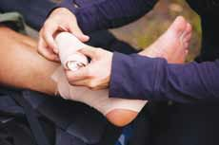

**In case of emergency call 000 p. 24**

**Managing sprains and strains**

Apply RICE

* **R**est and avoid activities that cause significant pain
* **I**ce pack for 15–20 minutes every one to two hours
* **C**ompression—apply a firm bandage that does not restrict circulation or cause additional pain, covering the whole joint
* **E**levate the limb

Avoid HARM

* **H**eat—do not apply heat to the injury as this increases blood flow and swelling
* **A**lcohol—do not allow the casualty to consume alcohol as this increases blood flow and swelling and causes the casualty to be less aware of aggravating the injury
* **R**e-injury—avoid re-injury by protecting the joint until it has healed adequately
* **M**assage—do not massage sprains and strains as this promotes blood flow and swelling

If you have any concern that this is more than a sprain or strain treat it as a fracture.

### Dislocations and fractures

Joint dislocation occurs when bones in a joint become displaced or misaligned. It is often caused by a sudden impact to the joint. The ligaments also become damaged as a result of a dislocation. A bone fracture is a break in the continuity of the bone. It can be the result of high force impact, stress or trivial injury as a result of weakened bones (eg. osteoporosis or bone cancer).

#### Managing dislocations and fractures

* Support the injury in the most comfortable position for the casualty
* If in doubt treat it as a fracture
* Monitor the casualty for shock
* Seek medical assistance
* DO NOT try to relocate the dislocation or realign a fracture

If there’s external bleeding (open/compound fracture):

* Control bleeding
* Apply pressure and elevation—enough to stop the bleed but without causing further damage to the bone or tissues



**In case of emergency call 000 p. 25**

* Get the casualty to rest comfortably (restrict movement)
* Immobilise the affected body part

If there appears to be a life-threatening bleed (eg. major artery bleed) call an ambulance (000/112). Remember to stay calm and use a barrier.

Control of bleeding

In most situations external bleeding can be controlled by pressure on or near the wound if there is an object embedded in it. When delivering first aid to a bleeding casualty your aim is to reduce the amount of blood loss from the casualty.

#### Management

Use a barrier (gloves) to protect both yourself and the casualty. Use direct sustained pressure and a dressing or pad on the wound to stop bleeding. If bleeding continues place another pad/dressing over the first dressing and increase pressure to the bleed. Sit the casualty down, elevate the area where ever possible, calm and reassure the casualty. If bleeding does not cease you will need to replace the dressing and resecure.

###### Embedded object—DO NOT REMOVE THE OBJECT

When there is an object in the bleeding wound indirect pressure is required. A pad or rolled up dressing can be used to apply indirect pressure and stop bleeding.

Tourniquet—last resort (traumatic amputation, major injuries with massive blood loss)

If every effort has been made to stop the bleeding but it is now a life threatening situation a tourniquet can be used. Secure a wide bandage (5cm) high above the wound, but not on a joint or on the wound itself, this should be tight enough to stop

the circulation. The time the tourniquet is applied should be noted and passed on to emergency personnel. The tourniquet should be in clear view and not obstructed by clothing or other bandages.



**In case of emergency call 000 p. 26**

### Eye injury

**Signs**

* Stinging
* Burning sensation
* Redness
* Pain
* Swelling of the eyelids
* Foreign object in the eye

#### Managing eye injuries

* If the casualty wears contact lenses, remove them as soon as possible
* Eye injuries caused by liquid splashes should be irrigated for 15–20 minutes
* If the item cannot be irrigated out cover with a dressing and seek medical attention
* Any casualty with a chemical eye injury must be transported to medical assistance
* If there is a foreign object protruding from the eye use a ring bandage and cover both eyes to protect and reduce movement on the way to the hospital

### Ear injury

#### Signs

* Bleeding from the ear
* Bruising or redness
* Clear liquid coming out of the ear
* Dizziness
* Earache
* Loss of hearing
* Nausea and vomiting
* Noises in the ear
* Sensations of an object in the ear
* Swelling
* Visible object in the ear

#### Managing ear injuries

* Calm and reassure the casualty
* If you think a small object may be lodged within the ear, out of sight, **do not** reach inside the ear canal with tweezers or other objects. Try using gravity to get the object out by tilting the head to the affected side.
* If the object doesn’t come out, seek medical assistance.



**In case of emergency call 000 p. 27**

## Section 4—Poisons, bites and stings

### Poisoning



Poison is anything that kills or injures through its chemical actions. Poisons can enter the body after being ingested, inhaled, absorbed or injected (accidentally or deliberately). Poisoning can be life threatening to the rescuer and to the casualty, so ensure the environment is safe and use a barrier if necessary.

#### Signs

There may be no signs of poisoning, but signs may include:

* Nausea
* Vomiting
* Pain
* Trouble breathing
* Seizure
* Confusion
* Abnormal skin colour

A person may complain of physical symptoms without knowing they have been poisoned. They may also display abnormal behaviour, which may be interpreted as alcoholic confusion or psychiatric disturbance.

Because the affects from poison can be both rapid or delayed it is important to seek medical assistance or advice after significant exposure to a poison, even if the symptoms are initially mild or absent.

#### Managing poisoning—contact the poisons information centre 13 11 26

* Prevention of poisoning to the rescuer
* Decontamination to the casualty
* Resuscitation and supportive care
* Call an ambulance (000/112) and/or a poison control centre
* Do not induce vomiting

<http://www.health.qld.gov.au/PoisonsInformationCentre/>

### Animal Bites

#### Funnel Web Spider

Any bite from a large ( greater than 2cm) darker-coloured spider, NSW or south-eastern Queensland, should be considered as a dangerous bite and immediate treatment given.

Signs

* Pain at the bite site
* Tingling around the mouth
* Profuse sweating
* Copious secretions of saliva
* Abdominal pain
* Musculartwitching
* Breathing difficulty
* Confusion leading to unconsciousness

Management

* Keep the casualty at rest, reassured and under observation
* DRSABCD
* Apply pressure immobilisation technique

• Call 000/112

Do not:

* Use a tourniquet
* Cut, suck or wash the bite site

*PRESSURE IMMOBILISATION TECHNIQUE*

The purpose of the pressure immoblisation technique is to retard the movement of venom from the bite site into the circulation, thus “buying time” for the patient to reach medical care. Apply a bandage over the bitten area as tightly as you would for a sprained ankle and immobilise the limb. Extend the bandage up the limb.

**Only use the pressure immobilisation technique for funnel web spider and snake bites.**

Photo by Fir0002/Flagstaffotos, <http://en.wikipedia.org/wiki/GNU_Free_Documentation_License>

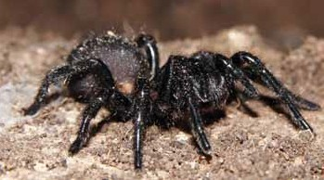

**In case of emergency call 000 p. 29**

**Australian snakes**

Many of the snakes found in Australia are capable of lethal bites to humans. These include:

* Taipans
* Brown snakes
* Tiger snakes
* Death adders
* Black snakes
* Copperhead snakes
* Rough scaled snakes and many sea snakes

Recognising snake bite

* Paired fang marks, but often a single scratch
* Headache
* Nausea and vomiting
* Occasionally, initial collapse followed by partial or complete recovery
* Abdominal pain
* Blurred or double vision
* Difficulty speaking

Note: life-threatening effects may not be seen for hours. In children symptoms may appear within minutes.

#### Management

* Keep the casualty at rest, reassured and under constant observation
* DRSABCD
* Apply pressure immobilisation technique

• Call 000/112

Do not:

* Use a tourniquet
* Cut, suck or wash the bite site

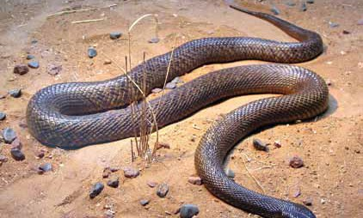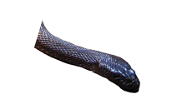

**In case of emergency call 000**

**Redback spider**

A redback spider bite may be life-threatening to a child, but is rarely serious for an adult.

Managing redback spider bite

* Keep casualty under constant observation
* Apply an ice pack or a cold compress to lessen the pain
* If the casualty is a young child or if collapse occurs or pain is severe transport the casualty to medical assistance
* Do not use a pressure immobilisation bandage

#### Bees, wasps and ants

Signs

* Immediate and intense localised pain
* Localised redness and swelling
* Localised itchy rash
* Allergic reactions—not localised to the bite area
* Itchy rash
* Facial swelling
* Wheezing and difficulty breathing
* Collapse

Managing stings from bees, wasps and ants

* DRSABCD
* Scrape out bee sting
* Apply ice pack
* If allergic reactions are present use a pressure immobilisation technique and transport the casualty to medical assistance

Note: the casualty with a known allergy may need assistance with prescribed medication before prompt transport to medical assistance. Eg. an epipen or anapen.

#### Box jellyfish

Stinging by jellyfish is caused by the simultaneous discharge of many thousands of microscopic stinging capsules called nematocyst. These are located on the surface of the tentacles and in some species on the body of the jellyfish. Nematocytsts contain coiled threads (tubules) loaded with the venom. Upon contact, the nematocysts discharge their tubules into the

victim’s skin like mini-harpoons. The more tentacles which make contact with the skin the more venom is injected.

Signs

* Immediate sharp pain and inflammation
* Red welt marks on the skin, goose pimple or blotching
* Multiple whip-like marks on the skin
* Tentacles on the skin



**In case of emergency call 000 p. 31**

* Frosted ladder pattern on the skin
* Later blistering or darkening of the sting pattern

Management

No one nationwide recommendation for first-aid can be made because of the differences between jellyfish species around Australia.

Tropical Australia

* Remove the casualty from the water
* Call an ambulance (000/112)
* DRSABCD
* Liberally douse the stung area with vinegar.
* If the victim has **clearly** been stung by a “Bluebottle” and is assessed as having a localised sting, is stable and not requiring an ambulance, vinegar should **not** be applied and the casualty managed as per stings in non- tropical Australia
* **Do not** wash with fresh water. Apply an ice pack or ice in a dry plastic bag to reduce pain.
* If vinegar is not available, pick off the tentacles (this is not harmful to the rescuer) and rinse the sting well with seawater

Non-tropical Australia

* Keep the casualty at rest, reassure and keep under

constant observation

* Do not allow rubbing of the sting area
* Pick off the tentacles (this is not harmful to the rescuer) and rinse sting area well with seawater to remove invisible nematocysts
* Place the casualty’s stung area in hot water (not hotter than the rescuer can comfortably tolerate) for 20 minutes
* If local pain is unrelieved by heat or if hot water is not available apply a cold pack or ice in a dry plastic bag
* If pain persists or is generalised, if the sting site is large or include sensitive areas such as eye, call an ambulance and seek assistance from a lifesaver/ lifeguard if available.

For further advice concerning any marine envemonation contact Australian Venom Research Unit 1300 760 451 or the Poison Information Centre 13 11 26



**In case of emergency call 000 p. 32**

**Blue-ringed octopus and cone shell**

Signs

* A spot of blood visible but a painless bite
* Numbness of lips and tongue
* The progressive weakening of muscles used in respiration, leading to inadequate or cessation of breathing

Managing blue-ringed octopus or cone shell stings

* Keep the casualty at rest, reassured and under constant observation
* DRSABCD
* Call an ambulance
* Use pressure and immobilisation technique

Photo by Jens Petersen, <http://en.wikipedia.org/wiki/GNU_> Free_Documentation_License

#### Fish Stings

A painful local reaction may be caused by the spines of a variety of fish. Stone fish (*Synanceis* Species) and Bullrouts (*Notesthes robusta*) have venom glands linked to spines which can deposit venom deeply into the casualty causing excruciating pain. These fish have excellent camouflage and are very dangerous to handle.

Signs and symptoms

* Intense pain
* Swelling
* Sometimes grey/blue discolouration around the sting site
* An open wound
* Bleeding
* Irrational behaviour and panic may occur

Management

* Place the affected area in hot water (no hotter than the casualty can comfortably tolerate)
* If in the uncommon event heat does not relieve the pain place the affected area in cold water
* Get medical assistance
* DO NOT use a Pressure Immobilisation Technique

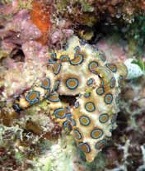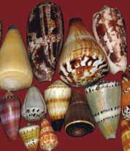

**In case of emergency call 000 p. 33**

### Substance misuse

Paracetamol is the most common pharmaceutical overdose leading to hospital admission; it is also responsible for the most calls to the Poisons Information Centre. The treatment for

paracetamol poisoning is most effective if administered as soon as possible.

Organic substances such as glues, hair spray, aerosol paints, lighter fluid, dry cleaning fluid, nail polish remover and petrol may be deliberately inhaled to produce altered sensation. Poisons effect may include

* Hyperactivity, followed by drowsiness and unconsciousness
* Irregular heartbeat, followed by cardiac arrest
* Difficulty breathing

Exercise, inhaling poison from a bag or in a confined space increase the dangers.

Mushrooms and toadstool (fungi) grow wildly throughout Australia. Some are edible but some are poisonous causing hallucinations, vomiting and diarrhoea. Ingestion of even one Amanita phalloides mushroom can cause liver failure and death. Cooking does not neutralise the toxin. Most reported cases of mushroom poisoning are in children less than five years old eating mushrooms growing in their home gardens.

#### Managing substance misuse

* Prevention of poisoning to the rescuer
* Decontamination of the casualty
* Resuscitation and supportive care
* Call an ambulance (000/112) and/or a poison control centre
* Do not induce vomiting

[www.health.qld.gov.au/PoisonsInformationCentre](http://www.health.qld.gov.au/PoisonsInformationCentre/)

### Needle stick injury

Needle stick injuries can occur in a number of settings. It can be from discarded needles in an outdoor setting, incorrectly disposed of needles, or when people try to re-cap needles.

#### Management

* Stay calm
* Wash the area with soap and water for at least 30 seconds
* Contact a doctor or hospital in case medical treatment, vaccination or testing is needed



**In case of emergency call 000 p. 34**

**Index**

Action plan 2



Animal bites 29

Airway 5

Asthma 16

Australian snakes 30 Bees, wasps and ants 31 Blue ringed octopus 33 Box jellyfish 31

Breathing 6

Burns 18

Chain of survival 12 Chest pain 15

Choking 10

Cold induced injury—hypothermia 23 Compressions 7

Cone shell 33

Crush injuries 22

Danger 3

Defibrillation 9

Diabetes 13

Dislocations and fractures 25 Drowning 11

Drug abuse 34

Ear injuries 27

Eye injuries 27

Fish stings 33

Funnel web spider 29 Head injury 21

Heat induced injury—hyperthermia 23 Hyperthermia 23

Hypothermia 23

Legal considerations 2

Medical conditions 13 Needle stick injuries 34 Poisoning 28

Redback spider 31

Rescuers recovery 12

Response 4 Send for help 5 Stroke 14

Seizure 16

Shock 18

Spinal injuries 22 Sprains and strains 24 Stone fish 33

Substance misuse 34

Notes



# *CONTACT US*

Book your first aid course

*‘Come to us or we come to you’*

Visit QldFirstAid.com Or call 1300 336 613



The Queensland First Aid Handbook is designed for Australian conditions and incorporates the current Australian Resuscitation Council guidelines and those of other expert bodies. The Queensland First Aid Handbook is an easy-to-use reference for managing first aid and emergency situations, including the DRSABCD action plan; performing CPR; managing medical conditions such as asthma, stroke, cardiac arrest and seizures; wound management and dealing with poisons, bites and stings.

[**WWW.QLDFIRSTAID.COM**](http://WWW.QLDFIRSTAID.COM/)