**Jennifer Wallace**

**Curriculum Vitae**

**(Short)**

* **Notice required for new appointment: 7 days.**

**Index:**

**Personal Details……………………………………………………………… Page 1**

**Referees…………………………………………………………………… Page 2**

**Brief Selected History of Employment and Community Service Projects… Page 2+3**

**Selected Qualifications………………………………………………………… Page 3**

**Selected Testimonials:**

* **Susan Walsch, The Empowerment Institute Australia……………… Page 4**
* **Professor Bengt-Ake Bengtsson, Sahlgrenska Institute Sweden…… Page 5**
* **Dr Leigh Atkinson, Neurosurgeon, Brisbane Australia……………. Page 6**
* **Excerpt from the Dean’s Bulletin, University of Queensland……… Page 8**

**Personal Details:**

**Name:**                          Jennifer D Wallace

**Address:**                      20 Aragon St, Indooroopilly, Brisbane, Queensland 4068, Australia.

**Telephone:**                  07 3342 2797 (H), 0412 667 533 (m)

**E-mail:**                        [jenndwallace@gmail.com](mailto:jenndwallace@gmail.com)

**D.O.B:**                         10th December 1963

**Place of Birth:**             England, United Kingdom

**Residence Status:**       Permanent Resident of Australia since 1990.

**Referees:**

**Professor Rick Jackson** supervised my PhD and has had longstanding association with me throughout my clinical research career.

**Russell Davie** has been a mentor for me throughout my training and appointment as an outdoor adventurous activity leader and Vocational Educational Trainer for Scouts Australia Institute of Training.

**Russell Davie**

Outdoors Adventurous Activities Branch Advisor

Scouts Australia

Tel: 33 66 55 24

E-mail: Russell.Davie@coordinatorgeneral.qld.gov.au

**Prof Richard V Jackson**, MBBS, BSc(Hons), FRACP

Director, Neuroendocrine Research Unit

Consultant, Endocrinology and Internal Medicine

Professor of Medicine, Logan Campus

School of Medicine

GRIFFITH UNIVERSITY

Telephone 07 3299 8155

Email [r.jackson@griffith.edu.au](mailto:r.jackson@griffith.edu.au)

**Brief Selected History of Employment and Community Service Projects**

2013/14 Climbing Team Trainer

6 Degrees NVDA Climb team

Friends of the Earth Brisbane

2013/14 Community Volunteer

Inspire Sustainability

Morningside Brisbane

2011-2013 55 for 5 Fundraising 55K Walk Guide

Leukaemia Foundation

2006 to 20014 *Leader of Youth and Adults Scouting Australia

Outdoor Adventurous Activity Leader

Trained to run Vocational Educational Training Courses

*Mt Gravatt Walking Group

*Crisis Counsellor, Lifeline

*Bushwalking/Navigation Guide and Leader Trainer (Various clubs)

*Environmental Protection Agency Lady Musgrave Island Host

1990 to 2012 *Clinical Researcher/ Academic/ Problem Based Learning Tutor

University of Queensland

*Founder of Adult Growth Hormone Deficiency Aware (AGHD Aware) Advocacy and support group for Adults with Pituitary damage.

Academic and Humanitarian biography and CV can be found at <http://aghdaware.org>

By clicking on “Founder”, reading the biography and then Clicking on the CV link. The academic CV has not been updated since 2006 but has an extensive list of first author publications and invited presentations.

1988 & 1989 Senior Physiological Measurement

Dpt Medicine, St Thomas’ Hospital

London

**Selected Qualifications:**

**2014 Leaders Wilderness Advanced First Aid (60hrs), Wilderness First Aid Australia**

**HTLFA311C Apply First Aid**

**HTLFA211A Perform CPR**

**HTLFA211A Provide Basic Emergency Life Support**

**SISOOPS305A Provide First Aid in a Remote Location**

**SISXEMR201A Respond to Emergency Situations**

**SISXEMR402A Coordinate Emergency Responses**

2012 Certificate IV in Outdoor Recreation Qualifications (for specific units please request excel spread sheet with 190 individual qualifications for outdoor rec, education, values education etc.)

2012 Myers-Briggs Type Indicator Administrator Accreditation

2011 Virtues Project International Facilitator Accreditation

**2011 Certificate IV in Training and Assessment**

**2011 Marine First Aid (Including suturing and injecting)**

2011 SROGR001A Facilitate a group

2011 SRXGR002A Deal with conflict

2011 SRXGR003A Provide Leadership to groups

2011 SRXRES003B Contribute to the planning, monitoring and control of resources

2011 CHCYTH1B Work effectively with young people

2011 CHCYTH5B Support youth program

**2008 HLTPAT9A Perform Intravenous Cannulation, Mater Education Centre**

2008 Certificate IV in Leadership

2008 SAP 401A Develop Implement and Manage Leadership Programs

2008 Certificate IV in Business and Front Line Management

1998 National Assessment in Respiratory Physiology (UK), 1988.

1997  B.Sc. (Hons.), University of London, UK. Aug. 1987, (2.2).

(Honours research project  on Physiological Correlates of Stress received First Class award).



* 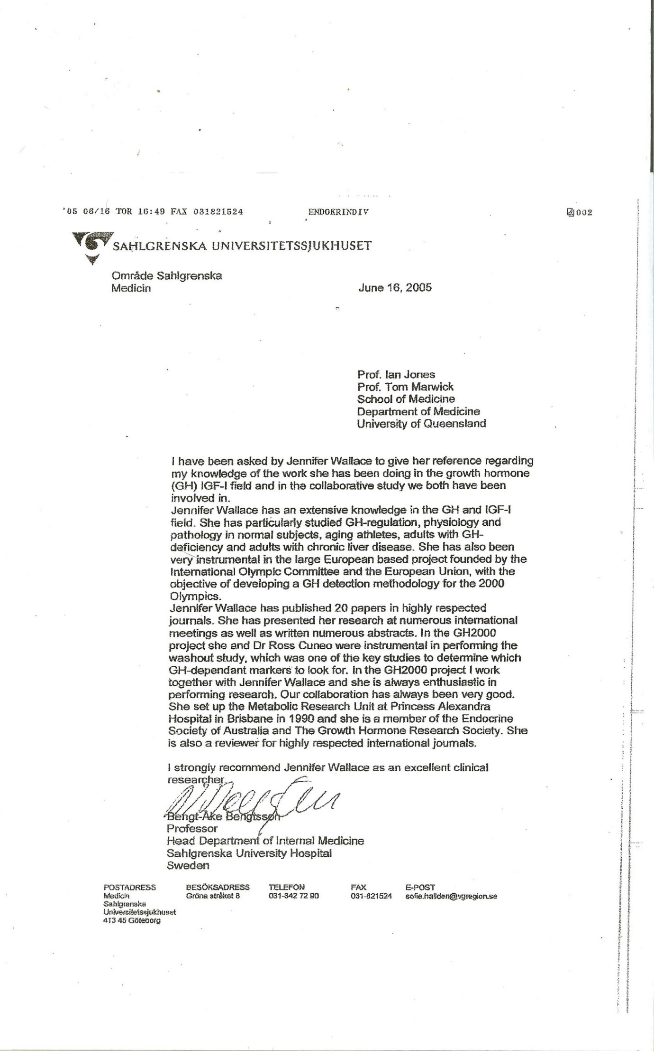
* 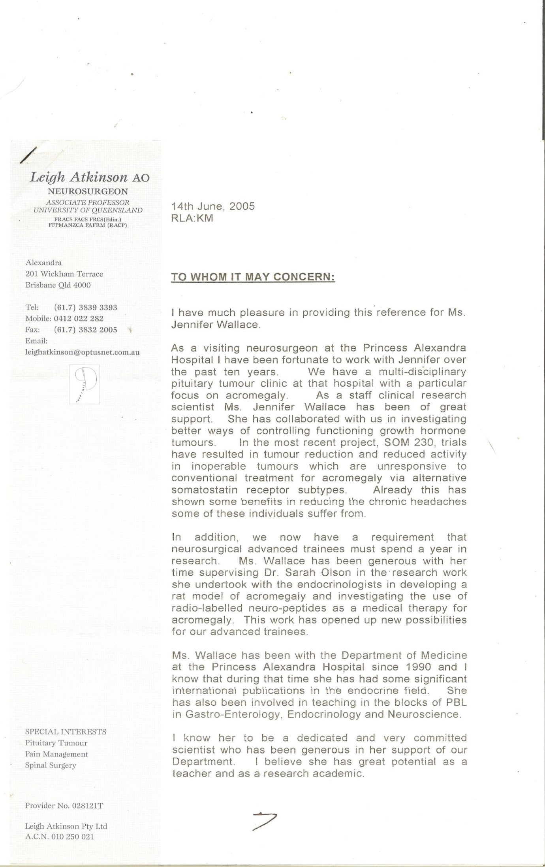
* 
* l