**Jennifer Durtanovich Resume/ curriculum vitae**



**Personal Details**

Address: 55 Bedfordale Hill road

MT RICHON, 6112

Mobile: 0407 717 709

Email: [info@bandaidz.com.au](mailto:info@bandaidz.com.au)

Emergency contact: Rod Durtanovich:

0412 343 261

Vicki Bosich (sister):

0417 092 887

**Personal Profile**

In the past I have always been a highly motivated, results-driven individual who enjoys a challenge and is committed to succeeding in a sale. I am a creative thinker with a positive, outgoing attitude. My new strengths are in educating people in the First Aid and Medical field offering a professional yet not intimidating approach. I am particularly passionate about Asthma and Defibrillation. I am happy to work without constant supervision, but I do like to be recognized for my efforts if the occasion arises.

I Hold a current Cert 4 in training and Assessing

**Career Objective/ Goals**

To encourage all new parents, grandparents and new drivers to attend a First Aid Course as part of their new responsibilities.

To educate the public on the importance of early defibrillation.

To ensure my participants leave my courses feeling confident to use their new skills

To emphasise the importance of First Aid Training to ALL members of the Public

**Memberships**  CERT 4 in Training And Assessing

WA Beauty Institute Beautician

Jarrahdale Sport Shooters Association

**Hobbies Competition metal target shoots , Interior Decorating , Asian Style garden themes**

**Employment History**

**Pulse Points First aid Training Current**

Continuing my First Aid business assisted with new training

Partner HealthCorp!

**Asthma Australia Perth**

**Asthma Educator Current**

Conducting accredited courses to the Work Place

**Pulse Points First Aid Training & Bandaidz for kidz 2008- 2012**

Working as a St John ambulance retail trainer, conducting my

Own business and contracting for St John ambulance.

**St John Ambulance, Belmont 2007- 2009**

First Aid consultant/ First Responder manager  
**St John Ambulance 2000-2008**

Also worked evenings and weekends as a casual First aid

Trainer for St John Ambulance.

**Care Pharmaceuticals (formerly Paedpharm) 2004-2007**

Territory Pharmacy Manager

**Bayer Pty. Ltd.**

**2003-2004**

OTC pharmacy Representative ( 6 month long service contract )

**Havenhall 1998-2003**

WA state manager

**Responsibilities:**

* Calling on all major pharmacies/ hospitals and clinics
* Responsible for the selling and merchandising of all new existing lines
* Promoting certain products with various pharmacy groups
* Liaison with wholesalers and organising in store promotions
* Meeting and achieving budgets

**Colgate Palmolive 1995- 1998**

Senior Sales Representative- Part time

**Thornlie Square Pharmacy 1992-1998**

Part-time Assistant and second in Charge

Blackmore’s Consultant of the month- November 1994

**Michael Harris Agencies, Perth 1988- 1991**

Manageress

**Responsibilities:**

* Promotion and sales of fashion ranges for both men and women
* Pre-selling and supply logistics
* Accounts payable and receivable
* Liaison with clothing supplies modelling of new ranges

**Karratha Pharmacy**

Pharmacy Assistant/Bookkeeper **1985-1986**

**Responsibilities:**

* Assisting with sales during peak times
* All facets of store bookkeeping and banking
* Training Junior staff
* Dispensary Assistant
* General merchandising

**Purely Australian, Perth 1984- 1985**

Sales Manageress

**Responsibilities:**

* Retail management of clothing store
* General sales & banking
* Budgeting & stock control

**Greg Day Fashion Agencies, Perth 1981- 1984**

Manageress/ Sales Representative

**Responsibilities:**

* Wholesale Fashion Agency Management
* Training and control of Sales and Administrative staff
* Promotion of new and existing lines
* Customer Liaison & general servicing
* Account establishment

**Hedey Bond Chemist, Perth 1974-1980**

Pharmacy Assistant

**Responsibilities:**

* Customer Service
* Stock control and general control of areas external to pharmaceutical issues

**Referees Natalie Veale- Director of Fotek**

0413 179 441

Jane Mcphedran- WA State Sales Manager ( Care Pharmaceuticals- Formally Paedpharm)

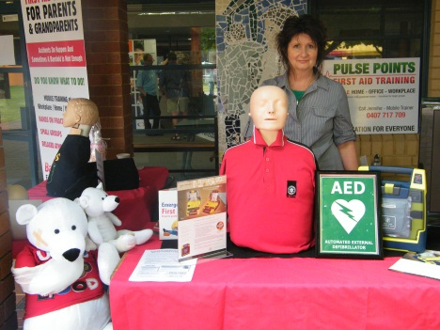 0413 625 412