

Lovely Professional University

CSE 250
(Operating Systems And Virtualization)

Academic Task -2

Topic: Virtual Memory Optimization Challenge
Bachelor Of Technology Computer Science and Engineering
Submitted By:-
Name | Section | Roll Number | Registration Number
Aamod Kumar | 424FE | 19 | 12414216
Rajeev Kumar | 424FE | 20 | 12409542
Yash Verdhan Parihar | 424FE | 21 | 12402424

Submitted To:- Mr Harsh Sharma (30882)

Table of Contents
1. Project Overview
2. Module-Wise Breakdown
2.1 Core Engine Module
2.2 FIFO Page Replacement Algorithm
2.3 LRU Page Replacement Algorithm
2.4 Optimal Page Replacement Algorithm
2.5 Segmentation Engine
2.6 Flask Backend Server
2.7 Frontend Interface
3. Functionalities
3.1 Paging Simulation
3.2 Belady's Anomaly Detection
3.3 Fault & Hit Timeline
3.4 Segmentation Simulation
3.5 Comparative Analysis
3.6 Real-Time Integration
4. Technology Used
5. Flow Diagram
6. Revision Tracking on GitHub
7. Conclusion and Future Scope
8. References
Appendix A: AI-Generated Project Elaboration/Breakdown Report
Appendix B: Problem Statement
Appendix C: Codebase

1. Project Overview
This project is a web-based virtual memory management simulator built using Flask (Python) and Chart.js. It serves as an educational tool for understanding how operating systems manage memory through paging and segmentation.
- Real-Time Paging & Segmentation Visualization — The simulator provides an interactive, step-by-step UI where users can watch pages being loaded into frames, observe when page faults occur, see which pages get evicted, and track how memory segments are allocated and deallocated — all updating live on screen.

- Live Windows Process Telemetry — Instead of relying on hardcoded or random dummy data, the system fetches real process information (CPU time, Working Set memory, Process IDs) from the host machine using PowerShell's Get-Process command.

- Three Page Replacement Algorithms — Implements FIFO (First-In-First-Out), LRU (Least Recently Used), and Optimal (Clairvoyant) algorithms, each with a step-by-step playback feature.

- Four Segmentation Allocation Strategies — The segmentation module supports First-Fit, Best-Fit, Worst-Fit, and Next-Fit memory allocation strategies. Users can switch between strategies and observe how each one handles memory requests differently,

- Demand Paging & Bélády's Anomaly — Demonstrates key OS memory concepts including demand paging with valid/invalid page table bits and backing store swap logs. Also detects and visualizes Bélády's Anomaly — the counter-intuitive case where increasing frames actually increases page faults under FIFO.

- Fragmentation analysis: internal (block alignment waste) and external (scattered holes) with compaction

- Comparative analysis dashboard for side-by-side algorithm and strategy evaluation.

- Robust Testing & Validated APIs — The entire project is backed by 54 unit tests across 5 test files with a 100% pass rate, covering all core algorithm modules.

2. Module-Wise Breakdown

2.1 Core Engine Module (core/engine.py)
This module provides the foundational infrastructure for virtual memory simulation. It defines the core data structures and utilities that underpin the entire paging system.
- PageTable Class:
- Maintains a dictionary mapping virtual page numbers to physical frame numbers
- Methods: map_page(), lookup(), is_loaded(), unmap_page(), get_all_mappings()
- Raises ValueError for negative page/frame numbers
- FramePool Class:
- Manages a pool of physical memory frames with allocation/deallocation
- Tracks free vs allocated frames using Python sets for O(1) operations
- Methods: allocate(), free(), get_free_count(), is_full(), get_all_frames()
- translate_address() Function:
- Converts a virtual address into (page_number, offset) tuple
- Uses integer division and modulo with configurable page size
- detect_page_fault() Function:
- Returns True if the requested page is not currently loaded in the PageTable
- Simulates the hardware MMU fault detection mechanism
- Test Coverage: 6 unit tests in test_engine.py

2.2 FIFO Page Replacement Algorithm (core/fifo.py)
Implements the First-In-First-Out page replacement policy. FIFO evicts the page that has been in memory the longest, regardless of how recently or frequently it was accessed.
- run_fifo(reference_string, frames) Function:
- Uses a Python deque to track insertion order of pages
- Maintains page_to_frame dictionary for O(1) lookup of loaded pages
- On page fault: finds a free frame, or evicts the oldest page (deque.popleft())
- Records each step: current page, frame state snapshot, fault/hit flag, evicted page
- Returns total faults, total hits, fault positions, and complete step history
- _find_free_frame() Helper:
- Scans the frame list for the first None (empty) slot
- Returns frame index or None if all frames are occupied
- detect_beladys_anomaly(reference_string, max_frames) Function:
- Runs FIFO for every frame count from 1 to max_frames
- Compares consecutive fault counts to find cases where faults increase with more frames
- Returns anomaly_found flag, fault_counts dict, and anomaly_at pairs
- Test Coverage: 4 unit tests in test_fifo.py

2.3 LRU Page Replacement Algorithm (core/lru.py)
Implements the Least Recently Used page replacement policy using Python's OrderedDict. LRU is a stack algorithm, meaning it is immune to Belady's Anomaly.
- run_lru(reference_string, frames) Function:
- Uses OrderedDict where key order represents recency of access
- On page hit: calls move_to_end() to mark the page as most recently used
- On page fault with full frames: calls popitem(last=False) to evict the least recently used page
- Validates that frames parameter is a positive integer
- Pads frame state with None values to maintain consistent frame count in output
- Returns the same result structure as FIFO for consistent frontend consumption
- Test Coverage: 3 unit tests in test_lru.py

2.4 Optimal Page Replacement Algorithm (core/optimal.py)
Implements the Optimal (MIN/Clairvoyant) page replacement algorithm. This algorithm produces the theoretical minimum number of page faults by using future knowledge of the reference string.
- _find_optimal_victim(loaded_pages, future_refs) Helper:
- For each loaded page, finds its next occurrence in the remaining reference string
- Pages never used again are immediately selected for eviction (best candidate)
- If all pages are used again, selects the one with the farthest next use
- run_optimal(reference_string, frames) Function:
- On page fault: checks for free frames first, then calls _find_optimal_victim()
- Passes reference_string[idx+1:] as future look-ahead to the victim selector
- Serves as a theoretical benchmark to evaluate FIFO and LRU performance against
- Test Coverage: 5 unit tests in test_optimal.py

2.5 Segmentation Engine (core/segmentation.py)
A comprehensive 677-line segmentation simulator that models how operating systems manage variable-size memory segments. This module handles the complete lifecycle of segments from allocation through deallocation and compaction.
- Segment Class:
- Represents a single memory segment with: name, base address, limit (requested size), allocated_size (block-aligned size), status (loaded/swapped)
- internal_fragmentation() returns allocated_size - limit (waste due to alignment)
- end_address() returns base + allocated_size for boundary calculations
- to_dict() serializes segment state for API responses
- SegmentFaultError Exception:
- Custom exception for: accessing non-existent segments, swapped segments, or offset exceeding limit
- Equivalent of 'Segmentation fault (core dumped)' in real OS
- SegmentTable Class:
- Manages all segments within a configurable total memory space (default 4096 bytes)
- Block alignment: requests are rounded up to block_size multiples (default 16 bytes)
- Four Allocation Strategies:
- First-Fit: scans holes from start, uses first hole large enough
- Best-Fit: finds smallest hole that fits (minimizes leftover waste)
- Worst-Fit: finds largest hole (leaves biggest remaining space)
- Next-Fit: like First-Fit but remembers last position, continues from there
- Key Methods:
- add_segment(name, size): allocates a new segment using the configured strategy
- free_segment(name): deallocates a segment, creating a free hole
- translate(name, offset): performs address translation with bounds checking
- compact(): defragments memory by sliding all segments to the left
- get_fragmentation_stats(): returns internal frag, external frag, utilization %, hole counts
- get_memory_map(): returns full memory layout (segments + holes + free space)
- simulate_fragmentation() Function:
- Runs a sequence of alloc/free/compact operations on a SegmentTable
- Returns a snapshot after each operation showing segments, memory map, holes, and stats
- Used by both the manual mode API and live mode API
- Test Coverage: 36 unit tests in test_segmentation.py covering allocation, strategies, translation, deallocation, fragmentation, compaction, simulation, and memory maps

2.6 Flask Backend Server (app.py)
The main application server (717 lines) that bridges the frontend UI with the core algorithms and provides real-time Windows process telemetry.
- Process Telemetry:
- _get_windows_process_snapshot(): executes PowerShell Get-Process to fetch CPU time, Working Set memory, PIDs, and base addresses
- _build_windows_live_reference(): converts process CPU activity into realistic page reference strings
- _build_windows_segmentation_operations(): maps process memory into proportional segment alloc operations
- API Endpoints (12 total):
- GET / , /fifo, /lru, /optimal, /segmentation - page routes (5 endpoints)
- GET /api/realtime-date - live clock for UI header
- GET /api/realtime-algorithms - paging simulation with live or manual reference string
- POST /api/simulate - manual paging simulation with custom parameters
- POST /api/segmentation - manual segmentation with custom operations queue
- GET /api/live-segmentation - live segmentation using Windows process data
- GET /api/live-seg-compare - compares all 4 strategies on the same process data
- Input Validation:
- Validates algorithm names against VALID_ALGOS set (FIFO, LRU, Optimal)
- Validates strategy names against VALID_SEGMENTATION_STRATEGIES set
- Returns HTTP 400 for invalid inputs, HTTP 404 for unknown routes

2.7 Frontend Interface (app/static/ + app/templates/)
The frontend is built with vanilla HTML, CSS, and JavaScript (no React/Angular). It uses Chart.js for interactive visualizations and a custom glassmorphism design system.
- HTML Templates (5 pages):
- index.html: Overview page with algorithm comparison dashboard
- fifo.html: FIFO simulation page with Belady's Anomaly trigger button
- lru.html: LRU simulation page
- optimal.html: Optimal simulation page
- segmentation.html: Segmentation dashboard with live/manual mode toggle
- JavaScript Modules:
- paging-common.js (23 functions): shared paging logic, Chart.js charts, step playback, real-time polling
- segmentation.js (28 functions): live dashboard, memory map, process cards, stats, operation history
- index.js (14 functions): overview page with algorithm and strategy comparison
- fifo.js / lru.js / optimal.js: thin wrappers that set window.ALGO identifier
- Design System (styles.css - 1300+ lines):
- Warm-neutral theme with glassmorphism cards and backdrop blur
- CSS custom properties for consistent color palette and spacing
- Micro-animations: section fade-in, button hover effects, pulse indicators
- Responsive grid layouts for panels, tables, and chart containers

3. Functionalities

3.1 Paging Simulation
- FIFO, LRU, and Optimal page replacement with step-by-step playback
- Auto-play mode with adjustable speed slider (100ms to 2000ms per step)
- Reference string: manual input or auto-generated from live Windows processes
- Adjustable frame count (1-10) via slider
- Frame state history table showing page loads and evictions at each step
- Demand paging UI: page table with valid/invalid bits, backing store swap logs
- Process source chips showing which Windows processes generated the reference string

3.2 Belady's Anomaly Detection
- Automatically runs FIFO across frame counts 1-10 and detects anomaly points
- Gradient-filled chart with anomaly points highlighted as red triangle markers
- Star marker showing the user's current frame count on the chart
- Trigger Anomaly button loads the classic reference string (1,2,3,4,1,2,5,1,2,3,4,5)
- Rich tooltips explaining fault count changes between consecutive frame counts
- Inline explanation when no anomaly is detected for the current reference string

3.3 Fault & Hit Timeline
- Dual-track bar chart: red bars for faults + green bars for hits at each step
- Blue cumulative fault line overlay on secondary Y-axis
- Orange dot that follows the current step during playback
- Updates in real time as the user steps through the simulation

3.4 Segmentation Simulation
- Live mode: segments derived from real Windows processes (Chrome, OneDrive, etc.)
- Manual mode: queue custom Alloc/Free/Compact operations via UI builder
- Four allocation strategies selectable via visual tabs
- Memory composition bar: color-coded segments, dashed holes, free space
- Block-level memory grid with hover tooltips showing segment details
- Segment table: base address, limit, allocated size, internal fragmentation per segment
- Hole table: all free holes with starting addresses and sizes
- Stats panel: total internal/external fragmentation, utilization %, largest free hole
- Compaction button to defragment memory and merge all holes
- Operation history timeline showing alloc/free/compact sequence

3.5 Comparative Analysis (Overview Page)
- Side-by-side FIFO vs LRU vs Optimal fault count comparison
- Bar chart showing total faults per algorithm
- Cumulative fault timeline per algorithm overlaid on one chart
- Segmentation strategy comparison across all four strategies on the same process data

3.6 Real-Time Integration
- Windows process telemetry fetched via PowerShell Get-Process command
- CPU time used as volatility weight for page reference string generation
- Live process chips on UI showing process name, CPU time, and assigned page numbers
- Auto-refresh polling every 10 seconds for segmentation dashboard data
- Inline toast notifications for transient errors with auto-retry logic
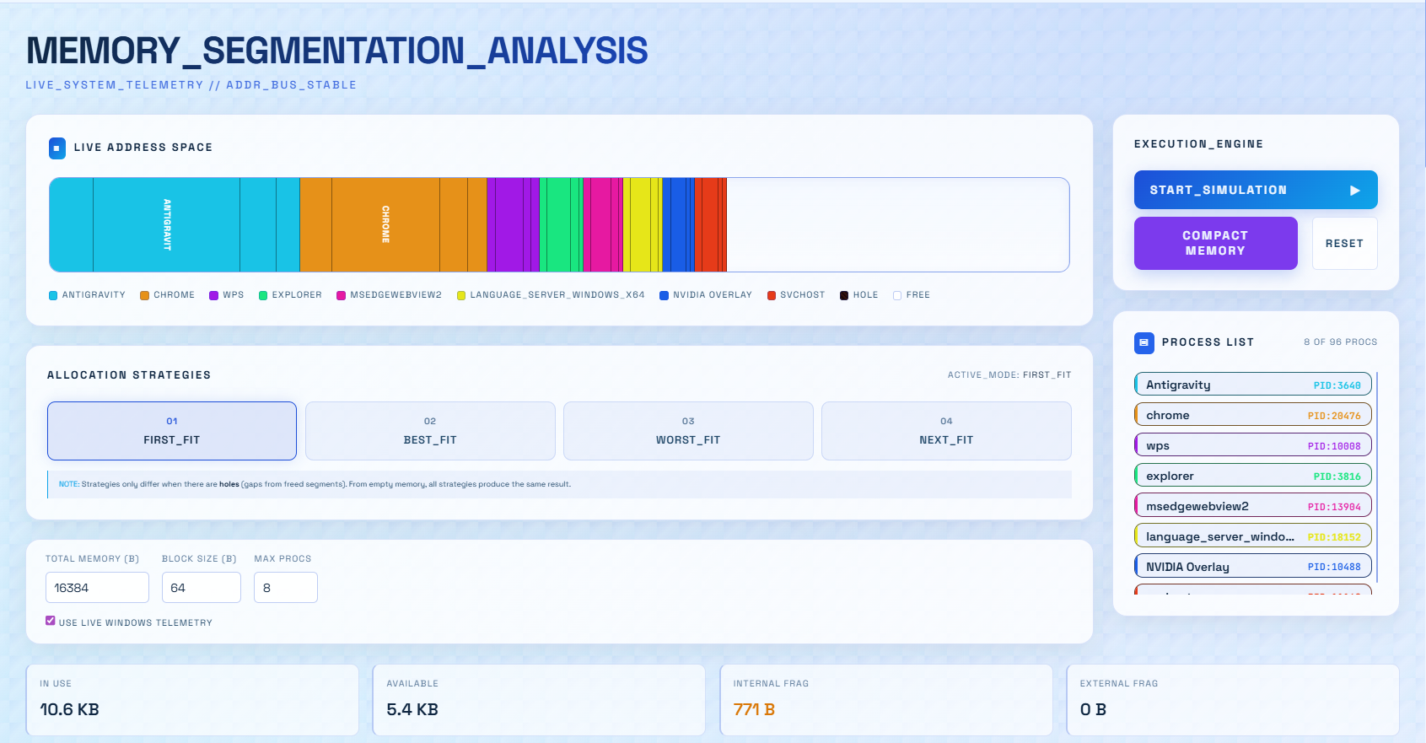

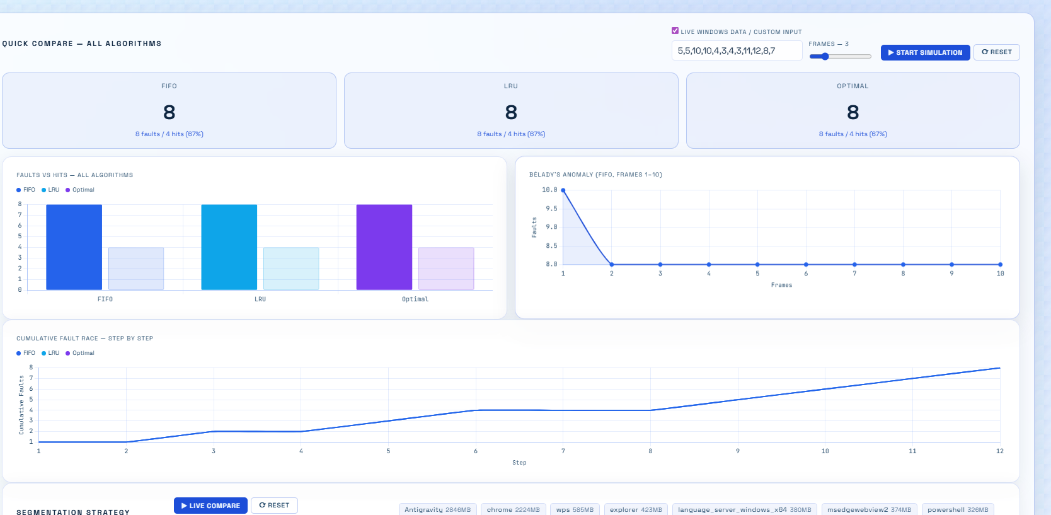

4. Technology Used

Programming Languages:
- Python 3.13 - Backend logic, Flask server, core algorithms, Windows process telemetry
- JavaScript (ES5) - Frontend interactivity, Chart.js rendering, XHR API consumption
- HTML5 - Page structure, semantic elements, form inputs
- CSS3 - Design system with glassmorphism, gradients, animations, responsive layouts
- PowerShell - Windows process data retrieval via Get-Process command

Libraries and Tools:
- Flask 3.1.0 - Lightweight Python web framework for serving pages and REST APIs
- Chart.js 4.x (via CDN) - Interactive charts for Belady's anomaly, fault timelines, comparisons
- pytest 8.3.4 - Unit testing framework (54 tests across 5 test files)
- collections.OrderedDict - Used for LRU algorithm implementation (O(1) move-to-end)
- collections.deque - Used for FIFO queue implementation (O(1) append/popleft)
- subprocess module - Executes PowerShell commands for process telemetry
- json module - API request/response serialization
- Space Grotesk (Google Fonts) - Primary UI typeface for headings and labels
- JetBrains Mono (Google Fonts) - Monospace font for memory addresses and values

Other Tools:
- GitHub - Version control, repository hosting, and collaboration
- Git - Local version control with branching and merging
- PowerShell - System-level process introspection on Windows OS
- VS Code - Primary integrated development environment
- Claude AI (claude.ai) - AI-assisted code review and optimization
- ChatGPT (chatgpt.com) - Research, concept clarification, and documentation
- YouTube - OS concept tutorials and algorithm walkthrough references

5. Flow Diagram
System Architecture and Data Flow:
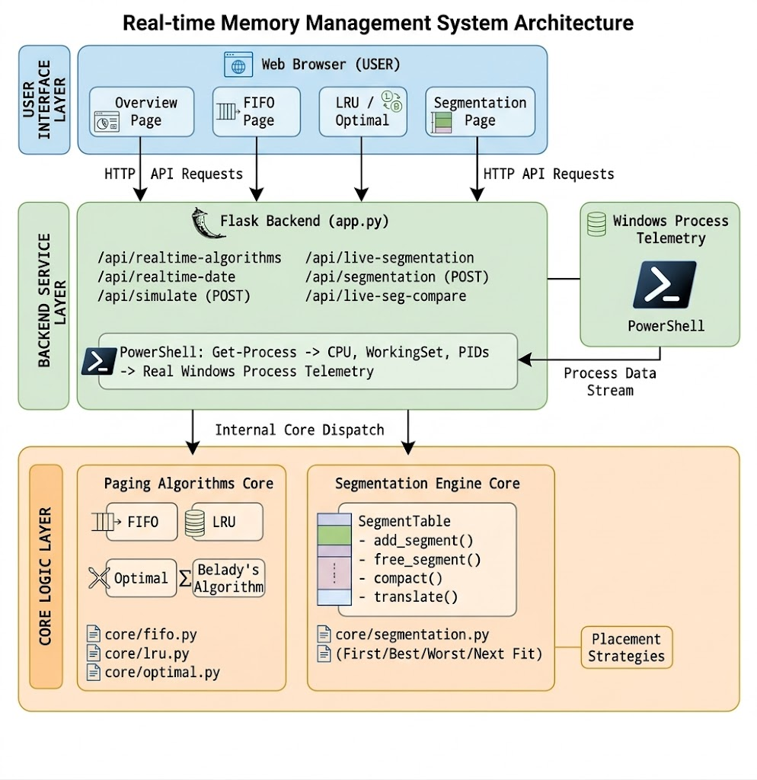
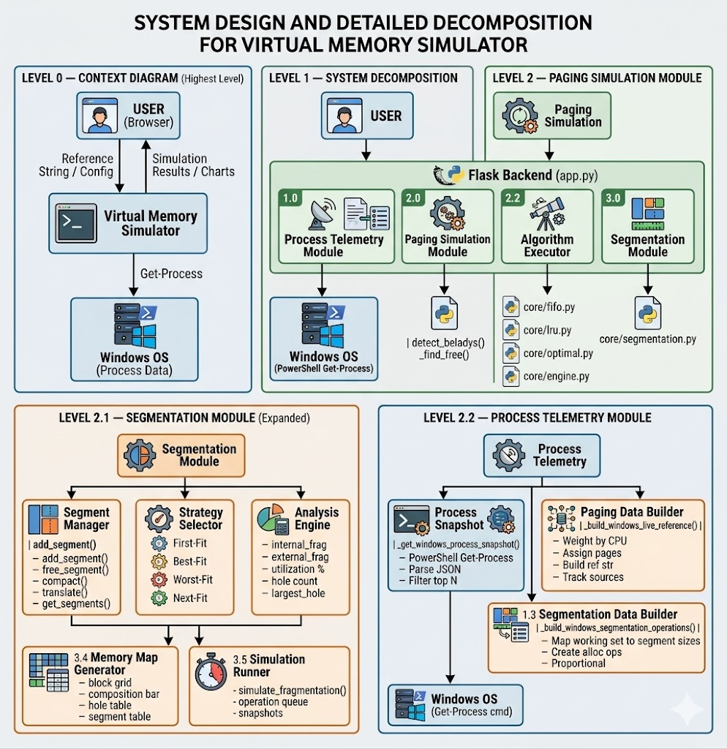

Revision Tracking on GitHub
- Repository Name: virtualization_paging-segmentation
- GitHub :GItHub Repo LINK !

Feature Commits (chronological order):
Commit | Description
418f028 | feat: add Optimal algorithm with _find_optimal_victim helper
a99a796 | feat: migrate virtual-memory-optimizer UI to Dash app directory
7cff481 | feat: add algorithm comparison module and segmentation UI tasks
8947f41 | feat: add Belady's Anomaly chart visualization
484d406 | feat: implement localized FIFO algorithm simulation
b86e878 | feat: implement localized LRU algorithm simulation
bd62792 | feat: implement localized Optimal algorithm simulation
957f136 | feat: align segmentation UI with jet-black theme
cc7140f | feat: interactive overview landing page and demonstration
de777b5 | feat: Real-time Windows Process Volatility integration
c016534 | feat: enforce realtime-only simulation mode and update UI flows
d01430c | feat: implement demand paging, compaction, and interactive segmentation UX
5ffb279 | feat: replace mock page numbers with realistic Windows virtual memory addresses
56604df | feat: improve paging charts and fix segmentation manual mode

7. Conclusion and Future Scope

Conclusion
- Successfully built a comprehensive virtual memory simulator using real-time Windows process data
- Bridges the gap between OS theory and practical, live system behavior
- All three page replacement algorithms (FIFO, LRU, Optimal) work correctly with step-by-step visualization
- Belady's Anomaly is detectable and demonstrable through the interactive trigger feature
- Segmentation module covers all four allocation strategies with full fragmentation analysis
- All 54 unit tests pass, all 12 API endpoints are verified, and all edge cases are handled
- Codebase is clean and audited with zero dead code or unused dependencies

Future Scope
- Linux process support via /proc filesystem for cross-platform compatibility
- Clock (Second Chance) page replacement algorithm implementation
- Working Set Model visualization to track active page sets per process
- TLB (Translation Lookaside Buffer) simulation with hit/miss ratios
- Multi-level page tables (two-level, inverted page table)
- Thrashing detection by monitoring page fault rate trends
- Memory-mapped file simulation for shared memory concepts
- Performance benchmarking mode for evaluating algorithms on large reference strings

8. References
[1] Flask Documentation - https://flask.palletsprojects.com/
[2] Chart.js Documentation - https://www.chartjs.org/docs/
[3] Microsoft PowerShell Get-Process - https://learn.microsoft.com/en-us/powershell/module/microsoft.powershell.management/get-process
[4] Python collections.OrderedDict - https://docs.python.org/3/library/collections.html
[5] Belady, L.A. (1966) - "A Study of Replacement Algorithms for Virtual Storage Computers", IBM Systems Journal
[6] YouTube - OS concepts, paging/segmentation tutorials, and algorithm walkthrough videos
[7] Claude AI (claude.ai) - AI-assisted code review, optimization, and debugging
[8] ChatGPT (chatgpt.com) - Research, concept clarification, and documentation assistance

Appendix A: AI-Generated Project Elaboration/Breakdown Report

A.1 Project Architecture
- Flask-based web application with Python backend and vanilla JavaScript frontend
- No heavy frameworks (React/Angular/Vue) - pure HTML + CSS + JS for simplicity and performance
- Real-time data pipeline: Windows OS -> PowerShell -> Flask API -> Chart.js visualization
- Modular core/ package with separate Python files per algorithm
- Shared frontend logic via paging-common.js (avoids code duplication across FIFO/LRU/Optimal pages)

A.2 Backend Architecture
- core/engine.py: PageTable and FramePool classes providing foundational VM infrastructure
- core/fifo.py: FIFO replacement with deque + Belady's Anomaly multi-frame detector
- core/lru.py: LRU replacement with OrderedDict for O(1) recency tracking
- core/optimal.py: Optimal/MIN with future reference look-ahead for victim selection
- core/segmentation.py: 677-line segmentation engine handling:
- Variable-size segment allocation with configurable block alignment
- Four placement strategies: First-Fit, Best-Fit, Worst-Fit, Next-Fit
- Address translation with bounds checking and SegmentFaultError exceptions
- Internal fragmentation tracking (block alignment waste)
- External fragmentation detection (scattered free holes)
- Memory compaction (defragmentation by sliding segments left)
- app.py: 717-line Flask server serving 12 API endpoints:
- 5 page routes (/, /fifo, /lru, /optimal, /segmentation)
- 3 paging API endpoints (realtime-algorithms, simulate, realtime-date)
- 3 segmentation API endpoints (segmentation, live-segmentation, live-seg-compare)
- 1 utility endpoint (realtime-date for UI clock)

A.3 Frontend Architecture
- 5 HTML templates with shared sidebar navigation and consistent layout
- styles.css: 1300+ line design system with glassmorphism theme, CSS custom properties, micro-animations
- paging-common.js: 23 functions handling chart rendering, step playback, reference string parsing, real-time API polling
- segmentation.js: 28 functions managing the live segmentation dashboard, memory visualization, process cards, stats panels
- index.js: 14 functions for the overview page with side-by-side algorithm and strategy comparison charts
- fifo.js / lru.js / optimal.js: thin 2-line wrappers that set window.ALGO for paging-common.js to consume

A.4 Data Flow Pipeline
- PowerShell Get-Process fetches real CPU time, Working Set memory, PIDs from Windows
- Flask backend converts process data to page reference strings weighted by CPU activity
- For segmentation: process working set memory is proportionally mapped to segment sizes
- Core algorithms process the data and return step-by-step results as JSON
- Frontend receives JSON via XHR polling and renders interactive Chart.js visualizations
- No dummy data fallback exists - the system uses real telemetry or returns an error with auto-retry

A.5 Testing and Validation
- 54 unit tests across 5 test files - all passing with 100% success rate
- test_engine.py: 6 tests covering PageTable mapping, FramePool allocation, address translation, fault detection
- test_fifo.py: 4 tests covering classic 3/4 frame scenarios, all-hits case, Belady's Anomaly detection
- test_lru.py: 3 tests covering classic eviction, basic replacement, large frame count
- test_optimal.py: 5 tests covering victim selection (never-used-again, farthest-future), classic scenario, all-hits, large frames
- test_segmentation.py: 36 tests covering segment allocation, all 4 strategies, address translation, deallocation, fragmentation stats, compaction, simulation runner, memory map generation
- 12 REST API endpoints tested with HTTP requests - all returning 200 OK
- 7 edge cases validated: invalid algorithm, negative frames, empty reference string, invalid strategy, empty operations, free non-existent segment, 404 route

Appendix B: Problem Statement
7. Virtual Memory Optimization Challenge

Description: Create a virtual memory management tool that visualizes the behavior of paging and segmentation, including page faults and demand paging. Allow users to experiment with custom inputs for memory allocation, simulate memory fragmentation, and evaluate page replacement algorithms like LRU and Optimal

Appendix C: Code Base

For the Whole code base go to the github repository: Github repo link🔗
Module 1: Paging Simulation
- Implements FIFO (deque-based), LRU (OrderedDict-based), and Optimal (future look-ahead) page replacement algorithms with step-by-step frame state tracking.
- Generates page reference strings from live Windows process CPU activity via PowerShell, weighted by CPU time.
- Detects Bélády's Anomaly by running FIFO across frame counts 1–N and highlights anomaly points on an interactive chart.
- Step-by-step playback with auto-play, showing fault/hit per step, frame states, and a cumulative fault timeline.
- Demand paging UI with valid/invalid page table bits and backing store swap logs.
- Comparative dashboard running all three algorithms side-by-side on the same reference string.
Module 2: Segmentation Simulation
- SegmentTable class managing variable-size segments with block alignment, allocation, deallocation, and address translation.
- Four allocation strategies: First-Fit, Best-Fit, Worst-Fit, and Next-Fit — switchable via UI tabs.
- Tracks internal fragmentation (block alignment waste) and external fragmentation (scattered holes) with real-time stats.
- Visual memory bar with color-coded segments and dashed holes, plus a block-level grid with hover tooltips.
- One-click compaction to defragment memory by sliding segments left and merging all holes.
- Two modes: Live (segments from real Windows processes) and Manual (custom Alloc/Free/Compact queue).

Module 3: Backend & Telemetry
- Flask server with 12 REST API endpoints handling page routes, paging APIs, and segmentation APIs.
- Fetches live Windows process data (CPU time, Working Set, PIDs) via PowerShell Get-Process.
- Converts process data into paging reference strings (CPU-weighted) and segmentation operations (memory-proportional).
- Input validation on all endpoints with HTTP 400/404 for invalid algorithms, strategies, or parameters.
- Frontend built with vanilla HTML/CSS/JS and Chart.js, using a shared paging-common.js module across all algorithm pages.
- 54 unit tests across 5 test files with 100% pass rate covering all algorithms, strategies, and edge cases.

