Physics Review Chapter 4
1. What type of images can continuous wave ultrasound create? ____________________________________________________________________________________________________________________________________________________________________________________________________
2. What is a pulse? ____________________________________________________________________________________________________________________________________________________________________________________________________
3. What are the two components of pulsed ultrasound? ____________________________________________________________________________________________________________________________________________________________________________________________________
4. What are the additional acoustic parameters associated with pulsed ultrasound? ______________________________________________________________________________________________________________________________________________________________________________________________________________________________________________________________________________________________________
5. What determines the characteristics of a pulse? ____________________________________________________________________________________________________________________________________________________________________________________________________
6. What is pulse duration? ____________________________________________________________________________________________________________________________________________________________________________________________________
7. What is the unit for pulse duration? _________________________________________________________________
8. What are the two ways to calculate pulse duration? ____________________________________________________________________________________________________________________________________________________________________________________________________
9. Pulse duration is determined by the _________________________________________________________________.
10. What two characteristics are associated with long pulse duration? ____________________________________________________________________________________________________________________________________________________________________________________________________
11. What two characteristics are associated with short pulse duration? ____________________________________________________________________________________________________________________________________________________________________________________________________
12. What is spatial pulse length? ____________________________________________________________________________________________________________________________________________________________________________________________________
13. What is the difference between spatial pulse length and pulse duration? ____________________________________________________________________________________________________________________________________________________________________________________________________
14. What are the units for spatial pulse length? __________________________________________________________
15. How is spatial pulse length calculated? _____________________________________________________________
16. Spatial pulse length is determined by ______________________________________________________________.
17. Spatial pulse length is analogous to _______________________________________________________________.
18. With more cycles in a pulse, the spatial pulse length will be __________________________________________.
19. Wavelength and spatial pulse length are ____________________________________________ proportional.
20. What two characteristics create long pulses? _______________________________________________________
21. What two characteristics create short pulses? ______________________________________________________
22. It is more desirable to have __________________________________________ pulses.
23. What is meant by imaging depth or depth of view? ____________________________________________________________________________________________________________________________________________________________________________________________________
24. What is indicated by white lines on the side of the ultrasound image? ___________________________________
25. What is pulse repetition period? ____________________________________________________________________________________________________________________________________________________________________________________________________
26. What are the units for Pulse repetition period? _______________________________________________________
27. What is pulse repetition frequency? ____________________________________________________________________________________________________________________________________________________________________________________________________
28. What are the units for PRF? _______________________________________________________________________
29. How are PRF and depth related? ____________________________________________________________________________________________________________________________________________________________________________________________________
30. Describe the relationship between pulse repetition period and pulse repetition frequency. ______________________________________________________________________________________________________________________________________________________________________________________________________________________________________________________________________________________________________
31. If PRP is doubled, PRF will be _____________________________________________________________________
32. If PRF is quartered, PRP will be ____________________________________________________________________
33. What is the duty factor? __________________________________________________________________________
34. What are typical values for duty factor in diagnostic medical imaging? ___________________________________
35. How can the sonographer change duty factor? ____________________________________________________________________________________________________________________________________________________________________________________________________
36. If Pulse duration is 100 microseconds and pulse repetition period is 500 microseconds, what is duty factor? __________________________________________________________________________________________________
37. If the transducer is unplugged, what is the duty factor? ________________________________________________
38. A continuous wave transducer has a duty factor of ___________________________________________________
39. ______________________________________________ is the time from the start of a pulse to the end of that pulse.
40. ______________________________________________ is the time from the start of a pulse to the start of the next pulse.
41. Pulse repetition frequency is the reciprocal of _______________________________________________________
42. What is the duty factor if pulse duration is 1 microsecond and pulse repetition period is 1 millisecond? __________________________________________________________________________________________________
43. What is the duty factor if the pulse duration is 0.005 seconds and the pulse repetition period is 0.5 seconds? __________________________________________________________________________________________________
44. What is the duty factor of this signal? ______________________________________________________________

45. What is the duty factor of this signal? _______________________________________________________________

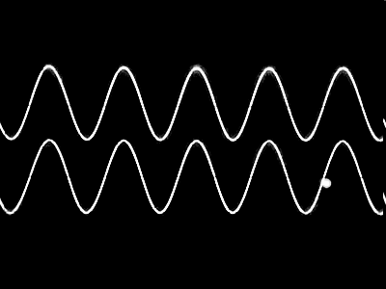

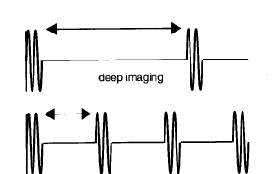
Use the following sound wave patterns for questions 46-47.

A.

B.

46. Which of the patterns indicate a system with a superficial imaging depth? _______________________________

47. Which of the patterns indicates a system with a deep imaging depth? ____________________________________

48. By changing the imaging depth, which of the following parameters does the operator also change? (circle those that change)

a. pulse repetition frequency
b. duty factor
c. propagation speed
d. pulse repetition period
e. initial amplitude
f. spatial pulse length

49. The speed of a 5 MHz continuous wave is 1.8 km/sec. The wave is then pulsed with a duty factor of 0.5. What is the new propagation speed? __________________________________________________________________________________________________

50. A sonographer adjusts the depth of view of an ultrasound scan from 8 cm to 16 cm. What happens to each of the following parameters? Do they increase, decrease or remain the same?

a. period ____________________________
b. frequency __________________________
c. wavelength __________________________
d. speed _____________________________
e. amplitude (initial) ____________________________
f. power (initial) _____________________________
g. intensity (initial) _____________________________
h. pulse duration _____________________________
i. PRF _____________________________
j. Duty factor ____________________________
k. spatial pulse length __________________________
l. Pulse repetition period ________________________

51. A sonographer is using a 3 MHz transducer and changes to a 6 MHz transducer. The imaging depth remains unchanged. What will happen to the following parameters? Do they increase, decrease, or remain the same?

a. period _____________________________
b. frequency _____________________________
c. wavelength _____________________________
d. speed _____________________________
e. amplitude (initial) __________________________
f. power (initial) ____________________________
g. intensity (initial) _____________________________
h. PRF ___________________________________
i. pulse repetition eriod__________________________

52. A sonographer is using a 3 MHz transducer and increases output power in order to visualize structures that are positioned deeper in the patient. No other controls are adjusted. What happens to each of the following parameters?

a. period _____________________________
b. frequency _____________________________
c. wavelength _____________________________
d. speed _____________________________
e. amplitude (initial) _________________________
f. power (initial) _____________________________
g. intensity (initial) _____________________________
h. pulse duration _____________________________
i. PRF _____________________________
j. Duty factor _____________________________
k. spatial pulse length __________________________
l. Pulse repetition period ________________________

Use the image below for questions 52-59.
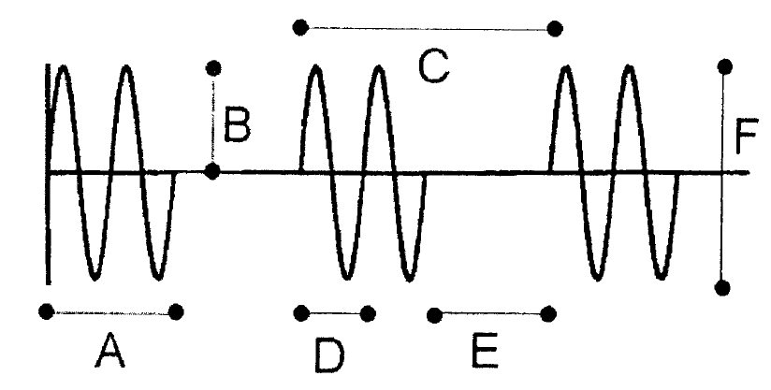

52. Which of the following best describes line A?
a. frequency
b. pulse repetition period
c. period
d. pulse duration
e. duty factor
f. amplitude

53. Which of the following best describes line B?
a. frequency
b. pulse repetition period
c. period
d. pulse duration
e. duty factor
f. amplitude

54. Which of the following best describes line C?
a. frequency
b. pulse repetition period
c. period
d. pulse duration
e. duty factor
f. amplitude

55. Which of the following best describes line D?
a. frequency
b. pulse repetition period
c. period
d. pulse duration
e. duty factor
f. amplitude

56. Which of the following best describes line E?
a. frequency
b. pulse repetition period
c. period
d. listening time
e. peak-to-peak amplitude
f. amplitude

57. Which of the following best describes line F?
a. frequency
b. peak-to-peak amplitude
c. period
d. pulse duration
e. duty factor
f. amplitude

58. Which of the following best describes line A?
a. frequency
b. pulse repetition period
c. period
d. spatial pulse length
e. duty factor
f. amplitude

59. Which of the following best describes line D?
a. frequency
b. pulse repetition period
c. wavelength
d. pulse duration
e. duty factor

