Physics Study Guide - Chapter 9
1. What is a transducer? ____________________________________________________________________________________________________________________________________________________________________________________________________
2. What is the piezoelectric effect? ____________________________________________________________________________________________________________________________________________________________________________________________________
3. What happens if the PZT is heated above the Curie point? ____________________________________________________________________________________________________________________________________________________________________________________________________
4. What are the two ways that an ultrasound crystal works as a transducer? ______________________________________________________________________________________________________________________________________________________________________________________________________________________________________________________________________________________________________
5. What are the two types of ultrasound transducers? __________________________________________________________________________________________________
6. What is the purpose of the transducer case? ____________________________________________________________________________________________________________________________________________________________________________________________________
7. What is the purpose of the transducer wire? ____________________________________________________________________________________________________________________________________________________________________________________________________
8. What is the purpose of the matching layer? ____________________________________________________________________________________________________________________________________________________________________________________________________
9. How thick is the matching layer? __________________________________________________________________________________________________
10. Place the following in order of increasing impedance: Matching layer, PZT, skin, gel
__________________________________________________________________________________________________
11. What is the active element? ____________________________________________________________________________________________________________________________________________________________________________________________________
12. How thick is the active element? __________________________________________________________________________________________________
13. What does a damping element do? ____________________________________________________________________________________________________________________________________________________________________________________________________
14. What is another name for damping element? _________________________________________________________
15. What three things are caused by damping? ______________________________________________________________________________________________________________________________________________________________________________________________________________________________________________________________________________________________________
16. What kind of transducers do not require damping material? __________________________________________________________________________________________________
17. What is bandwidth? ____________________________________________________________________________________________________________________________________________________________________________________________________
18. Why are imaging transducers wide bandwidth? __________________________________________________________________________________________________
19. A transducer’s main or resonant frequency is 10 MHz. What other frequencies may be present in the bandwidth? ____________________________________________________________________________________________________________________________________________________________________________________________________
20. What is quality factor? ____________________________________________________________________________________________________________________________________________________________________________________________________
21. What is the equation for calculating quality factor? __________________________________________________________________________________________________
22. A lower quality factor is associated with ____________________________________________________________.
23. A higher quality factor is associated with ___________________________________________________________.
24. What are six things that we MUST know about imaging transducers? ____________________________________________________________________________________________________________________________________________________________________________________________________________________________________________________________________________________________________________________________________________________________________________________________________________________________________________________________________________________________________________________________________________________________________________________________________________
25. How is frequency determined in a continuous wave transducer? ____________________________________________________________________________________________________________________________________________________________________________________________________
26. What determines the frequency in a pulsed wave transducer? ____________________________________________________________________________________________________________________________________________________________________________________________________
27. What two properties of the crystal determine frequency? ____________________________________________________________________________________________________________________________________________________________________________________________________
28. What type of relationship exists between the speed of sound in the crystal and the frequency of sound? __________________________________________________________________________________________________
29. What type of relationship exists between the thickness of the crystal and the frequency of sound? __________________________________________________________________________________________________
30. What characteristics of the crystal are associated with a high frequency transducer? ____________________________________________________________________________________________________________________________________________________________________________________________________
31. What characteristics of the crystal are associated with a low frequency transducer? ____________________________________________________________________________________________________________________________________________________________________________________________________
32. Label the diagram of the transducer below:

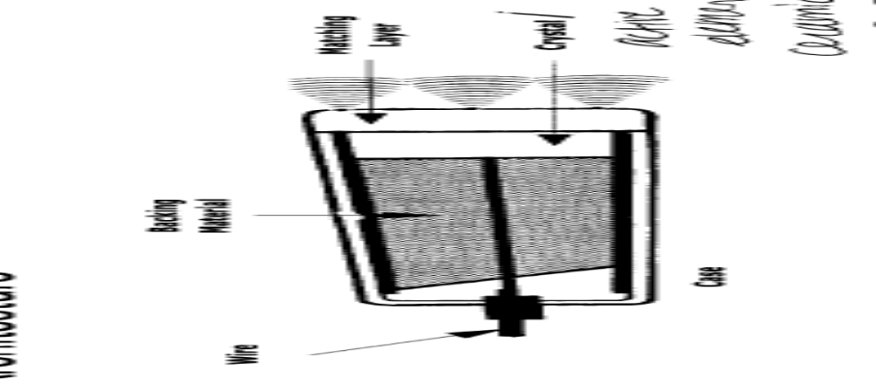
D.
C.
B.
E.
A.

