Physics Study Guide – Chapter 9

1. What is the shape of a sound beam? __________________________________________________________________________________________________
2. What is the near zone? ____________________________________________________________________________________________________________________________________________________________________________________________________
3. What is the focus? ____________________________________________________________________________________________________________________________________________________________________________________________________
4. What is the far zone? ____________________________________________________________________________________________________________________________________________________________________________________________________
5. Label the parts of a sound beam on the image below:

A.
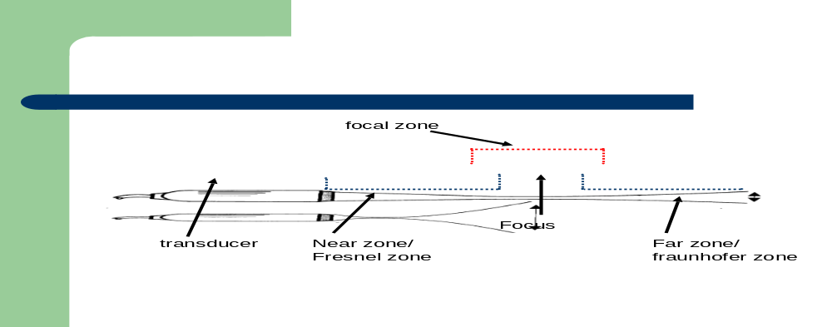
C.
D.
B.
E.
6. How does the beam behave in the near zone? ____________________________________________________________________________________________________________________________________________________________________________________________________
7. What is the focal length or focal depth and how is it determined? ______________________________________________________________________________________________________________________________________________________________________________________________________________________________________________________________________________________________________
8. What is the focal zone? ____________________________________________________________________________________________________________________________________________________________________________________________________9. A transducer with a small diameter and low frequency is associated with a ______________________________ focal depth.
10. A transducer with a large diameter and high frequency is associated with a _______________________________ focal depth.
11.Which transducer has a deeper focus?
a.5 cm transducer diameter and a frequency of 10 MHZ
b.8 cm transducer diameter and a frequency of 12 MHZ

12. Which transducer has a shallower focus?
a. 5 cm transducer diameter and a frequency of 8 MHz
b. 5 cm transducer diameter and a frequency of 5 MHz

13. Which two factors determine sound beam divergence? What characteristics of the crystal determine more or less divergence? ________________________________________________________________________________________________________________________________________________________________________________________________________________________________________________________________________________________________________________________________________________________________________________________________________
14. Which transducer has more divergence?
a.A 5 cm transducer diameter and a frequency of 12 MHz
b.A 3 cm transducer diameter and a frequency of 8 Mhz

15. Which transducer has less divergence?
a. A 3 cm transducer diameter and a frequency of 12 MHz
b. A 5 cm transducer diameter and a frequency of 12 MHz
16. What is Huygens’s principle and how is the hourglass shape of our ultrasound beam created? ______________________________________________________________________________________________________________________________________________________________________________________________________________________________________________________________________________________________________
17. What is lateral resolution? ____________________________________________________________________________________________________________________________________________________________________________________________________
18. What occurs when two side by side reflectors are closer together than the beam width? ____________________________________________________________________________________________________________________________________________________________________________________________________

