Physics Study Guide – Chapter 12

1. Fill in the chart below:
Transducer type | Image shape | Steering technique | Focusing technique | Crystal defect
Mechanical
Linear switched
Linear phased array
Annular phased
Convex sequential
Convex phased
Vector

2. What is an Array? ____________________________________________________________________________________________________________________________________________________________________________________________________
3. What is an Element? ____________________________________________________________________________________________________________________________________________________________________________________________________
4. What is a Channel? ____________________________________________________________________________________________________________________________________________________________________________________________________
5. What is the beam former? ____________________________________________________________________________________________________________________________________________________________________________________________________
6. How does a phased array create multiple focal zones? ____________________________________________________________________________________________________________________________________________________________________________________________________
7. Describe dynamic receive focusing. ________________________________________________________________________________________________________________________________________________________________________________________________________________________________________________________________________________________________________________________________________________________________________________________________________
8. Which type of probe combines technologies from linear sequential and phased arrays? __________________________________________________________________________________________________
9. Which type of probe is used for 3-D imaging? __________________________________________________________________________________________________
10. Describe slice thickness resolution. ____________________________________________________________________________________________________________________________________________________________________________________________________

Based on the crystal defect , which transducer created these images?
12.
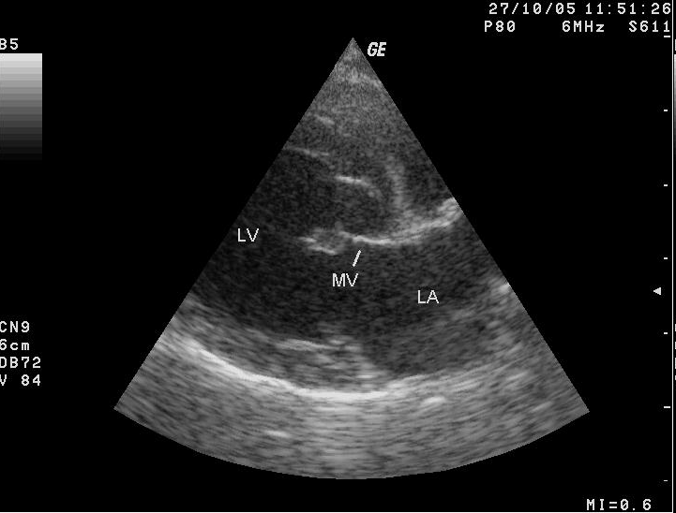

___________________________________________________________

13.
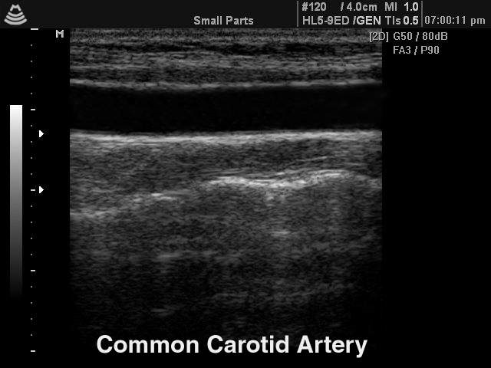

______________________________________________________________

14.
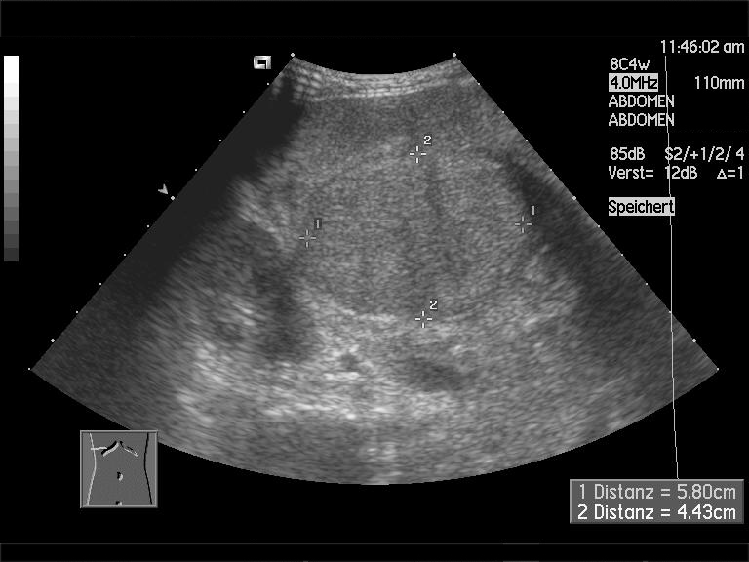

______________________________________________________________

15. Draw in the sound beam direction and focusing based on these beam patterns:

