DMSO 1040 Study Guide - Chapters 13 & 14

1. What is real time imaging? ____________________________________________________________________________________________________________________________________________________________________________________________________
2. What is frame rate? How is it measured?
____________________________________________________________________________________________________________________________________________________________________________________________________
3. How are frame rate and time required to create an image related? ____________________________________________________________________________________________________________________________________________________________________________________________________
4. What is the frame rate if each image is created in 0.5 seconds? ____________________________________________________________________________________________________________________________________________________________________________________________________
5. What is the frame rate if each image is created in 1/3 of a second? ____________________________________________________________________________________________________________________________________________________________________________________________________
6. What is the frame rate if each image is created in 1/100th of a second? ____________________________________________________________________________________________________________________________________________________________________________________________________
7. What is temporal resolution? ____________________________________________________________________________________________________________________________________________________________________________________________________
8. What determines temporal resolution? ____________________________________________________________________________________________________________________________________________________________________________________________________
9. Increased or better temporal resolution is associated with: __________________________________________________________________________________________________
10. Decreased or poor temporal resolution is associated with: __________________________________________________________________________________________________
11. What are the four factors that the sonographer can control that will affect temporal resolution? ____________________________________________________________________________________________________________________________________________________________________________________________________
____________________________________________________________________________________________________________________________________________________________________________________________________
12. What can you do to improve temporal resolution? ____________________________________________________________________________________________________________________________________________________________________________________________________
13. What would degrade temporal resolution? ______________________________________________________________________________________________________________________________________________________________________________________________________________________________________________________________________________________________________
14. If imaging depth is halved, frame rate is _________________________________________.
15. If imaging depth is halved, temporal resolution is _________________________________.
16. Why is imaging depth indirectly related to temporal resolution? ______________________________________________________________________________________________________________________________________________________________________________________________________________________________________________________________________________________________________
17. What are the factors that control the number of pulses? ____________________________________________________________________________________________________________________________________________________________________________________________________
18. How does single vs. multi focus impact temporal resolution? ____________________________________________________________________________________________________________________________________________________________________________________________________
19. How does the sector size impact temporal resolution? ____________________________________________________________________________________________________________________________________________________________________________________________________
20. How does line density impact temporal resolution? ____________________________________________________________________________________________________________________________________________________________________________________________________
21. What is spatial resolution? ____________________________________________________________________________________________________________________________________________________________________________________________________
22. What are the two major functions of an ultrasound system? ________________________________________________________________________________________________________________________________________________________________________________________________________________________________________________________________________________________________________________________________________________________________________________________________________
23. What is the function of the pulser? ____________________________________________________________________________________________________________________________________________________________________________________________________
24. What occurs when you change transducer output or power? ____________________________________________________________________________________________________________________________________________________________________________________________________
25. List and describe the three pulser modes: __________________________________________________________________________________________________________________________________________________________________________________________________________________________________________________________________________________________________________________________________________________________________________________________________________________________________________________________________________________________________________
26. What does the receiver do? ____________________________________________________________________________________________________________________________________________________________________________________________________
27. What is the order of operations in the receiver? ____________________________________________________________________________________________________________________________________________________________________________________________________
28. What is amplification? How does it change the image? What is it most commonly known as? ________________________________________________________________________________________________________________________________________________________________________________________________________________________________________________________________________________________________________________________________________________________________________________________________________
29. What is compensation? How does it change the image? What is it most commonly known as? ________________________________________________________________________________________________________________________________________________________________________________________________________________________________________________________________________________________________________________________________________________________________________________________________________
30. Adjustments to the TGC are related to ____________________________________________. Why? ________________________________________________________________________________________________________________________________________________________________________________________________________________________________________________________________________________________________________________________________________________________________________________________________________

31. Label the parts of the TGC curve.
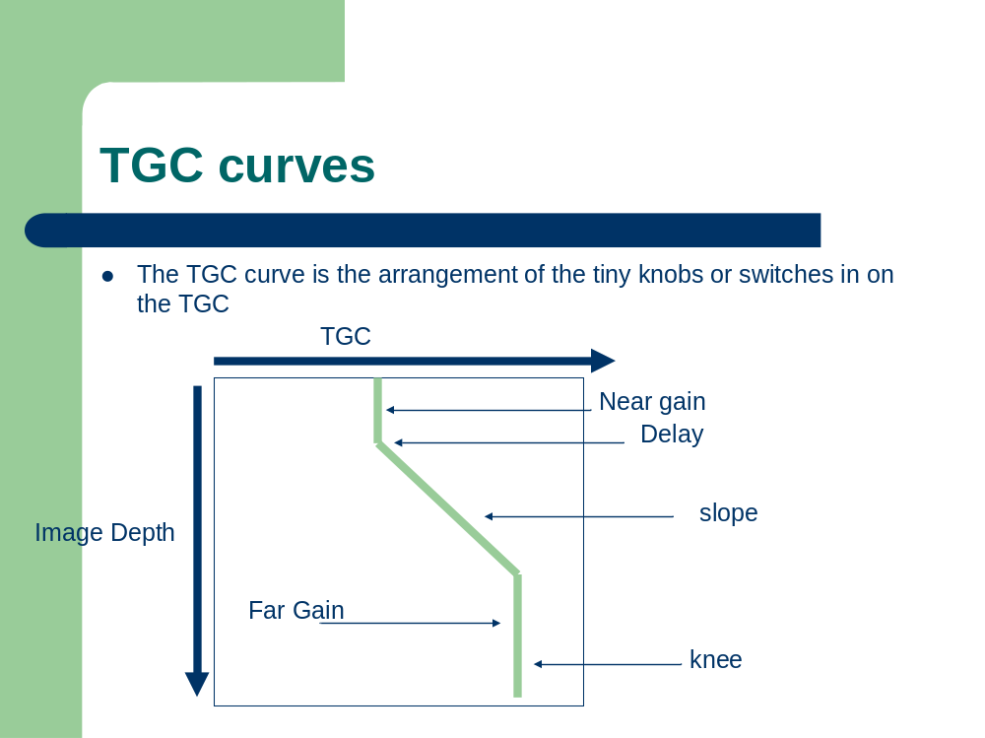
A.
D.
D.
C.
B.

32. What does the x-axis represent on the TGC curve? __________________________________________________________________________________________________
33. What does the y-axis represent on the TGC curve? __________________________________________________________________________________________________
34. What is the near field? __________________________________________________________________________________________________
35. What is the far field? __________________________________________________________________________________________________
36. What should you do if you cannot see reflectors in the near field of your image? __________________________________________________________________________________________________
37. What is compression? ______________________________________________________________________________________________________________________________________________________________________________________________________________________________________________________________________________________________________
38. What is demodulation? ____________________________________________________________________________________________________________________________________________________________________________________________________
39. What is rejection? ____________________________________________________________________________________________________________________________________________________________________________________________________
40. How will the TGC curve change if you increase your transducer frequency? ____________________________________________________________________________________________________________________________________________________________________________________________________
41. How will the TGC curve change if you decrease your transducer frequency? ____________________________________________________________________________________________________________________________________________________________________________________________________
42. What is dynamic frequency tuning? ____________________________________________________________________________________________________________________________________________________________________________________________________
43. How do you determine whether to adjust output power or receiver gain? ____________________________________________________________________________________________________________________________________________________________________________________________________

44. What controls should be adjusted in the image to reduce patient exposure?
______________________________________________
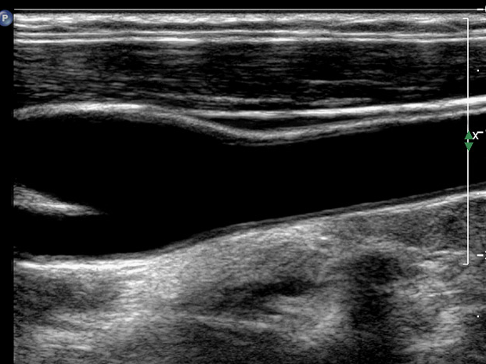

45. What controls should be adjusted in the image to reduce patient exposure?
______________________________________________
