Physics Study Guide Chapter 3
1. What do acoustic parameters tell us? ____________________________________________________________________________________________________________________________________________________________________________________________________
2. When we refer to the sound source, what are we referring to? __________________________________________________________________________________________________
3. When we refer to the medium, what are we referring to? __________________________________________________________________________________________________
4. What are acoustic variables? __________________________________________________________________________________________________
5. What are the 7 acoustic parameters?

___________________________
___________________________
___________________________
___________________________
___________________________
___________________________
___________________________

6. What is period? ____________________________________________________________________________________________________________________________________________________________________________________________________
7. What are the typical ultrasound values for period? __________________________________________________________________________________________________
8. What is frequency? ____________________________________________________________________________________________________________________________________________________________________________________________________
9. What does frequency have an impact on? __________________________________________________________________________________________________
10. What are typical ultrasound values for frequency? __________________________________________________________________________________________________
11. What kind of relationship exists between frequency and period? __________________________________________________________________________________________________
12. If frequency doubles, period is ________________________________________.
13. If period is halved, frequency is _______________________________________.
14. What do the bigness parameters tell us? __________________________________________________________________________________________________
15. What are the three bigness parameters?

____________________________
____________________________
____________________________

16. Define amplitude. ____________________________________________________________________________________________________________________________________________________________________________________________________
17. What are typical ultrasound values for amplitude? ____________________________________________________________________________________________________________________________________________________________________________________________________
18. What is power proportional to? _________________________________________________________________
19. If amplitude is tripled, what happens to power? _______________________________________________________
20. If amplitude is quartered, what happens to power? ____________________________________________________
21. What is intensity? __________________________________________________________________________________________________
22. What is the equation for intensity? __________________________________________________________________________________________________
23. What are typical values for intensity? _______________________________________________________________
24. How is intensity related to power and amplitude? ______________________________________________________________________________________________________________________________________________________________________________________________________________________________________________________________________________________________________
25. What is wavelength? ____________________________________________________________________________________________________________________________________________________________________________________________________
26. What are the typical values for wavelength in ultrasound? __________________________________________________________________________________________________
27. Wavelength is the only parameter determined by __________________________________________________________________________________________________
28. Describe the relationship between frequency and wavelength. ____________________________________________________________________________________________________________________________________________________________________________________________________
29. Higher frequencies are associated with ________________________________ wavelengths.
30. Lower frequencies are associated with _________________________________ wavelength.
31. Which has the longest wavelength, infrasound, audible sound, or ultrasound? The shortest? ____________________________________________________________________________________________________________________________________________________________________________________________________
32. What is the equation for wavelength? __________________________________________________________________________________________________
33. What is the wavelength of a sound wave with a frequency of 1 MHz in soft tissue? __________________________________________________________________________________________________
34.What is the wavelength of a sound wave with a frequency of 2 MHz in soft tissue?
__________________________________________________________________________________________________
35. Propagation speed in a medium is 50 mm/μs. The wavelength of the sound wave is 5 mm. What is the frequency of the sound wave? __________________________________________________________________________________________________
36. Why do high frequency transducers provide better resolution? __________________________________________________________________________________________________
37. What is propagation speed? ____________________________________________________________________________________________________________________________________________________________________________________________________
38. What is known about propagation speed of sound in relation to other acoustic parameters? ____________________________________________________________________________________________________________________________________________________________________________________________________
39. What is the equation for propagation speed?
__________________________________________________________________________________________________
40. What two properties of a medium determine the speed of sound?

____________________________________________
____________________________________________

41. Place the following in order of increasing propagation speeds: liquid, gas, solid
__________________________________________________________________________________________________
42. What is the general rule regarding the speed of sound in various tissues in the body? ____________________________________________________________________________________________________________________________________________________________________________________________________
43. If frequency is unchanged, period is _________________________.
44. What is the only acoustic parameter that is determined by the source and the medium? __________________________________________________________________________________________________
45. Which of the following media would have the highest speed of sound? The lowest? (dense and stiff), (compressible and dense), (low density, high stiffness)
__________________________________________________________________________________________________
46. What are the units of:

a. wavelength __________________________
b. frequency ___________________________
c. intensity ____________________________
d. propagation speed ___________________
e. period ______________________________
f. power _______________________________

47. Does the medium or the sound source determine these parameters?

a. wavelength __________________________
b. frequency ___________________________
c. intensity ____________________________
d. propagation speed ___________________
e. period ______________________________
f. power _______________________________

48. Using a particular ultrasound system. Which of the following cannot be changed by the operator?

a. wavelength __________________________
b. frequency ___________________________
c. intensity ____________________________
d. propagation speed ___________________
e. period ______________________________
f. power _______________________________

49. If the amplitude of the wave is increased 2 times, what is the intensity?

__________________________________________________________________________________________________

50. If the power of a wave is reduced to 1/2, the intensity is reduced to ______________________________________

51. The power in a beam is 1 watt and the area is 5 cm². What is the beam’s intensity?

__________________________________________________________________________________________________

52. Intensity remains the same while power is doubled. What happens to the beam area?

a. quadrupled
b. doubled
c. halved
d. unchanged

53. A sound beam travels 10 cm in 2 seconds. What is the speed of sound in this medium?

__________________________________________________________________________________________________

54. As frequency increases, propagation speed is _______________________________________________________.

55. Which of the following are considered acoustic variables? (circle the correct answers)

a. frequency
b. density
c. particle motion
d. amplitude
e. period
f. pressure

56. Medium 1 has a density of 9 and a stiffness of 6. Medium 2 has a density of 9 and a stiffness of 6. In which medium will sound travel slower?

__________________________________________________________________________________________________

57. Which of the following characteristics will create the fastest sound speed?

a. high density, high stiffness
b. low density, high stiffness
c. high density, low stiffness
d. low density, low stiffness

58. On the wave diagram below draw and/or label the following:

a. period

b. wavelength

c. amplitude

d. peak-to-peak amplitude

e. If the area shown is equal to 0.5 seconds, what is the frequency? ________________________________________

f. If the area shown is equal to 1 second what is the period for each cycle? __________________________________

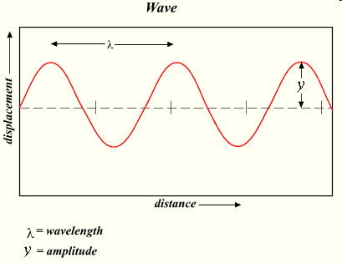

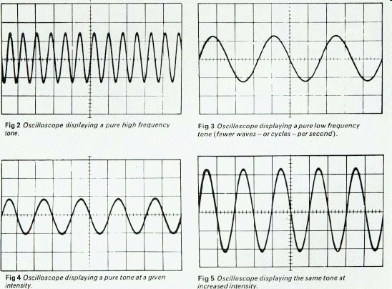
A B
C D

59. What is the frequency of box A if the sound wave above takes place in 1 second? What about ½ second?

__________________________________________________________________________________________________

60. What is the frequency of box B if the sound wave above takes place in 3 seconds? What about 1 second?

__________________________________________________________________________________________________

61. What is the frequency of box C if the sound wave above takes place in 2 seconds?

__________________________________________________________________________________________________

62. What is the frequency of box D if the sound wave above takes place in 1 second?

__________________________________________________________________________________________________

63. Which box has the highest amplitude? ______________________________________________________________

64. Which has the lowest amplitude? __________________________________________________________________

65. If the frequency of box B is 6 Hz, what is the period? __________________________________________________

66. If the period of each wave in Box C is 0.25 seconds, what is the frequency? _______________________

