Unit Test Summary
Base Pattern
1. Overview
The base.py module defines the core abstraction layer for all pattern detectors. It provides:
- A unified abstract class (BasePattern)
- Standardized execution pipeline (execute)
- Pre-trend adjustment mechanism for confidence scoring
- Validation and fallback handling using PatternResult

2. Test Coverage
The test suite includes 25 test cases, covering:
2.1 Base Interface
- get_expected_pretrend
- is_confidence_sufficient
2.2 Trend Strength Scaling
- None input
- Empty dict
- Zero / negative strength
- Positive strength
- Large values
2.3 Pretrend Adjustment Logic
- No pretrend case
- Neutral patterns (expected_pretrend = None)
- Unknown trend label
- Trend match (bonus)
- Sideways penalty
- Mismatch penalty
- Confidence clipping
- Confirmation update logic
- Candlestick-specific behavior
2.4 Execution Pipeline
- Normal execution
- Execution with pretrend
- ValidationError handling
- Exception handling

3. Test Results
- Total tests: 25
- Passed: 15
- Failed: 10
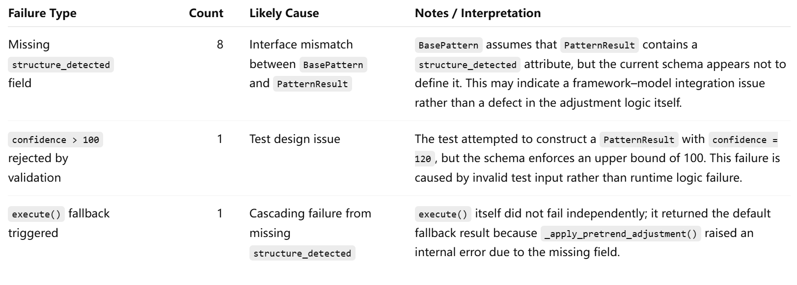
PatternResult Model
1. Overview of PatternResult
The PatternResult model is defined using and serves as the standard output schema for all pattern detectors in the system.

2. Key Fields and Their Roles
Field | Type | Description
confirmed | bool | Indicates whether the pattern is detected
confidence | float (0–100) | Confidence score with strict validation bounds
confidence_breakdown | Optional[dict[str, float]] | Detailed score components
confidence_metadata | Optional[dict[str, str | None]] | Contextual metadata
pivots | Optional[list[dict]] | Structural pivot points
direction | str | Pattern direction (default: "neutral")

3. Testing Strategy
The unit tests were designed to validate the model from multiple perspectives:
3.1 Valid Construction
- Minimal valid input
- Full field population
3.2 Boundary Conditions
- Confidence lower bound (0)
- Confidence upper bound (100)
- Invalid ranges (<0, >100)
3.3 Required vs Default Fields
- Missing required fields (e.g., confirmed)
- Default value behavior (confidence = 0, direction = "neutral")
3.4 Optional Field Handling
- Accepting None
- Accepting valid structured inputs
- Rejecting invalid types
3.5 Type Validation & Coercion
- Automatic parsing of:
  - "75.5" → 75.5
  - "true" → True
- Rejection of invalid types
3.6 Structural Integrity
- Validation of:
  - confidence_breakdown
  - confidence_metadata
  - pivots

4. Test Results
Category | Result
Total Tests | 23
Passed | 23
Failed | 0

Engine Module
1. Overview of engine.py
The engine.py module is responsible for the orchestration layer of the stock pattern detection system.
Its main responsibilities include:
- discovering enabled pattern classes
- managing execution windows
- running single and grouped pattern evaluations
- coordinating chart / candlestick / harmonic pattern pipelines
- handling parallel execution and fallback logic
- integrating with trend analysis and registry configuration

2. Intended Test Coverage
The unit test suite for engine.py was designed to cover the following functional areas:
Component | Intended Coverage
_get_pattern_windows | Registry lookup and fallback behavior
_get_pretrend_window | Pretrend window lookup and default fallback
_single_pattern_exec | Single pattern execution, signal extraction, trend analysis integration, exception handling
_group_pattern_exec | Parallel grouped execution, confirmed-result collection, handling failing patterns
get_patterns | Dynamic pattern discovery from packages, enabled/disabled filtering, import failure handling
execute_patterns | Sliding-window execution, confidence filtering, window limit behavior
chart_patterns_exec | Category-level execution and minimum-candle validation
candlestick_patterns_exec | Category-level execution and minimum-candle validation
harmonic_patterns_exec | Category-level execution and minimum-candle validation
exec_all_patterns | Process-pool execution and in-process fallback
exec_pattern | Single-pattern execution entry point and boundary checks

3. Test Results
Category | Result
Total Tests | 28
Passed | 13
Failed | 15
Errors | 1

4. Main Failure Categories
Type | Count | Cause
Abstract dummy pattern instantiation failure | 15 | Test doubles did not implement _run()
TrendAnalysis monkeypatch failure | 1 | Incompatible patching of Pydantic-managed instance

