United Window Mobile Delivery System

Ed Vergara

United Window Manufacturing

Baseline/Analysis

Abstract

Baseline analysis for Picking, Delivery and Accounts Receivable.

Keywords: Mobile Delivery, Picking, Manifest, Backorder, Proof of Delivery, Accounts Receivable, Invoicing

United Window Mobile Delivery

Current baseline analysis of United Window Manufacturing Manifest Creation, Scanning to Truck, Proof of Delivery, Accounts Receivable and Invoicing, and Backorder processing.

# Baseline Analysis

There were three main areas of exploration;

1. **Manifest Creation**,
2. **Accounting and Invoicing**,
3. **Packing the Trucks**.

## Manifest Creation

Generating the Driver’s Manifest is performed by Renato Pezzia. On October 28, 2019 @ 2:30pm we met to review the current process of generating Driver Manifests for trucks using Winsys.

### Create Manifest

Ronato uses Winsys’s Backlog Inquiry screen scanning for delivery date obligations and plans for the week. Marks items based on Route Code and Promise Date.

#### Filtering

Select all none’s.

Invert and Delete

Delete none interested items.

Clean log

Sort by customer

Customer could have multiple orders

Schedule it, put it into Second Set

1. Truck 3
2. Truck 7
3. Truck 2

#### Shipping Manifest

By Truck code

Notes abbreviated “Routed”, Can Close Truck.

Replace Routed: with Sealed# + Truck #” = Done.

Shipping Notices get added to Manifest.

Uses Map + Zip Code to order the route stops.

Scan to Truck

Truck Closed checkbox

Triggers IPad Create Manifest

* **Same Customer uses different address – need unique field.**
* **Delivery Sequence**

Using Winsys (Pezzia, 2019)

#### Proposed UWMD Manifest Generation

**Use shipping master file**

1. **Select Truck to Display**

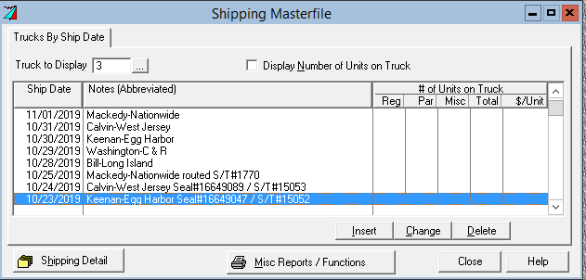

1. **Select Ship Date**
2. **If Truck is Closed Create the manifest**

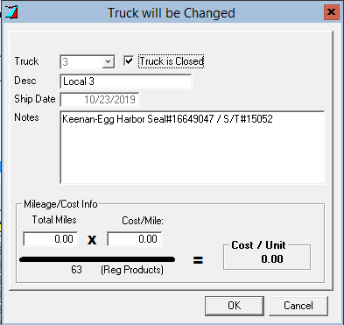

* 1. **Truck Code**
  2. **Ship Date**
  3. **Notes contains a Seal#**

Join scanfile + orderopt

SELECT

SCNFLE.ORD_NO,

SCNFLE.MDL_CNT,

ORDOPT.DESC$

FROM \"ORDOPT\"

INNER JOIN \"SCNFLE\"

ON

SCNFLE.ORD_NO=ORDOPT.ORD_NO

### Maria Shipping

Confirms everything was delivered

Refused items.

Items returned.

Scan to self, create file

Schedule after Manifest

Back Order – Broken/order #/ Truck Time

Send to Kelly or Janice

Gayle creates Back Order

Broken Items

Repaired

Retrieved from Trucks

Customer Service – Make it whole

Missing Something

Zenayda - Scan Order send email

## Picking

Generating the Pick Sheets with Order Details is performed by Eduardo. On October 28, 2019 @ 3:00pm we met to review the current process of generating Pick Sheets created by Renato for specific truck routes using Winsys.

### Planning the Truck Packing

Eduardo prints-out Truck Summary and assign pickers based on skills and training requirements

based on the Shipping Manifest generated by Renato. Eduardo makes handwritten notes for planning and organizing the days picks. He uses an assistant.

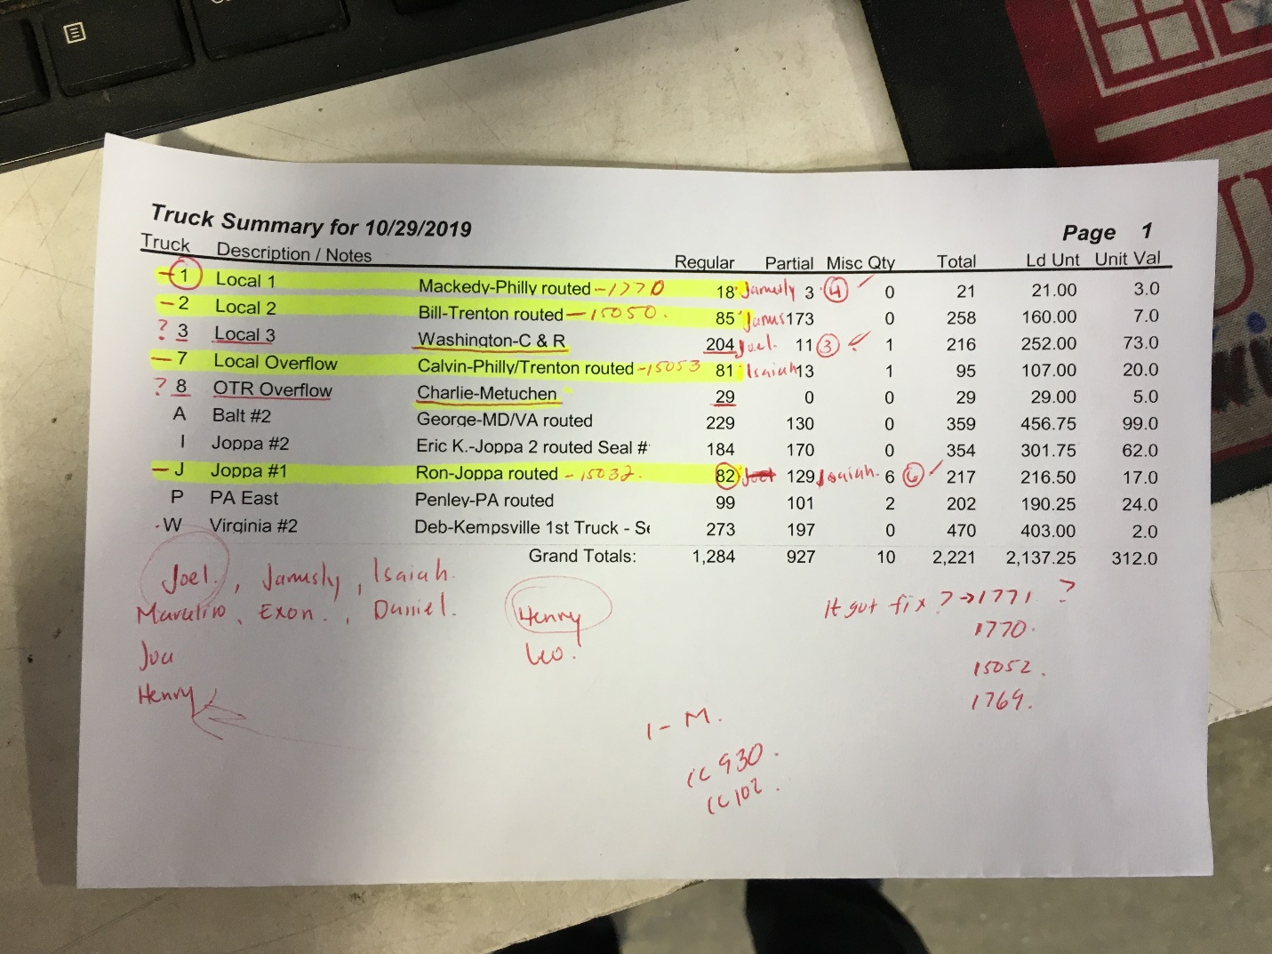

Figure 2. Truck Summary generated from Winsys

### Scanning to Truck

Scanning to the truck. Truck bays have a computer terminal connected to winsys with barcode scanner. Windows are scanned onto the truck and fed into winsys directly.

Once truck is completed it is sealed and the comment section is updated with the Seal Id.

Updates the scan winsys file we will use to generate the manifest table data in SQL Server.

Figure 3. Scan to Truck

### Status Dashboard

There is a dashboard using Excel which is manually updated to summarize current picking from bin to truck and their status. (Eduardo, 2019)

Dashboard for Picking to Truck.

Located above the Truck Loading Station.

Figure 1. Picking Dashboard located by the Truck Loading Bays.

This manually maintained Spreadsheet is used to gather current status of the loading of trucks.

## Accounts Receivable

Accounts Receivable (A/I) is performed by Gail with assistance from

### Billing

1. Inbox (to be billed) Tray
   1. Singles
   2. Married
   3. Manually Verified.
2. Invoicing
   1. Existing Orders on file.
3. Billing Screen
   1. Add Orders
      1. Single Order
         1. Order number
         2. Enter Invoice Date (Yesterday’s date)
      2. On a Truck
   2. There are also Whole Filled Trucks “Drop & Load”
      1. Take empty trailer and refill
      2. Pickup POD’s
      3. POD’s are billed immediately at time of Shipping.
      4. Need to capture shipping label as the POD signature.
   3. Bill full Truck
      1. Select truck by Code
      2. Too many (extra POD)
         1. If counts “Available”
         2. Whole lot not
            1. Margaret gives POD (extra)
            2. Gail bill from POD
      3. Margaret creates Packet
         1. Invoice
            1. Printout
            2. File Copies (Mail Copies if not emailed).
         2. Order
            1. Allow clicking manual
         3. Proof of Delivery (POD)
            1. Invoice

File by date (keep 7 years)

Invoice the Order

### Back Orders

Find Order number in Winsys

Dealer number

Customer is Job PO in Winsys

Customer Name

Dealer number PO

### Truck “U”

Tracking number for UPS POD lookup

* + - 1. Go to UPS site and download POD
         1. Need to store this in our DB (signature)

### Lowes Match Counts

Shipping manifest file

Select truck to display data

Looking through the manifest for the broken item

Broken Item

Finds Invoice

Orders Selected for Invoicing

Select Line number

Edit

Individual Products selected to invoice on Order

Adds to orders on file for a rescheduling of Shipping

Checking all PODs

Notes

Signatures

COD’s

Drivers collect checks

No invoice mailed to customers

Double click BO

Hit Reports

Orders selected to be Invoiced

Prints summary report Invoice number Orders

Invoice selected Orders

(Gayle, 10/24/2019)

ER DB Diagrams

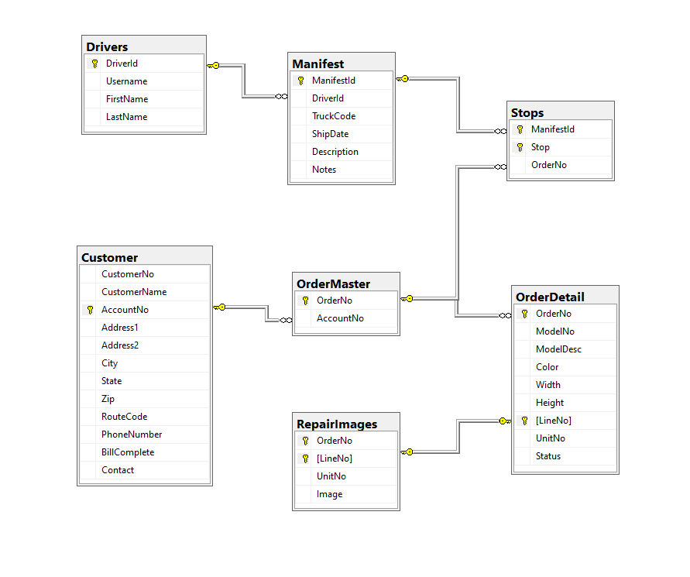

ER Diagram UMD Database

Static Tables:

Drivers and Customer

Dynamic Tables (uploaded with manifest creation):

ManifestMaster, Stops, OrderMaster, OrderDetail, Repair Images

Order Master:

Customer Table when order is created pulls in customer details snapshot whatever the address is customized it is in the order master.

References

Gayle (A/I – 10/24/2019)

Renato (Manifest – 10/28/2019)

Eduardo (Shipping – 10/28/2019)