United Window Mobile Delivery System

Ed Vergara

United Window Manufacturing

Detailed Design

Abstract

Software System to Generate Truck/Driver Manifests the Track the Delivery Shipping Process, Back-Order Status and Proof of Deliveries in real-time.

Keywords: Mobile Delivery, Manifest, Backorder, Proof of Delivery, Accounts Receivable, Invoicing, WinSys, SQL Server, Xamarin, C#, WebSockets

United Window Mobile Delivery

Xamarin Forms Clients (IOS, Windows Universal, Android), C#, Web Sockets, Pure Generic MVVM, WinSys32 Web Socket Server, United Window Delivery API, SQL Server.

# Detailed Design

There were three main components to the United Window Mobile Delivery software system;

1. **Front Ends**,
   1. Loader
      1. Interact with WinSys Server to extract the Manifest Master,
      2. Release the Manifest to the API by attaching a Driver toggling the Route/Truck.
2. **United Window Manager API**
   1. Generate Manifest initiated by Loader Front End,
      1. Interact with WinSys to build the Manifest Details, Stops and Order Details,
      2. Persist the Manifest Details to the SQL Server,
      3. Push the Manifest Details, Stops and Orders Details to each Driver iPad which will be used to make the deliveries.
3. **WinsSys32 Server**
   1. Store the query logic to extract and serve the necessary data from the WinSys32 TPS ERP Database.

## Front Ends

### Loader Dashboard

Generating the Driver’s Manifest is performed by the loaders connected to the WinSys Server.

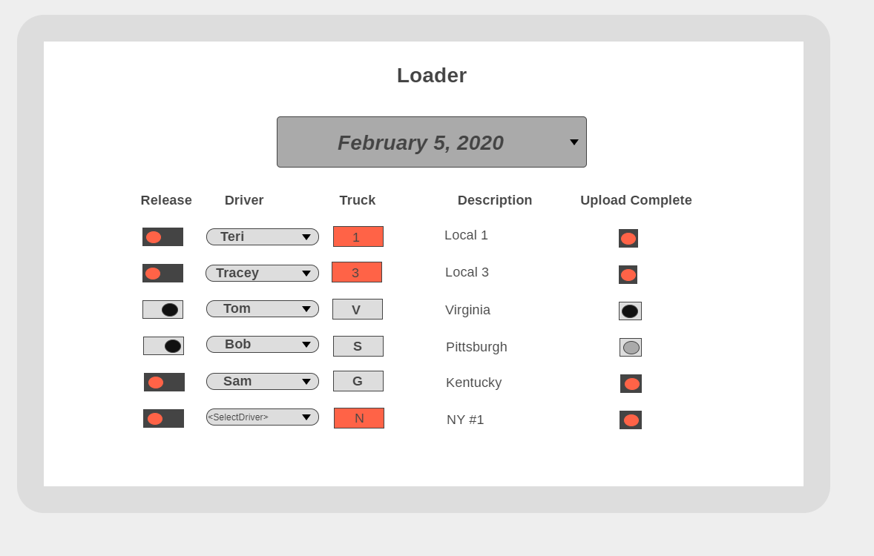

### Loader Steps

#### Select Date

* Selecting a Date loads the screen with the Manifest Master information represented via the following fields:
  + Release Toggle
  + Driver Selection Dropdown
  + Truck (isLocked indicator)
  + Description – (Probably want Desc/Notes concatenated)
  + Upload Complete (Status of Driver iPad receipt of Manifest upon Release Toggle)
  + *Do we want Notes as in the Shipping Master File*?

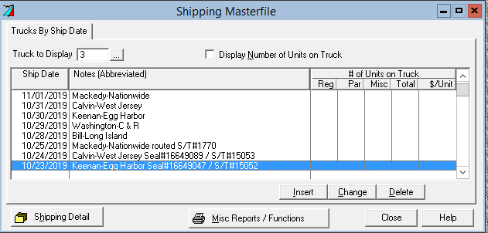

#### Select Driver

* Select a driver from the dropdown and assign to the particular Route.
* Drivers assignments should be distinct per Date.

#### Swipe to Release Manifest to the Manager API

* This sends the Manifest Master along with Driver assigned selection to the Manager API to be processed and pushed to the Truck Driver Manifest iPad displays.
* Once the Driver’s iPad confirms the receipt of the manifest details composed by the API and cached to SQL Server with Driver, the Loader front end will be indicated by the Upload Complete.

## United Window Manager API

The Manager API aka API is responsible for managing the Driver Manifest and Delivery Process. Clients (Dashboard/iPad/Mobile apps) connect to the API in order to interact with United Mobile Delivery Services and Data. The API (as a client) connects to the WinSys Server in order to extract data interactively as a centralized Host.

* Generate Manifest initiated by Loader Front End
  + Interact with WinSys to build the Manifest Details, Stops and Order Details,
  + Persist the Manifest Details to the SQL Server,
  + Push the Manifest Details, Stops and Orders Details to each Driver iPad which will be used to make the deliveries,
  + Monitor client connections.

### WinSys Server

WinSys acts as a Server hosting WinSys32 Database ERP based on TPS 32 bit proprietary files. This server accepts client connections and takes requests over TCP/IP WebSocket connections.