**MANAGEMENT INFORMATION SYSTEM OF**

**BARANGAY 60 – LETSUGAS SAN ROQUE**

**IN CAVITE CITY**

**PROJECT DESIGN**

**CAVITE STATE UNIVERSITY**

**Cavite City Campus**

Cavite City

**Department of Information Technology**

**CULAPAN, VERGEL**

**SIMON, TYRONE JAMES**

September 2020

**MANAGEMENT INFORMATION SYSTEM OF**

**BARANGAY 60 – LETSUGAS SAN ROQUE**

**IN CAVITE CITY**

Undergraduate Project Design

Manuscript Submitted to the Faculty

of the Department of Information Technology

Cavite State University-Cavite City Campus

Cavite

In partial fulfillment

of the requirements for the degree

Bachelor of Science in Information Technology

**VERGEL L. CULAPAN**

**TYRONE JAMES C. SIMON**

September 2020

**BIOGRAPHICAL DATA**

Tyrone James C. Simon was born on September 19, 1997 in Kidapawan City, North Cotabato. He is the third of the five siblings of Mr. Sulpicio and Mrs. Evangeline Simon. His siblings are Eva Mae Simon, Stephanie Simon, Ihna Grace Simon, and Cindy Grace Simon.

He finished elementary education at Digman Elementary School in 2009. Then he graduated secondary education in Bacoor National High School in the year of 2013.

He took up Bachelor of Science in Information Technology at Cavite State University – Cavite City Campus for tertiary education.

**BIOGRAPHICAL DATA**

Vergel L. Culapan was born on December 07,1994 in Cavite City, Cavite. He is the third of the five siblings of Mr. Vergilio Culapan and Mrs. Lilibeth G. Lozares. His siblings are, Vener, and Henry Vher.

He finished his elementary education at Bagumbuhay Elementary School in 2007. Then, he graduated secondary education at Cavite National High School in the year 2012.

He took up Bachelor of Science in Information Technology in Cavite State University – Cavite City Campus for tertiary education.

**ACKNOWLEDGMENT**

The researchers would like to express their sincere appreciation to those who assisted them and extended their kindest support in completing their research. They would not even be able to complete this research analysis without the assistance of the following people.

Mrs. Maria Cristina J. Baesa the campus administrator, for the guidance and support to the students.

Ms. Alma De Fiesta, their adviser and chairperson of the Department of Information Technology, for the continuous support and guidance throughout the entire development of the study.

Mr. Joemer L. Castillo, their technical critic, for the purpose of providing knowledge to enhance the study.

Respective family, for the love, encouragement and support in any means that gave inspiration to them to finish the study;

Their friends, who undoubtedly believed in their skills to finish the study and lend their support throughout the development of the study; and

Above all, to the Almighty God, for His undying love and guidance, countless blessings and for the knowledge together with the skills given to them that enabled them to complete the study.

**THE AUTHORS**

**PERSONAL ACKNOWLEDGMENT**

The author sincerely thanks everybody who helped make the research a success. The author wishes to express his greatest appreciation to the individuals mentioned below:

Ms. Alma De Fiesta thesis adviser and Mr. Joemer Castillo, his technical critic, for all the information encouragement, unending instruction, and advice imparted during the study;

Mr. Joel Madrigal, for his assistance and cooperation. Without his permission, this study will not be possible.

Parents, Mr. Vergilio and Mrs. Lilibeth Culapan and siblings for their unending support encouragement, and help, which also serve as a source of inspiration for him as he completes this research;

Mr. Tyrone James C. Simon, for his commitment and all of the assistance he provided in finishing their studies.

Furthermore, the author wishes to thank his friends, particularly Eugene D. Aligaen, Janella Mae Centeno, for their unwavering support, which inspired the author to complete this research, especially during times of self-doubt; and

Finally, we thank our Almighty God for providing him with good health, knowledge, and skills that have enabled him to complete the study.

**VERGEL L. CULAPAN**

**PERSONAL ACKNOWLEDGMENT**

The researcher would like to express his heartfelt appreciation to everyone who helped her complete this report. It would not have been a success without the following individuals who assisted him in different ways:

Mss. Alma De Fiesta, thesis adviser, Mr. Joemer Castillo, technical critic, for their guidance and contributions to the study.

Mr. Sulpicio and Mrs. Evangeline Simon, parents, for the never-ending love, inspiration, and belief in his potential to succeed in this study;

The researcher would also like to extend his appreciation to his thesis partner, Mr. Vergel L. Culapan, for the general collaboration and participation for the success of this study.

No name, for your unending encouragement, particularly when the author was at a point where she couldn't finish her analysis because he was instructing;

His classmates, and friends, particularly Mary Jane Valencia and Hector Lorence Chan, who are always supportive and have a helpful hand and;

The Almighty God, who gave the researcher the patience, determination, and ability to complete the tasks necessary for the completion of this analysis.

**TYRONE JAMES C. SIMON**

**ABSTRACT**

**CULAPAN, VERGEL L., SIMON, TYRONE JAMES C.,** Management Information System of Barangay 60 – Letsugas, San Roque, Cavite City. Undergraduate Project Design Manuscript. Bachelor of Science in Information Technology. Cavite State University – Cavite City Campus, Cavite City. April 2021. Adviser: Alma De Fiesta.

The study was conducted at Barangay 60 – Letsugas San Roque, Cavite City from March 2020 to April 2021. The study's main goal was to strengthen the Barangay day-to-day operations, reducing the possibility of accidents and creating a more structured record.

Specifically, it aimed to design a Management Information System with the following features: residents Information, issuance of certificates, and reports. Moreover, it also aimed to create the system using sublime text 3 as the Integrated Development Environment and MySQL as the database software and lastly, to test and improve the system and evaluate its performance based on ISO 25010.

For the evaluation, the developers used an instrument based on ISO 25010 to evaluate the system’s functional suitability, performance efficiency, compatibility, usability, reliability, security, maintainability, and portability. The system was evaluated by Information Technology experts which results in an overall mean score of 4.19 which means Very Good in verbal interpretation.

As for recommendations, the MIS must provide financial statements if possible and use pastel colors instead of bright colors.

**TABLE OF CONTENT**

**Page**

**BIOGRAPHICAL DATA**……………………………………………………… ii

**ACKNOWLEDGMENT**………………………………………………………. iv

**ABSTRACT**…………………………………………………………………… vii

**LIST OF TABLES**……………………………………………………………. xii

**LIST OF FIGURES**…………………………………………………………...xv

**LIST OF APPENDIX FIGURES**…………………………………………….xvii

**LIST OF APPENDICES**……………………………………………………... xix

**INTRODUCTION**……………………………………………………………...1

Statement of the Problem…………………………………………… 2

Objectives of the study………………………………………………. 2

Significance of the study…………………………………………...... 3

Time and place of the study………………………………………… 3

Scope and Limitation………………………………………………… 4

Definition of Terms…………………………………………………… 5

Conceptual Framework……………………………………………… 6

**REVIEW OF RELATED LITERATURE**……………………………………. 7

**METHODOLOGY**

Project Design…………………………………………………………… 13

Project Development…………………………………………………… 17

Operation and Testing Procedure……………………………………… 23

Evaluation Procedure…………………………………………………… 23

**RESULTS AND DISCUSSIONS**

Project Description……………………………………………………… 25

Project Structure………………………………………………………… 26

Project Test Result……………………………………………………… 40

Project Capabilities and Limitations…………………………………… 41

Project Evaluation Result.………………………………………………. 41

**SUMMARY, CONCLUSION, AND RECOMMENDATION**

Summary ……………………………………………………………... 42

Conclusion …………………………………………………………… 42

Recommendation ……………………………………………………. 43

**REFERENCES** ………………………………………………………………. 45

**APPENDICES** ………………………………………………………………… 46

**LIST OF TABLES**

**Figure Page**

24

25

34

36

36

37

37

38

39

39

40421

1. Likert Scale …………………………………………………………………...
2. Descriptive Evaluation of the mean…………………………….……………
3. Test and results of the software …………………………….……………....
4. Functional Suitability of the System …………………………...…………….
5. Performance of the System …………………………………………………
6. Compatibility of the System ………………………………………………...
7. Usability of the System …………………………………….…………………
8. Reliability of the System ………………………………………………………
9. Security of the System ………………………………….…………………….
10. Maintainability of the System ………………………………………………….
11. Portability of the System…………………………...……………………………
12. Overall Performance of the System ……………………………….…………

**LIST OF FIGURES**

**Figure Page**

1 Conceptual Framework of the Management Information System of Barangay-60 Letsugas, San Roque, Cavite City………………………………… 5

2 Context Diagram of the Management Information System of Barangay-60 Letsugas, San Roque, Cavite City……………………………………… 11

3 Functional Decomposition Diagram…………………………………… 12

4 Project Development of the Management Information System of

12

21

22

23

24

25

26

27

28

29

3031

Barangay-60, Letsugas San Roque, Cavite City……….…………….

5 Log in Module……………………………………………………………

6 Forgot Password Module……………………………………………….

7 Dashboard Module………………………………………………………

8 View Residents Information Module……………………………………

9 Add Residents Information Module…………………………………….

10 Complains Module……………………………………………………...

11 Add Incidents Module……………………………………………………

12 Mapping Module…………………………………………………………

13 Edit Profiling of the Mapping …………………………………………….

14 Mapping Record………………………………………………...............

15 Barangay Certificates………………………………………………......

16 Business Permit………………………………………………………… 32

17 Barangay Officials……………………………………………………… 33

18 Change Password……………………………………………………… 34

19 Profile of Secretary………………………………………………………. 35

**LIST OF APPENDICES**

**Appendix Page**

1. Gantt chart ………………………………………………………...………...

48

49

53

57

59

76

1. Evaluation Instrument (ISO 25010) ………………………....…........….
2. Evaluation Summary …………….………….…….……………………...
3. Certificate of Implementation…………………………………………….
4. User’s Manual…………….……………………………………………….…

6 RD Forms…………………………………………………………………….

**LIST OF APPENDIX FIGURES**

**Appendix**

**Figure Page**

48

58

59

60

61

62

64

65

66

67

69

70

71

72

73

1. Gantt chart of Activities………………….……………………...…………
2. Browsers ………………………………………………………………………….
3. Log-in Form………………………………….……………………………...
4. Forgot Password Form………………………………………………….…
5. Dashboard …………………………………………………………………
6. Add Residents…………………………………………………….……….
7. Complains ………………………………………………………………………
8. Add Complains ……………………………………………………………………
9. Incidents Report……………………………………………………………………
10. View Map Form …………………………………………………………………
11. Add Coordinates…………………………………………………………………..
12. Profiling ………………………………………………………….………….
13. Barangay Officials…………………………………………………………………
14. Certificates….……………………………………………………………….
15. Change Password …………………………………………………….......

**MANAGEMENT INFORMATION SYSTEM**

**OF BARANGAY 60 – LETSUGAS**

**SAN ROQUE CAVITE CITY**

**Vergel L. Culapan**

**Tyrone James Simon**

An undergraduate project design manuscript submitted to the faculty of the Department of Information Technology, Cavite State University – Cavite City Campus Cavite in partial fulfilment of requirement for the degree of Bachelor of Science in Information Technology Prepared under the supervision of Ms. Alma G. de Fiesta.

**INTRODUCTION**

Technology plays a significant role in managing people’s tasks. Making use of systems will surely help everyone to make things better and work faster. It may also provide information that organizations require to manage themselves efficiently and effectively. Also, to create, sort and file data. Keeping digital records can significantly reduce the amount of storage necessary for paper-based records plus electronic record systems are proven to dramatically improve efficiency.

A Management Information System (MIS) is a computer system consisting of hardware and software that serves as the backbone of an organization’s operations. MIS gathers data from multiple online systems, analyzes the information, and reports data to aid in management decision-making (shopify.com, 2020).

A barangay is the smallest administrative division in the Philippines and is the native Filipino term for a village, district or ward. Municipalities and cities are composed of barangays, and they may be further subdivided into smaller areas called purok, and sitio, which is a territorial enclave inside a barangay, especially in rural areas (definitions.net, 2020).

**Statement of the Problem**

The general problem of Barangay 60 – Letsugas is having difficulties in monitoring and maintaining the resident records update. Their current process may affect the efficiency of the barangay and is prone to have inaccurate data.

Specifically, this study seeks to provide solution for the following problems:

1. How to minimize the time effort in finding the barangay records?
2. How to ensure the accurate information was released by the barangay?
3. How to keep records efficiently?

**Objective of the Study**

The general objective of the study was to develop a Management Information System for Barangay 60 – Letsugas San Roque Cavite City.

Specifically, it aimed to:

1. design a Management Information System with the following modules:
2. Home-Dashboard
3. Residents Information
4. Services
5. Mapping
6. Certificates
7. Barangay Officials
8. create the system using PHP, JavaScript, CSS as the Integrated Development Environment and MySQL as the database software for the services;
9. test improve the system; and
10. evaluate the system based on ISO 25010.

**Significance of the Study**

The system was developed for the barangay personnel to store records easily, more reliable and easier to find. The study provides benefits to the assigned personnel, which is the secretary to easily maintain the records up to date, print reports, store all records in an accessible database, faster retrieval of any information and eliminate redundancy of records.

For the researchers, the study will help to improve their knowledge in creating a computerized system. This helps them be ready and prepared once they graduate and expose themselves to the field they are going to take.

For the future developers who will conduct the same study, this will serve as their reference and provide an idea on what this system will do, and the functionality that this system must have.

**Time and Place of the Study**

The study was conducted at Barangay 60 - Letsugas, San Roque, Cavite City from February 2020 to May 2021.

**Scope and Limitation**

The Management Information system consists of modules such as dashboard, resident’s information, services, mapping, certificates, barangay officials. The secretary will input the data that they gathered wherein the barangay has a master list of all citizens living there. The system can add and update resident’s datawhenever it is being added in the population. There is also a mapping where you can show a visual report of the location of each house with house numbers.

The service module contains reports which are divided into two parts: complaints and incident reports. The system has maintenance where the user can back-up and restore the data from and to the database. The system has many types of users; the administrator is the secretary and the barangay captain and they can access all the modules. The administrators can use the full functionality of the system such as the resident’s information module, complaints, incident report, providing the certificates viewing the population in mapping.

The whole features of the system can be accessed once the administrator logs in. On the other hand, the system is a stand-alone system that provides mapping/profiling within the barangay. Geographical changes cannot be made automated. Lastly, the financial statements that the treasurer handles are not covered by the system.

In the resident’s information module, personal information of the resident will be stored. The administrators can view, add, update/edit the information of residents easily. It includes a search bar to easily locate the resident’s record. Meanwhile, the barangay kagawad can only view the records.

Incident reports can provide the incident happened within the barangay and can be modified by the administrator and user as well as the complaints.

Under the barangay certificates, the system provides copies of different certificates that the barangay can provide. The user can print the certificates without restrictions, but unauthorized people cannot access all the functionality of the system. However, the Management Information system can only release information within the barangay and accept single information of the person such as personal information and year of living in the barangay means any other information will not be covered by the system.

**Operational Definition of Terms**

To provide better understanding of the study, the following words are defined on how it is used in the study.

**Administrator** is the person who can fully access the system.

**Reports** refers to communicate information which has been compiled as a result of research and analysis of data and of issues.

**Resident’s Information** is the basic details of someone who lives within the barangay.

**Complain** is expresses dissatisfaction or annoyance about something.

**Mapping** is a graphical representation of a procedure, process or structure.

**Profiling** is the recording and analysis of a person’s information or characteristics.

**Conceptual Framework**

The developers considered and defined the way, ideas and concepts are organized to achieve a research project development.

**Input**

Resident’s profile/information

Incident happened within the barangay

Barangay officials

**Process**

Residents Information

Services

Barangay certificates

Mapping

Reports

**Output**

MIS of Barangay 60 – Letsugas San Roque, Cavite City

Figure 1. Conceptual Framework of the Management Information System of

Barangay 60 – Letsugas, San Roque Cavite City

In the first block, the researchers need the residents’ information, incident report, and barangay officials. This will be done by conducting interviews with the barangay secretary and other barangay officials.

The second block consists of six modules such as resident information, incident reports, blotter reports, barangay certificates, barangay officials, and mapping.

The third block shows that the output of the system is the MIS of Barangay 60 – Letsugas San Roque, Cavite City.

**REVIEW OF RELATED LITERATURE**

This chapter presents related literature and writing of resource persons. The researcher found the following studies and literature as relevant to the proposed study.

**Adobe Photoshop**

Photoshop is special for drawing and graphics applications, software design for this purpose can produce superior results. When an image is complete, it can be incorporated into a presentation program for display with other visuals in a presentation (Valera, 2016).

Developers used Adobe Photoshop for designing the interface of the system. GUI will help the users to use the system easily.

**Barangay Profiling System**

According to Conde, the manual process of inputting records and handling of information and reports of the residents is a very laborious one. It may take a long procedure before accomplishing one request of the resident. Due to the increasing population of the barangay, Conde believes that with the help of the computer-based system, it will help to solve the huge amount of task.

The concept of this study will help the developers to create a system that improves the process of a procedure when accomplishing the request of residents. As time goes by, the population is growing faster, the computer-based system is a lot of help for the barangay constituents (Conde, 2016).

**Barangay Resident Record Management**

Algara mentioned that the barangay resident record management system focuses on the records of the said barangay. The barangay secretary is the one who prepares certificates, keeps track of the records, captures and maintains up-to-date records of all reports. They manually handed transactions daily such as barangay clearance, indigency, and other reports.

This study also becomes the background of the developers to know what the duties of the in-charge personnel are. It helped the developers to create and design a system that has an equal function with the duties of assigned personnel (Algara, 2015).

**Barangay Census**

Barangay census is a procedure of systematically acquiring and recording information about the members of a given population within a barangay. It is a regularly occurring and official count of a population. The term is used mostly in connection with national population and housing censuses; other common censuses include agriculture, business, and traffic censuses (Harper, 2016).

**Certificate Issuance System**

Stated that this study focuses on the certificates produced within the firm. The secretary is the one who prepares permits, certificates and other reports. Also, in charge of keeping track of the records and maintaining up-to-date. Before the accomplishment of the tasks, the constituents who request must undergo a long process. Same with sorting files, updating and accessing data, they used folders for its storage.

This study has the same concept in the Management Information System of Barangay 60 Letsugas, San Roque, Cavite City since it also provides printed certificates and reports. The developers gained an idea on how they will provide certificates in an easier way (Algara, 2015).

**Document and Files**

The document is a unit of record information, written or printed paper that bears the original, official or legal form of something and can be used to furnish decisive evidence or information. Files refer to the batch of records accumulated and maintained in a determined physical arrangement (Robek, 2015).

The developers must know the documents and files stored in the barangay. It helps the developers to arrange and sort documents in the system depending on their category.

**Development of Management Information System**

The developed management information system provided functionality specifically for the administration department and allowed the recording officer to manage employee records and employee schedule. (Mendoza, 2015)

This study became the basis of the developers in the concept of Management Information System for Barangay 60 Letsugas, Cavite City.

**File Management**

The data being worked on with computers is kept in a hierarchical file system in which directories have files and subdirectories beneath them. Although the computer operating system is used to keep the image data organized, how files and folders are named, how these nested folders are arranged, and how the files in these folders are handled the fundamental aspects of file management.

This study becomes the guide for the developers on how they organize the folders and arrange the files and documents based on its category (Anderson, 2015).

**Manual Information System**

The manual information system is one that does not rely on any computerized systems and a computer-based information system does. A manual-based system will see information recorded and kept in different ways such as in files in paper form. Whereas a computer-based information system will see data on various computer programs including on databases, word documents and excel (Medel, 2015).

In line with paper-based processes study, the developers must know all the information that is recorded and kept in a filing cabinet to create a system that improves the storing of data records.

**MySQL**

MySQL is an open-source relational database management system. It is developed, distributed, and supported by Oracle. It is based on the structured query language (SQL), which is used for adding, removing, and modifying information in the database. Standard SQL commands, such as add, drop, insert, and update can be used with MySQL.

Developers are using MySQL workbench for the back end of the system. It serves as the storage of data that has been added to the system (Bradley, 2016).

**Population**

The population in human biology, the whole number of inhabitants occupying an area such as country or the world and continually being modified by increases by births and immigration and losses by deaths and emigrations, as with any biological population, the size of a human population is limited by the supply of food, the effect of disease, and other environmental factors (Teitelbaum, 2017).

It is important to know the population of the barangay. The developers must know how big the population of the barangay is to create a system that is capable of handling an increasing population.

**Population Growth**

Population growth measures how populations change in size over time. The units of the population growth rate are individuals per time. Population size can only be changed by four factors. Births add new individuals to a population whereas deaths remove individuals from a population. Similarly, immigration into a population adds new individuals whereas emigration out of the population removes individuals (Mcginley, 2016).

It helps the developers to know that increasing population is a problem in a manual record keeping of barangay, also to develop an efficient system for the barangay that is increasing in population as time goes by.

**Security**

Stated that the term security refers to freedom from danger or anxiety. This implies a situation with no risk, no sense of threat and having the assurance of a sense of confidence or certainty. It runs all over life and it is inevitable. Its main objective is for protection and guarding against danger. The system needs to be secured because there were confidential records inside the system.

Since all data records are confidential, username and password will be the basis of helping the developers to develop a system that protects the data records inside the system (Baskerville, 2015).

**User Account**

According to the website of Computer Hope in 2017, it is a location on a network server used to store a computer username, password, and other information. A user account allows or does not allow a user to connect to a network, another computer, or other shares (Hope, 2017).

This study becomes the basis of the developers on how the users will access the system and be secured.

**METHODOLOGY**

This chapter discusses the process that will be used by the developers of the Management Information System of Barangay 60 Letsugas, San Roque, Cavite City and the operational and testing procedure as well as the evaluation procedure.

**Project Design**

**Administrator**

**0**

**Management Information System of Barangay 60 Letsugas, San Roque Cavite City**

**Barangay Personnel**

**Administrator**

**Barangay Personnel**

**LO, P**

**LO, P**

**UN, PW**

**UR, GF**

**UR, GF,**

**BDB`**

**UN, PW AR, UR**

**Legends:**

**UN-** Username  **GF-** Generate files

**PW-** Password  **LO-** Logout

**AR-** Adding Records  **P-** Print of certificates

**UR-** Update Records  **BDB –** Backup database

Figure 2. Context Diagram of Management Information system of Barangay 60

Letsugas, San Roque, Cavite City

Figure 2 illustrates the contextual diagram of the Management Information System of Barangay 60 Letsugas San Roque, Cavite City. It shows the system process and the flow of information requirements. The user has a choice on what to do depending on its purpose. There will be a log-in form for the administrator for adding, viewing, and updating records as well as generating files, printing and database backup. The next one is the barangay Kagawad Personnel which has limited the action, only the viewing of records and generating files are allowed to do.

**Functional Decomposition Diagram**

This chapter shows the functional decomposition diagram of the study. The simplicity of the structure and representation aids in understanding the breakdown of functions and processes. With this, the analysis phase of the study will be much easier.

Figure 3. Functional Decomposition Diagram of Management Information

Of Barangay 60 Letsugas, San Roque, Cavite City

Figure 3 shows the functional decomposition diagram of the Management Information System of Barangay 60 - Letsugas San Roque, Cavite City into more detailed components. The resident’s information, incident reports, and complaints modules have the same features of view a record, add a record, edit/update a record, and print. For the certificate’s module, by clicking the data of the specific resident, just modify the purpose of the certificate and proceed to print the document. For the mapping module, all the house profiles were displayed. Each house of the profiling will be displayed.

**Project Development**

This section presents the flowchart diagram of the study. This explains the workflow of processes that have been used in the developed system.

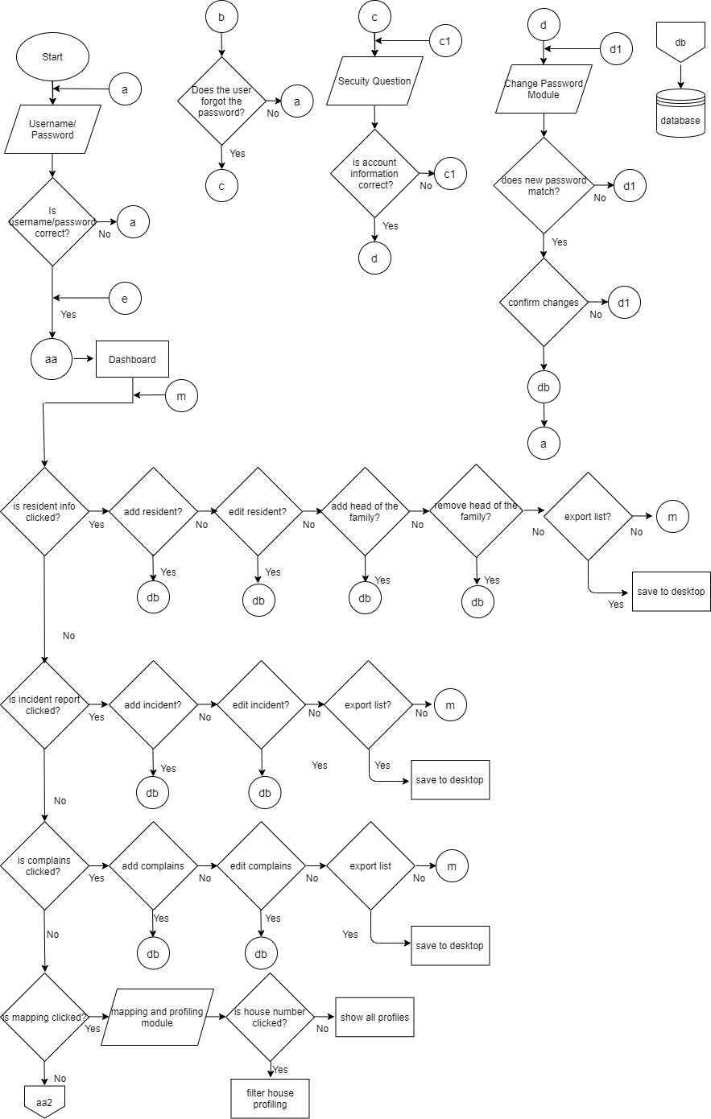

Figure 4. Flow Chart of Management Information System of Barangay-60 Letsugas San Roque, Cavite City

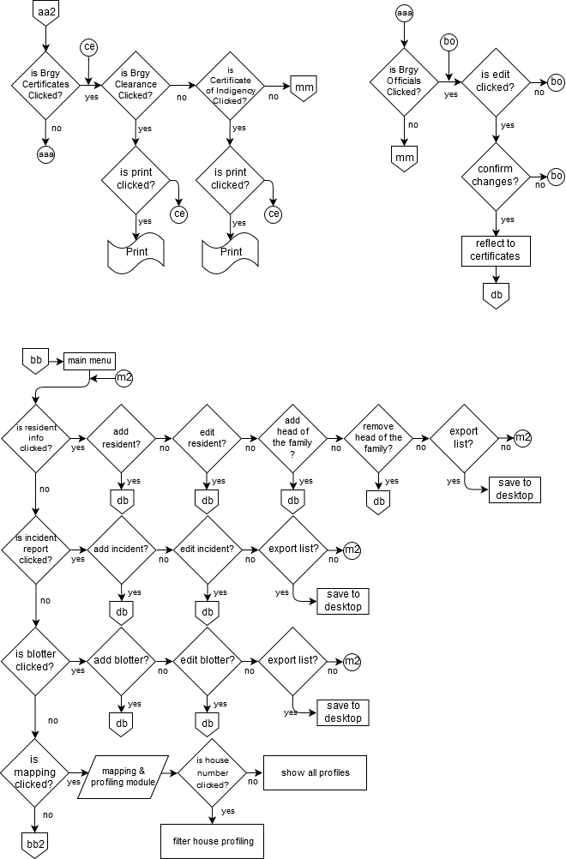

Figure 4. Continued.

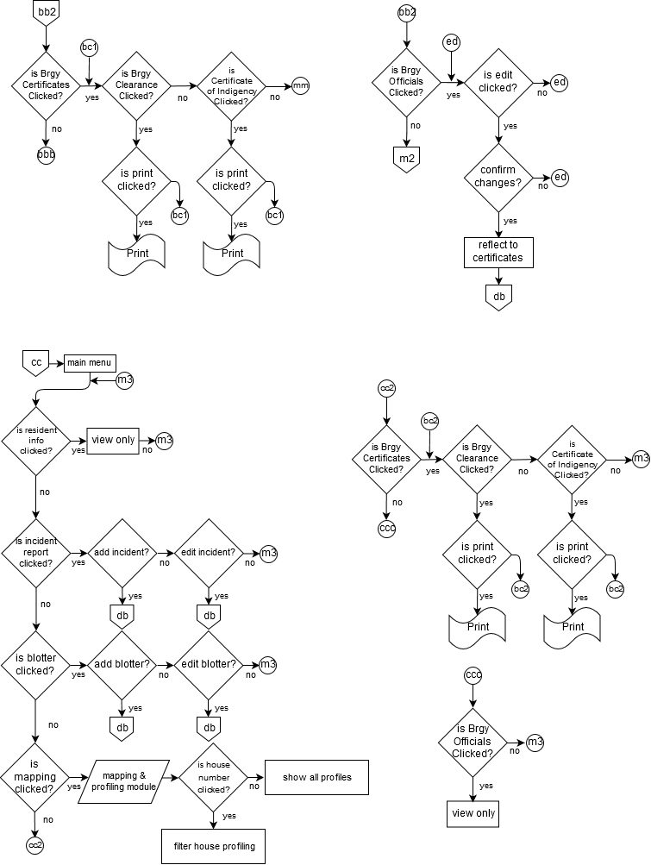

Figure 4. Continued.

.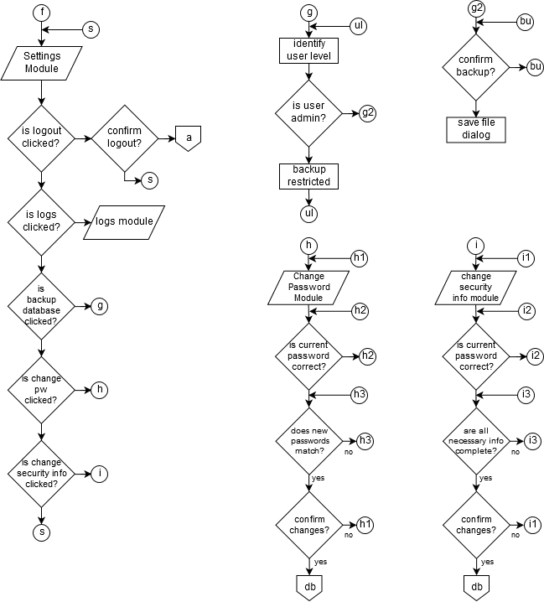

Figure 4. Continued.

Figure 4 shows the Management Information System of Barangay-60 Letsugas San Roque, Cavite City. The process will start with the login form, the administrator is the Barangay Captain who has access to the whole features of the system. While for the other user which is the secretary will have the limited access based on her duties and restrictions.

The Residents Information module has a function of view, add, update, edit. The Barangay Secretary and Barangay Captain can view, add, edit, update directly to the desktop, also there will be a profiling form when the users will add a new record to update the profiling of the household.

The Incident reports and complains have a function of view, add, and edit. All users have access to the whole feature of this module as the same as the incident and complaints.

Mapping profiling has the function of viewing, adding, editing, and updating. It records the name of the head of the family, house number, number of households, how many are employed and unemployed, and 0-12 years old. Also, it has the feature of viewing the map of the entire barangay. The barangay secretary and barangay captain have access to the whole features in this module, unlike the barangay kagawad he can only view the records and map.

The barangay official’s module displays the officials of the barangay, only the secretary and barangay captain can update this module. Once the barangay officials are updated in this module, it reflects the certificates provided by the barangay. Whereas the barangay kagawad can only view and print certificates in this module.

**Operation and Testing Procedure**

The steps to operate and test the Management Information System of Barangay-60 Letsugas San Roque in Cavite City are followed:

1. Open the system on a web browser using phone, laptop or PC
2. Test all the functions of different buttons
3. Debug and record base on the error

**Evaluation Procedure**

The following are the criteria to be carried out during evaluation; functional suitability, performance efficiency, compatibility, usability, reliability, security, maintainability, and portability which is based on ISO 25010 evaluation instrument.

These are the steps to be conducted:

1. Evaluation forms will be given to 10 information technology (IT) in professions and the secretary, barangay kagawad and the barangay captain.
2. The developers will demonstrate the operation of the system and explain its functions and mechanics.
3. The performance of the system will be rated by the evaluators or respondents based on a Likert scale as shown in Table1. The respondent will choose from a scale of 1-5 with 5 being the highest which means excellent and 1 being the lowest which needs improvement.
4. The system developers will use the rating scale in table 2 for interpreting the evaluation results.

**Statistical Treatment**

To determine the performance of the system, a questionnaire will be conducted. It covers tests for functional suitability, performance efficiency, compatibility, usability, reliability, security, maintainability and portability. The responses were tallied and analyzed. The mean was used to describe the validity of the responses of the experts.

Formula for the Mean:

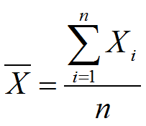

Legend:

n= number of respondents X= mean

∑= sum of

xı= observed value

|  |  |
| --- | --- |
| Table 1. Likert Scale |  |
| **Numerical** | **Scale Interpretation** |
| 5 | Excellent |
| 4 | Very Good |
| 3 | Good |
| 2 | Fair |
| 1 | Poor |

Table 1 shows the Likert scale. The highest rate would be the 5 which means that the system was given an excellent value. The lowest scale, on the other hand, would rate as 1, which means that the quality of the system is poor.

Table 2. Descriptive Evaluation of the Mean

|  |  |
| --- | --- |
| **Numerical** | **Scale Interpretation** |
| 4.51-5.00 | Excellent |
| 3.51-4.50 | Very Good |
| 2.51-3.50 | Good |
| 1.51-2.50 | Fair |
| 1.00-1.51 | Poor |

Table 2 shows the descriptive evaluation of the mean. The highest mean will be between the scales of 4.51 to 5.00. This numerical scale would be reflected as Excellent. The lowest mean, on the other hand, would garner a scale between 1.00 and 1.50 which would be reflected as poor.

**RESULTS AND DISCUSSION**

This chapter presents the project description and structure, project capabilities and limitations, project test results and evaluation results.

**Project Description**

The Management Information System of Barangay-60 Letsugas, San Roque, Cavite City can manage the information of all the residents living in the barangay. The system provides a report so the members or visitors will be able to know the status of the barangay.

This system has two user levels. These levels give a limitation to those who can access the system. The purpose of it is to secure all the information inside the system.

There are six modules in this system. First, is the dashboard module. This module contains the specific details of all the residents living in the barangay, the purpose of this is to monitor the number of residents living in the barangay. The second one is the resident’s information module; it shows here all the information of all residents in the barangay. The third is the complaints and incidents module; wherein it will record all the facts and events of the barangay that are alleged in crime. The fourth module is mapping; it will show the visual report of the location of each house. The fifth module is printable of certificates. The sixth module is the barangay official’s module; it will display all the elected officials in the barangay.

**Project Structure**

The project structure consists the detailed graphical user interface (GUI) with descriptions of major components and system features.

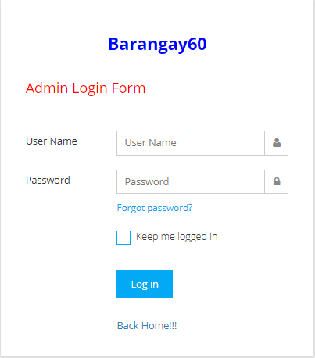

Figure 5. Login Form

Figure 5 shows the login module, wherein the system user needs to input their correct username and password before proceeding on the main menu. The system has two user levels for the administrator and use, also it used only by two persons which are the barangay secretary and barangay captain.

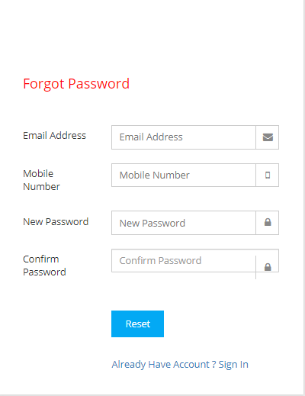

Figure 6. Forgot Password

Figure 6 shows the forgot password module, wherein the system user will forcely change their password by fulfilling the details needed. If the answer was correct, the user can already change for a new password.

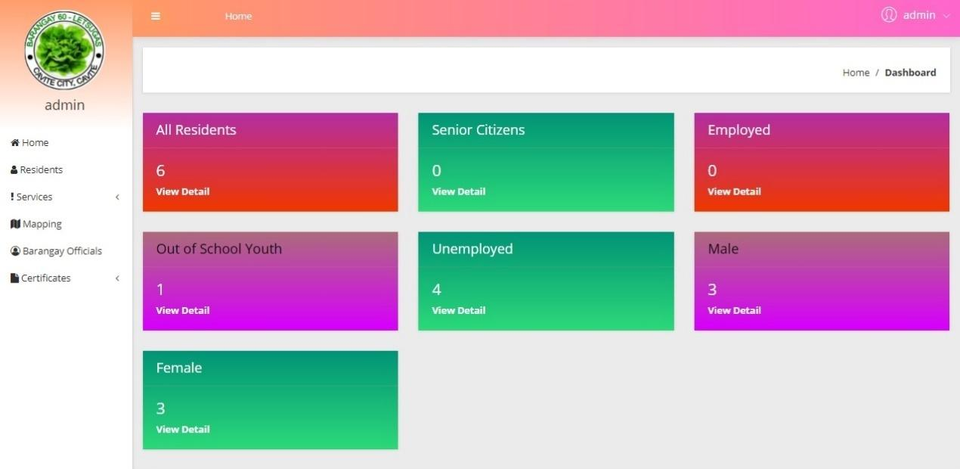

Figure 7. Dashboard

Figure 7 shows the dashboard of the admin wherein the admin can view the total numbers of all residents, senior citizens, employed and unemployed, out of school youth, male and females.

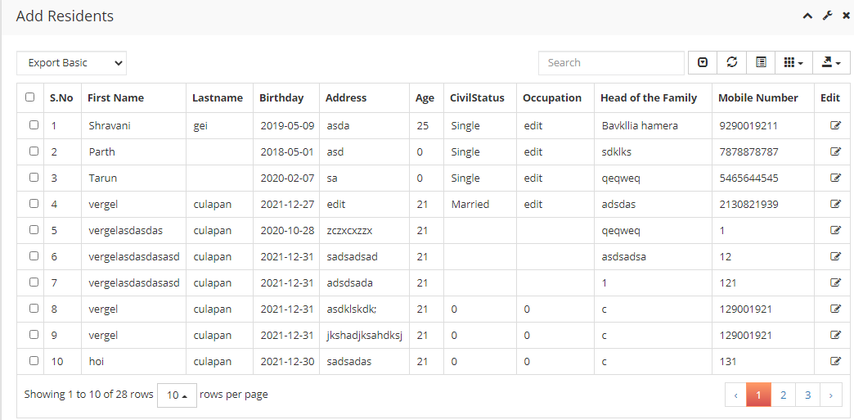

Figure 8. Residents Information

Figure 8 shows the specific information of all the residents wherein the two users can view, add, edit/update and export list.

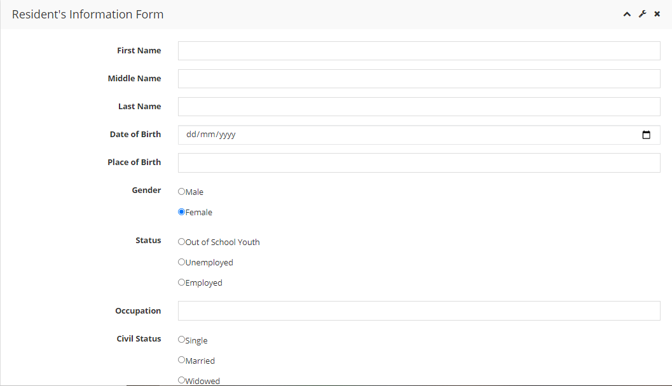

Figure 9. Residents Information Form

Figure 9 shows the residents information form wherein the barangay captain and barangay secretary can add a new record and update the profile of a resident.

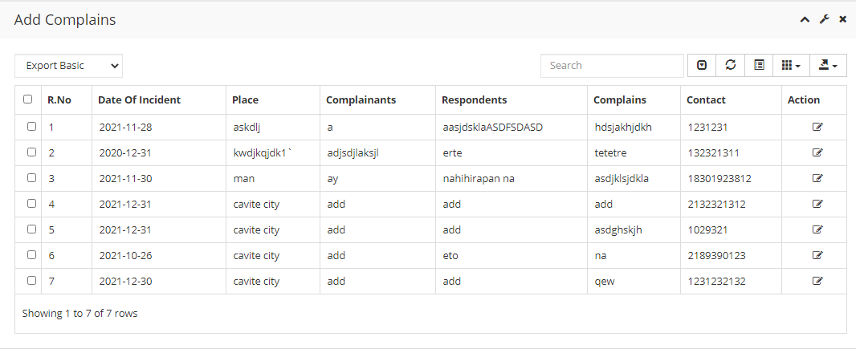

Figure 10. Complains

Figure 10 shows the complains module wherein the two users can view, add, edit/update and export list.

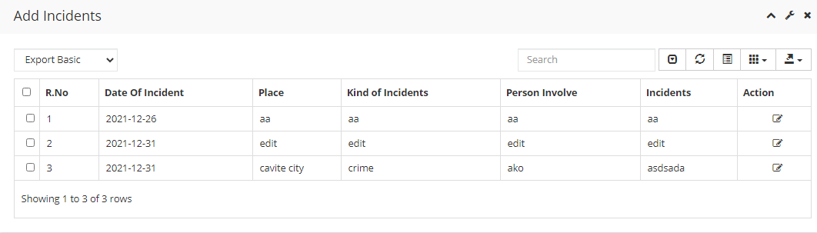

Figure 11. Incidents Report

Figure 11 shows the incidents report module, wherein the administrator and users can view, add, edit different incident reports.

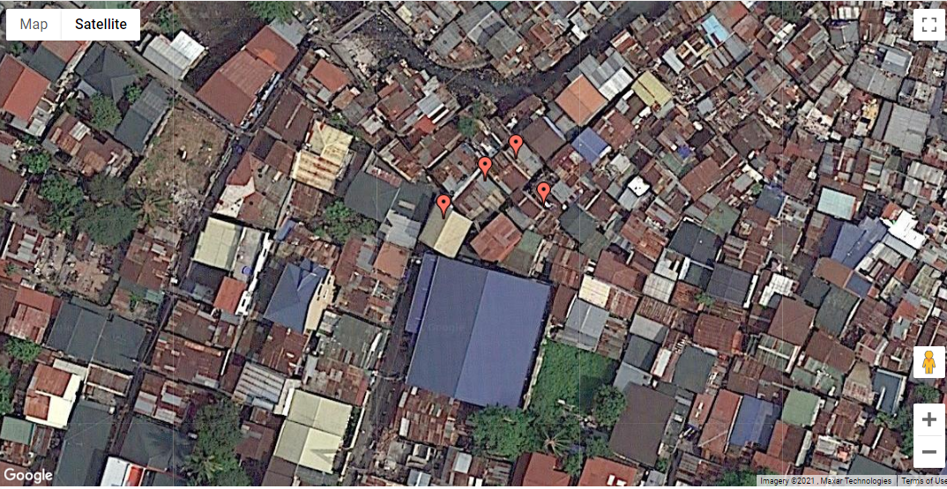

Figure 12. Mapping

Figure 12 shows the map of the entire barangay together with their perspective house number and street. When you click the house, it displays the profiling of each house.

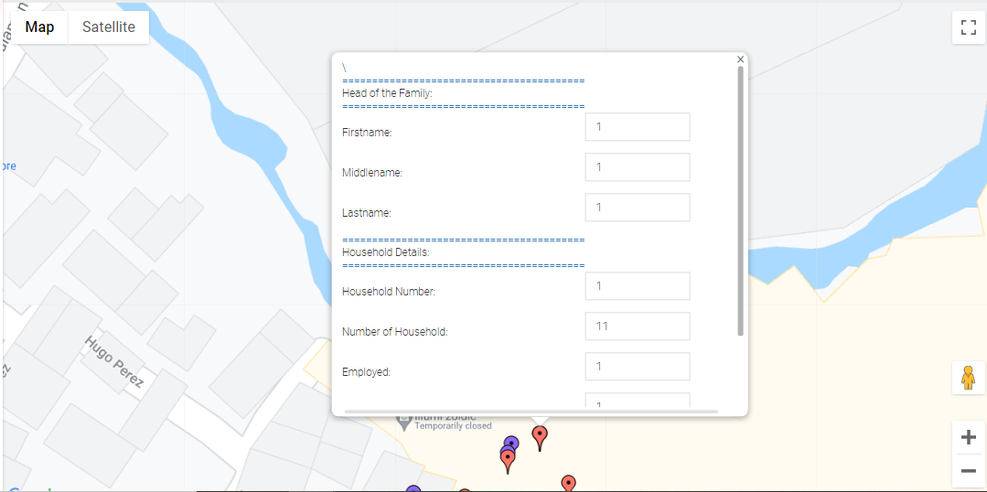

Figure 13. Edit Profiling of the Mapping

Figure 13 shows the edit profiling of the mapping. Wherein the user can edit the details of each house.

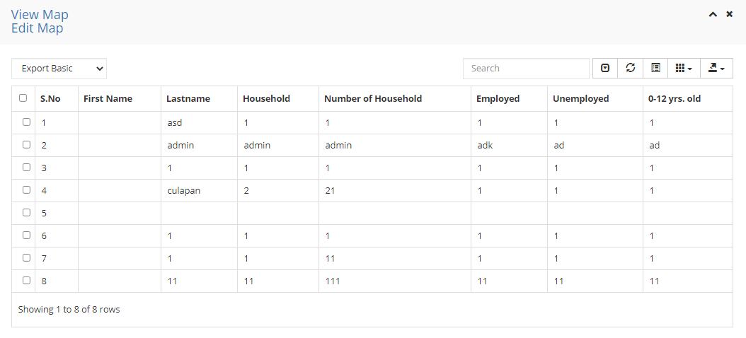

Figure 14. Mapping Record

Figure 14 shows the Mapping Record of the system. It will display all the information of the residents recorded in the mapping.

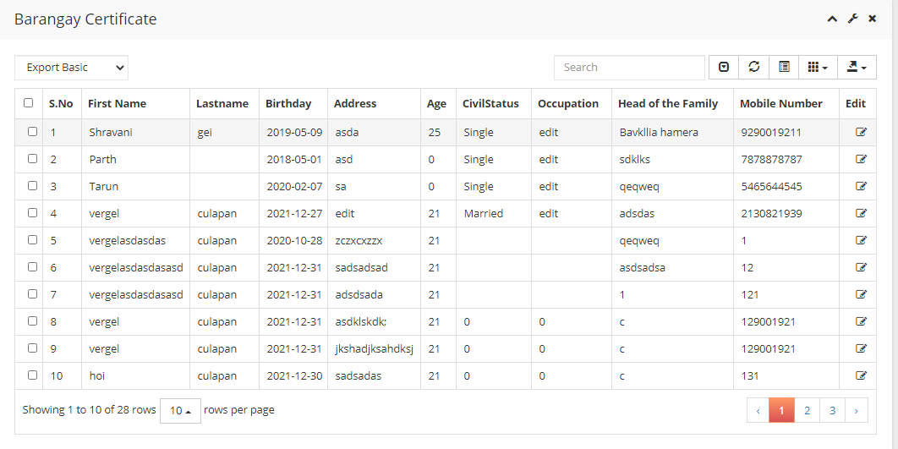

Figure 15. Barangay Certificates Module

Figure 12 shows the barangay certificates module wherein the administrator and barangay captain can print barangay clearance and certificate of indigency depending on its purpose.

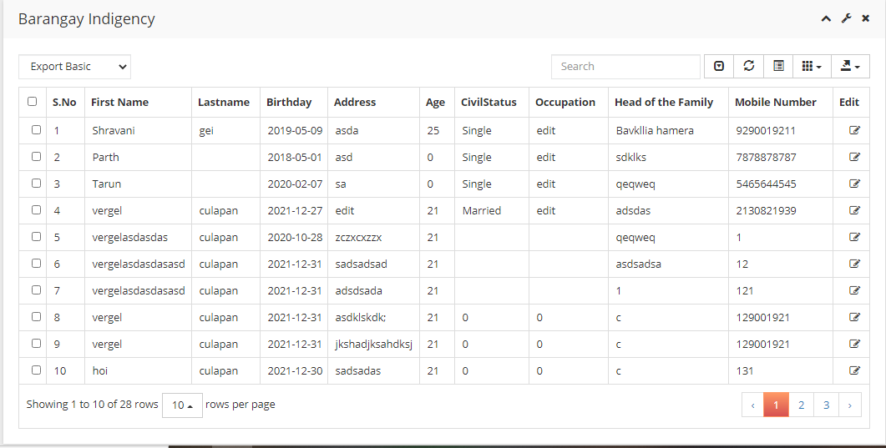

Figure 16. Barangay Indigency Module

Figure 13 shows the barangay indigency module wherein the administrator can print depending on its purpose.

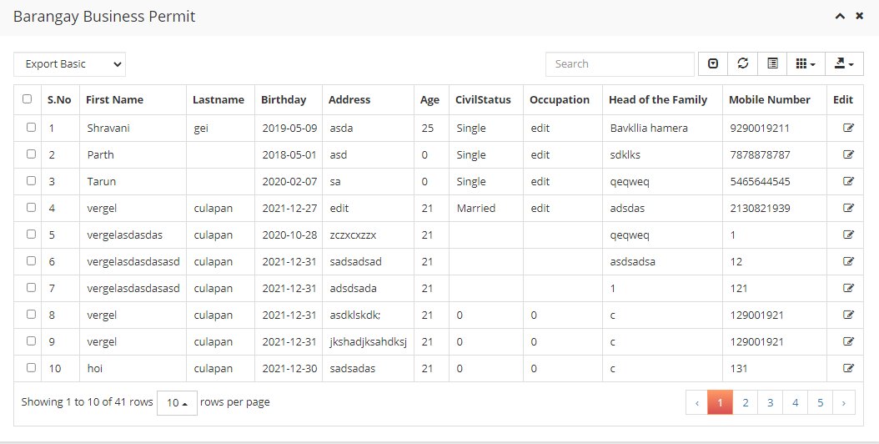

Figure 17. Business Permit

Figure 13 shows the business permit module wherein the administrator can print depending on its purpose.

# 

# Figure 18. Barangay Officials

Figure 14 shows the list of the names of barangay officials together with their committee belonging to barangay. It reflects the certificates that the barangay can provide.

# 

# Figure 19. Change Password

# Figure 15 shows the change password module, wherein the system users can change their password by fulfilling the information needed correctly. Otherwise, it cannot be changed.

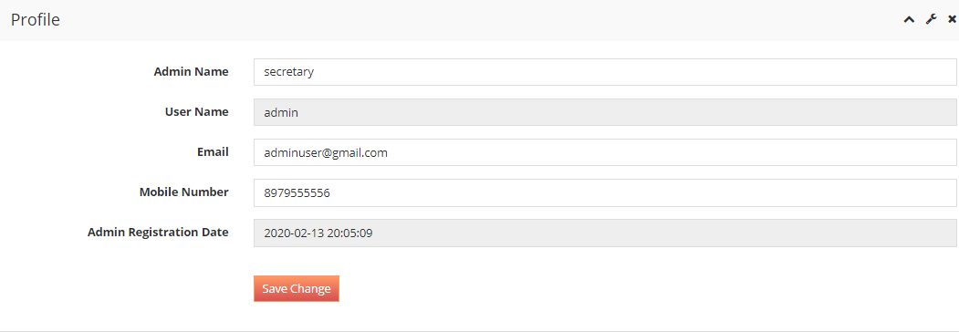

Figure 20. Profile of Secretary

Figure 18 shows the profile of the secretary, if the secretary wants to change his/her profile.

**Project Test Results**

This table illustrates how the developers test the whole system and it shows the behavior during the test and the result of the system.

Table 3. Test and result of the system

|  |  |  |
| --- | --- | --- |
| **ACTIVITY** | **BEHAVIOR** | **RESULTS** |
| Compatibility to windows 7 | System running successfully | PASSED |
| Compatibility to Windows 8 | System running successfully | PASSED |
| Compatibility to Windows 10 | System running successfully | PASSED |
| Login as system users | All the modules of the system were accessible and manageable | PASSED |
| Add New Record | Residents Record were added successfully | PASSED |
| Edit/Update record | Residents Record were edited/updated successfully | PASSED |
| Print reports | Reports were printed accurately | PASSED |
| Print Certificates | Certificates were printed successfully | PASSED |
| Modify User Account | Update user’s account details | PASSED |
| Update account | The account was successfully updated. | PASSED |
| Data Back up | Administrator can back up data. | PASSED |

**Project Capabilities and Limitations**

The capabilities of the system are to record and manage resident’s information within the barangay, provide certificates, generate reports such as complaints and incident reports. Moreover, the system can back up and secure data.

The system consists of Residents Information, Incident reports, complaints, Barangay Certificates, Mapping, Barangay Officials wherein the administrator can view, add, edit/update, and export records.

Meanwhile, the system is designed to operate in a web-based environment and can be accessed only by the assigned personnel. Also, the system will not be capable of generating reports when it comes to financial reports.

**Project Evaluation**

The performance of the system was subjected to run in series of tests to check its functional suitability, performance efficiency, compatibility, usability, reliability, security, maintainability, and portability based on ISO 25010. There were 10 evaluators which were composed of 10 Information Technology experts to check the overall performance of the system.

The result of the evaluation regarding the system's functional suitability is shown in Table 4. The first indicator, functional completeness, gained a mean of 4.40 and rated as Very Good. The second indicator, functional correctness, gained a mean of 4.40 and was rated as Very Good. Lastly, the third indicator, which is functional appropriateness, gained a mean of 4.50 and was rated as Very Good. Overall, the functional suitability of the system got a grand mean of 4.43 which was rated as Very Good.

This means that the system met the stated and implied needs of the client.

Table 4. Functional Suitability of the system

|  |  |  |
| --- | --- | --- |
| **INDICATOR** | **MEAN** | **VERBAL INTERPRETATION** |
| Functional Completeness | 4.31 | Very Good |
| Functional Correctness | 4.23 | Very Good |
| Functional Appropriateness | 3.85 | Very Good |
| **GRAND MEAN** | **4.13** | **VERY GOOD** |

Table 5 presents the result of the system regarding the performance efficiency. The indicator capacity got the highest mean of 4.00 with a verbal interpretation of very good. To be followed by the time behavior and got the mean 3.92 with a verbal interpretation of very good. Lastly, the resource utilization indicator got the lowest mean of 3.69 but still has a verbal interpretation of very good.

The system got an overall mean of 3.87 rated as very good. This indicates that the system was efficient.

Table 5. Performance Efficiency of the System

|  |  |  |
| --- | --- | --- |
| **INDICATOR** | **MEAN** | **VERBAL INTERPRETATION** |
| Time Behavior | 3.92 | Very Good |
| Resource Utilization | 3.69 | Very Good |
| Capacity | 4.00 | Very Good |
| **GRAND MEAN** | **3.87** | **VERY GOOD** |

# Table 6 shows the compatibility of the system where the indicators co-existence and interoperability got the same mean of 4.31 and rated as very good.

Overall, the system rated as very good with a grand mean of 4.31. It indicates that the system has very good compatibility performance.

Table 6. Compatibility of the System

|  |  |  |
| --- | --- | --- |
| **INDICATOR** | **MEAN** | **VERBAL INTERPRETATION** |
| Co-existence | 4.31 | Very Good |
| Interoperability | 4.31 | Very Good |
| **GRAND MEAN** | **4.31** | **VERY GOOD** |

Table 7 illustrates the usability of the system. The indicators operability and accessibility got the highest mean of 4.54 with the verbal interpretation of excellent. Followed by the user error protection of 4.46 with a verbal interpretation of very good. Next is the recognizability got the mean of 4.23. Lastly, the user interface aesthetic got the lowest mean of 4.19 but still rated as very good.

Overall, the system was rated as very good with the mean of 4.39. It indicates that the system was efficient to use.

Table 7. Usability of the System

|  |  |  |
| --- | --- | --- |
| **INDICATOR** | **MEAN** | **VERBAL INTERPRETATION** |
| Appropriateness Recognizability | 4.23 | Very Good |
| Learnability | 4.38 | Very Good |
| Operability | 4.54 | Very Good |
| User Error Protection | 4.46 | Very Good |
| User Interface Aesthetics | 4.19 | Very Good |
| Accessibility | 4.54 | Very Good |
| **GRAND MEAN** | **4.39** | **VERY GOOD** |

Table 8 shows the reliability performance of the system. The indicator fault tolerance got the highest mean of 4.31 with a verbal interpretation of very good. Followed by three indicators with the same mean of 4.23 and rated as very good which are the maturity, availability, and recoverability.

Overall, the reliability performance of the system got a mean of 4.25 and rated as very good. This indicates that the system was reliable to use.

Table 8 shows the reliability performance of the system. The indicator fault tolerance got the highest mean of 4.31 with a verbal interpretation of very good. Followed by three indicators with the same mean of 4.23 and rated as very good which are the maturity, availability, and recoverability.

Overall, the reliability performance of the system got a mean of 4.25 and rated as very good. This indicates that the system was reliable to use.

Table 8. Reliability of the System

|  |  |  |
| --- | --- | --- |
| **INDICATOR** | **MEAN** | **VERBAL INTERPRETATION** |
| Maturity | 4.23 | Very Good |
| Availability | 4.23 | Very Good |
| Fault Tolerance | 4.31 | Very Good |
| Recoverability | 4.23 | Very Good |
| **GRAND MEAN** | **4.25** | **VERY GOOD** |

Table 9 presents the security performance of the system. The indicator confidentiality got the highest mean of 4.54 with a verbal interpretation of excellent while the non-repudiation got the lowest mean of 4.00 but still has a very good verbal interpretation.

The system got an overall mean of 4.40 with the verbal interpretation of very good. This indicates that the system was secured.

Table 9. Security of the System

|  |  |  |
| --- | --- | --- |
| **INDICATOR** | **MEAN** | **VERBAL INTERPRETATION** |
| Confidentiality | 4.54 | Very Good |
| Integrity | 4.15 | Very Good |
| Non-Repudiation | 4.00 | Very Good |
| Accountability | 4.31 | Very Good |
| Authenticity | 4.29 | Very Good |
| **GRAND MEAN** | **4.40** | **VERY GOOD** |

Table 10 illustrates the maintainability of the system. The indicator modifiability got the highest mean of 4.46 with a verbal interpretation of very good. Followed by modularity with a mean of 4.23 and rated as very good. For the analyzability indicator it has the mean of 4.15 which is rated as very good. Reusability indicator has a mean of 4.08 and has a very good interpretation. Lastly, the testability indicator got the lowest mean of 4.07 but still has a very good rating.

Overall, the maintainability performance of the system got a mean of 4.20 which rated as very good. This indicates that the system is maintainable.

Table 10. Maintainability of the System

|  |  |  |
| --- | --- | --- |
| **INDICATOR** | **MEAN** | **VERBAL INTERPRETATION** |
| Modularity | 4.23 | Very Good |
| Reusability | 4.08 | Very Good |
| Analyzability | 4.15 | Very Good |
| Modifiability | 4.46 | Very Good |
| Testability | 4.07 | Very Good |
| **GRAND MEAN** | **4.20** | **VERY GOOD** |

Table 11 depicts the portability performance of the system. The indicator installability got the highest mean of 4.31 with a verbal interpretation of very good. Followed by adaptability with a mean of 4.00 and rated as very good. Lastly, replaceability indicator got the lowest mean of 3.92 but still has a very good interpretation.

Overall, the system’s portability performance got a mean of 4.08 and rated as very good. This indicates that the system is portable.

Table 11. Portability of the System

|  |  |  |
| --- | --- | --- |
| **INDICATOR** | **MEAN** | **VERBAL INTERPRETATION** |
| Adaptability | 4.00 | Very Good |
| Installability | 4.31 | Very Good |
| Replaceability | 3.92 | Very Good |
| **GRAND MEAN** | **4.08** | **VERY GOOD** |

.

Table 12 shows the overall performance of the system that is measured by its usability with the highest mean of 4.39, compatibility with the mean of 4.31, followed by security with the mean of 4.29, reliability with the mean of 4.25, maintainability with the mean of 4.20, functional suitability with the mean of 4.12, portability with the mean of 4.08, and performance efficiency with the lowest mean of 3.87.

Overall, the system’s summary evaluation got a mean of 4.19 and rated as very good. This indicates that the system passed the standard evaluation.

Table 12. Overall Performance of the System

|  |  |  |
| --- | --- | --- |
| **INDICATOR** | **MEAN** | **VERBAL INTERPRETATION** |
| Functional Suitability | 4.12 | Very Good |
| Performance Efficiency | 3.97 | Very Good |
| Compatibility | 4.14 | Very Good |
| Usability | 3.95 | Very Good |
| Reliability | 3.89 | Very Good |
| Security | 4.11 | Very Good |
| Maintainability | 4.07 | Very Good |
| Portability | 4.12 | Very Good |
| **GRAND MEAN** | **4.19** | **VERY GOOD** |

**SUMMARY, CONCLUSIONS, AND RECOMMENDATIONS**

This chapter presents the summary of findings, conclusions, and recommendations based on the results of the test and evaluation.

**Summary**

The developers created a Management Information System of Barangay 60 – Letsugas, San Roque, Cavite City based on the gathered information from the client through a series of interviews. This study was conducted at Barangay 60- Letsugas, San Roque, Cavite City. This study was done in order to establish the exact requirements of the system.

This study aimed to design the system with different features to easily manage and secure the information of the Barangay. The developers used software applications such as PHP, JavaScript as the integrated development environment and MySQL for the database to store data.

The evaluators found that the system is functioning well in accordance with the criteria during the evaluation. Overall, the system was rated as very good with the mean of 4.19.

**Conclusion**

In consideration of the objectives of the study and the results of the system evaluation and testing, the following conclusions were derived.

1. design a Management Information System with the following features:
2. to make records reliable, and more accessible and therefore easy to find;
3. to minimize the time in writing the record to reduce the use of paper:
4. to easily locate the specific information of each resident; and
5. to identify the profiling of each houses:
6. The system was created in PHP, JavaScript, CSS for programming language, and MySQL for the database.
7. The functionality of the system was tested and improved by the evaluators; and
8. The performance of the system was rated very good by the respondent according to the criteria of ISO 25010.

**Recommendations**

Based on the findings of the study, there were recommendations to further enhance the developed Management Information System of Barangay 60 – Letsugas, San Roque, Cavite City.

The following were a few recommendations to enhance the systems.

1. Improve the graphical user interface.
2. Should have a financial statement if possible.

# **REFERENCES**

(2020, December 7). Retrieved from definitions.net: https://www.definitions.net/definition/barangay

(2020, October 20). Retrieved from shopify.com: https://www.shopify.com/encyclopedia/management-information-systems-mis

Algara. (2015). *Google*. Retrieved from https://www.academia.edu/31530757/Barangay_Resident_Record_Management_and_Certificate_Issuance_System_Of_Barangay_Ticol_Sorsogon_City

Anderson, K. (2015). *Google*. Retrieved from https://www.dpbestflow.org/file-management/file-management-overview

Baskerville. (2015). *Google*. Retrieved from https://www.scribd.com/document/87217740/Literature-Review

Bradley, A. (2016). *Google*. Retrieved from https://www.academia.edu/19004711/MySQL_Database_Assignment

Conde. (2016). *Google*. Retrieved from https://www.academia.edu/33868590/Barangay_profilling_information_system

Harper, C. (2016). *Google*. Retrieved from http://www.jstor.org/stable/1823424?seq=1#page_scan_tab_contents

Hope, C. (2017). *Google*. Retrieved from https://www.computerhope.com/jargon/u/useracco.htm

Mcginley, M. (2016). *Google*. Retrieved from https://www.definitions.net/definition/population+growth

Medel. (2015). *Google*. Retrieved from https://ziglinkit.com/manual-and-computerized-information-system/

Mendoza. (2015). *Google*. Retrieved from http://bizfluent.com/how-8256522-development-management-information-system.html

Robek. (2015). *Google*. Retrieved from https://www.academia.edu/Documents/in/Document_Management_System

Teitelbaum, M. (2017). *Google*. Retrieved from https://stats.oecd.org/glossary/detail.asp?ID=2087

Valera, H. (2016). *Google*. Retrieved from https://www.guru.com/d/freelancers/c/design-art/skill/adobe-photoshop-135-literature-review-4365/

**APPENDICES**

**Appendix 1**

Gantt Chart

|  |  |  |  |  |  |  |  |  |  |  |  |  |
| --- | --- | --- | --- | --- | --- | --- | --- | --- | --- | --- | --- | --- |
| **Special Activity** | **Sept**  **2020** | **Oct**  **2020** | **Nov**  **2020** | **Dec**  **2020** | **Jan**  **2021** | **Feb**  **2021** | **Mar**  **2021** | **Apr**  **2021** | **May 2021** | **Jun 2021** | **Jul 2021** | **Aug 2021** |
| **1.Analysis** |  |  |  |  |  |  |  |  |  |  |  |  |
| Defining the Problem |  |  |  |  |  |  |  |  |  |  |  |  |
| Analyze system needs |  |  |  |  |  |  |  |  |  |  |  |  |
| Gathering Information |  |  |  |  |  |  |  |  |  |  |  |  |
| System specification |  |  |  |  |  |  |  |  |  |  |  |  |
| **2.Designing the system** |  |  |  |  |  |  |  |  |  |  |  |  |
| Database Design |  |  |  |  |  |  |  |  |  |  |  |  |
| Software Design |  |  |  |  |  |  |  |  |  |  |  |  |
| Graphical User Interface design |  |  |  |  |  |  |  |  |  |  |  |  |
| **3.Developing the system** |  |  |  |  |  |  |  |  |  |  |  |  |
| Creating the database |  |  |  |  |  |  |  |  |  |  |  |  |
| Coding |  |  |  |  |  |  |  |  |  |  |  |  |
| Initial Testing |  |  |  |  |  |  |  |  |  |  |  |  |
| **Testing** |  |  |  |  |  |  |  |  |  |  |  |  |
| **4.Implementation** |  |  |  |  |  |  |  |  |  |  |  |  |
| **5.Evaluation** |  |  |  |  |  |  |  |  |  |  |  |  |
| **6.Final Defense** |  |  |  |  |  |  |  |  |  |  |  |  |
| **7.Documentation** |  |  |  |  |  |  |  |  |  |  |  |  |

Appendix Figure 1. Gantt chart of the development of Management Information System of Barangay 60 – Letsugas San Roque, Cavite City

**Appendix 2**

Evaluation Instruments

**EVALUATION INSTRUMENT FOR SOFTWARE MATERIAL (ISO 25010)**

***Management Information System of Barangay 60 – Letsugas San Roque, Cavite City***

Name: _________________________   Position: _________________

Date: _________________________

Instruction:  Please evaluate the software material by using the given scale and placing a checkmark (✔) under the corresponding numerical rating:

**Numerical Rating         Equivalent**

5 Excellent

4 Very Good

3 Good

2 Fair

1 Poor

|  |  |  |  |  |  |
| --- | --- | --- | --- | --- | --- |
| **INDICATOR** | **5** | **4** | **3** | **2** | **1** |
| 1. **Functional Suitability** |  |  |  |  |  |
| 1. **Functional completeness.** Degree to which the set of functions covers all the specified tasks and user objectives. |  |  |  |  |  |
| 1. **Functional correctness.** Degree to which a product or system provides the correct results with the needed degree of precision. |  |  |  |  |  |
| 1. **Functional appropriateness.** Degree to which the functions facilitate the accomplishment of specified tasks and objectives. |  |  |  |  |  |
| 1. **Performance Efficiency** |  |  |  |  |  |
| 1. **Time behavior.** Degree to which the response and processing times and throughput rates of a product or system, when performing its functions, meet requirements. |  |  |  |  |  |
| 1. **Resource utilization.** Degree to which the amounts and types of resources used by a product or system, when performing its functions, meet requirements. |  |  |  |  |  |
| 1. **Capacity.** Degree to which the maximum limits of a product or system parameter meet requirements. |  |  |  |  |  |
| 1. **Compatibility** |  |  |  |  |  |
| 1. **Co-existence.** Degree to which a product can perform its required functions efficiently while sharing a common environment and resources with other products, without detrimental impact on any other product. |  |  |  |  |  |
| 1. **Interoperability.** Degree to which two or more systems, products or components can exchange information and use the information that has been exchanged. |  |  |  |  |  |
| 1. **Usability** |  |  |  |  |  |
| 1. **Appropriateness recognizability.** Degree to which users can recognize whether a product or system is appropriate for their needs. |  |  |  |  |  |
| 1. **Learnability.** degree to which a product or system can be used by specified users to achieve specified goals of learning to use the product or system with effectiveness, efficiency, freedom from risk and satisfaction in a specified context of use. |  |  |  |  |  |

|  |  |  |  |  |  |
| --- | --- | --- | --- | --- | --- |
| 1. **Operability.** Degree to which a product or system has attributes that make it easy to operate and control. |  |  |  |  |  |
| 1. **User error protection.** Degree to which a system protects users against making errors. |  |  |  |  |  |
| 1. **User interface aesthetics.** Degree to which a user interface enables pleasing and satisfying interaction for the user. |  |  |  |  |  |
| 1. **Accessibility.** Degree to which a product or system can be used by people with the widest range of characteristics and capabilities to achieve a specified goal in a specified context of use. |  |  |  |  |  |
| 1. **Reliability** |  |  |  |  |  |
| 1. **Maturity.** Degree to which a system, product or component meets needs for reliability under normal operation. |  |  |  |  |  |
| 1. **Availability**. Degree to which a system, product or component is operational and accessible when required for use. |  |  |  |  |  |
| 1. **Fault tolerance.** Degree to which a system, product or component operates as intended despite the presence of hardware or software faults. |  |  |  |  |  |
| 1. **Recoverability.** Degree to which, in the event of an interruption or a failure, a product or system can recover the data directly affected and re-establish the desired state of the system. |  |  |  |  |  |
| 1. **Security** |  |  |  |  |  |
| 1. **Confidentiality.** Degree to which a product or system ensures that data are accessible only to those authorized to have access. |  |  |  |  |  |
| 1. **Integrity.** Degree to which a system, product or component prevents unauthorized access to, or modification of, computer programs or data. |  |  |  |  |  |
| 1. **Non-repudiation.** degree to which actions or events can be proven to have taken place, so that the events or actions cannot be repudiated later. |  |  |  |  |  |
| 1. **Accountability.** Degree to which the actions of an entity can be traced uniquely to the entity. |  |  |  |  |  |
| 1. **Authenticity.** Degree to which the identity of a subject or resource can be proved to be the one claimed. |  |  |  |  |  |
| 1. **Maintainability** |  |  |  |  |  |
| 1. **Modularity.** Degree to which a system or computer program is composed of discrete components such that a change to one component has minimal impact on other components. |  |  |  |  |  |
| 1. **Reusability.** Degree to which an asset can be used in more than one system, or in building other assets. |  |  |  |  |  |
| 1. **Analyzability.** Degree of effectiveness and efficiency with which it is possible to assess the impact on a product or system of an intended change to one or more of its parts, or to diagnose a product for deficiencies or causes of failures, or to identify parts to be modified. |  |  |  |  |  |
| 1. **Modifiability.** Degree to which a product or system can be effectively and efficiently modified without introducing defects or degrading existing product quality. |  |  |  |  |  |
| 1. **Testability.** Degree of effectiveness and efficiency with which test criteria can be established for a system, product or component and tests can be performed to determine whether those criteria have been met. |  |  |  |  |  |
| 1. **Portability** |  |  |  |  |  |
| 1. **Adaptability.** Degree to which a product or system can effectively and efficiently be adapted for different or evolving hardware, software or other operational or usage environments. |  |  |  |  |  |
| 1. **Installability.** Degree of effectiveness and efficiency with which a product or system can be successfully installed and/or uninstalled in a specified environment. |  |  |  |  |  |
| 1. **Replaceability.** Degree to which a product can replace another specified software product for the same purpose in the same environment. |  |  |  |  |  |

Recommendations:

_______________________________________________________________________________________________________________________________________________________________________________________________________________________________________________________________________________________________________________________________________________

__________________________

Signature of Respondent

**Appendix 3**

Evaluation Summary

# **SUMMARY OF EVALUATION**

|  |  |  |
| --- | --- | --- |
| **INDICATOR** | **MEAN** | **INTERPRETATION** |
| **Functional Suitability** |  |  |
| • *Functional completeness*. The functions cover all the specified tasks and user objectives. | 4.31 | Very Good |
| • *Functional correctness.* The system provides the correct results with the needed degree of precision. | 4.23 | Very Good |
| • *Functional appropriateness.* Degree to which the functions facilitate the accomplishment of specified tasks and objectives. | 3.85 | Very Good |
| **Overall Mean** | **4.13** | **Very Good** |
| **Performance Efficiency** |  |  |
| • *Time behavior*. Degree to which the response and processing times and throughput rates of a product or system, when performing its functions, meet requirements. | 3.92 | Very Good |
| • *Resource utilization.* Degree to which the amounts and types of resources used by a product or system, when performing its functions, meet requirements. | 3.69 | Very Good |
| • *Capacity*. Degree to which the maximum limits of a product or system parameter meet requirements. | 4.00 | Very Good |
| **Overall Mean** | **3.87** | **Very Good** |
| **Compatibility** |  |  |
| • *Co-existence*. Degree to which a product can perform its required functions efficiently while sharing a common environment and resources with other products, without detrimental impact on any other product. | 4.31 | Very Good |
| • *Interoperability*. Degree to which two or more systems, products or components can exchange information and use the information that has been exchanged. | 4.31 | Very Good |
| **Overall Mean** | **4.31** | **Very Good** |
| **Usability** |  |  |
| • *Appropriateness Recognizability.* Degree to which users can recognize whether a product or system is appropriate for their needs. | 4.23 | Very Good |
| • *Learnability.* degree to which a product or system can be used by specified users to achieve specified goals of learning to use the product or system with effectiveness, efficiency, freedom from risk and satisfaction in a specified context of use. | 4.38 | Very Good |
| •*Operability.* Degree to which a product or system has attributes that make it easy to operate and control. | 4.54 | Very Good |
| •*User error protection.* Degree to which a system protects users against making errors. | 4.46 | Very Good |
| •*User interface aesthetics.* Degree to which a user interface enables pleasing and satisfying interaction for the user. | 4.19 | Very Good |
| •*Accessibility.* Degree to which a product or system can be used by people with the widest range of characteristics and capabilities to achieve a specified goal in a specified context of use. | 4.54 | Very Good |
| **Overall Mean** | **4.39** | **Very Good** |
| **Reliability** |  |  |
| • *Maturity*. Degree to which a system, product or component meets needs for reliability under normal operation. | 4.23 | Very Good |
| • *Availability*. Degree to which a system, product or component is operational and accessible when required for use. | 4.23 | Very Good |
| • *Fault tolerance.* Degree to which a system, product or component operates as intended despite the presence of hardware or software faults. | 4.31 | Very Good |
| • *Recoverability*. Degree to which, in the event of an interruption or a failure, a product or system can recover the data directly affected and re-establish the desired state of the system. | 4.23 | Very Good |
| **Overall Mean** | **4.25** | **Very Good** |
| **Security** |  |  |
| • *Confidentiality*. Degree to which a product or system ensures that data are accessible only to those authorized to have access. | 4.54 | Very Good |
| • *Integrity*. Degree to which a system, product or component prevents unauthorized access to, or modification of, computer programs or data. | 4.15 | Very Good |
| • *Non-repudiation*. degree to which actions or events can be proven to have taken place, so that the events or actions cannot be repudiated later. | 4.00 | Very Good |
| • *Accountability*. Degree to which the actions of an entity can be traced uniquely to the entity. | 4.46 | Very Good |
| • *Authenticity.* Degree to which the identity of a subject or resource can be proved to be the one claimed. | 4.31 | Very Good |
| **Overall Mean** | **4.29** | **Very Good** |
| **Maintainability** |  |  |
| *• Modularity.* Degree to which a system or computer program is composed of discrete components such that a change to one component has minimal impact on other components. | 4.23 | Very Good |
| *• Reusability.* Degree to which an asset can be used in more than one system, or in building other assets. | 4.08 | Very Good |
| *• Analyzability.* Degree of effectiveness and efficiency with which it is possible to assess the impact on a product or system of an intended change to one or more of its parts, or to diagnose a product for deficiencies or causes of failures, or to identify parts to be modified. | 4.15 | Very Good |
| *• Modifiability.* Degree to which a product or system can be effectively and efficiently modified without introducing defects or degrading existing product quality. | 4.46 | Very Good |
| *• Testability.* Degree of effectiveness and efficiency with which test criteria can be established for a system, product or component and tests can be performed to determine whether those criteria have been met. | 4.15 | Very Good |
| **Overall Mean** | **4.22** | **Very Good** |
| **Portability** |  |  |
| *• Adaptability.* Degree to which a product or system can effectively and efficiently be adapted for different or evolving hardware, software or other operational or usage environments. | 4.00 | Very Good |
| *• Installability.* Degree of effectiveness and efficiency with which a product or system can be successfully installed and/or uninstalled in a specified environment. | 4.31 | Very Good |
| *• Replaceability.* Degree to which a product can replace another specified software product for the same purpose in the same environment. | 3.92 | Very Good |
| **Overall Mean** | **4.08** | **Very Good** |

**Appendix 4**

Certificate of Implementation

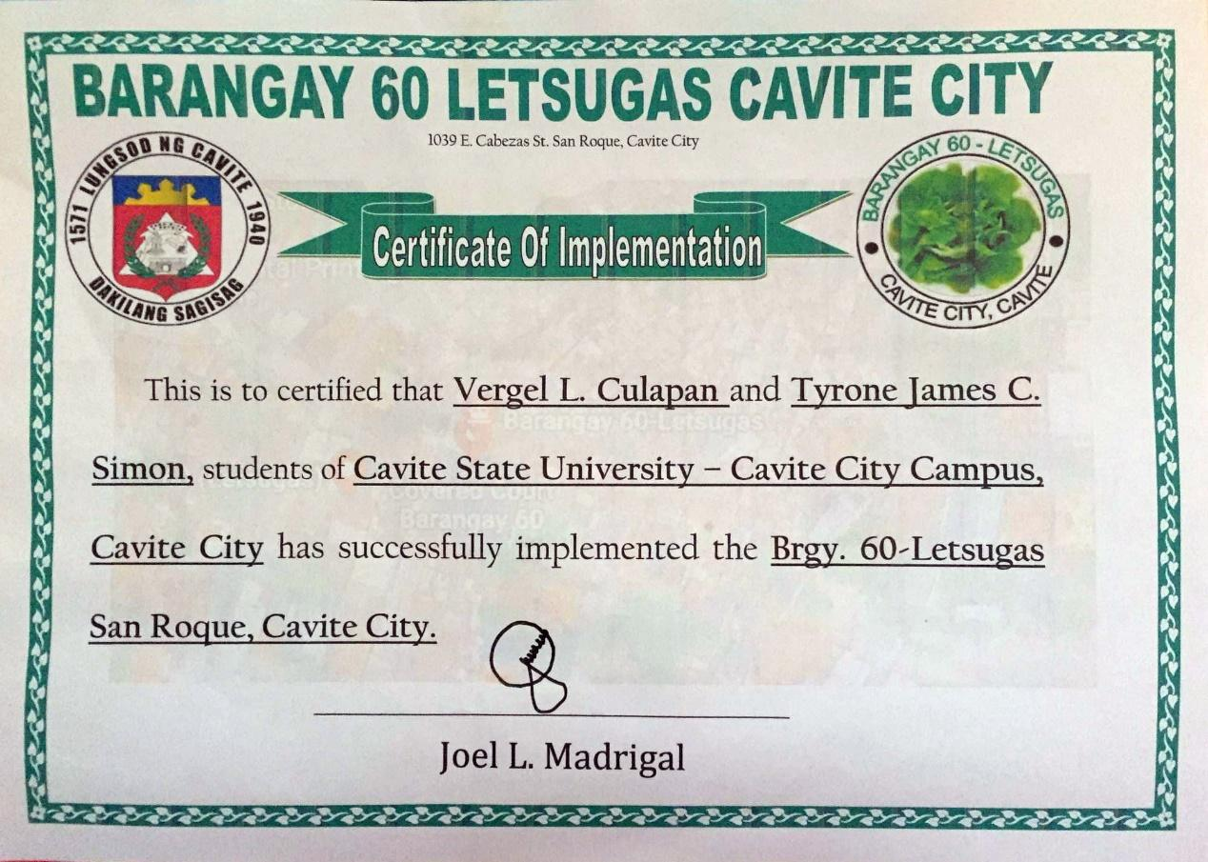

Appendix Figure 4. Certificate of Implementation

**Appendix 5**

User’s Manual

**User’s Manual**

**Introduction**

This user’s manual provides an instructional pattern and guide to the user of the Management Information System of Barangay 60 – Letsugas San Roque, Cavite City.

**How to access the web-based system?**



Appendix Figure 2. Browsers

1. Use any of these web browsers to open the website.

2. Type to the browser the URL of the site.



4

1

2

3

5

Appendix Figure 3. Login Form

* 1. Enter the correct username.
  2. Enter the correct password.
  3. Click “Login” to access the whole system with the corresponding modules.
  4. Click “Forgot password” in case the user forgot the password.
  5. Click “Keep me logged in” if you want to be log in all the time.



1

2

4

3

Appendix Figure 4. Forgot Password Form

1. Enter your email address and mobile number.
2. If the system detects your email or mobile number exists it would send an email and set your new password.
3. Confirm your new password.
4. Click “reset” if you want to reset your old password.

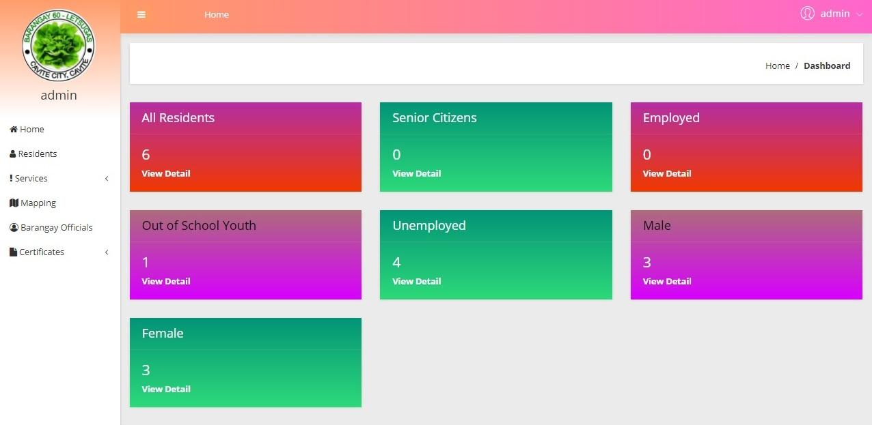

1

2

Appendix Figure 5. Dashboard Form

1. Choose from dashboard residents, services, mapping, barangay officials, and certificates to access the different modules of the system.
2. Display all the demographic data of people living in the barangay.

1

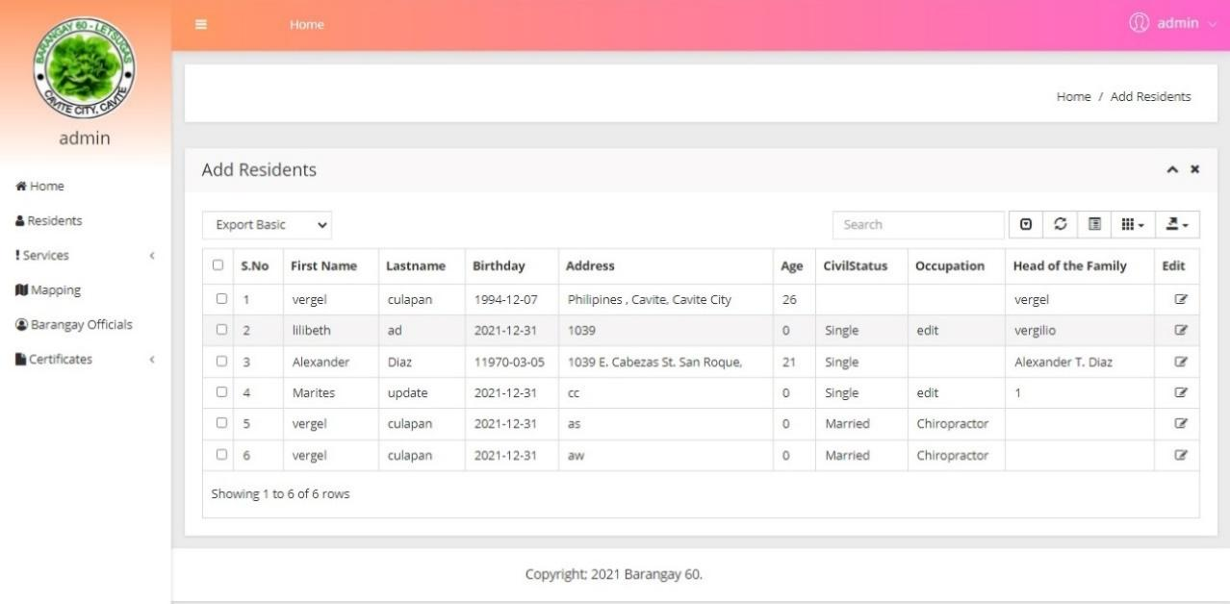

Appendix Figure 6. Add Residents Form

1. By clicking “add residents” you can add a new resident.

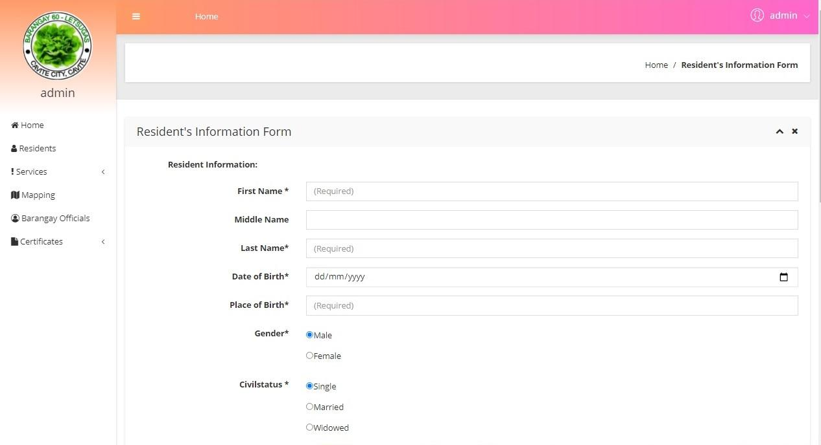

Appendix Figure 6. Continued.

Fill up the necessary information needed. Somehow it was connected to the Mapping/Profiling module, once “yes” was clicked on the Head of the Family it will automatically save as the new head of the family in the profiling module. Click save to save the new record.

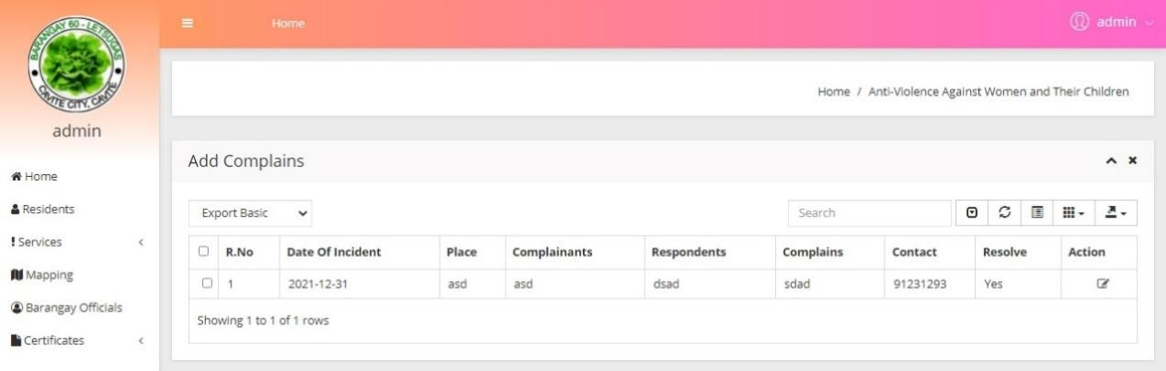

Click

1

Appendix Figure 7. Complains Form

1. Click the “Services” button to view the services and choose complains and click the “Action” button to add complains.

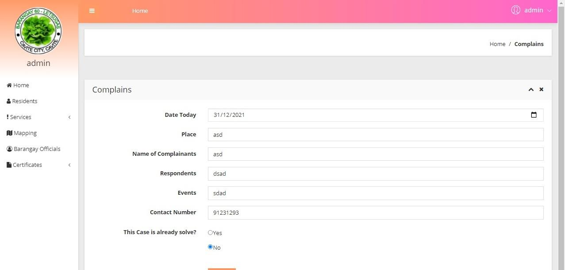

Appendix Figure 8. Add Complains Form

Fill up the necessary information in the complaints form and add details to save the record.

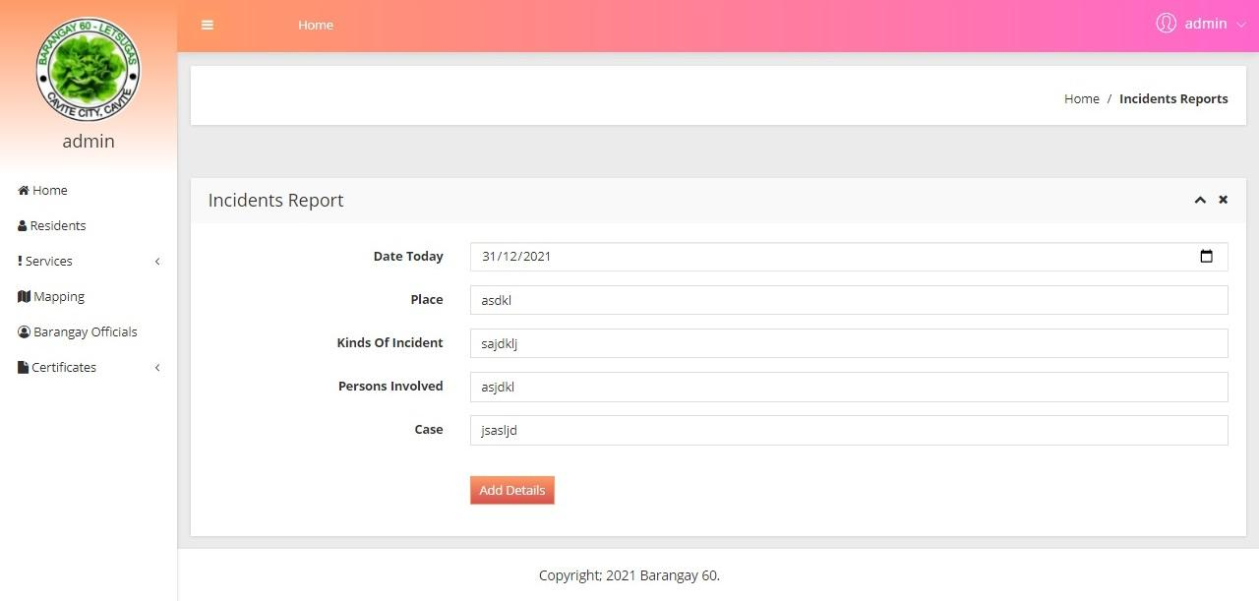

Appendix Figure 9. Incidents Report Form

Fill up the necessary information in the Incidents Report Form and add details to save the record.

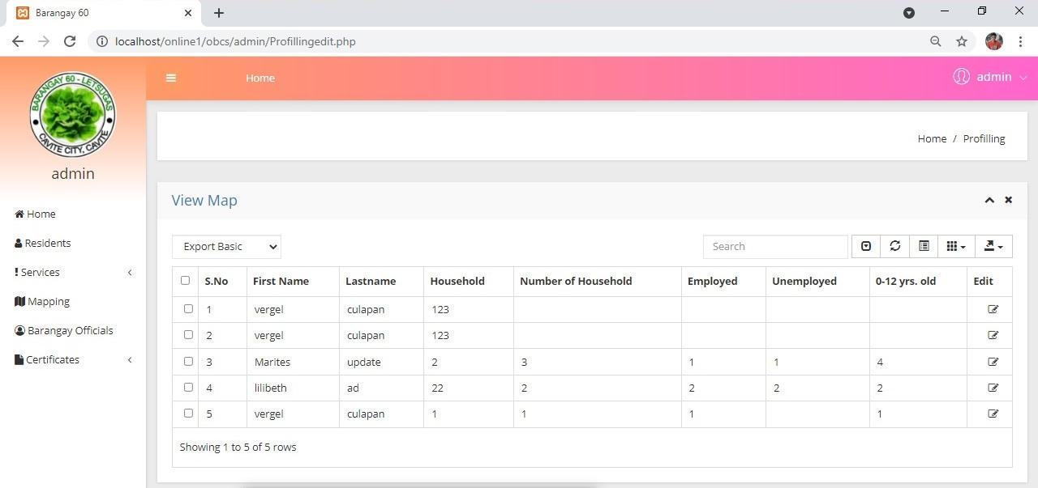

1

Click

Appendix Figure 10. View Map Form

1. Click the “Mapping” module to view the records and click the action to edit a specific record.



Click

Appendix Figure 10. Continued

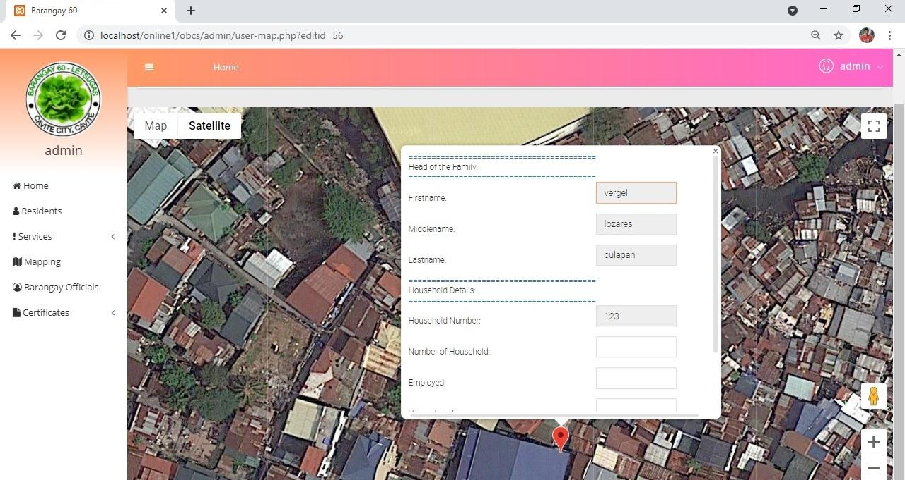

Appendix Figure 11. Map

The map will show up when you click the view and also when you click a specific house the information of the house will show up too.

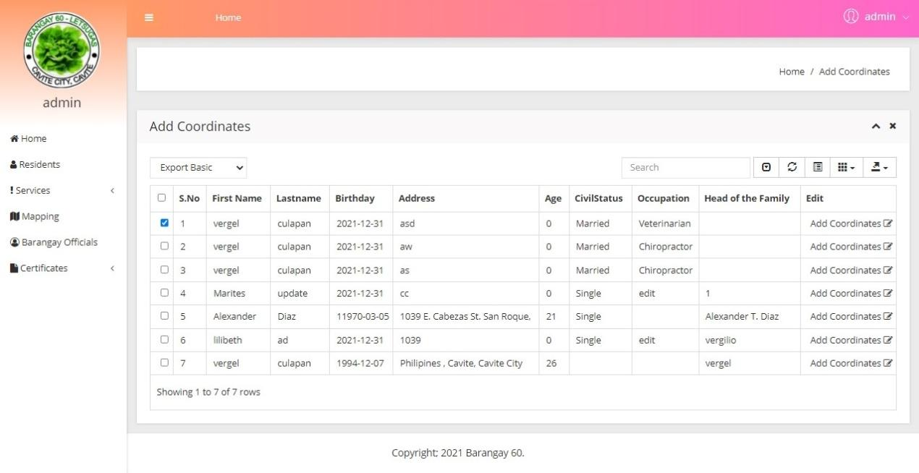

Appendix Figure 12. Add Coordinates Form

When you click the “Add Coordinates” automatically the head of the family will be show up and then fill up the necessary field.

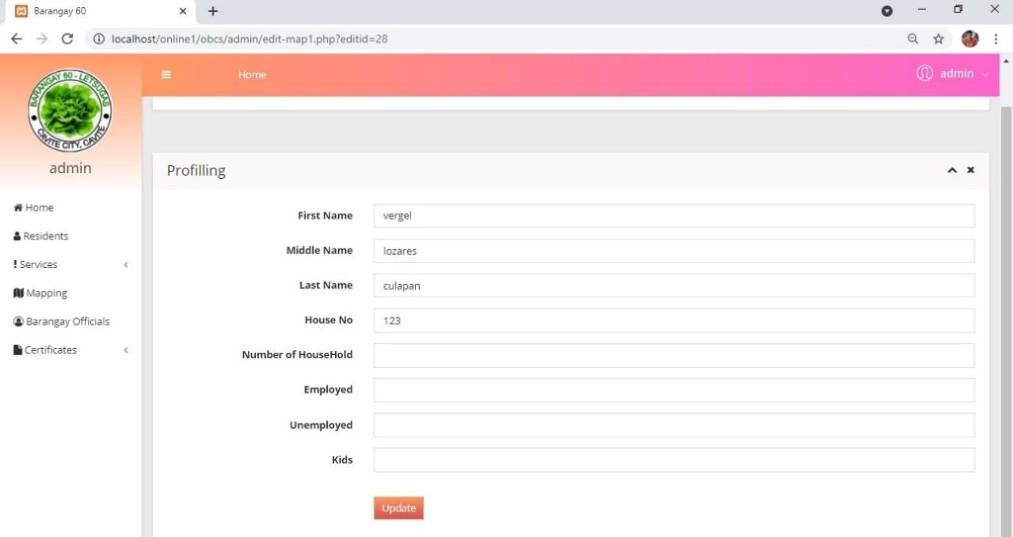

Appendix Figure 13. Profiling Form

This is the profiling form in mapping wherein you can update all the information of people living in the barangay.

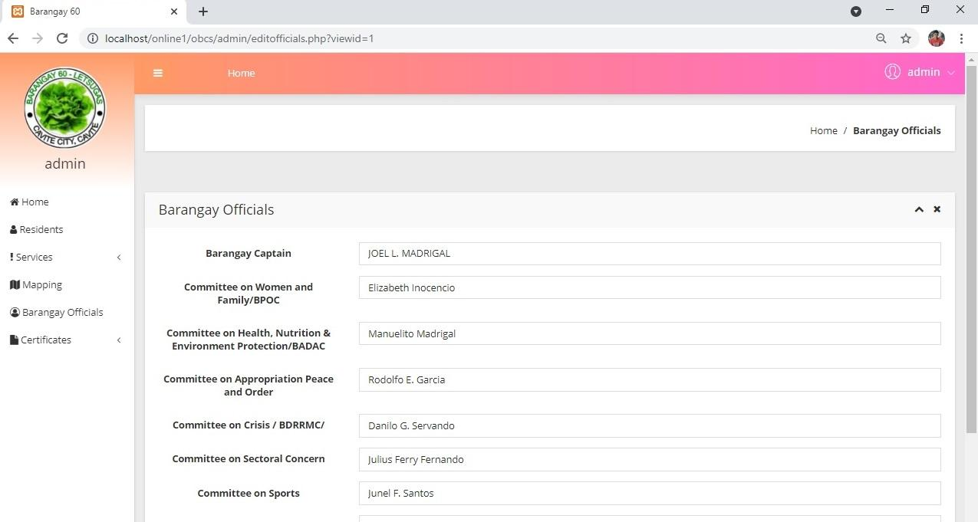

Click

Appendix Figure 14. Barangay Officials Form

To view the barangay officials, click the “Barangay Officials” button. Once the barangay officials were updated, it will automatically update the barangay officials written within the certificates.

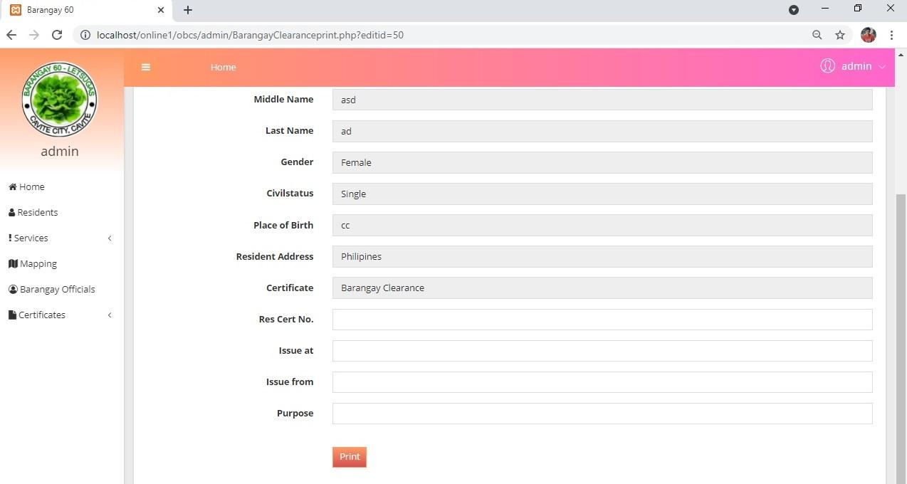

Appendix Figure 15. Barangay Certificates Form

Appendix Figure 15. Continued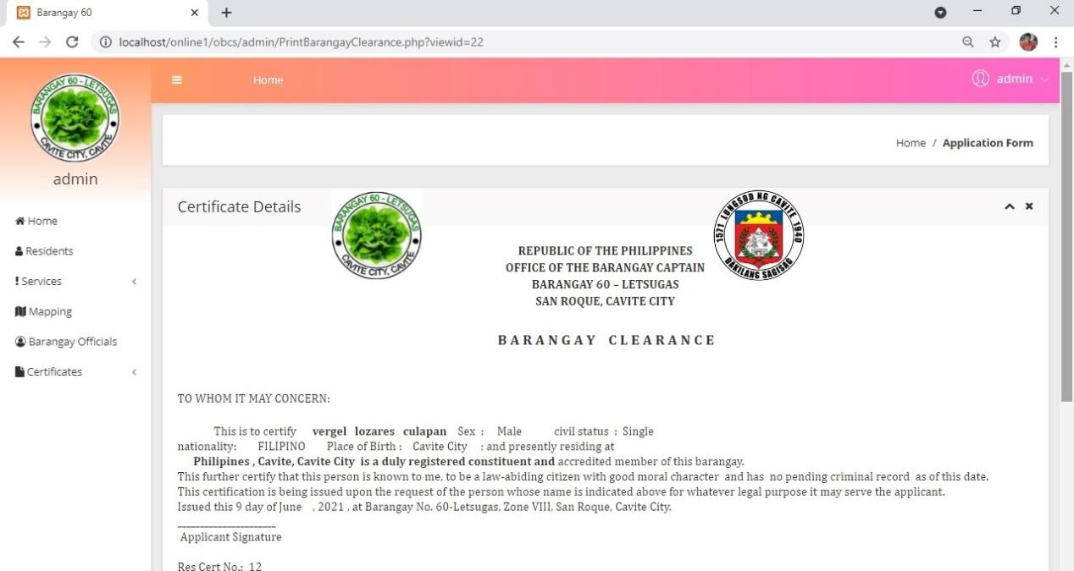

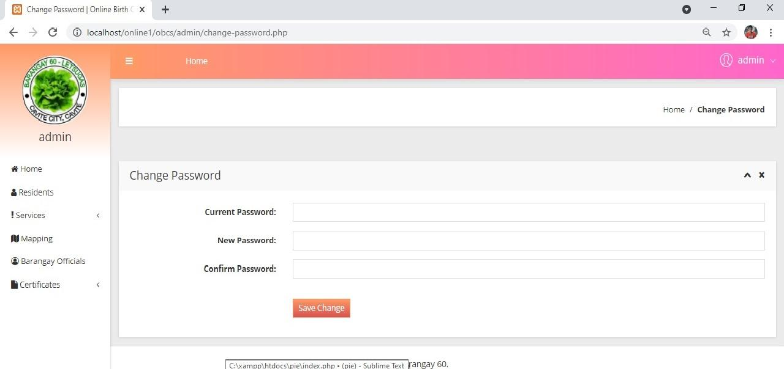

1

Appendix Figure 16. Change Password Form

1. Click the word “admin” and go to settings then you will automatically go to change password form and fill up the form to be able to change the old password.

**Appendix 6**

RD Forms

Republic of the Philippines

**CAVITE STATE UNIVERSITY VISION**

THE PREMIER UNIVERSITY IN HISTORIC CAVITE RECOGNIZED FOR EXCELLENCE IN THE DEVELOPMENT OF GLOBALLY COMPETITIVE AND MORALLY UPRIGHT INDIVIDUALS

**CAVITE STATE UNIVERSITY**

Cavite City Campus

*Pulo II, Dalahican, Cavite City*

Tel. (046) 431-35-70; (406) 431-35-80

**DEPARTMENT OF INFORMATION TECHNOLOGY**



**PROJECT DESIGN TITLE APPROVAL SHEET**

Name Signature



**Vergel L. Culapan** ________________________

**Tyrone James C. Simon**  ________________________

Degree: **BSIT / BSCS** Type of Study: **Undergraduate Thesis**

Title: **MANAGEMENT INFORMATION SYSTEM OF BARANGAY 60**

* **LETSUGAS SAN ROQUE,**

**CAVITE CITY**

**A P P R O V E D:**

**ALMA DE FIESTA, MSManE 09/16/20**

Research Instructor Date

**ALMA DE FIESTA, MSManE 09/16/20**

Department Head Date

**N O T E D:**

**EMERIZA S. CAPARAZ, MSHRM 09/16/20**

Campus Coordinator, RDE Date

Republic of the Philippines

**CAVITE STATE UNIVERSITY VISION**

THE PREMIER UNIVERSITY IN HISTORIC CAVITE RECOGNIZED FOR EXCELLENCE IN THE DEVELOPMENT OF GLOBALLY COMPETITIVE AND MORALLY UPRIGHT INDIVIDUALS

**CAVITE STATE UNIVERSITY**

Cavite City Campus

*Pulo II, Dalahican, Cavite City*

Tel. (046) 431-35-70; (406) 431-35-80

**DEPARTMENT OF INFORMATION TECHNOLOGY**



**REQUEST FOR ADVISER AND TECHNICAL CRITIC**

Name Signature



**Vergel L. Culapan** ________________________

**Tyrone James C. Simon** ________________________

Degree: **BSIT** Type of Study: **Undergraduate Thesis**

**C O N F O R M E:**

**ALMA DE FIESTA, MSManE JOEMER L. CASTILLO**

Adviser Technical Critic

**__9/09/20__** **__9/09/20__**

Date Date

**A P P R O V E D:**

**ALMA DE FIESTA**

Department Head

**__9/09/20__**

Date

Republic of the Philippines

**CAVITE STATE UNIVERSITY**

Cavite City Campus

*Pulo II, Dalahican, Cavite City*

Tel. (046) 431-35-70; (406) 431-35-80

**DEPARTMENT OF INFORMATION TECHNOLOGY**



**PROGRAM OF WORK**

Name Signature



**Vergel L. Culapan** ________________________

**Tyrone James C. Simon** ________________________

Degree: **BSIT** Type of Study: **Undergraduate Thesis**

Title: **MANAGEMENT INFORMATION SYSTEM OF BARANGAY 60 – LETSUGAS SAN ROQUE, CAVITE CITY**

|  |  |  |  |
| --- | --- | --- | --- |
| **Activity** | **Target Dates** | **Expected Output** | **Date Accomplished** |
| Activity Planning | **02/25/2020** | Program of work | **04/29/2021** |
| Research title development | **8/17/2020** | Research title approved | **09/16/2020** |
| Research instruments drafting and consultations | **04/20/2021** | Instruments and methodologies accepted | **04/19/2020** |
| Research outline defense | **12/02/2020** | Research proposal approved | **09/16/2020** |
| Data gathering/Testing | **09/25/2020** | Needed information collected | **04/27/2021** |
| Manuscript Preparation | **05/01/2021** | Data analyzed/ Written-up | **03/5/2021** |
| Final oral defense | **05/30/2021** | Research study approved | **04/19/2021** |
| Manuscript review | **09/20/2021** | Manuscript approved/ hardbound |  |

**A P P R O V E D:**

**ALMA G. DE FIESTA, MSManE JOEMER L. CASTILLO**

Adviser Technical Critic

Date: ____________ Date: ____________

**N O T E D:**

**EMERIZA S. CAPARAZ, MSHRM**

Department Head

Date: ______________

Republic of the Philippines

**CAVITE STATE UNIVERSITY VISION**

THE PREMIER UNIVERSITY IN HISTORIC CAVITE RECOGNIZED FOR EXCELLENCE IN THE DEVELOPMENT OF GLOBALLY COMPETITIVE AND MORALLY UPRIGHT INDIVIDUALS

**CAVITE STATE UNIVERSITY**

Cavite City Campus

*Pulo II, Dalahican, Cavite City*

Tel. (046) 431-35-70; (406) 431-35-80

**DEPARTMENT OF INFORMATION TECHNOLOGY**

**REQUEST FOR PRELIMINARY ORAL REVIEW**

12/09/2020

Dear Department Chair:

We wish to request for a preliminary oral review of our project design outline entitled **Management Information System of Barangay 60 – Letsugas San Roque, Cavite City** on 1:00 P.M, December 09, 2020 at Cavite State University–Cavite City Campus.

Very truly yours,

**VERGEL L. CULAPAN**

**TYRONE JAMES C. SIMON**

Degree: **BSIT** Type of Study: **Undergraduate Thesis**

**A P P R O V E D:**

**ALMA G. DE FIESTA, MSManE JOEMER L. CASTILLO**

Adviser Technical Critic

Date: **12/09/20** Date: **12/09/20**

**ALMA G. DE FIESTA, MSManE**

Department Head

Date: **12/09/20**

**N O T E D:**

**EMERIZA S. CAPARAZ, MSHRM**

Campus Coordinator, RDE

Date: **12/09/20**

Republic of the Philippines

**CAVITE STATE UNIVERSITY VISION**

THE PREMIER UNIVERSITY IN HISTORIC CAVITE RECOGNIZED FOR EXCELLENCE IN THE DEVELOPMENT OF GLOBALLY COMPETITIVE AND MORALLY UPRIGHT INDIVIDUALS

**CAVITE STATE UNIVERSITY**

Cavite City Campus

*Pulo II, Dalahican, Cavite City*

Tel. (046) 431-35-70; (406) 431-35-80

**DEPARTMENT OF INFORMATION TECHNOLOGY**



**OUTLINE/PROPOSAL APPROVAL SHEET**

Name Signature



**Vergel L. Culapan** ________________________

**Tyrone James C. Simon** ________________________

Degree: **BSIT** Type of Study: **Undergraduate Thesis**

Title: **MANAGEMENT INFORMATION SYSTEM OF BARANGAY 60 – LETSUGAS SAN ROQUE, CAVITE CITY**

**A P P R O V E D:**

**ALMA G. DE FIESTA, MSManE JOEMER L. CASTILLO**

Adviser Technical Critic

Date: **12/02/20** Date: **12/02/20**

**ALMA G. DE FIESTA, MSManE**

Department Head

Date: **12/02/20**

**N O T E D:**

**EMERIZA S. CAPARAZ, MSHRM**

Campus Coordinator, RDE

Date: **12/02/20**

**MARIA CRISTINA J. BAESA, MAEd**

Campus Administrator

Date: **12/02/20**

Republic of the Philippines

**CAVITE STATE UNIVERSITY VISION**

THE PREMIER UNIVERSITY IN HISTORIC CAVITE RECOGNIZED FOR EXCELLENCE IN THE DEVELOPMENT OF GLOBALLY COMPETITIVE AND MORALLY UPRIGHT INDIVIDUALS

**CAVITE STATE UNIVERSITY**

Cavite City Campus

*Pulo II, Dalahican, Cavite City*

Tel. (046) 431-35-70; (406) 431-35-80

**DEPARTMENT OF INFORMATION TECHNOLOGY**

**REQUEST FOR ORAL DEFENSE**

04/27/2021

Dear Department Head:

We wish to request for the final oral defense of our undergraduate thesis/project design manuscript entitled, **Management Information System of Barangay 60 Letsugas San Roque, Cavite City** on 10:00 A.M, April 27, 2021 at Cavite State University-Cavite City Campus.

Very truly yours,

**Vergel L. Culapan**

**Tyrone James C. Simon**

Degree: **BSIT** Type of Study: **Undergraduate Thesis**

**A P P R O V E D:**

**ALMA G. DE FIESTA, MSManE JOEMER L. CASTILLO**

Adviser Technical Critic

Date: **04/27/21** Date: **04/27/21**

**ALMA G. DE FIESTA, MSManE**

Department Head

Date: **04/27/21**

**N O T E D:**

**EMERIZA S. CAPARAZ, MSHRM**

Campus Coordinator, RDE

Date: **04/27/21**

**MARIA CRISTINA J. BAESA, MAEd**

Campus Administrator

Date: **04/27/21**

Republic of the Philippines

**CAVITE STATE UNIVERSITY VISION**

THE PREMIER UNIVERSITY IN HISTORIC CAVITE RECOGNIZED FOR EXCELLENCE IN THE DEVELOPMENT OF GLOBALLY COMPETITIVE AND MORALLY UPRIGHT INDIVIDUALS

**CAVITE STATE UNIVERSITY**

Cavite City Campus

*Pulo II, Dalahican, Cavite City*

Tel. (046) 431-35-70; (406) 431-35-80

**DEPARTMENT OF INFORMATION TECHNOLOGY**



**ORAL DEFENSE EVALUATION**

Name Signature



**Vergel L. Culapan** ________________________

**Tyrone James C. Simon** ______________________

Degree: **BSIT** Type of Study: **Undergraduate Thesis**

Title: **MANAGEMENT INFORMATION SYSTEM OF BARANGAY 60**

**LETSUGAS SAN ROQUE, CAVITE CITY**

|  |  |  |  |  |
| --- | --- | --- | --- | --- |
| **CRITERION** | **WEIGHT** | **RATING** | | |
| **Chair Panel** | **Panel Member** | **Panel Member** |
| 1. Document (Content and Organization) | 20% |  |  |  |
| 1. System Functionality (Completion/Design) | 60% |  |  |  |
| 1. Oral Presentation   (Comprehension / Q7A) | 20% |  |  |  |
| **TOTAL** | **100%** |  |  |  |
| **Average Rate** |  | | | |

**A P P R O V E D:**

**ALMA G. DE FIESTA, MSManE JOEMER L. CASTILLO**

Adviser Technical Critic

Date: **__04/30/21__**  Date**: __04/30/21__**

**N O T E D:**

**EMERIZA S. CAPARAZ, MSHRM**

Campus Coordinator, RDE

Date: **__04/30/21__**

**MARIA CRISTINA J. BAESA, MAEd**

Campus Administrator

Date: **__04/30/21__**

Republic of the Philippines

**CAVITE STATE UNIVERSITY VISION**

THE PREMIER UNIVERSITY IN HISTORIC CAVITE RECOGNIZED FOR EXCELLENCE IN THE DEVELOPMENT OF GLOBALLY COMPETITIVE AND MORALLY UPRIGHT INDIVIDUALS

**CAVITE STATE UNIVERSITY**

Cavite City Campus

*Pulo II, Dalahican, Cavite City*

Tel. (046) 431-35-70; (406) 431-35-80

**DEPARTMENT OF INFORMATION TECHNILOGY**

**ROUTING SLIP**

Name Signature



**Vergel L. Culapan** ________________________

**Tyrone James C. Simon** ________________________

Degree: **BSIT** Type of Study: **Undergraduate Thesis**

Title: **MANAGEMENT INFORMATION SYSTEM OF BARANGAY 60**

* **LETSUGAS SAN ROQUE, CAVITE CITY**

|  |  |  |  |  |
| --- | --- | --- | --- | --- |
|  | Remarks | Date Received | Date Released | Signature |
| **ALMA G. DE FIESTA**  Adviser | With correction | 7/2/2021 | 7/21/2021 |  |
| With correction | 7/22/2021 | 7/27/2021 |  |
|  |  |  |  |
| **JOEMER L. CASTILLO**  Technical Critic | With revisions | 07/29/2021 | 08/02/2021 |  |
|  |  |  |  |
|  |  |  |  |
| **ALMA G. DE FIESTA**  Department Head |  |  |  |  |
|  |  |  |  |
|  |  |  |  |
| **EMERIZA S. CAPARAZ**  Campus Coordinator, RDE |  |  |  |  |
|  |  |  |  |
|  |  |  |  |
| **MARIA CRISTINA J. BAESA, MAEd**  Campus Administrator |  |  |  |  |
|  |  |  |  |
|  |  |  |  |