# 听说模拟12答案

## 朗读句子

1. Operas often tell stories of love, anger and jealousy.

1. Gardening is caring for and growing plants, both outdoors and indoors.

2. Scientists and researchers are finding innovative uses for robots, many of which promise to change the world in a positive way.

## 朗读段落

The majority of my time on the Web involves looking up technical computer information, which I use for teaching Microsoft application classes and providing technical advice at work. Outside of work, I really like following all aspects of the financial world, and the Web has turned into a great resource for this hobby. I can’t imagine being without it. Although it takes time to compare the huge amount of sources, I find that after years of use I can quickly analyze the search results to find the most appropriate site.

## 情景提问

**Questions 1~2** Your neighbour tells you that a new underground railway station is being built near your neighbourhood. Ask her two questions for more details.

* When will the new underground railway station be finished? Where will the new line passed?
* Where will this new line start? What’s the length of the new line?
* How many stations will the new line have? Which line does this station belong to?

Keywords: when station finished where line passed|when station finished what’s length line|when station finished which line belong to

**Questions 3~4** You are wondering what optional course to take, so you turn to your teacher and ask him two questions for help.

* Which optional course should I take? Which optional course is better for me?
* What optional course is suitable for me? Which optional course is better for me?
* Should I take the health and medicine class as my optional class? Which optional course is better for me?

Keywords: which course should take which course better|what course suitable which course better|should take class optional class which course better

## 情景描述

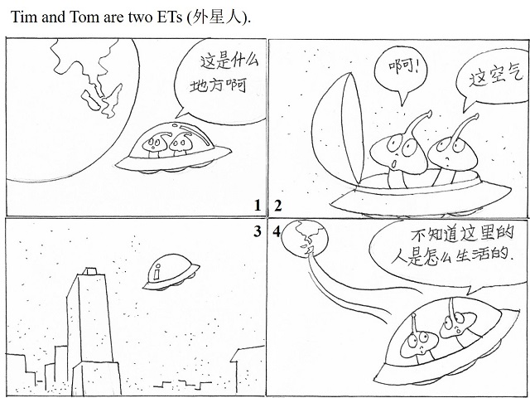

* Tim and Tom are two ETs. They often travel in the spaceship to different places. One day, they found a planet, on which the land is surrounded with water. They wondered what it was, and they decided to go there to have a look. However, when they arrived on the planet and opened the door of the spaceship, they found that the air was so dirty that they didn’t want to land on it. Therefore, they immediately closed the door and flew away. They couldn’t imagine how people could survive on such an unpleasant planet.
* Tim and Tom are two ETs. They enjoy traveling in their UFO to different places in the universe. One day, they came to a planet that they had never seen before, the Earth. The land in the Earth is surrounded with water. It looked so beautiful that Tim and Tom decided to go there to have a look. When they landed on the Earth, they opened the door of their UFO, ready to enjoy the beautiful scenery and breathe the clean air. However, what welcomed them was the dirty air. They were surprised at seeing this. Then they closed the door and flew away at once. They could not imagine that people on the Earth could live on such a terrible planet.
* Tim and Tom are two ETs. They like to travel around the universe in their UFO. One day, when they were travelling, they saw a blue planet, which is surrounded by water. They thought it must be very beautiful on the planet, so they decided to go there to have a look. When they arrived on the planet, they couldn’t wait to open the door to enjoy the beautiful scenery. But at the moment, they felt terrible, because the air was so dirty that they could hardly breathe. They immediately closed the door and flew away. They wondered how people could live on such an unpleasant planet.

## 快速应答

**1.** Would you like some more coffee?

* Yes, please.
* No, thanks.
* No, thanks. I have drunk enough.

Keywords: yes please|no thanks|no thanks drunk enough

**2.** How often do you go to the school library?

* Once a week.
* Twice a month.
* I go to the school library three times a month.

Keywords: a week|a month

**3.** You look marvelous in this suit.

* Thank you.
* Thank you very much.
* Oh, you flattered me!

Keywords: thank you|you flattered me

**4.** I failed in the driving test yesterday.

* How bad the news is!
* Oh, I’m sorry to hear that.
* Don’t be sad. You’ll pass it the next time.

Keywords: how bad news|sorry hear|don’t sad you pass next time

## 简述和回答

**Listen to the following speaker talking about Mary Louise Defender Wilson, an American Native story-teller.**One person who has devoted her life to storytelling is Mary Louise Defender Wilson. Wilson was born in 1930 on the Standing Rock Indian Reservation in Shields, North Dakota. She grew up hearing native stories from her mother and grandparents. Wilson’s mother told her stories of the plants and animals she saw while traveling to and from work. Through these stories, Wilson learned the values, beliefs, history, and language of her culture.Today Wilson shares what she has learned whenever she can. She hosts Native-language radio programs and records stories in two languages on CDs for all to hear. Storytelling has played a large role in her work as a teacher and as the director of a number of programs. For her, storytelling is a way of life.Wilson believes that the stories she tells convey valuable lessons. They teach history and reveal the interconnection of all life forms. Many stories she shares tell about local sites. One story about a rock near Fort Ransom, North Dakota, is of a woman who turned herself to stone because of her love of nature. Another tells of a woman who lived with a family of wolves on a local hill. Each of the stories she tells conveys a respect for nature, others, and for one’s homeland, culture, and history.

**1.** According to Wilson, what valuable lessons are conveyed by the stories she tells?

* They teach history and reveal the interconnection of all life forms.
* The stories teach history and reveal the interconnection of all life forms.
* They convey a respect for nature, others, and for one’s homeland, culture and history.

Keywords: teach history reveal interconnection life forms|convey respect nature homeland culture history

**2.** What kind of stories do you like most? Why?

* I like stories that convey a respect for nature most. There are two reasons. First, we live in nature. It seems that nowadays we are so busy with our studies or work that we do not pay enough attention to nature. In this way, stories about nature can remind us of the importance of nature. Second, as a high school student, I always concentrate on my studies and I feel tired at times. Stories that convey a respect for nature can purify my heart and soul, which will restart me on academic study.
* I like comedy stories most. There are two reasons. First of all, when I am free to read a story, I hope I can be relaxed and happy. Compared with tragedies, comedy stories will make me feel happy and pleasant. Second, comedy stories always have happy endings, which gives me a belief — everything will be all right in the end. It will cheer me up when I meet with difficulties.
* I like tragedies most. There are two reasons. To begin with, life is not always happy and not all people’s lives are happy. Tragedies can reveal the real life of some people. From these stories, I can know how people’s life differs from one another. Secondly, through reading tragedies, I can see the optimistic parts in my life, and then cherish my happy life.

Keywords: like stories most reasons