# 听说模拟13答案

## 朗读句子

1. Mozart was only five years old when he wrote his first piece of music.

1. Operas often tell stories of love, anger and jealousy.

2. Wouldn’t it be wonderful if the characters in books could really come alive and tell their own stories?

## 朗读段落

At some expensive dinners, guests are provided with finger-bowls so that they can dip their dirty fingers in the water and wash them. On one famous occasion, Queen Victoria gave a state dinner for a visiting queen. Not realizing what the finger-bowl was for, the visitor picked it up and drank some of the water in it. Queen Victoria did not wish to embarrass her guest, so she had a little drink from her finger-bowl too. The other guests had to follow the Queen’s example.

## 情景提问

**Questions 1~2** You’ve got lost on the way to the Grand Theatre. Ask a passerby two questions for help.

* Excuse me, I can’t find my way to the Grand Theatre. Could you please tell me how I can get there? Which direction should I turn to?
* Excuse me, do you know the way to the Grand Theatre? Which direction should I turn to?
* Do you know how I can get to the Grand Theatre? Which direction should I turn to?

Keywords: can’t find way Grand Theatre tell how can get there Which direction turn|do know way Grand Theatre Which direction turn|Do know how can get Grand Theatre Which direction turn

**Questions 3~4** Your friend, Tom, has won the first prize in the English speech contest. Ask him two questions about it.

* How did you prepare the English speech contest? Did you meet anyone you know in the contest?
* Congratulations! How are you going to celebrate it? Did you ask our teacher’s help when you were preparing the contest?
* Are you going to take part in the next contest? How are you feeling now?

Keywords: How prepare English speech contest meet anyone know contest|Congratulations How going celebrate ask teacher’s help when preparing contest|going take part next contest How feeling

## 情景描述

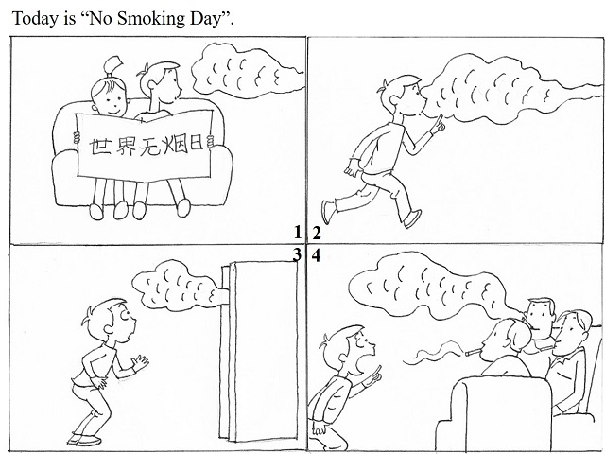

* Today is “No Smoking Day”. Mike and his friend are reading a book about it in his room. Suddenly, he smells a heavy smoke of cigarettes. He wants to know where the smell comes from, so he follows the smell. Then he comes to the living room, and sees his family members smoking. He immediately asks them to stop smoking. He tells them that smoking will do harm to their health. Hearing this, his family members stop smoking at once.
* Today is “No Smoking Day”. Joe and his classmate are reading a poster about it in his room. There comes a heavy smoke of cigarettes. Joe smells it and he wonders where it comes from, so he follows the smell. The smell leads him to the living room. Joe comes into the living room and finds that his father and some visitors are smoking. He is shocked and he asks them to stop smoking. Meanwhile, he tells them that smoking will do harm to their health. After hearing this, his family members stop smoking and speak highly of Joe.
* Today is “No Smoking Day”. Peter and his sister are reading a book about smoking in his bedroom. Suddenly, Peter smells a heavy smoke of tobacco. He feels surprised and decides to find out where it comes from, so he follows the smell. At last, he arrives at the living room. He comes into it and finds that his father and his uncles are all smoking. Being shocked, he tells them that smoking will be bad for their health and asks them to stop smoking. His father and his uncles realize that what Peter says is true, so they stop smoking and praise Peter.

## 快速应答

**1.** You don’t look well. What’s the matter?

* I feel painful in my stomach.
* I failed my math exam. I feel sad.
* I don’t know. I’m not feeling well after having the sandwich.

Keywords: feel painful stomach|failed math exam feel sad|don’t know I’m not feeling well after having sandwich

**2.** Do you mind if I leave my bag here?

* No, I don’t mind. Please put it here.
* Not at all. You can put it here.
* Sorry, this is my friend’s seat and he’ll be here later.

Keywords: No don’t mind Please put here|Not at all You can put here|Sorry this friend’s seat and he’ll here later

**3.** I don’t think the movie is as exciting as I expected.

* I agree with you.
* Neither do I. That movie is too boring.
* Really? But I think it’s exciting for me.

Keywords: agree|Neither do movie boring|it’s exciting

**4.** I’m afraid I have to be going.

* OK. Be careful and have a good trip.
* Oh, it’s still early now. Please have lunch with us before your leaving.
* OK. See you next time.

Keywords: careful have good trip|early now have lunch before leaving|See next time

## 简述和回答

**Listen to the following speaker talking about the scientific process.**The world is full of new things to discover. Through a process of experimenting and documenting, we can find out how different parts of the natural world work. This is called the scientific process, or scientific method.The scientific process can be broken down into steps. The first step is to raise a question about something you have observed in the natural world. The wording you use for the question is very important. A question must be objective — it can’t deal with values or feelings.After you establish a question, create a statement of what you expect to happen during an experiment. Suppose your question is “What will happen to the seeds if I change the temperature they are kept at before I plant them?” Your statement might be “The higher the temperature at which I keep the seeds, the quicker I expect them to come up.”The next step is to write a procedure for your experiment. This will include all the steps needed to carry out the experiment. Then conduct your experiment. After completing the experiment, record your results and draw a conclusion based on the results. Sometimes your conclusion will prove your statement to be wrong. That’s OK! You will still have learned something on your path of discovery.

**1.** List two of the steps that follow “raising a question” in the scientific process.

* Create a statement of what you expect to happen during an experiment; write a procedure for your experiment.
* Write a statement of what you expect to happen during your experiment; write down all the steps needed to carry out the experiment.
* Create a statement of what you expect to happen during the experiment; write down all the steps needed to carry out the experiment.

Keywords: Create statement what expect happen write procedure experiment|Write statement what expect happen write all steps needed carry out experiment|Create statement what expect happen write all steps needed carry out experiment

**2.** Describe an experiment you have ever carried out in or out of class.

* One month ago, I raised a question of “What will happen to the sunflowers if I change the direction of light?” Then I thought the sunflowers would follow the direction of light as it moves. To testify my theory, I wrote a very detailed procedure and prepared all the materials. In the end, I was proved to be right.
* When I was in Grade Two, I wondered if ice would melt faster in the sunlight than in a room. So I prepared two ice blocks and put them into two different glasses respectively. I put one of them in the sunlight, and another of them in the room for five minutes. Five minutes later, I found that there was more water in the glass which was put in the sunlight. Then I knew that the ice block in the sunlight melted faster than the one in the room.
* I did an experiment when I was in middle school. I wondered what would happen if I mix different colors together. I prepared different kinds of colored water. Then I mixed the colored water of yellow and blue together. To my surprise, the water turned into green. I kept mixing different colored water, and the water turned into different colors. At last, I drew a conclusion that if I mixed different colors together, it would turn into different colors.

Keywords: An Experiment