# 听说模拟9答案

## 朗读句子

1. To travel around the world is the dream of many adventurous people.

1. With great power comes great responsibility: this is my gift.

## 朗读段落

Volunteers are the backbone of many organizations. They are giving of their time and labour and expect very little in return. Recognizing volunteers for their efforts is an important part of retaining and recruiting volunteers. Organizations that show their appreciation keep volunteers as well as attract new ones to help with their cause. There are many ways to recognize volunteers from free and simple ideas to those that require some cost and effort. No matter what way works for you, it is important to do something to make those who are so giving of themselves know that they are appreciated and a precious part of your success as an organization.

## 情景提问

**Questions 1~2** Your classmate Jane has just got a Christmas gift, a new dress, from her mother. You ask her two questions about the dress.

* What colour is your new dress? What’s its style?
* How much is the dress? Do you like it?
* Where does your mother buy the dress? Is it the latest one?
* What is the brand name of your new dress? Is it expensive?
* What is the price of the dress? Did your mother buy it online?
* What is the style of your new dress? Do you like it?
* What do you think of the new dress? Is it beautiful?
* How do you like the new dress? Have you tried it on yet?
* What colour is your new dress? How much is it?
* What's the colour of the dress? Do you like the dress?

Keywords: What colour What’s style|how much do you like|where buy latest|what brand name is it expensive|what price did buy online|what style do you like|what think of is it beautiful|how like have you tried on|what colour how much

**Questions 3~4** Your best friend attended a wedding last Sunday. Ask him two questions about the wedding.

* How many people attended the wedding? Did you enjoy yourself at the wedding?
* What impressed you most at the wedding? Was it full of surprises?
* Where was the wedding held? Was it held in a church?
* How do you like the wedding? Is it interesting?
* What present did you give to the new couple? Did they like your present?
* What did the bride wear? Was she in a beautiful wedding dress?
* What did the bride wear? Did she wear a red Chinese wedding gown?
* What did the groom wear? Did he wear a dinner jacket?
* What activities was held at the wedding? Did you take any photos?
* How many guests were there at the wedding? What time did it begin?
* How many guests were invited? When did it end?

Keywords: How many people attended Did you enjoy|What impressed most Was it full surprises|Where held Was it held in|How like Is it|What present give couple Did they like|What bride wear was she in|What bride wear did she wear|What groom wear Did he wear|What activities held Did you take photos|how many guests What time begin|How many guests When end

## 情景描述

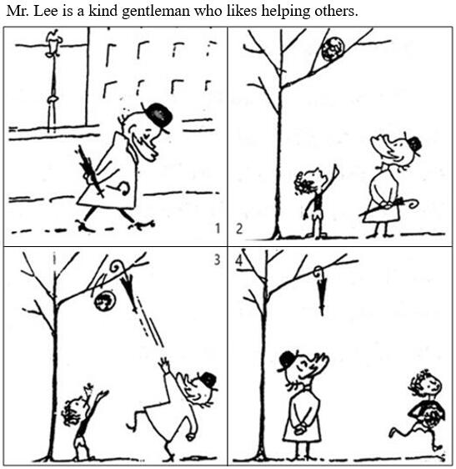

* Mr. Lee is a kind gentleman who likes helping others. One morning, Mr. Lee was walking in the street when he saw a little boy standing under a tree. The boy was so helpless that he was almost crying out. It turned out that his ball was stuck on the tree and he couldn’t get it. Mr. Lee decided to help him, so he threw his umbrella at the ball. With Mr. Lee’s help, the boy got his ball and went back home happily. But Mr. Lee was not happy because his favourite umbrella was left on the tree.
* Mr. Lee is a kind gentleman who likes helping others. On a cold winter morning, he was walking in the street. Suddenly he saw a boy standing under a tree and looking up sadly. The boy told Mr. Lee that his ball was on the tree and he didn’t know how to get it. Mr. Lee wanted to help, so he threw his umbrella at the ball. Then the ball fell down and the boy got his ball back happily. But Mr. Lee looked up and found his umbrella was hanging in the tree.
* Mr. Lee is a kind gentleman who likes helping others. One day, he was on the way back home. A little boy came over to him suddenly and asked for help. He pointed at a tree and Mr. Lee found a ball was stuck in the branches. He decided to help the poor boy. He glanced at his umbrella and had a good idea. He threw the umbrella at the ball. In this way, the ball fell down and the boy was pleased to get his ball back. But Mr. Lee’s favourite umbrella was thus left on the tree.

## 快速应答

**1.** I’m wondering if I can use your laptop for a while.

* Sure. Here you are.
* Of course you can.
* Sorry, I left it at home.
* Sure. Go ahead.
* Sure. You can use it as long as you like.
* OK. Go ahead.
* Certainly.
* Certainly. Go ahead.
* Certainly you can.
* Certainly, but could you please wait a second?
* Sorry, I’m waiting for an important e-mail.
* I am sorry you can’t. Because I lent it to my cousin.

Keywords: sure|sure of course|sorry left home|sure can use as long as|ok go ahead|certainly|certainly go ahead|certainly can|certainly but could you please wait|sorry waiting important e-mail|sorry Because lent to

**2.** There will be a party this Friday evening, and I’d like to invite you go with me.

* Oh, I’d love to. Thank you.
* Thank you. With pleasure.
* Sorry, I’m unavailable then.
* Sorry, I’m busy then.
* Sorry, I’m not available then.
* Sorry, I can’t find time then.
* I’m sorry but I have another appointment this Friday evening.
* I’d love to, but I’m afraid I can’t make it.
* Thank you, but I’m afraid I can’t go.
* I’d like to. I love parties.
* Oh, I really love to. Thank you.
* I’d love to. Thanks.
* I really love to. Thanks.
* Sorry, I’m not interested in parties.
* Sorry, I don’t like parties.
* Oh, thank you for inviting me. But I’m afraid I can’t go.

Keywords: I’d love to thank you|with pleasure|I’d like to|sorry unavailable|sorry busy|sorry not available|sorry can’t find time|sorry have another appointment|love to but can’t make it|thank you can’t go|I’d like to love parties|love to thank you|love to thanks|sorry not interested|sorry don’t like parties|thank for inviting afraid can’t

**3.** Please take care of yourself. Hope to meet you soon.

* Sure. Hope to see you soon.
* I will. See you next time.
* I will. Take care!
* Thanks. Take care of yourself too!
* Thank you. I will.
* Thank you. I will. See you soon.
* Thank you. I will. Hope to see you soon.
* Thanks. I’ll miss you.
* Sure. Take care!
* OK. See you.

Keywords: Sure hope see soon|I will see next time|I will take care|Thanks take care|thank you I will|thank you I will see you soon|thank you I will hope see you soon|thanks I’ll miss you|sure take care|OK see you

**4.** What do you think of the charity event held by our school today?

* It’s meaningful.
* It can help people in need.
* I think it is great.
* It’s great.
* It’s boring but very meaningful.
* I think it is fantastic.
* I think it is boring.
* Interesting.
* It’s boring.
* It’s wonderful.
* It’s exciting.
* It’s amazing.
* It’s fantastic.
* It is exciting
* It is amazing.
* I think it is amazing.
* I think it is exciting.
* I think it’s a great success.
* I love it. It’s so meaningful.
* It’s wonderful. I think we should have more events like this.

Keywords: meaningful|help people in need|great|boring but meaningful|fantastic|fond of|boring|interesting|wonderful|exciting|amazing|a great success|love meaningful

## 简述和回答

Listen to the following passage about the Mid-Autumn Festival. Every year in September or October, the Mid-Autumn Festival is celebrated as a day for family reunions. In the past, people all over China looked forward to eating moon cakes and watching the moon with their families. But nowadays people are celebrating the festival in modern ways. One way many people choose is to travel during the festival. As a result, scenic spots across China become crowded. Traffic in many areas becomes busy due to the huge numbers of people on the roads. Another popular way to celebrate the festival is to do shopping. There are lots of holiday sales. Usually people can enjoy considerate services specially offered for the holiday in different shopping malls. They don’t keep time for a big family reunion, since they no longer think a big family dinner is a necessity for this special day. However, a professor from Nankai University warns that festivals cannot be celebrated just for fun. He says that we should keep the valuable elements of the traditional festivals and preserve them for future generations. He also suggests that children should be taught about traditional festivals in kindergarten. Now listen again please.

**1.** What are the two ways people celebrate Mid-Autumn Festival nowadays?

* They choose to travel or do shopping at the festival.
* One way is to choose to travel during the festival and another way is to do shopping at the festival.
* Many people choose to travel during the festival and many will do shopping in different shopping malls.
* They will do shopping or travel.
* One way is to do shopping in different shopping malls. The other is to travel during the festival.

Keywords: travel do shopping|do shopping travel

**2.** Do you like celebrating Mid-Autumn Festival in modern ways? Why?

* No, I prefer to celebrate Mid-Autumn Festival in a traditional way. Mid-Autumn Festival is a day for family reunions. I really enjoy the big family dinner with my parents and my grandparents, and we always have a good time when eating the mooncakes and admiring the moon together.
* Yes, I like celebrating Mid-Autumn Festival in modern ways. Although Mid-Autumn Festival is a day for family reunions, it doesn't mean we should only celebrate it through traditional activities like having a big family dinner or sharing moon cakes. Every year, I travel to the countryside with my family on this special day. We also have a good time with each other.
* No, I don't like celebrating Mid-Autumn Festival in modern ways. I think shopping on this special day is a waste of time. Although there are lots of sales and discounts, we buy things more than we need. That’s also a waste of money. Mid-Autumn Festival is an occasion on which people observe cultural traditions. I think we should spend more time with our families and spend our money in selecting gifts for the people we love.

Keywords: Opinions on Celebrating Mid-Autumn Festival in Modern Ways