# 综合模拟19答案

## 朗读句子

1. She stood up immediately and helped him into her seat.

1. The ability to tolerate pain varies from person to person.

2. They use their huge teeth and work hard to cut down trees, remove branches and put them across streams.

## 朗读段落

An old lady felt frightened when she was on a plane. She had a blanket over her head and did not want to take it off. She said to the air hostess, “I am going to keep this blanket over my head until we are back on the ground again!” Then the captain came. He said, “Madam, the weather is fine, everything is going very well. ” But she looked out from under the blanket with one eye and said, “I am sorry, young man, but I don’t like planes. But I’ll say one thing, ” She continued kindly, “You and your wife keep your plane very clean!”

## 情景提问

**Questions 1~2** You are in a department store and you want to buy a new TV set. You ask the shop assistant two questions about it.

* How much is this TV set? Is there any discount?
* How many kinds of TV sets do you have? Which kind of TV set is the best seller?
* How long is the warranty period of this new TV set? What should I do if I need after-sale service?
* How much does this TV set cost? Is there any discount?
* How much discount could you offer on this TV set? How long is the warranty period of this new TV set?
* How many kinds of sizes do your TV sets have? Which one is cheaper?
* How large is the screen of this TV set? Will you provide home delivery service?
* How much does this TV set cost? What’s the dimensions of this TV set?
* Which one is better? Can you recommend a TV set to me?
* How many kinds of TV sets do you have? What brands of TV sets are selling at a discount?
* What methods of payment do you accept? Do you accept credit card payment?
* Which brand of TV set should I buy? Can you recommend a TV set to me?
* Which brand of TV set is more expensive? Is there any discount?
* Which brand of TV set is cheaper? Is there any discount?

Keywords: How much TV any discount|How many kinds TV Which TV best seller|How long warranty period TV What do need after-sale service|How much TV cost any discount|How much discount offer TV How long warranty period TV|How many sizes TV Which cheaper|How large screen TV provide home delivery service|How much TV cost What’s dimensions TV|Which better recommend TV|How many kinds TV What brands TV selling discount|What payment accept credit card payment|Which brand TV buy recommend TV|Which brand TV more expensive any discount|Which brand TV cheaper any discount

**Questions 3~4** Your class will have a picnic. Ask your classmate two questions about it.

* What time shall we meet? Where will we have the picnic?
* How is the weather on that day? How will we get to the destination?
* What should we prepare for the picnic? Shall we bring something to eat?
* Where shall we meet? Shall we bring something to eat?
* Shall we go together? What should we prepare for the picnic?
* Where will we have the picnic? Shall we bring something to eat?
* Where will we have the picnic? How will we get there?
* How is the weather on that day? Will our teacher go for the picnic with us?
* What will the weather be like on that day? How should we get to the destination?
* What should we take? Do we need to take food and drinks?
* How should we get to the destination? Will our teacher go for the picnic with us?

Keywords: What time we meet Where we have picnic|How weather day How we get destination|What we prepare picnic we bring something eat|Where we meet we bring something eat|we go together What we prepare picnic|Where we have picnic we bring something eat|Where we have picnic How we get there|How weather day Will our teacher go picnic us|What weather like day How we get destination|What we take we need take food drinks|How we get destination our teacher go picnic us

## 情景描述

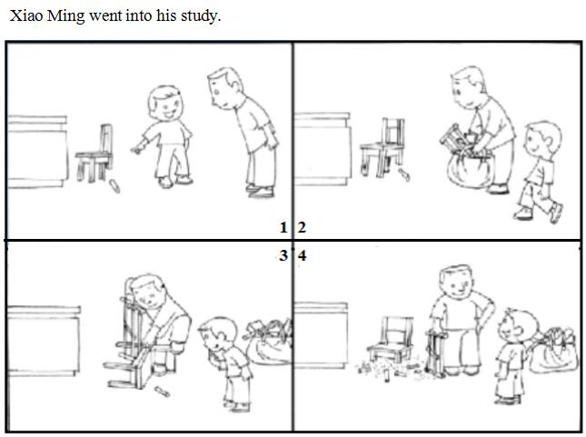

* Xiao Ming went into his study. He found that one of his chair’s feet was broken. So he asked his father to repair it. His father came in and looked at the broken chair. He stood there and thought for a while. Then he took a big bag with some tools in it. He took out a saw from the bag and used it to cut down another three feet of the chair. A few minutes later, the chair could stand still again. This quick and smart reaction surprised Xiao Ming a lot. “How clever my father is!” Xiao Ming said.
* Xiao Ming went into his study. He saw that one of his chair’s leg was broken. So he asked his father for help. His father looked at the broken chair and thought for a while. Then his father came to his study with a big bag in which there are some tools. Then he took his saw out and cut down another three chair legs to make the chair stand firm again. Seeing what his father had done, Xiao Ming was very surprised and he thought proudly that his father was so clever!
* Xiao Ming went into his study. He found that there was something wrong with his chair, because one of the chair leg was broken. So he asked his father to fix the chair. His father stood there for a moment and then a good idea came to his mind. Then he took a big bag of tools and came back. He used his saw to cut down another three legs of the chair. After that, the chair stood firm again. Seeing what his father had done, Xiao Ming was surprised. He said proudly, “How clever my father is!”

## 快速应答

**1.** I wonder if I could use your mobile phone.

* Yes, of course.
* Sure, here you are.
* I’m afraid not. I just need to use it now.
* I’m afraid not. My mobile phone has run out of power.
* I’m afraid not. My mobile phone is charging.
* Certainly, here you are.
* No problem, here you are.
* OK. Here you are.
* Sorry, I forgot to take my mobile phone.
* Sorry, I left my mobile phone at home.
* Sorry. I’m afraid not. There is something wrong with my mobile phone.
* Sorry, but I’m leaving now.
* Sorry, but I’m afraid not because I’m leaving now.
* Of course, here you are.

Keywords: Yes|Sure|I’m afraid not|Certainly|No problem|OK|sorry|Of course

**2.** Hello, may I speak to Mr. Smith?

* Hold on please.
* Yes, this is Smith speaking.
* Sorry, he is busy now. Can I take a message?
* Speaking, please.
* Sorry, he is busy now.
* I’m afraid he is not in now.
* I’m afraid he is not in now. Can I take a message?

Keywords: Hold please|Yes this is Smith speaking|Sorry he is busy now|Speaking please|I’m afraid he is not now

**3.** Sorry, I forgot to bring you the book.

* It’s OK.
* Never mind. It doesn’t really matter.
* It doesn’t matter. We can share one book together.
* It doesn’t matter. But please remember to take it next time.
* It doesn’t matter.
* It’s OK. But please remember to take it next time.
* It’s OK. We can share one book together.
* That’s fine.
* That’s all right.
* It’s OK. No problem.
* It’s no big deal.
* It’s nothing at all.
* Never mind.
* Never mind about that.
* Please think nothing of it.
* Please don’t blame yourself.
* Take it easy. It doesn’t matter.

Keywords: It’s OK|Never mind|It doesn’t matter|That’s fine|That’s all right|It’s no big deal|It’s nothing all|think nothing it|don’t blame yourself|Take it easy

**4.** I’d love you to come to my birthday party on Sunday.

* Thanks for inviting me.
* I’d love to. What time will the party begin?
* I’d love to. But I need to prepare for my exam on that day.
* Thanks for inviting me. I’d love to.
* Happy birthday! What time will the party begin?
* Thank you for inviting me. I’ll be there on time.
* Thank you for inviting me.
* Sounds good.
* That’s great! Thanks for inviting me.
* Sounds great! I’d love to.
* That would be fun. I’d love to go.
* Sorry, but I have a lot of things to do.
* Sorry, but I have to take care of my little brother this Sunday.
* Sorry, but I will be busy this Sunday.

Keywords: Thanks inviting me|That’s great|I’d love to But I need prepare my exam that day|Happy birthday What time will the party begin|Thank you inviting me|Sounds good|I’d love to|Sounds great I’d love to|That would be fun|Sorry but I have things do Sorry but I have take care my little brother this Sunday|Sorry but I will be busy this Sunday

## 简述和回答

**Listen to the following speaker talking about some states of the United States.**There are fifty states in the United States. The largest in population is California. The largest in area is Alaska. Alaska is the smallest in population and Rhode Island is the smallest in size. The oldest states are the ones along the Atlantic coast. The newest states are Alaska and Hawaii. Alaska is also the coldest state. California and Florida are the warmest. Henry and his family live in Seattle, a big city on the Pacific coast. But Los Angeles and San Francisco, also on the Pacific coast, are larger than Seattle. Henry’s cousin, Susan, lives in New York. It is the largest city in the United States. Thousands of people visit New York each year. The most important city in the United States is Washington, D.C. It is the capital, but it is much smaller than New York.

**1.** List two cities of the United States that are on the Pacific coast.

* Seattle and Los Angeles.
* Los Angeles and San Francisco are on the Pacific coast.
* Los Angeles and San Francisco.
* Seattle and San Francisco.

Keywords: Seattle Los Angeles|Los Angeles San Francisco are Pacific coast|Los Angeles San Francisco|Seattle San Francisco

**2.** Which American city or state would you like to visit most? Why?

* New York is the city which I like to visit most. Because it’s the biggest city and has the largest population in America. Moreover, it’s not only the financial center of America but also the financial center of the world.
* Washington, D.C. is the city which I like to visit most. Named after the famous president George Washington, it is the capital and political center of America. The beautiful White House is located in this city as well.
* As far as I am concerned, Hawaii is the state which I like to visit most. I love this state very much. It’s the only state constituted by islands in America and people of all races live here. The scenery in this place is very beautiful and the weather is fine. It’s a good place for traveling.

Keywords: The City I Like to Visit Most in America