# 综合模拟2答案

## 朗读句子

1. They have all agreed to be part of the American Talent Initiative.

1. She stood up immediately and helped him into her seat.

2. Many of these students do not think any top college would want them to attend, let alone help them pay the cost.

## 朗读段落

“Hi, Dr. Peterson. My name is John Woods, and I work for the Voice of America ... Are you available for an interview sometime in the next two weeks? We’re looking for advice from education experts, and your presence would be greatly appreciated.”In the email above, we can see some important pattern-like phrases, such as “Are you available ...”, “We’re looking for advice ...” and “your presence would be appreciated”. These expressions are considered polite ways, in English, to express your intention to ask another person for something. They are socially acceptable and grammatically correct.Building a large set of socially acceptable and grammatically correct phrases can make your language formal and standard, both in oral and written form.

## 情景提问

**Questions 1~2** You want to buy a computer. You are now in front of the computers in a shop. You ask the shop assistant two questions.

* Can you recommend a computer suitable for me? How much is it?
* What’s special about this new computer? Could you show me how to use it?
* Which computer is better, this one or that one? How much are they?
* Are these computers suitable for middle school students? What do you suggest?
* How much is this one? Can I get a discount?
* Do you have computers for high school students? How much are they?
* What’s special about this computer? Is it expensive?
* What is the difference between this one and that one? Which is better?
* Which one is best for middle school students? Can you give me some suggestions?
* Which one is best for students? Can you give me some advice?
* Is this one good for students? How much does it cost?

Keywords: Can you recommend computer suitable for me How much is it|What’s special about this new computer Could you show me how to use it|Which computer is better this one or that one How much are they|Are these computers suitable for middle school students What you suggest|How much is this one Can I get a discount|Do you have computers for high school students How much|What’s special about this computer Is it expensive|What is difference between this one that one Which is better|Which one is best for middle school students Can you give some suggestions|Which one is best for students Can you give some advice|Is this one good for students How much it cost

**Questions 3~4** Your friend Dave just visited a new art museum in your city yesterday. You ask him two questions about it.

* How is the museum? What impressed you most?
* What are on display in the museum? Did you take any photos?
* What did you see in the museum? Is it allowed to take pictures in it?
* What do you think of the museum? Are there any interesting exhibits in it?
* What works of art are displayed in the museum? Are they impressive?
* How is the museum? Do you like it?
* How was your visit to the museum? Was it interesting?
* What are on show in the museum? Did you take photos?
* How do you like the museum? Did you take photos?
* How do you like the museum? Was it impressive to you?
* What was the most impressive exhibit to you? Can you tell me about it?
* How were the works of art there? Were they created by famous artists?
* What are on display there? Are there any works by world-famous artists?
* Did you take any photos there? If yes, can you show them to me?
* What impressed you most in the museum? Can you describe it to me?

Keywords: How is the museum What impressed you most|What are on display in museum Did you take photos|What you see in museum Is it allowed take pictures|What you think of museum Are there interesting exhibits|What works of art are displayed in museum Are they impressive|How is the museum Do you like it|How was your visit to museum Was it interesting|What are on show in museum Did you take photos|How do you like the museum Did you take photos|How do you like museum Was it impressive|What was most impressive exhibit Can you tell me about it|How were the works of art there Were they created by famous artists|What are on display Are there works by world-famous artists|Did you take photos can you show them to me|What impressed you most Can you describe it

## 情景描述

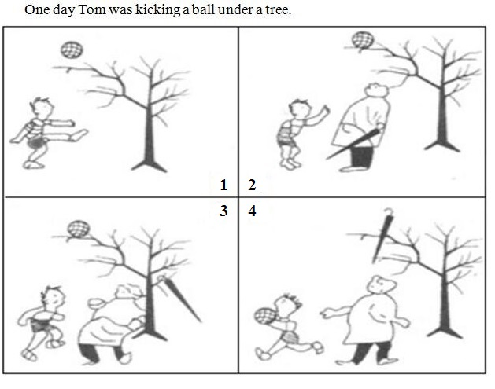

* One day Tom was kicking a ball under a tree. He kicked the ball so high that it got stuck between the branches of the tree. He couldn’t reach it. So he asked a man passing by for help. The man threw his umbrella and hit the ball. It fell off the tree. But unluckily, the umbrella was stuck in the tree now. Tom got the ball back and went away. The man was helpless.
* One day Tom was kicking a ball under a tree. He kicked it very hard. Suddenly it got stuck in the tree. Tom couldn’t reach it. He was anxious. Just then a man went by with an umbrella. Tom walked to him and asked for help. The man threw his umbrella at the ball and the ball was knocked down. But this time the umbrella was caught in the tree. Tom picked up the ball and walked away without saying “thank you” to the man. Who could help the man now?
* One day Tom was kicking a ball under a tree. He kicked it high into the air. Suddenly it got stuck between two branches of the tree. He was too short to reach the ball. While he was wondering how to get it down, a man passed by with an umbrella in his hand. Tom turned to him. The man threw his umbrella at the ball and got it down. But the umbrella was stuck in the tree instead. Tom went away happily with his ball. He didn’t even say a word to the man. How could the poor man get back his umbrella?

## 快速应答

**1.** How are things with you?

* Wonderful.
* Everything is OK with me.
* Not bad.
* Just so-so.
* I’m quite busy these days.
* I’m fine. And you?
* I’m good. Thank you.
* It’s terrible.
* So bad. What about you?

Keywords: Wonderful|OK|not bad|so so|busy|fine|good|terrible|bad

**2.** We’re having an outing on Saturday and I hope you can join us.

* Thank you. I will go with you.
* I’d love to. But I have had an appointment that day.
* Thank you for inviting me and I will go with you.
* Great. I’d love to.
* I would love to, but I’m preoccupied on Saturday.
* I would love to, but I am quite busy then.
* Thanks. I will join you.
* I’d love to. But I’m afraid I couldn’t find time that day.

Keywords: Thank you|love to but have appointment|great|love to but preoccupied|love to but busy|thanks|love to but couldn’t find time

**3.** May I speak to Mr. Johnston, the hotel manager?

* Hold on, please.
* I’m sorry. He’s not available now.
* This is Johnson speaking.
* I’m sorry. He isn’t in right now. Can I take a message?
* I’m sorry. He is not in now. Would you like to leave a message?
* I’m sorry. He isn’t in right now.
* Speaking.

Keywords: Hold on|sorry not available|sorry isn’t in|sorry not in would like leave a message|speaking

**4.** Your beef is really tasty.

* Thank you.
* Thank you. I’m glad you like it.
* Many thanks for your compliment.
* Thank you very much. I’m flattered.
* Thank you. That’s very kind of you!
* Thank you. It’s very kind of you to say so.
* Thank you for your compliment.

Keywords: thank you|thanks

## 简述和回答

**Listen to the following speaker talking about American colleges and universities.**There are thousands of colleges and universities in the United States. Nearly half of the high school graduates in America go on to college. Most students, like Bob and Jenny, go to large universities. These are state universities. Some of them have 40,000 or more students. There are also many small universities with only a few hundred students. Large universities have many teaching buildings, each building for a particular subject. The buildings are in the university campus. Often, students must go from one class in one building to the next class in another building across the campus. They may have only a few minutes between classes to go from one building to another. When students begin university, they must take classes in many different subjects. These are the required courses. English and math are usually required courses. In addition, a history and a science course are often required, too. Bob and Jenny will mainly study these required courses during their first year. Later, they will specialize and take courses in one subject, that is, their major subject.

**1.** What courses will Bob and Jenny take in university?

* They will usually take many required courses like English, math, history and science in the first year of university. Later, they will take courses in one subject.
* During the first year at university, they must take classes in many different subjects, such as English, math, history and science. These are the required courses. Later, they will attend courses in their major subject.
* Usually, Bob and Jenny will mainly take the required courses when they begin university, including English, maths, science and history. After that, they will specialize and have courses in one subject.

Keywords: English math history science required courses one subject|required courses English maths science history specialize

**2.** Do you plan to study in America in the future? Why?

* Yes, I do. I have dreamed about going to university in America since I was in junior high school. On one hand, I like the learning environment in American universities. On the other hand, students there have more free time to take part in after-school activities. It’s different from the situation in Chinese universities. I think that’s very important to us. We need to study, but we also need to relax.
* No, I don’t have such a plan. I love my country. And I love my family, too. I don’t want to stay far away from them. I prefer Chinese colleges to American ones. Besides, we also have many good schools in China. We can receive good education here. So there’s no need to go to college in the USA. Students can work hard and improve themselves in our colleges as well. Why not just study here in China?
* Yes, I’d like to go for further study in the US. Because I love English and I’m interested in everything about America. It’s an amazing country and I want to know more about it. So it is good to live and study in the country. I heard that university courses in America are more interesting than those in China. There are more choices of courses in the US than in China, too. Then I can study what I like in college. Therefore, studying in an American college is a good choice for me.
* Yes, I have a plan like that. First of all, the United States has the most famous universities. Some of them are among the top ten in the world. Second, universities in the United States focus more on students’ personal improvement than school reports. I think this is important to us, for we need more skills to live in the world. We should do more things than just study. So I plan to study in America in the near future and I’m working hard for that.
* No, I don’t want to study in America. First, I think colleges and universities in our country are good enough. We can also learn a lot in them if we concentrate on what we study. Second, we might experience great culture shocks when we study in American colleges, because we have very different cultures. Many of us may not be used to the life there. But this will never happen if we stay in our country. So I will choose Chinese universities instead of American ones.

Keywords: To Study in America